Case studies on the usability, acceptability and functionality of autonomous mobile delivery robots in real-world healthcare settings

Mikaela Law¹[0000-0002-6667-6076], Ho Seok Ahn¹[0000-0001-7418-6280], Elizabeth Broadbent¹[0000-0003-3626-9100], Kathy Peri¹, Ngaire Kerse¹[0000-0002-5992-3681], Eve Topou¹, Norina Gasteiger^{1[0000-0001-7801-7417]}, Bruce MacDonald¹[0000-0001-7602-8497]
¹Centre for Automation and Robotic Engineering Science (CARES), the University of Auckland, Auckland, New Zealand

Corresponding author: Elizabeth Broadbent, e.broadbent@auckland.ac.nz

Acknowledgements: We wish to thank staff at Labtests and Mercy Parklands for their involvement and assistance in this study.

Declarations
Funding: This study was supported by Yujin Robot Co., Ltd.
Conflicts of interest: The authors declare that they have no conflict of interest
Availability of data and material: Due to ethics requirements, we are unable to share data
Code availability: Not applicable
Author contributions: Bruce MacDonald and Ho Seok Ahn secured funding for the study. Ho Seok Ahn, Elizabeth Broadbent, Kathy Peri, Ngaire Kerse and Bruce MacDonald designed the study. Eve Topou collected the data. Mikaela Law, Elizabeth Broadbent and Eve Tupou analysed data. Mikaela Law wrote the manuscript, Norina Gasteiger wrote part of the manuscript and all other authors edited and approved the final manuscript.

Abstract
Autonomous mobile delivery robots are being used as a way to improve efficiency in hospitals and reduce staff workload amongst a growing workforce shortage in healthcare. These two case studies investigated the usability, acceptability and functionality of two GoCart delivery robots at two different healthcare settings. The GoCart robots assisted with delivering blood and urine samples at a pathology laboratory and delivering meals at a residential care facility during a two-week period. A total of 50 participants (direct and secondary users, and managers) were interviewed about their experiences with the robot, and answered questions about its design and functionality, safety and security, usability and their overall attitudes towards having the robot at their facility. Results showed that the participants from both sites thought the robots could be a good addition to their facilities to improve efficiency and reduce staff workload. The robot was received more positively at the residential care facility than the pathology laboratory. Improvements still need to be made to adapt the robots to each site before implementing the GoCarts long-term, including changes to the size and screen. These case studies demonstrate that autonomous mobile delivery robots could be a useful addition to residential care facilities and pathology laboratory sites. Overall, this research adds to the current evidence showing potential uses for delivery robots and highlights important design considerations.
Keywords: robot, delivery, pathology laboratory, residential care facility, GoCart

- Introduction
An ageing population combined with a workforce shortage in the healthcare sector in many developed countries is driving the need for innovative methods to meet rising healthcare demands [1, 2]. Many tasks currently require a human to fulfil them, but add little value to healthcare and patient interaction, such as safely transporting goods or removing waste [3]. The acceleration of technological advancements has resulted in healthcare systems adopting the use of robots in an attempt to meet increasing workload demands while maintaining high-quality services [4-7]. Several international research teams are working on robots that are designed to perform menial or repetitive tasks, to allow healthcare workers more time to provide quality care and interact with their patients.
In particular, autonomous mobile delivery robots are on the rise in healthcare facilities to replace manual delivery, which is bounded by human limitations such as time and availability [8]. This work contributes to commercially available autonomous delivery tools, including drones [9]. Autonomous mobile delivery robots are able to self-navigate around environments and react flexibly to changing operating conditions, such as by avoiding obstacles [10]. These autonomous mobile delivery robots are able to deliver samples, meals, linen, medicines, medical supplies and packages, with little need for human assistance [11]. This frees up staff from time-consuming activities, allowing them more time to focus on other tasks, such as patient care [12]. Importantly, robots may also be able to help move patients, which can be a dangerous task and is attributed to hospital and ambulance workers experiencing musculoskeletal injuries up to five times higher than the national average [3].
As well as decreasing staff workload and alleviating staff shortages, robots can increase the efficiency of delivery. Delivery robots allow for more flexibility with deliveries, rather than having to wait for a human to be available [8]. Robots can also conduct repetitive tasks, which are seen as menial by humans, reduce manpower, increase effectiveness and ensure uniformity [8]. For example, one study showed that the HelpMate delivery robot could lead to a decrease in overall cost, turnaround time and delivery variability compared to human deliveries of medical equipment and medications [10]. Robots can also complete deliveries that may be difficult for humans physically, such as delivering heavy items or delivering over long distances [14]. Lastly, a delivery robot can minimise risks to staff by handling hazardous materials and reducing sample contamination. This can improve the safety and security of deliveries. Most importantly, delivery robots can perform all of these tasks at a constant level of performance [15]
  - Related work
Examples of autonomous mobile delivery robots deployed in hospital settings include the TUG robot, which currently delivers blood samples and other medical products through multiple hospitals in America [12, 16], HelpMate, a delivery robot which delivers medication, equipment, supplies and meals in hospitals [1, 13], i-Merc which delivers hot meals in hospitals [15], and the 3-DX robot, which has been shown to work well for delivering items in a simulated hospital environment [17]. Data can be gathered and extracted from some of these delivery service robots, such as through the personalised diet management system embedded in i-Merc [15]. This system contains information on each patient’s diet requirements, which may be input and accessed by nursing staff and dieticians.
These examples illustrate how autonomous mobile delivery robots can be used in hospital settings to deliver products. Autonomous mobile delivery robots have also been used in non-healthcare setting such as office buildings [10, 18, 19], logistics companies [20] and catering companies [21]. Multi-national corporation Amazon has also realised their potential benefit and developed Scout, an autonomous delivery robot that is the size of a cooler and moves at a human walking pace to deliver small packages [22]. However, there has been little research into the use of these delivery robots in other healthcare settings.
Given their vast potential and widespread benefit, delivery robots could also be used in other healthcare settings that require improved time-efficiency due to increased healthcare demand combined with staff shortages. Possible settings that may benefit include aged residential care and clinical laboratory settings which have both experienced inadequate staffing due to a shortage of personnel [23, 24], and in aged care- an unbalanced staff to resident ratio [24]. In both settings, inadequate staffing is expected to negatively impact the safety and quality of care provided [25, 16]. No research has been conducted investigating the acceptability, functionality and usability of autonomous mobile delivery robots in these two important settings. Therefore, the two case studies within this paper are conducted in a residential care setting and a laboratory setting to address this gap in the literature.
Autonomous mobile delivery robots tend to be designed for the specific environments that they are intended for. This means that they cannot always be adapted and used in other related settings [3]. Lack of seamless adaptation can also be problematic, as although technology is rapidly advancing, common real-world challenges in human social settings may include lost data, sensors being interfered with and environmental clutter [27]. This requires robots to adapt quickly, such as by employing an algorithm that autonomously determines a collision avoidance path by considering a patient’s ease of mobility within a hospital setting [28]. Therefore, it is important to investigate the use of robots in each new setting before they are fully deployed. In this way, any issues specific to the individual setting can be addressed.
Robots are increasingly being co-designed with end-users [29, 30]. While this has obvious merits, the development process tends to focus on direct users and excludes broader stakeholder input, resulting in robots that may not be usable by all. This creates issues in sustained used, and when transferring robots to other settings and requiring users of different backgrounds to engage with them. For example, it has been documented that clinicians often have low digital literacy skills [31]. If a robot has been co-designed with only those who are interested in them and those who have higher digital literacy skills, the end product may not be easy to implement beyond these users nor be intuitive to use. This highlights the importance of a service-centered design process which includes not only the single intended end-user, but the broader ecosystem surrounding technological products [32].
In robotics research, this broader ecosystem may include related physical environments (e.g. other sites within a hospital), cultural and social environment (e.g. general acceptability and attitudes toward robots) and perceptions of robots by secondary/indirect users. Secondary and indirect users may include stakeholders not directly using a robot, such as administrators, managers, other healthcare professionals, advocacy groups, insurers and policymakers [3]. These groups may influence implementation by creating barriers to or facilitating uptake and may be expected to interact with the robot in the future. The current case studies therefore gain feedback not just from the direct users of the robots, but also secondary users and site managers.
  - Present study
In the current case studies, two GoCart delivery robots from Yujin Robot, Korea were used to deliver items in different healthcare sites, outside the hospital environment. Previous research has demonstrated the use of the GoCart robots in one setting and for one purpose- delivering blood samples around hospitals [11]. The objective of these case studies was to investigate whether a GoCart robot would be a feasible addition to two different environments (a laboratory and a retirement facility) and to gather feedback on the GoCart’s usability, acceptability and functionality through interviews and questionnaires with both direct and secondary users.
As previously discussed, increasing demand and workload has resulted in the need for aged care and laboratory facilities to improve logistics and productivity within their workplace. This provides an opportunity to evaluate an autonomous mobile delivery robot. Although both settings require the collection and delivery of goods in healthcare settings, these goods are very different (laboratory specimens vs food and drink) and serve different customer bases (laboratory staff vs older adults and residential care staff). The differences between these two settings allow an investigation into how the GoCarts can be specifically adapted for different healthcare environments, and will highlight the individual requirements for each setting.
The present case studies therefore provide feedback on improving delivery efficiency by deploying autonomous mobile delivery robots in these two settings. Additionally, the research contributes new understandings of how different groups of people may use an autonomous mobile delivery robot in different settings, and what aspects of the robot are most valuable. This may help to support further transferability of delivery robots.
2. Methods
2.1. Design. Two case studies trialled the use of two GoCart robots at two different sites; a pathology laboratory (Labtests, labtests.co.nz) and a residential care facility (Mercy Parklands, mercyparklands.co.nz). The evaluation consisted of a set of scenarios to determine the usability and functionality of the GoCart robots from both direct and secondary users of the robots. Ethics was approved by University of Auckland Human Participants Ethics Committee and written informed consent was obtained from all participants.
2.2. Participants. The participants included direct users, secondary users and managers. The direct users were defined as staff members who had loaded or unloaded the GoCarts. The secondary users were defined as any staff members, visitors or residents who had observed the robot in use but did not load or unload the GoCarts. The managers included managers of the relevant departments that were involved in the study.
In the Labtests scenario, there were 12 direct users (seven from the specimen reception department and five from the microbiology department), 17 secondary users (15 from the specimen reception department and two from the microbiology department) and one manager. In the Mercy Parkland scenario, there were six direct users (two chefs and four caregiving staff members), 12 secondary users (one kitchen staff member, eight other staff members and three residents) and two managers.
2.3. GoCart robots. Two types of autonomous mobile delivery robots were used in the study, both manufactured by Yujin Robot Co., Ltd., Korea. GoCart Mini (shown in Figure 1a and 1b) was situated at Labtests. This GoCart was 112cm in height and 45cm in diameter and could carry a load of up to 10kg, which was designed mainly for secure pathology sample delivery. GoCart V2.0 (shown in Figure 1c and 1d) was situated at Mercy Parklands. This GoCart was 158cm tall and 56cm in diameter and could carry a weight load of up to 120kg, which was designed mainly for meal delivery. Both these robots have an LCD screen, speakers, LED lights, IR obstacle sensors, 3D cameras and an emergency button. They can self-navigate from one place to another, avoid obstacles, keep items hot or cold, interact with lifts and electronic doors, and move from one place to another inside a building. Both robots had an accompanying tablet, which could be used to book deliveries and deploy the robots.
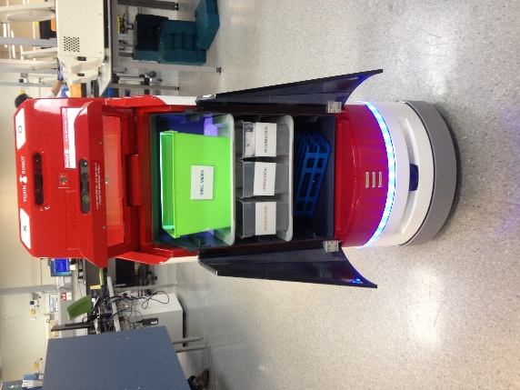
(a) (b)
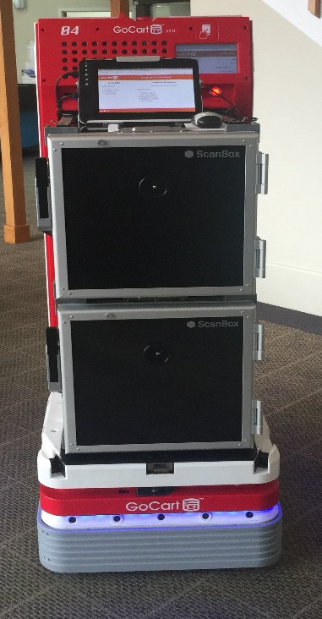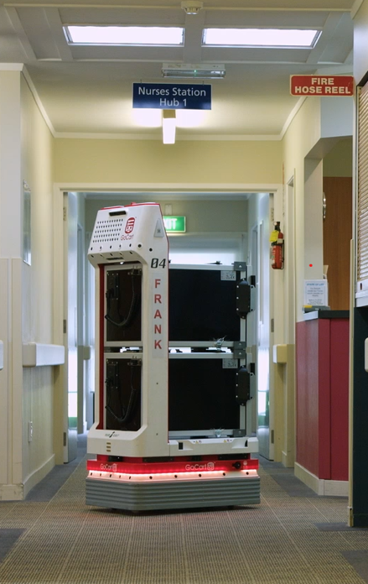
(c) (d)
Fig. 1 Photos of the robots used in the study; GoCart Mini (a and b), used at the pathology laboratory and GoCart V2.0 (c and d), used in the residential care facility for delivering meals. Photos were taken in the field at each location.
2.4. Procedure. The evaluation consisted of a set of scenarios to determine the usability and functionality of the GoCart robots. In these testing scenarios, the GoCart navigated itself from its docking station to its delivery points using its navigation system. The GoCarts were programmed with a map of the facilities and the route it was to follow. The speed of the GoCarts was limited to 0.5m/s for the evaluation. As a safety precaution, the robots were also programmed to slow down when they were less than one metre away from a person or obstacle and stop completely when a person or object came within 30cm of the GoCart. At each site, the GoCart was set up and the staff were trained on how to use it. Each robot was then tested for a two-week period, from the 25th July to 5th August 2016.
2.4.1. Labtests Scenario. Labtests is a large commercial blood, urine and pathology testing facility (labtests.co.nz). At Labtests, the GoCart was used to deliver samples on 15-minute intervals from 12pm to 5pm, Mondays-Fridays, at their main testing centre. Figure 2 shows an example route for the GoCart. The GoCart was docked at the specimen reception department. The staff in the reception deployed the GoCart from the docking station to the pickup point using the “O” button or the mobile tablet. When it arrived to the pickup point, the staff loaded the lab samples for delivery and deployed the GoCart using the “O” button. The GoCart navigated its way from one department to the other, passing through a corridor while avoiding people and any obstacles in its path using its built in RFID sensors. On arrival at the microbiology department the GoCart navigated its way to five predetermined delivery points where staff at each workbench then unloaded the samples and deployed the GoCart using the “O” button to its next destination. When it arrived at each station it made an “ahem” sound to get users attention. After delivery to the last destination was completed, the robot was deployed to return to its docking station to charge and await the next delivery. This location had a 9.5% slope, which was easily managed by the GoCart.
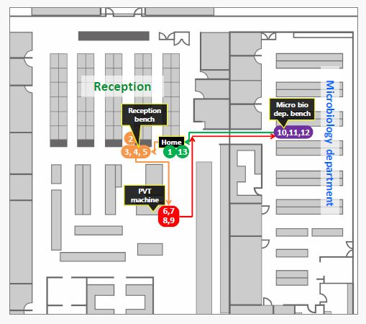
Fig. 2 A map of the layout at Labtests, showing an example route for the GoCart from the docking station (green), to the pickup point (yellow) where the staff loads the samples, and then to the delivery points (red and purple) where the staff unload the delivery, before returning to the docking station (green).
2.4.2. Mercy Parkland Scenario. The GoCart at Mercy Parklands was used to deliver meals to residents, twice a day from Monday to Friday. The route the GoCart took is shown in Figure 3. For this scenario, the GoCart was docked in the dining room and deployed to go to the kitchen 15 minutes before lunch time. The GoCart navigated its way through the lobby and down corridors to the kitchen, avoiding people and any obstacles in its path. On arrival at the kitchen, the GoCart waited for the kitchen staff to open the kitchen doors before entering. The kitchen staff then loaded the GoCart with containers of food and drink and deployed it to return to the dining room, where staff unloaded the containers and served the residents their meals.
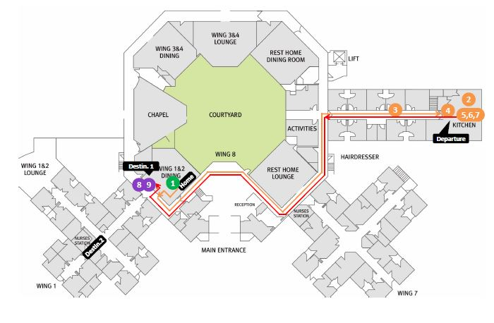
Fig. 3 A map of the layout at Mercy Parklands, showing an example route for the GoCart from the docking station (green), to the kitchen (yellow), where the staff load the meals into the GoCart, and delivery points (purple) where the staff unload the meals, before returning to the docking station (green).
Some residents had lunch in their rooms so the GoCart waited until the staff loaded it with the residents’ prepared meals and deployed the GoCart to go from the dining room down the corridor to the nurses’ station. Once it reached the nurses’ station the staff unloaded the individual meals and delivered them to the residents’ rooms. Once all those meals are delivered the staff deployed the GoCart to return to its docking station in the dining room where it docked and recharged. When lunch was over, staff loaded the GoCart with the dirty dishes and deployed the GoCart to return it back to the kitchen where the staff unloaded the dirty dishes and deployed the GoCart to return to its docking station to charge and await the next delivery.
The GoCart also delivered afternoon tea to the residents akin to the lunchtime scenario. The kitchen staff loaded the GoCart with teapots, cups and snacks. At the end of this delivery the robot returned to the researchers’ room to dock overnight.
2.5. Measures. At the end of the two-week trial period, the participants completed a one-on-one interview which included a set list of both quantitative and open-ended questions, provided in more detail in the sections below. Four participants (two at Labtests and two at Mercy Parkland) completed the questionnaire in their own time as they were not available for an interview. The type of questions differed depending on whether the participant was a direct user, secondary user or manager, as they had different interactions with the robots. Closed questions were used (either in a yes or no format, or on an ordinal scale of 1-5) and participants had the option to add further qualitative comments to any of the quantitative questions.
2.5.1. Secondary users’ questionnaire. Secondary users were asked questions about their robot experience satisfaction levels and their opinions on the robot’s driving, lights and sound features. This included questions about the perceived safety levels of the GoCart, whether they were satisfied with the design and functionality of the GoCart, whether the size and speed of the GoCart was appropriate and their overall views of whether they were in favour of having a robot at their facility.
2.5.2. Managers’ questionnaire. The managers were asked the same questions as the secondary users, as well as a post-evaluation questionnaire. This questionnaire evaluated overall satisfaction with the GoCart, as well as the perceived usefulness of the robot at their facility. Lastly the post-evaluation questionnaire asked whether they believed the GoCart improved time-efficiency at the facility.
2.5.3. Direct users’ questionnaire. The direct users answered the same questions as the secondary users and managers, including the post-evaluation questionnaire. They also answered questions about their direct experience using the GoCart. This included how convenient they thought the robot cart was, how easy the buttons and tablet were to use, how easy it was to load and unload the GoCart, whether the volume of the GoCart was an appropriate size, and whether the different functions of the robot were appropriate.
2.6. Data analysis. The answers to the quantitative questions are reported as category percentages (for two-point scales) and means (for five-point scales). The qualitative answers were extracted and summarised with the quantitative responses in order to understand the users’ views on the GoCarts’ design and functionality, safety and security, usability and overall attitudes towards the GoCart.
3. Results
3.1. Labtests
3.1.1. Design and functionality. On average, users were moderately satisfied with the exterior design of the GoCart robot on a 1 (not at all) to 5 (very satisfied) scale (N=29, M=3.55, SD=1.30). They mentioned that it looked durable and that the surface was easy to wipe clean. They liked the glass on top as it allowed them to see if the samples were inside. However, 20/29 (69%) of users believed that the GoCart was too small, whereas no one reported that the robot was too big. A few users mentioned that the GoCart was too short which made it hard to notice the robot over the tall benches. 14/29 (48%) of users thought that the volume of the GoCart’s noises was too quiet, whilst no one thought it was too loud. They commented that the volume needed to be increased because there were other machines nearby that made regular beeping noises, masking the robot’s sounds.
17/29 (59%) of the users believed that the meaning of the lights on the GoCart were unclear, with the majority of these stating that they weren’t aware that the GoCart’s lights had different meanings. Some users suggested that the lights should be on top of the robot and brighter to attract better attention to their meaning. Similarly, 18/29 (62%) of the users reported that the meaning of the different sounds the GoCart made were unclear, with only 7/29 (24%) reporting that they understood the meaning of all the sounds. Users mentioned that the sounds could be more clearly differentiated and louder. Some participants mentioned that they did not hear any of the GoCart’s sounds or were too busy to notice. Those who did notice the sound mentioned that the ‘ahem’ grunt came across as rude and could be changed to a beep or something more polite.
3.1.2. Safety and security. On average, the respondents reported feeling safe when the GoCart was driving around the lab on a scale of 1 (not at all) to 5 (very safe) (N=29, M=3.93, SD=1.03). Those who reported feeling only slightly or not at all safe were all secondary users of the robot. To improve the safety of the GoCart, it was suggested to set up route markers on the floor of the lab to reduce hazards and collisions with the robot.
21/29 (72%) of participants believed that the GoCart was too slow, especially when it was going from the docking station to the pickup point, as they believed they could have delivered the samples faster. No one reported that the robot moved too quickly. Most users (26/29, 90%) believed that the GoCart did a good job at keeping the right distance from people when it was moving. However, some reported that the robot stopped when a person was still far away which sometimes caused unnecessary delays with delivery.
The participants liked the fact that the GoCart prevented cross-contamination of the samples. However, some users were worried about the security for when spillages in the GoCart occurred, as there was no form of notifying staff of spillages. It was suggested that an alert system or automatic shutting down process when a spill is detected would be a good addition to the robot. They would also like more information on the safety procedures behind what would happen if a sample was spilled (e.g. how it would be cleaned up).
3.1.3. Usability. Usability of the GoCart was only assessed for direct users of the robot. Most of the direct users (9/12, 75%) stated that it was easy to immediately recognise the functions of the GoCart‘s buttons. The 2/12 (17%) users who stated it was not easy to recognise the function of the buttons thought the buttons were not labelled distinctly enough and that the buttons could be made larger. All of the direct users reported that the buttons were in appropriate locations, were visible and were at a good height. However, the majority of direct users did not notice the information on the LCD screen. Those that did said the writing on the screen was too small, although still readable.
All of the direct users reported that it was easy to learn and master how to book the GoCart for a delivery and found it user-friendly. Those who used the accompanied tablet, found it was also simple to use. They liked that the GoCart had programmed route set instead of choosing each individual destination all the time. Although, it was suggested that the destinations could be named using workbench names rather than numbers.
All but one of the direct users found it easy to load and unload the GoCart‘s cart. However, some mentioned that they would prefer a taller robot to prevent bending over too much during the day. 11/12 (92%) of the direct users thought that the volume of the GoCart was too small to fit the number of samples they needed to process, and it may be better suited for smaller labs. Some users mentioned it would be good to have more space inside, as this would make it easier to load and unload, as well as allow the robot to carry more samples. Other users suggested that more shelves, instead of compartments, would be better so that each station in the lab could have its own shelf. Lastly, it was mentioned that it would be better to have shelves that could slide out, to make it easier to load and unload the robot.
3.1.4. Overall attitudes towards the robot. The overall reactions to the GoCart from the direct users and managers from the post-evaluation questionnaire are provided in Figures 4-7. Overall, after the experience with the GoCart, there were mixed reactions as to whether participants were in favour of having robots in the lab (N=29, M=3.28, SD=1.28). However, all of the respondents who reported they were only slightly or not at all in favour, were secondary users. In the open-ended questions, the participants stated that there was potential for the GoCart to be used full-time and take on more tasks once the staff were accustomed to using it. They believed that after improvements were made, it could save time and improve efficiency and mentioned that they appreciated that research was being conducted to help improve the efficiency of their work. Other than those improvements already mentioned above, participants suggested a few general improvements including; adding a hand so it could pick up and load the sample itself, adding a voice so that the GoCart could converse with the users to add the ‘human touch’, and to add more features to help with the registration of samples, such as scanning the barcodes into a database as the sample is loaded inside the robot.

Fig. 4 Bar chart showing the proportion of responses to the question “Are you satisfied with your overall experience of using the GoCart?” from the post-evaluation questionnaire given to direct users and managers at the Labtests and Mercy Parklands Facilities.

Fig. 5 Bar chart showing the proportion of responses to the question “Do you think the delivery service the GoCart provides is useful?” from the post-evaluation questionnaire given to direct users and managers at the Labtests and Mercy Parklands Facilities.

Fig. 6 Bar chart showing the proportion of responses to the question “Did you feel generally at ease and comfortable using the GoCart service?” from the post-evaluation questionnaire given to direct users and managers at the Labtests and Mercy Parklands Facilities.

Fig. 7 Bar chart showing the proportion of responses to the question “Does the GoCart service provide more time efficiency for you compared to before adopting the service?” from the post-evaluation questionnaire given to direct users and managers at the Labtests and Mercy Parklands Facilities.
3.2. Mercy Parklands
3.2.1. Design and functionality. Overall, the staff at Mercy Parklands were mostly satisfied with the design and functionality of the GoCart. Most of the users were satisfied with the GoCart’s exterior design (N=18, M=4.22, SD=0.88), with 17/18 (94%) of users reporting that the GoCart’s size was just right. 14/18 (78%) of users also found that the volume of the GoCart’s sounds was just right, with only 4/18 (22%) stating that it was too quiet.
However, most of the participants (12/18, 67%) stated that they didn’t understand the meaning of the lights. Some of the staff mentioned that they weren’t aware that the lights had different meanings and suggested it would be better to put the light near the top of the robot so that it was more easily noticed. Only 7/18 (39%) of staff reported that they knew the meaning of the different GoCart’s sounds, with 4/18 (22%) stating they didn’t know the meaning or were not aware that the sounds had different meanings
3.2.2. Safety and security. Participants felt sufficiently safe while the GoCart was driving around the residential care facility (N=18, M=4.44, SD=0.86). 78% of people mentioned that the GoCart’s speed was appropriate, with no one stating that it was too fast. However, one staff member mentioned that one particular resident did become scared of the GoCart when they thought it moved too fast. All participants reported that the GoCart kept the right distance away from people when moving. The direct users were satisfied with the safety of the cart and mentioned that it was safer than existing trolleys, which were hard to manoeuvre and could tip over, causing spillages. Whereas, if the GoCart was to tilt, the spillage would be contained within the compartment. Lastly, some users mentioned that the robot could have softer edges and round hinges as a safety precaution for those residents who might bump into it.
3.2.3. Usability. Usability questions were only administered to the direct users of the GoCart. All six direct users reported that they could easily recognise the functions of the GoCart’s buttons immediately. All the users also stated that the buttons, sensors and screen were in appropriate locations and that overall, the robot was easy to use. The LCD screen was not used by most of the staff as they didn’t need it, but 2/6 (33%) still thought that the information provided on the screen was useful. They also thought the screen was in the right place, however, some of the shorter staff members had to tiptoe to see it.
All the direct users mentioned that it was easy to both load and unload the GoCart. Most (5/6, 83%) also thought that the volume of the GoCart was just right, with only one user saying that it was too small. However, only 3/6 (50%) thought that the drawers and shelves in the GoCart were appropriate, as the soup cups used were too tall to fit, which meant they had to use only two trays per box, limiting capacity. Lastly, the direct users commented that the GoCart was stable and easy to clean if anything spilled, and that the temperature of the food was generally maintained. Although tested prior to the study, there were issues with connecting the tablet to the Wi-Fi at Mercy Parklands, so the tablet was not used in this case study. The GoCart could still be operated manually, but questions about the use of the tablet could not be answered.
3.2.4. Overall attitudes towards the robot. The overall reactions to the GoCart from the post-evaluation questionnaire are provided in Figures 4-7. Overall, participants were mostly in favour of having a GoCart in the residential care facility (N=18, M=4.00, SD=0.97). The users mentioned that the GoCart worked well, was a good idea and they enjoyed having it in the kitchen. They thought that when the robot was running smoothly, it allowed them to spend more time tending to resident needs and reduced caregiver workload. In particular, it gave staff an extra 45 minutes to spend with the residents instead of walking back and forth to the kitchen. However, a few staff members stated that they did not think it would improve staff labour time, as they believed they could make deliveries faster by foot. They also mentioned that it may not be appropriate for aged care facilities due to financial constraints, and human labour could be just as efficient. Lastly, the users mentioned that the residents themselves looked forward to seeing the GoCart and enjoyed having it around.
Other than those already mentioned above, the staff mentioned a few additional improvements including; giving the robot the ability to open the kitchen doors by itself, making it do other activities with the residents so they could interact more with it, giving it the ability to speak with residents, voice activated deployment of the GoCart, and improving the consistency of the robot, as there were a few technical difficulties and problems with the Wi-Fi connection for the tablet.
4. Discussion
These two case studies investigated the usability, acceptability and functionality of two autonomous mobile delivery robots at two different sites; a pathology laboratory and a residential care facility. Overall, the residential care facility users were satisfied with their experience with the GoCart robot. They were in favour of using robots and thought the robot improved time-efficiency in delivering meals to residents. They mentioned that with improvements, including fixing technical issues, the robot would be a great addition to the residential care facility. In contrast, the participants at the laboratory had more mixed reactions to the GoCart robot. They varied on whether they were satisfied with their experience of the GoCart and mixed on the perceived usefulness of the GoCart. Lastly, most of the direct users at the laboratory stated that they did not think that the GoCart improved time efficiency but could see the potential if more improvements were made to the robot.
Participants from both sites were satisfied with the exterior design of the robot, although it was suggested that the robot edges be made smoother. Other researchers have mentioned that delivery robots can be quite solid and rigid, which could lead to injuries if a collision occurred [13]. This is particularly an issue in a residential care facility. The size of the robot was also an issue for the direct users from both sites who would like to see the GoCarts’ deliver more meals and samples in one trip. It was made clear by both sites, that the meanings of the lights and sounds of the GoCart need to be made clearer so that they were understandable.
Participants from both sites believed that the robot was safe when driving, and the items inside were secure. Direct users from both sites believed that the GoCart was easy to use, however, shelves designed for each particular site and item type would be more appropriate. This suggests that a degree of customisation would be a good addition to allow the GoCart to be more usable in different settings. Overall staff at both sites felt that once the robot was better adapted to their specific facility and needs it would be a benefit and they look forward to seeing it trialled again.
These findings demonstrate that autonomous mobile delivery robots are seen as acceptable and useful in healthcare settings other than the hospital environment. Previous research with autonomous mobile delivery robots, such as the GoCart robot, has only been conducted in hospital settings or in businesses and office environments, so this study demonstrates that these robots could be used in laboratory and residential care facilities as well. However, improvements need to be made to make sure the robot can seamlessly be added to these environments, including specific improvements particular to the different types of products delivered and different users delivered to at each site. With these improvements, most secondary and direct users from both sites, thought the GoCart robots would be good additions to their facilities. This has large implications for these facilities, as the addition of a delivery robot could lead to a lower staff workload and more time for staff to conduct other tasks. As stated by participants from both sites, the GoCart would also be more secure than human deliveries, as spillages and cross contamination are lessened and contained.
However, this research has several limitations. First, it was only conducted over a two-week period, so it’s difficult to assess long-term benefits or costs associated with the robot. Future research should investigate the efficiency of the GoCart over a longer period of time. Second, the questionnaire used to assess users’ experiences, satisfaction and opinions of the robot was short, in order to minimise participant burden for busy staff members. Once the feedback from these two case studies has been taken into account and the GoCarts have been improved, future research could look at other aspects of acceptability with more detailed questionnaires and data analyses. As well as this, future research should conduct a cost-benefit analysis with further focus on the installation, running and maintenance costs of the GoCarts. Third, there were some technical difficulties experienced during the study period, including issues with Wi-Fi connection at Mercy Parklands. Although the robot could still be operated manually without Wi-Fi, these technical difficulties may have skewed the views of the users due to lack of consistency. If a longer study was to be conducted, these issues would need to be fixed to ensure smooth running of the robot.
Existing autonomous mobile delivery robots, such as the TUG robot, have further functionalities such as the safety lock system, self-opening of corridor doors, faster speed, and bigger compartments [12, 16]. A future phase of this trial could be to add these existing functionalities. This could make the GoCart a more feasible addition to the pathology laboratory and residential care facilities and improve the operational deployment of the GoCart robots.
More generally, these results from both case studies highlight some key design considerations for delivery robots including size, making the display and lights meaningful, safety, voice activation, and notably possible social aspects of interaction with both staff and residents, including politeness and enjoyment. Although many of these design issues are already known, adding sociability to delivery robots for residents in residential care facilities is a newer insight in the literature. If developed, this might help with the high rates of loneliness in older adults [33], but further research is needed to investigate this.
5. Conclusion
These case studies demonstrate that a GoCart delivery robot is a feasible addition to two different sites (a pathology laboratory and a residential care facility) as it is usable, safe, secure and functional. This demonstrates that autonomous mobile delivery robots can be used in environments other than the typical hospital environment, demonstrating the versatility of these autonomous mobile delivery robots. However, more improvements are still needed, including customisation to the particular site, before the GoCarts can be deployed in these settings permanently.

References
1. Dahl TS, Boulos MNK. Robots in health and social care: A complementary technology to home care and telehealthcare? Robot. 2014;3:1-21. https://doi.org/10.3390/robotics3010001
2. Shi L, Singh DA (2014) Delivering health care in America. Jones & Bartlett Learning, MA, USA.
3. Riek LD. Healthcare robotics. Commun ACM. 2017;60(11):68-78. https://doi.org/10.1145/3127874
4. Kim J. Use of robots as a creative approach in healthcare ICT. Healthc Inform Res. 2018;24(3):155-6. https://doi.org/10.4258/hir.2018.24.3.155
5. Ahn HS, Lee MH, MacDonald BA. Healthcare robot systems for a hospital environment: CareBot and ReceptionBot. 2015 24th IEEE International Symposium on Robot and Human Interactive Communication (RO-MAN); IEEE; 2015. https://doi.org/10.1109/ROMAN.2015.7333621
6. Ahn HS, Zhang S, Lee MH, Lim JY, MacDonald BA. Robotic Healthcare service system to serve multiple patients with multiple robots. International Conference on Social Robotics; Springer; 2018. https://doi.org/10.1007/978-3-030-05204-1_48
7. Law M, Sutherland C, Ahn HS, MacDonald BA, Peri K, Johanson DL, et al. Developing assistive robots for people with mild cognitive impairment and mild dementia: a qualitative study with older adults and experts in aged care. BMJ Open. 2019;9(9):e031937. http://dx.doi.org/10.1136/bmjopen-2019-031937
8. Ozkil AG, Fan Z, Dawids S, Aanes H, Kristensen JK, Christensen KH. Service robots for hospitals: A case study of transportation tasks in a hospital. 2009 IEEE International Conference on Automation and Logistics; IEEE; 2009. doi: 10.1109/ICAL.2009.5262912
9. Amazon Prime Air (2020). Drone delivery. Amazon. Retrieved from https://www.amazon.com/Amazon-Prime-Air/b?ie=UTF8&node=8037720011
10. Bhaskar K, Mansooor A, Anand KR, Ramani A. Intelligent mail delivery robot. 2011 2nd International Conference on Intelligent Agent & Multi-Agent Systems; IEEE; 2011. https://doi.org/10.1109/IAMA.2011.6048994
11. Jeon S, Lee J. Multi-robot control architecture for hospital delivery service in unstable network environment. ICINCO (2);2017. https://doi.org/10.5220/0006410502700277
12. Lum G, D’Amarino MJ. Use of laboratory robots for transport and delivery of blood products. Lab Med. 2009;40(9):517-22. https://doi.org/10.1309/LMR9EV8GT9XCQAMK
13. Nejat G, Sun Y, Nies M. Assistive robots in health care settings. Home Health Care Manag Pract 2009;21(3):177-87. https://doi.org/10.1177/1084822308325695
14. Jeon S, Lee J. The simulator for performance analysis of multiple robots for hospital delivery. 2016 13th International Conference on Ubiquitous Robots and Ambient Intelligence (URAI); IEEE; 2016. https://doi.org/10.1109/URAI.2016.7734105
15. Carreira F, Canas T, Silva A, Cardeira C. I-Merc: A mobile robot to deliver meals inside health services. 2006 IEEE Int Conf Robot Autom; IEEE; 2006. https://doi.org/10.1109/RAMECH.2006.252651
16. Bloss R. Mobile hospital robots cure numerous logistic needs. Ind Robot. 2011;38(6):567-71. https://doi.org/10.1108/01439911111179075
17. Silva JB, Santos C, Sequeira J. Developing a timed navigation architecture for hospital delivery robots. 2013 IEEE 3rd Portuguese Meeting in Bioengineering (ENBENG); IEEE; 2013. https://doi.org/10.1109/ENBENG.2013.6518412
18. Hada Y, Gakuhari H, Takase K, Hemeldan EI. Delivery service robot using distributed acquisition, actuators and intelligence. 2004 IEEE/RSJ International Conference on Intelligent Robots and Systems (IROS) (IEEE Cat. No. 04CH37566); IEEE; 2004. https://doi.org/10.1109/IROS.2004.1389865
19. Jean J, Wei C, Lin Z, Lian K. Development of an office delivery robot with multimodal human-robot interactions. 2012 Proceedings of SICE Annual Conference (SICE); IEEE; 2012.
20. Gao K, Xin J, Cheng H, Liu D, Li J. multi-mobile robot autonomous navigation system for intelligent logistics. 2018 Chinese Automation Congress (CAC); IEEE. https://doi.org/10.1109/CAC.2018.8623343
21. Li C, Liu X, Zhang Z, Bao K, Qi ZT. Wheeled delivery robot control system. 2016 12th IEEE/ASME International Conference on Mechatronic and Embedded Systems and Applications (MESA); IEEE; 2016. https://doi.org/10.1109/MESA.2016.7587137
22. Scott S. Meet Scout: Field testing a new delivery system with Amazon Scout. The Amazon Blog; 2019. https://blog.aboutamazon.com/transportation/meet-scout
23. Crowley C, Proser M, Bazemore A. High demand, low supply: Health centers and the recruitment of family physicians. Am Fam Physician. 2018;98(3):146. https://www.aafp.org/afp/2018/0801/p146.html
24. Ludlow K, Churruca K, Mumford V, Ellis LA, Testa L, Long JC, Braithwaite J. Unfinished care in residential aged care facilities: An integrative review. Gerontologist. 2019;gnz145. https://doi.org/10.1093/geront/gnz145
25. Thornton K. Reversing the lab-workforce shortage trend. Advance for Administrators of the Laboratory. 2011;25(3):1-4. http//laboratory- manager.advanceweb.com/Feaatures/Articles/Reversing-the-Lab-Workforce- Shortage-Trend.aspx
26. Willis E, Price K, Bonner R. National aged care staffing and skills mix project report 2016. Meeting residents’ care needs: A study of the requirement for nursing and personal care staff. Melbourne, Australia: Australian Nursing and Midwifery Federation, 2016.
27. Riek LD. The social co-robotics problem space: Six key challenges. Proceedings of the 1st Workshop on Robotics Challenges and Vision (RCV2013). 2013:13-16.
28. Fernando JB, Tanigawa T, Naito E, Yamagami K, Ozawa J. Collision avoidance path planning for hospital robot with consideration of disabled person's movement characteristic. The 1st IEEE Global Conference on Consumer Electronics 2012;392-396. https://doi.org/10.1109/GCCE.2012.6379636.
29. Björling EA, Rose E. Participatory research principles in human-centered design: Engaging teens in the co-design of a social robot. Multimodal Technologies and Interaction. 2019;3(1):8. https://doi.org/10.3390/mti3010008
30. Rodil K, Rehm M, Krummheuer AL. Co-designing social robots with cognitively impaired citizens. Proceedings of the 10th Nordic Conference on Human-Computer Interaction 2018:686-690. https://doi.org/10.1145/3240167.3240253
31. Lluch M. Healthcare professionals’ organisational barriers to health information technologies—A literature review. Int J Med Inform. 2011;80(12):849-62. https://doi.org/10.1016/j.ijmedinf.2011.09.005
32. Forlizzi J, Zimmerman J. Promoting service design as a core practice in interaction design. Proc. of IASDR13. 2013:1-12.
33. Victor CR, Yang K. The prevalence of loneliness among adults: A case study of the United Kingdom. J Psychol. 2012;146(1-2):85-104. https://doi.org/10.1080/00223980.2011.613875

