On improving the hydrogen and methanol production using an auto-thermal double-membrane reactor: Model prediction and optimisation

Hamid Rahmanifard¹, Reza Vakili², Tatyana Plaksina¹, Mohammad Reza Rahimpour³, Masoud Babaei², Xiaolei Fan^{2,∗}
¹ Department of Chemical and Petroleum Engineering, Schulich School of Engineering, University of Calgary, 2500 University Dr. NW, Calgary, Alberta, T2N 1N4, Canada
² School of Chemical Engineering and Analytical Science, The University of Manchester, Oxford Road, Manchester, M13 9PL, United Kingdom
³ Department of Chemical Engineering, School of Chemical and Petroleum Engineering, Shiraz University, Shiraz 71345, Iran

Abstract
The concentric configured thermally-coupled double-membrane reactor (TCDMR) was optimised to improve the co-production of hydrogen and methanol. Using a detailed approach, we identified the non-linear differential evolution (DE) algorithm as the most suitable optimisation tool among the most used optimisation algorithms in reactor design (GA, PSO, and DE) due to its ability to converge to the optimal solution with fewer iterations. Considering DE algorithm with the industry benchmark data, we optimised the key operational parameters of TCDMR (as OTCDMR), leading to the improved reactor performance (regarding the overall heat transfer and methanol/hydrogen production) compared to the conventional methanol reactor (CMR) and TCDMR. Simulation results show that the methanol production rate of OTCDMR could reach 315.7 tonnes day⁻¹, representing a 22.6% enhancement than CMR (257 tonnes day⁻¹). For the hydrogen production, OTCDMR is predicted to deliver 19.7 tonnes of hydrogen per day, surpassing the 15.5 tonnes day⁻¹ production rate by TCDMR.
Keywords: Non-linear optimisation; Auto-thermal reactor; Membrane reactor; Hydrogen; Methanol.

Introduction
According to the International Energy Agency (IEA, 2013), energy consumption, which was 15 TW in 2011, is predicted to increase to 30 TW by 2050. On the other hand, the depletion of fossil fuels along with the assocaited environmental concerns has stimulated the exploration of alternative fuels to increase the energy security, among which methanol and hydrogen have been identified as promising energy carriers. Methanol (CH₃OH) is easy to handle and transport with low risk of flammability, as well as low emissions (Lange, 2001). It is produced from natural gas, as well as number of renewable resources including biomass, via exothermic catalytic carbon monoxide hydrogenation (ΔH₂₉₈ = −90.55 kJ mol⁻¹); and can be used as either the combustion fuel or the building block to produce other important chemicals as dimethyl ether (DME) and methyl t-butyl ether (MTBE).
Hydrogen (H₂) is a high-quality energy carrier which is used by electrochemical cells or internal engines with the benefit of zero carbon emission. It can be produced through different process routes (Hodoshima et al., 2003), mainly through the steam reforming of hydrocarbon feedstocks such as methane (ca. 48%) and naphtha (<30%) (Ewan & Allen, 2005). However, the storage and transportation of H₂ are challenging due to its poorer volumetric energy density (12.7 MJ m⁻³) compared to hydrocarbons (e.g. 40.0 MJ m⁻³ for methane). Therefore, chemical storage materials with high storage densities are of interest to be investigated to develop reversible, safe and cost-effective systems. Cyclohexane (with a relatively high gravimetric storage density of 6.2 wt.% and 46.5 kg-H² m⁻³) is a liquid organic hydrogen carrier, being able to hydrogenated/dehydrogenated for energy/H₂ switch (dehydrogenation of cycloalkanes is highly endothermic, ΔH₂₉₈ = +206.2 kJ mol⁻¹) (Brown, 2001; Gallucci & Basile, 2008).
According to the process intensification, the heat integration is one of the guidelines to maximise the efficiency of processes (Stankiewicz & Moulijn, 2003), which is exemplified by the concept of catalytic multifunctional reactors (Fan, Lapkin, et al., 2009; Fan, Manchon, et al., 2009) and auto-thermal reactors (Vakili et al., 2011). In the auto-thermal reactors, the exothermic side of the reactor supplies the heat to sustain its endothermic side (Zanfir & Gavriilidis, 2001). Khademi et al. (2009) proposed a thermally coupled membrane reactor (TCMR) to couple a conventional methanol reactor (CMR) (the exothermic side) with a cyclohexane dehydrogenation reactor (the endothermic side) for the coproduction of CH₃OH and H₂. In order to improve the process efficiency, other strategies for overcoming the thermodynamic equilibria were proposed, e.g. supply H₂ to the exothermic side using a hydrogen permselective membrane (Rahimpour et al., 2011), in situ removal of water from the exothermic side using a sweeping gas hydroxy sodalite membrane (Bayat & Rahimpour, 2011), and coupling cyclohexane dehydrogenation process with methanol synthesis and methanol dehydration reactions (Samimi et al., 2014). The results show that the thermally coupled double membrane reactor (TCDMR) (Rahimpour et al., 2011), where H₂ is supplied to the exothermic side, demonstrates the improved CH₃OH/H₂ production compared to other configurations (e.g. 19% and 11% enhancement for CH₃OH and H₂ production, respectively, than TCMR). Therefore, TCDMRs are promising reactor technologies, which deserve further investigation for the production of alternative fuels of CH₃OH/H₂.
In the simulation of TCDMRs (Rahimpour et al., 2011), the operational parameters such as temperature, pressure and flow-rate were either adopted from other reactor types (e.g. TCMR and CMR) (Rahimpour et al., 2011; Rezaie et al., 2005) or identified by local sensitivity analysis (where one variable is varied while keeping other variables fixed), which was not sufficient to identify the key parameters and understand the parameter correlations to achieve the optimal design. Therefore, in order to maximise the CH₃OH and H₂ production, the optimisation of the process using the TCDMR (Rahimpour et al., 2011), should be performed towards the optimal (or near optimal) solution, enabling the comprehensive consideration of all key design variables. The inclusion of several design parameters as the decision variables during the optimisation of a reactor results in a nonlinear scenario, and hence requiring nonlinear optimisation algorithms.
State-of-the-art nonlinear optimisation algorithms include derivative (or gradient-based) and direct (or gradient-free) optimisation algorithms (Chen, 2013; Fujii & Horne, 1995; Mohagheghian, 2016; Watson et al., 1980). The gradient-based optimisation algorithms require the derivative information from the objective functions. However, the lack of a computable derivative (e.g. with the non-differentiable objective function) can fail the gradient-based optimisers and call for the derivative-free algorithms (Kramer et al., 2011; Price et al., 2006).
Derivative-free optimisation algorithms can be classified into direct-search, model-based or hybrid methods. The decision making of the direct search methods is based on the previously evaluated points and the best solution so far. Conversely, the model-based algorithms attempt to capture the curvature of the original model using data-driven surrogate models and the search process is guided by optimising the surrogate model. The direct search methods (e.g. AI algorithms) are generally successful for non-smooth problems, whereas model-based algorithms are preferred for smooth problems (Bajaj et al., 2017).

To date, the stochastic gradient-free (derivative-free) algorithms, especially artificial intelligence (AI) methods (Bayat, et al., 2014), have shown improved performance in comparison to the gradient-based methods, i.e. the improved capability of establishing the optimum solution for non-linear optimisation problems with multiple objectives (Amirabadi et al., 2013; Azarhoosh et al., 2014; Bayat & Rahimpour, 2013; Eberhart & Kennedy, 1995; Farsi et al., 2014; Khademi et al., 2010; Shen et al., 2006; Shi & Eberhart, 1999; Soleimani et al., 2013). AI methods with different algorithms has been applied to various chemical process simulations including the optimisation of (i) methanol synthesis reactors using the differential evolution (DE) algorithm (Amirabadi et al., 2013; Bayat, Dehghani, et al., 2014; Bayat & Rahimpour, 2013; Khademi et al., 2010), (ii) multi-stage spherical reactors for DME production using the genetic algorithm (GA) (Farsi et al., 2014), (iii) fixed-bed reactors for methanol-to-olefins (MTO) using particle swarm optimisation (PSO) algorithm (Rostami et al., 2016) and etc. (Domingues et al., 2014; Ganesan et al., 2013; Leong et al., 2016; Na et al., 2017; Soltani & Shafiei, 2015) Although these practices commonly obtained satisfactory results of the optimisation, the rationales of using different algorithms (i.e. GA, PSO or DE) are generally lacking (details of GA, PSO and DE AI algorithms are presented in the Supporting Information, SI).
As commented above, the advantages of the multifunctional auto-thermal reactor for coupling the exothermic/endothermic reactions in one unit, being one of the promising solutions for the coproduction of CH₃OH and H₂ to meet today’s energy demand. Therefore, in order to facilitate the development of multifunctional auto-thermal reactors, we perform the numerical study of a model reactor of TCDMR, by employing the AI algorithms for nonlinear optimisation with respect to the yield of CH₃OH and H₂. For the first time, we conduct a comparative study using the state-of-the-art AI algorithms of GA, DE and PSO methods to identify the most suitable algorithm for the case of TCDMR, which is based on careful evaluation of the objective function value, the number of iterations for obtaining the optimum solution, runtime, and standard deviation. Additionally, the performance of the optimised TCDMR (OTCDMR) regarding the thermal behaviour (the trend of transferred and absorbed heat along the reactor) and the yields of CH₃OH and H₂ are compared to that of TCDMR and CMR to verify the theoretical superiority of the optimised case established by this study.

Methodology

2.1. Description of thermally coupled double membrane reactor (TCDMR)
TCDMR is functionalised by adding the hydrogen permselective membrane to the exothermic side (side 1, between the exothermic and recycle side) and enabling the hydrogen permeation from the recycle side (side 4) to the methanol synthesis reactions (Rahimpour et al., 2011). The thermal and chemical stability of the application of this type of membranes at high-temperatures (< 773 Kº) and high-pressures have been confirmed by the previous research (Peters et al., (2007); Medrano et al., (2016); Maneerung et al., (2014); and Gao et al., (2004)). The resulting TCDMR with two hydrogen permselective membranes has the reactor configuration with four concentered tubes, as shown in Fig. 1. In the operation of TCDMR, the syngas is fed to the side 1 and the high-pressure effluent after the exothermic reactions is compressed and recycled through the side 4, at the same time allowing the surplus hydrogen to permeate through the membrane into the side 1 for sustaining the methanol synthesis reactions (Appendix A, Eq. A1–A3). The remaining sections of TCDMR include the endothermic reactor (for the dehydrogenation of cycloalkane, Eq. A4, side 2) and the outer permeation side (for hydrogen production, side 4) which are identical to that of TCMR.
Fig. 1. Schematic diagram of the TCDMR with the Pd-Ag membranes for hydrogen permeation.

The kinetic model used in this work is obtained from the literature (Graaf et al., 1986), which has been used to model a CMR (a one-dimensional, steady-state heterogeneous model as in the Supporting Information, SI) and has been validated against the methanol reactor of Shiraz Petrochemical Complex (Rezaie et al., 2005). In order to evaluate the performance of the optimised case of TCDMR (i.e. OTCDMR) by this work, the relevant performance of a conventional CMR (Rezaie et al., 2005) and a TCDMR (Rahimpour et al., 2011) is used as the reference cases in this study. The simulation of CMR and TCDMR is performed using the operational conditions presented in Tables A2 and S3.

2.2. Variable selection for optimisation

For thermally-coupled reactors, temperatures along the reactor are determining factors, having the significant effect on the thermodynamic equilibrium, catalyst activity and size of pre-heaters. Therefore, the temperatures shown in Fig. 1 are considered as the decision variables, i.e. the exothermic side temperature (T₁), endothermic side temperature (T₂), outer permeation inlet temperature (T₃). The inner side temperature (T₄) is assumed to be equal to the output temperature of the exothermic side (T₁). The pressures of the exothermic (76.98 bar), endothermic (1 bar) and permeation (0.1 bar) side fixed and adopted from literature and the commercialized methanol reactors (Bayat & Rahimpour, 2013; Khademi et al., 2010; Rezaie et al., 2005), while the pressure of the recycle side (P₄) is considered as the decision variable for the optimisation. Additionally, the coupling of the exothermic and endothermic reactions makes the heat transfer between exothermic and endothermic sides another key parameter, which depends on the gas flow rate in each side. As a result, the flow rate of the exothermic (F₁) and endothermic (F₂) side are also considered as optimisation variables.

2.3. Objective function and constraints

The optimum purpose of the optimisation practice is to maximise the production of CH₃OH, benzene (product of cyclohexane dehydrogenation reaction) and H₂, respectively, from the exothermic, endothermic and permeation side. Thus, the objective function is defined as the total mole fraction of the produced CH₃OH, benzene and H₂ as in Eq. 1.

(1)

In the process of optimisation, constraints are also considered along with the objective function, which are based on the operational limitations with respect to the reactions, as presented in Table 1. Additionally, to create a driving force for the heat flow from the exothermic side to the endothermic side, the constraint of T₂ < T₁ is also applied. The inlet flow rates into the reactor should also be selected carefully since neither low (leading to the reduced production) nor high values (leading to the low residence time of reactants is not ideal. Thus, proper constraints for the feed flow rates are considered based on the design parameters used in the relevant industrial reactors (Vakili & Eslamloueyan, 2012).
Table 1 Constraints considered with the objective function for the optimisation of TCDMR (Bayat & Rahimpour, 2013; Khademi et al., 2010; Vakili & Eslamloueyan, 2012).
Description | Constraint | Comments
Exothermic side temperature (T₁) | 495 K<T₁<535 K | The temperature range for CuO/ZnO/Al₂O₃ catalysts to be active in the methanol synthesis reaction
Endothermic side temperature (T₂) | 423 K<T₂<523 K | The temperature range for the Pt/Al₂O₃ catalyst to be active in the cyclohexane dehydrogenation reaction
Permeation side temperature (T₃) | 298 K<T₃<535 K | The ambient temperature is selected as the lower bound, while its upper bound was considered as the maximum temperature in the exothermic side
Initial molar flow rates on the exothermic side (F₁) | 0.3 mol s⁻¹< F₁<1.5 mol s⁻¹ | The industrial molar flow-rate range for the methanol synthesis reactions
Initial molar flow rates on the endothermic side (F₂) | 0.1 mol s⁻¹ <F₂<1.5 mol s⁻¹ | The industrial molar flow-rate range for cyclohexane dehydrogenation reaction
Recycle side pressure (P₄) | 78 bar<P₄<100 bar | Due to permeation of H₂ from the recycle side to the exothermic side, the pressure of this side should always be greater than the exothermic side (lower bound)  100 bar was used as the upper pressure bound according to the operational pressure of reactor and relevant safety regulations

Based on the defined constraints and the Lagrangian method (Rao, 2009), the objective function to be minimised by the optimisation algorithms is re-written as Eq. 2:
(2)
where 10⁷ is the Lagrangian multiplier used for automatic elimination of unacceptable results (G_{i})
G₁ | max (0, T₂–T₁)
G₂ | max (0, T₁–535 K)
G₃ | max (0, 495 K–T₁)
G₄ | max (0, T₂–523 K)
G₅ | max (0, 423 K–T₂)

2.4. Optimisation procedure

The optimisation process starts with the random production of the initial population (60 vectors) for the six decision variables (6 elements in each vector) in each algorithm. Then, the objective function (Eq. 2) for each optimisation scheme is computed according to the TCDMR model (Appendix A). Based on the highest values for the objective function, GA and DE generate the next population randomly using selection, crossover and mutation operators, while PSO updates the velocity and position of the particles. The processes are iterated for new populations until the stopping criteria are met, i.e. (i) the maximum number of iterations or (ii) the convergence criterion of 10⁻⁶ (0.0001% relative error).
All heuristic optimisation algorithms used in this study are well-known in finding near optimal solutions over continuous spaces (Wahab et al., 2015; Rahmanifard and Plaksina, 2018) due to the natural selection and genetic recombination (GA), the natural pattern of bird flocking or fish schooling (PSO), and the adaptive random search and a normal random generator (DE). However, finding the global optimality cannot always be guaranteed. To ensure the near optimal solution point found by these algorithms, running them for several times is recommended (Mohagheghian, 2016). If the algorithm converges into the same point in most of the runs (consistent convergence to a point), that point is considered as the optimum point for the problem.
For this purpose, five trials with 60 particles (population size) for 600 iterations (totally 36000 functions for each run) are performed in this work. The optimisation toolbox of MATLAB R2016a is used for GA (with relevant settings shown in Table S2), while for DE and PSO, the parameters presented in Table S2 are used. These parameter values have shown generally good convergence in the literature (Bansal et al., 2011; Bayat & Rahimpour, 2013; Cai et al., 2009; Khademi et al., 2010).

Results and Discussion

3.1. Evaluation of the optimisation algorithm

The performance of the three optimisation algorithms was assessed for each trial based on three parameters including the objective function value and the number of iterations, from which the value of the objective function remains constant (stabilisation point). The values of the decision variables calculated by the GA, DE, and PSO methods in the five trials are shown in Table S5. The optimisation results for the five trials of GA, DE, and PSO are presented in Fig. 2. The DE method obtained the highest values of the objective function (approximately 2.2445) and converged to the same optimal solution in all trials, whereas GA and PSO did not converge to the same solution in all trials. The GA method was not stable with two failed convergence (i.e. trial 1 and 4) after 600 iterations. The performance of the PSO algorithm was better than that of the GA method with less fluctuation in the obtained objective function value. The PSO method converged for all trials fairly quickly, as shown in Fig. 2b, with small stabilised iteration numbers. However, it estimated lower values for the objective function in all five trials than that by the DE method (by ca. 0.13%).
Fig. 2. Evaluation of the nonlinear optimisation algorithms in modelling TCDMR. Comparison of (a) the objective function values and (b) stabilized iteration numbers for five initial trials (N.B. the optimisation runtime for all trials of the three algorithms were approximately the same, i.e. about 3 hours).

The standard deviation (Mohagheghian, 2016) was also considered to compare the performance of optimisation algorithms during the iteration, as shown in Fig. 3. In general, the standard deviation is a criterion that is used to measure the amount of variation or dispersion of a set of data values. A low standard deviation indicates that the generations tend to be close to the optimum point of the function, while a high standard deviation indicates that the generations are spread out over a wider range of values (far from the optimum point) (Bland & Altman, 1996). The standard deviation of PSO and DE method decreased gradually with an increase in the irritation number, indicating that the optimisation was approaching the optimum point (Bland & Altman, 1996). Conversely, the variation of the standard deviation values was produced by the GA method, suggesting its difficulty in converging the calculation for the optimised solution. Therefore, the GA method was excluded from the subsequent simulation practice due to its less stable performance compared to PSO and DE method.
Fig. 3. Standard deviation over 600 iterations in each simulation trial for (a) GA, (b) PSO and (c) DE method.

In order to identify the most suitable algorithm from PSO and DE method for the optimisation of TCDMR, the residual objective function (as in Eq. 3) (Mohagheghian, 2016) was defined to evaluate their ability to establish the optimum solution within a limited number of iterations.

(3)

where n is the number of iterations of a trial included in the calculations and obj. function_{max} is the maximum overall objective function for all trials.

Residual objective functions after 150, 300, 450 and 600 iterations for th PSO and DE method in different trials are shown in Fig. 4. DE method generally produces smaller values of the residual objective function than PSO method, suggesting its better performance in establishing a solution close to the optimum target. In addition, DE method was also more capable than PSO method to converge the solution with fewer iterations, saving the computational time and resources. Therefore, according to the apparent results of the initial simulation trials using the three optimisation methods, we conclude that DE technique is the most suitable algorithm for the optimisation of TCDMR. Details of the optimisation procedure of three methods are presented in SI. However, the theoretical explanation of the trial results by the three methods is out of the scope of this work since the objective is the identification of the most capable algorithms for the efficient simulation of TCDMR.
Fig. 4. Comparison of values of the residual objective function for DE and PSO algorithm: (a) iterations 1 to 150, (b) iterations 1 to 300, (c) iterations 1 to 450 and (d) iterations 1 to 600.

By using DE algorithm and the industrially relevant CMR conditions, TCDMR was optimised, giving the predicted decision variables as summarised in Table 2. In OTCDMR, higher temperature in the exothermic side, lower temperature in the permeation side and higher pressure in the recycling side are suggested, in comparison to TCDMR, to improve the overall performance of the thermally coupled reactor, which is discussed in details in the following sections.

Table 2 A comparison between the decision variable values in TCDMR and OTCDMR.
Variables under consideration | TCDMR | OTCDMR  (by the DE algorithm)
T₁ [K] | 503 | 520
T₂ [K] | 503 | 520
T₃ [K] | 503 | 535
F₁ [mol s⁻¹] | 0.64 | 0.63
F₂ [mol s⁻¹] | 0.1 | 0.13
P₄ [bar] | 76.98 | 87.3

3.2. Reactor performance in methanol synthesis
The performance of OTCDMR is compared to that of TCDMR and CMR. In addition to parameters such as the mole fraction, temperature and conversion profiles along the reactor length, the key indicators of the reactors for the coproduction of CH₃OH/H₂, such as the methanol yield and hydrogen recovery yield (Eqs. 4–5) are also considered for the further analysis.

(4)
(5)

Fig. 5 shows the CO conversion, methanol yield and temperature profile along the exothermic side (i.e. methanol synthesis, side 1) of reactors with different configurations. In the exothermic side, at the entrance region, the reaction is kinetically controlled, resulting in the gradual increase in CO and CO₂ conversions and methanol formation (Figs. 5a and 5b), as well as the associated temperature rise as shown in Fig. 5c. With the progress of the methanol synthesis reactions along the reactor, it gradually becomes the thermodynamically controlled, levelling off the conversion and yield. The transition of the methanol synthesis reactions from kinetically controlled region to the thermodynamically controlled one was also reflected by the temperature profiles of three reactor configurations (the exothermic side, Fig. 5c). The gradual decrease of temperatures after the maxima suggest (i) the depletion of the fuel (for all configurations) and (ii) the heat transfer to the endothermic side (for OTCDMR and TCDMR). In OTCDMR, the faster rates of the exothermic reactions (Eq. A1–A3) were predicted than that of TCDMR and CMR, as evidenced by the plotted mole fractions in Fig. S5, as well as the hot spot development along the reactors (535 K and 1.89 m). By comparing the temperature profiles of the exothermic side in CMR and TCDMR, the coupling of the exothermic side with the endothermic side enables the heat transfer between them, leading to the lower temperatures in TCDMR. In OTCDMR, the initial value of T₁ is suggested to be 20 K higher than the TCDMR, enabling the initial heat transfer between the two sides (i.e. T₁ – T₂: 0 K for TCDMR versus 16 K for OTCDMR).
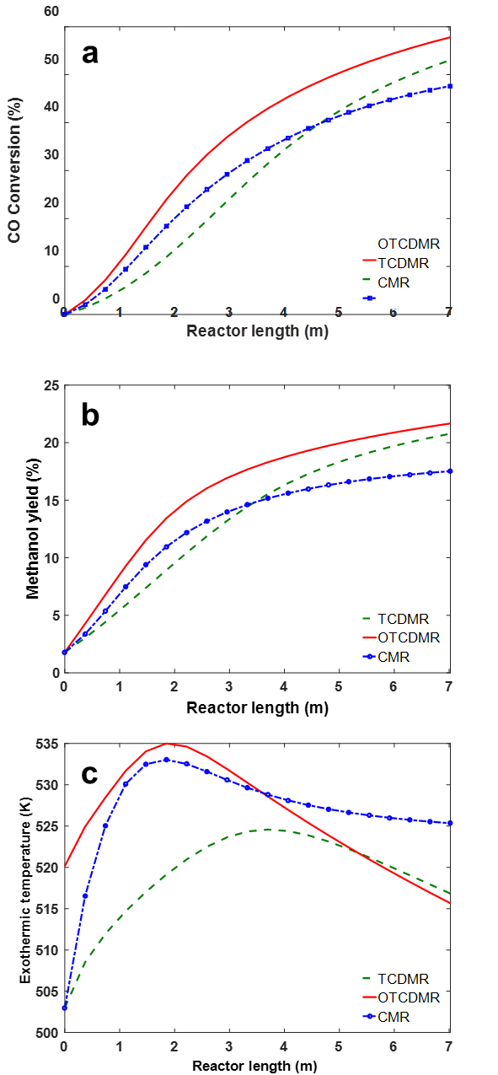
Fig. 5. The comparison of (a) CO conversion, (b) methanol yield and (c) temperature profiles of the exothermic side of CMR, TCDMR and OTCDMR for methanol synthesis.

3.3. Reactor performance in cyclohexane dehydrogenation
For OTCDMR and TCDMR, on the endothermic side of cyclohexane dehydrogenation (Eq. A4), OTCDMR shows the better performance in the conversion of cyclohexane (by ca. 6 %) than TCDMR over the whole length of the reactor (Fig. 6a). The temperature profiles of the endothermic side of the two thermally coupled reactors generally match that of their exothermic sides, apart from the entrance regions (Fig. 6c). Fig. 6c shows sudden temperature drops at the vicinity of the reactor entrance (endothermic side), which can be attributed to the initial shortage of transferred heat from the exothermic sides. The transferred heat from the exothermic methanol synthesis reactions to the endothermic cyclohexane dehydrogenation causes the acceleration of cyclohexane dehydrogenation, as well as the constant increase in H₂ mole fraction in the endothermic side of OTCDMR and TCDMR (Fig. 6b). Note that the absolute yield of H₂ in the endothermic side of thermally coupled reactors is not available due to the transfer of H₂ to the permeation side via the membrane. At the end of the reactor length, the H₂ mole fraction in the endothermic side of OTCDMR surpass that of TCDMR by ca. 15%.
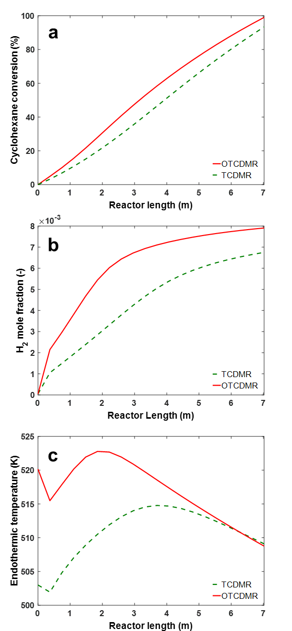
Fig. 6. The comparison of (a) cyclohexane conversion, (b) H₂ mole fraction and (c) temperature profile of the endothermic side of TCDMR and OTCDMR for hydrogen production.

3.4. The overall performance
The larger temperature difference in OTCDMR (at the start-up of the reactor), as well as the overall better conversions in its exothermic side (Figs. 5a and S5), enable a better heat transfer than that of TCDMR, as shown by the improved heat transfer flux of OTCDMR along the whole length of the reactor (Fig. 7a). In the thermally coupled reactors (i.e. TCDMR and OTCDMR), the heat removal from the exothermic side and the addition of hydrogen into the exothermic side (due to the coupled endothermal reaction) promote the shift of reactions (Eq. A1-A3) to the right-hand side, leading to higher amounts of methanol produced at the end of the reactor in comparison to that of CMR (Fig. 5b). Quantitatively, under the optimised process condition, the methanol yield in OTCDMR is increased by 3.4% and 22.6%, respectively, compared to TCDMR and CMR, corresponding to the increase of methanol production rate by 10.4 tonnes day⁻¹ and 58.3 tonnes day⁻¹ (the calculation of the production rate is in SI), respectively.
In the two thermally coupled reactors, the heat transfer between the exothermic and endothermic sides (Fig. 7) proceed in accordance with the temperature difference between them (i.e. the driving force, Figs. 5c, 6c and S7). OTCDMR promotes the better conversions of CO and CO₂ in the exothermic side, leading to the initial accumulation of a higher amount of thermal energy (by ca. 30%) than TCDMR (Fig. 7a), which is subsequently transferred to the endothermic side. In the endothermic side of OTCDMR and TCDMR, the transferred heat from the exothermic side is well consumed by the dehydrogenation of cyclohexane (Fig. 7b).
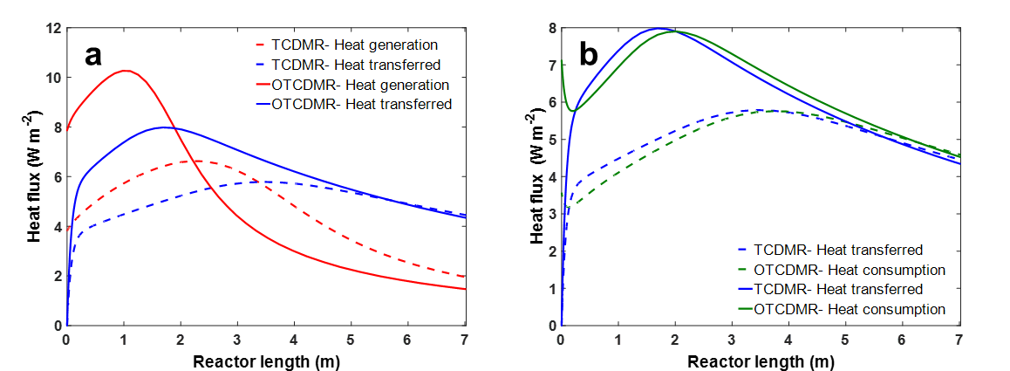
Fig. 7. Heat flux in (a) the exothermic side and (b) the endothermic side of TCDMR and OTCDMR.

In comparison to CMR, the hydrogen addition to the exothermic sides of the thermally coupled reactors, via the membrane from the recycling sides is beneficial to (i) maintain the H₂ supply for the methanol synthesis and (ii) drive the exothermic reactions forward to products. Comparing to the H₂ mole fraction in the exothermic side of the reactors, the coupling of the endothermic section causes the initial rise in the H₂ mole fraction of the thermally coupled reactors at the entrance region (Fig. 8a). Under the optimal condition in OTCDMR, the higher reaction rate results in more hydrogen consumption and consequently lower H₂ mole fraction along the reactor length in relation to TCDMR (Fig. 8a). Conversely, the methanol synthesis reactions in CMR causes the continuous depletion of H₂ along the reactor. Fig. 8b shows the H₂ flux of the membrane from the recycling side (4) to the exothermic side (1) in TCDMR and OTCDMR, evidencing the gradual transfer of H₂ to the methanol synthesis reaction from the recycling stream. Therefore, the predicted methanol production rate can be improved by about 22.6% by replacing CMR with OTCDMR (i.e. from 257.4 tonnes day⁻¹ by CMR to 315.7 tonnes day⁻¹ by OTCDMR, SI).
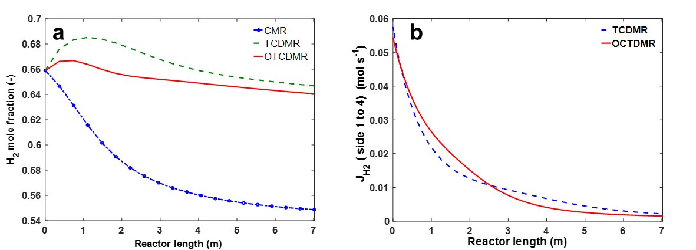
Fig. 8. (a) H₂ mole fraction in the exothermic side along the reactor; (b) hydrogen flux of TCDMR and OTCDMR from the recycle side (4) to the exothermic side (1).

Fig. 9 shows the simulated results related to H₂ in the permeation and recycling side of TCDMR and OTCDMR. In comparison to TCDMR, the higher mole fraction of H₂ in the endothermic side of OTCDMR (Fig. 6b) increases the driving force of the H₂ permeation (i.e. the hydrogen partial pressure difference between side 2 and 3). This leads to improved hydrogen diffusion through the membrane in the permeation side of OTCDMR in comparison to that of TCDMR, as shown by the H₂ flux in Fig. 9b. For the recycling side, OTCDMR suggests a high pressure of 90 bar (76.98 bar in TCDMR) which enhance the H₂ transfer from side 4 to 1, leading to the relatively low mole fraction of H₂ in the recycling side along the length of OTCDMR than TCDMR (Fig. 9a). Furthermore, in the recycling side, the higher conversion of CO and CO₂ (Figs. 5a and S5) in the exothermic side of OTCDMR consumes more hydrogen than TCDMR, and hence causes the H₂ concentration drop with a steeper slope in the recycling side of OTCDMR (Fig. 9a).
Fig. 9c shows the hydrogen recovery yield in the permeation side of OTCDMR and TCDMR, showing that the H₂ recovery is improved by 5.5% under the optimised condition. This result suggests that the hydrogen production from TCDMR can be improved by ca. 27% after the optimisation practice (i.e. from 15.5 tonnes day⁻¹ by TCDMR to 19.7 tonnes day⁻¹ by OTCDMR, SI).
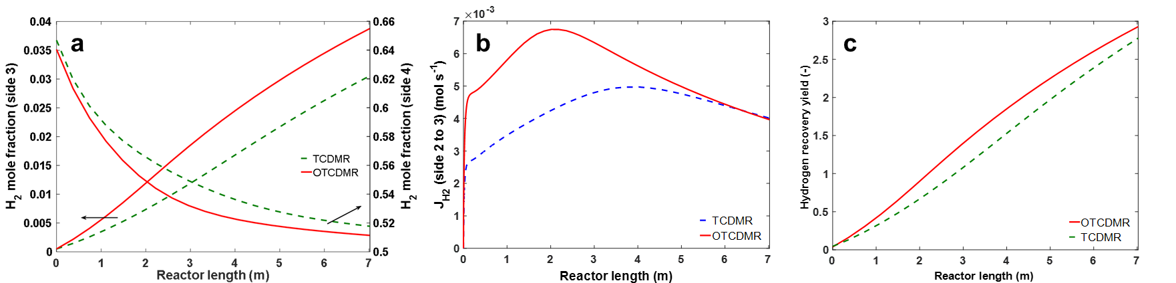
Fig. 9. (a) Hydrogen mole fraction in sides 3 (permeation side) and 4 (recycling side) along OTCDMR and TCDMR; (b) hydrogen flux from the side 2 (endothermic side) to 3 (permeation side) along OTCDMR and TCDM; (c) recovery yield in the permeation side (side 3) of OTCDMR and TCDMR.

Conclusions
In this study, a one-dimensional heterogeneous model based on the ideal gas model was used to perform the optimisation of a thermally coupled double membrane reactor (TCDMR) with two Ag-Pd membranes for the co-production of methanol (via exothermic methanol synthesis reactions) and hydrogen (via endothermic cyclohexane dehydrogenation). Comparative simulation practice using the nonlinear genetic algorithm (GA), differential evolution (DE) and particle swarm optimisation (PSO) algorithms was carried out and identified the DE algorithm as the most suitable optimisation tool due to its ability to converge to the optimal solution with a fewer number of iterations. This study elucidates the rationales for selecting DE as the best optimisation algorithm and acclaims the importance of the selection of a proper optimisation algorithm to guarantee the finding of the improved optimal solution.

Based on the DE algorithm, TCDMR was optimised as OTCDMR (i.e. the operation parameters of temperatures, pressures and flowrates) and its performance (in terms of heat transfer, methanol synthesis, cyclohexane dehydrogenation and hydrogen permeation) was discussed and compared with that by the conventional methanol reactor (CMR) and TCDMR which are operated using the industry-relevant conditions. The simulation results showed that the operation of TCDMR under the optimised condition could improve the heat transfer performance of the system, which favours both methanol synthesis and cyclohexane dehydrogenation reactions. In comparison with the CMR, the methanol production rate by OTCDMR could be improved by 22.6% as 315.7 tonnes day⁻¹. In the endothermic side of TCDMR, after the optimisation, the cyclohexane conversion could be improved by 6.1%, along with the 5.5% increase in the hydrogen recovery from the endothermic side to the permeation sides. After the optimisation, OTCDMR could improve the total hydrogen production by ca. 27%, from 15.5 to 19.7 tonnes day⁻¹. Therefore, this work provides a guideline to improve and optimise the process for the co-production of methanol and hydrogen, which is technically relevant to address the demand for sustainable energy by the industry and society.
It is worth noting that despite much ongoing research in the field of the coupled auto-thermal reactors, there are still technical barriers such as their operability and controllability, hindering their real practice in the industry (Altimari & Bildea, 2009). Therefore, the operational and control difficulties, arising from the integration of heat transfer, reaction and hydrogen diffusion through membranes in these reactors, should be addressed for the further design of a highly performing system. In this regard, the integrated process design and control should be taken into consideration which is beyond the scope of the current contribution and needs to be considered in future studies (Vega et al., 2014; Baldea & Harjunkoski, 2014).

Acknowledgement
RV acknowledges The University of Manchester President's Doctoral Scholar Award for supporting his PhD research.

Nomenclature
a_{v} | Specific surface area of the catalyst pellet [m² m⁻³]
A_{c} | Cross section area of the reactor tube [m²]
A_{i} | Inside the area of the inner tube [m²]
A_{o} | Outside the area of the inner tube [m²]
C | Total concentration [mol m⁻³]
C_{p} | Specific heat of the gas at constant pressure [J mol⁻¹]
d_{p} | Particle diameter [m]
D_{i} | The tube inside diameter [m]
D_{ij} | The binary diffusion coefficient of component i in j [m² s⁻¹]
D_{im} | Diffusion coefficient of component i in the mixture [m² s⁻¹]
D_{o} | Tube outside diameter [m]
f_{i} | Partial fugacity of component i [bar]
F | Total molar flow rate [mol s⁻¹]
h_{f} | Gas-solid heat transfer coefficient [W m⁻² K⁻¹]
h_{i} | Heat transfer coefficient between fluid phase and reactor wall in the exothermic side [W m⁻² K⁻¹]
h_{o} | Heat transfer coefficient between fluid phase and reactor wall in the endothermic side [W m⁻² K⁻¹]
ΔH_{f,i} | Enthalpy of formation of component i [J mol⁻¹]
J_{H} | Permeation rate of hydrogen through the Pd-Ag membrane [mol s⁻¹]
k_{g} | Mass transfer coefficient for component i [m s⁻¹]
K | Thermal conductivity of fluid phase [W m⁻¹ K⁻¹]
L | Reactor length [m]
M_{i} | Molecular weight of component i [g mol⁻¹]
N | Number of components [6 for methanol synthesis reaction, 4 for dehydrogenation reaction]
P | Total pressure [bar]
P_{i} | Partial pressure of component i [bar]
r₁ | Rate of reaction for hydrogenation of CO [mol kg⁻¹ s⁻¹]
r₂ | Rate of reaction for hydrogenation of CO₂ [mol kg⁻¹ s⁻¹]
r₃ | Rate of reversed water-gas shift reaction [mol kg⁻¹ s⁻¹]
r₄ | Rate of reaction for dehydrogenation of cyclohexane [mol m⁻³ s⁻¹]
r_{i} | Reaction rate of component i [for the exothermic reaction: mol kg⁻¹ s⁻¹; for the endothermic reaction: mol m⁻³ s⁻¹]
R | Universal gas constant [J mol⁻¹ K⁻¹]
R_{p} | Particle radius [m]
Re | Reynolds number [-]
Sc_{i} | Schmidt number of component i [-]
T | Temperature [K]
u | Superficial velocity of fluid phase [m s⁻¹]
u_{g} | Linear velocity of fluid phase [m s⁻¹]
U | Overall heat transfer coefficient between exothermic and endothermic sides [W m⁻² K⁻¹]
v_{ci} | critical volume of component i, [cm³mol⁻¹]
y_{i} | Mole fraction of component i [mol mol⁻¹]
z | Axial reactor coordinate [m]
Greek letter
μ | Viscosity of fluid phase [kg m⁻¹ s⁻¹]
ρ | Density of fluid phase [kg m⁻³]
ρ_{b} | Density of catalytic bed [kg m⁻³]
τ | Tortuosity of catalyst [-]
Superscripts
g | in bulk gas phase
s | at surface catalyst
Subscripts
0 | inlet conditions
B | Benzene
i | chemical species
j | reactor side
k | reaction number index

References
Ab Wahab MN, Nefti-Meziani S, Atyabi A (2015) A comprehensive review of swarm optimisation algorithms. PLoS ONE 10(5):e0122827
Altimari, P., Bildea, C. S. (2009). Integrated design and control of plantwide systems coupling exothermic and endothermic reactions. Computers and Chemical Engineering, 33, 911–923
Amirabadi, S., Kabiri, S., Vakili, R., Iranshahi, D., & Rahimpour, M. R. (2013). Differential evolution strategy for optimisation of hydrogen production via coupling of methylcyclohexane dehydrogenation reaction and methanol synthesis process in a thermally coupled double membrane reactor. Ind. Eng. Chem. Res. 52, 1508–1522.
Azarhoosh, M., Farivar, F., & Ebrahim, H. A. (2014). Simulation and optimisation of a horizontal ammonia synthesis reactor using genetic algorithm. RSC Adv. 4, 13419–13429.
Bajaj, I., Iyer, S. S., & Hasan, M. F. (2017). A trust region-based two phase algorithm for constrained black-box and grey-box optimisation with infeasible initial point. Computers & Chemical Engineering.
Baldea, M., Harjunkoski, I., (2014). Integrated production scheduling and process control: A systematic review. Computers & Chemical Engineering ,71, 377–390
Bansal, J. C., Singh, P., Saraswat, M., Verma, A., Jadon, S. S., & Abraham, A. (2011). Inertia weight strategies in particle swarm optimisation. In Nature and Biologically Inspired Computing (NaBIC), 2011 Third World Congress on (pp. 633–640): IEEE.
Bayat, M., Dehghani, Z., & Rahimpour, M. (2014). Membrane/sorption-enhanced methanol synthesis process: Dynamic simulation and optimisation. J. Ind. Eng. Chem. 20, 3256–3269.
Bayat, M., Hamidi, M., Dehghani, Z., Rahimpour, M., & Shariati, A. (2014). Hydrogen/methanol production in a novel multifunctional reactor with in situ adsorption: modeling and optimisation. Inter. J. Energy Res. 38, 978–994.
Bayat, M., & Rahimpour, M. (2011). Simultaneous utilization of two different membranes for intensification of ultrapure hydrogen production from recuperative coupling autothermal multitubular reactor. Inter. J. Hydrogen Energy 36, 7310–7325.
Bayat, M., & Rahimpour, M. (2013). Production of hydrogen and methanol enhancement via a novel optimised thermally coupled two‐membrane reactor. Inter. J. Energy Res. 37, 105–120.
Bland, J. M., & Altman, D. G. (1996). Statistics notes: measurement error. BMJ, 313, 744.
Brown, L. F. (2001). A comparative study of fuels for on-board hydrogen production for fuel-cell-powered automobiles. Inter. J. Hydrogen Energy, 26, 381–397.
Cai, X., Zeng, J., Tan, Y., & Cui, Z. (2009). Individual parameter selection strategy for particle swarm optimisation: INTECH Open Access Publisher London.
Chen, Z. (2013). A Genetic Algorithm Optimizer with Applications to the SAGD Process. University of Calgary.
Cussler, E. L. (2009). Diffusion: mass transfer in fluid systems: Cambridge university press.
Domingues, L., Pinheiro, C. I., & Oliveira, N. M. (2014). Optimal design of reactive distillation systems: Application to the production of ethyl tert-butyl ether (ETBE). Comput. Chem. Eng. 64, 81–94.
Eberhart, R. C., & Kennedy, J. (1995). A new optimizer using particle swarm theory. In Proceedings of the sixth international symposium on micro machine and human science (Vol. 1, pp. 39–43): New York..
Ewan, B., & Allen, R. (2005). A figure of merit assessment of the routes to hydrogen. Int. J. Hydrogen Energy 30, 809–819.
Fan, X., Lapkin, A. A., & Plucinski, P. K. (2009). Liquid phase hydrogenation in a structured multichannel reactor. Catal. Today 147, S313–S318.
Fan, X., Manchon, M. G., Wilson, K., Tennison, S., Kozynchenko, A., Lapkin, A. A., & Plucinski, P. K. (2009). Coupling of Heck and hydrogenation reactions in a continuous compact reactor. J. Catal. 267, 114–120.
Farsi, M., Asemani, M., & Rahimpour, M. (2014). Mathematical modeling and optimisation of multi-stage spherical reactor configurations for large scale dimethyl ether production. Fuel Process. Technol. 126, 207–214.
Fogler, H. S. (1999). Elements of chemical reaction engineering.
Fujii, H., & Horne, R. (1995). Multivariate optimisation of networked production systems. SPE Production & Facilities, 10, 165–171.
Gallucci, F., & Basile, A. (2008). Pd–Ag membrane reactor for steam reforming reactions: a comparison between different fuels. Inter. J. Hydrogen Energy 33, 1671–1687.
Ganesan, T., Elamvazuthi, I., Shaari, K. Z. K., & Vasant, P. (2013). Swarm intelligence and gravitational search algorithm for multi-objective optimisation of synthesis gas production. Appl. Energy 103, 368–374.
Gao, H., Lin, Y. S., Li, Y., & Zhang, B. (2004). Chemical stability and its improvement of palladium-based metallic membranes. Industrial & engineering chemistry research, 43(22), 6920-6930.
Graaf, G., Scholtens, H., Stamhuis, E., & Beenackers, A. (1990). Intra-particle diffusion limitations in low-pressure methanol synthesis. Chem. Eng. Sci. 45, 773–783.
Graaf, G., Sijtsema, P., Stamhuis, E., & Joosten, G. (1986). Chemical equilibria in methanol synthesis. Chem. Eng. Sci. 41, 2883–2890.
Hodoshima, S., Arai, H., & Saito, Y. (2003). Liquid-film-type catalytic decalin dehydrogeno-aromatization for long-term storage and long-distance transportation of hydrogen. Inter. J. Hydrogen Energy 28, 197–204.
International Energy Agency (IEA) (2013). Key world energy Statistics. http://www.iea.org/publications/freepublications/publication/KeyWorld2013_FINAL_WEB.pdf, access date: 01/05/2018.
Khademi, M., Jahanmiri, A., & Rahimpour, M. (2009). A novel configuration for hydrogen production from coupling of methanol and benzene synthesis in a hydrogen-permselective membrane reactor. Inter. J. Hydrogen Energy 34, 5091–5107.
Khademi, M., Rahimpour, M., & Jahanmiri, A. (2010). Differential evolution (DE) strategy for optimisation of hydrogen production, cyclohexane dehydrogenation and methanol synthesis in a hydrogen-permselective membrane thermally coupled reactor. Inter. J. Hydrogen Energy 35, 1936–1950.
Kramer, O., Ciaurri, D. E., & Koziel, S. (2011). Derivative-free optimisation. In Computational optimisation, methods and algorithms (pp. 61–83): Springer-Verlag Berlin Heidelberg.
Lange, J.-P. (2001). Methanol synthesis: a short review of technology improvements. Catal. Today 64, 3–8.
Leong, C. C., Blakey, S., & Wilson, C. W. (2016). Genetic Algorithm optimised Chemical Reactors network: A novel technique for alternative fuels emission prediction. Swarm Evol. Comput. 27, 180-187.
Lindsay, A. L., & Bromley, L. A. (1950). Thermal conductivity of gas mixtures. Ind. Eng. Chem. 42, 1508–1511.
Maneerung, T., Hidajat, K., & Kawi, S. (2014). Ultra-thin (< 1 μm) internally-coated Pd–Ag alloy hollow fiber membrane with superior thermal stability and durability for high temperature H2 separation. Journal of membrane science, 452, 127-142.
Medrano, J. A., Fernandez, E., Melendez, J., Parco, M., Tanaka, D. A. P., van Sint Annaland, M., & Gallucci, F. (2016). Pd-based metallic supported membranes: High-temperature stability and fluidized bed reactor testing. International Journal of Hydrogen Energy, 41(20), 8706-8718.
Mohagheghian, E. (2016). An application of evolutionary algorithms for WAG optimisation in the Norne Field. Memorial University of Newfoundland.
Na, J., Kshetrimayum, K. S., Lee, U., & Han, C. (2017). Multi-objective optimisation of microchannel reactor for Fischer-Tropsch synthesis using computational fluid dynamics and genetic algorithm. Chem. Eng. J. 313, 1521–1534.
Perry, R. H., & Green, D. W. (1999). Perry's Chemical Engineers' Handbook: McGraw-Hill Education New York.
Peters, T. A., Stange, M., Klette, H., & Bredesen, R. (2008). High pressure performance of thin Pd–23% Ag/stainless steel composite membranes in water gas shift gas mixtures; influence of dilution, mass transfer and surface effects on the hydrogen flux. Journal of membrane science, 316(1-2), 119-127.
Price, K., Storn, R. M., & Lampinen, J. A. (2006). Differential evolution: a practical approach to global optimisation: Springer-Verlag Berlin Heidelberg.
Rahimpour, M., Bayat, M., & Rahmani, F. (2010). Enhancement of methanol production in a novel cascading fluidized-bed hydrogen permselective membrane methanol reactor. Chem. Eng. J. 157, 520–529.
Rahimpour, M., & Ghader, S. (2004). Enhancement of CO conversion in a novel Pd–Ag membrane reactor for methanol synthesis. Chem. Eng. Process. 43, 1181–1188.
Rahimpour, M., & Pourazadi, E. (2011). A comparison of hydrogen and methanol production in a thermally coupled membrane reactor for co‐current and counter‐current flows. Int. J. Energy Res. 35, 863–882.
Rahimpour, M., Rahmani, F., Bayat, M., & Pourazadi, E. (2011). Enhancement of simultaneous hydrogen production and methanol synthesis in thermally coupled double-membrane reactor. Inter. J. Hydrogen Energy 36, 284–298.
Rahmanifard, H., & Plaksina, T. (2018). Application of artificial intelligence techniques in the petroleum industry: a review. Artificial Intelligence Review, 1-24.
Rao, S. S. (2009). Engineering optimisation: theory and practice: John Wiley & Sons New Jersey.
Reid, R., & Prausnitz, J. (1977). The Properties of gases and Liquids. In: McGraw-Hill New York.
Rezaie, N., Jahanmiri, A., Moghtaderi, B., & Rahimpour, M. (2005). A comparison of homogeneous and heterogeneous dynamic models for industrial methanol reactors in the presence of catalyst deactivation. Chem. Eng. Process. 44, 911–921.
Rostami, R. B., Lemraski, A. S., Ghavipour, M., Behbahani, R. M., Shahraki, B. H., & Hamule, T. (2016). Kinetic modelling of methanol conversion to light olefins process over silicoaluminophosphate (SAPO-34) catalyst. Chem. Eng. Res. Design 106, 347–355.
Samimi, F., Kabiri, S., & Rahimpour, M. R. (2014). The optimal operating conditions of a thermally double coupled, dual membrane reactor for simultaneous methanol synthesis, methanol dehydration and methyl cyclohexane dehydrogenation. J. Nat. Gas Sci. Eng. 19, 175–189.
Shen, Q., Shi, W.-m., Yang, X.-p., & Ye, B.-x. (2006). Particle swarm algorithm trained neural network for QSAR studies of inhibitors of platelet-derived growth factor receptor phosphorylation. Eur. J. Pharm. Sci. 28, 369–376.
Shi, Y., & Eberhart, R. C. (1999). Empirical study of particle swarm optimisation. In Evolutionary Computation, 1999. CEC 99. Proceedings of the 1999 Congress on (Vol. 3): IEEE.
Smith, J. M. (1981). Chemical Engineering Kinetics: McGraw-Hill New York.
Soleimani, R., Shoushtari, N. A., Mirza, B., & Salahi, A. (2013). Experimental investigation, modeling and optimisation of membrane separation using artificial neural network and multi-objective optimisation using genetic algorithm. Chem. Eng. Res. Design 91, 883–903.
Soltani, H., & Shafiei, S. (2015). Adiabatic reactor network synthesis using coupled genetic algorithm with quasi linear programming method. Chem. Eng. Sci. 137, 601–612.
Stankiewicz, A., & Moulijn, J. A. (2003). Re-engineering the Chemical Processing Plant: Process Intensification: CRC Press Boca Raton Florida.
Vakili, R., & Eslamloueyan, R. (2012). Optimal design of an industrial scale dual-type reactor for direct dimethyl ether (DME) production from syngas. Chemical Engineering and Processing: Process Intensification, 62, 78-88.
Vakili, R., Rahmanifard, H., Maroufi, P., Eslamloueyan, R., & Rahimpour, M. (2011). The effect of flow type patterns in a novel thermally coupled reactor for simultaneous direct dimethyl ether (DME) and hydrogen production. Inter. J. Hydrogen Energy 36, 4354–4365.
Vega, P., Rocco, R. L. D., Revollar S., Francisco, M., (2014). Integrated design and control of chemical processes – Part I: Revision and classification, Computers and Chemical Engineering, 721, 602–617
Watson, A., Seinfeld, J., Gavalas, G., & Woo, P. (1980). History matching in two-phase petroleum reservoirs. Soc. Pet. Eng. J. 20, 521–532.
Wilke, C. (1949). Estimation of liquid diffusion coefficients. Chem. Eng. Prog. 45, 218–224.
Zanfir, M., & Gavriilidis, A. (2001). Modelling of a catalytic plate reactor for dehydrogenation–combustion coupling. Chem. Eng. Sci. 56, 2671–2683.

Appendix A: Mathematical reactor model for the TCDMR
Four reactions including hydrogenation of CO and CO₂ and reverse water-gas shift for methanol production and dehydrogenation of cyclohexane will take place (Khademi et al., 2009):
(A1)
(A2)
(A3)
(A4)
To provide sufficient information about the kinetics of methanol and hydrogen production, the rate equations with equilibrium constants are considered according to the literature (Graaf et al., 1990; Graaf et al., 1986; Khademi et al., 2009; Rostami et al., 2016).
In general, some assumptions were made to derive the mathematical models, which are as follows (Khademi et al., 2009; Rahimpour & Ghader, 2004; Rahimpour & Pourazadi, 2011; Rahimpour et al., 2011):
- Laminar plug flow in all sides.
- Steady-state conditions.
- Negligible variation of heat and mass in the radial direction.
- Constant bed porosity in all directions (axial and radial).
- No heat loss to surrounding (Adiabatic).
- One dimensional heterogeneous model is assumed

Solid phase (Rahimpour et al., 2011): Mass and energy balance (Eq. A5 and A6, respectively) using Taylor series for the solid phase are as follows:

(A6)
(A7)

Fluid phase (Rahimpour et al., 2011): Mass and energy balance (Eq. A8 and A9, respectively) using Taylor series for the fluid phase are as follows:

(A8)
(A9)

where β and φ are equal to 1 for the endothermic side (side 3) and syngas side (side 1), respectively, while they are 0 for the other sides. All terms are defined the same as in the previous section, the positive sign of the third term in Eq. A9 belongs to the exothermic reaction, while the negative sign relates to the endothermic reaction.

Permeation side (Rahimpour et al., 2011): Mass and energy balance (Eq. A10 and A11, respectively) using Taylor series for the permeation side are as follows:

(A10)
(A11)

where β is equal to 1 for the hydrogen component and 0 for the sweep gas. Additionally, hydrogen permeation through the Pd/Ag membrane is calculated using Sievert’s law according to Eq. A12.

(A12)

Synthesis gas side (Rahimpour et al., 2011): Mass and energy balance (Eq. A13 and A14, respectively) using Taylor series for the permeation side are as follows:

(A13)
(A14)

where φ is equal to 1 for the hydrogen component and 0 for the other components. Additionally, hydrogen permeation through the Pd/Ag membrane is calculated using Sievert’s law according to Eq. A15.

(A15)

where and E_{p} for temperatures higher than 200 ͦ C are 6.33×10⁻⁸ mol m⁻² s⁻¹ Pa^{−0.5} and 15.7 kJ mol⁻¹ (Rahimpour et al., 2010). Other required correlations, which are necessary for modeling the TCDMR reactor, are summarised in Table A1.

Table A1 Auxiliary correlations used for modeling the reactor (Cussler, 2009; Fogler, 1999; Khademi et al., 2010; Lindsay & Bromley, 1950; Perry & Green, 1999; Reid & Prausnitz, 1977; Smith, 1981; Wilke, 1949).
Parameter | Equation
component heat capacity
mixture heat capacity | Based on local compositions
gas density | Obtained from PR EOS
average molecular weight
the viscosity of reaction mixtures
mixture thermal conductivity
mass transfer coefficient between gas and solid phases
the overall heat transfer coefficient
heat transfer coefficient between the gas phase and reactor wall
Ergun equation (for pressure drop through reactor bed)

Note that the mathematical modelling of TCDMR leads to 17 ordinary differential equations for which the following initial conditions are considered (Rahimpour et al., 2011):

; | (A16)

Using the backward finite difference method, all ordinary differential equations are converted into a set of nonlinear algebraic equations along the reactor length, which is divided into 20 separate sections. One of the ODE solvers (ode23s) in the MATLAB 2016a programming environment is then applied for solving the set of nonlinear algebraic equations in each section.
Additionally, a 3D schematic diagram of TCMR and its operational conditions are depicted in Fig. 1 and Table A2, respectively.

Table A2 Operating conditions for TCDMR (Rahimpour et al., 2011).
Exothermic (1) and recycling (4) sides  Parameters value  CH₃OH mole fraction [-] 0.005  CO₂ mole fraction [-] 0.094  CO mole fraction, [-] 0.046  H₂O mole fraction [-] 0.0004  H₂ mole fraction [-] 0.659  N₂ mole fraction [-] 0.093  CH₄ mole fraction [-] 0.1026  Total molar flow rate [mol s⁻¹] 0.64  Inlet pressure [bar] 76.98  Inlet temperature [K] 503  Density [kg m⁻³] 1,770  Particle diameter [m] 5.47×10⁻³  Heat capacity [kJ kg⁻¹ K⁻¹] 5  Specific surface area [m² m⁻³] 626.98  Bed void fraction 0.39  Density of catalyst bed [kg m⁻³] 1,140  Wall thermal conductivity [W m⁻¹ K⁻¹) 48  Feed synthesis gas side diameter [m] 0.038  Exothermic side diameter [m] 0.053  Membrane thickness [m] 6×10⁻⁶ | Endothermic side (2)  Parameters Value  C₆H₁₂ [mole fraction [-] 0.1  C₆H₆ [mole fraction [-] 0.0  H₂ [mole fraction [-] 0.0  Ar [mole fraction [-] 0.9  Total molar flow rate [mol s⁻¹] 0.1  Inlet pressure [bar] 1.013  Inlet temperature [K] 503  Particle diameter [m] 3.55×10⁻³  Bed void fraction [-] 0.39  Shell inner diameter [m] 0.068  Permeation side (3)  Ar (sweep gas) mole fraction [-] 1.0  H₂ mole fraction [-] 0.0  Total molar flow rate [mol s⁻¹] 1  Inlet temperature [K] 503  Inlet pressure [bar] 0.1  Wall thermal conductivity [W m⁻¹ K⁻¹) 153.95  Shell inner diameter [m] 0.0827  Membrane thickness [m] 6×10⁻⁶

∗ Corresponding author. Tel.: +44 (0)16130 62690; email: xiaolei.fan@manchester.ac.uk

