**Global Sensitivity Analysis of a Perfusion Bioreactor for Tissue Engineering based on CFD Modelling**

Ioana Nașcua,b,c,*, Daniel Sebastia-Saezb, Tao Chenb, Ioan Nascuc, Wenli Dua

a Key Laboratory of Advanced Control and Optimization for Chemical Processes, Ministry of Education, East China University of Science and Technology, Shanghai 200237, China  
Shanghai Institute of Intelligent Science and Technology, Tongji University, Shanghai 200092, China  
b Department of Chemical and Process Engineering, University of Surrey, GU2 7XH Guildford, United Kingdom

c Department of Automation, Faculty of Automation and Computer Science, Technical University of Cluj Napoca, 400114, Cluj-Napoca, Romania

*Corresponding author email address: [ioana.nascu@surrey.ac.uk](mailto:ioana.nascu@surrey.ac.uk), [ioana.nascu@aut.utcluj.ro](mailto:ioana.nascu@aut.utcluj.ro)

*Abstract*— Perfusion bioreactors are important tools in tissue engineering that are used for cell cultivation. Unfortunately these types of processes are not yet fully understood in literature and information about the model is scarce. Furthermore, mathematical models that are used for perfusion bioreactors have posed significant challenges. This work presents a concise overview and analysis of mathematical models for a perfusion bioreactor process. The comprehensive mathematical model of convection and diffusion in a perfusion bioreactor, combined with cell growth kinetics, is developed using Computational Fluid Dynamics. The model describes the spatio-temporal evolution of glucose concentration, oxygen concentration, lactate concentration and cell density within a polymeric scaffold. For an in-depth understanding of this type of processes, global sensitivity analysis and simulations is performed using the method of high-dimensional model representation (RS-HDMR). A quantitative analysis of the complex kinetic mechanisms using recently developed advanced mathematical approaches to global sensitivity and uncertainty analysis through RS-HDMR can be exploited to investigate the important features of the perfusion bioreactor process as well as possible factors underlying qualitative discrepancies. Moreover, for a further understanding of the process, a relative gain analysis is performed. The results will help us gain an in depth understanding of the process and will be used as the foundation for advanced control algorithms that will facilitate manufacturing for any type of cell culture using a continuous perfusion bioreactor thus paving the way towards Industry 4.0.

*Keywords* —tissue engineering, perfusion bioreactor, CFD modeling, high-dimensional model representation, global sensitivity analysis, relative gain array

# INTRODUCTION

Tissue engineering (TE) is an emerging complex field that combines chemical and material engineering, biology, and medicine. It implies growing cells with adequate functionality that are used for in vivo implantation. Moreover, it is an important part of regenerative medicine for tissue repair (Tonelli et al. 2017) which is focused on proposing innovative ways to ensure that the body tissues and organs are working properly, to promote health (Stoltz et al. 2015). For the cultivation of cells, bioreactor systems need to use tissue-engineered grafts having uniform viability, cell distribution and growth in a reproducible way. The application of bioreactor systems gives rise to improved tissue quality compared to static cultivation by using suitable cultivation conditions that will mimic an in vivo environment (Schmid et al. 2018). To determine these suitable cultivation conditions as well as the reproducible generation of tissue engineered grafts, a bioreactor system is beneficial. This bioreactor system includes the control of critical cultivation parameters, such as flow rate and nutrient concentration, in bioreactors. Using perfusion bioreactors enables even cell distributions on stable scaffolds and allows for an optimal feed of nutrients. Moreover, it has been proven to successfully remove the toxic metabolites from the cell culture (Coletti et al. 2006).

Hitherto, previous experimental work reported in literature has highlighted the advantages of using perfusion bioreactors including high cell specific productivity as well as high viable cell density and higher economic profitability especially when compared to static cultures or fed batch reactors. Improving the productivity and performances of such a system will require the use of model based control and optimization. (Ionescu and Copot 2019) can be used as an operator support in tunning or retuning the developed controllers. Even though there have been various studies in literature presenting the potential of using model-based control and optimization for perfusion bioreactors (Nascu et al. 2021), there is still a lot of work to be done in developing and implementing these control strategies.

Before implementing advanced control studies, we first need to have an adequate model and a good understanding of the process. In tissue engineering, most of the reported work in literature regarding tissue regeneration and growth is focused on experimental results and not so much on the mathematical modelling part (Nokhbatolfoghahaei et al. 2020, Bancroft et al. 2003). Mathematical models are very important in understanding the complex chemical, mechanical, and biological factors that are involved in engineered tissue cultures. Moreover, they provide an important platform for testing and simulation as well as developing control algorithms. Unfortunately, mathematical models that are used for perfusion bioreactors have posed significant challenges such as: (i) nonlinearity and complexity of the models; (ii) the mathematical models found in literature show discrepancies between the models as well as discrepancies between the values of the parameters; (iii) there are no mathematical models for this type of system that have been developed from fundamental principles; (iv) there is no model structure that is universally accepted that guarantees to capture the transient as well as the steady state behavior of the process; (v) there is no consensus concerning the best procedures for model identification, mathematical modeling and how this can be used for control and optimization (Rodrigues et al. 2021, López-Meza et al. 2016). This work attempts to evaluate the main contributions regarding mathematical modeling of perfusion bioreactor and perform an in-depth analysis of the mathematical model derived as a result of this study.

A common problem related to developing mathematical models is how to choose the parameter values that have to reflect the properties of the real system. Unfortunately, most of the time the values of the parameter are inaccurate since it’s very difficult to estimate or determine their exact values. The values of the parameters are determined from multiple sources such as in vitro and in vivo experimental data. Parameter fitting will frequently result in ambiguous parameter sets and often the experiments that are performed in vitro will not match the conditions of in vivo (Kent et al. 2013, Acosta Santamaría et al. 2013). Moreover, models can include parameter values that are determined from experiments that have biological systems different than the target one and also values can be estimated based only on high level constraints (such as an equilibrium constant which is limited by thermodynamic constraints or a rate constant which is limited by diffusion). Since all this will bring uncertainty to the parameter values it is important for models to be thoroughly studied to determine the degree to which the parameter values affect the modelling results.

Sensitivity analysis is an important field that brings forward vast benefits especially for model development and control (Razavi et al. 2021). It has proven to be beneficial in: reducing dimensionality by identifying factors that are uninfluential in a system (Sobol’ et al. 2007); towards scientific discovery by exploring how distinct processes, scales, parameters as well as their interactions can affect a system (Gupta and Razavi 2018); by identifying parameters, scales and processes that control a system in a dominant way, for which acquisition of new data reduces uncertainty (Guillaume et al. 2019). The use of sensitivity analysis in the biomedical field has been very beneficial especially for the assessment of the robustness of complex biological and biomedical models and in uncertainty quantification (Kiparissides et al. 2009). Assessing the impact of the lack of knowledge regarding the model inputs on the predicted outputs of the model is an important step. This is usually performed using sensitivity analysis (SA) and uncertainty analysis.

The main scope of SA is to estimate the effects of each model input, either in isolation or through combined effects, on the model output and to determine the main contributors to the output uncertainty. Local sensitivity approaches are usually used at parameter values close to the nominal ones. If large uncertainties are present, significant changes in sensitivity can occur across the input parameter range for which local methods do not account for. Due to its capability of detecting parameter interactions, and providing more insight for nonlinear models, global sensitivity analysis has gained more attention compared to local sensitivity analysis approaches (Saltelli et al. 2004). Due to the computational cost of the models and their nonlinearity, traditional methods for sensitivity analysis are often not suitable (Ziehn and Tomlin 2009, Chen and Yang 2011). To express the input–output relationship of such complex models with high-dimensional input spaces, the random sampling high-dimensional model representation (RS-HDMR) method was developed. A fully functional surrogate model (meta-model) that uses relatively simpler models to emulate the dynamic behavior of the original computationally intensive model are used in this work. This can be easily employed within global sensitivity analysis, and it provides an importance ranking for the input parameters and it explores the influence of parameter interactions. In terms of quantitative analysis of complex kinetic mechanisms, the recent development of advanced mathematical approaches to global sensitivity and uncertainty analysis through RS-HDMR can be exploited to investigate the important features of the perfusion bioreactor process. Perfusion bioreactors for tissue engineering is not a process that is yet fully understood in literature and information about the model is scarce. Therefore, the model provides an interesting case study for the application of global sensitivity methods, since there is a lack of consensus and information in the literature as to the nominal values and uncertainty ranges for certain of its input parameters.

Simulation technology together with the currently evolving data processing capacity can prove to be an important tool for understanding perfusion bioreactor processes. The use of computational models will help towards the objective interpretation of experimental data. Furthermore, model directed experimentation will aid in refining the models as well as identifying their parameters but also will help to clarify the interpretation of experimental results.

This work sets the foundation towards the design and implementation of advanced control algorithms to facilitate manufacturing for any type of cell culture using a continuous perfusion bioreactor. The analysis performed here helps us understand the way changes in some of the kinetic parameters affects the behavior of the entire process and allows us to determine how the control system can handle these changes. Moreover, the analysis will help in making control design decision and model based control optimization that include sustainability and resilience manufacturing within the control objectives and can be done by using a multi-objective optimization procedure (Ionescu et al. 2020). This is suitable for industrial settings and cyber physical systems with strong interaction dynamics. The final goal of this work is to pave the way towards Industry 4.0. This can be done by using context aware control systems (CPS), proactive integrated structures that are able to adapt their operations to context changes without explicit user intervention and thus increase usability and effectiveness. CPSs are capable of combining context awareness, the use of a digital twin as well as intelligent control and consider humans as system elements (Diaz et al. 2020).

The paper is organized as follows: the perfusion bioreactor, the CFD model as well as the mathematical fundamental of RS-HDMR and Global Analysis using RS-HDMR is presented in Section 2. The methodologies are applied on the perfusion bioreactor process and the results are presented in Section 3 together with the Relative Gain Array analysis of the model. Finally, Section 4 summarizes the main outcome of this paper.

# Perfusion Bioreactor

## Process Description

Bioreactors are devices where biological and/or biochemical processes that can be used in the aid of the in-vitro development of new tissue by providing biochemical and physical regulatory signals, can develop. For this to happen, the operating and the environmental conditions (such as temperature, nutrient supply, pressure, etc.) need to be tightly controlled and monitored.

Figure 1 presents a general approach for tissue transplant. The first step is to take a small cell biopsy from the patient then the cells are seeded in a scaffold. The scaffold can be made from natural materials such as collagen or they can be artificially synthesized polymers such as PGA or PLA. Next, the celled scaffold is then put in a bioreactor which is designed to enhance nutrient transports. To have an easy delivery to the cells, scaffolds must have large enough porosity.

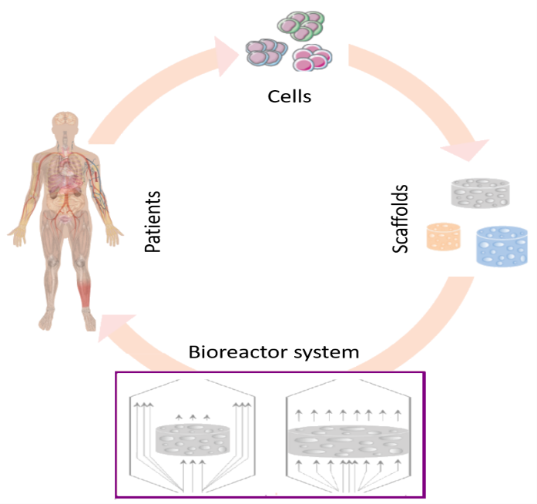

Fig. 1. Tissue engineering grafts bioreactor systems.

Initially bioreactors were developed to allow the high-mass culture of cells utilized for applications in different areas, including wastewater treatment, fermentation, drug production and food processing (Martin et al. 2004). These applications had an important role in understanding and establishing the principles of bioreactors. Many of these principles have recently been adapted for tissue engineering purposes. Bioreactors used in tissue engineering applications should: (i) provide as well as maintain the physiological requirements of the cell such as growth factors, nutrients and oxygen; (ii) enable uniform cell distribution; (iii) expose cells to physical stimuli; (iv) increase mass transport using the mixing systems of the culture medium; and (v) facilitate reproducibility, monitoring, control and automation (Martin et al. 2004). The basic characteristics of a tissue engineering bioreactor are required to engineer tissue substitutes for possible clinical applications, such as the use of materials that can endure numerous cycles of high temperature and pressure and also that do not release toxic products. The final design of the bioreactor will be application specific.

Different types of bioreactors have been used to culture different types of cells for tissue regeneration or repair. Table 1 presents some of the most significant works found in literature with respect to the type of bioreactors used, cell type and species modeled.

Table 1. Types of bioreactors, cells and species used - Indicative list

|  |  |  |  |
| --- | --- | --- | --- |
| Authors | Bioreactor type | Cell type | Species modeled |
| (Freed et al. 1994) | Petri dishes  Static culture  well-mixed bioreactors | Cartilage cells (Chondrocytes) on biodegradable polyglycolic acid (PGA) scaffolds | glucose |
| (Galban and Locke 1999) | Petri dish filled with nutrients | Cartilage cells (chondrocytes) in polymer scaffold | glucose |
| (Chung et al. 2006) | Static culture | chondrocyte | glucose |
| (Coletti et al. 2006) | Perfusion | murine immortalized rat cells C2C12 on collagen scaffolds | oxygen |
| (Chung and Ho 2010) | Static culture  (i) petri dish  (ii) immersed in the culture medium in a flask (compared to Freed) | chondrocyte | Glucose  Type II collagen |
| (Lin et al. 2011) | Static culture  Petri dishes | Cartilage cells (chondrocytes) | Glucose  Oxygen  Type II collagen |
| (Kiparissides et al. 2011) | Batch bioreactor | monoclonal antibodies  (mAbs) harvested from cultures of hybridoma cells | Glucose & glutamine  Lactate & ammonia |
| (Yan et al. 2012) | Perfusion bioreactor | chondrocytes in polymer implants | Glucose & oxygen |
| (Paim et al. 2019) | Static culture | Chung model | Glucose  oxygen |

Perfusion bioreactors are culture systems composed of various key elements (Figure 2): (i) one or more perfusion chambers for the cell/scaffold constructs; (ii) a reservoir for the medium; (iii) a pump for mass transport of oxygen and nutrients throughout the perfusion chamber; and (iv) a tubing circuit. They have been proved to: enhance growth, increase construct cellularity and matrix deposition, support cell viability and to guide the maturation of functional tissue. The scaffold is placed in position across the flow path of the bioreactor and media is perfused through the scaffold, enhancing fluid transport. Perfusion bioreactors can be generally classified into direct or indirect systems. This classification depends on the way the culture medium is perfused throughout or around the cell/scaffold constructs. Culture using perfusion bioreactors provide more homogeneous cell distribution through the scaffold and have shown to be the best for fluid transport.

In the indirect perfusion systems, as presented in Figure 2A, the scaffold that is connected to the cassette is not tightly sealed. This will enable the medium to follow the path of least resistance around the scaffold. For this reason, flow-derived shear stress may not reach the cells that are found in the construct interior.

In direct perfusion bioreactors, presented in Figure 2B the scaffold is placed inside the perfusion chamber in a press-fit manner such as the culture medium will be forced to pass through the center of the samples. This type of bioreactor exerts biophysical forces by fluid flow in the interior of the so cultivated cell/ scaffold constructs and allows the reduction of internal mass transfer limitations (Bancroft et al. 2003). Systems using direct perfusion have proven to enhance cell density in the scaffold center (Warren et al. 2009), cell proliferation and differentiation. Therefore, in this work, a direct perfusion bioreactor will be used.

The easiest manipulated operating degree of freedom in a glucose exchange unit is flow rate of the medium. The cell density profiles and the glucose concentration inside the scaffold will increase with higher velocities, especially in the deeper sections of the scaffold. Therefore, the shear stress generated in the scaffold will give an upper bound for the flow rate. If it becomes too high, the cells will detach from the porous surface. An upper velocity value of 4 ml/min is used in this paper.

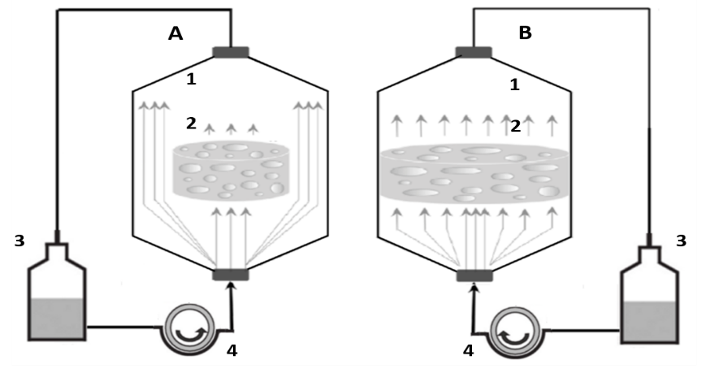

Fig. 2. The indirect (A) and the direct (B) perfusion bioreactor. (1) - culture chambers, (2) the cell/scaffold constructs, (3) the culture medium reservoirs, (4) the peristaltic pumps and (5) - the tubing systems .

## Process model

For the development of the mathematical model several works related to different types of bioreactors have been studied: batch bioreactor (Kiparissides et al. 2011) and perfusion bioreactor (Coletti et al. 2006, Chung et al. 2006, Hossain et al. 2015). A review of key developments regarding model development is given in Table 2. These represent some of the most significant works found in literature and are also presented in Table 1.

Table 2. Model development. Key contributions

|  |  |
| --- | --- |
| **Authors** | **Key Contributions** |
| (Freed et al. 1994) | Developed an empirical equation for the analysis of cell culture in a PGA scaffold  The cell growth and the related changes in implant permeability to glucose were studied as a function of implant thickness, cell density, cultivation time, and in vitro culture conditions (static vs. well-mixed).  Chondrocyte growth rates, maximum implant cell densities and proliferation times are calculated using experimentally determined kinetic parameters. |
| (Galban and Locke 1999) | Mathematical model using a volume average method which allows the cell growth profiles and effective diffusion coefficients to be determined and compared with experimental data. It elucidates the distribution of glucose concentration and its corresponding effect on cell number density  The model is developed to directly relate the effects of increasing cell mass in the polymer matrix on the transport of nutrients. |
| (Chung et al. 2006) | Mathematical model for cell generation and diffusion with a focus on cell mortality, cell growth rate, and cell consumption rate of nutrients to investigate chondrogenesis and glucose consumption in a cell-polymer construct.  This model, is able to investigate cell motility, heterogeneous cell distributions, and non-uniform seeding for tissue engineering applications  In addition to cell growth kinetics, the model incorporates cell diffusion in the model to describe the effects of cell random walks. |
| (Coletti et al. 2006) | Develops a comprehensive perfusion bioreactor model that describes the spatial-temporal evolution of oxygen concentration and cell density within a 3D polymeric scaffold. It includes both convection and diffusion (combined with cell growth kinetics) as concurrent transport phenomena responsible for oxygen gradients as well as the time-dependent porosity and permeability changes due to the cell density. |
| (Chung and Ho 2010) | a mathematical model that accounts for the effects of glucose and type II collagen on chondrocyte growth (uses the Michaelis–Menten model to describe the glucose uptake). Dependence of cell growth on collagen was assumed as a biphasic function of collagen quantity, whereby the cell growth rate increases and then decreases with increasing collagen content.  The model was then applied to investigate the effects of cell seeding area, demonstrating the spatiotemporal evolution of cell distribution in scaffolds |
| (Lin et al. 2011) | Extends the model of Chung 2010, incorporating the simultaneous effects of glucose and oxygen. The model also incorporates the modulation of chondrocyte growth by type II collagen to account for the biphasic impact that type II collagen put, which promotes chondrocyte growth in the initial phase of cultivation, while inhibits cell growth in the long term. |
| (Kiparissides et al. 2011) | Presents a biological model development framework highlighting challenges and ‘‘real life’’ problems associated with each stage of model development.  An example of an industrial process for the production of monoclonal antibodies (mAbs) harvested from cultures of hybridoma cells is employed both in batch and fed-batch where the aim is to process and maximise the final antibody titre in the culture through in silico experimentation. |
| (Yan et al. 2012) | Develops a mathematical model to represent the nutrient transport and cell growth incorporating the mass transfer and scaffold degradation on the porosity of the construct.  The developed model allows for investigating the effect of parameters that are controllable in the scaffold fabrication (i.e., scaffold porosity) and the cultivation process (i.e., flow rate) on the mass transfer in the cell culture process, including the distribution of glucose and oxygen with time. |
| (Paim et al. 2019) | Evaluates the contribution of oxygen transport in Contois proliferation kinetics and the porosity variation with time due to polymer degradation, using the model of Chung et al. (2006) considering the Michaelis-Menten model for the nutrient consumption.  A sensitivity analysis was used to compare the models and to verify the impact of each variable on the model outputs. |

The mathematical model developed for this study was implemented using the commercial finite element method code COMSOL Multiphysics v.5.4.

The computational domain was divided in two zones: the scaffold, defined as a porous medium, and the surroundings. The momentum conservation equation was solved in the surroundings. The modification according to Darcy’s law was included to solve the flow in the porous scaffold:

|  |  |
| --- | --- |
| $$ρ\frac{∂\vec{v}}{∂t}=-∇P-\frac{μ}{K}\vec{v}+μ∇^{2}\vec{v}+ρ\vec{g},$$ | (1) |

The solution for the velocity field was coupled with the transport equation

|  |  |
| --- | --- |
| $$\frac{∂c_{i}}{∂t}=-\left(∇∙\right)∇P-\frac{μ}{K}\vec{v}+μ∇^{2}\vec{v}+ρ\vec{g}+R_{i},$$ | (2) |

where  is the convective term vector and Ri is a mass source term that accounts for the creation/consumption of product/nutrients. Ri is defined in the scaffold (Ri is the generation rate of species i (here due to reactions only) and is a spatial-temporal functions of the cell concentration). In this work, we consider two input species, glucose and oxygen; hence, *i =* g (glucose), o (oxygen).

When cells grow and proliferate, they occupy some of the void space. The scaffold porosity decreases thus from its initial value as the cell density increases. The porosity of the scaffold was set as a function of the number of cells density:

|  |  |
| --- | --- |
| $$ε=ε_{0}-V_{cell}ρ_{cell}.$$ | (3) |

For the permeability $K$, the functional form of Koponen (Koponen et al. 1996) was used

|  |  |
| --- | --- |
|  | (4) |

where $s$ is the pore surface area per unit volume of scaffold and r is a structural scaffold parameter. The consumption of the nutrient and the production of the product was modelled as a mass source term Ri in the transport equation. The reaction was only defined in the scaffold domain.

Within the scaffold, glucose and oxygen are consumed (Hossain et al. 2015) according to the Michaelis–Menten kinetics as

|  |  |
| --- | --- |
|  | (5) |

where *Qm,i* is the maximum consumption rate of species *i*, *Cm,i* is the substrate concentration at which the reaction occurs at half of the maximum rate and *ρcell* is the cell concentration (cells per unit volume in the scaffold). The inclusion of the cell density in the Michaelis-Menten equation ensures appropriate intertwining between all the physics involved in this problem. Cell growth in the scaffold was modelled by introducing an extra equation, the Contois equation, to be solved only in the scaffold subdomain. It was chosen in preference to other typical equations as it accounts well for contact inhibition (Galban and Locke 1999).

 (6)

The parameters in eq (6) are defined as: , the maximum cell growth rate; Kc, the Contois parameter; *ρc* and *Vcell*, the single cell density and volume, respectively; KL, the lactate Michaelis-Menten growth constant and Cg, Co and CL are the glucose, the oxygen and the lactate concertation, respectively. The cell density variation with respect to time is given by the following differential equation:

|  |  |
| --- | --- |
|  | (7) |

where *kd* is the cells death kinetic parameter.

# Theoretical Background

## High Dimensional Model Representation (HDMR)

The high dimensional model representation (HDMR) method is a set of tools (explored by (Rabitz and Aliş 1999)) used to define the input–output relationship of complex models that have a large number of input variables. The mapping between the input variables *x1, ., xn* and the output variables  in the domain Rn can be written in the following form (Sobol 2001):

 (8)

Where *f0* is the mean effect (zeroth order), which is a constant. The function *fi(xi)* is a first order term that represents the effect of variable *xi* acting independently (generally non-linearly) on the output *f(x)*. The function *fij(xi, xj)* represents a second order term that describes the cooperative effects of the variables *xi* and *xj* on the output *f(x)*. The higher order terms reflect the cooperative effects of increasing numbers of input variables that are acting together to influence the output *f(x)*. In the case where there is no interaction between the input variables, the zeroth order term *f0* and the first order terms *fi(xi)* will appear in the HDMR expansion.

If higher order input variable correlations are weak and can therefore be neglected, the HDMR expansion is computationally very efficient. For a lot of systems a HDMR expression up to second order already provides satisfactory results and a good approximation of *f(x)* (Li et al. 2001).

A particular way of deriving an HDMR representation through Monte Carlo sampling is the Random Sampling HDMR technique (RS-HDMR). Since the computation of multidimensional integrals may become prohibitive (Sobol 2001), an alternative technique based on the use of interpolation has been introduced by Li and co-workers (Li et al. 2002).

In the RS-HDMR approach (Li et al. 2002), a set of random sample points N over the entire domain *Rn* is used. The zeroth order term *f0* can be approximated by the average value of *f(x)*. To determine the higher order component functions, the approximation of the component functions by orthonormal basis functions is used:

 (9)

where *k, l, l’* represent the order of the polynomial expansion,  and are constant coefficients to be determined, and , and  are the orthonormal basis functions. Note that only one set of random samples N is necessary in order to determine all RS-HDMR component functions (Li et al. 2002) since the approximation of the component functions will significantly reduce the sampling effort. However, the sample size used to determine an accurate representation of the component functions given in Equation (8) should be large enough.

## Global Sensitivity Analysis using HDMR

A common method used in global SA is the method of Sobol’ (Sobol 2001), which is based on the same concept as the RS-HDMR approach. In statistics, the decomposition of *f(x)* into summands of increasing dimensionality (see equation (8)) is called Analysis of Variance (ANOVA) decomposition, a member of the high dimensional model representations known as ANOVA–HDMR (Rabitz and Aliş 1999). However, the estimation procedure is not the same, and the aim is to calculate the total and partial variances instead of the HDMR component functions.

The total variance D can be obtained by:

 (10)

where the partial variances can be determined from equation (8):

 (11)

Monte Carlo (MC) integration can be used to approximate the integrals in equations (11). However, for a full characterisation of the model, the calculation of the partial variances requires the evaluation of 2n Monte Carlo integrals. Therefore, a separate MC integral is needed for the computation of each of the partial variances, leading to a computationally expensive method.

The calculation of the partial variances on the basis of the RS-HDMR function expansion provides a much more efficient approach, because the RS-HDMR expansion already gives the ANOVA decomposition (Rabitz and Aliş 1999).

Once the partial variances are determined the sensitivity indices can be calculated as follows:

  (12)

so that all its terms add up to 1:

 (13)

The first order sensitivity index *Si* represents the main effect of the input variable *xi* on the output, meaning that it is the fractional contribution of *xi* to the variance of *f(x)*. The second order sensitivity index *Sij* is a measurement of the interaction effect of x*i* and x*j* on the output and so on. For a better understanding about the calculation of the sensitivity indices based on the RS-HDMR component functions more detailed information can be found in (Li et al. 2002).

# Results

Hitherto, most of the mathematical models found show discrepancies between the models as well as discrepancies between the values of the parameters. Moreover, for some of the parameters, no values could be found for the case of the perfusion reactor. For example, in the case of mammalian cells even though such models have been employed for many years in the production of biotherapeutics, information related to their kinetic parameters is scarce (López-Meza et al. 2016).

Due to the lack of consensus in the literature regarding the nominal values as well as the uncertainty ranges for some of the model parameters, this model provides an interesting case study for the application of global sensitivity methods. Because global sensitivity analysis provides an importance ranking for the input parameters and it explores the influence of parameter interactions, this is also an important tool for the design of control strategies. The first order sensitivity indices *Si* representing the main effect of the considered input variable on the output are determined and analyzed. Having an adequate mathematical model as well as a good understanding of the process will lead to increasing the productivity and performances of the perfusion bioreactor process by being able to use optimization and control strategies. To have a more in-depth understanding on the process manipulated and control variables and how they can be paired, combined with GSA we will also perform a relative gain array analysis (RGA).

The HDMR methods have been used over the Monte Carlo approach as a way to reduce computational cost. Moreover, the used methods are capable of exploring the input output mapping of a model by developing a replacement of the model and improve the accuracy of the metamodel with less computational costs compared to the full model without needing a large number of full model runs. Contrary to other input output methods for mapping, HDMR methods, reduces the exponential difficulty to a problem of only polynomial complexity (Zuniga et al. 2013). To rank the importance of the parameters as well as explore the influence of the interactions of parameters, sensitivity indices will be determined automatically by using the model replacement. The constructed metamodel can be also verified using a different sample set than the one which was used to construct the metamodel, then a different set of sample input and output files can be provided for the accuracy test.

In this work, to perform global sensitivity analysis based on RS-HDMR methods we used the GUI-HDMR software developed by the authors (Ziehn and Tomlin 2009, Ziehn and Tomlin 2017) which we have adapted to fit more recent developments in the field as well as the process at hand. Another GUI driven global sensitivity analysis and metamodeling software that can be used to compute various sensitivity measures and/or to develop metamodels is (Kucherenko and Zaccheus 2022).

For the global sensitivity analysis, two different scenarios are considered. First, we would like to explore the discrepancies between the models found in literature as well as the nominal parameter values and the uncertainty ranges. The model parameters considered are: Qm,g, Cm,g, Qm,o, Cm,o (equation 5), Kc, Kl (equation 6), and Kd (equation 7).

In the second scenario the relative influence of the input concentration of glucose and oxygen as well as the initial number of cells on the outputs is investigated. For both cases the selected target outputs are the output concentration of glucose, the output concentration of oxygen, the output concentration of lactate, cell density and cell growth. This analysis is important especially for control purposes in understanding how these inputs affect the selected outputs.

For both scenarios, the analysis was first performed based on a quasi-random sample size of N=10000. Since the presence of higher order effects is low and mostly first order effects were observed, a smaller sampling size can be used to efficiently calculate these effects (N=1000).

The model proposed in Section II is implemented using the commercial finite element method code COMSOL Multiphysics v.5.4 includes a number of parameters, some of which depend on the type of cells and their growth kinetics, others are properties of the reactor itself, and finally a few which depend on the way the bioreactor is prepared and operated. The values of the most important parameters (nominal values) used in this paper are presented in Table 3.

Table 3. Model parameters and values

|  |  |  |  |
| --- | --- | --- | --- |
| **parameter** | **value** | **unit** | **ref** |
| $$μ_{cell}^{max}$$ | 0.3056e-5 | 1/sec | (Chung et al. 2006) |
| *Kc* | 0.006 | mol/m3 | (Coletti et al. 2006) |
| *Vcell* | 2.5e-18 | m3 | (Coletti et al. 2006) |
| *Kd* | 0.0285 | 1/h | (Chung et al. 2006) |
| *Qm,g* | 1.339e-12 | kg/h | (Chung and Ho 2010) |
| *Qm,o* | 1.607e-13 | mol/cells·s | (Coletti et al. 2006) |
| *Cm,g* | 0.063 | kg/ m3 | (Chung and Ho 2010) |
| *Cm,o* | 0.006 | mol/m3 | (Coletti et al. 2006) |
| *Kl* | 3.87 | kg/ m3 | (Osiecki et al. 2018) |
| *Vsc* | 6.635e-7 | m3 | calculated |
| *ρc* | 182 | kg/ m3 | (Chung et al. 2006) |
|  | 1.737e+10 | 1/ m3 | calculated |

Fig. 3 provides a visual of the CFD simulated results for the direct and indirect perfusion bioreactor, including color maps for the cells density within the scaffold and isosurfaces for the concentration of lactic acid produced during the process at 15 days flow time. Here, the results for both direct and indirect perfusion bioreactors are presented to compare the two types of perfusion bioreactors. Direct perfusion provides uniform and more effective cell growth across the scaffold than the indirect option. The sensitivity analysis presented in this work uses the model of the direct perfusion bioreactor given its advantages. Figure 4 shows color maps for the cell density within the scaffold, concentration of lactic acid, concentration of oxygen and concentration of glucose at 5 hours and 5 days flow time. Cell growth is faster at the input of the feed medium flow of the scaffold as glucose entering its porous domain is consumed quickly.

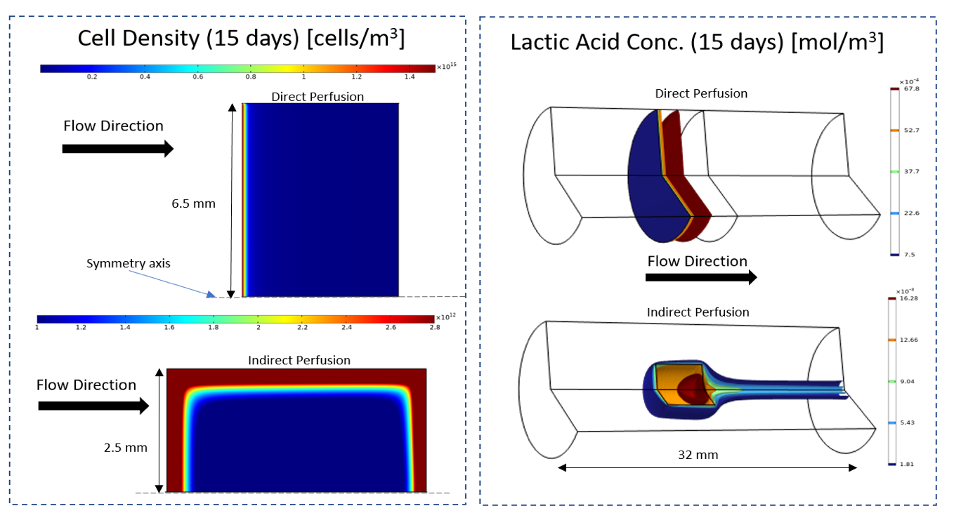

Fig. 3. CFD Color maps and isosurfaces for cell density and lactic acid concentration for direct and indirect perfusion bioreactors

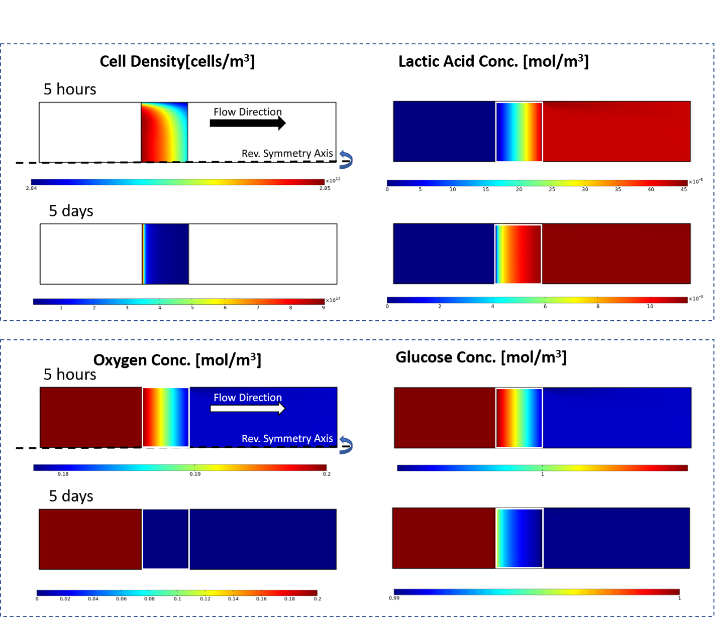

Fig. 4. CFD color maps for cell density, lactic acid concentration, oxygen concentration and glucose concentration at 5 hours and 5 days for the direct perfusion bioreactor

## Global Sensitivity Analysis – Case 1 (Scenario 1)

For the first scenario, the inputs considered for SA are part of the model parameters: Kc, Kl, Qm,g, Cm,g, Qm,o, Cm,o and Kd. Since no information about the uncertainties of these parameters are available and for a better understanding of how different ranges will affect the sensitivity indices of the inputs with respect to the outputs, a set of simulations for different ranges of the parameter uncertainties has been performed. A comparison of the SA results for two different ranges is presented and analyzed in Fig. 5 for the glucose concentration output. For the rest of the simulations presented in Case 1, the uncertainties presented are in the interval [50% - 200%] of the nominal value.

The relative influence of the uncertainty in these parameters on the output concentration of glucose, the output concentration of oxygen, the output concentration of lactate, cell density and cell growth is investigated. The sensitivity index (SI) represents the relative influence of the parameter on the output at the given time. To perform SI analysis, using the mathematical models presented in Section II, a perfusion bioreactor experiment was simulated. A value of 10 [mol/m3] has been considered for the input glucose concentration and 0.2 [mol/m3] for the input oxygen concentration. The evolution of the output was investigated on an interval of 15 days. During simulations all parameters were varied between their bounds.



Fig. 5: Evolution of the sensitivity indices with respect to the glucose concentration output

Fig. 5 presents the evolution of the first order sensitivity indices at different sample points for the glucose concentration output for two different sets of input uncertainty ranges. For the parameters with solid line the range is in the interval [50% - 200%] and for the parameters with dashed line the range is in the interval [20% - 500%]. It can be observed that there are no significant changes for different input ranges (solid line vs dashed line). Analyzing the sensitivities indices from Fig. 5, it is observed that the only parameter that has a noticeable change are the Qm,g and Qm,o and from these only Qm,o has a significant relative deviation. Therefore, we can say that for the glucose concentration output the most important parameters are the maximum consumption rate of glucose and oxygen respectively (Qm,g and Qm,o). This comparison between ranges is only presented for the glucose concentration output. The rest of the outputs maintain similar behavior. After performing the analysis on different ranges for all the outputs, we can say that the influence of the kinetic parameters Qm,o and Qm,g increases with the decrease of the uncertainty range interval while the sensitivity index for Kc decreases.

Analyzing the sensitivities indices from Fig. 5, Qm,g, the maximum uptake rate of glucose has the highest sensitivity index with respect to the glucose concentration output but it starts decreasing after ~1.75 days while Kc and Qm,o start gaining importance.



Fig. 6: Evolution of the sensitivity indices with respect to the oxygen concentration output

In Fig. 6 It can be observed that the sensitivity indices with respect to the oxygen concentration output has a very similar profile with the sensitivity indices with respect to the glucose concentration output (Fig. 5).

From Fig. 5 and Fig. 7 we can observe that the first order sensitivity indices for the lactate concentration output (Fig. 7) are almost identical to the sensitivity indices for the glucose concentration output. This makes sense since the output lactate concentration model is using the same reaction rate (Rg) as the model for glucose.



Fig. 7: Evolution of the sensitivity indices with respect to the lactate concentration output



Fig. 8: Evolution of the sensitivity indices with respect to the cell density output

For the evolution of the sensitivity indices of the cell density output from Fig. 8, in the beginning of the process only the cell death rate, Kd has an effect on the output of the process. After 1.5 days, Kc has the highest sensitivity index, the highest value being at 2 days then it starts decreasing while the sensitivity index for Qmo starts increasing. Other two important parameters here are Qmg and Kl.



Fig. 9. Evolution of the sensitivity indices with respect to the cell growth output

Fig. 9 presents the evolution of the first order sensitivity indices for the cell growth output. Analyzing the sensitivities indices, the most important parameters are Kc for the first 2.6 days of the process, then Qmo and after 5.6 days Kd becomes the most important parameter. It can be observed that at around 2.6 days (which can also be seen at the intersection point in Fig. 10), the sensitivity index for Kc drops to 0 and then starts increasing again, meaning that around day 3 it will have no influence on the output. To understand this behavior, Fig. 10 depicts the cell growth output for different values of Kc. It can be observed that by changing Kc we will have different outputs for the cell growth. Decreasing the value of Kc will make the cell growth steeper and increasing Kc less steep. But regardless the change in Kc all outputs for the cell growth will intersect around the same point and this is the same point where in Fig. 9 the SI for Kc drops to 0.01. Meaning that around that point Kc has almost no influence on the cell growth output since regardless of the Kc value they will all go through the same point.



Fig. 10. the cell growth output for different values of Kc

## Global Sensitivity Analysis – Case 2 (Scenario 2)

The inputs considered for the SA for Case 2 are: the input glucose concentration (Cg,in), the input oxygen concentration (Co,in) and the initial number of cells. The range for the simulations is between the lower and the upper bounds found in literature for the three parameters.

The relative influence of the input variables on the output concentration of glucose, the output concentration of oxygen, the output concentration of lactate, cell density and cell growth are investigated. This analysis is important especially for control purposes in understanding how these inputs affect the selected outputs.



Fig. 11. Evolution of the sensitivity indices with respect to the glucose concentration output

Fig. 11 presents the evolution of the first order sensitivity indices for the glucose concentration output. In the beginning of the process evolution since the number of cells is very low, the uptake rate is also very low and therefore the decrease of the output glucose concentration compared to the input glucose concentration is insignificant. The output glucose concentration is fully sensitive (only influenced) to the input glucose concentration. In the same time, the only way through which the oxygen concentration can influence the glucose uptake rate is through the cell growth rate (presented in Fig. 15). In the beginning of the process evolution, since the number of cells is very small, the change in cell numbers per unit time is also very small. Therefore, the influence of the input oxygen concentration on the glucose uptake rate is not significant.

The evolution of the first order sensitivity indices for the oxygen concentration output presented in Fig. 12 shows a similar behaviour. The influence of the initial number of cells is insignificant in both cases.



Fig. 12. Evolution of the sensitivity indices with respect to the oxygen concentration output



Fig. 13. Evolution of the sensitivity indices with respect to the lactate concentration output

For the evolution of the first indices of the sensitivity for the lactate concentration output presented in Fig. 13 it can be observed that initially the output depends only on the initial number of cells. With the time evolution, the input glucose concentration starts influencing the lactate production, more than the input concentration of oxygen.



Fig. 14. Evolution of the sensitivity indices with respect to the cell density output

The evolution of the first order sensitivity indices for the cell density output is presented in Fig. 14. Initially, the cell density output depends only on the initial number of cells but with time the input concentration of oxygen will have a high impact on the output compared to that of the input concentration of glucose.



Fig. 15. Evolution of the sensitivity indices with respect to the cell growth output

For the evolution of the first order sensitivity indices for the cell growth output, presented in Figure 15 the input glucose concentration sensitivity index remains constant after a couple of days throughout the duration of the process. Initially the initial number of cells and oxygen concentrations have the highest impact on the output while the input glucose have little influence. The influence of the initial number of cells starts to increase while the influence of the input oxygen concentration starts to decrease. After approx. 4.6 days the oxygen input concentration will start again influencing the output more while the initial number of cells will become less and less important.

An important note here is that the sensitivity indices are relative and depend on the number of the input values considered as well as the influence of the parameter interaction. The importance of the parameters regarding their influence on the output variance can be ranked. This will help in focusing further kinetic studies on key parameters influencing the accuracy of the model regarding validation data

## Relative Gain Array analysis

The Relative Gain Array (RGA) analyzed in this section is based on the 2 inputs (glucose input concentration (cg,in), oxygen input concentration (co,in)), 4 outputs (cell density, glucose output concentration, oxygen output concentration, lactic acid concentration) and the steady state gain matrix. The RGA provides two types of useful information: measure of process interactions and gives recommendation about best pairing of controlled and manipulated variables (Xiong et al. 2005, Masoumi and Zarandi 2011). The RGA is represented by a matrix with one column for each input/manipulated variable and one row for each output variable. From this matrix one can easily compare the relative gains associated with each input-output variable pair, and to match the input and output variables minimizing undesired side effects. Standard analysis suggests that RGA elements corresponding to input-output pairings close to 1 should be preferred. Large or negative RGA elements are disadvantageous as they correspond to loops which may be nominally stable, but which become unstable if saturation occurs.

In conclusion, some of the rules in how to pair best the controlled and manipulated variables are: (i) Avoid input and output pairs which have negative relative gains; (ii) Avoid input and output pairs which have large relative gains and (iii) Select input and output pairs which have the relative gain close to 1.

Based on the input/output variables involved and on the available high fidelity process model, calculating RGA from the steady-state gain matrix was found to be the simplest approach. In this case, considering changing one input/manipulated variable while maintaining the other ones constant and observing the changes in steady state for each of the output variables, the elements of G are obtained with:

 (14)

where ui represents the input/manipulated variables, yj the output variables and Δ the changes at steady-state. The RGA, for a non-singular square matrix G, is a square complex matrix defined as , where x denotes element-by-element multiplication (Hadamard or Schur product).

Because the high fidelity model is strongly nonlinear, the the steady-state gain matrix will depend on the chosen operating point. In the first variant of analysis are considered models in the state space after a certain time of evolution of the process.

|  |  |  |  |  |  |  |  |  |  |  |  |  |  |  |  |  |  |  |  |  |  |  |  |  |  |  |  |  |  |  |  |
| --- | --- | --- | --- | --- | --- | --- | --- | --- | --- | --- | --- | --- | --- | --- | --- | --- | --- | --- | --- | --- | --- | --- | --- | --- | --- | --- | --- | --- | --- | --- | --- |
| Table 4. Relative Gain Array (t=1 day)   |  |  |  | | --- | --- | --- | | RGA | *cg,in* | *co,in* | | *ρcell* | 0 | 0.999 | | *cg* | 0.999 | 0 | | *co* | 0 | 0 | | *cl* | 0 | 0 | | Table 5. Relative Gain Array (t=2 days)   |  |  |  | | --- | --- | --- | | RGA | *Cg,in* | *co,in* | | *ρcell* | -0.00043 | 1.00043 | | *cg* | 1.00035 | -0.00044 | | *co* | 0 | 0 | | *cl* | 0 | 0 | |
| Table 6. Relative Gain Array (t=3 days)   |  |  |  | | --- | --- | --- | | RGA | *cg,in* | *co,in* | | *ρcell* | 0.000017 | 0.99998 | | *cg* | 0 | 0 | | *co* | 0 | 0 | | *cl* | 0 | 0 | |  |

The RGA was first performed for the same parameter values as the ones used in the model simulation and presented in Table 3. Using these values, at the beginning of the experiment (simulation) the input glucose concentration is much higher than what the initial number of cells would need. From the RGA matrix in Table 4 and Table 5 one can observe that there is a strong coupling between *co,in* and *ρcell* and *cg,in* and *cg*. The RGA indicates that the output *ρcell* can be controlled using the input co,in, and the output *cg* can be controlled using cg,in until time t=~2.5 days.

|  |  |  |  |  |  |  |  |  |  |  |  |  |  |  |  |  |  |  |  |  |  |  |  |  |  |  |  |  |  |  |  |
| --- | --- | --- | --- | --- | --- | --- | --- | --- | --- | --- | --- | --- | --- | --- | --- | --- | --- | --- | --- | --- | --- | --- | --- | --- | --- | --- | --- | --- | --- | --- | --- |
| Table 7. Relative Gain Array (t=1 day)   |  |  |  | | --- | --- | --- | | RGA | *Cg,in* | *co,in* | | *ρcell* | 1 | 0 | | *cg* | 0 | 0 | | *co* | 0 | 1 | | *cl* | 0 | 0 | | Table 8. Relative Gain Array (t=2 days)   |  |  |  | | --- | --- | --- | | RGA | *Cg,in* | *co,in* | | *ρcell* | 0.9999992 | 0.00000079 | | *cg* | 0 | 0 | | *co* | 0 | 0 | | *cl* | 0 | 0 | |

If the input glucose concentration cg,in decreases to a value close to the amount needed by the initial number of cells (ro_cell_in) then RGA depicted in Table 7 and 8 indicates that the output *ρcell* can be controlled by the input glucose concentration, cg_in and the output co can be controlled using co,in until time t=~1.5 days.

Therefore, we can say that to maintain the best pair between the controlled and manipulated variables and to maximize ro_cell's growth we should determine by using mathematical optimization the optimal feeding profile for the two concentration inputs cg,in and co,in.

# conclusion

Perfusion bioreactors for tissue engineering are complex processes that are not yet fully understood. Moreover, literature information about the model as well as the values of the parameter and ranges are scarce. This work presents an in-depth analysis of the mathematical models for a perfusion bioreactor process. The model used for simulations describes the spatio-temporal evolution of glucose, oxygen and lactic acid concentration and cell density within a 3D polymeric scaffold and is implemented using Computational Fluid Dynamics (with the commercial software COMSOL Multiphysics v5.5).

Global sensitivity analysis is performed using the method of random sampling high-dimensional model representation (RS-HDMR). These methods have been shown to provide a straightforward approach that can explore the input–output mapping of the perfusion bioreactor model.

For the global sensitivity analysis, two different scenarios are considered. The first scenario explores the discrepancies between the models found in literature as well as the nominal parameter values and the uncertainty ranges, having as input parameters: Kc, Kl, Qm,g, Cm,g, Qm,o, Cm,o and Kd. The second scenario investigates the relative influence of the input concentration of glucose and oxygen as well as the initial number of cells on the outputs. For both cases the selected target outputs are the output concentration of glucose, the output concentration of oxygen, the output concentration of lactate, cell density and cell growth. The results are presented and analyzed in detail.

The use of sensitivity analysis on the perfusion bioreactor quantifies the importance of model inputs and their interactions with respect to model output and provides an overall view on the influence of inputs on outputs. For a more in-depth understanding of the process, a relative gain analysis is performed which gives information on the measure of process interactions and gives recommendation about best pairing of controlled and manipulated variables.

This analysis is a key step in the development and implementation of model based control and optimization that will lead to improving the productivity and performances of the perfusion bioreactor process.

Acknowledgements

Financial support from National Natural Science Fund for Distinguished Young Scholars (61725301), International (Regional) Cooperation and Exchange Project（61720106008).

**Notation**

*P* = pressure (Pa)

C = molar concentration (mol/m3)

*C*m = Michaelis-Menten parameter (mol/m3)

*Ri* = reactive term (mol/m3·s)

 = gravity force vector (m/s2)

*K* = scaffold permeability (m2)

*K*c = Contois parameter (mol/m3)

*k*d = cells death kinetic parameter, (1/s)

*Q*m = Michaelis-Menten constant (mol/cells·s)

*r* = Radial coordinate (m)

*s* = pore surface area per unit volume of porous material (1/m2)

= effective velocity vector (m/s)

*V*cell = single cell volume (m3)

δ = characteristic length of the scaffold porous matrix (m)

*ε* = scaffold porosity (%)

*μ* = medium viscosity (kg/m·s)

*μcell*= cell growth rate (1/s)

= maximum cell growth rate (1/s)

ρ = medium density (kg/m3)

ρc = single cell density (g/m3)

ρcell = cell density (cells/m3)

= initial cell density (cells/m3)

**References**

Acosta Santamaría, V. A., Malvè, M., Duizabo, A., Mena Tobar, A., Gallego Ferrer, G., García Aznar, J. M., Doblaré, M. and Ochoa, I. (2013) 'Computational Methodology to Determine Fluid Related Parameters of Non Regular Three-Dimensional Scaffolds', *Annals of Biomedical Engineering,* 41(11), 2367-2380.

Bancroft, G. N., Sikavitsas, V. I. and Mikos, A. G. (2003) 'Design of a flow perfusion bioreactor system for bone tissue-engineering applications', *Tissue Engineering,* 9(3), 549-554.

Chen, T. and Yang, Y. (2011) 'Interpretation of non-linear empirical data-based process models using global sensitivity analysis', *Chemometrics and Intelligent Laboratory Systems,* 107(1), 116-123.

Chung, C. A. and Ho, S.-Y. (2010) 'Analysis of Collagen and Glucose Modulated Cell Growth within Tissue Engineered Scaffolds', *Annals of Biomedical Engineering,* 38(4), 1655-1663.

Chung, C. A., Yang, C. W. and Chen, C. W. (2006) 'Analysis of cell growth and diffusion in a scaffold for cartilage tissue engineering', *Biotechnology and Bioengineering,* 94(6), 1138-1146.

Coletti, F., Macchietto, S. and Nlvassore, N. (2006) 'Mathematical modelling of three-dimensional cell cultures in perfusion bioreactors. Part II' in Marquardt, W. and Pantelides, C., eds., *Computer Aided Chemical Engineering*,Elsevier, 1699-1704.

Diaz, R. A. C., Ghita, M., Copot, D., Birs, I. R., Muresan, C. and Ionescu, C. (2020) 'Context Aware Control Systems: An Engineering Applications Perspective', *IEEE ACCESS,* 8, 215550-215569.

Freed, L. E., Marquis, J. C., Langer, R. and Vunjak-Novakovic, G. (1994) 'Kinetics of chondrocyte growth in cell-polymer implants', *Biotechnol Bioeng,* 43(7), 597-604.

Galban, C. J. and Locke, B. R. (1999) 'Analysis of cell growth kinetics and substrate diffusion in a polymer scaffold', *Biotechnology and Bioengineering,* 65(2), 121-132.

Guillaume, J. H. A., Jakeman, J. D., Marsili-Libelli, S., Asher, M., Brunner, P., Croke, B., Hill, M. C., Jakeman, A. J., Keesman, K. J., Razavi, S. and Stigter, J. D. (2019) 'Introductory overview of identifiability analysis: A guide to evaluating whether you have the right type of data for your modeling purpose', *Environmental Modelling & Software,* 119, 418-432.

Gupta, H. V. and Razavi, S. (2018) 'Revisiting the Basis of Sensitivity Analysis for Dynamical Earth System Models', *Water Resources Research,* 54(11), 8692-8717.

Hossain, M. S., Bergstrom, D. J. and Chen, X. B. (2015) 'Modelling and simulation of the chondrocyte cell growth, glucose consumption and lactate production within a porous tissue scaffold inside a perfusion bioreactor', *Biotechnology Reports,* 5(1), 55-62.

Ionescu, C., Cajo, R., Shiquan, Z., Ghita, M., Ghita, M. and Copot, D. (2020) 'A Low Computational Cost, Prioritized, Multi-Objective Optimization Procedure for Predictive Control Towards Cyber Physical Systems', *IEEE ACCESS,* PP, 1-1.

Ionescu, C. and Copot, D. (2019) 'Hands-on MPC Tuning for Industrial Applications', *Bulletin of the Polish Academy of Sciences: Technical Sciences,* No. 5, 925-945.

Kent, E., Neumann, S., Kummer, U. and Mendes, P. (2013) 'What can we learn from global sensitivity analysis of biochemical systems?', *PLoS One,* 8(11), e79244.

Kiparissides, A., Koutinas, M., Kontoravdi, C., Mantalaris, A. and Pistikopoulos, E. N. (2011) '‘Closing the loop’ in biological systems modeling — From the in silico to the in vitro', *Automatica,* 47(6), 1147-1155.

Kiparissides, A., Kucherenko, S. S., Mantalaris, A. and Pistikopoulos, E. N. (2009) 'Global sensitivity analysis challenges in biological systems modeling', *Industrial and Engineering Chemistry Research,* 48(15), 7168-7180.

Koponen, A., Kataja, M. and Timonen, J. (1996) 'Tortuous flow in porous media', *Physical Review E - Statistical Physics, Plasmas, Fluids, and Related Interdisciplinary Topics,* 54(1), 406-410.

Kucherenko, S. and Zaccheus, O. (2022) 'SobolGSA Software. Manual', *Imperial College London*.

Li, G., Rosenthal, C. and Rabitz, H. (2001) 'High dimensional model representations', *Journal of Physical Chemistry A,* 105(33).

Li, G., Wang, S. W., Rabitz, H., Wang, S. and Jaffé, P. (2002) 'Global uncertainty assessments by high dimensional model representations (HDMR)', *Chemical Engineering Science,* 57(21), 4445-4460.

Lin, T. H., Lin, C. H. and Chung, C. A. (2011) 'Comutational study of oxygen and glucose transport in engineered cartilage constructs', *Journal of Mechanics,* 27(3), 337-346.

López-Meza, J., Araíz-Hernández, D., Carrillo-Cocom, L. M., López-Pacheco, F., Rocha-Pizaña, M. d. R. and Alvarez, M. M. (2016) 'Using simple models to describe the kinetics of growth, glucose consumption, and monoclonal antibody formation in naive and infliximab producer CHO cells', *Cytotechnology,* 68(4), 1287-1300.

Martin, I., Wendt, D. and Heberer, M. (2004) 'The role of bioreactors in tissue engineering', *Trends in Biotechnology,* 22(2), 80-86.

Masoumi, E. and Zarandi, B. M. (2011) 'Dynamic simulation and control of a distillation column using Effective Relative Gain Array', *World Academy of Science, Engineering and Technology,* 76, 787-794.

Nascu, I., Sebastia-Saez, D., Chen, T. and Du, W. L. (2021) 'A combined computational-fluid-dynamics model and control strategies for perfusion bioreactor systems in tissue engineering', *IFAC-PapersOnLine*, 1-6.

Nokhbatolfoghahaei, H., Bohlouli, M., Adavi, K., Paknejad, Z., Rezai Rad, M., khani, M. M., Salehi-Nik, N. and Khojasteh, A. (2020) 'Computational modeling of media flow through perfusion-based bioreactors for bone tissue engineering', *Proceedings of the Institution of Mechanical Engineers, Part H: Journal of Engineering in Medicine,* 234(12), 1397-1408.

Osiecki, M. J., McElwain, S. D. L. and Lott, W. B. (2018) 'Modelling mesenchymal stromal cell growth in a packed bed bioreactor with a gas permeable wall', *PLoS One,* 13(8), e0202079.

Paim, Á., Cardozo, N., Pranke, P. and Tessaro, I. (2019) 'SENSITIVITY ANALYSIS FOR MODEL COMPARISON AND SELECTION IN TISSUE ENGINEERING', *Brazilian Journal of Chemical Engineering,* 36, 383-391.

Rabitz, H. and Aliş, Ö. F. (1999) 'General foundations of high-dimensional model representations', *Journal of Mathematical Chemistry,* 25(2-3), 197-233.

Razavi, S., Jakeman, A., Saltelli, A., Prieur, C., Iooss, B., Borgonovo, E., Plischke, E., Lo Piano, S., Iwanaga, T., Becker, W., Tarantola, S., Guillaume, J. H. A., Jakeman, J., Gupta, H., Melillo, N., Rabitti, G., Chabridon, V., Duan, Q., Sun, X., Smith, S., Sheikholeslami, R., Hosseini, N., Asadzadeh, M., Puy, A., Kucherenko, S. and Maier, H. R. (2021) 'The Future of Sensitivity Analysis: An essential discipline for systems modeling and policy support', *Environmental Modelling & Software,* 137, 104954.

Rodrigues, D., Abdalmoaty, M. R., Jacobsen, E. W., Chotteau, V. and Hjalmarsson, H. (2021) 'An integrated approach for modeling and identification of perfusion bioreactors via basis flux modes', *Computers & Chemical Engineering,* 149, 107238.

Saltelli, A., Tarantola, S., Campolongo, F. and Ratto, M. (2004) 'Sensitivity Analysis in Practice: A Guide to Assessing Scientific Models'.

Schmid, J., Schwarz, S., Meier-Staude, R., Sudhop, S., Clausen-Schaumann, H., Schieker, M. and Huber, R. (2018) 'A Perfusion Bioreactor System for Cell Seeding and Oxygen-Controlled Cultivation of Three-Dimensional Cell Cultures', *Tissue Eng Part C Methods,* 24(10), 585-595.

Sobol, I. M. (2001) 'Global sensitivity indices for nonlinear mathematical models and their Monte Carlo estimates', *Mathematics and Computers in Simulation,* 55(1-3), 271-280.

Sobol’, I. M., Tarantola, S., Gatelli, D., Kucherenko, S. S. and Mauntz, W. (2007) 'Estimating the approximation error when fixing unessential factors in global sensitivity analysis', *Reliability Engineering & System Safety,* 92(7), 957-960.

Stoltz, J. F., de Isla, N., Li, Y. P., Bensoussan, D., Zhang, L., Huselstein, C., Chen, Y., Decot, V., Magdalou, J., Li, N., Reppel, L. and He, Y. (2015) 'Stem Cells and Regenerative Medicine: Myth or Reality of the 21th Century', *Stem cells international,* 2015, 734731-734731.

Tonelli, F. M. P., de Cássia Oliveira Paiva, N., de Medeiros, R. V. B., Pinto, M. C. X., Tonelli, F. C. P. and Resende, R. R. (2017) '12 - Tissue Engineering: The Use of Stem Cells in Regenerative Medicine' in Thomaz-Soccol, V., Pandey, A. and Resende, R. R., eds., *Current Developments in Biotechnology and Bioengineering*,Elsevier, 315-324.

Warren, S. M., Sailon, A. M., Allori, A. C., Davidson, E. H., Reformat, D. D. and Allen Jr, R. J. (2009) 'A novel flow-perfusion bioreactor supports 3D dynamic cell culture', *Journal of Biomedicine and Biotechnology,* 2009.

Xiong, Q., Cai, W. J. and He, M. J. (2005) 'A practical loop pairing criterion for multivariable processes', *Journal of Process Control,* 15(7), 741-747.

Yan, X., Bergstrom, D. J. and Chen, X. B. (2012) 'Modeling of cell cultures in perfusion bioreactors', *IEEE Trans Biomed Eng,* 59(9), 2568-75.

Ziehn, T. and Tomlin, A. S. (2009) 'GUI-HDMR - A software tool for global sensitivity analysis of complex models', *Environmental Modelling and Software,* 24(7), 775-785.

Ziehn, T. and Tomlin, A. S. (2017) 'Efficient Tools for Global Sensitivity Analysis Based on High-Dimensional Model Representation' in *Sensitivity Analysis in Earth Observation Modelling*,297-318.

Zuniga, M. M., Kucherenko, S. and Shah, N. (2013) 'Metamodelling with independent and dependent inputs', *Computer Physics Communications,* 184(6), 1570-1580.