Varieties of semantic cognition revealed through simultaneous decomposition of intrinsic brain connectivity and behaviour

Deniz Vatansever¹, Danilo Bzdok^{2,3,4}, Hao-Ting Wang¹, Giovanna Mollo¹, Mladen Sormaz¹, Charlotte Murphy¹, Theodoros Karapanagiotidis¹, Jonathan Smallwood¹ & Elizabeth Jefferies¹.

¹ Department of Psychology, University of York, Heslington, York, United Kingdom.
² Department of Psychiatry, Psychotherapy and Psychosomatics, Medical Faculty, RWTH Aachen, Germany
³ JARA, Translational Brain Medicine, Aachen, Germany
⁴ Parietal team, INRIA, Neurospin, bat 145, CEA Saclay, 91191 Gif-sur-Yvette, France

Keywords: semantics, cognition, functional connectivity, resting state, canonical correlation analysis

Address for correspondence:
Deniz Vatansever, PhD
Post-doctoral Research Associate
Department of Psychology
University of York
Heslington, York, YO10 5DD
Tel: +44 (0) 1904 322889
E-mail: deniz.vatanesever@york.ac.uk
Abstract
Contemporary theories assume that semantic cognition emerges from a neural architecture in which different component processes are combined to produce aspects of conceptual thought and behaviour. In addition to the state-level, momentary variation in brain connectivity, individuals may also differ in their propensity to generate particular configurations of such components, and these trait-level differences may relate to individual differences in semantic cognition. We tested this view by exploring how variation in intrinsic brain functional connectivity between semantic nodes in fMRI was related to performance on a battery of semantic tasks in 154 healthy participants. Through simultaneous decomposition of brain functional connectivity and semantic task performance, we identified distinct components of semantic cognition at rest. In a subsequent validation step, these data-driven components demonstrated explanatory power for neural responses in an fMRI-based semantic localiser task and variation in self-generated thoughts during the resting-state scan. Our findings showed that good performance on harder semantic tasks was associated with relative segregation at rest between frontal brain regions implicated in controlled semantic retrieval and the default mode network. Poor performance on easier tasks was linked to greater coupling between the same frontal regions and the anterior temporal lobe; a pattern associated with deliberate, verbal thematic thoughts at rest. We also identified components that related to qualities of semantic cognition: relatively good performance on pictorial semantic tasks was associated with greater separation of angular gyrus from frontal control sites and greater integration with posterior cingulate and anterior temporal cortex. In contrast, good speech production was linked to the separation of angular gyrus, posterior cingulate and temporal lobe regions. Together these data show that quantitative and qualitative variation in semantic cognition across individuals emerges from variations in the interaction of nodes within distinct functional brain networks.

1. Introduction

Semantic cognition allows us to understand the meaning of words, objects, places and people, and guides our thoughts and actions in a manner that suits the circumstances (Jefferies, 2013; Lambon Ralph et al., 2016; Patterson et al., 2007). In addition, this type of cognition also plays a critical role in thoughts that are unconnected from the here and now, such as when we daydream about a future achievement or remember a past event (Binder et al., 2009; Smallwood et al., 2016). Contemporary accounts suggest that semantic cognition emerges from the interactions of multiple components, supported by distinct brain networks (Jefferies and Lambon Ralph, 2006; Lambon Ralph et al., 2016). Studies have recently begun to address how these between-network interactions might momentarily change, depending on task demands (Bianchi et al., 2013; Davey et al., 2016; Hallam et al., 2016; Jung and Lambon Ralph, 2016; Krieger-Redwood et al., 2016). However, relatively little is known about individual differences in semantic cognition i.e. aspects of brain connectivity that are associated with trait-level variability in semantic task performance.

From the component process perspective, semantic cognition is thought to involve the interaction of semantic representations and control processes that tailor retrieval to suit the behavioural circumstances (Jefferies, 2013; Lambon Ralph et al., 2016). Evidence suggests that the semantic representations in long-term memory draw on modality-specific brain regions (supporting visual and verbal features, such as our knowledge that zebras have black and white stripes, and linguistic associations, such as “zebra crossing” (Buccino et al., 2016; Fernandino et al., 2016)), as well as heteromodal areas, including the anterior temporal lobe (Lambon Ralph et al., 2016; Patterson et al., 2007). Anterior temporal cortex is argued to provide a graded “hub” supporting the convergence of diverse unimodal semantic features. This permits the extraction of deep conceptual similarity incorporating both verbal and non-verbal knowledge. In addition, since we all know a diverse range of features and associations to any given concept, conceptual retrieval must be constrained in accordance with goals and environmental conditions (Badre et al., 2005; Jefferies and Lambon Ralph, 2006; Thompson-Schill et al., 1997). Hence, semantic control processes may play a vital role in focusing retrieval on currently relevant aspects of knowledge and supressing strongly encoded but currently irrelevant information. This aspect of semantic cognition is thought to be supported by a distinct set of brain regions including domain-general executive areas (e.g. dorsal/posterior inferior frontal gyrus, pre-supplementary motor area) and areas more specifically implicated in semantic control (e.g. ventral/anterior inferior frontal gyrus, posterior middle temporal gyrus (Davey et al., 2016; Noonan et al., 2013)).

In line with this interactive view, cognitive neuroscience research has provided converging evidence for multiple, interrelated components within semantic cognition. Lesion studies have revealed that selective damage to the anterior temporal lobe, left inferior frontal gyrus and/or posterior middle temporal gyrus produce dissociable impairments, compromising the integrity of conceptual representations (Bozeat et al., 2000; Patterson et al., 2007), or their use in a goal-oriented manner, respectively (Jefferies and Lambon Ralph, 2006; Jefferies et al., 2008; Noonan et al., 2010; Rogers et al., 2015). The functional dissociation between these brain regions is also supported by neuroimaging (Hoffman et al., 2015; Humphreys et al., 2015; Noonan et al., 2013) and neurostimulation (Binney et al., 2010; Davey et al., 2015; Pobric et al., 2007; Whitney et al., 2011) investigations of semantic processing in healthy participants.

Recent studies have also shown that although these brain regions act in concert to support semantic cognition (i.e., they co-activate during task fMRI), they form distinct large-scale brain networks at rest (Davey et al., 2016; Jackson et al., 2016), depicting functional integration when participants shift from rest to semantic tasks (Krieger-Redwood et al., 2016). For example, as an important hub of semantic processing (Patterson et al., 2007), anterior temporal lobe (ATL) shows strong connectivity at rest to regions of the default mode network (DMN), including angular gyrus and posterior cingulate cortex (Jackson et al., 2016; Murphy et al., 2017). In contrast, semantic control regions such as left inferior frontal gyrus and posterior middle temporal gyrus show strong intrinsic connectivity to each other, and they connect to both default mode and fronto-parietal networks (Davey et al., 2016). Together these studies suggest that semantic cognition is an emergent property of variable interactions between not only particular brain regions, but also distributed large-scale brain networks, present at rest and in cognitive tasks (Cole et al., 2014).

Although this assumption is broadly accepted, it remains unclear how individual differences in the strength of specific connections within and between these networks might relate to trait-level differences in semantic abilities. For example, the strength of particular network interactions might give rise to global differences in the efficiency of semantic retrieval across tasks, linked to the tendency to stay on task. Studies have associated both task-based semantic behaviour and off-task mind-wandering to overlapping brain regions involved in semantic processing that are allied to the DMN (Binder et al., 2009; Smallwood et al., 2016). The strength of intrinsic connectivity between these default mode regions and areas linked to task engagement might therefore determine whether individuals are generally willing or able to focus semantic retrieval on an externally-imposed goal, as opposed to conceptual associations that might have greater personal relevance. In addition, since research has revealed network differences that relate to the modality of information being retrieved (i.e., words vs. pictures) and the extent to which semantic control processes are required to shape retrieval to suit the task, we might expect individual differences in patterns of intrinsic network connectivity to relate to relative strengths and weaknesses in these varieties of semantic cognition across participants.

To assess these hypotheses, we recorded task-based and resting state functional magnetic resonance imaging (fMRI) data in a large cohort of participants, who also described their thoughts while at rest inside the scanner. On a subsequent day, these participants performed a battery of semantic tasks, including relatedness, identity and feature judgements, picture naming and verbal fluency. The tasks used different types of stimuli including words and pictures, manipulated the requirement for controlled retrieval using strong and weak associations (Badre et al., 2005; Davey et al., 2016), and assessed both comprehension and production, allowing us to characterise diverse aspects of semantic cognition. We used advanced multivariate statistics (Smith et al., 2015; Tsvetanov et al., 2016) to simultaneously decompose individual variation in brain data (resting state connectivity) and behaviour (measured outside the scanner) to identify the neurocognitive components of semantic cognition. We confirmed the validity of these components by examining their association with independent measures: the neural response to meaningful over meaningless information in task-based fMRI and subjective descriptions of self-generated thoughts during the resting-state scan (Gorgolewski et al., 2014). This allowed us to specify neurocognitive components that relate to the (i) average performance on semantic tasks and (ii) varieties of semantic cognition. Overall, these results help to elucidate the fundamental mechanisms underpinning variation in semantic cognition in healthy individuals.

2. Methods

2.1 Participant Demographics
Ethical approval was obtained from the Department of Psychology and York Neuroimaging Centre, University of York ethics committees. A total of 165 right-handed, native English speaker, undergraduate or postgraduate students with normal to corrected vision were recruited for this study. Informed consent was sought prior to taking part in the fMRI as well as the behavioural assessments. The participants received either a monetary reward of £80 or eight hours of course credit.

As per the exclusion criteria, none of the participants had a history of psychiatric or neurological illness, severe claustrophobia, anticipated pregnancy or drug use that could alter cognitive functioning. In total, 11 participants were excluded from the analysis; eight due to incomplete behavioural assessment and three because of registration problems associated with the neuroimaging data. Consequently, the final group included 154 participants, who completed all the neuroimaging and behavioural assessments. The average age for this group was 20.20 years (range = 18-31, SD = 2.43) with 94 females.

2.2. Behavioural Assessment
Following the imaging protocol, participants took part in a comprehensive set of behavioural assessments that captured different aspects of semantic cognition. The tasks were completed over three 2-hour long sessions on different days, with the order of the sessions counterbalanced across participants. Full details about the semantic tasks are provided in the supplementary materials (Table S1-5). In total, there were 12 tasks that examined semantic cognition:
- Two 3-alternative forced choice (3AFC) tasks required participants to identify pictures at two levels of specificity. Superordinate word-picture matching required participants to link a picture of a Dalmatian with the word “animal” (as opposed to distractors such as “vehicle; clothes”). Specific-level matching, however, involved the same probe image and specific-level names (e.g., target word “Dalmatian” with distractors “Labrador; Corgi”). Previous research has shown that ventral and medial aspects of anterior temporal lobe show a stronger response to specific concepts (Rogers et al., 2006), while greater integration of visual information in this condition allows similar concepts to be successfully distinguished (Clarke et al., 2013). In addition, inhibitory transcranial magnetic stimulation (TMS) to angular gyrus has been shown to disrupt the retrieval of specific conceptual information using this task (Davey et al., 2015).
- Two 3AFC tasks examined the effect of presentation format, contrasting verbal semantic judgements (when the probe and response options were presented as written words) with picture semantic judgements (when items were presented as pictures). Comparisons of verbal and non-verbal semantic decisions have been used to distinguish cognitive components that support amodal and abstract aspects of conceptual processing (such as ventral anterior temporal lobe), from ‘embodied’ or modality-specific aspects (Bright et al., 2004; Patterson et al., 2007; Vandenberghe et al., 1996; Visser et al., 2012).
- Two 3AFC tasks assessed the retrieval of strong and weak semantic associations. These judgements presented a picture probe and three response options as words (in line with the identity-matching tasks). The strength of association between the probe and target was manipulated. Previous studies focusing on the neural basis of controlled semantic retrieval have frequently used contrasts of strong versus weak associations, and have commonly reported greater activation within left inferior frontal gyrus and posterior middle temporal gyrus when the relevant link is harder to retrieve (Badre et al., 2005; Davey et al., 2016; Gold and Buckner, 2002; Krieger-Redwood et al., 2015).
- A feature-matching task (presented in the form of 3AFC) assessed the ability to match probe and target words based on a specific semantic feature (e.g., colour, shape, size, texture). One of the distractors was a strong global associate that had to be ignored. This task is thought to require goal-driven selection of relevant knowledge (Badre et al., 2005) and has been shown to strongly activate dorsal aspects of the left inferior frontal gyrus and other regions within the multiple-demand system (Davey et al., 2016; Duncan, 2010). Thus, we included tasks that tapped two potentially separable aspects of semantic control: top-down feature selection (in the feature matching task) and recovery of weakly-encoded associations in a more bottom-up fashion (Badre et al., 2005; Davey et al., 2016).
- A 3AFC task that required pattern matching of meaningless scrambled images was employed as a control task. It had similar decision-making and response requirements as the semantic tasks described above.
- Picture naming task required participants to say aloud the most specific name possible for a set of common objects.
- Three verbal fluency tasks required participants to list as many items as possible within one minute. There were four general categories (e.g. animals, fruit, vehicles, tools), two specific categories (e.g. types of birds and types of boat) and three letters (e.g. F,A,S).

2.3 Neuroimaging Data Acquisition
The scanning session was carried out at the York Neuroimaging Centre, York with a 3T GE HDx Excite Magnetic Resonance Imaging (MRI) scanner using an eight-channel phased array head coil. Following a T1-weighted structural scan with 3D fast spoiled gradient echo (TR = 7.8 s, TE = minimum full, flip angle= 20°, matrix size = 256 x 256, 176 slices, voxel size = 1.13 x 1.13 x 1 mm) and a FLAIR sequence, a nine-minute resting state fMRI scan was carried out using single-shot 2D gradient-echo-planar imaging (TR = 3 s, TE = minimum full, flip angle = 90°, matrix size = 64 x 64, 60 slices, voxel size = 3 x 3 x 3 mm3, 180 volumes). During resting state scanning, the participants were asked to focus on a fixation cross and not to think of anything in particular.

Using the same scanning parameters as for the resting state scans, we also acquired a semantic localiser task in which the participants were asked to passively view meaningful (e.g., her + secrets + were + written + in + her + diary) and meaningless sequences of non-words (e.g. crark + dof + toin + mesk + int + lisal + glod + flid). A total of 10 sentences with meaningful content, based on Rodd et al. (2005), and 10 meaningless sentences with nonsensical content, matched in word length and number of syllables, were presented in two blocks of five (i.e., a total of 4-blocks), in a pseudo-random order. While transition between blocks was denoted by a task instruction (e.g., Meaningful), a red fixation marked the end of each sentence, with a jittered duration of 4000-6000ms. Each sentence was presented one word at a time (600 ms) to ensure that the speed of reading was matched across meaningful and non-meaningful stimuli, interleaved by 250 ms fixation periods.

2.4 Neuroimaging Data Pre-processing
All functional data were pre-processed using a standard pipeline, and analysed via FMRIB Software Library (FSL Version 6.0). The spatial pre-processing of the resting state functional data involved motion correction via MCFLIRT, slice-timing correction with Fourier space time-series phase-shifting, and normalisation to the MNI-152 template space using FLIRT as well as skull-stripped FLAIR and T1-weighted structural images. In addition, high-pass (sigma = 200 s) and low-pass temporal filtering (sigma = 2.8 s) was applied in order to focus on the slow-wave fluctuations. Finally, the confounding six motion parameters as well as the top 5 PCA components of the cerebrospinal fluid and white matter signal was removed using the CompCor method (Behzadi et al., 2007). This eliminated the need for a global signal regression that is reported to introduce spurious anti-correlations (Chai et al., 2012; Murphy et al., 2009). No spatial smoothing was applied. The same pre-processing pipeline was also applied to the semantic localiser functional neuroimaging data, except for the low-pass temporal filtering.

2.5 ROI Definitions and Functional Connectivity Matrix Construction
In order to objectively identify a set of semantic regions of interest (ROIs) that formed the brain functional connectivity matrices, we selected spatial maps from the literature that covered large-scale brain networks previously implicated in semantic cognition (Fig. 1A). We started with a meta-analytic map of “semantic” processing derived from Neurosynth, and identified regions on this map that fell within two distinct networks: the default mode network (DMN – associated with relatively easy semantic judgements and the presentation of strongly coherent conceptual combinations (Bemis and Pylkkanen, 2013; Davey et al., 2016; Humphreys et al., 2015; Price et al., 2016)) and the semantic control network (associated with harder semantic judgements and the presentation of weak conceptual combinations (Noonan et al., 2013)). The DMN was selected from the Yeo7 parcellation of whole-brain functional connectivity (Yeo et al., 2011) and downloaded from the Freesurfer website (https://surfer.nmr.mgh.harvard.edu /fswiki/CorticalParcel lation_Yeo2011), while the semantic control map was taken from the Noonan et al. (2013) meta-analysis of 53 semantic cognition studies that varied the required level of executive control. The binarised maps of these two contrasting networks were overlaid on the false-positive discovery rate corrected, statistical co-activation map (P_{term} | activation) of the “semantic” term in the Neurosynth database (accessed May 2016), and masked with the Automated Anatomical Labelling (AAL) map.

Using this procedure, we identified clusters of voxels where the Neurosynth semantic map overlapped with the DMN in anterior temporal lobe, ventral angular gyrus and posterior cingulate cortex. Moreover, the Neurosynth semantic map was overlapped with regions implicated in semantic control in posterior inferior frontal gyrus, pre-supplementary motor area, posterior middle temporal gyrus and ventral-mid-middle temporal gyrus. Finally, we identified regions where the Neurosynth semantic map overlapped with both the default mode and the semantic control networks, in anterior inferior frontal gyrus, posterior middle temporal gyrus, middle temporal gyrus and dorsal angular gyrus. Brain regions in the right hemisphere were omitted to improve the interpretability of the results and to solve the limitations associated with the CCA technique. The resulting 11 regions were used to extract BOLD signal time-series based on 6 mm seed spheres placed in the centre of these regions (Fig. 1B). Z-scored Pearson correlation coefficients of the signal between each of the 11 ROIs defined the functional connectivity matrices for each participant, utilised in the subsequent brain and behaviour decomposition analysis.

2.6 Sparse Canonical Correlation Analysis
With the aim of collectively characterising patterns of brain connectivity and behavioural performance measured outside the scanner, we employed a multivariate pattern analysis technique, canonical correlation analysis (CCA). Over and above independent components analysis of neuroimaging data (Beckmann et al., 2005), CCA identifies distinct canonical components from the linear combinations of two variable spaces (behaviour and brain). Thus, this technique allowed us to test the component process hypothesis by describing the relationship between intrinsic brain functional connectivity and semantic task performance simultaneously (Hardoon et al., 2004).

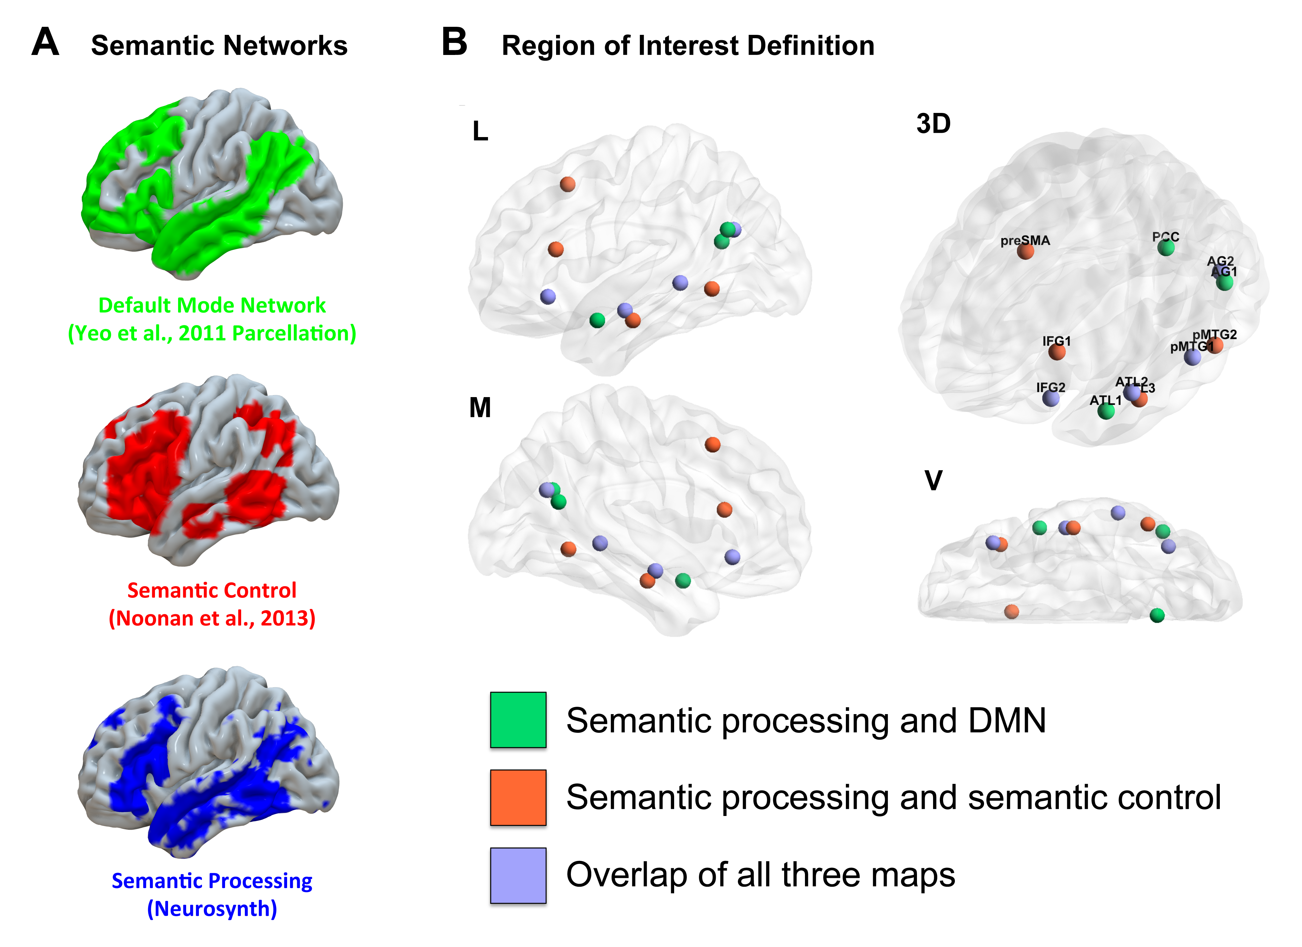
Figure 1 Definition of semantic ROIs. A) The seeds used for the simultaneous decomposition analysis were objectively defined as overlaps between the meta-analytic map derived for the term “semantic” from the Neurosynth database, and two large-scale brain networks previously implicated in semantic cognition: a semantic control network based on Noonan et al.’s (2013) meta-analysis of fMRI studies, plus the DMN as defined by Yeo et al.’s (2011) 7-network parcellation of whole-brain functional connectivity. ROIs were defined as being within the Neurosynth map (i.e., relevant for semantic cognition) and (i) also in the DMN; (ii) also in the semantic control map; (iii) also in both DMN and the semantic control maps. The resulting regions were masked with the AAL atlas for labelling purposes and 6 mm seeds were placed in the centre of each area of overlap, creating seed regions for the functional connectivity analysis. B) A total of 11 semantic ROIs were included in this analysis (visualised on an MNI152 glass brain). The posterior cingulate cortex (PCC), angular gyri (AG1) and temporal pole (ATL1) fell within the DMN (green). The semantic control network included regions in the pre-supplementary motor area (pre-SMA), posterior middle temporal gyrus (posterior pMTG2), posterior inferior frontal gyrus (pIFG1) as well as mid-MTG (ATL3; orange). A few regions were common to both the default mode and the semantic control networks (anterior IFG2; anterior pMTG1; ATL2, light blue).
The standardized (unit variance scaled and mean-centred) functional connectivity matrices as well as the standardized behavioural scores were fed into a reliable and robust implementation of the CCA method, using the Penalised Multivariate Analysis (PMA) R package from the CRAN repository. In order to improve the interpretability of the obtained decomposition solutions (Hastie et al., 2015), we applied an L₁-penalised variant of CCA introduced by Witten et al. (2009). This is achieved by setting a maximum number of brain or behaviour variables to exactly zero, which in turn cancels their contribution to the prediction goal and increases the sparseness of the solutions. This results in a regularised version of the singular value decomposition, reducing the excess information to meaningful decompositions. In other words, this sparsity (variable selection) method considers the entire model to derive canonical components, automatically de-weighing variables as unimportant if they did not explain variation in the data. In the current analysis, the L₁ penalty on resting state functional connectivity was 0.4, and 0.5 on the behavioural performance. The resulting brain and behaviour components were visualised using BrainNet Viewer on a glass MNI152 brain, in three different planes (Xia et al., 2013). In addition, circular representations were provided for better visual description of the components (Irimia et al., 2012) as implemented in Gephi (Version 0.91) (Bastian et al., 2009).

2.7 Neurocognitive Pattern Description
Similar to other commonly used decomposition techniques in neuroimaging (e.g. ICA or PCA), biologically meaningful number of CCA components is determined by external knowledge. In other words, the number of viable components are usually determined by the level at which the components identified from one set of data are still meaningful in a different set of data. This procedure then validates the interpretability and importance of the identified components. Thus, our aim was to describe the patterns of brain and behaviour relationships (i.e. varieties of semantic cognition) that were identified from the CCA analysis, utilising separate datasets. For that purpose, we employed the semantic localiser task performed inside the scanner, as well as self-report measures of mind-wandering at the end of the resting state scan.

For assessing differential BOLD activity in the semantic localiser task, we first examined the contrast of meaningful > meaningless task blocks, and the reverse effect, and confirmed that the task activated brain regions that are expected to be involved in semantic processing (Fig. 2A). Subsequently, the participant-specific component expression (i.e. brain and behaviour component loadings from the CCA for each participant) were carried forward as covariates to the higher-level activation analysis, collectively forming a group-wise general linear model. We searched for shared associations between both the brain and the behaviour component loadings for a given CCA component and beta values from the chosen task contrast. The resulting clusters were multiple comparison corrected via Family-Wise Error (FWE) detection technique at a Z threshold greater than 2.6 (p < 0.05). The unthresholded statistical maps were uploaded to the NeuroVault repository (http://neurovault.org/collections/2108/). The regions showing a significant linear relationship between the beta values of the meaningful > meaningless contrast and the participants’ CCA loadings were visualised on an MNI152 glass brain. Finally, a conjunction using the minimum statistics method (Nichols et al., 2005) was used to identify brain regions that showed a correlation with BOLD activity across all of the relevant CCA components. We then explored the seed-based functional connectivity of this conjunction region on an independent dataset, based on the intrinsic functional connectivity calculations of 1,000 subjects, publicly available on the Neurosynth website (Yeo et al., 2011). In order to provide an objective description of the multiple roles that are associated with this conjunction region, we later used the Neurosynth database (accessed May 2016) to examine the typically associated terms.

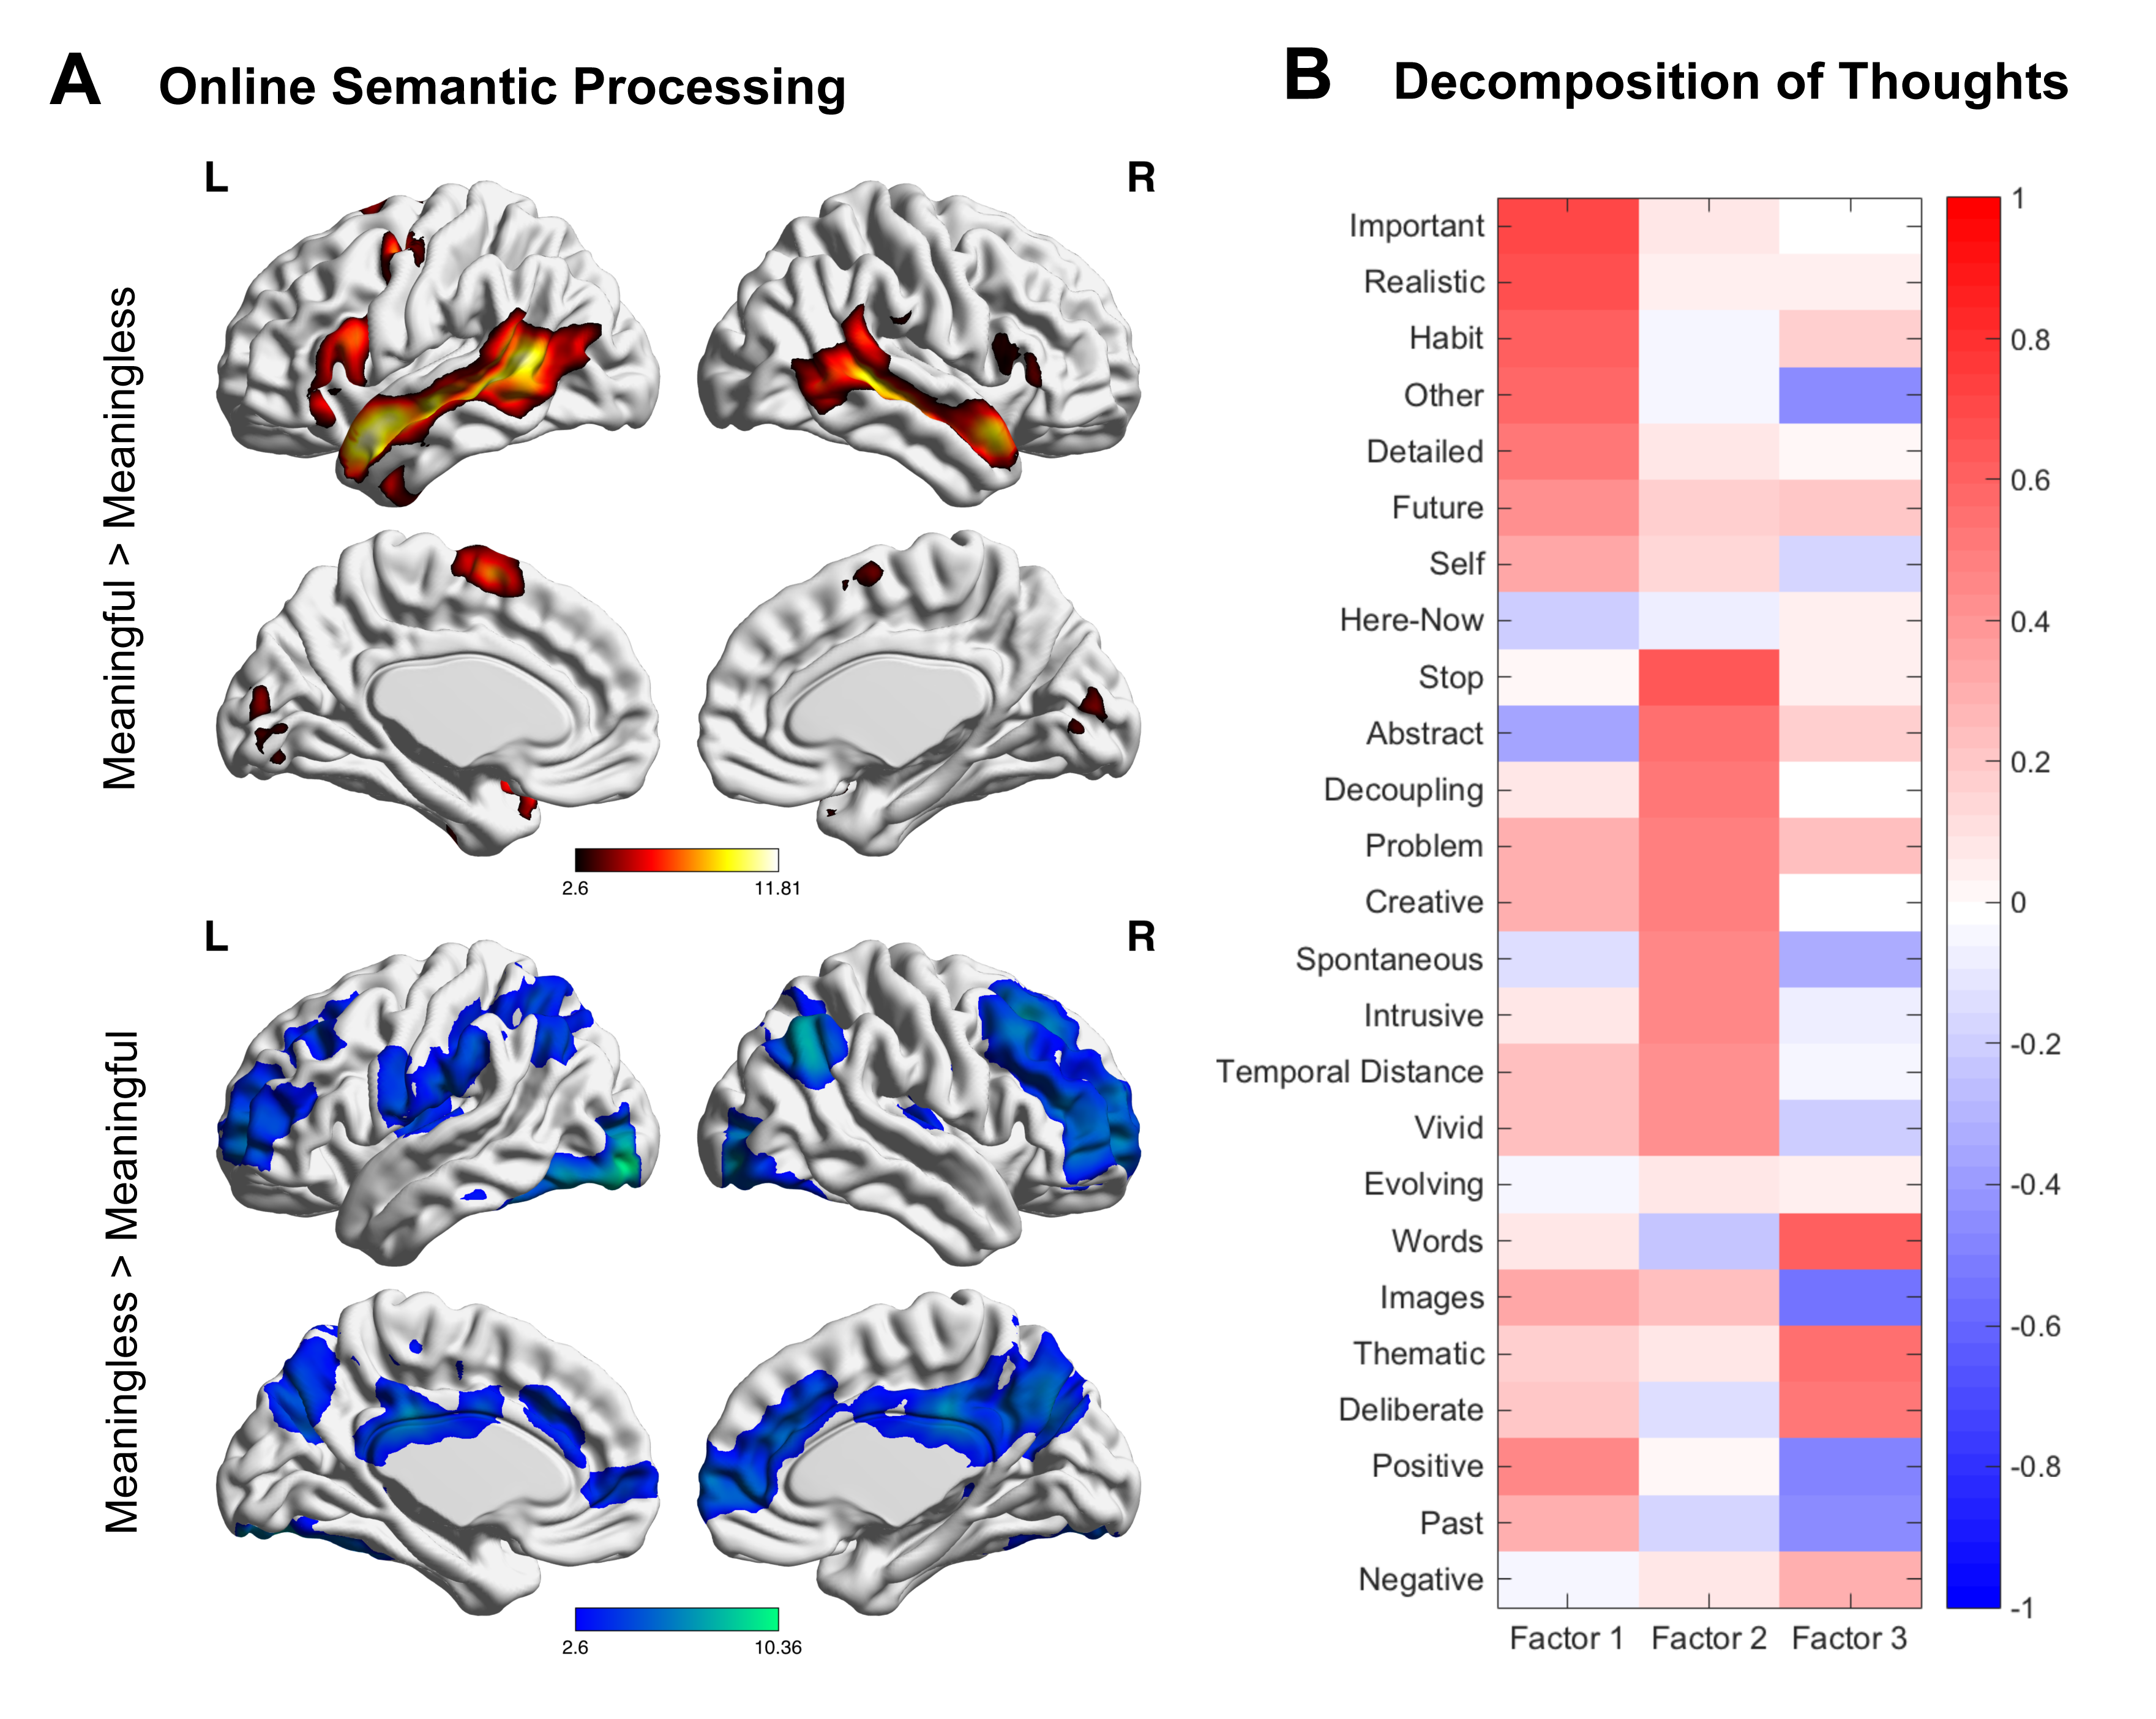

Figure 2 Description of neurocognitive components. A) The CCA components were first validated using neuroimaging data acquired during a semantic localiser task. In this paradigm, the participants were presented with sequences of words in sequences and non-words, interleaved with a baseline fixation condition. The group-level forward and reverse contrasts were cluster corrected at a threshold of Z > 2.6 (p < 0.05). B) The components were also validated using the subjective description of the participants’ thoughts acquired at the end of the resting state scan, using a set of questions that were previously used to assess the ongoing mental experiences of participants (Smallwood et al., 2016). The principle components covering three main categories of thought – broadly corresponding to realistic, important mental time travel, intrusive thought and verbal thematic thoughts are visualised in a heat map displaying Varimax-rotated component loadings.
Moreover, with the aim of capturing different features of the participants’ spontaneous mental experiences, we employed a 4-choice questionnaire at the end of the resting-state scanning session that required the participants to subjectively rate their thoughts from “Not at all” to “Completely” based on a series of mind-wandering questions previously used in the literature (Gorgolewski et al., 2014; Medea et al., 2016; Ruby et al., 2013a; Ruby et al., 2013b; Smallwood et al., 2016). The set of questions are provided in the supplementary material (Table S6). Subsequently, the ratings for each participant were reduced to three factors using principal component analysis (PCA) in SPSS (Version 23), which broadly corresponded to realistic and important mental time-travel, intrusive thought, and verbal thematic thought. The component loadings were rotated using the Varimax method and the resulting factors were visualised on a heat map (Fig. 2B). Using linear regressions at p = 0.05 level of significance, these mind-wandering components were related to the average brain and behaviour component loadings obtained from the CCA analysis.
3. Results
The main objective of this study was to identify neurocognitive components of brain and behaviour relationships that described individual differences in semantic cognition. For that purpose, we first fed in to CCA the standardized (unit variance scaled and mean-centred) functional connectivity values between semantic regions at rest and standardized performance values in a battery of semantic tasks. The identified components were then validated through linear regressions in separate datasets, originating from the participants’ performance of a semantic localiser fMRI task inside the scanner and their mind-wandering tendencies captured at the end of the resting state scan. Such a multi-variate, multi-dataset approach enabled us to objectively assess the relationship between individual differences in brain connectivity and behaviour, in line with the component process view of semantic cognition.

First, Table 1 outlines the mean performance of the participants across all the behavioural tasks used in the semantic battery. In order to ensure that the manipulations of semantic strength, semantic category and modality of presentation produced the expected results previously reported in the literature, we compared the mean efficiency score (reaction time weighted by accuracy) for the relatedness and identity-matching tasks with repeated measures paired t-tests. On average, participants were faster in responding to pictures than words (t(153) = 16.282, p < 0.001), to specific (e.g. Dalmatian) than general (e.g. animal) terms (t(153) = 3.072, p = 0.003), and to strong than weak associations (t(153) = 24.675, p < 0.001).

Using CCA, of the six neurocognitive components identified, four predicted either the neural activation recorded during the presentation of meaningful versus meaningless sentences in task-based fMRI, or the spontaneous thoughts reported at the end of the resting-state scan. Our findings broadly support the component process hypothesis, by showing that varieties of semantic cognition can be related to different strengths of coupling between brain regions at rest. However, the analysis does not permit us to determine the potential number of separable components. Thus, in this report we focus on the four components for which construct validity was demonstrated through a relationship with other measures relevant to semantic cognition. The canonical correlations and the squared canonical correlated for these four components were 0.25 (p = 0.002), 0.20 (p = 0.012), 0.08 (p = 0.322), 0.19 (p = 0.016) and 0.06, 0.04, 0.01, 0.04, respectively. The remaining two components are presented in the supplementary materials (Fig. S1).

Table 1 Descriptive statistics for the battery of semantic tasks. For the relatedness, figure matching and feature matching tasks, the efficiency score reflected the reaction time divided by the proportion of correct responses. For the picture naming task response accuracy was used as the performance measure, whereas for the verbal fluency tasks the correct responses per minute were recorded.
SEMANTIC TASK | Minimum | Maximum | Mean | Standard Deviation
Relatedness Task: Picture  (Efficiency) | 467.55 | 3267.08 | 1335.87 | 345.73
Relatedness Task: Word  (Efficiency) | 1140.00 | 2833.33 | 1775.21 | 339.50
Non-semantic Figure Matching Task  (Efficiency) | 1222.64 | 4345.00 | 1957.59 | 489.16
Semantic Feature Matching Task  (Efficiency) | 1490.53 | 25740.00 | 2992.52 | 2817.89
Word-picture matching: General  (Efficiency) | 797.29 | 2661.07 | 1235.32 | 241.136
Word-picture matching: Specific  (Efficiency) | 769.47 | 2222.99 | 1200.05 | 241.065
Relatedness Task: Strong  (Efficiency) | 947.80 | 3125.45 | 1406.50 | 259.32
Relatedness Task: Weak  (Efficiency) | 1477.09 | 6654.07 | 2419.06 | 675.71
Picture Naming Task  (Accuracy) | 0.00 | 1.00 | 0.84 | 0.184
Verbal Fluency Task: Letter  (Correct per minute) | 6.00 | 25.30 | 14.44 | 3.74
Verbal Fluency Task: Category-General (Correct per minute) | 10.00 | 30.00 | 18.94 | 3.70
Verbal Fluency Task: Category-Specific (Correct per minute) | 6.75 | 19.50 | 12.59 | 2.60

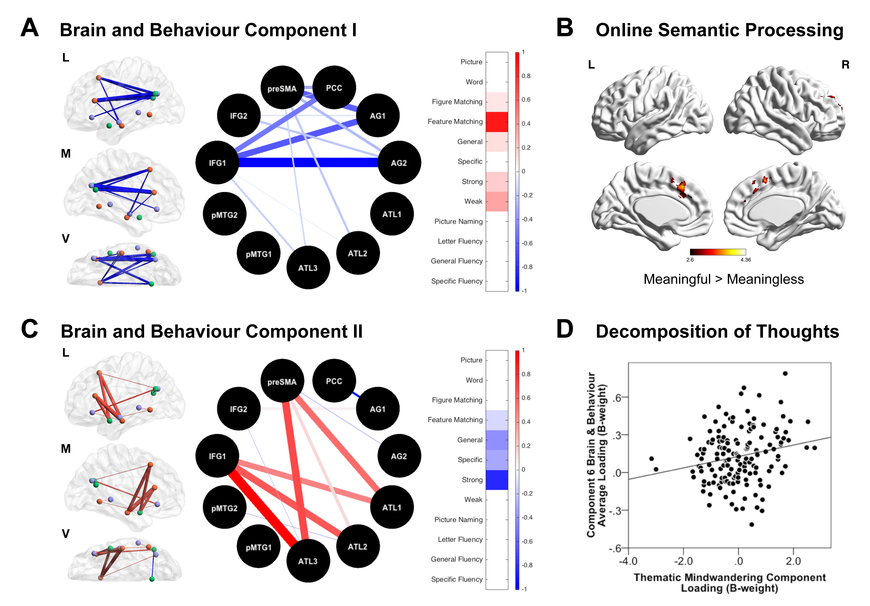

Figure 3 Neurocognitive components related to global performance in semantic cognition. The brain connectivity patterns based on the identified canonical components are displayed on an MNI152 glass brain in three different planes: lateral (L), medial (M) and ventral (V), as well as in a circular representation. In both displays, the thickness of the connections between the seed ROIs corresponds to the relative component weights of the functional connections as deviation away from the mean, whereas the colours represent directionality (red-positive, blue-negative). The associated behavioural performance is illustrated on a heatmap. The scale refers to the relative component weights of both the standardized brain functional connections and the standardized behavioural scores. The higher the value (more red), the greater the connectivity and the behavioural performance were. A) The first component was characterised by reduced connectivity between the default mode and executive control regions, and was associated with better performance on difficult comprehension tasks (feature matching and weak associations). B) Participants that displayed greater component loading on this pattern of brain and behaviour association at rest showed greater activity in the meaningful vs. meaningless contrast of the semantic localiser task, centred on the pre-supplementary motor area (one of the regions that showed decoupling from the default mode at rest). The reported regions were cluster-corrected at a threshold of Z > 2.6 (p < 0.05). C) Component II described a pattern of strong connectivity between executive control regions (pre-supplementary motor area, inferior frontal gyrus) and the anterior temporal lobe, related to poorer performance, primarily on easier semantic tasks (strong associations and identiry matching). D) Though this brain and behaviour pattern was not associated with activity in the semantic localiser tasks, it was linked to greater verbal, thematic, and deliberate thoughts reported at the end of the resting state scanning session (R = 0.213, p = 0.008).

The first two brain and behaviour patterns identified using CCA described general differences in semantic performance measured outside the scanner. Component I was characterized by patterns of reduced connectivity at rest for angular gyrus, posterior cingulate and anterior temporal lobe (i.e. default mode regions) with frontal areas that are linked to executive control (i.e. inferior frontal gyrus and pre-supplementary area) (Fig. 3A). Participants who strongly showed this pattern of reduced connectivity at rest showed better performance on a range of semantic tasks, particularly harder comprehension tasks thought to depend on semantic control (e.g. matching items based on specific features and ignoring global associations; identifying weak semantic associations). They also showed a stronger response in task-based fMRI for the meaningful > meaningless contrast within regions of the cingulate cortex and the pre-supplementary motor area (Fig. 3B). Thus, they showed separation at rest of one region (pre-supplementary motor area) that was recruited more strongly by semantic processing. There was no significant association between this CCA and any pattern of thoughts reported at rest.

Component II reflected a pattern of stronger coupling of the anterior temporal lobe with the left inferior frontal gyrus and the pre-supplementary motor area at rest (Fig. 3C). In terms of behaviour, this component was characterised by poor performance on tasks that are generally easy to perform, such as relatedness judgements for strongly associated words, and identity matching. This component did not vary with neural recruitment in task-based fMRI; however, regression of the average brain and behaviour component loadings against the thoughts reported at rest revealed an association with spontaneous cognition that was characterised as verbal, thematic and deliberate (R = 0.213, p = 0.008) (Fig. 3D). Overall, Components I and II reflected a common pattern: when regions implicated in cognitive control (inferior frontal gyrus and pre-supplementary motor area) were segregated from anterior temporal lobe and angular gyrus at rest, participants showed better performance on a range of tasks measuring semantic cognition.

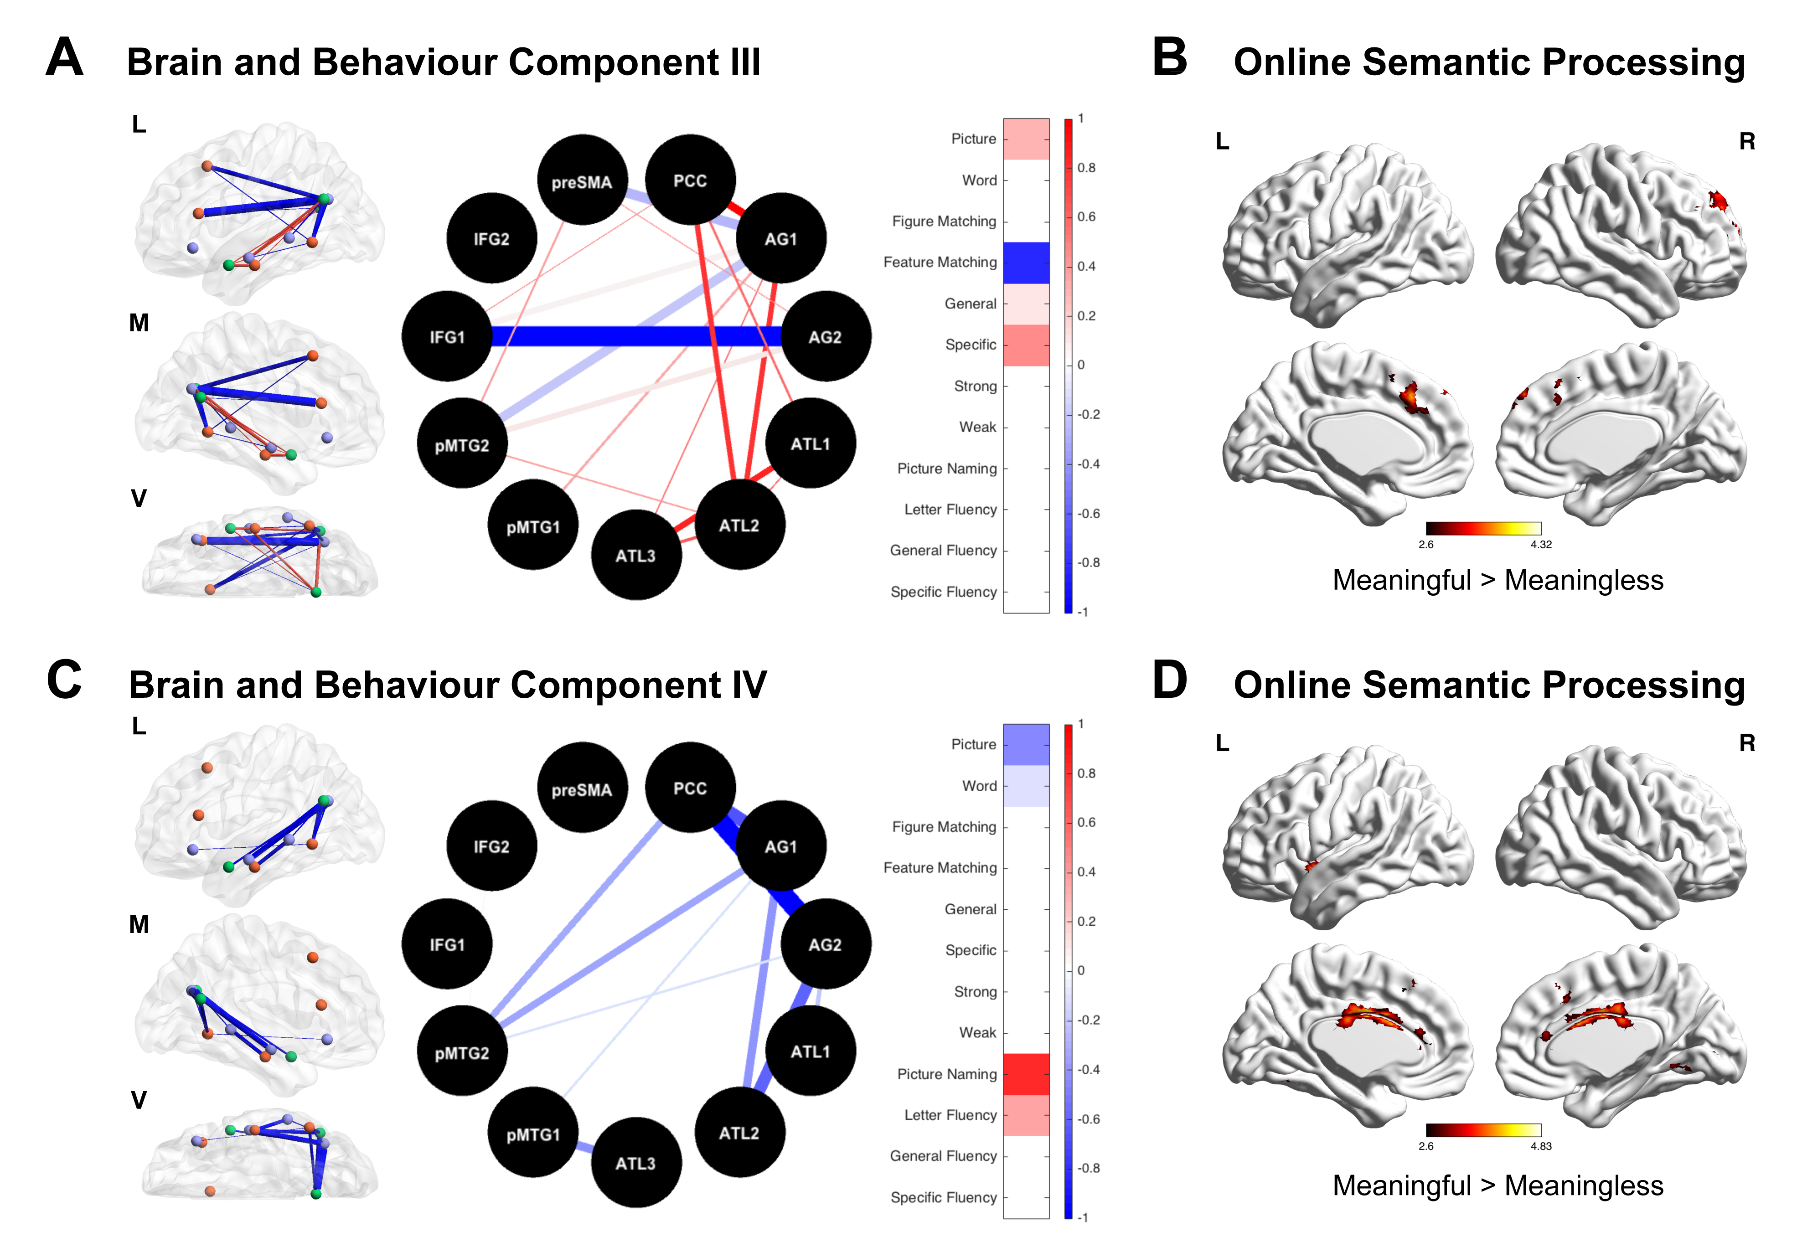
Figure 4 The neurocognitive components of semantic task engagement. A) Component III was characterised by reduced coupling between the angular gyrus and executive and semantic control regions, combined with stronger coupling between angular gyrus, posterior cingulate and anterior temporal lobe. This functional connectivity was associated with better performance on picture association and specific-level picture identity decisions, and poorer performance on a demanding verbal feature matching task. B) This neurocognitive pattern was linked to greater activity in the pre-supplementary motor area when participants viewed meaningful over meaningless sentences. C) Component IV on the other hand, reflected reduced connectivity between the DMN regions, which were associated with poor performance on the picture association, but good performance on the picture naming tasks. D) This pattern was linked to greater activity on the pre-supplementary motor area, bilateral medial occipital cortex and right insula.
In contrast, Components III and IV related to different qualities of semantic cognition, in other words, the relative strengths and weaknesses between semantic tasks. Component III reflected relatively good performance on picture association tasks (e.g. knowing that a picture of a dog goes with a picture of a bone) and identity-matching at the specific level (e.g. matching the picture of a dog with the word Dalmatian), plus poorer performance on the feature-matching task (i.e. a difficult verbal comprehension task). At rest, individuals who scored highly on this component showed separation between the angular gyrus and inferior frontal gyrus and pre-supplementary motor area, but at the same time, they showed stronger coupling between the angular gyrus, posterior cingulate and anterior temporal lobe (Fig. 4A). Unlike Component I, this segregation of inferior frontal gyrus and pre-supplementary motor area from angular gyrus did not extend to other regions in the DMN, namely anterior temporal lobe and posterior cingulate. There was, however, additional segregation of the angular gyrus from more posterior parts of posterior middle temporal gyrus, which is also implicated in semantic control. During the online presentation of semantic information in task-based fMRI, this component was associated with increased activation of a region in the pre-supplementary area (Fig. 4B). However, it was not associated with thoughts reported during the resting state scan.

Component IV described relatively good performance in two tasks involving overt speech production, picture naming and letter fluency, combined with relatively poor performance on semantic association tasks, particularly when these were presented using pictures. At rest, this component was linked to weaker coupling between nodes in the semantic system, chiefly reduced correlation between the angular gyrus and anterior temporal lobe, posterior cingulate cortex and posterior middle temporal gyrus (Fig. 4C). During the online presentation of semantic information in fMRI, this component was associated with greater activation of the pre-supplementary motor area, inferior mid-cingulate cortex, bilateral medial occipital cortex and right insula (Fig. 4D). It was not associated with the reports of thoughts at rest. Thus, in both Components III and IV, strong coupling between the anterior temporal lobe and angular gyrus at rest related to better picture comprehension, while separation of these regions was associated with better verbal semantic performance. In addition, Components III and IV shared a pattern of decoupling between angular gyrus and posterior middle temporal gyrus, and segregation of these regions at rest may be crucial for the capacity to engage successfully in externally-presented semantic tasks in the absence of strong separation between posterior cingulate cortex and frontal executive regions at rest.

Notably, our analysis highlighted a region of pre-supplementary motor area and dorsomedial prefrontal cortex, which showed greater activity during meaningful information in task-based fMRI for participants who had higher scores on three of the four components identified by CCA. To quantify this similarity, we conducted a post-hoc analysis using a formal conjunction of the activation patterns related to Components I, III and IV to reveal significant co-activation in pre-supplementary motor area (Fig. 5A). To understand the functional connectivity of this region, we seeded it in an independent data set available on Neurosynth, revealing a pattern of connectivity within lateral prefrontal and parietal regions, aspects of posterior temporal cortex and the anterior insula (Fig. 5B). This pattern shares many features with the multi-demand network that is implicated in performance on demanding tasks across cognitive domains (Fig 5C). This interpretation was supported by a meta-analytic decoding of the functional connectivity map using Neurosynth, which revealed that this pattern of connectivity was often associated with terms related to cognitive engagement such as “monitoring”, “difficulty” and “strategy” (Fig. 5D).
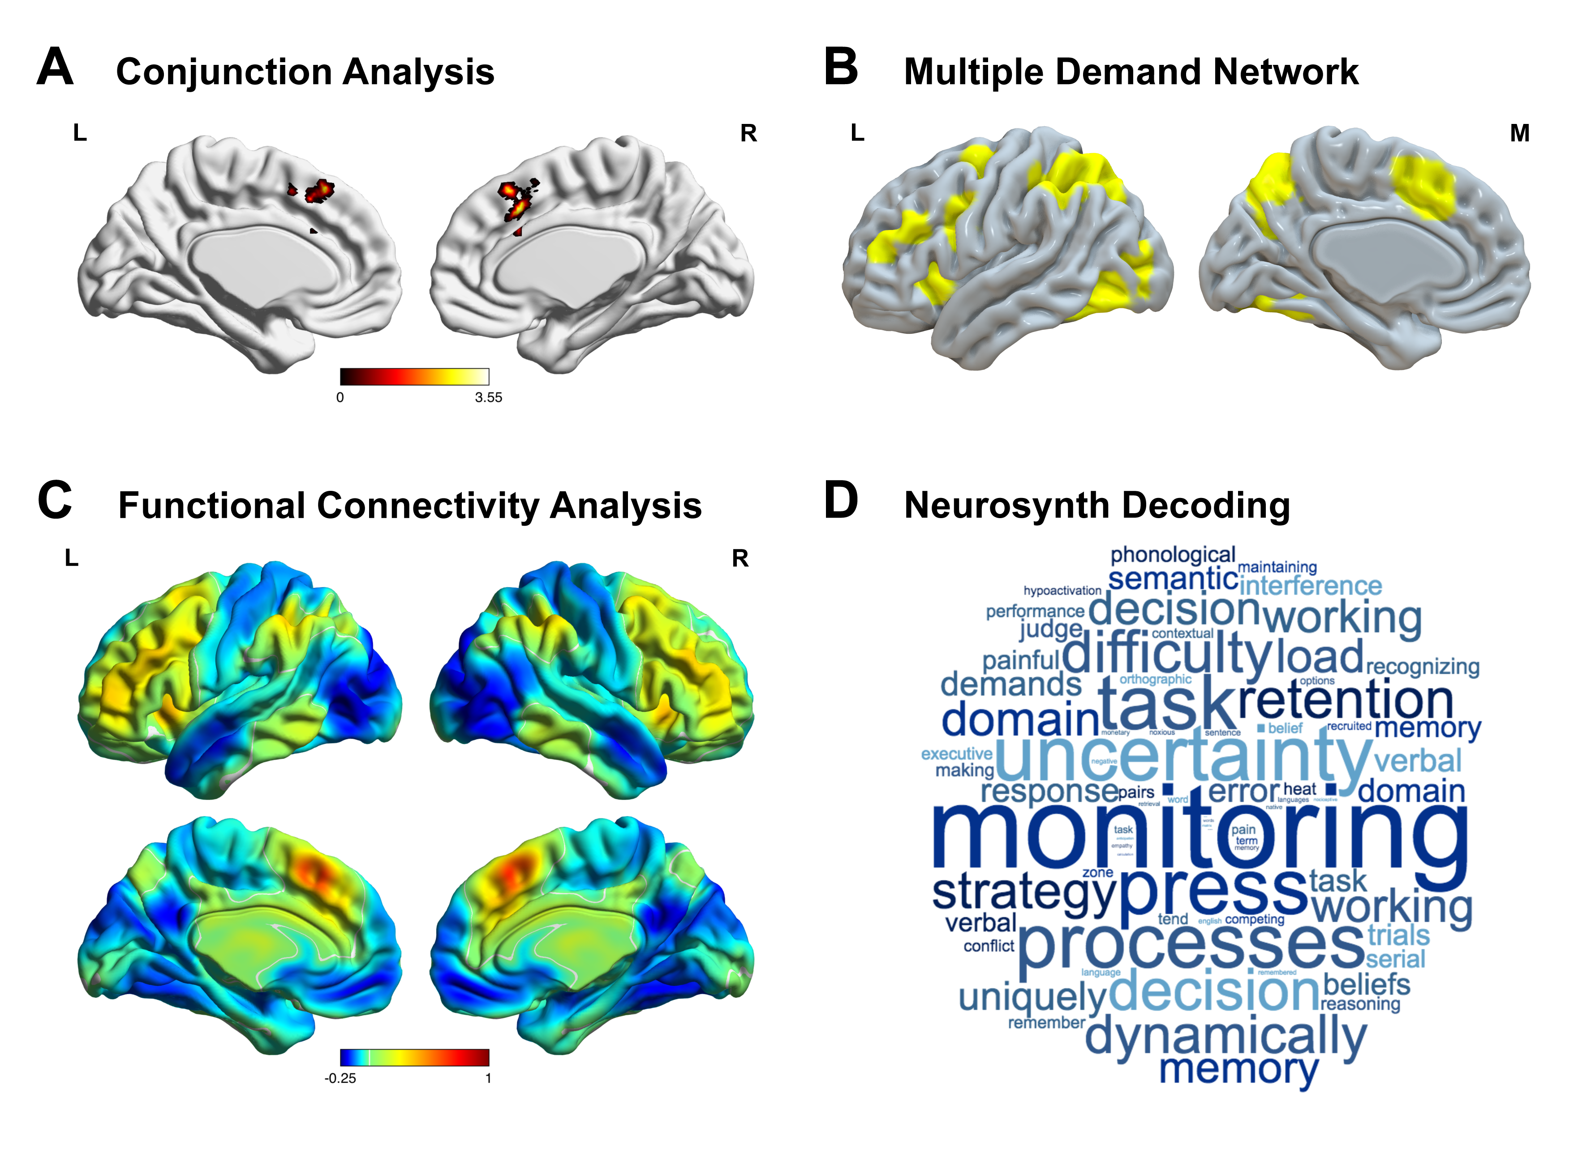

Figure 5 Convergence across the neurocognitive components of semantic cognition. A) Components I, III and IV all shared online activity in the semantic localiser task centered on the pre-supplementary motor area (conjunction analysis, Z > 2.6, p < 0.05). B-C) The functional connectivity of this region with the rest of the brain revealed a large-scale brain network commonly associated with regions of the multiple demand network. D) The decoding of this region with reverse inference using the Neurosynth database revealed a number of terms such as monitoring, strategy and decision that are often associated with demands across multiple cognitive domains.
4. Discussion

Our study set out to understand the relationship between emergent patterns of functional connectivity in nodes associated with semantic processing at rest and the application of semantic cognition during tasks, measured outside the scanner. We used a multivariate technique (CCA) to simultaneously decompose variability in brain and behaviour, applying an L₁-penality that improved the interpretability of the neurocognitive components. The identified patterns of brain connectivity at rest successfully predicted task-based activation during sentence comprehension, or related to the spontaneous mental experiences of the participants during the resting-state scan. These findings support the view that individual differences in semantic cognition can be understood in terms of the balance of diverse network interactions. The findings of our study are highly coherent with component process accounts of semantic cognition (Lambon Ralph et al., 2016), since variability in semantic performance could be related to an interplay of different cognitive processes supported by distributed brain regions (see also Xu et al. (2016)).

Better performance on relatively difficult semantic tasks was associated with greater segregation at rest between regions important for cognitive control and regions in the DMN. An association between better cognitive performance and enhanced segregation between usually anti-correlated functional networks has been observed in prior studies of both executive control (Hampson et al., 2010; Kelly et al., 2008) and language. For instance, Mollo et al. (2016) found that better letter fluency performance was associated with reduced coupling between dorsal inferior frontal gyrus and retrosplenial cortex in the DMN. Building on these previous findings, our study suggests that the broad tendency to segregate regions implicated in cognitive control from the anterior temporal lobe and default mode regions at rest may relate, in general terms, to good performance on a wide range of semantic tasks.

We also found patterns of functional coupling in the brain at rest that related to each participant's relative strengths and weaknesses across the tasks in our semantic battery. Specifically, Component III described a form of semantic cognition in which picture association judgements and picture-word identity matching for specific concepts were in opposition to verbal feature matching. This component was associated with stronger coupling between the angular gyrus and other regions in the DMN (anterior temporal lobe and posterior cingulate cortex), as well as weaker coupling between the angular gyrus and cognitive and semantic control regions (inferior frontal gyrus, pre-supplementary area, posterior middle temporal gyrus). Component IV described a pattern of semantic cognition in which picture naming and letter fluency was in opposition to picture association judgements. Better performance on speech production measures was associated with relative separation of posterior cingulate, angular gyrus and anterior and posterior temporal lobe regions. While Components I and II related to overall performance on semantic tasks, Components III and IV revealed qualitative differences in semantic cognition: both aspects of variability were related to the strength of coupling between brain regions across multiple networks, in line with the component process account of semantic cognition.

As well as providing evidence of the heterogeneity of semantic cognition, our study provides hypotheses about the underlying network architecture that may give rise to strengths and weaknesses on pictorial semantic tasks. Greater coupling between angular gyrus and posterior cingulate and anterior temporal cortex was associated with better relatedness judgements for pictorial stimuli in Components III and IV. This could reflect effective integration of amodal conceptual representations, thought to be formed within the anterior temporal lobe (Olson et al., 2007; Patterson et al., 2007; Zahn et al., 2007), into the core of the DMN (Andrews-Hanna et al., 2010; Bonnici et al., 2016; Yeo et al., 2011). Both posterior cingulate and angular gyrus have shown stronger responses to more imageable than concrete words in brain imaging studies (Binder et al., 2005; Sabsevitz et al., 2005; Wang et al., 2010), in contrast to other semantic and language areas such as posterior middle temporal gyrus and inferior frontal gyrus. Moreover, TMS work shows that the angular gyrus plays a critical role in specific object recognition (Davey et al., 2015) – a task that may require stronger integration of visual features (e.g., stripes) to distinguish between similar concepts (e.g., horse and zebra). The posterior cingulate cortex is thought to be critical for the re-representation and global integration of diverse aspects of experience, including meaning, episodic/working memory and vision (Bzdok et al., 2015; Margulies et al., 2016; Smallwood et al., 2016; Vatansever et al., 2015a). The angular gyrus has also been described as an interface between multisensory aspects of experience and memory (Bonnici et al., 2016; Bzdok et al., 2016a; Seghier, 2013; Vatansever et al., 2016a), and is implicated in vivid recollection. Thus, aspects of semantic cognition that involve the simulation of sensory experiences may involve more integration between semantic representations in the anterior temporal lobe and the DMN (Xu et al., 2016).

There are several limitations that should be borne in mind when considering these results. First, though our ROIs were selected from a large-scale meta-analysis, there may be other regions of cortex that contribute to semantic cognition. Specifically, brain regions in the right hemisphere were omitted in this analysis. Although semantic processing is known to be strongly left-lateralised, executive control regions on the right hemisphere have been previously shown to contribute to tasks with high semantic control demands (Noonan et al., 2013). Moreover, right hemispheric brain regions has been implicated in metaphor processing (Schmidt et al., 2007) and the retrieval of broad semantic connections (Jung-Beeman et al., 2004). However, such triaging procedure was necessary to improve the interpretability of our results and to solve the limitations associated with the CCA technique. Notably, exclusion of the right-hemisphere helped us overcome the limitations on the number of seeds that could be entered into CCA, depending on the available sample size. In addition, there may be important aspects of semantic processing that we did not capture in our battery of tasks. As a consequence, our data provide evidence for brain connectivity patterns that relate to quantitative and qualitative varieties of semantic cognition, but we cannot specify the exact number of the varieties of semantic cognition in full. Furthermore, our implementation of CCA imposed orthogonality between the latent components (Witten et al., 2009). In other words, the aspects of functional connectivity and behavioural patterns that would be shared between the factors of variation in the population are largely collapsed into the components by the present analysis that focuses mainly on finding components that do correlate with each other only to the least possible extent. Nevertheless, it should be noted that although the optimization goal of CCA is to have components as uncorrelated as possible, this procedure does not guarantee zero correlation. This is because regularised CCA does not force strict orthogonality in order to avoid overfitting (Melzer et al., 2003). In summary, though similar decomposition methods (such as PCA) has been successfully used as models in psychological research, the existing caveats analogously also apply here to our CCA components, which will require further investigation and optimisation.

Moreover, our study examined individual differences in patterns of brain connectivity solely at rest. However, it is possible that connectivity during task states will also relate to differences in semantic cognition between individuals – and these network interactions are likely to differ in substantial ways from those described here (Krieger-Redwood et al., 2016; Vatansever et al., 2015a, b). For instance, we observed more activation of pre-supplementary motor area during semantic processing in task-based fMRI both for participants who were generally good at semantic tasks (and who strongly separated default mode and executive areas at rest in general terms) and for participants who showed an uneven profile of relatively better or worse performance on different tasks (and who separated angular gyrus from a region linked to semantic control in posterior middle temporal gyrus). Thus, some degree of functional separation at rest between default mode and control regions may support the capacity to flexibly reorganise cognition to engage with a task (Vatansever et al., 2016b). The recruitment of pre-supplementary motor area could reflect general task engagement, consistent with the contribution of this region to the multiple-demand network (Duncan, 2010). This prediction needs to be explored in future studies by applying a similar decomposition approach to task-based fMRI data.

Our data also provides insight into the contribution of semantic processes to the generation of unconstrained thoughts at rest (Binder et al., 2009; Binder et al., 2003; Smallwood et al., 2016). A pattern of strong coupling of the anterior temporal lobe and angular gyrus with inferior frontal gyrus and pre-supplementary area predicted reports of verbal, thematic and deliberate thoughts at rest (Component II). This finding is consistent with the view that self-generated thoughts rely on the same component processes as external tasks and supports a role for control processes in the coordination of some aspects of spontaneous thought (Bzdok et al., 2016b; Smallwood, 2013; Smallwood and Schooler, 2015). Participants who showed too much coupling between nodes of the DMN and the executive system may have failed to engage with our external tasks, consistent with studies showing that mind-wandering is linked to poor task performance (Mooneyham and Schooler, 2013).

5. Conclusions

Overall, the results of this study provide compelling evidence for the component process account of semantic cognition. The results suggest that different patterns of connectivity between large-scale brain networks show relationships to both quantitative and qualitative variability in semantic cognition. Further studies exploring the basis of these neurocognitive components will not only illuminate the underlying neural mechanisms in this domain, but will also pave the way for improving our understanding of semantic impairments in disease states.

6. Acknowledgements

This study was supported by the European Research Council (Project ID: 646927). The authors thank Andre Gouws, Ross Devlin, Jane Hazell and the rest of the York Neuroimaging Centre staff for their support in setting up the imaging protocol and scanning. Finally, we thank all the participants for their time and effort in taking part in this study.

7. References

Andrews-Hanna, J.R., Reidler, J.S., Sepulcre, J., Poulin, R., Buckner, R.L., 2010. Functional-anatomic fractionation of the brain's default network. Neuron 65, 550-562.
Badre, D., Poldrack, R.A., Pare-Blagoev, E.J., Insler, R.Z., Wagner, A.D., 2005. Dissociable controlled retrieval and generalized selection mechanisms in ventrolateral prefrontal cortex. Neuron 47, 907-918.
Bastian, M., Heymann, S., Jacomy, M., 2009. Gephi: An Open Source Software for Exploring and Manipulating Networks.
Beckmann, C.F., DeLuca, M., Devlin, J.T., Smith, S.M., 2005. Investigations into resting-state connectivity using independent component analysis. Philosophical Transactions of the Royal Society of London. Series B: Biological Sciences 360, 1001-1013.
Behzadi, Y., Restom, K., Liau, J., Liu, T.T., 2007. A component based noise correction method (CompCor) for BOLD and perfusion based fMRI. Neuroimage 37, 90-101.
Bemis, D.K., Pylkkanen, L., 2013. Basic linguistic composition recruits the left anterior temporal lobe and left angular gyrus during both listening and reading. Cerebral Cortex 23, 1859-1873.
Bianchi, A.M., Marchetta, E., Tana, M.G., Tettamanti, M., Rizzo, G., 2013. Frequency-based approach to the study of semantic brain networks connectivity. Journal of Neuroscience Methods 212, 181-189.
Binder, J.R., Desai, R.H., Graves, W.W., Conant, L.L., 2009. Where is the semantic system? A critical review and meta-analysis of 120 functional neuroimaging studies. Cerebral Cortex 19, 2767-2796.
Binder, J.R., McKiernan, K.A., Parsons, M.E., Westbury, C.F., Possing, E.T., Kaufman, J.N., Buchanan, L., 2003. Neural correlates of lexical access during visual word recognition. Journal of Cognitive Neuroscience 15, 372-393.
Binder, J.R., Westbury, C.F., McKiernan, K.A., Possing, E.T., Medler, D.A., 2005. Distinct brain systems for processing concrete and abstract concepts. Journal of Cognitive Neuroscience 17, 905-917.
Binney, R.J., Embleton, K.V., Jefferies, E., Parker, G.J., Lambon Ralph, M.A., 2010. The ventral and inferolateral aspects of the anterior temporal lobe are crucial in semantic memory: evidence from a novel direct comparison of distortion-corrected fMRI, rTMS, and semantic dementia. Cerebral Cortex 20, 2728-2738.
Bonnici, H.M., Richter, F.R., Yazar, Y., Simons, J.S., 2016. Multimodal Feature Integration in the Angular Gyrus during Episodic and Semantic Retrieval. Journal of Neuroscience 36, 5462-5471.
Bozeat, S., Lambon Ralph, M.A., Patterson, K., Garrard, P., Hodges, J.R., 2000. Non-verbal semantic impairment in semantic dementia. Neuropsychologia 38, 1207-1215.
Bright, P., Moss, H., Tyler, L.K., 2004. Unitary vs multiple semantics: PET studies of word and picture processing. Brain and Language 89, 417-432.
Buccino, G., Colage, I., Gobbi, N., Bonaccorso, G., 2016. Grounding meaning in experience: A broad perspective on embodied language. Neuroscience and Biobehavioral Reviews 69, 69-78.
Bzdok, D., Hartwigsen, G., Reid, A., Laird, A.R., Fox, P.T., Eickhoff, S.B., 2016a. Left inferior parietal lobe engagement in social cognition and language. Neuroscience and Biobehavioral Reviews 68, 319-334.
Bzdok, D., Heeger, A., Langner, R., Laird, A.R., Fox, P.T., Palomero-Gallagher, N., Vogt, B.A., Zilles, K., Eickhoff, S.B., 2015. Subspecialization in the human posterior medial cortex. Neuroimage 106, 55-71.
Bzdok, D., Varoquaux, G., Grisel, O., Eickenberg, M., Poupon, C., Thirion, B., 2016b. Formal Models of the Network Co-occurrence Underlying Mental Operations. PLoS Computational Biology 12, e1004994.
Chai, X.J., Castanon, A.N., Ongur, D., Whitfield-Gabrieli, S., 2012. Anticorrelations in resting state networks without global signal regression. Neuroimage 59, 1420-1428.
Clarke, A., Taylor, K.I., Devereux, B., Randall, B., Tyler, L.K., 2013. From perception to conception: how meaningful objects are processed over time. Cerebral Cortex 23, 187-197.
Cole, M.W., Bassett, D.S., Power, J.D., Braver, T.S., Petersen, S.E., 2014. Intrinsic and task-evoked network architectures of the human brain. Neuron 83, 238-251.
Davey, J., Cornelissen, P.L., Thompson, H.E., Sonkusare, S., Hallam, G., Smallwood, J., Jefferies, E., 2015. Automatic and Controlled Semantic Retrieval: TMS Reveals Distinct Contributions of Posterior Middle Temporal Gyrus and Angular Gyrus. Journal of Neuroscience 35, 15230-15239.
Davey, J., Thompson, H.E., Hallam, G., Karapanagiotidis, T., Murphy, C., De Caso, I., Krieger-Redwood, K., Bernhardt, B.C., Smallwood, J., Jefferies, E., 2016. Exploring the role of the posterior middle temporal gyrus in semantic cognition: Integration of anterior temporal lobe with executive processes. Neuroimage 137, 165-177.
Duncan, J., 2010. The multiple-demand (MD) system of the primate brain: mental programs for intelligent behaviour. Trends in Cognitive Sciences 14, 172-179.
Fernandino, L., Binder, J.R., Desai, R.H., Pendl, S.L., Humphries, C.J., Gross, W.L., Conant, L.L., Seidenberg, M.S., 2016. Concept Representation Reflects Multimodal Abstraction: A Framework for Embodied Semantics. Cerebral Cortex 26, 2018-2034.
Gold, B.T., Buckner, R.L., 2002. Common prefrontal regions coactivate with dissociable posterior regions during controlled semantic and phonological tasks. Neuron 35, 803-812.
Gorgolewski, K.J., Lurie, D., Urchs, S., Kipping, J.A., Craddock, R.C., Milham, M.P., Margulies, D.S., Smallwood, J., 2014. A correspondence between individual differences in the brain's intrinsic functional architecture and the content and form of self-generated thoughts. PloS One 9, e97176.
Hallam, G.P., Whitney, C., Hymers, M., Gouws, A.D., Jefferies, E., 2016. Charting the effects of TMS with fMRI: Modulation of cortical recruitment within the distributed network supporting semantic control. Neuropsychologia 93, 40-52.
Hampson, M., Driesen, N., Roth, J.K., Gore, J.C., Constable, R.T., 2010. Functional connectivity between task-positive and task-negative brain areas and its relation to working memory performance. Magnetic Resonance Imaging 28, 1051-1057.
Hardoon, D.R., Szedmak, S.R., Shawe-taylor, J.R., 2004. Canonical Correlation Analysis: An Overview with Application to Learning Methods. Neural Computation 16, 2639-2664.
Hastie, T., Tibshirani, R., Wainwright, M., 2015. Statistical learning with sparsity : the lasso and generalizations. CRC Press, Taylor & Francis Group, LLC, Boca Raton, FL.
Hoffman, P., Binney, R.J., Lambon Ralph, M.A., 2015. Differing contributions of inferior prefrontal and anterior temporal cortex to concrete and abstract conceptual knowledge. Cortex 63, 250-266.
Humphreys, G.F., Hoffman, P., Visser, M., Binney, R.J., Lambon Ralph, M.A., 2015. Establishing task- and modality-dependent dissociations between the semantic and default mode networks. Proceedings of the National Academy of Sciences of the United States of America 112, 7857-7862.
Irimia, A., Chambers, M.C., Torgerson, C.M., Van Horn, J.D., 2012. Circular representation of human cortical networks for subject and population-level connectomic visualization. Neuroimage 60, 1340-1351.
Jackson, R.L., Hoffman, P., Pobric, G., Lambon Ralph, M.A., 2016. The Semantic Network at Work and Rest: Differential Connectivity of Anterior Temporal Lobe Subregions. Journal of Neuroscience 36, 1490-1501.
Jefferies, E., 2013. The neural basis of semantic cognition: converging evidence from neuropsychology, neuroimaging and TMS. Cortex 49, 611-625.
Jefferies, E., Lambon Ralph, M.A., 2006. Semantic impairment in stroke aphasia versus semantic dementia: a case-series comparison. Brain 129, 2132-2147.
Jefferies, E., Patterson, K., Lambon Ralph, M.A., 2008. Deficits of knowledge versus executive control in semantic cognition: insights from cued naming. Neuropsychologia 46, 649-658.
Jung, J., Lambon Ralph, M.A., 2016. Mapping the Dynamic Network Interactions Underpinning Cognition: A cTBS-fMRI Study of the Flexible Adaptive Neural System for Semantics. Cerebral Cortex 26, 3580-3590.
Jung-Beeman, M., Bowden, E.M., Haberman, J., Frymiare, J.L., Arambel-Liu, S., Greenblatt, R., Reber, P.J., Kounios, J., 2004. Neural activity when people solve verbal problems with insight. PLoS Biology 2, E97.
Kelly, A.M., Uddin, L.Q., Biswal, B.B., Castellanos, F.X., Milham, M.P., 2008. Competition between functional brain networks mediates behavioral variability. Neuroimage 39, 527-537.
Krieger-Redwood, K., Jefferies, E., Karapanagiotidis, T., Seymour, R., Nunes, A., Ang, J.W., Majernikova, V., Mollo, G., Smallwood, J., 2016. Down but not out in posterior cingulate cortex: Deactivation yet functional coupling with prefrontal cortex during demanding semantic cognition. Neuroimage 141, 366-377.
Krieger-Redwood, K., Teige, C., Davey, J., Hymers, M., Jefferies, E., 2015. Conceptual control across modalities: graded specialisation for pictures and words in inferior frontal and posterior temporal cortex. Neuropsychologia 76, 92-107.
Lambon Ralph, M.A., Jefferies, E., Patterson, K., Rogers, T.T., 2016. The neural and computational bases of semantic cognition. Nature Reviews: Neuroscience.
Margulies, D.S., Ghosh, S.S., Goulas, A., Falkiewicz, M., Huntenburg, J.M., Langs, G., Bezgin, G., Eickhoff, S.B., Castellanos, F.X., Petrides, M., Jefferies, E., Smallwood, J., 2016. Situating the default-mode network along a principal gradient of macroscale cortical organization. Proceedings of the National Academy of Sciences of the United States of America 113, 12574-12579.
Medea, B., Karapanagiotidis, T., Konishi, M., Ottaviani, C., Margulies, D., Bernasconi, A., Bernasconi, N., Bernhardt, B.C., Jefferies, E., Smallwood, J., 2016. How do we decide what to do? Resting-state connectivity patterns and components of self-generated thought linked to the development of more concrete personal goals. Experimental Brain Research.
Melzer, T., Reiter, M., Bischof, H., 2003. Appearance models based on kernel canonical correlation analysis. Pattern Recognition 36, 1961-1971.
Mollo, G., Karapanagiotidis, T., Bernhardt, B.C., Murphy, C.E., Smallwood, J., Jefferies, E., 2016. An individual differences analysis of the neurocognitive architecture of the semantic system at rest. Brain and Cognition 109, 112-123.
Mooneyham, B.W., Schooler, J.W., 2013. The costs and benefits of mind-wandering: a review. Canadian Journal of Experimental Psychology 67, 11-18.
Murphy, C., Rueschemeyer, S.A., Watson, D., Karapanagiotidis, T., Smallwood, J., Jefferies, E., 2017. Fractionating the anterior temporal lobe: MVPA reveals differential responses to input and conceptual modality. Neuroimage 147, 19-31.
Murphy, K., Birn, R.M., Handwerker, D.A., Jones, T.B., Bandettini, P.A., 2009. The impact of global signal regression on resting state correlations: are anti-correlated networks introduced? Neuroimage 44, 893-905.
Nichols, T., Brett, M., Andersson, J., Wager, T., Poline, J.B., 2005. Valid conjunction inference with the minimum statistic. Neuroimage 25, 653-660.
Noonan, K.A., Jefferies, E., Corbett, F., Lambon Ralph, M.A., 2010. Elucidating the nature of deregulated semantic cognition in semantic aphasia: evidence for the roles of prefrontal and temporo-parietal cortices. Journal of Cognitive Neuroscience 22, 1597-1613.
Noonan, K.A., Jefferies, E., Visser, M., Lambon Ralph, M.A., 2013. Going beyond inferior prefrontal involvement in semantic control: evidence for the additional contribution of dorsal angular gyrus and posterior middle temporal cortex. Journal of Cognitive Neuroscience 25, 1824-1850.
Olson, I.R., Plotzker, A., Ezzyat, Y., 2007. The Enigmatic temporal pole: a review of findings on social and emotional processing. Brain 130, 1718-1731.
Patterson, K., Nestor, P.J., Rogers, T.T., 2007. Where do you know what you know? The representation of semantic knowledge in the human brain. Nature Reviews: Neuroscience 8, 976-987.
Pobric, G., Jefferies, E., Lambon Ralph, M.A., 2007. Anterior temporal lobes mediate semantic representation: mimicking semantic dementia by using rTMS in normal participants. Proceedings of the National Academy of Sciences of the United States of America 104, 20137-20141.
Price, A.R., Peelle, J.E., Bonner, M.F., Grossman, M., Hamilton, R.H., 2016. Causal Evidence for a Mechanism of Semantic Integration in the Angular Gyrus as Revealed by High-Definition Transcranial Direct Current Stimulation. Journal of Neuroscience 36, 3829-3838.
Rodd, J.M., Davis, M.H., Johnsrude, I.S., 2005. The neural mechanisms of speech comprehension: fMRI studies of semantic ambiguity. Cerebral Cortex 15, 1261-1269.
Rogers, T.T., Graham, K.S., Patterson, K., 2015. Semantic impairment disrupts perception, memory, and naming of secondary but not primary colours. Neuropsychologia 70, 296-308.
Rogers, T.T., Hocking, J., Noppeney, U., Mechelli, A., Gorno-Tempini, M.L., Patterson, K., Price, C.J., 2006. Anterior temporal cortex and semantic memory: reconciling findings from neuropsychology and functional imaging. Cognitive, Affective & Behavioral Neuroscience 6, 201-213.
Ruby, F.J., Smallwood, J., Engen, H., Singer, T., 2013a. How self-generated thought shapes mood--the relation between mind-wandering and mood depends on the socio-temporal content of thoughts. PloS One 8, e77554.
Ruby, F.J., Smallwood, J., Sackur, J., Singer, T., 2013b. Is self-generated thought a means of social problem solving? Frontiers in Psychology 4, 962.
Sabsevitz, D.S., Medler, D.A., Seidenberg, M., Binder, J.R., 2005. Modulation of the semantic system by word imageability. Neuroimage 27, 188-200.
Schmidt, G.L., DeBuse, C.J., Seger, C.A., 2007. Right hemisphere metaphor processing? Characterizing the lateralization of semantic processes. Brain and Language 100, 127-141.
Seghier, M.L., 2013. The angular gyrus: multiple functions and multiple subdivisions. Neuroscientist 19, 43-61.
Smallwood, J., 2013. Distinguishing how from why the mind wanders: a process-occurrence framework for self-generated mental activity. Psychological Bulletin 139, 519-535.
Smallwood, J., Karapanagiotidis, T., Ruby, F., Medea, B., de Caso, I., Konishi, M., Wang, H.T., Hallam, G., Margulies, D.S., Jefferies, E., 2016. Representing Representation: Integration between the Temporal Lobe and the Posterior Cingulate Influences the Content and Form of Spontaneous Thought. PloS One 11, e0152272.
Smallwood, J., Schooler, J.W., 2015. The science of mind wandering: empirically navigating the stream of consciousness. Annual Review of Psychology 66, 487-518.
Smith, S.M., Nichols, T.E., Vidaurre, D., Winkler, A.M., Behrens, T.E., Glasser, M.F., Ugurbil, K., Barch, D.M., Van Essen, D.C., Miller, K.L., 2015. A positive-negative mode of population covariation links brain connectivity, demographics and behavior. Nature Neuroscience 18, 1565-1567.
Thompson-Schill, S.L., D'Esposito, M., Aguirre, G.K., Farah, M.J., 1997. Role of left inferior prefrontal cortex in retrieval of semantic knowledge: a reevaluation. Proceedings of the National Academy of Sciences of the United States of America 94, 14792-14797.
Tsvetanov, K.A., Henson, R.N., Tyler, L.K., Razi, A., Geerligs, L., Ham, T.E., Rowe, J.B., Cambridge Centre for, A., Neuroscience, 2016. Extrinsic and Intrinsic Brain Network Connectivity Maintains Cognition across the Lifespan Despite Accelerated Decay of Regional Brain Activation. Journal of Neuroscience 36, 3115-3126.
Vandenberghe, R., Price, C., Wise, R., Josephs, O., Frackowiak, R.S., 1996. Functional anatomy of a common semantic system for words and pictures. Nature 383, 254-256.
Vatansever, D., Manktelow, A.E., Sahakian, B.J., Menon, D.K., Stamatakis, E.A., 2016a. Angular default mode network connectivity across working memory load. Human Brain Mapping.
Vatansever, D., Manktelow, A.E., Sahakian, B.J., Menon, D.K., Stamatakis, E.A., 2016b. Cognitive Flexibility: A Default Network and Basal Ganglia Connectivity Perspective. Brain Connect 6, 201-207.
Vatansever, D., Menon, D.K., Manktelow, A.E., Sahakian, B.J., Stamatakis, E.A., 2015a. Default mode dynamics for global functional integration. The Journal of neuroscience : the official journal of the Society for Neuroscience 35, 15254-15262.
Vatansever, D., Menon, D.K., Manktelow, A.E., Sahakian, B.J., Stamatakis, E.A., 2015b. Default mode network connectivity during task execution. Neuroimage 122, 96-104.
Visser, M., Jefferies, E., Embleton, K.V., Lambon Ralph, M.A., 2012. Both the middle temporal gyrus and the ventral anterior temporal area are crucial for multimodal semantic processing: distortion-corrected fMRI evidence for a double gradient of information convergence in the temporal lobes. Journal of Cognitive Neuroscience 24, 1766-1778.
Wang, J., Conder, J.A., Blitzer, D.N., Shinkareva, S.V., 2010. Neural representation of abstract and concrete concepts: a meta-analysis of neuroimaging studies. Human Brain Mapping 31, 1459-1468.
Whitney, C., Kirk, M., O'Sullivan, J., Lambon Ralph, M.A., Jefferies, E., 2011. The neural organization of semantic control: TMS evidence for a distributed network in left inferior frontal and posterior middle temporal gyrus. Cerebral Cortex 21, 1066-1075.
Witten, D.M., Tibshirani, R., Hastie, T., 2009. A penalized matrix decomposition, with applications to sparse principal components and canonical correlation analysis. Biostatistics 10, 515-534.
Xia, M., Wang, J., He, Y., 2013. BrainNet Viewer: a network visualization tool for human brain connectomics. PloS One 8, e68910.
Xu, Y., Lin, Q., Han, Z., He, Y., Bi, Y., 2016. Intrinsic functional network architecture of human semantic processing: Modules and hubs. Neuroimage 132, 542-555.
Yeo, B.T., Krienen, F.M., Sepulcre, J., Sabuncu, M.R., Lashkari, D., Hollinshead, M., Roffman, J.L., Smoller, J.W., Zollei, L., Polimeni, J.R., Fischl, B., Liu, H., Buckner, R.L., 2011. The organization of the human cerebral cortex estimated by intrinsic functional connectivity. Journal of Neurophysiology 106, 1125-1165.
Zahn, R., Moll, J., Krueger, F., Huey, E.D., Garrido, G., Grafman, J., 2007. Social concepts are represented in the superior anterior temporal cortex. Proceedings of the National Academy of Sciences of the United States of America 104, 6430-6435.

