Modes of operation: A topographic neural gradient supporting stimulus dependent and independent cognition

Charlotte Murphy; Hao-Ting Wang; Delali Konu; Rebecca Lowndes; Daniel Margulies; Elizabeth Jefferies; Jonny Smallwood

Abstract

Human cognition is flexible - drawing on both sensory input, and representations from memory, to
successfully navigate complex environments. Contemporary accounts suggest this flexibility is
possible because neural function is organized into a hierarchy. Neural regions are organized along
a macroscale gradient, anchored at one end by unimodal systems involved with perception and
action, and at the other by transmodal systems, including the default mode network, supporting
cognition less directly tied to immediate stimulus input. The current study tested whether this
cortical hierarchy captures modes of behavior that depend on immediate input, as well as those
that depend on representations from memory. Participants made decisions regarding the location
or identity of shapes using information in the environment (0-back) or from a prior trial (1-back).
Using task based imaging we established that, regardless of the nature of the decision, medial and
lateral visual cortex were recruited when decisions rely on immediate input, while transmodal
regions were recruited when judgments depend on information from the prior trial. Using
principal components analysis, we demonstrated that shifting decision-making from perception to
memory altered the focus of neural activity from unimodal to transmodal regions (and vice versa).
Notably, the more pronounced these shifts in neural activity from unimodal to transmodal regions
when decisions relied on memory, the more efficiently individuals performed this task. These data
illustrate how the macroscale organization of neural function into a hierarchy allows cognition to
rely on input, or information from memory, in a flexible and efficient manner.

1. Introduction
To find your keys in the morning you must draw on information available in your environment,
as well as knowledge from memory (i.e. where you last left them the evening before). Human
cognition is therefore flexible - drawing on both immediate sensory input, and representations
from memory, to successfully navigate through the environment. Traditional neuroanatomy and
modern brain imaging techniques, such as resting-state functional MRI (rs-fMRI), have provided
convergent support for the emergence of brain network hierarchies that capture the propagation
of sensory inputs into transmodal regions of the cortex (Buckner & Krienen, 2013; Chomiak & Hu,
2017; He, 2014; Margulies et al., 2016; Mesulam, 1998; Power et al., 2011; Taylor, Hobbs, Burroni
& Siegelmann, 2015; vanden Heuvel et al., 2012). Specifically, these accounts suggest a hierarchy
of neural function from sensory and motor regions, with locally clustered connectivity patterns, to
a distributed array of brain regions with long-range connections that form a ‘rich club ‘of
transmodal integration regions. Recent work utilizing a dimensionality reduction technique on RS-
fMRI revealed a principal gradient of connectome organization along the cortical surface
(Margulies et al., 2016). This macroscale gradient is anchored at one end by unimodal sensory
cortices and at the other by transmodal association cortex, including the default mode network
(DMN), and coincides with the pattern of cortical hierarchy previously established in primate tract
tracing studies (Felleman & Van Essen, 1991; Hilgetag, O’Neill & Young, 2000; Markov et al., 2013).
Notably, the explanatory power of the functional hierarchy is highlighted in its potential to
explain how the organization of the brain gives rise to different modes of behavior. Regions of
visual and sensori-motor cortex have a well established role in controlling perception and action,
while regions of transmodal association cortex are known to play a role in more complex actions
what are guided by representations from memory (Andrews‐Hanna et al., 2014). For instance, we
have previously shown that retrieval of complex representations from memory loaded most
heavily on the transmodal end of the gradient compared to simple representations or
perceptually-guided decisions (Murphy et al., 2018). This increase in activity in regions of
transmodal association cortex (i.e. the DMN) was taken to reflect the additional role that memory
representations can play in guiding behavior.
The current study we used a paradigm in which participants made decisions regarding the identity or spatial location of simple shapes (triangles, circles or squares). We manipulated whether decisions
regarding the shapes can be made based on visual input at the moment of decision, or whether they
depended on information from the prior trial and so required additional information from memory.
Participant’s are asked to encode pairs of shapes and are periodically interrupted and asked to make
simple task-relevant decisions. One type of probe presents a target shape at the center of the screen and participants are asked to match this to stimuli presented either side of fixation (0-back). This type
of probe assess decision-making in a situation when all of the necessary information upon which
to perform the task is available to sensory systems. A second type of probe (1-back) involves
presentation of an item at fixation and participants are asked to make decisions regarding this
item with respect to the shapes on the prior trial. This probe assess an individuals ability to make
decisions using information that is no longer available to sensory system and so must use
information from memory. We refer to the latter as “memory-guided decision making”. Both
types of probes occur equally frequently, and both require that participants make a similar
behavioural response. Accordingly, comparison of neural process when participants make correct
responses to the different probes, will reveal processes differentiable in terms of whether they
can be made using perception or information from memory. Notably, this comparison requires different processes to those observed in a standard working memory paradigm since our probe explicitly probes information about the prior trial that cannot be determined by perceptual similarity between the encoded trial and the target (e.g. we present the targets at fixation, while the probed items on the prior trial were either on the left or the right hand sides of the screen so participants are not looking for a simple match). In our prior studies, we used an explicit block design in which we were able to dissociate patterns of neural activity that reflected the operations important for those needed to maintain representations of the information in canonical task positive regions. So-called task positive regions in the dorso-lateral pre-frontal cortex, and, the anterior insula, were more active throughout 1 back blocks, while making decisions using information from a prior trial recruited regions in the default mode network including the angular gyrus, the posterior cingulate and the medial pre-frontal cortex (Konishi et al., 2015). In a subsequent study we found that the activity within these transmodal regions, as well as the middle temporal gyrus, show heightened activity when the information upon which this retrieval must take place contains meaningful semantic associations (Murphy et al., 2018).
In this experiment we adapted our paradigm to allow us to further our understanding of the functional role of this topographical gradient of neural function in two ways. First, we aimed to directly test the hypothesis that activity in transmodal cortex contributes to the flexibility of behavior by facilitating the use of representations from memory to contribute directly to behaviour (Konishi et al., 2015, Crittenden et al., 2017, Vatansever et al., 2017). In our prior studies we observed activity in transmodal cortex while participants made decision using information from memory, however, certain views of neural activity in transmodal cortex suggest it may be involved in homeostatic functions that do not directly contribute to behavior (see Raichle 2015). In the current study we sought evidence that the topographic distribution of neural activity observed during memory guided decision making (i.e. greater activity in transmodal cortex and reductions in unimodal cortex) is behaviorally relevant. To test the functional significance of the observed shift in neural activity to transmodal cortex during memory guided decision making, we examined whether individuals who show this neural pattern the most perform these types of decisions the most effectively. Second, we sought to better understand the nature of the decision137 making process that transmodal cortex are important for. In our prior investigations of this question we have focused on paradigms that probe visuospatial elements of memory (i.e. Murphy et al., 2018). Since regions of transmodal cortex have a well established role in a range of different functions, including navigation (Spreng, Mar and Kim, 2009), it is possible that the role of transmodal systems in memory guided decision making is limited to situation when spatial aspects of memory are probed.
The current study aimed too this address both the generality and behavioral relevance of neural activity in transmodal cortex observed in our prior study (Murphy et al., 2018). We recorded neural activity while participants made two types of decision – (i) a location decision in which they matched the target shape to one based on it’s position (left / right) and (ii) a recognition decision in which they determined if the item was present (yes / no). These decisions were made either under conditions when the information necessary to make this decision was present (0 back) or when it was only represented in memory (1 back). We hoped to use this comparison to determine whether the patterns observed in our prior studies that used location judgments generalized to conditions in which non spatial features of memory were probed. Second, we aimed to test whether the role of transmodal cortex is important in the effectiveness with which a decision is made. We explored whether patterns of activity associated with decisions using information from memory, were associated with better performance on this task and if so whether this supported the notion that a stronger tendency to recruit regions of transmodal cortex was associated with better performance.
Similar to our prior work our current study found that decisions based on immediate input recruited regions at the unimodal end of the gradient, in visual cortex, while those depending on information from the prior trial recruited regions at the transmodal end of the gradient. This pattern was comparable across both location and recognition decisions. Critically, individuals for whom the shift in the focus of neural activity towards the transmodal end of the gradient was greater, made faster responses when behavior was guided by representations from memory. These data show that the topographical hierarchy provides a description that captures both behavioral modes that rely on immediate input as well as a general class of decisions that depend on prior representations from memory. Moreover, they suggest segregation between transmodal and unimodal regions is important when behavior is guided from internal representations (Margulies et al., 2016).

2. Material and methods
2.1. Participants

Thirty-one right-handed native British-speaking participants with normal or corrected-to normal vision were recruited from the University of York (18 female; mean age 21.39, range 19–28 years). Two participant's data was excluded due to scanner error leaving twenty-nine subjects in the final analysis (18 female; mean age 21.24, range 19–28 years). The study was approved by the York Neuroimaging Centre (YNIC) Ethics Committee. Participant's provided informed consent at the start of the experimental session.

2.2. Stimuli
The task paradigm had two conditions (0-back; 1-back) and two task manipulations (identity; location), yielding 4 experimental conditions: (A) 0-back location, (B) 0-back identity, (C) 1-back location and (D) 1-back identity. Our experiment used a mixed-block design. In all conditions, pairs of shapes (triangle, circle or square) were presented on a grey background separated by a central line. The contrast of 0-back and 1-back conditions allowed us to investigate the effect of stimulus-independent (1-back > 0-back) and stimulus dependent (0-back > 1-back) processing. In addition, the contrast between identity and location conditions allowed us to investigate regions that are important for different judgement types.
We made a methodological change to the nature of our paradigm. In our prior investigations, we explicitly blocked these decisions such that the participant was aware of the condition in which they performed the task. Using this block design, allowed us to demonstrate greater activity in regions such as the dorso lateral prefrontal cortex that were related to the greater maintenance of information in working memory in the 1 back paradigm. However, explicitly blocking this task could induce concerns about different strategies that participants perform during encoding that could induce changes in the underlying baseline level of neural activity. To minimize this concern, the current study used a design in which participants alternated between short blocks of each type of decisions in an unpredictable manner. During this study we
did not present information regarding which block they were in. We hoped that this would reduce
baseline differences observed between the encoding conditions observed in our prior work (e.g.
Konishi et al., 2015).

2.2. Procedure

In the scanner, participants completed a total of four functional runs (average run time 9 min 16 s). Within each run, there were two blocks related to each of the two conditions (1-back; 0-back). Blocks consisted of observing pairs of items (1000 ms); each pair was separated by a jittered inter-stimulus interval (ISI; 2000–4000 ms) in which a fixation cross was presented. At random periods of time (ranging between 3 and 5 trials) a probe-trial occurred (highlighted by the dashed box in Fig. 1) where a third item was presented in the centre of the screen with the addition of a coloured line. A red line requires participants to indicate the identity of the item (for example whether or not a circle is present; yes or no). A blue line requires participants to indicate the location of the same stimulus (for example the position of a triangle; left or right). In the 0-back probe-trials participants had to make a decision regarding the third item with the respect to the stimulus immediately present. In the 1-back probe-trials participants had to make a decision
regarding the third item with respect to the stimuli in the previous trial. Transitions between blocks were denoted by a ‘SWITCH’ prompt. This paradigm ensured that participants would not be able to predict whether they were making an identity or location judgement until the moment of decision. The rule associated with the colour line was counterbalanced across participants. Each block consisted of 9 identity and 9 location trials and lasted on average 275 s.

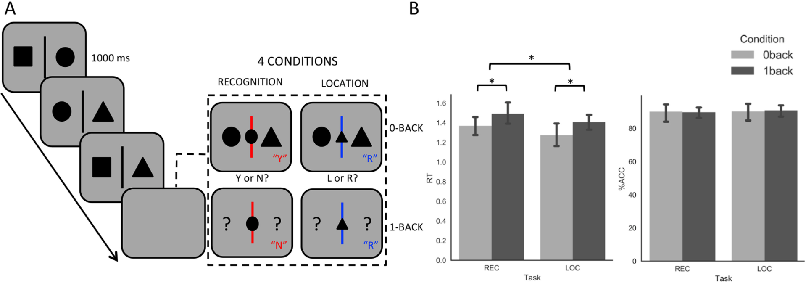
Figure 1. Experimental design and behavioural results for the fMRI experiment. (A) Experimental
design. The four different judgments that participants made in this experiment. Four conditions:
(A) 0-back Recognition, (B) 0-back Location, (C) 1-back Recognition and (D) 1-back Location. 0-back
and 1-back trials was presented in a block design. Each block consisted of observing pairs of items
(1000 ms), each pair was separated by a jittered inter-stimulus interval (ISI; 2000-4000 ms. At
random periods of time (between 3 and 5 pair trials) participants would observe a catch-trial
(highlighted by dashed box) where a third item was presented in the centre of the screen with the
addition of a coloured line. A red line requires participants to indicate whether they recognise the
item (for example whether or not a circle is present; yes or no). A blue line requires participants to
indicate the location of the same stimulus (for example the position of a triangle; left or right). In
the 0-back catch-trials participants had to make a decision regarding the third item with respect to
the stimulus immediately present. In the 1-back catch-trials participants had to make a decision
regarding the third item with respect to the stimuli in the previous trial. Transitions between
blocks were denoted by a ‘SWTICH’ prompt. (B) Behavioural responses in the form of reaction
time (RT) in seconds and percentage of correct responses (%ACC). No significant differences
between the percentage of correct responses across task (location/recognition) or condition (0-
back/1-back), however there was a significant difference in RT between condition (0-back versus
1-back; F(1,29)=6.07, p = .02) and task (recognition versus location; F(1,29)=5.69, p=.02). No significant interaction. * Denotes p < .05 and the error bars represent 95% confidence intervals.

2.3. fMRI acquisition

Data for the fMRI experiment was acquired using a GE 3 T HD Excite MRI scanner at the
York Neuroimaging Centre. A Magnex eight-channel phased array head coil was used in conjunction with a birdcage, radio-frequency insert coil tuned to 127.4 MHz. A gradient-echo EPI sequence was used to collect data from 38 bottom-up axial slices aligned with the temporal lobe (TR = 2s, TE = 18 ms, FOV = 192 × 192 mm, matrix size = 64 × 64, slice thickness = 3 mm, slice gap = 1 mm, flip-angle = 90°). Voxel size was 3 × 3 × 3mm. Functional images were co-registered onto a T1-weighted anatomical image from each participant (TR = 7.8s, TE = 3 ms, FOV = 290 × 290 mm, matrix size = 256 × 256 mm, voxel size = 1.13 × 1.13 × 1mm) using linear registration.

2.4. Pre-processing

All imaging data were pre-processed using a standard pipeline and analysed via FMRIB Software Library (FSL Version 6.0). Images were skull-stripped using a brain extraction tool (BET (Smith, 2002)). The first five volumes (10s) of each scan were removed to minimize the effects of magnetic saturation, and slice-timing correction with Fourier space time-series phase-shifting was applied. Motion correction (MCFLIRT (Jenkinson et al., 2002),) was followed by temporal high-pass filtering (cut-off = 0.01 Hz). Individual participant data was registered to their high-resolution T1-anatomical image, and then into a standard spare (Montreal Neurological Institute); this process included tri-linear interpolation of voxel sizes to 2 × 2 × 2 mm. For univariate analyses, data were additionally smoothed (Gaussian full width half maximum 6 mm).

2.5. Task based fMRI

For our task-based analysis, the time points of interest were the probe-trials where participants had to make a decision (identity or location) about shapes that were either present (0-back) or absent (1-back) from the screen. We therefore used a box-car regressor to model the probe-trials for each condition and another one to model the entire block. Modelling the entire block ensured any effect detected from our analysis can be attributed to the probe itself and not the general effect of the block. Box-car regressors for each probe/block, for each condition, for each run, were convolved with a double gamma hemodynamic response function. Regressors of no interest were included to account for head motion. We computed four contrasts: (1) 0-back > 1-back, (2) 1-back > 0-back, (3) identity > location and (4) location > identity. A fixed effect design (FLAME, http://www.fmrib.ox.ac.uk/fsl) was conducted to average the four runs, within each individual. Individual participant data were then entered into a higher-level group analysis using a mixed effects design (FLAME, http://www.fmrib.ox.ac.uk/fsl) whole-brain analysis. All statistical maps produced in these analyses are freely available at NeuroVault at the following URL: http://neurovault.org/collections/2296/.

3. Results
3.1. Behavioural Results

Figure 1 presents behavioural performance, in the form of reaction time (RT) and percentage accuracy (%ACC), for each of the four conditions of our experiment. These data were compared using a 2 (condition; 0-back vs. 1-back) by 2 (task; identity vs. location) repeated measures analysis of variance (ANOVA). There were no significant differences between the percentage of correct responses across task or condition, however there was a significant difference in RT between condition (0-back versus 1-back; F(1,29)=6.07, p = .02) and task (identity versus location; F(1,29)=5.69, p=.02). O-back judgements were faster than 1-back judgements, while recognition judgements took longer than location judgements. There was no significant interaction (F(1,29)=.025, p = .88). These analyses demonstrate that while our conditions were matched for accuracy, performance on the 1-back task was slower than for the 0-back task, and that location judgements were faster than identity judgements.

3.1. Univariate fMRI Results
We next generated statistical maps describing patterns of neural activity at the moments when participants responded in each of our four experimental conditions. These maps were compared at the group level using a General Linear Model (GLM, see Methods). The contrast of 0-back > 1-back decisions captures periods of decision-making that can be made based on immediate input, revealing increased activity in the bilateral ventral visual stream, from occipital pole through to posterior fusiform cortex (these are presented in the cool colours in the top panel of Fig. 2). These regions have a well-documented role in online visual processing. The contrast of 1-back > 0-back reflects stimulus independence in decision-making and this comparison revealed greater activation in left inferior frontal gyrus and frontal pole, angular gyrus and lateral middle temporal gyrus, as well as medial structures in bilateral precuneus and posterior cingulate cortex and left middle temporal gyrus (these are presented in warm colours in the bottom panel of Fig.2). To identify which neural networks these regions fall within we contrasted the 1 > 0-back map with Yeo et al (2011) 7-parcellation brain maps. This revealed that 64.90% of voxels in the 1 > 0-back contrast fell within the DMN and 25.56% fell within the frontoparietal network (FPN). Thus the mode of memory guided decision making captures elements of both of the core transmodal networks.

One possible difference between our 0-back and 1-back conditions reflects their ‘baseline’ states. For 0-back, there is nothing to be done until the probe, while for 1-back every display must be stored in case the next trials is a probe. Our model included a block regressor to remove any differences between 0-back and 1-back baselines (see methods). However, to quantify whether the estimates of response to probes in the previous contrasts (0-back > 1-back; 1-back > 0-back) reflects deviation from the baseline established by the surrounding no-response trials, we compared the neural activity to the no-response trials that immediately preceded the probe trial (T-1). The comparison of 0-back > 1-back and 1-back > 0-back T-1 trials yielded no significant whole-brain corrected results (See Table S1 for the mean values). Taken together, our results indicate the difference between 0-back and 1-back probe trials reflects task differences between perceptually-guided and memory-guided retrieval as opposed to deviations in baselines. Finally, the contrast of identity > location and location > identity yielded no significant whole-brain corrected results. All results are summarised in Table 1.

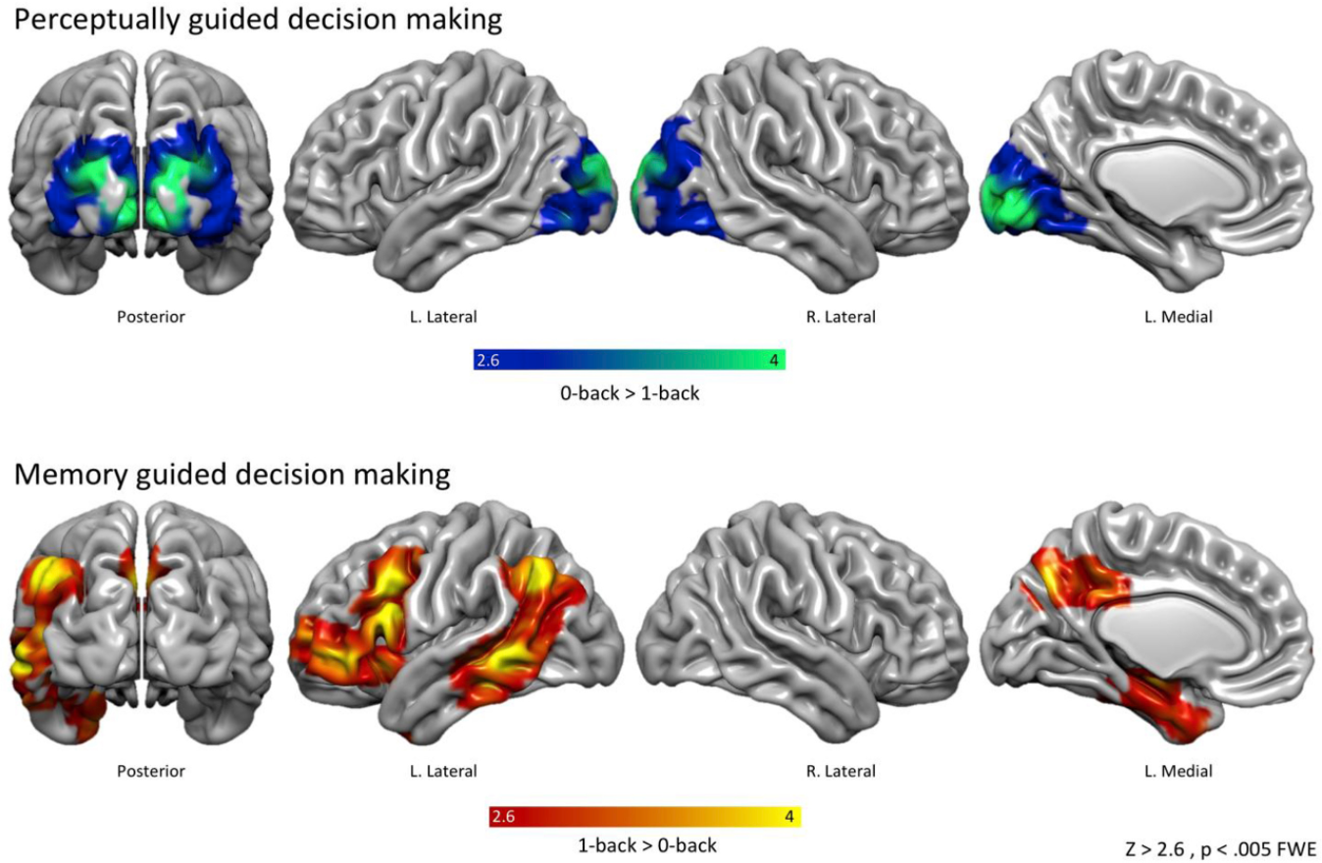

Figure 2. Whole-brain univariate results. Top panel: the contrast of 0-back > 1-back catch trials (the moments when a decisions is made) revealed activity centered on bilateral occipital pole extending throughout visual cortex. Bottom panel: the contrast of 1-back > 0-back revealed an extensive system of brain areas encompassing regions commonly associated with the default mode network (angular gyrus, lateral middle temporal gyrus, anterior temporal lobe and precuneous/posterior cingulate cortex). There were no significant results in the location < recognition or recognition > location contrasts. Spatial maps were cluster corrected at Z = 2.6, p <.005 FWE.

As our identity versus location contrasts did not reveal neural activity that survived cluster correction at the whole-brain level, we conducted a supplementary analysis to confirm that these regions were consistent across the identity and location conditions. We extracted parameter estimates from each significant cluster within 0-back > 1-back map and 1-back > 0-back map for all conditions (see Table 1 for peak clusters). This yielded six left hemisphere clusters; one cluster taken from 0-back > 1-back (centred on occipital pole), and five clusters taken from 1-back > 0-back (centred on anterior parahippocampal, frontal pole, inferior frontal gyrus, precuneus and lateral middle temporal gyrus respectively). A 2 (Condition; 0-back, 1-back) x 2 (Task; identity;location) x 6 (ROI) repeated-measures ANOVA revealed a Condition x ROI interaction (F(5,145)=52.42, p < .001) but not a Task x ROI interaction (F(15,45)=0.89, p = .49). This more liberal analysis highlighted that the peak clusters embedded within the whole-brain maps do not
significantly differ for identity or location judgements and instead describe patterns that reflect
neural processes that are important when task relevant actions depend primarily on input or
memory.

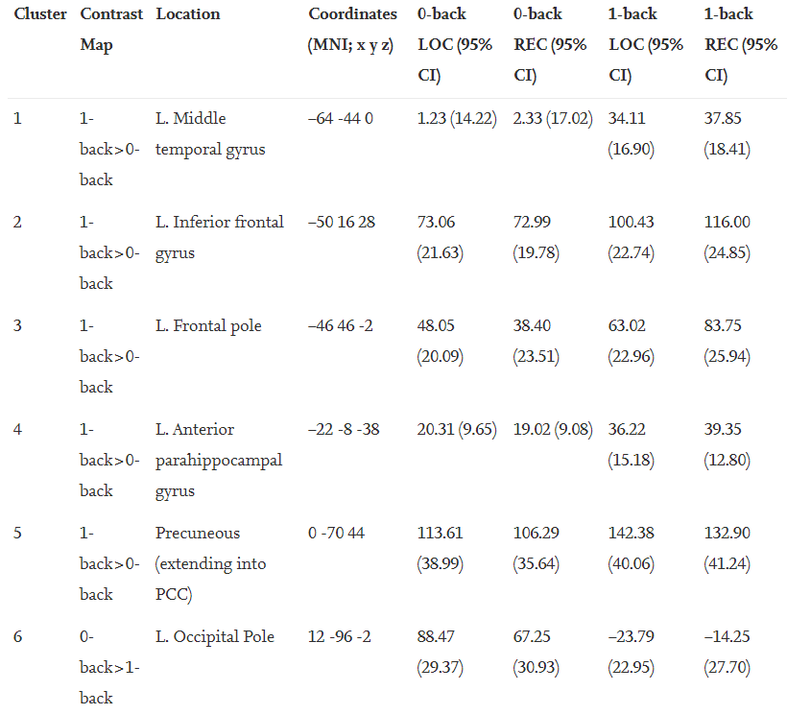
Footnote: Parameter estimates were extracted from 6mm regions of interest (ROIs) centered onpeak clusters for the contrasts 1-back > 0-back and 0-back > 1-back and (see Table 1). This yielded six regions of interest in the left hemisphere: (1) Left middle temporal gyrus, (2) Left inferior frontal gyrus, (3) left frontal pole, (4) left anterior parahippocampal gyrus, (5) bilateral precuneous extending into posterior cingulate cortex and (6) left occipital pole. A 2 (Condition; 0-back, 1-back) x 2 (Task; Recognition; Location) x 6 (ROI) repeated-measures ANOVA revealed a Condition x ROI interaction (F(5,145)=52.42, p < .001) but not a Task x ROI interaction (5,145)=0.89, p = .49. These findings highlight that the peak clusters embedded within the whole-brain maps do not significantly differ for recognition or location judgments. 95% confidence intervals represented in parentheses. The light grey box highlights the 0-back conditions, and the dark grey box highlighted the 1-back conditions.

Although our analysis were cluster corrected using a z-statistic threshold of 2.6 to define contiguous clusters, using FSL FLAME1, and the regions were significant while controlling for multiple comparisons using Gaussian Random Field Theory at a threshold of p < .005, there are concerns that lower cluster forming thresholds may be a source of type II error (Eklund et al., 2016). Although our analysis used FLAME, a method that was least likely to yield false positive results we nonetheless ensured that the observed data in our study are not a Type II error by comparing the pattern revealed in our prior study (see Figure 3). A formal conjunction revealed overlapping patterns of activity within the left angular gyrus, left frontal pole, left middle temporal gyrus and the posterior cingulate cortex. This pattern of activity across two independent data sets provides firm evidence that these patterns of activation are unlikely to be a Type II error.

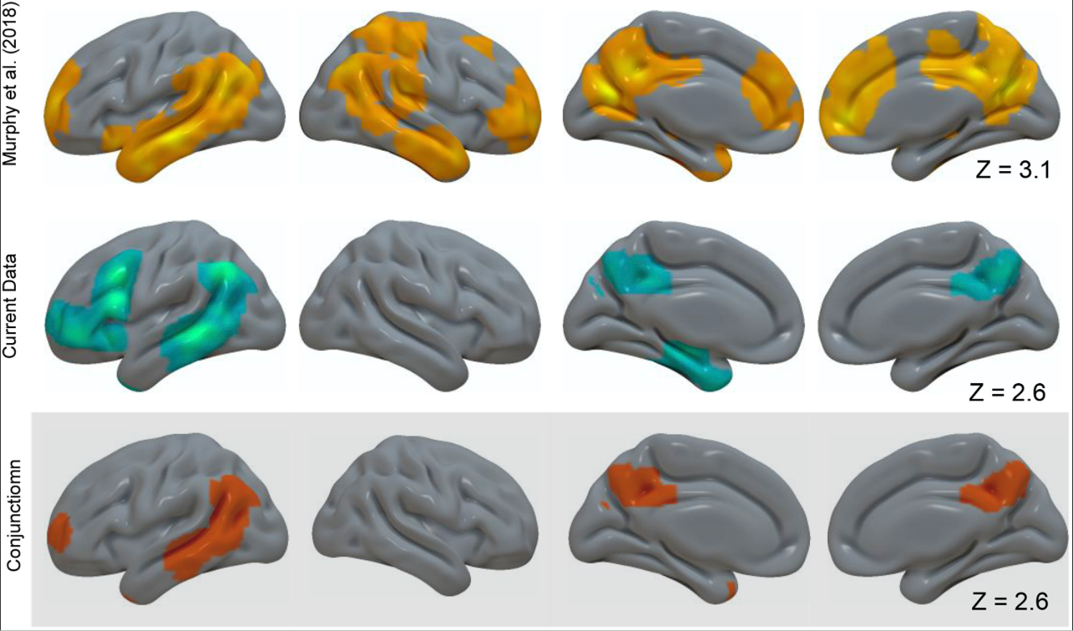
Figure 3. Conjunction results. Top panel: the contrast of 1-back > 0-back catch trials from Murphy et al., (2018) thresholded at z = 3.1. Middle panel: the contrast of of 1-back > 0-back catch trials from the current experiment thresholded at z = 2.6. ). A formal conjunction (using FSL easythreshconj) revealed overlapping patterns of activity within the left angular gyrus, left frontal pole, left middle temporal gyrus and the posterior cingulate cortex. This pattern of activity across two independent data sets provides firm evidence that these patterns of activation are unlikely to be a Type II error.

Next we investigated the distribution of neural activity as it is distributed along the principle gradient from Margulies et al., (2016). We examined whether observed patterns of neural activity reflect a shift in cortical activity at the whole-brain level, as would be expected based on the gradient view of cortical hierarchy (in line with previous literature such as Murphy et al., 2018). This analysis tests whether the principal gradient can account for the different behavioural modes captured by our experimental conditions: we might expect a gradually-increasing response in regions with higher gradient values across the whole cortical surface for tasks relevant to the principal gradient, even though these regions of cortex are highly distributed. The gradient bins were calculated in the same manner as outlined in Margulies et al., (2016). The original gradient map labelled each voxel in the brain between 0 and 100 relating to where it fell on the gradient (0 = unimodal end; 100 = DMN end). This map was then divided into five percentile bins (all voxels with the value 0–5 were assigned to bin1; 6–10 = bin 2 etc) yielding 20 bins in total. Next for each participant we calculated the average signal in each bin for each condition of our task. To quantify these patterns, we compared their distribution using a 2 (stimulus independence: 0-back, 1-back) X 2 (stimulus complexity; identity, location) X 20 (Gradient Bin) Analysis Of Variance (ANOVA). Mauchly’s Test of Sphericity indicated that the assumption of sphericity had been violated, χ2(189)=311.78, p < .001, therefore the GreenHouse Geisser correction was applied. This revealed a significant 2-way interaction between stimulus independence and gradient bin (F (3.38,98.14) = 21.76, p < .001) but no significant two-way interaction between judgement and gradient bin (F(3.68,106.57) = 2.03, p = .10). The three-way interaction was also non significant (F(3.58,308.16)=2.07, p = .097).
The results of the stimulus independence X region interaction are presented visually in Figure 4. The lower grey panel presents the principal gradient as adapted from Margulies et al., 2016, while the upper panel presents the data from our study, plotted across the principle gradient separately for each condition (0-back; 1-back); the shaded bars represent the 95% confidence intervals. It can be seen that the unimodal end of the gradient has the highest values when participants made judgments about items present in the environment (0-back) whereas the more transmodal end has highest values when participants have to retrieve information from memory (1-back). To further understand this pattern, we subtracted the neural activity within each bin for the 0-back conditions from the 1-back conditions and plotted these data in the form of a ribbon plot (see Fig. 4B). In this plot a higher score indicates greater activity in the 1-back condition, while a lower number indicates greater activity in the 0-back condition. The error bars describe two tailed 99.50% C.I. (and so correspond to estimates of the mean of each condition that account for the number of regions included in our analysis). In this figure, therefore, bins in which the confidence intervals do not overlap with 0 indicates regions that show significant differences following the application of the Bonferroni correction. It can be seen that neural activity was higher in bins 1-3 for the 0 back condition, and for bins 15-17 in the 1-back condition (indicated by asterisks in the Fig. 4B).

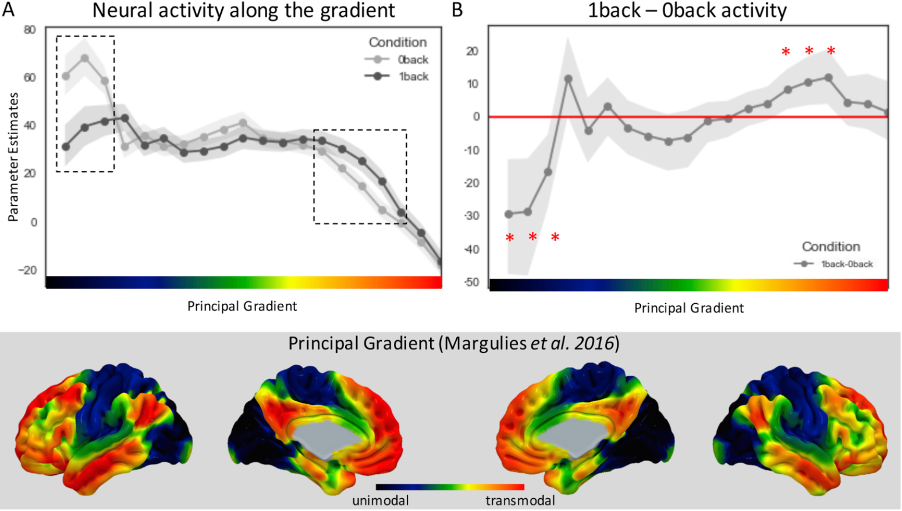
Figure 4. The principal gradient organization captures differences between stimulus dependent and stimulus independent decision making. (A) A regions-of-interest analysis using 20 bins of the principal gradient revealed that the decisions that are made on 0-back rather than 1-back trials led to higher activity towards the unimodal end of the gradient, whereas decisions made on 1-back rather than 0-back trials led to higher activity towards the transmodal end of the gradient. Error bars indicated 95% confidence intervals. The dashed boxes highlight the points where the two conditions differ. (B) To further interrogate the differences between 1-back and 0-back activity, the signal extracted from the contrast (1-back – 0-back) was plotted along the gradient. Errors bars indicated 99.50% confidence intervals. * Highlights portions of the gradient whether the neural activity significantly differs from 0 (red line). Grey panel illustrates the principal gradient account of cortical organization as depicted in Margulies et al. (2016). This gradient situates unimodal portions of the cortex at one end, and transmodal brain regions that correspond to the default mode at the other. This organization is thought to capture functional differences between large441 scale brain networks.

3.2 PCA Analysis Results
Our analysis thus far has demonstrated how neural function in each of the conditions of our experiment is distributed along the principal gradient. Next we address how the relationship between brain activity at each point on the gradient is related to the different cognitive components captured by our tasks. We performed a principle components analysis (PCA) unimodal decomposition using SPSS (versions 24) on the condition level data analysed in our prior analytic step. We created a 20 column X 116 row matrix in which each column was a region along the principal gradient and each row was the average neural activity for one condition of our study for a single participant. Applying PCA to this matrix allows us to determine the underlying topographical relationships between the neural activity in different regions along the gradient and to compare how these load onto the conditions of our design (see Smallwood et al., 2012 and Murphy et al., 2018 for a previous use of this approach). The results revealed three components with eigenvalues greater than 1 accounting for over 92.80% of the variance (component 1 = 74.35%; component 2 = 11.64%; component 3 = 6.81%) across the principal gradient bins. These components are presented in Figure 5. The first component captures an inverse relationship between neural activity towards the middle of the gradient and regions towards either unimodal or transmodal regions (left hand column of Fig. 5). The second component has lower loadings on unimodal end of the gradient and higher levels towards the transmodal end (middle column of Fig.5). Finally, the third component shows the reverse pattern, where increased activity was seen in region towards the unimodal end of the gradient involved in perception (right hand column of Fig.5). To visualize these components we projected the values for each region on to the cortex and generated spatial maps that describe each component. These are presented in the top row of Figure 5. We also examined the similarity between the spatial activity identified by these components and the distribution of neural activity identified in the initial analyses by Margulies et al., (2016). These relationships are presented in the middle row of Figure 5 where it can be seen that Component 1 did not show a linear relationship with the gradient (r = -.23, p = .33), while Component 2 showed a positive correlation (r = .94, p <. 001) and Component 3 had a negative relationship (r = -.86, p < .001). Finally, we projected these loadings back onto the task conditions and averaged them at the group-level; these are presented in the bottom column of Figure 5. A 3 (PC loadings) x 4 (conditions) repeated-measures ANOVA revealed no significant main effect of either PC (F(3,84) = 2.64, p = .06) or condition (F(2,56) = 0, p = 1.00), but a significant interaction between PC and condition (F(6, 168) = 8.59, p < .001). Post-hoc analyses revealed that the pattern of variance in Component 1 loaded equally on all four conditions with no significant main effect of stimulus independence (0-back versus 1-back (F(1,28) = .20, p = .66) or stimulus complexity (location versus judgment) F(1,28) = .003, p - .96) and no significant interaction ((F(1,28) = 2.84, p =.09)). Component 2 had a positive loading on the 1-back conditions with a significant main effect of stimulus independence (1-back > 0-back; F(1,28) = 8.53, p = .007), but no significant main effect of stimulus complexity (F(1,28) = .94, p = .34) and no significant interaction (F(1,28) = 2.46, p =.13). While Component 3 had a positive loading on 0-back conditions with a significant main effect of stimulus independence (0-back > 1-back; F(1,28) = 33.09, p < .001), but no significant main effect of stimulus complexity (F(1,28) = 3.07, p = .09) and no significant interaction (F(1,28) = .36, p =.55). This analysis shows that key aspects of the different modes of the behaviour captured by our conditions can be understood as patterns of segregation between unimodal and transmodal portions of cortex.

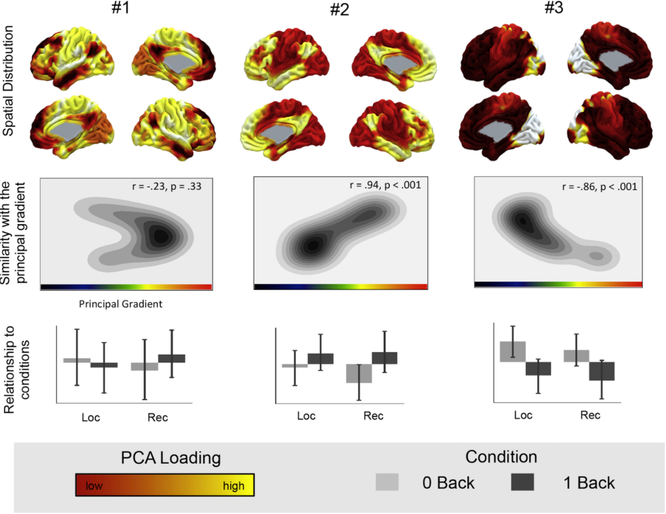
Figure 5. Decomposition of experimental differences along the gradient was related to three components that describe segregation between neural activity in transmodal and unimodal regions of cortex. Top row. Spatial distribution of the three principle components identified in our analysis. Middle Row. The similarity between the components in our study and the principle gradient identified by Margulies et al. (2016). Bottom row. Distribution of the component loadings across the experimental conditions of our experiment Error bars indicated 95% confidence intervals.

Finally, we examined whether the extent of segregation of neural activity between unimodal and transmodal regions of the cortical hierarchy that are captured by the components loadings, was associated with behavioural performance on our task. If a shift towards greater neural activity towards transmodal regions of cortex is linked to a mode of cognition that favours behaviour guided by memory, then individuals who show the most positive loading on Component 2, should perform faster when making decisions from memory. Prior to our analysis we down sampled the data to two conditions (0-back and 1-back) to minimise the number of comparisons in our analysis, and because no differences had been found between recognition and location judgements in our prior analyses. To control our false positive rates, we performed a Bonferonni correction, controlling for each component (3) and conditions (2). This yielded an alpha level of p <.008 (one-tailed). Correlating the components for each condition with the behavioural scores, in the form of RT, across participants, revealed that the second component significantly correlated with RT in the 1-back condition, but not in the 0-back conditions (see Table 2). Notably, neither component 1 or 3 significantly correlated with behaviour. To determine whether our component 2 result was consistent for location and recognition judgements we also calculated the pearson correlations between component 2 and each of our four experimental conditions (see Fig 6). These highlights that the distribution of neural activity captured by component 2 - that shows a positive with the pattern of neural activity described by the principle gradient - correlated across individuals with faster task performance when participants had to retrieve information from memory (1-back) but not during stimulus dependent judgements (0-back). This final analysis, therefore, confirms that the segregation of transmodal regions, from regions of unimodal cortex supports more efficient behaviour when it is guided by information from memory. As a supplementary analysis we interrogated whether it was transmodal activity exclusively or a shift of activity from unimodal to transmodal (as captured by component 2) that relates to behaviour on the task. We therefore extracted the signal from the DMN for each condition and correlated this activity against performance. Notably, changes in the DMN activity alone did not correlate with performance (see Supplementary Table 1), and therefore cannot account for the observed correlation between component 2 and behaviour.

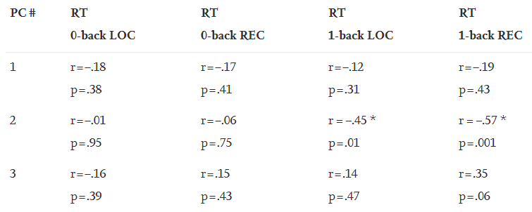
Footnote: Pearson’s r correlation values between the reaction time (RT) for each experimental condition and principal component loadings. * denotes a significant relationship after Bonferonni correction has been applied to control for multiple comparisons (0.05 / 6 = 0.008).

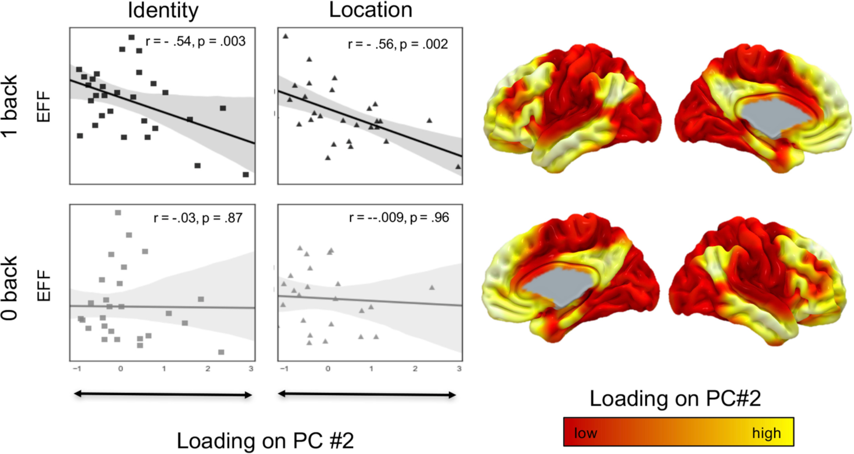
Figure 6. The gradient captures differences between 0-back and 1-back decision that can predict behavioural performance. Right hand panel. Reaction time (RT) for each condition was correlated against PCA2 values, revealing that this component had a strong correlation with task performance in both 1-back conditions but not 0-back, suggesting that participants who show this pattern make faster judgments when having to retrieve information from memory (1-back) as opposed to when the information is present in the environment (0-back). r value denotes Pearson’s r correlation. Left hand panel. Spatial distribution of the second PCA. Darker colors reflecting lower loadings, and warmer colors describing higher loadings.

4. Discussion

Network hierarchy has been consistently recognized as a fundamental principle of human brain organization (Markov et al., 2013; Mesulam, 1998). The explanatory power of network hierarchies, such as the principal gradient account (Margulies et al., 2016), is reflected in their ability to explain both how information is passed across systems via bottom-up and top-down propagation but also why networks are organized in the manner that they are. The latter may reflect a hierarchical architecture that imposes a natural segregation between sensory-motor interactions with the external environment and complex actions that are guided by representations from memory. Using task based imaging we established that, regardless of the nature of the decision, medial and lateral visual cortex were recruited when decisions rely on immediate input, while transmodal regions that broadly align with aspects of the default mode network, were recruited when judgments depend on information from the prior trial. Furthermore, we demonstrated that shifting decision-making from perception to memory altered the focus of neural activity from unimodal to transmodal regions (and vice versa). Going beyond our prior study (Murphy et al., 2018) we found a direct link between the distribution of neural activity along the principal gradient and behavior - the more pronounced the shifts in neural activity from unimodal to transmodal regions when decisions relied on memory, the more efficiently the individual responded to these trials. Together our results illustrate, therefore, how the macroscale organization of neural function into a hierarchy allows cognition to form cognitive modes that contribute to behavior either through a reliance on sensory input, or information from memory, in an efficient flexible manner.
Our data provides a novel perspective on how segregating neural processing is linked to adaptive cognition. Prior research has often assumed that the process of neural segregation is one directional largely based on the erroneous view of the DMN as a task negative system (e.g., Fox et al., 2005). For instance, previous studies have shown that for judgments that are difficult because they rely on specific aspects of environmental input, activity in the DMN can hinder task performance (Gui et al., 2015; Smallwood et al., 2013; Weissman et al., 2006). These results are often interpreted as problems in down regulating cognitive processes linked to the DMN under circumstances when the task in hand does not rely on these cognitive components (i.e. mind568 wandering, Fox et al., 2015; Smallwood and Schooler, 2015). Our prior studies (Murphy et al., 2018) highlighted that activity is higher in transmodal regions of cortex whenever individuals made decision using information from memory, a pattern our current study shows generalizes to both location and recognition judgments. Importantly, our study shows that under situations when environmental input is insufficient to make a decision, then segregating activity within the DMN from activity within unimodal regions is both necessary for performing the task, and that the more effectively this process takes place in an individual, then the faster these judgements are made. This pattern of data suggests a more general principle of neural segregation than has been recognised by prior studies. For example, our results suggests that adaptive cognition does not depend on the suppression of neural activity within a single system (i.e. the DMN) but rather depends on the appropriate balance of neural processes in line with the demands on the moment. In other words, while activity of the DMN may be unhelpful to task performance in particular situations (such as the Stroop or the Eriksen flanker task; e.g., Eichele et al., 2008), in other contexts (such as those captured by decisions made using information from memory in our study) neural processes that serve functions to do with perception which are irrelevant are similarly down regulated and segregated from processes within the DMN in order for behaviour to be as efficient as possible.
Finally, our study adds to a growing body of evidence that highlights the view that the organisation of human cognition emerges from multiple overlapping cognitive hierarchies (Margulies et al., 2016, Hutenberg et al., 2017, Crittenden et al., 2015, Vatansever et al., 2017). The evidence in the current study, as well as from our prior work (e.g. Margulies et al., 2016, Murphy et al., 2018), suggests that one such neural hierarchy describes the segregation between unimodal and transmodal systems and corresponds to the difference between cognitive states that take as input sensory information, from those that depend on information from existing memory representations. A similar cortical hierarchy captured by memory related decision, requires a degree of coactivation between the DMN and the FPN (see also Spreng et al., 2010, 2015). Another cognitive hierarchy, the multiple demand system, reflects co-activation within the FPN, as well as the attention systems, both of which are in opposition to regions within the DMN (Hellyer et al., 2014; Scott, Hellyer, Hampshire & Leech, 2015). This latter pattern of neural activity is argued to be important for patterns of cognition necessary for the implementation of behaviours determined by highly abstract, task-specific, rules (Duncan, 2010), for example as occur in standard manipulations of working memory (Owen et al., 2005). Importantly, the decomposition of the Human Connectome project performed by Margulies and colleagues (2016) captured spatial patterns that are similar to both of these neural hierarchies, indicating that they can be considered orthogonal patterns of macro scale neural organisation. It will be important in the future, to understand how these distinct patterns of large scale neural organisation contribute to the flexible and adaptive nature of human cognition.
One suggestion is that the interplay between these distinct neural hierarchies allows cognition to be flexibly organised across a range of different temporal scales, that is made possible by the balance that cognition places on information from the senses or memory representations (Margulies and Smallwood, 2017). For example, the neural hierarchy spanning unimodal and transmodal regions, may support cognition when representations from memory or perception can directly support cognition. Our current study suggests that regions of unimodal cortex are active when decisions are made based on information from memory, while transmodal cortex can guide different types of decision based on recent experience, while our prior work showed this activity pattern was potentiated when the information to be retrieved was rich in prior associations (Murphy et al., 2018). Over time, however, novel opportunities may arise within the environment that deviate from over learnt patterns. In order to take advantage of these possibilities, neural processes highlighted by the multiple demand system may be required to guide behaviour since memory representations would be insufficient to perform these acts. At the same time, the combination of fronto-parietal and default mode regions are important for simulating the future (for reviews see Schacter and Addis, 2007, Schacter et al., 2012), and guiding behaviour in a creative manner (Beatty et al., 2018). It is possible, therefore, that in combination transmodal systems may also allow cognition to mentally simulate potential future behaviours in a creative manner, yielding novel potential actions, that may subsequently be implemented by the multiple demand system. We note that this view is consistent with several recent studies. For example, in the Wisconsin card sorting task, the FPN is important when the current rules for behaviour are not yet represented in memory, while the DMN is important when the task goals are known (Vatansever et al., 2017). This study shows that the relative balance between processing in the DMN, and the FPN, can support cognition when internal representations can efficiently guide behaviour and when they cannot. In contrast, when switching between different tasks, the DMN is important in the change of context that supports the reinstatement of different sets of task rules, which can then be subsequently implement by the FPN (Crittenden et al., 2015; Muhle-Karbe et al., 2016). This pattern of activity is consistent with a role of the DMN in reinstating cognitive contexts in line with longer term goal representations. Taken together these recent studies are consistent with the general claim that the dynamic interactions between different cognitive hierarchies may be important in the service of cognition as it emerges across relatively long time scales (Margulies and Smallwood, 2017). More generally, we speculate that understanding the pattern of temporal interaction between these distinct neural hierarchies, may play a role in the cycle of exploration and exploitation that allows supports navigation within a complex and unpredictable environment over longer periods of time (e.g. Cohen, Mclure and Yu, 2007).

5. Conclusion
Our study demonstrates that the neural organization of cortical regions into a cognitive hierarchy that spans unimodal and transmodal cortex provides a description for two complementary modes of decision making. Patterns of activity in unimodal regions support sensory guided decision making, while activity in transmodal cortex, in regions of the DMN and FPN, are important when decisions are made efficiently based on information from memory. This pattern of activity during memory-guided decision-making engaged the posterior cingulate cortex, and the angular gyrus, middle temporal gyrus, and temporal pole in the left hemisphere and was reproducible across studies. We found that segregation between unimodal and transmodal cortex predicted more efficient responding when decision-making was made using information represented in memory, demonstrating that this pattern has behavioural relevance. Together this data is incompatible with accounts of the DMN as a task negative system, and instead supports accounts of this system as the top of a cortical hierarchy that is important in behaviour because it supports the processing of transmodal information that extends beyond immediate sensory input (Margulies et al., 2016).

References

Andrews‐Hanna, J. R., Smallwood, J., & Spreng, R. N. (2014). The default network and self‐generated thought: component processes, dynamic control, and clinical relevance. Annals of the New York Academy of Sciences, 1316(1), 29-52.
Beaty, R. E., Kenett, Y. N., Christensen, A. P., Rosenberg, M. D., Benedek, M., Chen, Q., ... & Silvia, P. J. (2018). Robust prediction of individual creative ability from brain functional connectivity. Proceedings of the National Academy of Sciences, 201713532.
Buckner, R. L., & Krienen, F. M. (2013). The evolution of distributed association networks in the human brain. Trends in cognitive sciences, 17(12), 648-665.
Chomiak, T., & Hu, B. (2017). Mechanisms of Hierarchical Cortical Maturation. Frontiers in cellular neuroscience, 11, 272.
Cohen, J. D., McClure, S. M., & Angela, J. Y. (2007). Should I stay or should I go? How the human brain manages the trade-off between exploitation and exploration. Philosophical Transactions of the Royal Society B: Biological Sciences, 362(1481), 933-942.
Cole, M. W., Reynolds, J. R., Power, J. D., Repovs, G., Anticevic, A., & Braver, T. S. (2013). Multi-task connectivity reveals flexible hubs for adaptive task control. Nature neuroscience, 16(9), 1348.
Crittenden, B. M., Mitchell, D. J., & Duncan, J. (2015). Recruitment of the default mode network during a demanding act of executive control. Elife, 4.
Davey, J., Thompson, H. E., Hallam, G., Karapanagiotidis, T., Murphy, C., De Caso, I., ... & Jefferies, E. (2016). Exploring the role of the posterior middle temporal gyrus in semantic cognition: Integration of anterior temporal lobe with executive processes. NeuroImage, 137, 165-177.
Duncan, J. (2010). The multiple-demand (MD) system of the primate brain: mental programs for intelligent behaviour. Trends in cognitive sciences, 14(4), 172-179.
Eichele, T., Debener, S., Calhoun, V. D., Specht, K., Engel, A. K., Hugdahl, K., ... & Ullsperger, M. (2008). Prediction of human errors by maladaptive changes in event-related brain networks. Proceedings of the National Academy of Sciences, 105(16), 6173-6178.
Eklund, A., Nichols, T. E., & Knutsson, H. (2016). Cluster failure: why fMRI inferences for spatial extent have inflated false-positive rates. Proceedings of the National Academy of Sciences, 113(28), 7900-7905.
Felleman, D. J., & Van, D. E. (1991). Distributed hierarchical processing in the primate cerebral cortex. Cerebral cortex (New York, NY: 1991), 1(1), 1-47.21.
Fox, M. D., Snyder, A. Z., Vincent, J. L., Corbetta, M., Van Essen, D. C., & Raichle, M. E. 2005). The human brain is intrinsically organized into dynamic, anticorrelated functional networks. Proceedings of the National Academy of Sciences of the United States of America, 102(27), 9673-9678.
Fox, K. C., Spreng, R. N., Ellamil, M., Andrews-Hanna, J. R., & Christoff, K. (2015). The wandering brain: Meta- analysis of functional neuroimaging studies of mind-wandering and related spontaneous thought processes. Neuroimage, 111, 611-6.
Gui, D., Xu, S., Zhu, S., Fang, Z., Spaeth, A. M., Xin, Y., ... & Rao, H. (2015). Resting spontaneous activity in the default mode network predicts performance decline during prolonged attention workload. Neuroimage, 120, 323-330.
He, B. J. (2014). Scale-free brain activity: past, present, and future. Trends in cognitive sciences, 18(9), 480- 487.
Hellyer, P. J., Shanahan, M., Scott, G., Wise, R. J., Sharp, D. J., & Leech, R. (2014). The control of global brain dynamics: opposing actions of frontoparietal control and default mode networks on attention. Journal of Neuroscience, 34(2), 451-461.
Hilgetag, C. C., O'Neill, M. A., & Young, M. P. (2000). Hierarchical organization of macaque and cat cortical sensory systems explored with a novel network processor. Philosophical Transactions of the Royal Society of London B: Biological Sciences, 355(1393), 71-89.
Huntenburg, J. M., Bazin, P. L., Goulas, A., Tardif, C. L., Villringer, A., & Margulies, D. S. (2017). A systematic relationship between functional connectivity and intracortical myelin in the human cerebral cortex. Cerebral Cortex, 27(2), 981-997.
Jenkinson, M., Bannister, P., Brady, M., & Smith, S. (2002). Improved optimization for the robust and accurate linear registration and motion correction of brain images. Neuroimage, 17(2), 825-841.
Krieger-Redwood, K., Jefferies, E., Karapanagiotidis, T., Seymour, R., Nunes, A., Ang, J. W. A., ... & Smallwood, J. (2016). Down but not out in posterior cingulate cortex: Deactivation yet functional coupling with prefrontal cortex during demanding semantic cognition. Neuroimage, 141, 366-377.
Margulies, D. S., Ghosh, S. S., Goulas, A., Falkiewicz, M., Huntenburg, J. M., Langs, G., ... & Jefferies, E. (2016). Situating the default-mode network along a principal gradient of macroscale cortical organization. Proceedings of the National Academy of Sciences, 113(44), 12574-12579.
Margulies, D. S., & Smallwood, J. (2017). Converging evidence for the role of transmodal cortex in cognition. Proceedings of the National Academy of Sciences, 201717374.
Markov, N. T., Ercsey-Ravasz, M., Van Essen, D. C., Knoblauch, K., Toroczkai, Z., & Kennedy, H. (2013). Cortical high-density counterstream architectures. Science, 342(6158), 1238406.
Mesulam, M. M. (1998). From sensation to cognition. Brain: a journal of neurology, 121(6), 1013-1052.
Muhle-Karbe, P. S., Duncan, J., De Baene, W., Mitchell, D. J., & Brass, M. (2016). Neural coding for instruction-based task sets in human frontoparietal and visual cortex. Cerebral Cortex, 27(3), 1891- 1905.
Murphy, C., Jefferies, E., Rueschemeyer, S. A., Sormaz, M., Wang, H. T., Margulies, D. S., & Smallwood, J. (2018). Distant from input: Evidence of regions within the default mode network supporting perceptually-decoupled and conceptually-guided cognition. NeuroImage.
Noonan, K. A., Jefferies, E., Corbett, F., & Lambon Ralph, M. A. (2010). Elucidating the nature of deregulated semantic cognition in semantic aphasia: evidence for the roles of prefrontal and temporo-parietal cortices. Journal of Cognitive Neuroscience, 22(7), 1597-1613.
Owen, A. M., McMillan, K. M., Laird, A. R., & Bullmore, E. (2005). N‐back working memory paradigm: A meta‐ analysis of normative functional neuroimaging studies. Human brain mapping, 25(1), 46-59.
Power, J. D., Cohen, A. L., Nelson, S. M., Wig, G. S., Barnes, K. A., Church, J. A., ... & Petersen, S. E. (2011). Functional network organization of the human brain. Neuron, 72(4), 665-678.
Schacter, D. L., & Addis, D. R. (2007). The cognitive neuroscience of constructive memory: remembering the past and imagining the future. Philosophical Transactions of the Royal Society B: Biological Sciences, 362(1481), 773-786.
Schacter, D. L., Addis, D. R., Hassabis, D., Martin, V. C., Spreng, R. N., & Szpunar, K. K. (2012). The future of memory: remembering, imagining, and the brain. Neuron, 76(4), 677-694.
Scott, G., Hellyer, P. J., Hampshire, A., & Leech, R. (2015). Exploring spatiotemporal network transitions in task functional MRI. Human brain mapping, 36(4), 1348-1364.
Smallwood, J., Gorgolewski, K. J., Golchert, J., Ruby, F. J., Engen, H. G., Baird, B., ... & Margulies, D. S. (2013). The default modes of reading: modulation of posterior cingulate and medial prefrontal cortex connectivity associated with comprehension and task focus while reading. Frontiers in human neuroscience, 7, 734.
Smallwood, J., & Schooler, J. W. (2015). The science of mind wandering: empirically navigating the stream of consciousness. Annual review of psychology, 66, 487-518.
Spreng, R. N., Gerlach, K. D., Turner, G. R., & Schacter, D. L. (2015). Autobiographical planning and the brain: activation and its modulation by qualitative features. Journal of cognitive neuroscience, 27(11), 2147-2157.
Spreng, R. N., Stevens, W. D., Chamberlain, J. P., Gilmore, A. W., & Schacter, D. L. (2010). Default network activity, coupled with the frontoparietal control network, supports goal-directed cognition. Neuroimage, 53(1), 303-317.
Taylor, P., Hobbs, J. N., Burroni, J., & Siegelmann, H. T. (2015). The global landscape of cognition: hierarchical aggregation as an organizational principle of human cortical networks and functions. Scientific reports, 5, 18112.
van den Heuvel, M. P., Kahn, R. S., Goñi, J., & Sporns, O. (2012). High-cost, high-capacity backbone for global brain communication. Proceedings of the National Academy of Sciences, 109(28), 11372-11377.
Vatansever, D., Menon, D. K., & Stamatakis, E. A. (2017). Default mode contributions to automated information processing. Proceedings of the National Academy of Sciences, 201710521.
Weissman, D. H., Roberts, K. C., Visscher, K. M., & Woldorff, M. G. (2006). The neural bases of momentary lapses in attention. Nature neuroscience, 9(7), 971.

