Improved tunicate swarm algorithm: solving the dynamic economic emission dispatch problems

Authorship

Ling-Ling Li
- State Key Laboratory of Reliability and Intelligence of Electrical Equipment, Hebei University of Technology, Tianjin 300130, China.
- Key Laboratory of Electromagnetic Field and Electrical Apparatus Reliability of Hebei Province, Hebei University of Technology, Tianjin 300130, China.
E-mail: lilinglinglaoshi@126.com

Zhi-Feng Liu
- State Key Laboratory of Reliability and Intelligence of Electrical Equipment, Hebei University of Technology, Tianjin 300130, China.
- Key Laboratory of Electromagnetic Field and Electrical Apparatus Reliability of Hebei Province, Hebei University of Technology, Tianjin 300130, China.

E-mail: tjliuzhifeng@126.com

Ming-Lang Tseng *(Corresponding author)
- Institute of Innovation and Circular Economy, Asia University, Taiwan
- Department of Medical Research, China Medical University Hospital, China Medical University, Taichung, Taiwan
- Faculty of Economics and Management, Universiti Kebangsaan Malaysia, Malaysia
E-mail: tsengminglang@gmail.com; tsengminglang@asia.edu.tw
Sheng-Jie Zheng
- State Key Laboratory of Reliability and Intelligence of Electrical Equipment, Hebei University of Technology, Tianjin 300130, China.
E-mail: hebutzsj@gmail.com
Ming K. Lim
- Faculty Research Centre for Business in Society, Coventry University, United Kingdom
Email: ac2912@coventry.ac.uk

Improved tunicate swarm algorithm: solving the dynamic economic emission dispatch problems

Abstract
This study proposes improved tunicate swarm algorithm (ITSA) for solving and optimizing the dynamic economic emission dispatch (DEED) problem. The DEED optimization target is to reduce the fuel cost and pollutant emission of the power system. In addition, DEED is a complex optimization problem and contains multiple optimization goals. To strengthen the ability of the ITSA algorithm for solving DEED, the tent mapping is employed to generate initial population for improving the directionality in the optimization process. Meanwhile, the gray wolf optimizer is used to generate the global search vector for improving global exploration ability, and the Levy flight is introduced to expand the search range. Three test systems containing 5, 10 and 15 generator units are employed to verify the solving performance of ITSA. The test results show that the ITSA algorithm can provide a competitive scheduling plan for test systems containing different units. ITSA proposed algorithm gives the optimal economic and environmental dynamic dispatch scheme for achieving more precise dispatch strategy.

Keywords: Soft-computing; improved tunicate swarm algorithm; power system; dynamic economic emission dispatch; fuel cost

Improved tunicate swarm algorithm: solving the dynamic economic emission dispatch problems
1. Introduction
The demand for electricity is increasing with continuous advancement of industrialization on global scale [1]. Adjusting the power supply mode flexibly according to load changes to improve the economy of the power system has become an urgent problem to be solved in the optimization of power system operation [2,3]. However, traditional thermal power generation emits a large amount of pollutants into the atmosphere, including sulfur oxides (SO_{x}), nitrogen oxides (NO_{x}), etc. These pollutants affect not only humans, but also other organisms. Hence, the pollutant emission index must be introduced into the optimization objectives to make the economic dispatch also have the function of environmental protection [4,5]. Dynamic economic emission dispatch (DEED) is an optimization problem that includes multiple objective functions that usually include reducing pollutant emission and reducing fuel cost. Solving the optimal DEED improves the environmental friendliness and economy of power system [6].
DEED is an urgent problem to be solved in the power system operation optimization, and the task of DEED is to adjust the output power of generator units according to the predicted load demand during the dispatch period [7]. For instance, Kheshiti et al. [8] argued that the DEED improvement helps to develop the power system economy and environmental friendliness. The entire scheduling cycle is usually 24 hours, and the output power of generator unit changes with load demand in the dispatching process. The dispatching scheme must satisfy many constraints, such as the slope rate constraint of the generator unit, the output power constraint, etc [9,10]. In this study, fuel cost and pollutant gas emission are considered simultaneously in the objective function of the DEED problem, which requires higher solving ability of the optimization algorithm.
The output power of the thermal generator unit shows nonlinearity due to the limitation of the valve point effect [11]. Karthik et al. [12] argued that the valve point effect increases the complexity of the objective function and difficulty of solving the DEED problem. In addition, the computational cost of solving the mathematical model of DEED increases with the increase of grid-connected generator units in the power system. When the mathematical method is used to solve the DEED problem, mathematical method is highly sensitive to the initial value, which needs the initial value to be close to the optimal solution [13]. Thus, mathematical method is unsuitable for solving DEED problems. Intelligent optimization method has the advantages of not being affected by the dimension and non-differentiability problem to be solved. Based on the above reason, scholars have developed a variety of intelligent optimization algorithms to solve the DEED problem [14].
In prior studies, classic intelligent algorithms have been applied to solve DEED problem, such as simulated annealing algorithm, particle swarm optimization algorithm (PSO), etc [15,16]. However, emission and cost are two conflicting goals, so reducing cost leads to increase emission [17]. Therefore, it is difficult for traditional intelligent algorithms to obtain optimal solutions when solving DEED problems. Tunicate swarm algorithm (TSA) is a new type of intelligent algorithm and its optimized performance is better than traditional intelligent algorithms such as PSO [18]. To further enhance the ability of TSA algorithm to solve the DEED problem, this paper improves the TSA algorithm. Specific improvement measures include: initialization based on Tent mapping, global search vector generated by gray wolf optimization algorithm, and Levy flight strategy. This research compares the convergence performance of the proposed ITSA algorithm with the state-of-the-art algorithms, and uses 3 test systems to verify the performance of the ITSA algorithm for solving the DEED problem. The objective of this study is as follows:
- Construct a DEED model considering the valve point effect.
- To propose a new DEED problem solving method.
- To improve the economy and environmental friendliness of the power system.
The contributions of this study are as follows: (1) The weight coefficient is used to transform DEED problem into a single-objective optimization problem for making the DEED problem easier to solve; (2) The valve point effect is considered in the DEED problem to make it closer to the reality; (3) A novel ITSA algorithm is proposed to solve DEED problem; and (4) Compared with the state-of-the-art algorithms, the dispatch scheme given by ITSA algorithm is more competitive with lower operation cost and less pollution gas emission.
Although the ITSA algorithm proposed in this study gives competitive solutions to the DEED problem, there are still several limitations in this study. First, the convergence performance of the ITSA algorithm proposed in this research can be further explored, and the generalization ability of the ITSA algorithm can be improved. Second, the scheduling problem of the integrated energy system considering new energy has become a hot research issue. How to consider the new energy in the modeling process of the integrated energy system requires further research. The above two limitations will be solved in future research work.
This study includes the following sections: Second 2 presents the previous study on DEED. Section 3 constructs the DEED problem mathematical model in detail. Section 4 introduces the TSA and ITSA mathematical models. Section 5 verifies the performance of ITSA through three test systems. Section 6 summarizes the contributions of this study.
2. Literature review
The goal of DEED problem is to reduce the fuel cost of the power system while reducing its pollutant emission. However, fuel cost and pollutant emission are essentially contradictory. Moreover, the objective function of DEED becomes complicated because the fuel cost and the emission functions are non-smooth and non-convex. The switch of a large steam turbine produces the valve point effect that makes the output curve of the unit not smooth during actual operation. Valve point effect changes the objective function of fuel cost from a quadratic function to the sum of a quadratic function and a sine function, which puts forward higher requirements for the algorithm's solving performance. Dosoglu et al. [19] used the symbiotic organism search algorithm to solve the DEED problem. The fuel cost obtained by this method is not ideal due to the valve point effect. Jevtic et al. [20] used the moth swarm algorithm to solve the DEED problem considering the valve point effect. The optimal value obtained by moth swarm algorithm is poor because the solution performance of the moth swarm algorithm is not ideal. Dey et al. [21] employed the whale optimization algorithm to solve the DEED problem. Affected by the valve point effect, the whale optimization algorithm has poor convergence ability when solving DEED problem.
To date, DEED problem solving methods have focused on two aspects, namely mathematical methods and intelligent algorithms. Mathematical methods are computationally expensive and require high-quality initial values. The slope rate constraint must be met when the output of the generator unit changes with the load demand. However, mathematical methods cannot handle this dynamic constraint of DEED problem well, which leads to poor accuracy of running results. Elsheakh et al. [22] proposed gradient projection method and Momoh et al. [23] developed an interior point method to solve DEED problem. The calculation cost of the above two methods is relatively large, and the compromise solutions obtained are not ideal. Muralidharan et al. [24] used recursive method to solve DEED problem. This method has poor convergence accuracy during the solution process.
Due to powerful optimization capabilities, intelligent algorithms are employed to solve DEED problem [25], such as PSO[26], genetic algorithm[27] and simulated annealing algorithm[28]. In addition, intelligent algorithms are not affected by the dimensionality of the optimization problem and have low requirements for initial values, which makes intelligent algorithms more suitable for solving DEED problems. Basu [29] used simulated annealing algorithm to solve DEED problem. Simulated annealing algorithm has better convergence ability during the solution process. Basu [30] used PSO algorithm to solve DEED problem and obtained satisfactory compromise solutions when solving DEED problem. Hagh et al. [31] employed the exchange market algorithm to solve DEED problem, and the fuel cost and pollutant emission obtained were competitive.
Although intelligent algorithms have strong optimization performance, they tend to fall into local extreme solutions when solving non-convex and non-smooth DEED problem. Prior studies have begun to propose targeted improved algorithms based on the original algorithm. Compared with traditional algorithms, improved algorithms have stronger solution performance. For instance, Daryani et al. [32] introduced the disturbance to the producer's position update formula in the group search algorithm to prevent population from falling into the local optimal solution. Through position disturbance, the convergence performance of the original algorithm is enhanced. Vijay et al. [33] added group sensing and anti-predatory behavior to the bacteria swarm algorithm to develop the optimization ability during the process of cognitive behavior and social behavior. The improved algorithm is more suitable for solving DEED problem. Li et al. [34] improved the harmony search algorithm by using the global optimal value and the global worst value to update the new value. Qian et al. [35] proposed an improved PSO through adding the clone selection principle to PSO. Moreover, the improved PSO algorithm enhances global exploration capability and is more reasonable for solving DEED problem compared with the original algorithm.
In addition, hybrid algorithms that combine with various single algorithms are also developed for solving DEED problem. Hybrid algorithms overcome the shortcomings of the single algorithm through proper combination, and retain the advantages of the single algorithm. For instance, Sen et al. [36] combines ant colony algorithm, artificial bee colony algorithm and harmonic search algorithm together. This proposed hybrid algorithm initializes population by ant colony algorithm, optimizes objective by artificial bee colony, and selects the optimal value by harmony search algorithm. The test results show that the hybrid algorithm has strong solving ability. Naderi et al. [37] proposed the fuzzy hybrid particle swarm-differential evolution algorithm and used differential evolution algorithm to improve the convergence and optimization capabilities of PSO algorithm. The hybrid PSO algorithm presents more strong convergence performance for solving DEED problem. Gherbi et al. [38] combined the bat algorithm and the firefly algorithm to propose a new hybrid algorithm that inherited the robustness of the bat algorithm and the global search capability of the firefly algorithm. In addition, Chavez et al. [39] combined simulated annealing algorithm and genetic algorithm together and achieved better results in solving DEED problem.
Tunicate swarm algorithm (TSA), which has strong global optimization ability, robustness and fast convergence speed, is a new proposed intelligence algorithm [18]. Although TSA algorithm has stronger convergence performance compared with traditional algorithms, TSA algorithm is not very competitive when solving DEED problem, so it is necessary to further explore the solution performance of TSA algorithm. To further improve the algorithm's performance for solving DEED problems, this study makes adaptive improvements. First, Tent mapping is employed to generate initial population for improving the directionality in the optimization process. Second, the gray wolf optimizer is used to generate a global search vector for improving the algorithm's global exploration ability. Finally, the Levy flight is introduced to expand the search range of the ITSA algorithm. This study uses three DEED test systems for examining the effectiveness and superiority of the ITSA algorithm. Test results reveal that ITSA reduces the pollutant emissions and improves economy of the power system.
3. DEED problem formulation
3.1. Objective function
DEED is an optimization problem containing multiple optimization goals. This study uses the coefficient w to change the multi-objective function into a single objective function, as shown below:
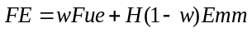 (1)
where FE is the function to be optimized, Fue is the fuel cost function, Emm is the total pollutant emission, and H is the price penalty factor when w=0.
The value of w affects the emphasis of the objective function on fuel cost and pollution emission. The closer the w value is to 1, the more the objective function focuses on fuel cost; the closer the w value is to 0, the more the objective function focuses on pollutant emission. The DEED problem is changed into dynamic economic dispatch when w=1. In addition, the DEED problem is changed into dynamic emission dispatch when w=0.
3.1.1. Fuel cost function
The fuel cost function of the DEED problem considering the valve point effect is the sum of the quadratic function and the sine function, as follows:
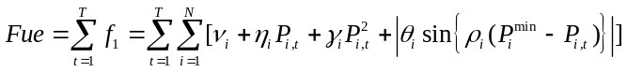 (2)
where f₁ is the single period fuel cost, T represents 24 scheduling cycles, and N represents the number of generator units. v_{i}, η_{i}, ϒ_{i}, θ_{i} and ρ_{i} are the fuel cost coefficients of unit i. P_{i,t} is the output power of unit i in the t_{th} dispatch period.
3.1.2. Pollutant emission function
Pollutants include SO_{x}, NO_{x}, etc. This study adopts the comprehensive polluted gas model [40], which is expressed as:
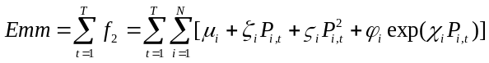 (3)
where f₂ is the pollutant emission of the system in a single dispatch period. μ_{i}, ζ_{i}, ϛ_{i}, ф_{i}, χ_{i} are the pollutant emission coefficients of unit i.
3.2. Restrictions for DEED
A. Power balance constraints
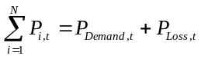 (4)
where P_{Loss,t} and P_{Demand,t} are the network loss and the load demand of the system in the period t.
The network loss P_{Loss,t} is calculated using Kron’s formula [40]:
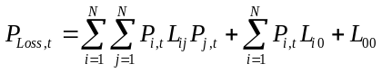 (5)
where L_{ij}, L_{i0} and L₀₀ are network loss coefficients.
B. Unit output power constraints
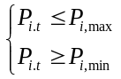 (6)
where P_{i,min} and P_{i,max} are the minimum and maximum output power of unit i.
C. Slope rate constraints
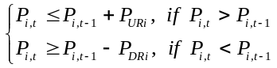 (7)
where P_{URi} and P_{DRi} are the maximum value and minimum value of up regulation power and down regulation power of unit i between adjacent periods.
3.3. Overall DEED objective function
By combining equations (1) to (7), the overall objective function of DEED problem is obtained as follows:
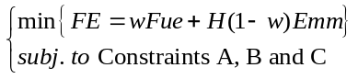 (8)
3.4. Selection of compromise solution
For the DEED problem, the satisfaction of the obtained results with different goals is evaluated by establishing the membership function. The coefficient w in equation (1) is increased from 0 to 1 with an interval of 0.05. The results obtained in each increment are retained to form a pareto solution set. The compromise solution is determined by the membership function. The specific process is as follows:
(1) Calculate the satisfaction of each solution in the pareto solution set, as shown below:
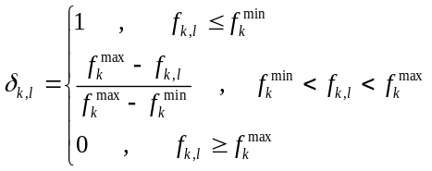 (9)
where δ_{k,l} is the satisfaction degree of the k_{th} goal of the l_{th} solution. f_{k}^{max} and f_{k}^{min} represent the upper and lower limits of the k_{th} goal in the pareto solution set.
(2) Calculate the overall satisfaction of each solution:
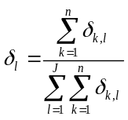 (10)
where n is the target number. Because this study considers two goals of fuel cost and pollutant emission, n is equal to 2. J is the number of solutions in the pareto solution set.
(3) Choose the solution with the largest δ_{l} as the compromise solution.
4. Proposed method
In this section, TSA and ITSA are introduced in detail. The improvement strategies contain: (1) Tent mapping initialization; (2) Global search vector; and (3) Levy flight.
4.1. Tunicate swarm algorithm
The algorithm was inspired by two foraging behaviors which includes jet propulsion and swarm intelligence.
Jet propulsion is divided into three parts, which are avoiding conflicts between search agents, moving to the best neighbor, and converging to the best search agent.
4.1.1. Avoid conflicts between search agents
Vector is used to calculate the new search agent position for avoiding conflicts between search agents.
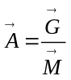 (11)
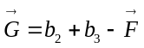 (12)
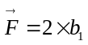 (13)
where is gravity, and is advection in the deep sea. The variables b₁, b₂ and b₃ are randomly distributed between [0, 1]. 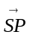 represents the social power. The calculation of vector is as follows:
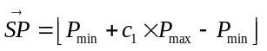 (14)
where P_{min} and P_{max} represent the initial and secondary speed of social interaction. In this algorithm, P_{min} and P_{max} are set to 1 and 4, respectively.
4.1.2. Move to the best neighbor
The search agent moves in the direction of the best neighbor after avoiding conflicts between neighbors.
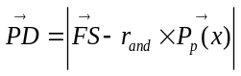 (15)
where 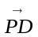 represents the distance of the tunicates from the food source, 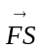 is the location of the food source (optimal solution), 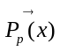 presents the position of the tunicates, x represents the current number of iterations, and r_{and} is randomly distributed between [0, 1].
4.1.3. Convergence to the best search agent
The tunicates population move towards the food source (optimal solution), as follows:
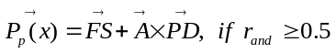 (16)
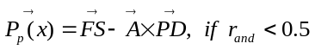 (17)
4.1.4. Swarm behavior
The swarm behavior of the tunicate is defined as updating the positions of other search agents through the positions of the first two best search agents, as shown below:
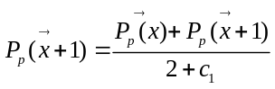 (18)
where 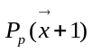 is the location of the updated search agent, and c₁ is randomly distributed between [0, 1].
4.2. Improved tunicate swarm algorithm
4.2.1. Tent mapping initialization
The random initialization of intelligent algorithm weakens the convergence rate of the algorithm in the iterative process. Tent mapping has the characteristics of ergodicity and regularity to make the initial population evenly distributed within the feasible region. The expression of Tent mapping is as follows:
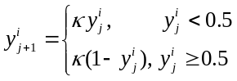 (19)
where κ(κ=2) is the chaos parameter, i is size of the population, and j is number of the chaotic variable.
4.2.2. Global search vector
This study introduces the gray wolf optimizer into the original algorithm to generate the global search vector for enhancing the global exploration capability. Gray wolf optimizer includes several steps:
(1) Social hierarchy mechanism
The wolves are divided into four groups (W₁, W₂, W₃ and W₄) according to their fitness values. The first three groups are the best adaptable gray wolves and have the function of directing the wolves.
(2) Surround the prey
During predation, the gray wolves need to surround its prey. The mathematical model is as follows:
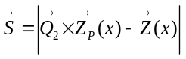 (20)
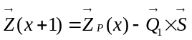 (21)
where x represents the current iteration number. is the distance and direction of the wolf from its prey. 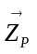 represents the position of the prey. represents the position of the wolves. 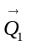 and 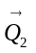 are two coefficient vectors, which are defined as follows:
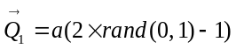 (22)
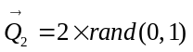 (23)
where a is the attenuation factor.
As the number of iterations increases, the coefficient a decreases linearly from 2 to 0.
(3) Hunting
The wolf W₁ leads the wolves W₂ and W₃ to guide the wolves to shrink the encircling circle of the prey to achieve the purpose of predation. The mathematical model is as follows:
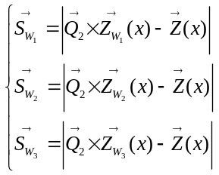 (24)
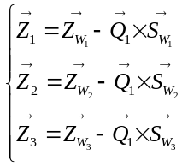 (25)
where 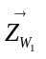, 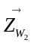, 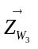 represent the position of wolf W₁, wolf W₂, wolf W₃ respectively. indicates the position of other wolves. 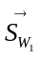, 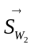, 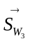 represent the direction and step length of wolf W₄ moving towards wolf W₁, wolf W₂, wolf W₃ respectively.
(4) Generate global search vector
The global search vector is expressed as:
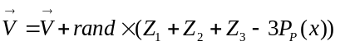 (26)
The improved position update formula is as follows:
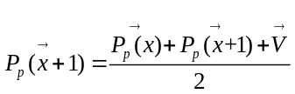 (27)
4.2.3. Levy flight strategy
This study introduces Levy flight strategy to the ITSA for rising the diversity of the population and expanding the search range of the algorithm. The position update equation after introducing Levy flight strategy is as follows:
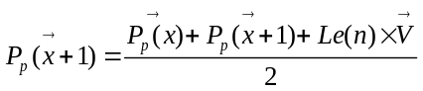 (28)
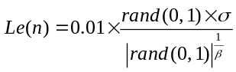 (29)
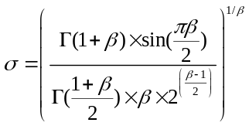 (30)
where n presents the dimension of the global search vector. β(β=1.5) is a constant. Γ(x)=(x-1)!.
The pseudo code of ITSA algorithm is listed in Table 1, and the flow chart is shown in Figure 1.
Table 1. ITSA Pseudo code
Initialize the population size M_{n}, the maximum number of iterations M_{i} and related parameters.
x=0.
Generate initial population by Tent mapping.
While (x<M_{i})
Calculate the fitness value of the individual and update the optimal individual x_{best}.
For m=1 To M_{n}
The tunicate individual moves towards the best individual using equation (14).
If(rand≥0.5)
Update the position of the tunicates using equation (15).
Else
Update the position of the tunicates using equation (16).
End if
End for
Calculate individual fitness value.
For i=1 To M_{n}
/* Use gray wolf optimizer to generate global search vector */
The gray wolf performs the operation of surrounding the prey according to the equation (21).
The gray wolf performs hunting operations according to equation (25).
Generate the global search vector according to equation (26)
Update individual position according to global search vector and Levy flight strategy using equation (28)
End for
x=x+1
End while
Output optimal value
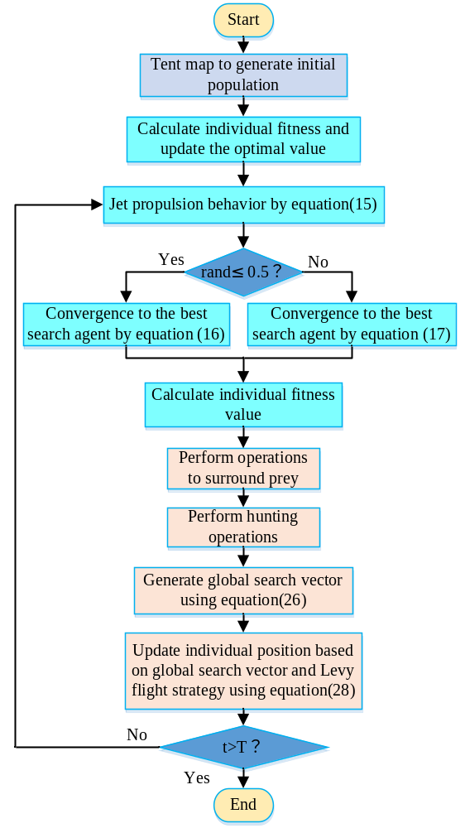
Figure 1. The ITSA flow chart
5. Case analysis
This study verifies the effectiveness and superiority of the ITSA algorithm through the statistical analysis of the test results of single-peak and multi-peak benchmark functions, and compares it with the state-of-the-art algorithms. In addition, three test systems containing five, ten and fifteen generator units are applied to verify the solution performance of the proposed ITSA algorithm. Moreover, each test system considers the transmission loss and slope rate constraint. System parameters are detailed in Qian et al. [35].
5.1. Statistical data analysis of benchmark function test results
The single-peak and multi-peak benchmark functions shown in Table 2 were selected to verify the effectiveness of ITSA. Moreover, TSA, PSO, distributed arithmetic algorithm (DA) are selected as comparison algorithms. As revealed in table 2, f₁(z), f₂(z) and f₃(z) are single-peak test functions; f₄(z), f₅(z) and f₆(z) are multi-peak test functions. The parameter setting of each algorithm is listed in Table 3.
Table 2. Benchmark functions
Function Attributes | Expressions | Variable scope | Solution | dim
Single-peak | 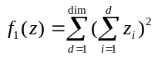 | [-100, 100] | 0 | 10/40
Single-peak | 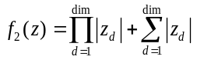 | [-10, 10] | 0 | 10/40
Single-peak | 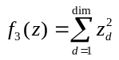 | [-100,100] | 0 | 10/40
Multi-peak | 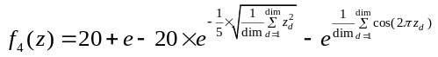 | [-32, 32] | 0 | 10/40
Multi-peak | 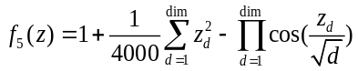 | [-600, 600] | 0 | 10/40
Multi-peak | 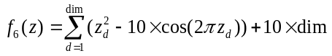 | [-5.12, 5.12] | 0 | 10/40
Table 3. Parameter setting
Algorithm | Parameter
ITSA | M_{i}=1000, M_{n}=30, μ=2, P_{min}=1, P_{max}=4
TSA | M_{i}=1000, M_{n}=30
DA | M_{i}=1000, M_{n}=30
PSO | M_{i}=1000, M_{n}=30, C1=C2=1.45, w=0.729

The maximum number of iterations and population size of the four algorithms are set to 1000 and 80, respectively. The remaining parameters are set as: for ITSA, the chaos parameter μ is 2, the initial speed P_{min} and the secondary speed P_{max} of the social parameters are 1 and 4, respectively. In the PSO, the inertial weight w is set to 0.729, and the acceleration factors C1 and C2 are set to 1.45.
The convergence performance of ITSA algorithm is analyzed on the basis of statistical method. Each benchmark function is used to test each algorithm 30 times, and the optimal value, the worst value, the average value, the standard deviation and the average running time are counted. The statistical results are listed in Table 4.

Table 4. The statistics data analysis of testing results
Test functions | Algorithms | Statistical results(dim=10 and dim40)
Test functions | Algorithms | Best value | Worst value | Mean value | Standard deviation(Std) | Average running time(s)
f₁(x) | PSO | 4.59e-05/ 6.32e+03 | 61.28/ 3.22e+04 | 8.94/ 1.21e+04 | 14.99/ 5.25e+03 | 0.24/ 0.50
f₁(x) | DA | 3.85/ 3.60e+03 | 794.94/ 5.39e+04 | 114.24/ 2.11e+04 | 150.81/ 1.01e+03 | 14.62/ 32.32
f₁(x) | TSA | 1.45e-63/ 4.70e-14 | 2.23e-48/ 4.5e-03 | 7.88e-80/ 2.41e-04 | 4.07e-49/ 8.60e-04 | 0.17/ 0.54
f₁(x) | ITSA | 7.00e-184/ 2.82e-115 | 2.92e-174/ 2.11e-107 | 1.00e-175/ 8.47e-109 | 0/ 3.89e-108 | 0.56/ 2.04
f₂(x) | PSO | 8.40e-03/ 23.17 | 2.10/ 74.75 | 0.38/ 40.23 | 0.42/ 23.17 | 0.17/ 0.18
f₂(x) | DA | 0.28/ 9.61 | 3.16/ 41.52 | 1.26/ 22.45 | 0.78/ 7.57 | 17.73/ 27.73
f₂(x) | TSA | 6.61e-31/ 2.57e-31 | 2.54e-28/ 2.90e-28 | 8.03e-29/ 5.69e-29 | 7.70e-29/ 7.30e-30 | 0.19/ 0.19
f₂(x) | ITSA | 1.87e-128/ 1.18e-83 | 1.73e-122/ 1.21e-81 | 7.40e-124/ 2.62e-82 | 3.19e-123/ 2.51e-82 | 0.49/ 1.74
f₃(x) | PSO | 3.46e-05/ 5.91e+03 | 0.47/ 1.38e+03 | 4.36e-03/ 3.63e+03 | 9.38e-03/ 987.47 | 0.16/ 0.17
f₃(x) | DA | 1.40e-03/ 1.12e+03 | 64.56/ 5.59e+03 | 13.38/ 2.85e+03 | 15.98/ 1.23e+03 | 13.65/ 26.41
f₃(x) | TSA | 1.94e-92/ 5.09e-44 | 1.91e-83/ 2.31e-39 | 2.13e-84/ 2.75e-40 | 5.06e-84/ 5.66e-40 | 0.11/ 0.22
f₃(x) | ITSA | 9.78e-238/ 5.52e-160 | 7.64e-228/ 8.02e-157 | 4.81e-229/ 1.23e-157 | 0/ 2.22e-157 | 0.49/ 1.70
f₄(x) | PSO | 1.64/ 10.36 | 6.42/ 14.79 | 3.54/ 12.10 | 1.11/ 0.89 | 0.18/ 0.21
f₄(x) | DA | 8.88e-16/ 6.47 | 5.30/ 14.01 | 3.16/ 10.14 | 1.12/ 1.57 | 13.38/ 25.54
f₄(x) | TSA | 4.44e-15/ 1.51e-14 | 3.61/ 3.56 | 1.92/ 1.62 | 1.71/ 1.55 | 0.11/ 0.24
f₄(x) | ITSA | 4.44e-15/ 7.99e-15 | 4.44e-15/ 7.99e-15 | 4.44e-15/ 7.99e-15 | 0/ 0 | 0.50/ 1.71
f₅(x) | PSO | 9.44e-02/ 15.83 | 1.17/ 62.31 | 0.34/ 34.61 | 0.26/ 12.77 | 0.22/ 0.23
f₅(x) | DA | 0/ 7.98 | 1.25/ 52.51 | 0.68/ 29.32 | 0.39/ 11.42 | 13.24/ 27.88
f₅(x) | TSA | 1.30e-02/ 0 | 0.97/ 1.97e-02 | 0.46/ 5.00e-03 | 0.28/ 6.50e-03 | 0.13/ 0.26
f₅(x) | ITSA | 0/ 0 | 4.77e-12/ 2.01e-07 | 1.67e-12/ 6.10e-08 | 1.27e-12/ 7.20e-08 | 0.51/ 1.72
f₆(x) | PSO | 4.99/ 128.45 | 31.85/ 246.09 | 16.42/ 188.47 | 7.29/ 28.51 | 0.17/ 0.21
f₆(x) | DA | 7.69/ 100.83 | 59.48/ 400.78 | 25.91/ 247.80 | 12.88/ 55.59 | 16.01/ 28.69
f₆(x) | TSA | 5.93/ 132.47 | 46.62/ 378.99 | 22.70/ 255.45 | 10.38/ 54.37 | 0.12/ 0.25
f₆(x) | ITSA | 0/ 0 | 21.51/ 217.37 | 9.51/ 66.56 | 5.52/ 67.79 | 0.49/ 1.87
Table 4 presented statistical results for the single-peak and multi-peak test functions. For the statistical results of the single-peak benchmark functions, the statistical results obtained by the ITSA algorithm are significantly better than the other three algorithms, showing the strong convergence performance of the ITSA algorithm. For statistical average running time, ITSA algorithm is higher than PSO algorithm and TSA algorithm. This is because the improvement of algorithm convergence accuracy and the reduction of running time are two contradictory goals, but this contradiction has been well resolved with the continuous improvement of the performance of computing tools. For the statistical results of the multi-peak benchmark functions, ITSA still shows good convergence capability. For both f₅ and f₆, the ITSA algorithm converges to the optimal value 0, showing strong global exploration capability. This is because the GWO idea and Levy strategy make the ITSA algorithm have stronger global exploration and local search performance.
In addition, the statistical results in Table 4 reveal that each algorithm has high sensitivity to the number of test dimension. Under different test dimensions, the convergence results of each algorithm are different. With the increase of test dimension, the computational cost of the algorithm increases, resulting in the poor convergence results of each algorithm. For the statistical average running time, the sensitivity of ITSA algorithm to test dimension is higher than that of PSO, TSA and DA algorithms. With the increase of test dimension, the running time of PSO, TSA and DA algorithm is nearly doubled, and the average running time of ITSA algorithm is nearly tripled. Although the ITSA algorithm is more sensitive to the test dimension, the ITSA algorithm obtains the most competitive statistics results under different test dimensions.
It is found that compared with the traditional TSA algorithm, the convergence performance of ITSA algorithm has been greatly improved by analyzing the statistical results in Table 4. Through tent mapping, ITSA algorithm can get more evenly distributed initial solution, which makes ITSA algorithm more likely to converge to the optimal value. Meanwhile, ITSA algorithm maintains the diversity of the population in the iterative process by introducing the principle of GWO algorithm, which improves the ability of the ITSA algorithm to jump out of the local extremum in the iterative process. In addition, the random walk characteristic of Levy flight strategy can make ITSA algorithm jump out of the local extremum in the late iteration, which can better balance the local search and global convergence ability of ITSA algorithm. On the basis of the above analysis, it can be found that the proposed ITSA algorithm has superiority.
At present, many scholars have proposed a variety of state-of-the-art intelligent algorithms. The statistical results of the proposed algorithm are compared with those of the state-of-the-art algorithms. For example, Muthusamy et al. [41] proposed an improved elephant herding optimization (EHOI) algorithm, and the EHOI algorithm was tested in 30 dimensions. For f₁ to f₃, the Mean values obtained by EHOI algorithm are 4.03e-110, 4.86e-76 and 1.58e-144 respectively; the Std values obtained by EHOI algorithm are 1.27e-109, 7.83e-76 and 4.95e-144. Zhang et al. [42] proposed a hybrid algorithm named HGWOP that combined grey wolf optimizer and PSO. For multi-peak functions f₄ to f₆, the Mean values obtained by the HGWOP algorithm are 2.08e+01, 7.65e-02 and 1.47e+01; the Std values are 6.64e-02, 3.98e-02 and 5.36e+00. Tudose et al. [43] proposed an improved salp swarm algorithm(ISSA), and the ISSA algorithm was verified in 10 dimensions. For single-peak functions f₁ to f₃, the Mean values obtained by ISSA algorithm are 2.53e-12, 3.08e-07 and 6.38e-12; the Std values obtained by ISSA algorithm are 1.72e-12, 1.10e-07 and 4.02e-12. For multi-peak functions f₄ to f₆, the Mean values obtained by ISSA algorithm are 4.79e-07, 5.91e-12 and 1.01e-12; the Std values obtained by ISSA algorithm are 1.99e-07, 6.39e-12 and 7.44e-13. In addition, Li et al. [44] developed an improved atomic search algorithm(IASO), and the IASO algorithm was tested in 30 dimensions. For single-peak function f₁, the Mean value obtained by IASO is 2.06e-28. For multi-peak function f₄, the Mean value obtained by IASO is 1.13e-14. Through the analysis of the statistical results obtained by the state-of-the-art intelligent algorithms, it is found that the statistical results obtained by the proposed ITSA algorithm are competitive. The above analysis verifies the effectiveness and superiority of the proposed ITSA algorithm.
5.2. Test system 1: 5-units system
The test system 1 includes five thermal power generator units, and the load forecast curve of the test system 1 is shown in Figure 2.

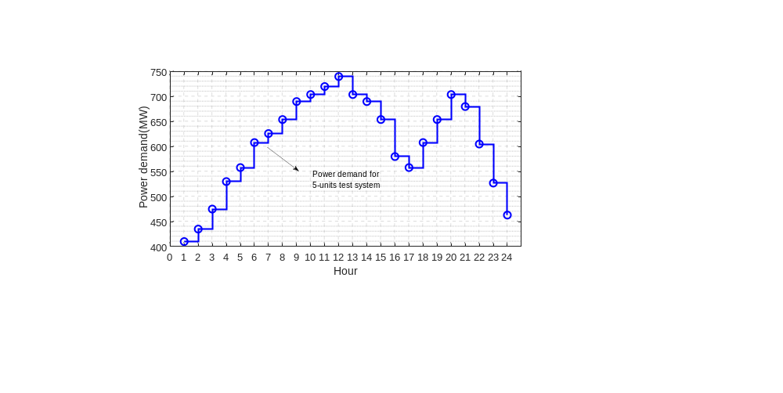
Figure 2. Load forecast curve for test system 1

Figure 3 presents the Pareto frontier solutions obtained by ITSA and TSA, and the compromise solutions obtained by the state-of-the-art methods.
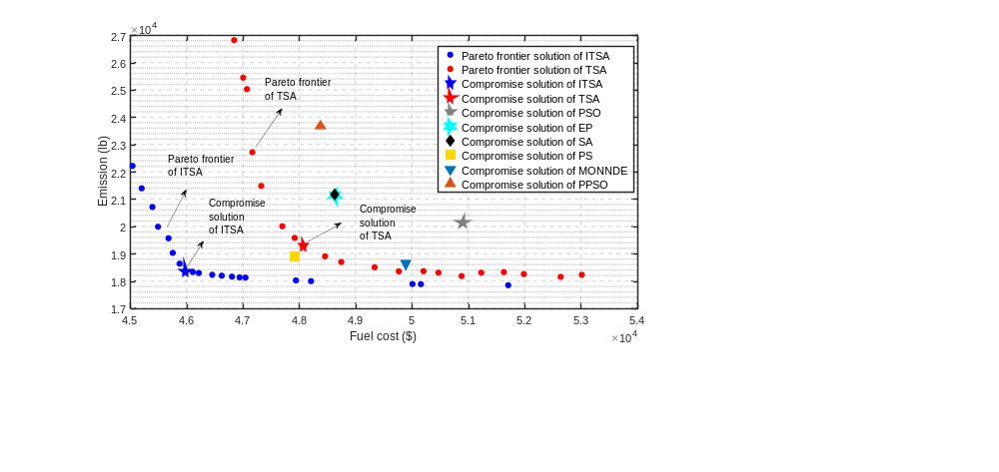
Figure 3. Comparison of Pareto frontier solution and compromise solution for test system 1

Figure 3 indicates that the Pareto frontier of ITSA is smoother than that of TSA and is closer to the origin. The compromise solutions of the ITSA and TSA algorithms are marked in Figure 3. The compromise solution is calculated using the membership function given in Section 3.4. The compromise solution of ITSA is lower than that of TSA in terms of fuel cost and emission. Figure 3 also gives the compromise solutions from different literatures, and the compromise solutions consider both the economy and environmental protection of power system. For the 5-units test system, ITSA algorithm obtains a satisfactory compromise solution. Table 5 shows the comparison of the compromise solutions of different algorithms in test system 1.

Table 5. Comparing the compromise solutions of different algorithms in test system 1
Algorithms | PSO | EP | SA | PS | MONNDE
Fuel cost ($) | 50893 | 48628 | 48621 | 47911 | 49884
Emission (lb) | 20163 | 21154 | 21188 | 18927 | 18647
Algorithms | PPSO | NSCSO-MH | TSA | ITSA
Fuel cost ($) | 48369 | 47497 | 48063.97 | 45971.2
Emission (lb) | 23685 | 18172 | 19298.74 | 18370.7

Table 5 presents the state-of-the-art methods to solve the problem, such as PSO[29], EP[40], SA[49], PS[49], MONNDE[47], PPSO[35] and NSCSO-MH[48]. Analysis results reveal that the fuel cost obtained by ITSA is the smallest. The fuel cost obtained by ITSA is 10% lower than that obtained by PSO. Meanwhile, the emission obtained by ITSA is 9% lower than that obtained by PSO. The emission of ITSA algorithm is slightly higher than that of NSCO-MH algorithm, but the fuel cost of ITSA algorithm is 3.21% lower than that of NSCO-MH algorithm. On the basis of above analysis, it is found that the compromise solution of ITSA algorithm is the most competitive for the 5-units test system. The dispatch scheme given by ITSA algorithm has minimum fuel cost and satisfactory emission, which improves the economy and environmental friendliness of the power system. Figure 4 presents the convergence curves of ITSA and TSA algorithms when obtaining the compromise solution.

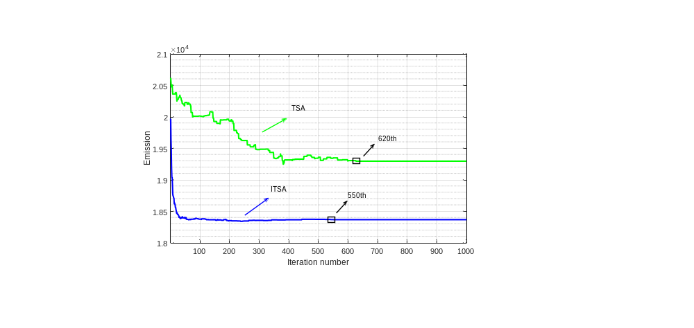
Figure 4. Iterative curves of ITSA and TSA algorithms when solving test system 1

Figure 4 reveals that ITSA algorithm iterates to the optimal value around the 550th generation, and TSA converges to the optimal value after the 620th generation. In addition, the optimal value obtained by ITSA is lower than the TSA optimal value. The quality of initial solution is improved by the Tent mapping, which accelerates the convergence speed of ITSA algorithm. Meanwhile, Levy flight strategy enhances the ability of ITSA algorithm to jump out of local extremum. Therefore, ITSA has better global search capability and convergence characteristics compared with TSA.
Table 6 presents the detailed output power of each unit when ITSA obtains the compromise solution.

Table 6. Hourly output power (MW), Fuel cost (×10⁴$) and Emission (×10⁴lb) obtain by ITSA when solving the 5 generator units system
Hour | P1 | P2 | P3 | P4 | P5
1 | 25.50 | 98.77 | 113.33 | 125.52 | 50.58
2 | 51.71 | 99.32 | 112.82 | 125.16 | 50.07
3 | 75.00 | 98.56 | 112.52 | 130.31 | 63.30
4 | 75.00 | 100.07 | 118.57 | 128.83 | 113.30
5 | 75.00 | 97.31 | 126.02 | 126.67 | 139.38
6 | 74.73 | 98.17 | 166.02 | 136.81 | 139.74
7 | 75.00 | 98.90 | 134.73 | 186.81 | 138.86
8 | 75.00 | 98.95 | 138.19 | 211.90 | 138.99
9 | 75.00 | 98.64 | 175.00 | 209.77 | 141.39
10 | 75.00 | 110.08 | 175.00 | 211.07 | 143.13
11 | 75.00 | 125.00 | 175.00 | 211.04 | 144.86
12 | 75.00 | 125.00 | 175.00 | 210.54 | 165.80
13 | 75.00 | 112.40 | 175.00 | 211.75 | 140.25
14 | 75.00 | 101.68 | 173.54 | 210.44 | 139.21
15 | 73.43 | 99.09 | 141.95 | 210.19 | 138.28
16 | 74.81 | 98.96 | 113.78 | 160.19 | 139.26
17 | 75.00 | 99.96 | 120.43 | 128.02 | 141.06
18 | 75.00 | 98.80 | 124.27 | 178.02 | 139.72
19 | 75.00 | 98.22 | 140.43 | 208.90 | 140.31
20 | 75.00 | 110.06 | 175.00 | 212.50 | 141.80
21 | 74.19 | 99.60 | 166.94 | 209.49 | 139.25
22 | 72.59 | 99.39 | 126.94 | 173.84 | 139.93
23 | 58.85 | 98.56 | 111.43 | 125.32 | 138.48
24 | 28.85 | 68.56 | 112.62 | 122.63 | 134.79
Fuel cost | 4.59
Emission | 1.83

Table 6 reveals the obtained compromise solution when ITSA solves the 5-units system, and the output power of all units in each cycle meets the unit output power constraints. Moreover, the output power of the unit between each time period satisfies the slope rate constraint. Figure 5 presents constraint check for the compromise solution of ITSA.
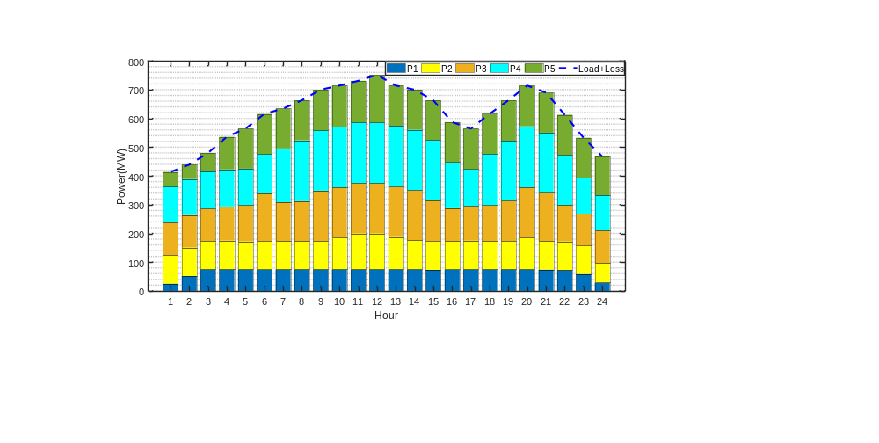
Figure 5. Constraint check for the compromise solution for test system 1
Figure 5 indicates that the sum of the output power of each unit meets the load demand and network loss. The curve in the figure is the sum of load demand (Load) and network loss (Loss) in different time periods. The histogram of different colors is the output power of each unit. The total output power of all units in the power system is equal to the sum of load demand and network loss, indicating that the unit combination obtained by ITSA conforms to the system power balance using equation (4). In addition, the output power of thermal power units 1, 2 and 3 is relatively stable, but the output power of units 4 and 5 changes greatly, which is used for peak load regulation.

5.3. Test system 2: 10-units system
The test system 2 includes ten thermal power generator units. The load demand at each scheduling moment is presented in Figure 6. Table 7 shows the compromise solutions of the state-of-the-art methods proposed in other literatures and the pareto frontier solutions obtained by ITSA and TSA algorithms.
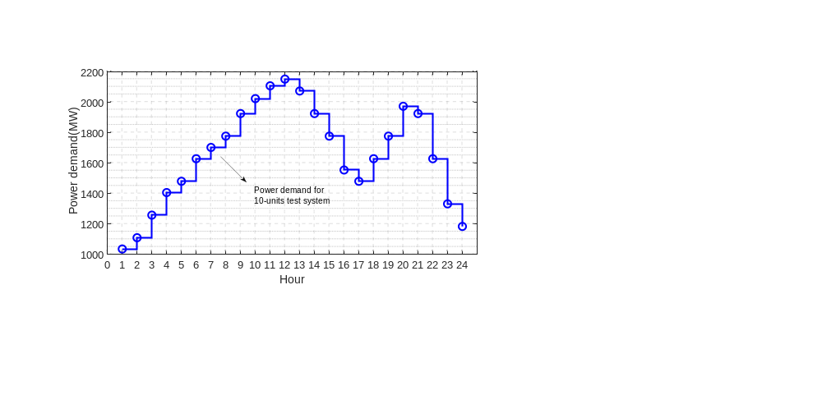
Figure 6. Load forecast curve for test system 2
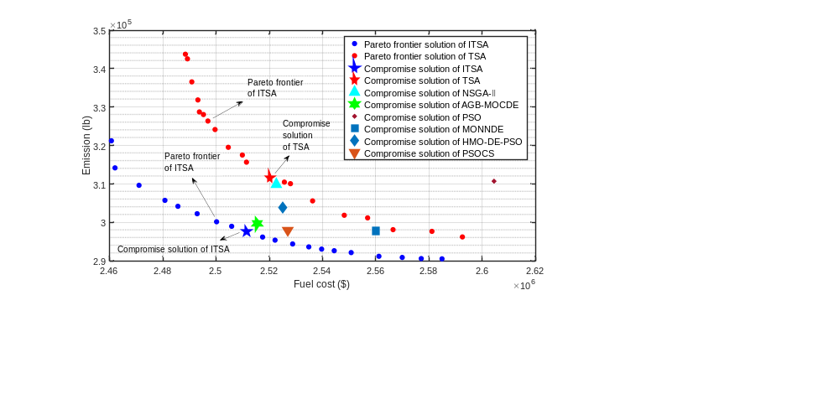
Figure 7. Comparison of Pareto frontier solution and compromise solution for test system 2

Table 6 reveals that the load demand of the 10-units test system becomes larger compared with the 5-units test system. Figure 7 shows the pareto front solution obtained by ITSA algorithm has uniform distribution and wide coverage, indicating that the pareto frontier solution of ITSA are more competitive than that of TSA. In addition, the compromise solutions of ITSA and TSA are marked in the Figure 7. The fuel cost and emission obtained by ITSA are both lower than those obtained by TSA, revealing that ITSA's global convergence ability is better than TSA. Compared with the compromise solutions of the state-of-the-art methods, the compromise solution of ITSA algorithm is also competitive, indicating that ITSA can effectively solve the 10-units test system. Table 7 lists the compromise solution of each algorithm.

Table 7. Comparing the compromise solutions of different algorithms in test system 2
Algorithms | NSGAⅡ | AGB-MOCDE | PSO | MONNDE | HMO-DE-PSO
Fuel cost ($) (10⁶) | 2.5226 | 2.5155 | 2.6044 | 2.56 | 2.525
Emission (lb) (10⁵) | 3.0994 | 2.9975 | 3.1075 | 2.9782 | 3.039
Algorithms | PSOCS | TSA | EMODE | NSCSO-MH | ITSA
Fuel cost ($) (10⁶) | 2.5269 | 2.5201 | 2.5110 | 2.5150 | 2.5114
Emission (lb) (10⁵) | 2.98 | 3.1164 | 2.9870 | 3.0029 | 2.9768

Table 7 presents the state-of-the-art methods for solving the 10-units test system, such as NSGAII[46], AGB-MOCDE[49], PSO[50], MONNDE[47], HMO-DE-PSO[51], PSOCS[35], EMODE[52] and NSCO-MH[48]. Test results reveals that the emission obtained by ITSA are smallest compared with the existing algorithms. The fuel cost obtained by ITSA is 4% lower than that obtained by PSO; meanwhile, the emission obtained by ITSA is 5% lower than that obtained by PSO. In addition, for the newly proposed EMODE and NSCSO-MH algorithms, the compromise solution obtained by the ITSA algorithm is also competitive. Compared with the NSCO-MH algorithm, the fuel cost obtained by the ITSA algorithm is 0.14% less than that of the NSCSO-MH, and the emission is 0.87% less. Since the power system is a huge system, even a small improvement is very helpful for reducing the fuel cost and the emission of pollutants of the power system. For the 10-units test system, ITSA algorithm gives the dispatch scheme with the least emissions, while taking into account the economy of the power system.

Figure 8 shows the convergence curves of the ITSA and TSA algorithms when obtaining the compromise solutions.
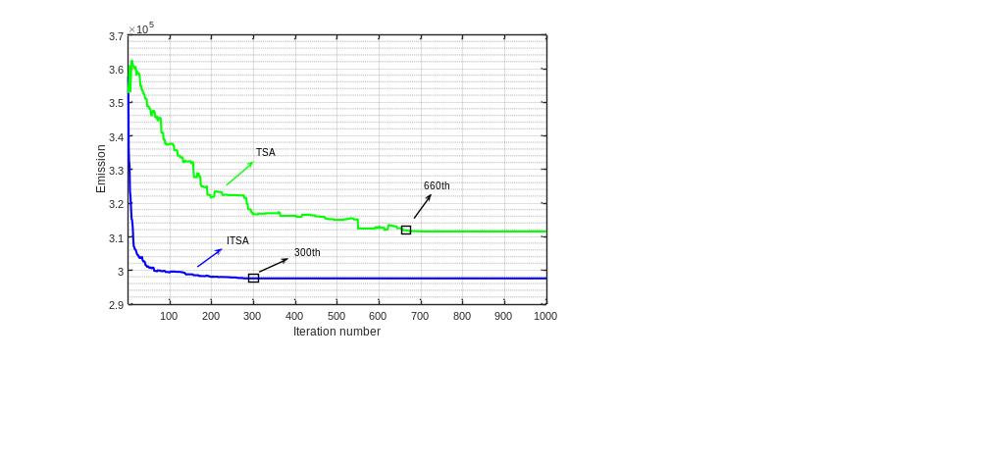
Figure 8. ITSA and TSA iterative curves when solving test system 2

Figure 8 indicated ITSA iterates to the optimal value around the 300th generation. However, TSA converges to the optimal value after the 660th generation. Moreover, the optimal value obtained by ITSA is lower than the optimal value of TSA. ITSA solves the DEED problem of the 10-units system faster and more efficiently. When solving the DEED problem of 10-units test system, the ITSA algorithm converges to the optimal value quickly by introducing Tent mapping and GWO technology. Meanwhile, Levy flight strategy makes ITSA algorithm avoid falling into local extremum to a great extent. Table 8 lists the detailed output power of each unit when ITSA obtains the compromise solutions.
Table 8. Hourly output power (MW), Fuel cost (×10⁶$) and Emission (×10⁵lb) obtain by ITSA when solving the 10-units system
Hour | P1 | P2 | P3 | P4 | P5 | P6 | P7 | P8 | P9 | P10
1 | 150.00 | 135.00 | 74.19 | 115.30 | 122.01 | 120.64 | 123.83 | 117.58 | 52.07 | 44.46
2 | 150.00 | 135.14 | 85.69 | 118.65 | 172.01 | 121.20 | 130.00 | 120.00 | 53.71 | 46.31
3 | 150.00 | 135.00 | 122.73 | 125.25 | 222.01 | 160.00 | 130.00 | 120.00 | 80.00 | 41.73
4 | 150.27 | 140.67 | 189.59 | 174.80 | 243.00 | 157.87 | 130.00 | 120.00 | 80.00 | 55.00
5 | 150.00 | 204.86 | 200.43 | 180.15 | 239.70 | 160.00 | 130.00 | 120.00 | 79.65 | 54.72
6 | 227.12 | 226.40 | 205.63 | 230.15 | 243.00 | 160.00 | 130.00 | 120.00 | 80.00 | 55.00
7 | 236.57 | 227.51 | 254.08 | 250.78 | 243.00 | 160.00 | 130.00 | 120.00 | 80.00 | 54.24
8 | 253.78 | 256.46 | 272.91 | 263.80 | 243.00 | 160.00 | 130.00 | 120.00 | 80.00 | 55.00
9 | 296.39 | 310.16 | 298.64 | 300.00 | 243.00 | 160.00 | 130.00 | 120.00 | 80.00 | 55.00
10 | 332.64 | 341.03 | 340.00 | 300.00 | 243.00 | 160.00 | 130.00 | 120.00 | 79.26 | 55.00
11 | 371.59 | 391.42 | 339.75 | 300.00 | 243.00 | 160.00 | 130.00 | 120.00 | 80.00 | 55.00
12 | 404.36 | 408.89 | 340.00 | 300.00 | 243.00 | 160.00 | 130.00 | 120.00 | 80.00 | 52.72
13 | 365.80 | 361.76 | 340.00 | 300.00 | 243.00 | 160.00 | 130.00 | 120.00 | 80.00 | 55.00
14 | 295.49 | 311.07 | 301.09 | 300.00 | 243.00 | 160.00 | 130.00 | 120.00 | 78.67 | 55.00
15 | 241.70 | 273.32 | 282.00 | 250.00 | 243.00 | 160.00 | 130.00 | 120.00 | 80.00 | 55.00
16 | 162.29 | 218.73 | 203.37 | 227.98 | 240.58 | 160.00 | 130.00 | 120.00 | 80.00 | 55.00
17 | 151.17 | 140.92 | 202.14 | 237.46 | 243.00 | 160.00 | 129.32 | 120.00 | 80.00 | 55.00
18 | 222.31 | 220.92 | 216.89 | 229.41 | 243.00 | 160.00 | 130.00 | 120.00 | 80.00 | 55.00
19 | 248.89 | 292.02 | 265.71 | 240.86 | 243.00 | 159.76 | 130.00 | 120.00 | 80.00 | 55.00
20 | 307.16 | 340.36 | 318.58 | 290.86 | 243.00 | 160.00 | 130.00 | 120.00 | 80.00 | 55.00
21 | 302.77 | 309.27 | 294.46 | 300.00 | 243.00 | 159.12 | 130.00 | 120.00 | 80.00 | 55.00
22 | 222.77 | 229.27 | 214.46 | 250.00 | 215.37 | 160.00 | 130.00 | 120.00 | 80.00 | 55.00
23 | 150.00 | 149.27 | 152.92 | 200.00 | 173.83 | 160.00 | 130.00 | 120.00 | 80.00 | 47.46
24 | 150.00 | 135.00 | 91.62 | 150.00 | 171.64 | 138.48 | 130.00 | 120.00 | 80.00 | 42.77
Fuel cost | 2.51
Emission | 2.97

Table 8 presents that the output power of all units in each period meets the unit output power constraints, and the output power of the unit between each time period satisfies the slope rate constraint. Figure 9 shows constraint check for the compromise solution.
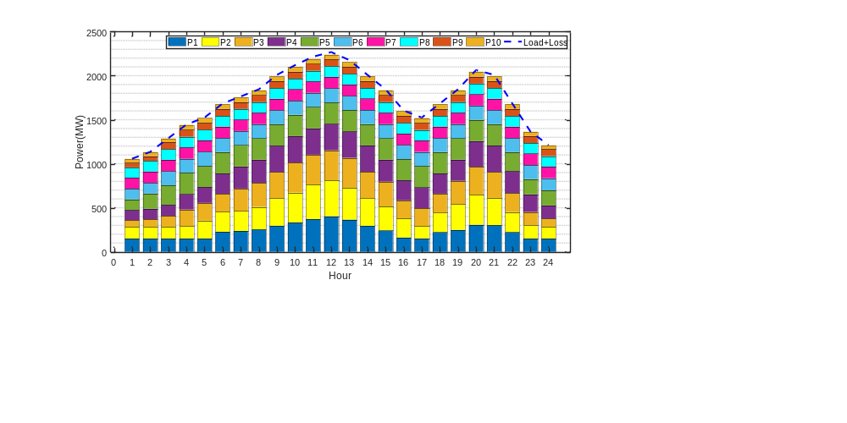
Figure 9. Constraint check for the compromise solution for test system 2

Figure 9 reveals the total output power of each unit is equal to the sum of the system load demand and the network loss, indicating that the dispatching scheme given by ITSA algorithm for 10-units test system satisfies the system power balance constraint. In addition, Figure 9 presents that units 5 to 10 are in full load operation, and units 1 to 4 change output power to regulate peak load to meet the change of load demand.

5.4. Test system 3: 15-units system
The test system 3 includes fifteen thermal power generator units. Compared with the 5-units and 10-units test systems, the 15-units test system contains the largest number of thermal power units, which makes the DEED model more difficult to solve and puts forward higher requirements for the algorithm’s solution performance. Figure 10 reveals the load demand in each period for the 15-units test system.
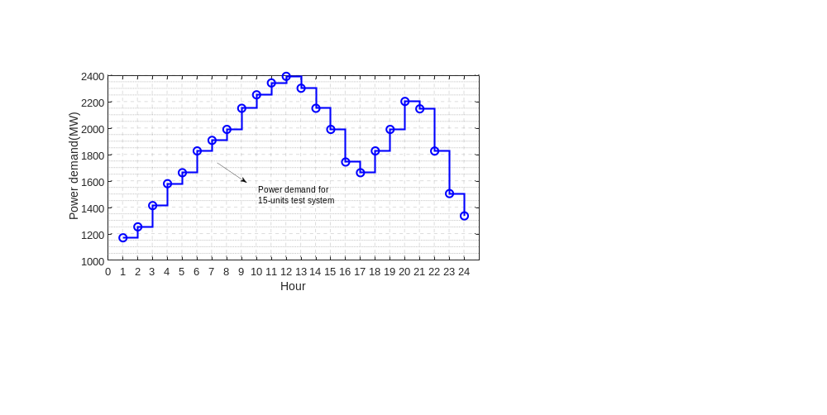
Figure 10. Load forecast curve of test system 3

Figure 10 shows that the load demand of the 15-units test system is further increased in each period compared with the 10-units test system. The pareto frontier solutions obtained by ITSA and TSA, and the compromise solutions obtained by the state-of-the-art methods proposed in other literatures are presented in Figure 11.
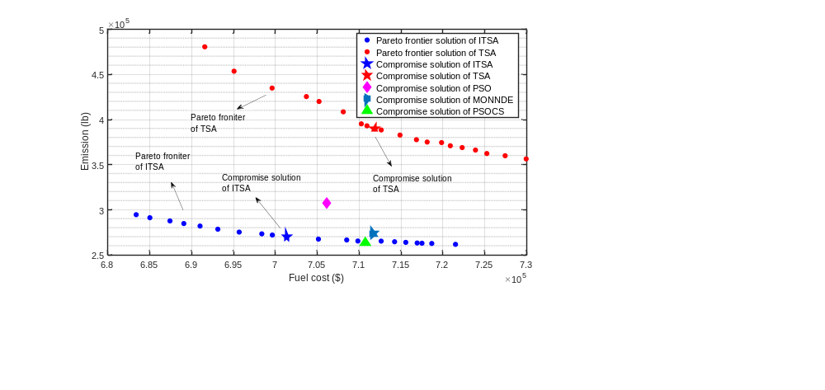
Figure 11. Pareto frontier solutions and compromise solutions for test system 3

Similar to the pareto frontier solution in Figure 7, the pareto frontier solution of the ITSA algorithm in Figure 11 is significantly better than the frontier solution of the TSA algorithm, and the frontier solution is more evenly distributed. The fuel cost and emission of ITSA's compromise solution are both smaller than those of TSA's compromise solution, revealing that ITSA's compromise solution is more competitive. In addition, Figure 11 presents the compromise solutions of various state-of-the-art methods. Compared with the state-of-the-art methods, the dispatching scheme given by ITSA algorithm is still competitive. In sum, ITSA effectively solves the DEED problem for the 15-units test system. Table 9 lists the compromise solution obtained by each algorithm.

Table 9. Comparing the compromise solutions of different algorithms for test system 3
Algorithms | PSO | MONNDE | PSOCS | PPSO | TSA | ITSA
Fuel cost ($) (10⁵) | 7.0613 | 7.1164 | 7.1074 | 7.2127 | 7.1185 | 7.0136
Emission (lb) (10⁵) | 3.0773 | 2.7391 | 2.6363 | 2.6300 | 3.9002 | 2.7037

Table 9 shows the state-of-the-art algorithms for solving the 15-units test system, such as PSO[50], MONNDE[47], PSOCS[35] and PPSO[35]. Test results presents that the fuel cost obtained by ITSA is the smallest. Although the fuel cost is slightly lower than PSO, the emission obtained by ITSA are 13% lower than that obtained by PSO. Compared with PSO, MONNDE and TSA algorithms, the compromise solution obtained by ITSA algorithm is more competitive, and the dispatching scheme with minimum fuel cost and emission is given. For PPSO and PSOCS algorithms, the emission obtained by the ITSA algorithm was slightly higher than PPSO and PSOCS algorithms, but ITSA algorithm gets the minimum fuel cost. ITSA effectively solves the DEED problem for the 15-units system. Compared with the state-of-the-art methods, ITSA reduces the fuel cost of thermal power units to a large extent and reduces emissions to a certain extent. Figure 12 shows the convergence curves of ITSA and TSA algorithms when obtaining the compromise solutions.
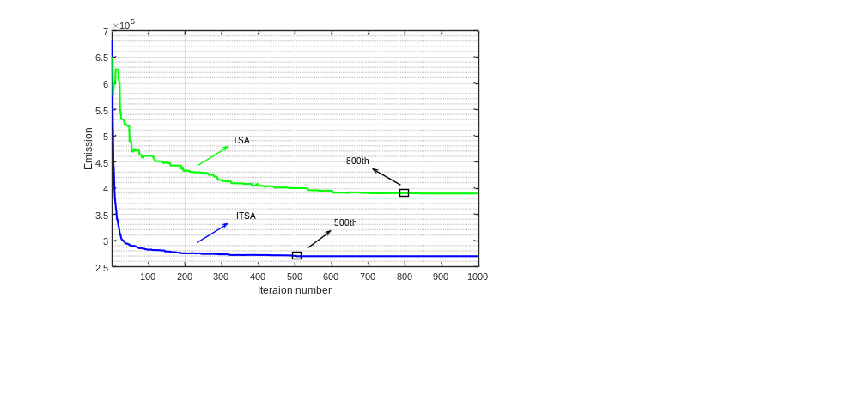
Figure 12. Iterative curves of ITSA and TSA algorithms when solving test system 3

Figure 12 indicates ITSA iterates to the optimal value around the 500th generation, and TSA only converges to the optimal value after the 800th generation. The optimal value obtained by ITSA is smaller than the TSA optimal value. For the 15-units test system, the compromise solution obtained by the ITSA algorithm containing the output of each unit in each period is listed in Table A (in the Appendix). Figure 13 presents constraint check for the compromise solution obtained by ITSA.

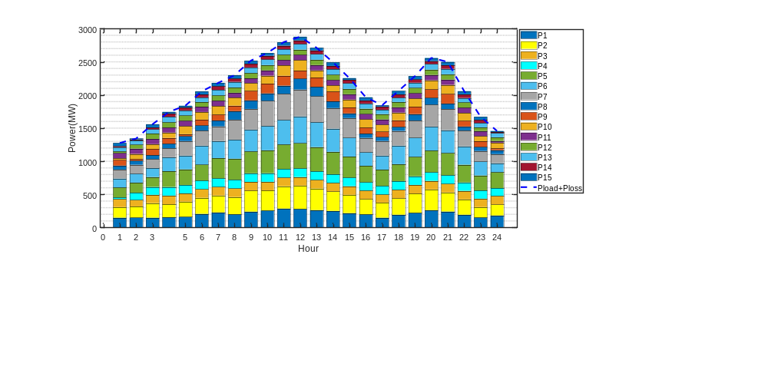
Figure 13. Constraint check for the compromise solution in test system 3

Figure 13 shows that the total output power of each unit is equal to the sum of the system load demand and the network loss, revealing that the compromise solution of ITSA meets the system power balance constraint. It can be seen from Table A in the Appendix that units 3, 4, 11 and 12 are operating at full load, and the remaining units are responsible for peak load adjustment to meet change of load demand.
For three test cases, the compromise solutions obtained by the ITSA algorithm are competitive compared to the state-of-the-art methods by analyzing the test results in Tables 5, 7 and 9. The performance of ITSA algorithm's global search and local exploitation is greatly strengthened through introducing Levy strategy and GWO technology, so that ITSA algorithm is not easy to fall into local extremum solution when solving DEED problem and gets better compromise solutions.

6. Discussion
Effective optimization of DEED problem considering the valve point effect improves stability of the power system and is of great significance to power system safety. Hence, the valve point effect is considered in the constructed DEED model to make the obtained dispatching scheme closer to reality, but the valve point effect greatly increases difficulty to solve the DEED problem. Therefore, this study proposes ITSA to solve the DEED problem, and ITSA shows better convergence and optimization performance when solving DEED problems. The dispatching scheme obtained by ITSA reduces the fuel cost and pollutant emission of the grid, and improves the economy and environmental protection of the grid by reasonably distributing the output of generator units. For the test system with different number of units, ITSA algorithm can get a competitive dispatching scheme, which enriches the diversity of power system dispatching and improves stability of dispatching.
In addition, this study has important reference significance for power grid dispatching. In 2014, Pakistan’s thermal power generation was approximately 87.3 billion kWh, the cost of power generation was approximately US$8.8 billion, and total pollutant emission was approximately 166 million tons. In 2018, Rwanda's thermal power generation was approximately 369 million kWh, the cost of power generation was approximately US$36 million, and pollutant emission was about 960,000 tons. In 2010, China’s thermal power generation was approximately 3,416.5 billion kWh, the cost of power generation was approximately US$122.2 billion, and the pollutant emission was 1.582 billion tons. If the above-mentioned countries adopt the PSO algorithm to achieve the above results, fuel cost reduces by up to 10% after using ITSA, which is a reduction of 800 million US dollars, 3.6 million US dollars and 12.2 billion US dollars respectively. Meanwhile, pollutant emission reduces by up to 13%, which is a reduction of 21 million tons, 124,800 tons and 200 million tons respectively. Therefore, this study provides a new idea for the power sector to formulate a more refined dispatching scheme, which has practical significance.

7. Concluding remarks
DEED adjusted each generator unit output, thereby reducing pollutant emission of the power system and improves its economic outcomes. The two conflicting goals of fuel cost and pollutant emission need to be optimized. The unit combination in the optimization result plays a role in reducing fuel costs and emissions. The conclusions are summarized as follows:
- A multi-objective optimal dispatch model considering economy and environmental protection is constructed. In addition, the valve point effect is considered in the optimization objective, and the multi-objective optimization problem is transformed into a single objective optimization problem by weight technology to reduce the calculation of the optimization model.
- To improve the optimization performance of TSA algorithm, ITSA algorithm is proposed. In ITSA algorithm, Tent mapping is used to improve the uniformity of initial solution distribution, and Levy flight strategy is employed to maintain the diversity of population. On this basis, the proposed ITSA algorithm is verified by the benchmark functions. The convergence results of ITSA algorithm are more competitive than those of TSA, PSO and DA.
- The proposed ITSA is employed to optimize the test systems containing 5, 10, and 15 units to verify the ability for solving the DEED problem. ITSA algorithm gives more satisfactory dispatch schemes, which makes the operation cost of the generation system smaller and the pollution gas emission less. The results show that the fuel cost is reduced by 10%, 4%, and 1%, and the pollutant emission is reduced by 9%, 10%, and 13% compared with PSO.
- The maximum satisfaction criterion is employed to determine the compromise solution of the Pareto frontier, and the compromise solution gives consideration to both economic benefits and environmental protection of power generation system. The constructed DEED model and the ITSA algorithm proposed in this study provide a new idea for the economic and environmental dispatch of the power system.

Acknowledgment
This study was supported by the key project of Tianjin Natural Science Foundation [Project No. 19JCZDJC32100] and the Natural Science Foundation of Hebei Province of China [Project No. E2018202282].

References
[1] Alomoush, M. I., & Oweis, Z. B. (2018). Environmental-economic dispatch using stochastic fractal search algorithm. International Transactions on Electrical Energy Systems, 28(5), e2530.
[2] Edwin Selva Rex, C. R., Beno, M. M., & Annrose, J. (2019). Optimal Power Flow-Based Combined Economic and Emission Dispatch Problems Using Hybrid PSGWO Algorithm. Journal of Circuits, Systems and Computers, 28(09), 1950154.
[3] Li, L., Yang, Y., Tseng, ML., Wang, C. H., Wu, K-J., Lim., M. (2018). A novel method to solve sustainable economic power loading dispatch problem. Industrial Management and Data Systems 118(4), 806-827.
[4] Li, J., Sang, H., Pan, Q., Duan, P., & Gao, K. (2017). Solving multi-area environmental economic dispatch by Pareto-based chemical-reaction optimization algorithm. IEEE/CAA Journal of Automatica Sinica, 6(5), 1240-1250.
[5] Liang, H., Liu, Y., Li, F., & Shen, Y. (2018). A multiobjective hybrid bat algorithm for combined economic/emission dispatch. International Journal of Electrical Power & Energy Systems, 101, 103-115.
[6] Mahdi, F. P., Vasant, P., Abdullah-Al-Wadud, M., Kallimani, V., & Watada, J. (2018). Quantum-behaved bat algorithm for many-objective combined economic emission dispatch problem using cubic criterion function. Neural Computing and Applications, 31(10), 5857-5869.
[7] Maity, D., Banerjee, S., & Chanda, C. K. (2018). Bare Bones Teaching Learning-Based Optimization Technique for Economic Emission Load Dispatch Problem Considering Transmission Losses. Iranian Journal of Science and Technology, Transactions of Electrical Engineering, 43(S1), 77-90.
[8] Kheshti, M., Kang, X., Li, J., Regulski, P., & Terzija, V. (2017). Lightning flash algorithm for solving non-convex combined emission economic dispatch with generator constraints. IET Generation, Transmission & Distribution, 12(1), 104-116.
[9] Rajagopalan, A., Kasinathan, P., Nagarajan, K., Ramachandaramurthy, V. K., Sengoden, V., & Alavandar, S. (2019). Chaotic self‐adaptive interior search algorithm to solve combined economic emission dispatch problems with security constraints. International Transactions on Electrical Energy Systems, 29(8), e12026.
[10] Shen, X., Zou, D., Duan, N., & Zhang, Q. (2019). An efficient fitness-based differential evolution algorithm and a constraint handling technique for dynamic economic emission dispatch. Energy, 186, 115801.
[11] Jayabarathi, T., Ramesh, V., Kothari, D. P., Pavan, K., & Thumbi, M. (2008). Hybrid differential evolution technique for economic dispatch problems. Journal of Electrical Engineering & Technology, 3(4), 476-483.
[12] Karthik, N., Parvathy, A. K., & Arul, R. (2019). Multi-objective economic emission dispatch using interior search algorithm. International Transactions on Electrical Energy Systems, 29(1), e2683.
[13] Wang, L., & Singh, C. (2007). Environmental/economic power dispatch using a fuzzified multi-objective particle swarm optimization algorithm. Electric Power Systems Research, 77(12), 1654-1664.
[14] Baziar, A., Rostami, M. A., & Akbari-Zadeh, M. R. (2014). An intelligent approach based on bat algorithm for solving economic dispatch with practical constraints. Journal of Intelligent & Fuzzy Systems, 27(3), 1601-1607.
[15] Gupta, A., Swarnkar, K. K., Wadhwani, S., & Wadhwani, D. A. K. (2012). Combined economic emission dispatch problem of thermal generating units using particle swarm optimization. International Journal of Computer Applications, 49(6), 1-6.
[16] Hardiansyah, H., Junaidi, J., & Yandri, Y. (2016). Combined Economic Emission Dispatch Solution using Simulated Annealing Algorithm. IOSR Journal of Electrical and Electronics Engineering, 11(05), 141-148.
[17] Wang, L., & Singh, C. (2008). Stochastic economic emission load dispatch through a modified particle swarm optimization algorithm. Electric Power Systems Research, 78(8), 1466-1476.
[18] Kaur, S., Awasthi, L. K., Sangal, A. L., & Dhiman, G. (2020). Tunicate Swarm Algorithm: A new bio-inspired based metaheuristic paradigm for global optimization. Engineering Applications of Artificial Intelligence, 90, 103541.
[19] Kenan Dosoglu, M., Guvenc, U., Duman, S., Sonmez, Y., & Tolga Kahraman, H. (2016). Symbiotic organisms search optimization algorithm for economic/emission dispatch problem in power systems. Neural Computing and Applications, 29(3), 721-737.
[20] Jevtic, M., Jovanovic, N., Radosavljevic, J., & Klimenta, D. (2017). Moth Swarm Algorithm for Solving Combined Economic and Emission Dispatch Problem. Elektronika Ir Elektrotechnika, 23(5), 21-28.
[21] Dey, B., Roy, S. K., & Bhattacharyya, B. (2018). Solving multi-objective economic emission dispatch of a renewable integrated microgrid using latest bio-inspired algorithms. Engineering Science and Technology, an International Journal, 22(1), 55-66.
[22] Elsheakh, Y., Zou, S., Ma, Z., & Zhang, B. (2018). Decentralised gradient projection method for economic dispatch problem with valve point effect. IET Generation, Transmission & Distribution, 12(16), 3844-3851.
[23] Momoh, J. A., Guo, S. X., Ogbuobiri, E. C., & Adapa, R. (1994). The quadratic interior point method solving power system optimization problems. IEEE Transactions on Power Systems, 9(3), 1327-1336.
[24] Muralidharan, S., Srikrishna, K., & Subramanian, S. (2006). Emission Constrained Economic Dispatch—A New Recursive Approach. Electric Power Components and Systems, 34(3), 343-353.
[25] Mousavi, S. Z., Akhondali, A. M., Naseri, A., Eslamian, S., Saadati, S., Evaluation of Whale and Particle Swarm Optimization Algorithms in Optimal Allocation of Water Resources of Irrigation Network to Maximize Net Benefit Case Study: Salman Farsi, International Journal of Hydrology Science and Technology, Accepted for Publication. https://www.inderscience.com/info/ingeneral/forthcoming.php?jcode=ijhst
[26] Dorigo, M., Oca, M. A. M. D., & Engelbrecht, A. P. (2008). Particle swarm optimization. Scholarpedia, 3(8), 1486.
[27] Whitley, D., Starkweather, T., & Bogart, C. (1990). Genetic algorithms and neural networks: optimizing connections and connectivity. Parallel Computing, 14(3), 347-361.
[28] Mahmoud H. Alrefaei and Sigrún Andradóttir. (1999). A simulated annealing algorithm with constant temperature for discrete stochastic optimization. Management ence, 45(5), 748-764.
[29] Basu, M. (2004). An Interactive Fuzzy Satisfying-Based Simulated Annealing Technique for Economic Emission Load Dispatch with Non-smooth Fuel Cost and Emission Level Functions. Electric Power Components and Systems, 32(2), 163-173.
[30] Basu, M. (2006). Particle Swarm Optimization Based Goal-Attainment Method for Dynamic Economic Emission Dispatch. Electric Power Components and Systems, 34(9), 1015-1025.
[31] Hagh, M. T., Kalajahi, S. M. S., & Ghorbani, N. (2020). Solution to economic emission dispatch problem including wind farms using Exchange Market Algorithm Method. Applied Soft Computing, 88, 106044.
[32] Daryani, N., & Zare, K. (2016). Multiobjective power and emission dispatch using modified group search optimization method. Ain Shams Engineering Journal, 9(3), 319-328.
[33] Vijay, R. (2018). Quorum Sensing Driven Bacterial Swarm Optimization to Solve Practical Dynamic Power Ecological Emission Economic Dispatch. International Journal of Computational Methods, 15(03), 1850089.
[34] Li, Z., Zou, D., & Kong, Z. (2019). A harmony search variant and a useful constraint handling method for the dynamic economic emission dispatch problems considering transmission loss. Engineering Applications of Artificial Intelligence, 84, 18-40.
[35] Qian, S., Wu, H., & Xu, G. (2020). An improved particle swarm optimization with clone selection principle for dynamic economic emission dispatch. Soft Computing. doi: 10.1007/s00500-020-04861-4.
[36] Sen, T., & Mathur, H. D. (2016). A new approach to solve Economic Dispatch problem using a Hybrid ACO–ABC–HS optimization algorithm. International Journal of Electrical Power & Energy Systems, 78, 735-744.
[37] Naderi, E., Azizivahed, A., Narimani, H., Fathi, M., & Narimani, M. R. (2017). A comprehensive study of practical economic dispatch problems by a new hybrid evolutionary algorithm. Applied Soft Computing, 61, 1186-1206.
[38] Gherbi, Y. A., Lakdja, F., Bouzeboudja, H., & Gherbi, F. Z. (2019). Hybridization of two metaheuristics for solving the combined economic and emission dispatch problem. Neural Computing and Applications, 31(12), 8547-8559.
[39] Silva Chavez, J. C., Zamora-Mendez, A., Arrieta Paternina, M. R., Yrena Heredia, J. F., & Cardenas-Javier, R. (2019). A hybrid optimization framework for the non-convex economic dispatch problem via meta-heuristic algorithms. Electric Power Systems Research, 177, 105999.
[40] Basu, M. (2007). Dynamic Economic Emission Dispatch Using Evolutionary Programming and Fuzzy Satisfying Method. International Journal of Emerging Electric Power Systems, 8(4), Article 1.
[41] Muthusamy, H., Ravindran, S., Yaacob, S., & Polat, K. (2021). An improved elephant herding optimization using sine-cosine mechanism and opposition based learning for global optimization problems. Expert Systems with Applications, 172, 114607.
[42] Zhang, X. M., Lin, Q. Y., Mao, W. T., Liu, S. W., Dou, Z., & Liu, G. Q. (2021). Hybrid Particle Swarm and Grey Wolf Optimizer and its application to clustering optimization. Applied Soft Computing, 101, 107061
[43] Tudose, A. M., Picioroaga, I. I., Sidea, D. O., & Bulac, C. (2021). Solving Single- and Multi-Objective Optimal Reactive Power Dispatch Problems Using an Improved Salp Swarm Algorithm. Energies, 14(5), 1222.
[44] Li, L. L., Chang, Y. B., Tseng, M. L., Liu, J. Q., & Lim, M. K. (2020). Wind power prediction using a novel model on wavelet decomposition-support vector machines-improved atomic search algorithm. Journal of Cleaner Production, 270(12), 121817.
[45] Alsumait, J. S., Qasem, M., Sykulski, J. K., & Al-Othman, A. K. (2010). An improved Pattern Search based algorithm to solve the Dynamic Economic Dispatch problem with valve-point effect. Energy Conversion and Management, 51(10), 2062-2067.
[46] Basu, M. (2008). Dynamic economic emission dispatch using nondominated sorting genetic algorithm-II. International Journal of Electrical Power & Energy Systems, 30(2), 140-149.
[47] Mason, K., Duggan, J., & Howley, E. (2018). A multi-objective neural network trained with differential evolution for dynamic economic emission dispatch. International Journal of Electrical Power & Energy Systems, 100, 201-221.
[48] Chinnadurrai, C. L., & Victoire, T. A. A. (2020). Dynamic Economic Emission Dispatch Considering Wind Uncertainty Using Non-Dominated Sorting Crisscross Optimization. IEEE Access, 8, 94678-94696.
[49] Zhang, H. F., Lei, X. H., Wang, C., Yue, D., & Xie, X. P. (2017). Adaptive grid based multi-objective Cauchy differential evolution for stochastic dynamic economic emission dispatch with wind power uncertainty. Plos One, 12(9), 25.
[50] Mason K, Duggan J, Howley E (2017). Multi-objective dynamic economic emission dispatch using particle swarm optimization variants. Neurocomputing 270(12): 188–197.
[51] Liu, G., Zhu, Y. L., & Jiang, W. (2018). Wind-thermal dynamic economic emission dispatch with a hybrid multi-objective algorithm based on wind speed statistical analysis. Iet Generation Transmission & Distribution, 12(17), 3972-3984.
[52] Bai, Y. J., Wu, X. D., & Xia, A. M. (2021). An enhanced multi-objective differential evolution algorithm for dynamic environmental economic dispatch of power system with wind power. Energy Science & Engineering, 9(3), 316-329.

Appendix
Table A. Hourly output power (MW), Fuel cost (×10⁶$) and Emission (×10⁵lb) obtain by ITSA when solving the 10-units system
Hour | P1 | P2 | P3 | P4 | P5 | P6 | P7 | P8
1 | 150.00 | 159.44 | 121.52 | 24.54 | 150.00 | 135.00 | 135.00 | 60.00
2 | 151.20 | 167.86 | 98.18 | 109.91 | 151.07 | 135.00 | 135.00 | 60.00
3 | 150.02 | 219.69 | 125.07 | 118.27 | 150.00 | 135.00 | 135.00 | 60.00
4 | 155.49 | 197.04 | 130.00 | 130.00 | 238.21 | 210.59 | 135.00 | 68.79
5 | 162.69 | 228.53 | 125.21 | 126.83 | 235.61 | 207.73 | 218.92 | 72.24
6 | 207.58 | 242.32 | 130.00 | 130.00 | 239.87 | 287.09 | 226.64 | 78.09
7 | 228.91 | 255.63 | 130.00 | 128.91 | 305.01 | 258.20 | 220.59 | 88.01
8 | 200.92 | 260.22 | 130.00 | 130.00 | 318.08 | 288.03 | 300.63 | 128.32
9 | 240.94 | 318.15 | 130.00 | 130.00 | 330.42 | 329.63 | 311.35 | 128.72
10 | 257.66 | 303.37 | 130.00 | 130.00 | 345.35 | 366.40 | 379.32 | 112.85
11 | 287.28 | 337.65 | 129.61 | 130.00 | 369.37 | 370.86 | 393.42 | 123.11
12 | 281.37 | 351.73 | 130.00 | 130.00 | 380.48 | 404.93 | 404.80 | 163.99
13 | 263.30 | 326.23 | 130.00 | 130.00 | 365.22 | 375.58 | 390.60 | 142.56
14 | 251.97 | 292.97 | 130.00 | 130.00 | 338.00 | 349.69 | 310.60 | 101.65
15 | 218.35 | 276.38 | 130.00 | 130.00 | 316.98 | 284.30 | 296.44 | 70.14
16 | 200.23 | 228.63 | 130.00 | 125.54 | 247.95 | 204.64 | 216.44 | 63.81
17 | 150.00 | 227.20 | 121.71 | 130.00 | 245.65 | 211.88 | 220.45 | 60.00
18 | 194.4 | 246.49 | 130.00 | 130.00 | 255.68 | 280.69 | 221.38 | 60.00
19 | 222.94 | 291.21 | 130.00 | 130.00 | 293.40 | 288.66 | 259.19 | 96.04
20 | 262.20 | 314.12 | 128.71 | 130.00 | 327.19 | 362.59 | 329.97 | 102.80
21 | 242.39 | 288.04 | 130.00 | 130.00 | 334.65 | 344.97 | 319.03 | 81.86
22 | 194.40 | 230.74 | 130.00 | 126.90 | 267.19 | 277.02 | 239.03 | 60.00
23 | 153.05 | 156.80 | 127.21 | 123.95 | 225.76 | 210.15 | 159.03 | 61.14
24 | 183.13 | 164.79 | 130.00 | 118.32 | 240.44 | 135.15 | 136.73 | 60.00

Continued Table A. Hourly output power (MW), Fuel cost (×10⁶$) and Emission (×10⁵lb) obtain by ITSA when solving the 10-units system
Hour | P9 | P10 | P11 | P12 | P13 | P14 | P15
1 | 84.52 | 25.00 | 79.32 | 25.61 | 62.18 | 15.87 | 48.05
2 | 25.43 | 77.48 | 80.00 | 60.19 | 62.43 | 15.00 | 15.00
3 | 92.96 | 72.75 | 79.38 | 80.00 | 64.38 | 27.68 | 48.19
4 | 87.90 | 80.37 | 75.81 | 80.00 | 83.96 | 47.19 | 24.99
5 | 31.15 | 122.83 | 80.00 | 80.00 | 75.40 | 45.46 | 25.38
6 | 86.22 | 116.02 | 79.92 | 69.76 | 70.24 | 45.77 | 45.09
7 | 89.86 | 129.31 | 80.00 | 80.00 | 84.05 | 55.00 | 49.35
8 | 83.47 | 121.6 | 72.38 | 80.00 | 85.00 | 50.51 | 49.23
9 | 143.55 | 117.62 | 71.09 | 80.00 | 84.39 | 55.00 | 47.25
10 | 146.26 | 120.26 | 80.00 | 80.00 | 85.00 | 55.00 | 41.89
11 | 149.24 | 158.40 | 79.48 | 80.00 | 83.93 | 51.50 | 52.48
12 | 119.81 | 160.00 | 80.00 | 77.91 | 85.00 | 53.84 | 55.00
13 | 139.65 | 108.81 | 80.00 | 80.00 | 85.00 | 55.00 | 40.61
14 | 148.54 | 92.57 | 80.00 | 80.00 | 85.00 | 47.47 | 55.00
15 | 89.72 | 119.34 | 80.00 | 80.00 | 85.00 | 52.73 | 25.56
16 | 92.27 | 124.55 | 80.00 | 80.00 | 77.47 | 46.20 | 48.28
17 | 81.62 | 103.70 | 79.59 | 80.00 | 66.14 | 47.88 | 18.92
18 | 99.62 | 116.36 | 80.00 | 80.00 | 64.55 | 50.98 | 51.30
19 | 111.71 | 125.19 | 79.56 | 80.00 | 77.97 | 49.44 | 49.82
20 | 128.39 | 136.86 | 80.00 | 80.00 | 84.56 | 44.64 | 46.64
21 | 145.44 | 136.20 | 79.44 | 80.00 | 82.88 | 54.91 | 49.05
22 | 86.18 | 118.43 | 80.00 | 79.49 | 65.59 | 55.00 | 47.74
23 | 85.80 | 77.28 | 75.37 | 56.07 | 66.70 | 46.57 | 46.56
24 | 27.40 | 85.70 | 24.25 | 56.15 | 64.10 | 15.00 | 15.93

