Modeling the distribution of the Near Eastern fire salamander (Salamandra infraimmaculata) and Kurdistan newt (Neurergus derjugini) under current and future climate conditions in Iraq

Nabaz R. Khwarahm^{1*}, Korsh Ararat², Sarchil Qader^{3, 4}, Dana Khdr Sabir⁵
¹Department of Biology, College of Education, University of Sulaimani, Sulaimani 334, Kurdistan Region, Iraq
²Department of Biology, College of Science, University of Sulaimani, Sulaimani 334, Kurdistan Region, Iraq
³WorldPop, Geography and Environmental Science, University of Southampton, Southampton SO17 1BJ, UK
⁴Natural Resources Department, College of Agricultural Engineering Sciences, University of Sulaimani, Sulaimani 334, Kurdistan Region, Iraq
⁵Department of Medical Laboratory Science, Charmo University, Chamchamal 46023, Sulaimani, Kurdistan Region, Iraq

*khwarahm21302@alumni.itc.nl https://orcid.org/0000-0002-0183-8388

Abstract
Among the amphibians, the most sensitive group to climate change are salamanders (e.g., S. infraimmaculata and N. derjugini). In Iraq, these species are considered threatened by the International Union for Conservation of Nature (IUCN) RED List (2020). Apart from their important role in forest ecosystems stability and integrity, they are useful indicators for ecosystems functions. These species occur only in the mountain forests of the northeast, the Kurdistan region of Iraq (KRI), and information on their distributions is limited and poorly understood. Using the maximum entropy modeling and geospatial techniques, we aimed to: (i) map current distributions of the two species, and predict potential habitat distributions; (ii) model impact of the future climate change on their distributions; (iii) map overlapping habitat range for the species; and (iv) determine the main environmental variables shaping their distributions.

Under the Representative Concentration Pathway (RCP) 2.6 2070 and RCP8.5 2070 climate change scenarios, the overall expansion magnitude of the habitat for the species would be smaller than the contraction magnitude. For S. infraimmaculata and N. derjugini, the habitat would contract by 1751.58 km² (3.42%) and 2127.22 km² (4.16%), whereas expand only 226.77 km² (0.44%) and 1877.49 km² (3.67%), respectively. Climate change would significantly reduce the habitat ranges of the two species in Iraq. Habitat reduction for S. infraimmaculata would be more than N. derjugini. The potential distribution of the species would be toward the mountain forests of the east mainly and southeast of the KRI. Conservation actions should concentrate on the mountain forests (mixed oak) by establishing national parks, protected areas, and developing forest management policy. Current emphasis for conservation priority should focus specifically on areas where the species overlap by 1583.71 km² (3.09%). Our study provides baseline information for further investigation of the mountain forest ecosystems, and biodiversity conservation actions in Iraq.

Keywords: predictive modeling, climate change, S. infraimmaculata, N. derjugini, species distribution

1. Introduction
Over the last two decades, amphibian populations have been declining in various parts of the world, predominantly, due to the climate change, and land degradation (Greenberg et al. 2018; Stuart et al. 2004; Wake 1991). Among the amphibians, the most sensitive group to climate change conditions are salamanders because of their strong dependence on water availability, and limited dispersal abilities (Ashrafzadeh et al. 2019; Sutton et al. 2015; van Riemsdijk et al. 2017). Climate change is amongst the key factors reported to influence the population of salamanders either directly (e.g., drought episodes), or indirectly (e.g., affecting ecological processes, such as species interactions and spreading of diseases) (Achour and Kalboussi 2020; Miller et al. 2018).

In the Republic of Iraq, so far, three species of salamanders are described, namely; Kurdistan Newt (N. derjugini) (Nesterov 1916), Lake Urmia Newt (N. crocatus) (Cope 1862), and the Near Eastern Fire Salamander (S. infraimaculata) (Nesterov 1916). Based on the International Union for Conservation of Nature (IUCN 2020) RED list assessment, these species are critically endangered, vulnerable, and near threatened, respectively. In Iraq, the three species occur only in the mountain forests of the northeast, officially known as Kurdistan region of Iraq (KRI) (Fig.2). Previously thought, N. derjugini restricted only to localities in Hawraman and Penjiwen areas in the Sulaimani governorate in the KRI (Nesterov 1916); but recent studies showed wider distribution range of this species in Iraq (Hendrix et al. 2014; Schneider and Schneider 2011), Iran (Barabanov and Litvinchuk 2015; Bozorgi et al. 2015), and mid‐Zagros range between Iraq and Iran (Malekoutian et al. 2020). On the other hand, S. infraimaculata demonstrated wider regional distribution as described, a long time ago, by Martens (1885) from northern Iraq, northern Israel, western Iran, and southeastern and eastern Turkey (Olgun et al. 2015). Fortunately, in the last few years, several survey efforts by co-authors (e.g., KA) of this study, and international enthusiasts (Böhme et al. 2013) have rediscovered S. infraimaculata in few localities in the northeastern Iraq, for example in Siya Guves and Hawraman areas, respectively, in Sulaimani.

Salamanders apart from their important role in forest ecosystems stability and integrity, they are useful indicators for ecosystems health because of their sensitivity to climate change (Hocking and Babbitt 2014). In Iraq, the natural habitat of the salamanders (i.e., mountain forests of the KRI) has been deteriorating due to deforestation (e.g., war, clearing, cutting, over exploitation for firewood and charcoal), shifting cultivation, water extraction from streams, land cover land use change (Khwarahm et al. 2020; Nasser 1984), ecotourism site establishment, changing the path or controlling the natural streams by building local reservoirs, and severe drought episodes (Yenigun and Ibrahim 2019). The habitat deterioration caused by these factors could increase in the wake of climate change. Climate change has shown to influence the distribution of some species either by expanding or shrinking its range (Meynecke 2004; Monzón et al. 2011). Particularly salamanders are at higher risk as climate changes (Lawler et al. 2010; Urban 2015). In Iraq, studies on the geographical distributions of the amphibians and particularly on salamanders are limited or non-existent. Thus, information on current and future potential species ranges provides invaluable insight into biodiversity conservation actions and establishing the most suitable protected areas (which is non-existent in Iraq). Species distribution models (SDMs) and geographic information system (GIS) techniques provide a unique opportunity to map current and potential future distributions, and quantify possible habitat overlap and shifts as climate changes (Duan et al. 2016; Kalboussi and Achour 2018). SDMs, provide biodiversity conservationists with accurate spatial distributions by relating known locations of a species to environmental variables over space and time. With such information, SDMs, can provide estimates of potential suitable areas, particularly, for rare species (i.e., spare or restricted distribution and thus limited number of occurrence records) that could occupy and not covered by survey efforts (Hernandez et al. 2006). In other words, the spatial distribution is predicted by mapping potential areas where the environmental variables (or requirements) are met for the species’ presence (Elith et al. 2006; Guisan and Zimmermann 2000). Besides, offering significant aid in locating previously unknown populations, the models also identify potential areas for reintroduction, planning further survey efforts, and flagging protected areas for conservation actions (Graham et al. 2004). Among the SDMs, one of the widely accepted and popular models is the maximum entropy (MaxEnt) (Phillips et al. 2006), a machine learning algorithm with the least sensitivity to small sample sizes (Hernandez et al. 2006; Pearson et al. 2007; Støa et al. 2019) and its dependence on presence only data.

This study specifically aimed at: (i) mapping current known distribution of the N. derjugini and S. infraimaculata (Fig.1), and predict potential habitat distribution in the KRI; (ii) modeling and assessing potential influences of the future climate change on the distribution of the two species; (iii) determining the most relevant environmental predictors shaping the distribution of the species; and (iv) mapping overlapping habitat range of the species. For these aims, the MaxEnt model (Phillips et al. 2006), GIS techniques, species occurrence records, current climatic predictors (Hijmans et al. 2005), and the future climate change projections, Representative Concentration Pathway (RCP) 2.6 2070 and RCP8.5 2070 of the Beijing Climate Centre-Climate System Modelling 1.1 (BCC-CSM1.1) were used.

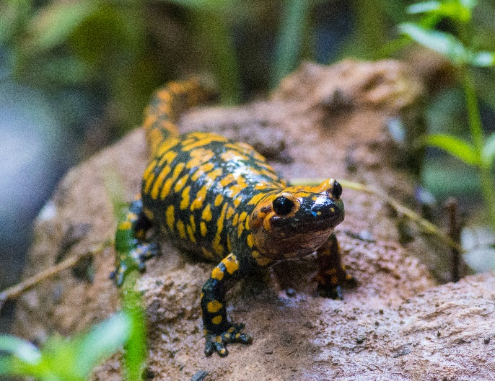
Fig. 1 N. derjugini (left) and S. infraimaculata (right); photos were taken in Hawraman area in Sulaimani governorate by KA (second author).

2. Materials and methods

2.1. Study area

Iraq is located (37°10′ N 47°00′ E) in the Middle East with an area of 438,000 km ² surrounded by Turkey to the north, Iran to the east, Arabian gulf to the south and the Kingdom of Saudi Arabia and Jordan to the west (Fig. 1). Iraq’s topography can be divided into four distinct physiographic regions: alluvial plains (marshlands) in the central and southeastern, desert in west and south, the uplands (hilly and undulating areas in the north between the Tigris and Euphrates), and highlands in the northeast part of the country (Bor and Guest 1968; Malinowski 2002). The highlands are mostly inaccessible and remote due to their high altitudes which range from ~ 800 to 3544 m.a.s.l. (Sissakian et al. 2015). Precipitation is highly seasonal, ranges from 375 mm in the south to 1200 mm up to the north with an average temperature of ~ 35–40 °C (https://gov.krd/ english/). Due to its subtropical continental climate, Iraq has an extreme hot summer with no rainfall and a short cool winter (FAO 2011).
Iraq currently consists of 19 governorates including an autonomous Kurdistan region (37°38′ N 46°35′ E) which was recognized by Iraq’s 2005 constitution. Kurdistan Regional of Iraq (KRI) consists of three main governorates including Sulaimani, Erbil, and Duhok with the total area of ~51173.65 km² (Fig. 1). Based on the available researches and records, only three distinct species of salamanders have been reported in Iraq (Hendrix et al. 2014; Martens 1885; Nesterov 1916) and within Iraq, they are only found in the forested mountain areas in the KRI, particularly in Sulaimani governorate thus far. The forest structure and composition, climate, and physiography of the KRI governorates are very similar. Therefore, the north of the country including the KRI is the focus of this study and modeling.

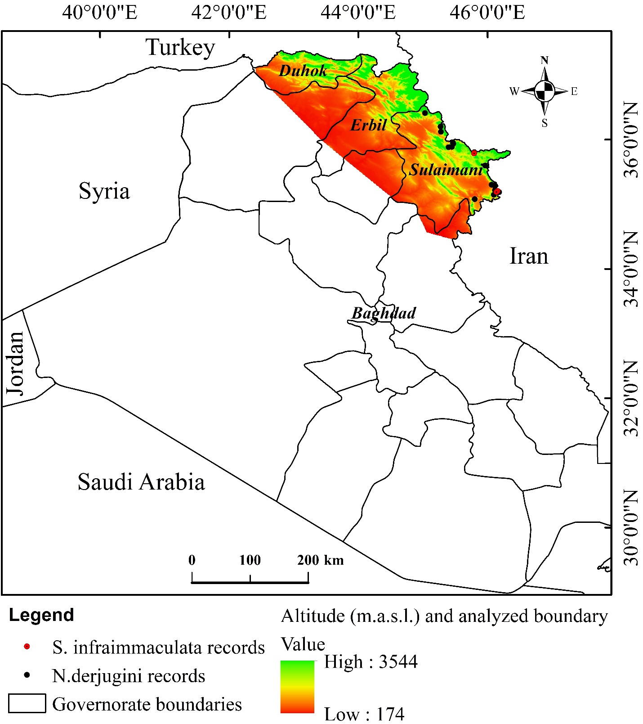
Fig. 2 Study area and administrative boundaries

2.2. Ground data for S. infraimaculata and N. derjugini

The ground truth data including GPS coordinates for the species for this study were obtained from multiple surveys that were conducted between 1st April through August 2010, 2017 and 2019. These datasets were combined and have gone through intensive quality checks with regard to their positional accuracy and representativeness on high resolution Google Earth imagery (Morales et al. 2017). The original number of the GPS points obtained through these surveys were around 30 but after applying some pre-processing such as spatial filtering and removing duplicates, only 20 records (n = 16, n = 4, for the two species respectively)
were retained and used in this study. To decrease the spatial autocorrelation among the locations, a spatial filtering of at least 1 km distance was applied to the dataset (Boakes et al. 2010). Applying such a technique could have the potential advantages to reduce sampling bias and accounts for heterogeneity in altitudinal variations across the study sites (Radosavljevic and Anderson 2014). In addition, the filtering could result in producing more robust model outputs by reducing model over-fitting and improving transferability (Boria et al. 2014). The ArcGIS 10.3 (ESRI, Redland, CA, USA) and extended SDMtoolbox 2.4 were used to carry out the spatial filtering and quality checking (Brown 2014).

The observations of S. infraimaculata and N. derjugini were recorded through transect-line survey by walking alongside the streams looking for these species without any disturbances. This study acknowledges the occurrence records for the S. infraimaculata were quite limited. This species is quite rare and only have been seen in two localities within the surveyed area so far. Often information about the spatial distribution of rare species are restricted to few records (Støa et al. 2019). The probability of its occurrence elsewhere in the mountains of the KRI is likely. During the survey efforts encountering adults S. infraimaculata were not frequent compare to their larvae. Adults are known to be nocturnal and the larvae mostly were seen during the day in the streams.

2.3. Environmental datasets

The high forested mountain areas in the northeast of Iraq are the natural habitat for the species that mostly cover Sulaimani, Erbil, and Duhok (Fig. 2). Apart from the highlands, the species have not been reported to occur naturally in other parts of Iraq. Therefore, the spatial extent of the KRI has been used to clip out our study area. This spatial extent was employed to extract the environmental variables for our modeling purposes. Previous studies have also highlighted the importance of training the models based on the geographical extent of the distribution of the species (Elith et al. 2010; Soberon and Peterson 2005).
Over the past decades, researchers have emphasized the importance of environmental variables (e.g., climatic, topographic, and edaphic) as the key drivers influencing the distribution of species (Austin and Van Niel 2011; Pradervand et al. 2014). Thus, in this study, multiple climatic, topographic and edaphic predictors were selected in order to build the model. Although we acknowledge the importance of landscape variables such as total core area of forest, human footprint and edge density, these data were not incorporated into our model because of the unreliability in the existing datasets. To build the model, initially, 19 bioclimatic variables were extracted for the current (i.e. average climatic variables from 1970 to 2000) and future climatic scenarios (i.e., 2070s). The World Climate database (Hijmans et al. 2005) (www.worldclim. org) was used to obtain the current climatic data while the widely used global circulation model of the Beijing Climate Centre-Climate System Modelling 1.1 (BCC-CSM1.1) was employed (Ebrahimi et al. 2017; Khwarahm 2020) to obtain data for future climate scenarios. This dataset was published by Intergovernmental Panel on Climate Change (IPCC) which consists of both Representative Concentration Pathway (RCP) 2.6 (Van Vuuren et al. 2011) and 8.5 (Riahi et al. 2011) for the time window 2070. The Shuttle Radar Topography Mission (SRTM) was used to derive topographic variables (http://srtm.csi.cgiar.org/srtmdata/). These topographic variables included DEM (Digital Elevation Model), slope and aspect. The slop and aspect were calculated in degree from the DEM. Other edaphic variables such as soil moisture, and soil PH were obtained from the Center for Sustainability and the Global Environment (SAGE) (http://www.sage. wisc.edu/atlas/index.php). These variables are model based originated from the indirect measurement of global and/or regional inventories with the spatial resolution of 0.5° × 0.5° (Task 2000; Willmott and Matsuura 2001).
The Normalized Difference Vegetation Index (NDVI) variable, a proxy for vegetation cover status and greenness biomass, was prepared from Landsat 8 Surface Reflectance (SR) bands 4 and 5 (NDVI = (Band 5 – Band 4) / (Band 5 + Band 4)) for the ‘greenness’ period (i.e., 15/03/2019 to 30/9/2019). Imagery scenes for the area of interest with 30 m spatial resolution and the least cloud cover percentage were obtained from the Earth Explorer portal (https://earthexplorer.usgs.gov). A global land cover map product for 2009 (GlobCover 2009) processed by ESA (European space agency) and the Université Catholique de Louvain in GeoTIFF format, with 300 m resolution, was downloaded from (http://due.esrin.esa.int/page_globcover.php.).The data pre-processing and spatial resampling of all the variables to ~ 1 km (Beck et al. 2018) were conducted in ArcGIS 10.3.
Due to high spatial correlation (collinearity) between the variables, only 8 environmental parameters out of 26 (Table 1) were incorporated into the model building. In the statistical models, collinearity may cause issues for parameter estimation as it inflates the variance of regression parameters and may result in wrong identification of relevant predictors (Dormann et al. 2013). In addition, to overcome the problem of collinearity, a conditional threshold approach (Dormann et al. 2013) was applied to retain predictors with Pearson’s pairwise correlation |r | ≤ 0.8 (Syfert et al. 2013). The ArcGIS 10.3 and SDMtoolbox extension were used to conduct the Pearson’s pairwise correlation analysis for the predictors (Brown et al. 2017).

Table 1 Environmental variables considered for modling (Only bold ones used in model building)
Variables | Code and Unit
Annual mean temperature | Bio1 (°C)
Mean diurnal range | Bio2 (°C)
Isothermality (Bio2/Bio7) | Bio3(× 100)
Temperature seasonality | Bio4 (standard deviation × 100)
Max temperature of warmest month | Bio5 (°C)
Min temperature of coldest month | Bio6 (°C)
Temperature annual range | Bio7 (Bio5-Bio6) (°C)
Mean temperature of wettest quarter | Bio8 (°C)
Mean temperature of driest quarter | Bio9 (°C)
Mean temperature of warmest quarter | Bio10 (°C)
Mean temperature of coldest quarter | Bio11 (°C)
Annual precipitation | Bio12 (mm)
Precipitation of wettest month | Bio13 (mm)
Precipitation of driest month | Bio14 (mm)
Precipitation seasonality (coefficient of variation) | Bio15 (mm)
Precipitation of wettest quarter | Bio16 (mm)
Precipitation of driest quarter | Bio17 (mm)
Precipitation of warmest quarter | Bio18 (mm)
Precipitation of coldest quarter | Bio19 (mm)
Normalized difference vegetation index | NDVI
Land cover land use 2009 | LCLU2009
Slope | Slope (degree)
Aspect | Aspect (degree)
DEM | Digital elevation model (m)
Soil PH | Soil (parts Hydrogen)
Soil moisture | Soil moisture (mm)

2.4. Model building

The predictive capability and presence records were taken into account as a base to select suitable model choice in this study. The MaxEnt model (Phillips et al. 2006), a machine learning-based approach, was chosen for this study due to its predictive accuracy compare to other models, user friendly and the ability to produce comparable results as one of the presence-only-dependent model types to presence-absence model approaches (Dudík et al. 2007; Elith et al. 2006; Wisz et al. 2008). More importantly, Maxent is not sensitive to small sample sizes (i.e., number of presence records often as small as n = 4-5 (Hernandez et al. 2006; Støa et al. 2019; Wisz et al. 2008)). Model boundary was set to the extent of the KRI (i.e., northeast) where the forested mountains are natural habitat for the species (Fig.2).

To build the model, 70% of each of presence data-points of S. infraimaculata and N. derjugini
were selected randomly as a training model and the remaining 30% for validation of the model. Model settings in general are used in ‘default-mode’ as suggested by Phillips et al., (2004) which would produce reasonably good outputs. However, the nature of the input data, local knowledge of the modeler on the study site and the parameterization of the model could significantly influence reliability of model outputs. In other words, the default-mode settings would not necessarily result in reliable models (Merow et al. 2013; Morales et al. 2017).

In this study, model replicate choice was set to 10 with 500 iterations of the algorithm (maximum entropy). Average suitability maps of the probability of occurrence for the S. infraimaculata and N. derjugini were also produced from the 10 model-replicate choices. To adjust for the presence records of species (n = 16, n = 4, for the two species respectively), it was necessary to set the background points to 150 and 100 respectively (Elith and Leathwick 2009). Following Phillips et al. (2006) and Merow et al. (2013) advise, the default value (1) was set for the regularization multiplier (β) in the model. Tuning this value within the model can have implication to the model’s complexity and simplicity. For instance, reducing the value to lower than one increases the model complexity while increasing it to above one simplifies the model (Merow et al. 2013).

To evaluate the variable’s relative importance and contribution to the probability of the habitat distribution of species, the Jackknife test was employed (Phillips 2005). Furthermore, the logistic output format with the ‘Minimum training presence Logistic threshold’ for delineating the continuous map was used (Shcheglovitova and Anderson 2013). The average value (i.e., threshold value) from 10 model outputs (10 replicates) were used to delineate the probability of habitat suitability and unsuitability distribution of the two species (i.e., probability of occurrences) (Jiménez-Valverde and Lobo 2007). The pixel value equal and larger than 0.4 and 0.35 were considered as suitable areas whereas pixels with lower than 0.4 and 0.35 values were considered as unsuitable areas for S. infraimmaculata and Neurergus derjugini distributions, respectively. Based on these thresholds (i.e., minimum training presence) suitability maps were categorized as: A- (i) unsuitable (0 - 0.4); (ii) low suitable (0.4 - 0.49); medium suitable (0.49 - 0.74); high suitable (0.74 - 0.99); and B- (i) unsuitable (0 - 0.35); (ii) low suitable (0.35 - 0.57); medium suitable (0.57- 0.78); high suitable (0.78- 0.99) (Khwarahm 2020) for the two species, respectively. Spatial analyst tools within the ArcGIS 10.3 platform were employed to execute these operations.

2.5. Model evaluation

Researchers have discussed potential challenges in selecting the best method for evaluating the MaxEnt distribution from presence-only data (Halvorsen et al. 2016; Jiménez-Valverde 2014). This research has adopted two widely acceptable evaluation metrics such as: (i) the area under the receiver operating curve (AUC) (Hanley and McNeil 1982); and (ii) the True Skill Statistics (TSS) (Allouche et al. 2006). AUC values represent the discrimination power which ranges from 0 to 1, where 1 means excellent discrimination and below 1 indicates that the model is worse than by chance (Fielding and Bell 1997; Phillips et al. 2017). Similar argument can imply to TSS value where the value ranges from -1 to 1 (Allouche et al. 2006). The MaxEnt model outputs and Allouche et al. (2006)’s equation (TSS = sensitivity (true positive rate) + specificity (true negative rate) – 1) were employed to compute the metrics.

2.6. Distribution change analysis between current and future habitat for the species

The current and future distribution changes predicted from the model were quantified using the habitat suitability maps. The change detection between current and future habitat distributions were achieved using multiple spatial tools in ArcGIS platform. The distribution changes for the species in the KRI were classified into five categories: (i) Range expansion (i.e., predicted areas that could be suitable for the species in 2070); (ii) Unsuitable (i.e., unsuitable areas under current environmental factors and would stay unsuitable in the future (2070); (iii) No change (i.e., areas already occupied by the species and will stay occupied in the future); (iv) Range contraction (areas of each species that would shrink in the future).

2.7. Distributional change direction and magnitude

The centroid of the species records across its range (i.e., spatial extent), was computed across time to provide a better insight into the distributional changes (shifts) between the current and future scenarios. To conduct such analysis, a GIS tool (i.e., SDMtoolbox), developed by Brown et al. (2017), was used to identify the centroid of the distribution changes of the suitable areas with attributes of the magnitude and direction.

3. Results

3.1. Model performance

The model performance for the S. infraimmaculata and N. derjugini were (AUC= 0.95 ± 0.01
, TSS = 0.92 ± 0.16); and (AUC = 0.83 ± 0.10, TSS = 0.75 ± 0.15) respectively. The model demonstrated better discriminatory power for the former species. Overall, the two models were efficient in predicting the probability of habitat suitability distributions for the two species under the selected environmental variables in the KRI.

3.2. Current and future habitat distributions of S. infraimmaculata and N. derjugini

Modeling demonstrated that the trend of habitat unsuitability areas for S. infraimmaculata would increase by (1.48% and 1.5%) under the RCP2.6 2070 and RCP8.5 2070 climate change scenarios respectively. In turn, the habitat suitability categories (classes) would decrease, for example, the high suitable category area would reduce by (-0.67% RCP2.6 and -0.76 % RCP8.5) respectively. Area reduction under the RCP8.5 climate change scenario showed slightly larger than the RCP2.6 scenario. Overall, the suitability categories (i.e., sum of low, medium, and high suitable areas) would reduce from current 1642.36 km² (3.2%) to 883.44 km² (1.72%) 875.09 km² (1.7 %), respectively (Fig.3, 4, and 5; Table 2).

For N. derjugini, the model demonstrated similar trend, for example, the areas of the unsuitable habitat would increase by (5.26% and 8.16%) under the two RCPs climate change scenarios respectively (Table 3). A significant area of the low suitable category would reduce (-7.11% from (8627.14 km² to 4991.11 km²; and -8.76% from (8627.14 km² to 4145.23 km²). For medium and high suitable categories, minimal increase in the habitat suitability areas were demonstrated, particularly under the RCP2.8 scenario. Overall, the suitability classes would reduce from current 10943.57 km² (21%) to 8252.2 km² (16%) (RCP2.6), and 6768.43 km² (13%) (RCP8.5) (Fig.6, 7, and 8; Table 3).
Table 2 Modeled current and future habitat suitability and unsuitability distribution areas (percentage) under RCP2.6 2070 and RCP8.5 2070 climate change scenarios for S. infraimmaculata
 | Current |  | RCP 2.6 2070 |  | RCP 8.5 2070
Class | Area (Km²) | % | Area (Km²) | % | Area (Km²) | %
Unsuitable | 49531.28 | 96.79 | 50290.20 | 98.27 | 50298.55 | 98.29
Low suitable | 640.67 | 1.25 | 247.64 | 0.48 | 339.46 | 0.66
Medium suitable | 473.02 | 0.92 | 449.37 | 0.88 | 396.51 | 0.77
High suitable | 528.67 | 1.03 | 186.43 | 0.36 | 139.12 | 0.27
Total area | 51173.65 | 100 | 51173.65 | 100 | 51173.65 | 100

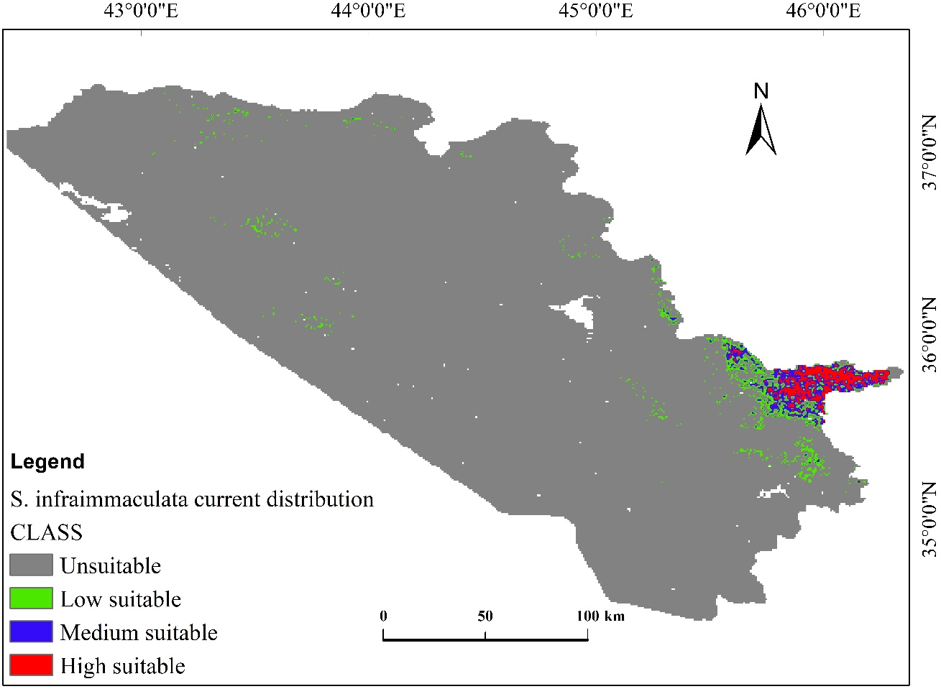
Fig. 3 Current habitat distribution of S. infraimmaculata in the KRI
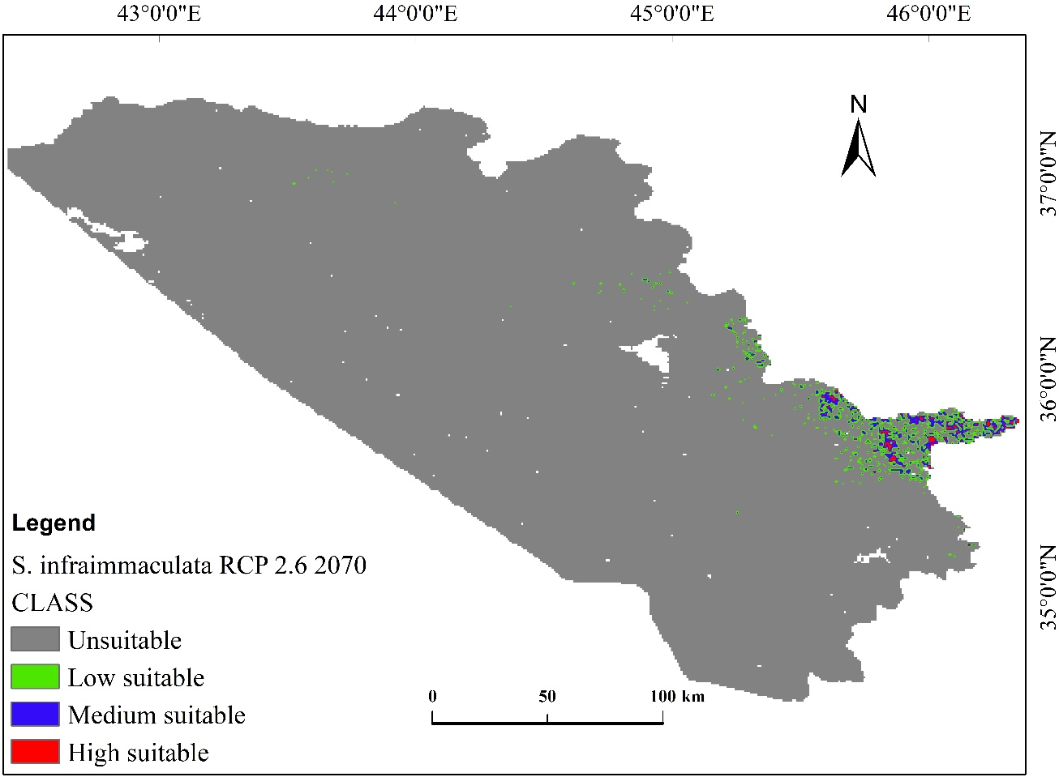
Fig. 4 Habitat distribution of the S. infraimmaculata under RCP2.6 2070 climate change scenario
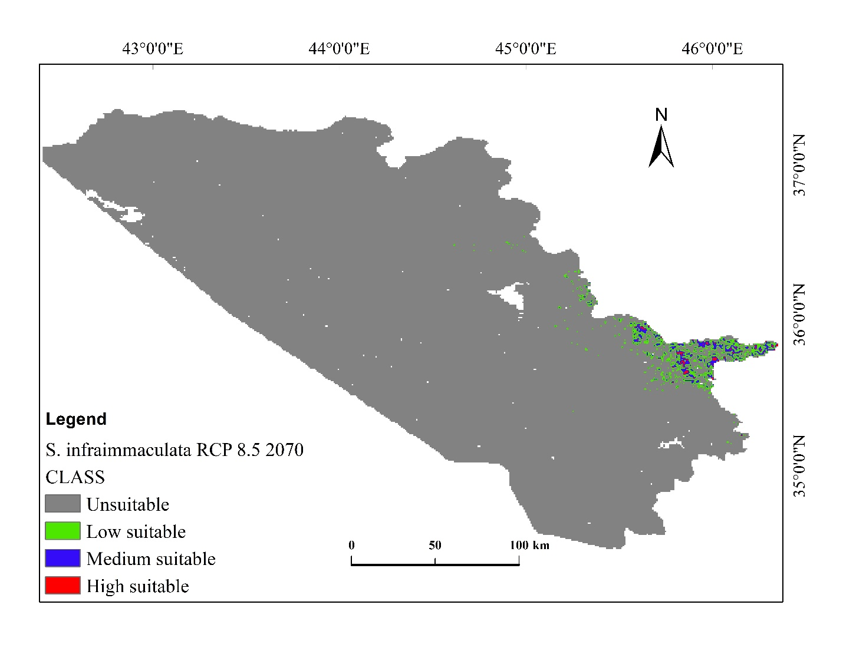
Fig. 5 Habitat distribution of S. infraimmaculata under RCP8.5 2070 climate change scenario

Table 3 Modeled current and future habitat suitability and unsuitability distribution areas (percentage) under RCP2.6 2070 and RCP8.5 2070 climate change scenarios for N. derjugini
 | Current |  | RCP 2.6 2070 |  | RCP 8.5 2070
Class | Area (Km²) | % | Area (Km²) | % | Area (Km²) | %
Unsuitable | 40230.08 | 78.61 | 42921.45 | 83.87 | 44405.22 | 86.77
Low suitable | 8627.14 | 16.86 | 4991.11 | 9.75 | 4145.23 | 8.10
Medium suitable | 1791.23 | 3.50 | 2472.95 | 4.83 | 2031.22 | 3.97
High suitable | 525.20 | 1.03 | 788.14 | 1.54 | 591.98 | 1.16
Total area | 51173.65 | 100 | 51173.65 | 100 | 51173.65 | 100

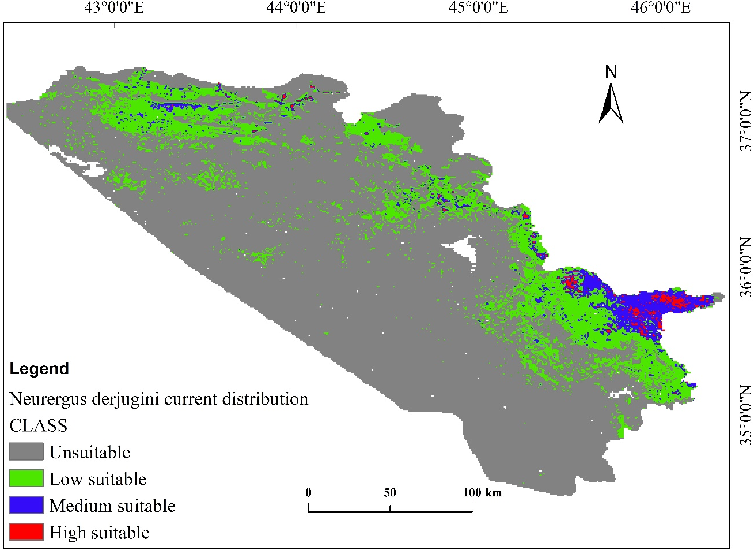
Fig. 6 Current habitat distribution of N. derjugini in the KRI

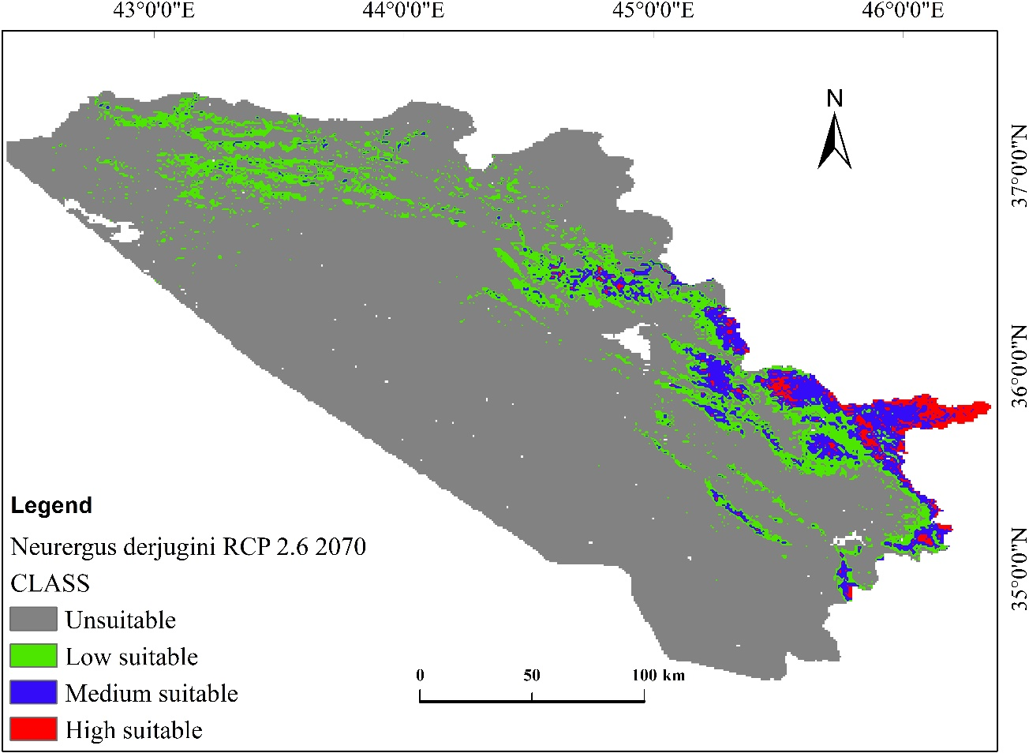

Fig. 7 Habitat distribution of N. derjugini under RCP2.6 2070 climate change scenario
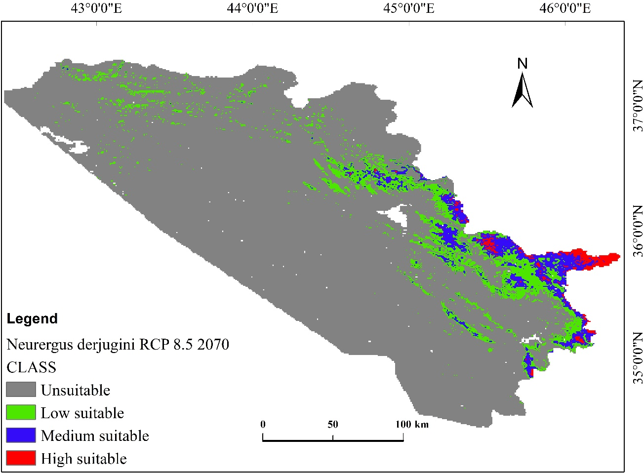
Fig. 8 Habitat distribution of N. derjugini under RCP8.5 2070 climate change scenario

3.3. Distribution change analysis between current and future habitat for S. infraimmaculata and N. derjugini

Modeling indicated spatial distributional change in the habitat ranges of the two species as climate changes (i.e., in 2070). For example, for S. infraimmaculata the habitat range would expand by 126.60 km² (0.25%), and 100.17 km² (0.20%) under the RCP2.6 and RCP8.5 scenarios, respectively. In contrast, the habitat would contract by 888.31(1.74%), and 863.27 (1.69%), respectively. The magnitude of contraction demonstrated to be bigger than the magnitude of the expansion (Fig.9 and 10; Table 4). For, N. derjugini modeling also demonstrated habitat range expansion (by 1017.00 km²; 1.99%, and 860.49 km²; 1.68% under the RCPs, respectively) and contraction (by 921.01 km²; 1.80%, 1206.21 km², 2.36% under the RCPs, respectively). The species habitat range would slightly expand (by 0.19% (from 921.01 km² to 1017.00 km²) under the RCP2.6 scenario whereas under the RCP8.5 the magnitude of contraction would be bigger than the magnitude of the expansion. Overall, the habitat of the species under the RCPs would contract by 2127.22 km² (4.16%) whereas expand only 1877.49 km² (3.67%) (Fig.11 and 12; Table 5).

Table 4 Distributional change in habitat range (areas) between the current and future under climate change scenarios (RCP 2.6 2070 and RCP 8.5 2070) for S. infraimmaculata
 | Current to RCP 2.6 |  | Current to RCP 8.5
Class | Area (Km²) | % | Area (Km²) | %
Range expansion | 126.60 | 0.25 | 100.17 | 0.20
Unsuitable | 49485.36 | 96.70 | 49511.80 | 96.75
No change | 673.36 | 1.32 | 698.41 | 1.36
Range contraction | 888.31 | 1.74 | 863.27 | 1.69
Total area | 51173.65 | 100 | 51173.65 | 100

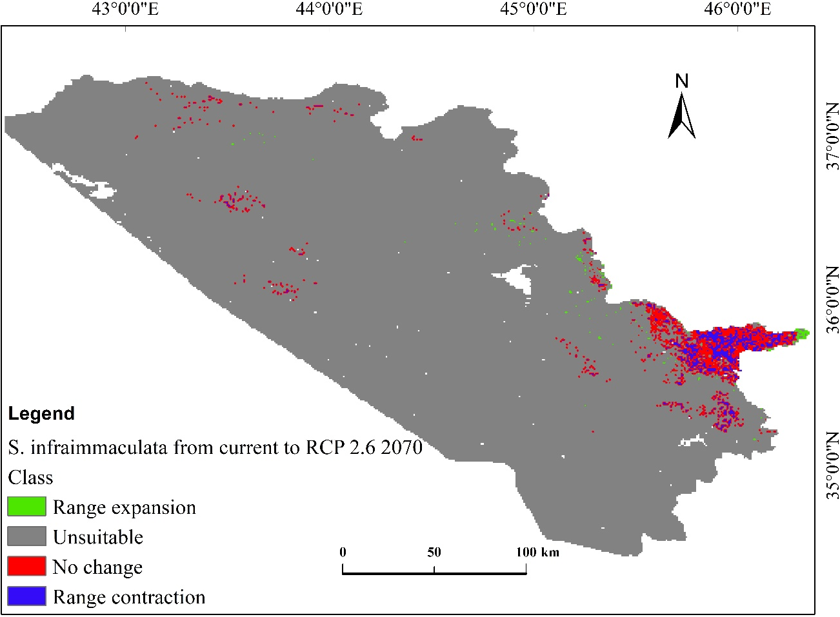
Fig. 9 Distributional change in habitat range between the current and future under climate
change scenario (RCP2.6 2070) for S. infraimmaculata in the KRI

Fig.10 Distributional change in habitat range between the current and future under climate change scenario (RCP8.5 2070) for S. infraimmaculata in the KRI

Table 5 Distributional change in habitat range (areas) between the current and future under climate change scenarios (RCP 2.6 2070 and RCP 8.5 2070) for N. derjugini
 | Current to RCP 2.6 |  | Current to RCP 2.6
Class | Area (Km²) | % | Area (Km²) | %
Range expansion | 1017.00 | 1.99 | 860.49 | 1.68
Unsuitable | 47673.26 | 93.16 | 47829.78 | 93.47
No change | 1562.37 | 3.05 | 1277.17 | 2.50
Range contraction | 921.01 | 1.80 | 1206.21 | 2.36
Total area | 51173.65 | 100 | 51173.65 | 100

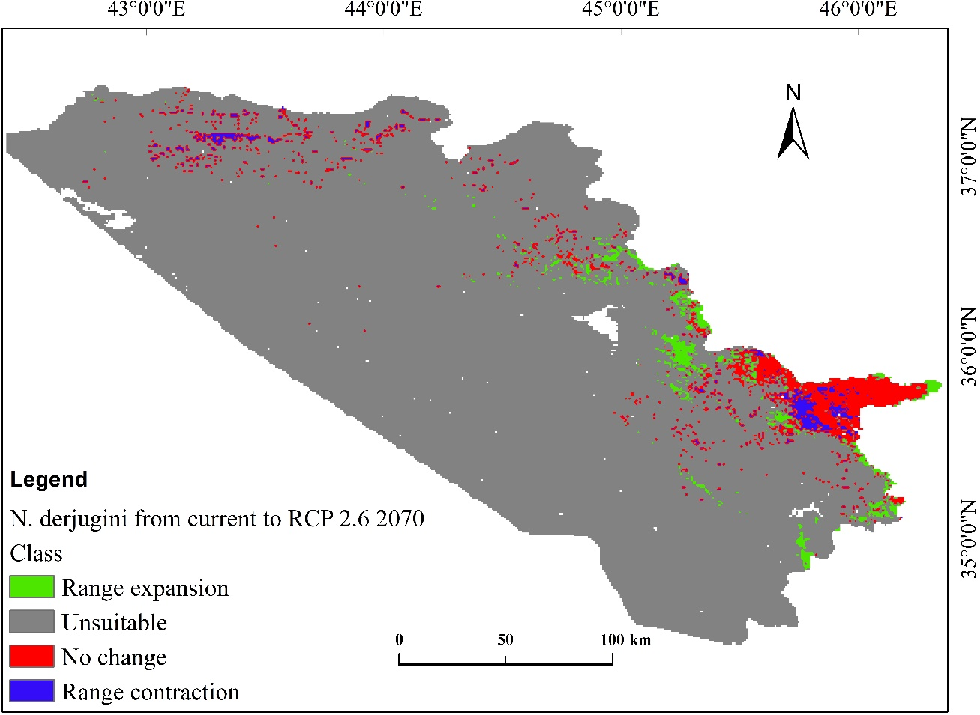
Fig. 11 Distributional change in habitat range between the current and future under
climate change scenario (RCP2.6 2070) for N. derjugini in the KRI
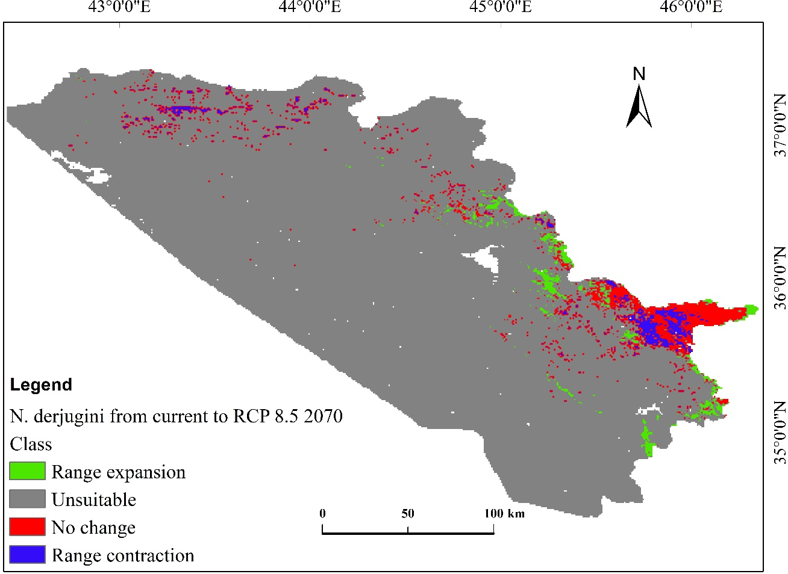
Fig. 12 Distributional change in habitat range between the current and future under
climate change scenario (RCP8.5 2070) for N. derjugini in the KRI

3.4. Distributional change direction and magnitude for S. infraimmaculata and N. derjugini

Under the climate change scenarios (RCP2.6 and RCP8.5 2070), the habitat distributional change centroid for S. infraimmaculata and N. derjugini indicted to shift toward the east and southeast, respectively. Overall, changes from current distribution centroid to new distribution centroid in direction and magnitude were slightly stronger under the RCP8.5 2070. For example, for N. derjugini, the current geographical coordinates’ centroid is 45°25'1.227" E and 35°57'55.625" N; under the climate change scenarios this centroid would change to 45°36'18.828" E ;35°50'20.797" N (RCP2.6) and 45°40'49.475" E ;35°47'7.182" N (RCP8.5) (Fig. A.₁ in Appendix).

3.5. Relative contribution and importance of the environmental variables in the distribution of S. infraimmaculata and N. derjugini

The NDVI, annual mean temperature, and mean diurnal range temperature have contributed relatively by 53.7%, 19.2%, and 13.6 %, respectively, to the probability of the habitat distribution of S. infraimmaculata in the KRI. These three variables together contributed significantly by 86.5% compared with other variables (Table 6). By contrast, temperature seasonality, and precipitation seasonality demonstrated the lowest contribution (Table 6).
For N. derjugini, annual mean temperature, Land cover land use 2009, and precipitation of the driest month have contributed by 31.1%, 28.3%, and 15.6% (collectively by 75%) to its habitat distribution. In contrast, the lowest relative contribution into the probability of habitat distribution were precipitation seasonality and temperature seasonality, respectively (Table 7).

For the variables importance, the Jackknife test to regularize the training gains (%) and AUC variable gains demonstrated that NDVI, annual mean temperature (bio1), and annual precipitation (bio12) contained more gains (information) in the distribution of S. infraimmaculata than other variables. For N. derjugini, annual mean temperature (bio1), LCLU2009, and annual precipitation (bio12) contained more gains in its distribution than other variables in the KRI (Fig. A.₂ in Appendix).

Table 6 Variables contribution into the probability of distribution of S. infraimmaculata in the KRI
Variable | Percent contribution | Permutation importance
Normalized difference vegetation index | 53.7 | 44.3
Annual mean temperature | 19.2 | 42.7
Mean diurnal range temperature | 13.6 | 9.9
Precipitation of driest month | 9.3 | 0.9
Land cover land use 2009 | 2.6 | 1.5
Annual precipitation | 1.2 | 0.2
Temperature seasonality | 0.3 | 0.3
Precipitation seasonality | 0.1 | 0.2

Table 7 Variables contribution into the probability of distribution of N. derjugini in the KRI

Variable | Percent contribution | Permutation  importance
Annual mean temperature | 31.1 | 51.5
Land cover land use 2009 | 28.3 | 26.4
Precipitation of driest month | 15.6 | 4.9
Mean diurnal range temperature | 11.7 | 10.8
Normalized difference vegetation index | 5.5 | 3.1
Annual precipitation | 4.4 | 1.3
Precipitation seasonality | 2.6 | 1.5
Temperature seasonality | 0.8 | 0.5

4. Discussion

Modeling demonstrated that under the RCP 2.6 2070 and RCP8.5 2070 climate change scenarios, the habitat distribution ranges for S. infraimmaculata would reduce from current 1642.36 km² (3.2%) to 883.44 km² (1.72%) 875.09 km² (1.7 %), respectively. For N. derjugini, the ranges would reduce from current 10943.57 km² (21%) to 8252.2 km² (16%), and 6768.43 km² (13%), respectively. In turn, there would be some habitat expansion spatially for the species; however, the magnitude of the expansion would be smaller than the contraction magnitude. For S. infraimmaculata and N. derjugini, the habitat would contract by 1751.58 km² (3.42%) and 2127.22 km² (4.16%), whereas expand only 226.77 km² (0.44%) and 1877.49 km² (3.67%), respectively. Key environmental variables contributing relatively to the two species spatial distributions were optimal ranges of annual mean temperature (7-16 °C; 5- 13°C ), annual precipitation (800-980 mm; 820-1030 mm), and the NDVI (~ 6.5 - 9.5), respectively. These results were not surprising, given the fact that the species dwell in mixed forest floor and streams of the mountains with significantly higher precipitation rate and lower annual temperature compared with the lowlands. The results also suggest that the species’ preference for cooler areas with dense vegetation cover (forested areas with semi-closed and/or closed canopy cover (i.e., high NDVI). NDVI, an index indicating vegetation growth, and precipitation demonstrated a positive correlation during the growing season. Al-Hedny and Muhaimeed (2020) also showed a strong positive relationship between NDVI and precipitation in the north of Iraq. Oak forests in the mountain ranges of the KRI comprise around 90% of the total forest cover, usually mixed with other plants species, for example, Pistacia khinjuk, Crataegus azaro, Juglans regia (Nasser 1984; Zohary 1973). The remainder 10% is composed of plantation, pine, and riverine forests (Guest and Al-Rawi 1966). These forests, particularly those alongside the valleys are the natural habitats for S. infraimmaculata and N. derjugini in the KRI. Similar results were also reported by Rastegar-Pouyani and Faizi (2006) from neighboring Kurdistan province of the west of Iran in which they reported that S. infraimmaculata are restricted to the mountainous areas with Quercus and Juglans vegetation types.

Annual precipitation is a key ecological factor in the distribution of the forests in the mountain ranges of the KRI (Khwarahm 2020; Nasser 1984). The availability of water has shown to significantly influence the biochemical and physiological processes of plants, predominantly in arid and semi-arid areas (e.g., Iraq and KRI) (Wang et al. 1998). In the KRI, during summer times, from June onwards (e.g., till early October) precipitation do significantly reduce in the mountains; however, mean temperature in these areas remain much cooler in comparison to the lowlands and cities. These results concur with previous studies that have reported the important role of climate particularly temperature and precipitation in the spatial distribution (latitudinal and elevational) of the terrestrial vegetation communities, especially mountain areas at various scales across the world (Buitenwerf et al. 2015; Hamid et al. 2019; Leonelli et al. 2011; Palomo 2017; Xu et al. 2019).

In the KRI, under both climate change scenarios (i.e., RCP2.6 and RCP8.5 2017), the annual precipitation rate would decrease from the current 1042 mm to 1031 mm and 843 under both RPC 2.6 and RPC 8.5, respectively. Such a decrease in the precipitation rate would affect the distribution direction of the two species, in which they are expected to move toward east and southeast latitudinal positions where mixed forests are denser; suggesting more water availability in the streams and hence lower temperature. Similarly, the annual mean temperature would increase by 3.7 °C in 2070 under the CRP2.8 scenario. The increase in temperature could lead to a decrease in the precipitation rate and increases drought, which in turn significantly affects the distribution of the plant species and hence the salamanders. Already several severe drought episodes in the KRI and Iraq has been reported (Al-Hedny and Muhaimeed 2020; Eklund and Thompson 2017). Besides, annual precipitation and mean temperature, LCLU2009 (e.g., mosaic forest or shrubland (50-70%)), and precipitation of driest month particularly for N. derjugini contributed significantly in its habitat distribution. This indicates the species is more reliance on water availability (e.g., streams, spring water outlets, ponds and perennial waters) during the growing season. This result corroborates with what has been reported on the breeding streams of the species in the western Zagros mountains in Iran and Iraq (Salehi et al. 2019; Vaissi et al. 2019). On the other hand, S. infraimmaculata also relies on water availability for breeding and larval development stages; however, its reliance duration is likely to be less than of that N. derjugini. S. infraimmaculata spend most of the day hiding in the forest floor and become active at night for hunting (i.e., are nocturnal) (Bar-David et al. 2007). This unique behavior could be one of the factors for co-existence of the two species in quite close proximities in the KRI.

N. derjugini and S. infraimmaculata are listed as endangered and near threatened by the IUCN RED List (2020); these threats would continue to increase as climate changes. Therefore, we are suggesting (i) valleys with deciduous mixed oak forest are important habitats (for the current and future) for the salamander species, which should be taken as a priority for conservation actions; (ii) human practices of, for example, cutting, clearing of the forests, and draining the springs and perennial stream waters should be controlled by immediate establishment of a management and monitoring policy; (iii) eco-friendly tourist passages (corridors) should be created to reduce disturbances; and (iv) the overlapping habitats indicate rich biodiversity, current emphasis should focus on protecting these areas (Fig. 13; Table 8).

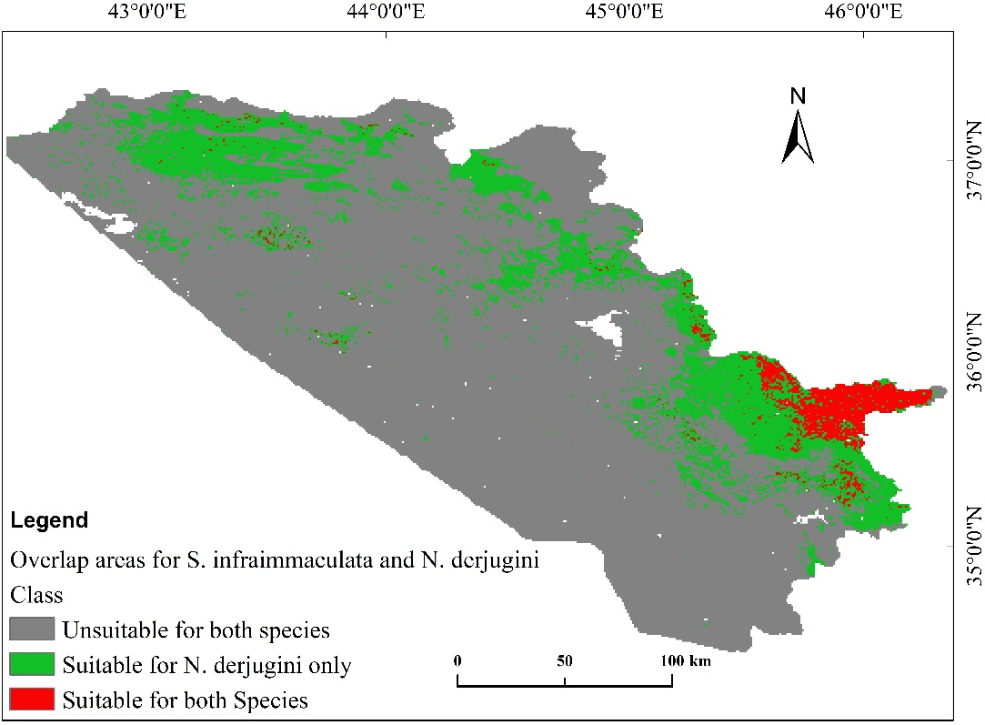
Fig. 13 Spatial representation of the overlapping habitat for N. derjugini and S. infraimmaculata in the KRI

Table 8 Overlapping habitat areas for N. derjugini and S. infraimmaculata in the KRI
Class | Area (Km²) | %
Unsuitable for both species | 40236.80 | 78.63
Suitable for N. derjugini only | 9353.14 | 18.28
Suitable for both Species | 1583.71 | 3.09
Total area | 51173.65 | 100

Conclusions
In the KRI, mixed oak forests in the mountain ranges of the north and east are important habitats for S. infraimmaculata and N. derjugini. Particularly in Sulaimani region where they overlap by an area of 1583.71 km² (only 3.09% of the total study area 51173.65 km²). Conservation and management actions should focus primarily on the overlapping areas (Fig.13 and Table 8) where the species co-exist and hence most vulnerable as mixed oak forest deteriorate. Under the climate change scenarios, these habitats would reduce significantly. Habitat reduction for S. infraimmaculata would be more than N. derjugini. The potential distribution of the species would be toward the mountain forests of the east (mainly) and southeast of the KRI where the forests are denser with semi-closed and closed canopy cover in the valleys with abundant perennial streams, springs, and ponds.

Categorized habitat suitability maps (for current and the future), and overlapping habitat areas for S. infraimmaculata and N. derjugini are useful means for improving and initiating conservation plans and actions. Correlation-based modeling and GIS techniques are useful tools for generating these means. Findings (i.e., categorical current and potential distribution maps) provide baseline information for further investigation of the mountain forest ecosystems, and biodiversity conservation actions in Iraq and similar ecoregions.

Appendix

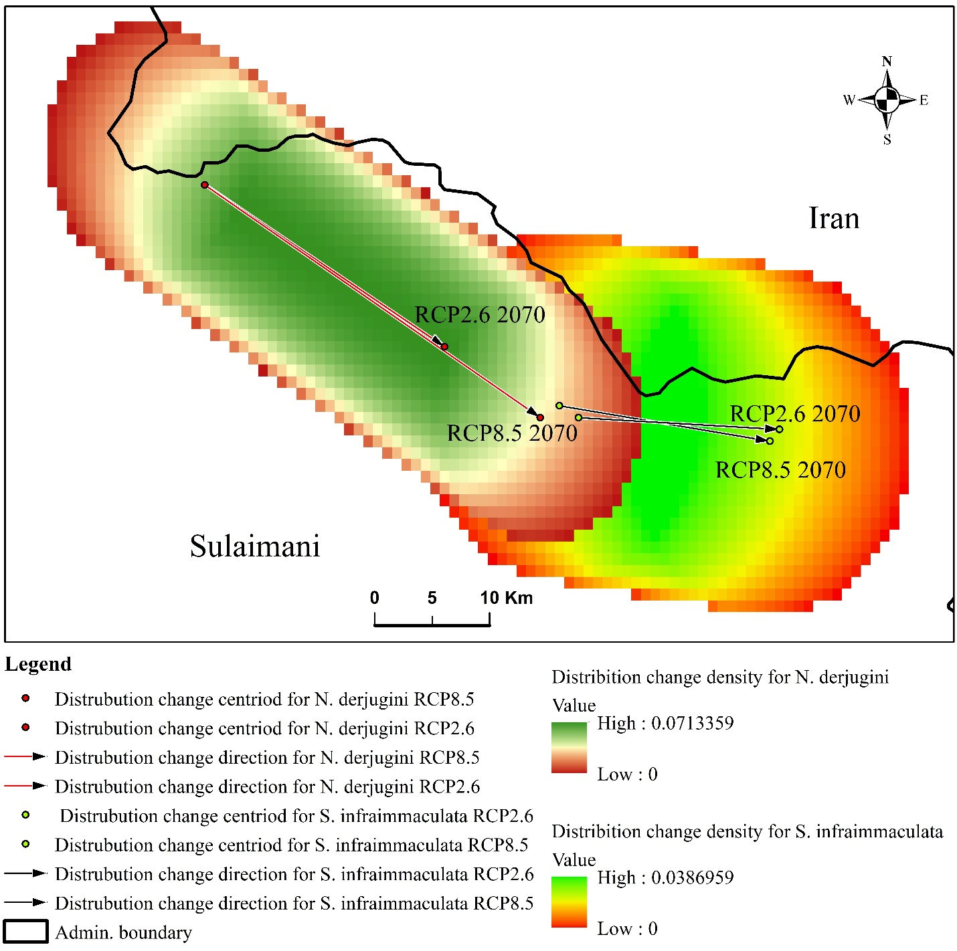
Fig. A.₁ Distribution change density (magnitude) and direction of the centroid (core) of S. infraimmaculata N. derjugini. The head of the arrow = direction of the distribution change under the RCP2.6 and RCP8.8; the tail of the arrow= current centroid

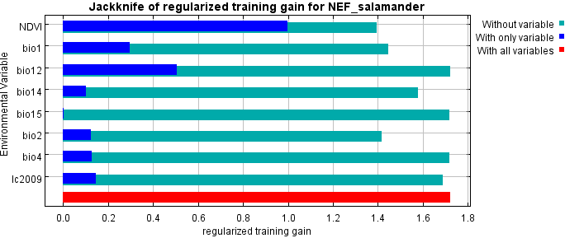
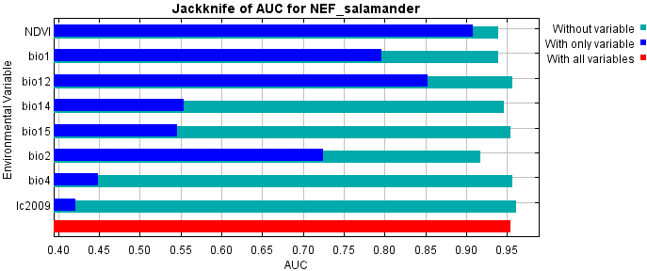
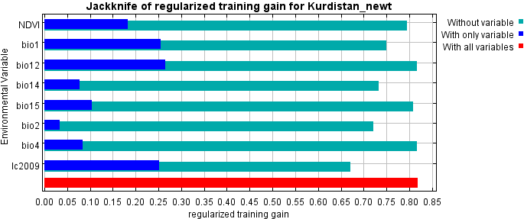
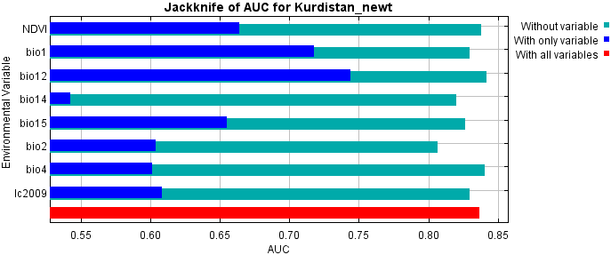
Fig. A.₂ The (Jackknife) test for environmental variables importance, the regularizing training gain(%), and AUC metric gian (%) for S. infraimmaculata (left) and N. derjugini (right).

Declaration of competing interest
The authors declare that there are no conflicts of interest.

Funding
This research did not receive any specific grant from funding agencies in the public, commercial, or not-for-profit sectors.

Acknowledgements
We would like to thank Philip Gerhardt (co-author of the book “Genus Salamandra”) for his support and guidance during field surveys conducted with second co-author (KR) of this study. We also equally would like to thank Binwar Rzgar for providing technical and logistic assistance to Philip Gerhardt, and KA during the fieldwork.

Author’s contributions
NRK conceived, designed, and analyzed the study, and KA performed field surveys and data collections. SQ, DKS, and PMN participated in writing and compiling the final version of the manuscript. All authors read and approved the final manuscript.

References
Achour H, Kalboussi M (2020) Modelling and mapping the current and future potential habitats of the Algero-Tunisian endemic newt Pleurodeles nebulosus under climate change European Journal of Wildlife Research 66:1-12
Al-Hedny SM, Muhaimeed AS (2020) Drought Monitoring for Northern Part of Iraq Using Temporal NDVI and Rainfall Indices. In: Environmental Remote Sensing and GIS in Iraq. Springer, pp 301-331
Allouche O, Tsoar A, Kadmon R (2006) Assessing the accuracy of species distribution models: prevalence, kappa and the true skill statistic (TSS) Journal of applied ecology 43:1223-1232
Ashrafzadeh MR, Naghipour AA, Haidarian M, Kusza S, Pilliod DS (2019) Effects of climate change on habitat and connectivity for populations of a vulnerable, endemic salamander in Iran Global Ecology and Conservation 19:e00637
Austin MP, Van Niel KP (2011) Improving species distribution models for climate change studies: variable selection and scale Journal of Biogeography 38:1-8
Bar-David S, Segev O, Peleg N, Hill N, Templeton AR, Schultz CB, Blaustein L (2007) Long-distance movements by fire salamanders (Salamandra infraimmaculata) and implications for habitat fragmentation Israel Journal of Ecology & Evolution 53:143-159
Barabanov A, Litvinchuk S (2015) A NEW RECORD OF THE KURDISTAN NEWT (Neurergus derjugini) IN IRAN AND POTENTIAL DISTRIBUTION MODELING FOR THE SPECIES Russian Journal of Herpetology 22
Beck HE, Zimmermann NE, McVicar TR, Vergopolan N, Berg A, Wood EF (2018) Present and future Köppen-Geiger climate classification maps at 1-km resolution Scientific data 5:180214
Boakes EH, McGowan PJ, Fuller RA, Chang-qing D, Clark NE, O'Connor K, Mace GM (2010) Distorted views of biodiversity: spatial and temporal bias in species occurrence data PLoS biology 8
Böhme W, Hartmann T, Fleck J, Schöttler T (2013) Miscellaneous notes on oriental fire salamanders (Salamandra infraimmaculata MARTENS, 1885)(Lissamphibia: Urodela: Salamandridae) Russian Journal of Herpetology 20:66-72
Bor N, Guest E (1968) Flora of Iraq, Vol. 9 Ministry of Agriculture, Baghdad
Boria RA, Olson LE, Goodman SM, Anderson RP (2014) Spatial filtering to reduce sampling bias can improve the performance of ecological niche models Ecological modelling 275:73-77
Bozorgi F, Kiabi BH, Kami HG, Ahmadzadeh F, Mohammadi R, Alizadeh K (2015) REDISCOVERY OF Neurergus derjugini derjugini NESTEROV 1916 (AMPHIBIA: CAUDATA: SALAMANDRIDAE) IN WESTERN IRAN Russian Journal of Herpetology 22
Brown JL, Bennett JR, French CM (2017) SDMtoolbox 2.0: the next generation Python-based GIS toolkit for landscape genetic, biogeographic and species distribution model analyses PeerJ 5:e4095
Buitenwerf R, Rose L, Higgins SI (2015) Three decades of multi-dimensional change in global leaf phenology Nature Climate Change 5:364-368
Cope ED (1862) Notes upon some reptiles of the Old World Proceedings of the Academy of natural Sciences of Philadelphia:337-594
Dormann CF et al. (2013) Collinearity: a review of methods to deal with it and a simulation study evaluating their performance Ecography 36:27-46
Duan R-Y, Kong X-Q, Huang M-Y, Varela S, Ji X (2016) The potential effects of climate change on amphibian distribution, range fragmentation and turnover in China PeerJ 4:e2185
Dudík M, Phillips SJ, Schapire RE (2007) Maximum entropy density estimation with generalized regularization and an application to species distribution modeling Journal of Machine Learning Research 8:1217-1260
Ebrahimi A, Farashi A, Rashki A (2017) Habitat suitability of Persian leopard (Panthera pardus saxicolor) in Iran in future Environmental Earth Sciences 76:697
Eklund L, Thompson D (2017) Differences in resource management affects drought vulnerability across the borders between Iraq, Syria, and Turkey Ecology and Society 22
Elith J et al. (2006) Novel methods improve prediction of species’ distributions from occurrence data Ecography 29:129-151
Elith J, Kearney M, Phillips S (2010) The art of modelling range-shifting species. Methods Ecol. Evol. 1, 330–342.
Elith J, Leathwick JR (2009) Species distribution models: ecological explanation and prediction across space and time Annual review of ecology, evolution, and systematics 40:677-697
Fielding AH, Bell JF (1997) A review of methods for the assessment of prediction errors in conservation presence/absence models Environmental conservation 24:38-49
Food Agriculture Organization of the United Nations (FAO) (2011) Country pasture/forage resource profiles. Rome, Italy Available: http://www.fao.org/ag/agp/AGPC/doc/Counprof/Iraq/Iraq.html, accessed on Dec. 12, 2014.
Graham CH, Ferrier S, Huettman F, Moritz C, Peterson AT (2004) New developments in museum-based informatics and applications in biodiversity analysis Trends in ecology & evolution 19:497-503
Greenberg C, Zarnoch S, Austin J (2018) Long term amphibian monitoring at wetlands lacks power to detect population trends Biological Conservation 228:120-131
Guest E, Al-Rawi A (1966) Flora of Iraq. Vol. 1: Introduction. Ministry of Agriculture. University Press, Glasgow,
Guisan A, Zimmermann NE (2000) Predictive habitat distribution models in ecology Ecological modelling 135:147-186
Halvorsen R, Mazzoni S, Dirksen JW, Næsset E, Gobakken T, Ohlson M (2016) How important are choice of model selection method and spatial autocorrelation of presence data for distribution modelling by MaxEnt? Ecological modelling 328:108-118
Hamid M, Khuroo AA, Charles B, Ahmad R, Singh C, Aravind N (2019) Impact of climate change on the distribution range and niche dynamics of Himalayan birch, a typical treeline species in Himalayas Biodiversity and Conservation 28:2345-2370
Hanley JA, McNeil BJ (1982) The meaning and use of the area under a receiver operating characteristic (ROC) curve Radiology 143:29-36
Hendrix R et al. (2014) First comprehensive insights into nuclear and mitochondrial DNA based population structure of Near East mountain brook newts (Salamandridae: genus Neurergus) suggest the resurrection of Neurergus derjugini Amphibia-Reptilia 35:173-187
Hernandez PA, Graham CH, Master LL, Albert DL (2006) The effect of sample size and species characteristics on performance of different species distribution modeling methods Ecography 29:773-785
Hijmans RJ, Cameron SE, Parra JL, Jones PG, Jarvis A (2005) Very high resolution interpolated climate surfaces for global land areas International Journal of Climatology: A Journal of the Royal Meteorological Society 25:1965-1978
Hocking DJ, Babbitt KJ (2014) Amphibian contributions to ecosystem services Herpetological conservation and biology
Jiménez-Valverde A (2014) Threshold-dependence as a desirable attribute for discrimination assessment: implications for the evaluation of species distribution models Biodiversity and Conservation 23:369-385
Jiménez-Valverde A, Lobo JM (2007) Threshold criteria for conversion of probability of species presence to either–or presence–absence Acta oecologica 31:361-369
Kalboussi M, Achour H (2018) Modelling the spatial distribution of snake species in northwestern Tunisia using maximum entropy (Maxent) and Geographic Information System (GIS) Journal of forestry research 29:233-245
Khwarahm NR (2020) Mapping current and potential future distributions of the oak tree (Quercus aegilops) in the Kurdistan Region, Iraq Ecological Processes 9:1-16
Khwarahm NR, Qader S, Ararat K, Al-Quraishi AMF (2020) Predicting and mapping land cover/land use changes in Erbil/Iraq using CA-Markov synergy model Earth Science Informatics:1-14
Lawler JJ, Shafer SL, Bancroft BA, Blaustein AR (2010) Projected climate impacts for the amphibians of the Western Hemisphere Conservation Biology 24:38-50
Leonelli G, Pelfini M, di Cella UM, Garavaglia V (2011) Climate warming and the recent treeline shift in the European Alps: the role of geomorphological factors in high-altitude sites Ambio 40:264-273
Malekoutian M, Sharifi M, Vaissi S (2020) Mitochondrial DNA sequence analysis reveals multiple Pleistocene glacial refugia for the Yellow‐spotted mountain newt, Neurergus derjugini (Caudata: Salamandridae) in the mid‐Zagros range in Iran and Iraq Ecology and Evolution 10:2661-2676
Malinowski JC (2002) Iraq: A Geography
Martens Ev (1885) Vorläufige Mittheilungen über die Molluskenfauna von Süd Georgien Sitzungsberichte der Gesellschaft naturforschender Freunde zu Berlin 1885:89-94
Merow C, Smith MJ, Silander Jr JA (2013) A practical guide to MaxEnt for modeling species’ distributions: what it does, and why inputs and settings matter Ecography 36:1058-1069
Meynecke J-O (2004) Effects of global climate change on geographic distributions of vertebrates in North Queensland Ecological Modelling 174:347-357
Miller DA et al. (2018) Quantifying climate sensitivity and climate-driven change in North American amphibian communities Nature communications 9:1-15
Monzón J, Moyer-Horner L, Palamar MB (2011) Climate change and species range dynamics in protected areas Bioscience 61:752-761
Morales NS, Fernández IC, Baca-González V (2017) MaxEnt’s parameter configuration and small samples: are we paying attention to recommendations? A systematic review PeerJ 5:e3093
Nasser M (1984) Forests and forestry in Iraq: prospects and limitations The Commonwealth Forestry Review:299-304
Nesterov P (1916) Tri novych chvostatych amfibii is kurdistana Annuaire du Musée Zoologique de L’Académie des Sciences, Petrograd 21:1-30
Olgun K, Avcı A, Bozkurt E, Üzüm N, Tural M, Fırat Olgun M (2015) RANGE EXTENSIONS OF TWO SALAMANDERS [Neurergus strauchii (STEINDACHNER, 1887) AND Salamandra infraimmaculata MARTENS, 1885](CAUDATA: SALAMANDRIDAE) FROM ANATOLIA, TURKEY Russian Journal of Herpetology 22
Palomo I (2017) Climate change impacts on ecosystem services in high mountain areas: a literature review Mountain Research and Development 37:179-187
Pearson RG, Raxworthy CJ, Nakamura M, Townsend Peterson A (2007) Predicting species distributions from small numbers of occurrence records: a test case using cryptic geckos in Madagascar Journal of biogeography 34:102-117
Phillips SJ (2005) A brief tutorial on Maxent AT&T Research 190:231-259
Phillips SJ, Anderson RP, Dudík M, Schapire RE, Blair ME (2017) Opening the black box: An open‐source release of Maxent Ecography 40:887-893
Phillips SJ, Anderson RP, Schapire RE (2006) Maximum entropy modeling of species geographic distributions Ecological modelling 190:231-259
Pradervand J-N, Dubuis A, Pellissier L, Guisan A, Randin C (2014) Very high resolution environmental predictors in species distribution models: moving beyond topography? Progress in Physical Geography 38:79-96
Radosavljevic A, Anderson RP (2014) Making better Maxent models of species distributions: complexity, overfitting and evaluation Journal of biogeography 41:629-643
Rastegar-Pouyani N, Faizi H (2006) On a collection of the Near Eastern Fire Salamander, Salamandra infraimmaculata semenovi (Salamandridae), from Kurdistan Province, Western Iran Zoology in the Middle East 37:115-117
Riahi K et al. (2011) RCP 8.5—A scenario of comparatively high greenhouse gas emissions Climatic change 109:33
Salehi T, Akmali V, Sharifi M (2019) Population genetic structure of the endangered yellow spotted mountain newt (Neurergus derjugini: Amphibia, Caudata) inferred from mitochondrial DNA sequences Herpetological Journal 29
Schneider C, Schneider W (2011) The Kurdistan newts of the Genus Neurergus in Iraq (Caudata: Salamandridae) Herpetozoa 23:3-20
Shcheglovitova M, Anderson RP (2013) Estimating optimal complexity for ecological niche models: a jackknife approach for species with small sample sizes Ecological Modelling 269:9-17
Sissakian V, Jabbar MA, Al-Ansari N, Knutsson S (2015) Development of Gulley Ali Beg Gorge in Rawandooz Area, Northern Iraq Engineering 7:16-30
Soberon J, Peterson AT (2005) Interpretation of models of fundamental ecological niches and species’ distributional areas
Støa B, Halvorsen R, Stokland JN, Gusarov VI (2019) How much is enough? Influence of number of presence observations on the performance of species distribution models Sommerfeltia 39:1-28
Stuart SN, Chanson JS, Cox NA, Young BE, Rodrigues AS, Fischman DL, Waller RW (2004) Status and trends of amphibian declines and extinctions worldwide Science 306:1783-1786
Sutton WB, Barrett K, Moody AT, Loftin CS, DeMaynadier PG, Nanjappa P (2015) Predicted changes in climatic niche and climate refugia of conservation priority salamander species in the northeastern United States Forests 6:1-26
Syfert MM, Smith MJ, Coomes DA (2013) The effects of sampling bias and model complexity on the predictive performance of MaxEnt species distribution models PloS one 8
Task GSD (2000) Global soil data products CD-ROM (IGBP-DIS), CD-ROM International Geosphere-Biosphere Programme, Data and Information System, Potsdam, Germany Available from Oak Ridge National Laboratory Distributed Active Archive Center, Oak Ridge, Tennessee, USA
Urban MC (2015) Accelerating extinction risk from climate change Science 348:571-573
Vaissi S, Farasat H, Mortezazadeh A, Sharifi M (2019) Incorporating habitat suitability and demographic data for developing a reintroduction plan for the critically endangered yellow spotted mountain newt, Neurergus derjugini Herpetological Journal 29
van Riemsdijk I, Arntzen JW, Bogaerts S, Franzen M, Litvinchuk SN, Olgun K, Wielstra B (2017) The Near East as a cradle of biodiversity: a phylogeography of banded newts (genus Ommatotriton) reveals extensive inter-and intraspecific genetic differentiation Molecular Phylogenetics and Evolution 114:73-81
Van Vuuren DP et al. (2011) RCP2. 6: exploring the possibility to keep global mean temperature increase below 2 C Climatic change 109:95
Wake DB (1991) Declining amphibian populations Science 253:860-861
Wang JR, Hawkins C, Letchford T (1998) Photosynthesis, water and nitrogen use efficiencies of four paper birch (Betula papyrifera) populations grown under different soil moisture and nutrient regimes Forest Ecology and Management 112:233-244
Willmott C, Matsuura K (2001) Terrestrial Water Budget Data Archive: Monthly Time Series (1950- 1999) Version 1.02.
Wisz MS, Hijmans R, Li J, Peterson AT, Graham C, Guisan A, Group NPSDW (2008) Effects of sample size on the performance of species distribution models Diversity and distributions 14:763-773
Xu X, Du H, Fan W, Hu J, Mao F, Dong H (2019) Long-term trend in vegetation gross primary production, phenology and their relationships inferred from the FLUXNET data Journal of environmental management 246:605-616
Yenigun K, Ibrahim WA (2019) Investigation of drought in the northern Iraq region Meteorological Applications 26:490-499
Zohary M (1973) Geobotanical foundations of the Middle East

