Designing Socially Optimal Rates of Tax and Rebate Structures in Directing Migration of Risk-Averse Suppliers Towards Sustainable Products
ABSTRACT
This study offers design of the ‘socially optimal’ rebate and tax structures, corresponding to the maximum expected gain and minimum risk from migration of prospective risk-averse suppliers towards supplying sustainable products. Risk-averse behaviour is caused by small and medium-sized suppliers who are financially constrained from the perspective of a textile company. This study addresses the unexplored but serious issue of suppliers’ willingness-to-pay for renouncing the option of migrating towards sustainable practices under uncertain market conditions for sustainable products, by using a mean-variance utility framework. The analytical model is validated using case-based real data collected from an Indian retailer who works with two types of suppliers in India: one natural fibre supplier and another chemical-based synthetic fibre supplier. Our model helps explain the effects of loss in expected market share and sudden increase in variability in market share for sustainable products respectively on the ‘socially optimal’ rate of tax and rebate. Also, we establish that with rate of tax increases, the ‘socially optimal’ rate of rebate on sustainable product must increase at an increasing rate to induce potential migration of suppliers towards sustainable practices. The implications of our findings on academics and practice are offered.
Keywords: Sustainable sourcing; Rebates; Tax; Risk aversion; Mean-variance utility model.
1. Introduction
Textiles is the second biggest polluting industry in the world. Textile waste is produced in every phase of the textile manufacturing process like spinning, weaving, dyeing, finishing, garment manufacturing, and even at the consumer end. For instance, the fashion industry accounts for 10% of global greenhouse gas emissions, using an exorbitant amount of natural resources, energy, and water to create an infinite amount of clothing1. Five percent of all global landfills is being taken up by dumped textile waste. Over the years, increase in consumers’ environmental awareness has forced the apparel industry to supply sustainable products (Ma and Wang, 2022). Below we cite some cases and the initiatives taken by focal companies and policy makers (governments) to handle such issues.
US-based companies like Patagonia and Walmart founded the Sustainable Apparel Coalition (SAC), an organization that believes in the fashion industry “that produces no unnecessary environmental harm and has a positive impact on the people and communities associated with its activities.” Similarly, the Government of India launched the Scheme for Integrated Textile Parks (SITPs) in 2005 to provide infrastructural facilities to promote industrial clusters that comply with environmental and social concerns of global business. As the world has seen, the Rana Plaza garment factory disaster in Bangladesh, influenced the formation of the Clean Clothes Campaign which called on fashion brands such as Levi Strauss, Gap, VF Corp, and Target to sign the International Accord for Health and Safety which was geared towards more sustainable practices. The Garment Manufacturers Association in Cambodia (GMAC) signed a memorandum of understanding with the European Chamber of Commerce in Cambodia (EuroCham Cambodia) to increase sustainability in the country’s garment industry and to set up a public training programme on sustainable textile sourcing, worker health and safety, and compliance. The Fashion Sustainability and Social Accountability Act was a watershed regulation template for the fashion industry. For years, scientists have tracked the pollution of waterways, due to use of synthetic textile dyes with chromium compounds, formaldehyde, and other harmful chemicals.
Despite the aforementioned initiatives, many textile suppliers continue to supply chemical-based (conventional) products due to revenue loss or lack of value addition in their supply chain. There are numerous instances (e.g., Shalique et al., 2021) in which sustainable suppliers migrate to conventional practises. Therefore, researchers have a surging interest in identifying factors that enable sustainable practices (e.g., Wiengarten et al., 2019). Several authors (e.g., Rui and Lai, 2015; Villena, 2019) have considered measures like monetary incentives, subsidies, rebates, discount in sourcing inputs, training, and continuous monitoring to reduce suppliers migrating away from sustainability. Of these measures, authors (e.g., Rui and Lai, 2015; Ye et al., 2021; Lin et al., 2022) have used game theoretic modelling approaches to study the impact of monitoring mechanisms such as supplier audits, tax policy, or penalties on unsustainability practices by suppliers. However, due to shortage in the availability of sustainable suppliers, government (or buyers) also employ various incentivisation scheme through rebates and subsidies that favour sustainability practices (Ye et al., 2021). For instance, Gimenez and Tachizawa (2012), based on a systematic review of literature on adopting sustainable practices among suppliers, observed that penalty measures alone could not retain sustainable suppliers unless accompanied by various incentivization measures by the Government. Notably, majority of previous studies have employed case studies and surveys-based analyses to see the impact of taxes and rebates in understanding the behaviour of sustainable suppliers (Gimenez and Tachizawa, 2012; Giunipero et al., 2019).
To summarize, we conclude that the extant research on sustainable production has several gaps that need to be filled. Firstly, existing studies (e.g., Tang et al., 2016; Cheng et al., 2019) focus primarily on motivating sustainability adoption in the supply chain, while the uncertainty prevailing in market demand (or market share) for sustainable products is largely unexplored. Also, because of the risk of reputation loss associated with not achieving environmental, economic and social (ESG) targets (Aouadi and Marsat 2016; Tamayo-Torres et al., 2019), there is more need to explore this issue in a more comprehensive manner. For example, the explanation behind possible migration of risk-averse sustainable suppliers towards supplying sustainable products has not been tackled. In particular, the use of analytical models and thinking which has the promise of revealing interesting insights are also few. Consequently, issues such as considering the appropriate socially optimal tax and rebate structures to encourage sustainable practices under market uncertainty is direly needed. Second, the implementation of sustainability from the perspective of financially constraint suppliers has not been adequately studied, even though it is crucial and challenging, given that they operate primarily in developing nations as resource-constrained small and medium-sized suppliers. A long-term sustainability orientation by providing social benefits in tax and rebate- rates may drive such suppliers to adopt sustainable practices. However, factors such as lack of funds, tax policies, high dependency on expected market share, and increased market share variability may push them towards a risk-averse ‘safe’ investment on-return behaviour. Thirdly, although there are incentives provided by the government to support suppliers, existing studies do not capture how such incentives need to be provided to reduce migration of risk averse sustainable suppliers. Specifically, the impact of an increase in the uniform rate of tax on socially optimal rate of rebate on sustainable products should be examined. The extant literature analyses sustainable sourcing from a macro perspective, hardly accounting for behavioural factors governing resource-constrained risk averse suppliers’ decision-making. Analytical models, according to Fahimnia et al. (2019), provide an incomplete picture of the complexities of decision-making under risk-averse behaviour because they fail to account for decision-makers’ behavioural characteristics.
The present study explores how small and medium sustainable suppliers could exhibit risk-averse behaviour towards government incentives using the mean-variance utility (MVU) model and validates the model through a numerical exercise. The mean variance utility model is popular in decision making literature on financial portfolios (Eichner, 2008; Eichner and Wagener, 2009; 2011; Huang & Jiang, 2020), banking firm’s risk-taking (Guo et al., 2018; Broll et al., 2015), generic drug manufacturer’s input sourcing under interconnected demand and supply-side risks (Mukherjee & Padhi, 2022) and has also been used in other settings such as agrisupply chains (Bontems and Nauges, 2019; Serra et al., 2006) and sports management (Padhi & Mukherjee, 2021).
To begin with, we assume that the market for sustainable practices A is uncertain of the market demand, while supplying B constitutes unsustainable (or conventional) practices, which is certain, but not enhancing social utility. Our framework deals with a risk-averse social planner’s problem of finding the “socially optimal quantity” that maximizes the expected net gain from switching towards sustainable practices and minimizes the risk associated with facing uncertainties in market share for the sustainable product (A).
Presuming that the suppliers anticipating their action of moving towards sustainable practices (A) vis-à-vis unsustainable practices (B) impacts the fiscal budget. Therefore, the social planner operates at a point on the “efficiency frontier” where supplier A earns positive expected price-cost margin and pays taxes, and supplier B must borrow from the Government to recover for the losses on per-unit of sales. Therefore, to support and encourage sustainable practices, the Government provides a rebate on the final post-tax net earnings of supplier A.
Given the above context, this study seeks to answer the following research questions (RQs):
- What is the “socially optimal” tax rate and “socially optimal” rate of rebate respectively, for the sustainable product A?

- What implications do the loss of expected market share and the increase in market share variability have on the socially optimal tax rate and rebate for the sustainable product A, assuming all other factors remain constant?

- What is the impact of an increase in uniform rate of tax on socially optimal rate of rebate, imposed on the sustainable product A?
Switching to the supply practices of sustainable products (A) not only requires the expected price-cost margin for A to be positive, but also demands that a positive risk-premium be used as leverage for switching to sustainable practices. Thus, while for a given level of rebate, higher taxation rates, disincentivises potential suppliers to engage in sustainable practices for a higher cost, but also it lowers risk because a higher tax rate can also induce suppliers towards sustainable practices. The interaction between these two effects provides us with the socially optimal tax rate. The optimal tax rate corresponds to the socially optimal sales levels that maximises the expected gain from switching to sustainable practices while simultaneously minimises the risk. However, it is shown that the socially optimal level of tax decreases as the possibility of loss in the market for A gets magnified or the variability of the market risk increases. This is provided that the willingness-to-pay for refusing to resort to sustainable practices decreases as the expected prospective gain from switching towards A becomes higher (“decreasing absolute risk aversion” preference structure), and the increase in market risk for A disincentivises risk-averse potential suppliers from engaging in supplying A (“variance vulnerable” preference).
On the other hand, as the rebate on taxes paid by supplier A goes up, post-tax expected gain from sustainable practices also becomes higher. With a higher exposure to market variability for supplying sustainable product A (encouraged by higher subsidy), the potential supplier may be dissuaded from switching towards sustainable practices A. The interplay of these two forces yields the socially optimal rate of rebate that corresponds to the socially optimal sales maximising expected gain from switching to sustainable practices and minimising the risk of sustainable practices. We show that expected market loss for A induces the government to reduce the socially optimal rate of rebate on final net earnings for A, while the socially optimal rate of rebate decreases for “variance vulnerable” supplier progressively at higher rates with increase in market risk for product A. In the same vein, as the rate of tax increases, we have shown and illustrated that the socially optimal rate of rebate on product A will increase at an increasing rate.
The paper is organized as follows. The next section reviews existing literature on sustainable sourcing. Subsequently, we develop a stylized mean variance utility (MVU) model as discussed above and then derive propositions pertaining to the ‘socially optimal’ design of tax and rebate structure that can be imposed on sustainable products, which will induce prospective suppliers towards sustainable practices under uncertain market condition for sustainable products. We find evidence of support for the propositions using numerical analysis. We conclude with a general discussion and implications of our findings for academic literature, managerial practice, and policy making.

2. Literature Review
Small and medium-sized sustainable suppliers exhibit risk-aversion behaviour due to financial liability and high operational costs associated with sustainable practises (Pacheco et al., 2019). Another reason could be the high demand uncertainties and volatile market share resulting from the high production cost and final product pricing. Furthermore, high maintenance costs, long-term planning, and low switching costs to conventional practice imply that the entry/exit barrier is negligible (Pardo et al., 2012). Considering the above facts, policymakers always try to sensitize suppliers towards social and environmental benefits of sustainable practice-related investments and to not look at economic outcomes only.
Studies have explored various compliance mechanisms — incentives, rebates, and subsidies — used by policymakers to enforce sustainability adoption by suppliers. For instance, Touboulic and Walker (2015) have suggested an incentive structure for the UK-based multinational food and beverage firm to control the migration of sustainable suppliers. A benevolent Government can also provide subsidy programs to control the migration of sustainable suppliers. In this context, Ye et al. (2021) have proposed two subsidy mechanisms: one for lower tier suppliers as farmers and the other for third-party energy suppliers; subsequently, they observed that energy supplier (producers) based incentive is the optimal one for supply chain members. Lin (2020) proposed a stylized two-stage game theoretic model to study the rebate mechanism of the policymaker for controlling migration of sustainable supplier and total profit of the supply chain. However, in this mechanism the policymaker’s utility margin reduces compared to supplier (or retailer) under information asymmetry and the case reverses under complete information scenario. Chen and Deng (2013) developed a stylized game theoretic model, single period deterministic model, to propose an incentivization mechanism to find the optimal investment decision of policymaker to improve the quality of sustainable supply. However, the mechanism is focused on large suppliers with no risk-averse attitudes. Similar, approach also has been proposed by Babich and Tang (2012) through deferred incentive mechanism. Recently, Wang et al. (2021) proposed a couple of incentive (reward) mechanisms under a collaborative buyer-supplier relationship using the Stackelberg model where both the supply chain members are risk averse. They observed that maximization of the supply chain’s total profit is impossible because of the risk-averse behaviour. Hence, researchers should focus more on the behavioural dimension of the decision maker while finding the optimal scenario (Fahimnia et al., 2019; Padhi and Mukherjee, 2021; Mukherjee and Padhi, 2022).
In contrast, other studies have proposed penalty mechanisms to limit suppliers’ unsustainable practises. In his conceptual study, Hitchcock (2012) recommended that the imposition of law and penalties provides a powerful incentive for behavioural change and is very effective in maintaining suppliers’ long-term compliance. Jiang et al. (2021) created a game-theoretic model for designing the optimal penalty mechanism to enhance the supply of sustainable products. Nidhi and Madhusudanan (2019) proposed a mixed integer linear programming formulation for sustainable supply chain to determine the optimal penalty structure for suppliers and producers who do not comply with disposal and recovery policies. Chen, Benjaafar, and Elomri (2019) investigate how penalties can enhance sustainable supply. They demonstrated through their analytic model that penalizing each supplier for an unsustainable practice can occasionally result in a greater overall loss. In addition, Chen, Qi, and Dawande (2020) and Chen, Yao, and Zhou (2019) discovered that the penalty structure for unsustainable or non-compliance practices by suppliers could backfire, causing suppliers to conceal information and increasing the likelihood of migration.
A few authors have also provided a trade-off between incentive and penalty mechanisms. For example, Porteous, Rammohan, and Lee (2015) developed an empirical model based on 334 companies from 17 industries to determine the relationship between the buyer’s incentives and penalties mechanisms toward suppliers for sustainable practises. The analysis identifies specific penalties and incentives associated with lower supplier violations and buyer operating costs. Shao, Yang, and Zhang (2017) compared the Government’s subsidy incentive and price discount mechanisms for electric vehicle consumers. While their study compares the impact of various incentives and penalties on supplier sustainability performance, it hardly accounts for the behavioural factors governing the decision-making of financially constrained risk-averse suppliers.
Based on the gaps in the extant literature, we focus on the policymakers’ role in promoting suppliers’ motives to switch towards more environmentally friendlier textiles, specifically for products like childrenswear, where the government and producers are also working at raising consumer awareness. However, the market for such sustainable textile products generally suffers from various demand-side risks. Such risks may stem from market uncertainty caused by high variability in customers’ perceptions that sustainable garments are less fashionable and attractive than the unsustainable ones (Eder-Hansen et al., 2012), regular changes in the policymakers’ environmental, economic, and social (ESG) targets (Aouadi and Marsat 2016; Tamayo-Torres et al., 2019), the quality of sustainable products, and fraudulent sustainable practises (Shalique et al., 2021). Although the government may provide incentives or penalties to control such activities, this may push the risk-averse sustainable supplier back to conventional practises. As a result, this study focuses on identifying socially optimal rebate and tax structures that correspond to the maximum expected gain and minimum risk from prospective risk-averse suppliers shifting to supplying sustainable products.

3. Mean-Variance Utility (MVU) Model
Mean-variance utility model employs a process of weighing risk, expressed as a variance, against expected return. Financial investors use mean-variance utility models to make investment decisions. Investors weigh how much risk they are willing to take on in exchange for different levels of rewards. Mean-variance utility model allows investors to find the biggest reward at a given level of risk or the least risk at a given level of return. This structure allows us to use MVU in a related context of sustainability investments by suppliers.
Consider a stylized model consisting of two financially constrained, small/medium-sized risk averse suppliers A and B, and a risk-averse social planner, aiming to maximise the net expected gain from switching to sustainable practices, minimising the opportunity costs (including any potential uncertainty associated with the market conditions for the sustainable products). Supplier B follows conventional practices and hence she is devoid of adequate support from the Government (Chen et al., 2019), whereas Supplier A is following sustainable practices at present. We consider a world where the suppliers anticipate that their action of moving towards supplying sustainable products (A) vis-à-vis unsustainable products (B) impacts the fiscal budget. We assume that both the suppliers supply the same products and are identical in terms of scale, however, the only difference between them being their sustainability compliances.
We assume that there is a proportional uniform rate of tax ($τ$) to be borne by Supplier A and B on their terminal net earnings. However, the Government, in order to promote sustainable practices A, offers a rebate on the tax paid by Supplier A only. We further assume that the market for A is uncertain of sudden drop in demand due to variations in customers’ awareness and preferences, or due to the ESG risks. We represent such unalleviated loss of market share by the random variable $\tilde{θ}$, which is distributed according to the cumulative distribution function $F(θ)$ with the continuous support on $\left[-θ,1\right]$. Now we assume that there is a single period with initial and terminal dates (viz., $t=0$ and $t=1$).
Expected terminal income for Supplier A (at $t=1$)
$Y_{A}=p_{A}\tilde{θ}Q-c_{A}Q-τQ\left(p_{A}\tilde{θ}-c_{A}\right)+Qρτ\left(p_{A}\tilde{θ}-c_{A}\right)=Q\left(p_{A}\tilde{θ}-c_{A}\right)\left(1-τ+ρ\right)$ (1)
Post-tax income for Supplier B
$Y_{B}=p_{B}Q-c_{B}Q-τ\left(p_{B}Q-c_{B}Q\right)$ (2)
We assume that the total expected tax revenue, viz., $τQ\left[\left(p_{A}μ_{θ}+p_{B}\right)-\left(c_{A}+c_{B}\right)\right]$ is used to finance government expenditure (G) plus the expected cost of rebate (at the rate of $ρ$) to support supplier A. Therefore,
$τQ\left[\left(p_{A}μ_{θ}+p_{B}\right)-\left(c_{A}+c_{B}\right)\right]=Qρτ\left(p_{A}μ_{θ}-c_{A}\right)+G$.
$τQ\left[\left(1-ρ\right)\left(p_{A}μ_{θ}-c_{A}\right)+\left(p_{B}-c_{B}\right)\right]=G>0$ (2.1)
$p_{A}≫p_{B};c_{A}≫c_{B};0<τ<0.5;0<ρ<1$; $0<τ\left(1-ρ\right)<1$. (2.2)
We further assumed that standing at $t=0$, a risk-averse benevolent social agent is looking to maximise the expected net gain from switching towards the sustainable practices A and minimise the risk associated with the loss of market share for A.
Hence, for this benevolent social agent, we want to maximise
$Y_{A}-Y_{B}=D=Q\left[\left(p_{A}\tilde{θ}-p_{B}\right)-\left(c_{A}-c_{B}\right)-τ\left(p_{A}\tilde{θ}-c_{A}\right)\left(1-ρ\right)+τ\left(p_{B}-c_{B}\right)\right]$ (3)
Wherein the expected ex-post gain from switching towards A ($μ\left(.\right)$) and the variability in the relative terminal gain from migrating towards supplying sustainable products A ($v\left(.\right)$) are given respectively by Eq.s (4)-(4.1) and (5):
$μ\left(Q,τ,ρ…\right)=Q\left[\left(p_{A}μ_{θ}-c_{A}\right)\left(1-τ\left(1-ρ\right)\right)-\left(1-τ\right)\left(p_{B}-c_{B}\right)\right]$ (4)
$μ\left(Q,τ,ρ…\right)=Q\left[\left\{\left(p_{A}μ_{θ}-c_{A}\right)-\left(p_{B}-c_{B}\right)\right\}-τ\left\{\left(1-ρ\right)\left(p_{A}μ_{θ}-c_{A}\right)-\left(p_{B}-c_{B}\right)\right\}\right]$ (4.1)
$v\left(Q,τ,ρ…\right)=Q^{2}p_{A}^{2}{\left(1-τ\left(1-ρ\right)\right)}^{2}σ_{θ}^{2}>0$ (5)
Given this, we want to maximise for a benevolent social agent the utility over risk and return of the post-tax income difference. The agent chooses the post-tax quantity that maximises the return and minimises the risk.
$$\max_{Q^{*}>0}{U\left(v,μ\right)}$$
subject to (2.1), (4.1), (5)
$$\left({∂U\left(.\right)}/{∂μ}\right)\left({∂μ}/{∂Q^{*}}\right)+\left({∂U\left(.\right)}/{∂v}\right)\left({∂v}/{∂Q^{*}}\right)=0$$
${\left[\left(p_{A}μ_{θ}-c_{A}\right)\left(1-τ\left(1-ρ\right)\right)-\left(1-τ\right)\left(p_{B}-c_{B}\right)\right]}/{\left\{2Q^{*}p_{A}^{2}{\left(1-τ\left(1-ρ\right)\right)}^{2}σ_{θ}^{2}\right\}}=S\left(v\left(Q^{*},…\right),μ\left(Q^{*},…\right)\right)$ (6)
We assume that $\left(p_{A}μ_{θ}-c_{A}\right)>\left(p_{B}-c_{B}\right)$. In other words, in the pre-tax scenario, expected terminal price-cost margin for Supplier A must be higher than the price-cost margin enjoyed by Supplier B, which generates the incentive for sustainable practices (i.e., inducing switching from B to A).
Therefore,
$\left\{\left(p_{A}μ_{θ}-c_{A}\right)-\left(p_{B}-c_{B}\right)\right\}=\left\{2Q^{*}p_{A}^{2}{\left(1-τ\left(1-ρ\right)\right)}^{2}σ_{θ}^{2}\right\}S\left(v\left(Q^{*},…\right),μ\left(Q^{*},…\right)\right)+τ\left\{\left(1-ρ\right)\left(p_{A}μ_{θ}-c_{A}\right)-\left(p_{B}-c_{B}\right)\right\}$ (6.1)
And,
$\left[\left(1-ρ\right)\left(p_{A}μ_{θ}-c_{A}\right)+\left(p_{B}-c_{B}\right)\right]=0$, as $τ>0$ (6.2)
This implies, at the optimal, whenever supplier A earns positive expected price-cost margin and pay taxes, supplier B must borrow from the Government to recover for the losses on per-unit of sell. This incentivises the Government and the benevolent social planner to induce each supplier of B for switching towards supplying A.
We consider the interior solution for $Q^{*}$ only and that the second-order condition for maximisation is satisfied already. Substituting Eq. (6.2) into Eq. (6.1) we obtain
$\left(p_{A}μ_{θ}-c_{A}\right)\left\{1+\left(1-2τ\right)\left(1-ρ\right)\right\}=\left\{2Q^{*}p_{A}^{2}{\left(1-τ\left(1-ρ\right)\right)}^{2}σ_{θ}^{2}\right\}S\left(v\left(Q^{*},…\right),μ\left(Q^{*},…\right)\right)$ (6.3)
Wherein the marginal rate of substitution between risk and return (MRS hereafter) or the relative willingness-to-pay for renouncing to migrate towards sustainable practices A for reduction in risk of migrating towards sustainable practices. This is akin to the two-parameter equivalent of the “Arrow-Pratt index of absolute risk aversion” (Arrow, 1965; Pratt, 1964). The first term in the LHS, $\left(p_{A}μ_{θ}-c_{A}\right)$, is the pre-tax expected price-cost margin for Supplier A. Second term in the LHS, $\left(p_{A}μ_{θ}-c_{A}\right)\left(1-2τ\right)\left(1-ρ\right)$, denotes risk-premium that the risk-averse social planner would like potential A suppliers to be leveraged for switching to sustainable practices. Both terms are positive, given Eq. (2.2). RHS denotes change in the slope due to the change in variance, which is positive.
Eq. (6.1) provides us with the “socially optimum” quantity to be sold, which maximises the post-tax net benefit (=D) for Supplier A, with respect to Supplier B.
$U^{*}=U\left(\left\{{Q^{*}}^{2}p_{A}^{2}{\left(1-τ\left(1-ρ\right)\right)}^{2}σ_{θ}^{2}\right\},Q^{*}\left\{\left(p_{A}μ_{θ}-c_{A}\right)\left(1-τ\left(1-ρ\right)\right)-\left(1-τ\right)\left(p_{B}-c_{B}\right)\right\}\right)$ (7)
Let us denote (7) as the indirect utility function, where stars indicate that the quantity sold is chosen socially optimal (i.e., which maximises the return and minimises the risk in Eq. (6.1)). Maximising (7) with respect to (w.r.t. hereafter) $τ$, applying the envelope theorem and substituting back from (6.2), we obtain the following first-order condition.
$${∂U^{*}(.)}/{∂τ}=-2\left(1-ρ\right)\left(p_{A}μ_{θ}-c_{A}\right)\left({∂U^{*}\left(.\right)}/{∂μ}\right)Q^{*}-2{Q^{*}}^{2}p_{A}^{2}σ_{θ}^{2}\left(1-ρ\right)\left(1-τ\left(1-ρ\right)\right)\left({∂U^{*}\left(.\right)}/{∂v}\right)=0$$
Consequently, we obtain the socially optimal tax rate ($τ^{*}$) by solving the following equation (Eq. 8):
$\left({∂U^{*}(.)}/{∂τU_{μ}}\right)=\underset{(I)}{\underbrace{-2\left(1-ρ\right)\left(p_{A}μ_{θ}-c_{A}\right)Q^{*}}}+\underset{(II)}{\underbrace{2\left(1-ρ\right)v^{*}{\left(1-τ^{*}\left(1-ρ\right)\right)}^{-1}S\left(v\left(Q^{*}, τ^{*}\right), μ\left(Q^{*},τ^{*}\right)\right)}}=0$ (8)
Term (I) reflects the “income effect” of sustainable practice owing to the increase in tax. Raising the tax rate, ceteris paribus, reduces the expected terminal D due to higher burden being borne by both the suppliers. For a given level of rebate, higher taxation, therefore, induces lesser suppliers to engage in sustainable practices and bearing higher costs ($c_{A}≫c_{B})$ and facing an uncertain market with higher taxation; rather they would like to face more certain choices, viz., selling B.
Term (II) represents the “substitution effect” – higher tax means reduced variability in D. Given the risk-averse nature of the benevolent social agent, $S\left(v\left(Q^{*}\right), μ\left(Q^{*}\right)\right)>0$, the “substitution effect” will induce moving away from B, and therefore, “utility enhancing”.
We further define
$$\frac{Q^{*}\left(p_{A}μ_{θ}-c_{A}\right)\left(1-τ^{*}\left(1-ρ\right)\right)}{v^{*}}$$
-- as the “efficiency frontier” of the socially optimal tax. (8.1)
This leads to the first observation.
Observation 1. The socially optimal tax rate, $τ^{*}$, that corresponds to the optimal sales maximizing the expected net gain from switching towards sustainable practices and minimizing the risk, leads to positive substitution and negative income (wealth) effects.
Comparative Static Exercises
Now we are going to trace out the effect of decrease in the expected market share for product A (i.e., reduction in $μ_{θ}$) on the socially optimal tax rate ($τ^{*}$). Implicit differentiation of Eq. (8) with respect to $μ_{θ}$ yields,
$$sgn\left({∂τ^{*}}/{∂μ_{θ}}\right)=sgn \left[-2\left(1-ρ\right)p_{A}Q^{*}+2\left(1-ρ\right)v^{*}{\left(1-τ^{*}\left(1-ρ\right)\right)}^{-1}S_{μ}\left({∂μ^{*}}/{∂μ_{θ}}\right)\right]$$
$=-2\left(1-ρ\right)Q^{*}p_{A} sgn \left(1-v^{*}S_{μ}\right)$ (9)
Where, $\left({∂μ^{*}}/{∂μ_{θ}}\right)=Q^{*}p_{A}\left(1-τ^{*}\left(1-ρ\right)\right)>0$.
Therefore, $\left({∂τ^{*}}/{∂μ_{θ}}\right)<0,$ whenever the sufficiency condition $S_{μ}(.)≤0$ is met.
If with higher expected D (i.e., with higher $μ$), the willingness to move towards selling A increases (signified by the “decreasing absolute risk aversion” preference structure, i.e., $S_{μ}<0$), then with a unit decline in market share for A, socially optimum tax rate would increase. Therefore, B suppliers would be ending up bearing more tax-burden than A (since the A suppliers are getting rebates from the Government).
This leads to assert our first proposition.
Proposition 1. As $μ_{θ}$ decreases, socially optimal rate of tax will increase, whenever the sufficiency condition of decreasing absolute risk aversion (DARA) preference structure is met.
Next, we proceed with the ceteris paribus increase in the variability of market share for A on the socially optimal tax rate.
Implicitly differentiating Eq. (8) w.r.t. $σ_{θ}$ and substituting values from Eq. (5) we obtain,
$sgn\left({∂τ^{*}}/{∂σ_{θ}}\right)=4\left(1-ρ\right){Q^{*}}^{2}p_{A}^{2}\left(1-τ^{*}\left(1-ρ\right)\right)σ_{θ} sgn \left(S\left(.\right)+S_{v}v^{*}\right)$ (10)
Therefore, $\left({∂τ^{*}}/{∂σ_{θ}}\right)≥0,$ if and only if $S\left(.\right)+S_{v}v^{*}≥0,$ or, equivalently, ${\left.ε_{v}\right|}_{Q=Q^{*},τ=τ^{*}}≥-1$; where $ε_{v}=\left({S_{v}(.)v(.)}/{S(.}\right)$ is the elasticity of risk aversion with respect to $v(.)$. Note that this also implies $S_{v}>0$, viz., “variance vulnerability” of preferences (Eichner, 2008; Eichner & Wagener, 2009; 2011; 2012; Padhi & Mukherjee, 2021; Mukherjee & Padhi, 2022).
Hence, we can now assert Proposition 2.
Proposition 2. Whenever the risk associated with potential market share loss for the product A goes up, the variance vulnerable social planner opts for increasing the optimal tax rate in order to reduce the opportunity cost of doing sustainable practices (A), provided ${\left.ε_{v}\right|}_{Q=Q^{*},τ=τ^{*}}≥-1$.
Next, we maximise Eq. (7) w.r.t. $ρ$ and applying the envelope theorem we obtain another first-order condition in Eq. (10).
${∂U^{*}(.)}/{U_{μ}∂ρ}=Q^{*}τ\left\{\underset{[Δ]}{\underbrace{\left(p_{A}μ_{θ}-c_{A}\right)}}+\underset{[Λ]}{\underbrace{-2S\left(.\right)Q^{*}p_{A}^{2}σ_{θ}^{2}\left(1-τ\left(1-ρ^{*}\right)\right)}}\right\}=0$ (11)
Term [$Δ$] denotes the “income effect” of increasing the rebate on taxes paid by the Supplier A only. This effect is positive, indicating higher expected gain from increasing the rebate on taxes paid by Supplier A. Term [$Λ$] indicates the “substitution effect” – as exposure to greater market variability for supplying sustainable product A goes up (encouraged by higher subsidy), the potential supplier is discouraged to opt for sustainable practices A. Therefore, this “risk effect” or “substitution effect” of increasing the subsidy rate is negative.
Hence, solving Eq. (10), we obtain the “socially optimal” rate of rebate that the Government can offer in order to come up with the socially optimal sales, $Q^{*}$, which maximises the expected gain of sustainable practices (A) as opposed to the standard practices (B).
Given this, we can now safely state the following observation.
Observation 2. The socially optimal rate of rebate, $τ^{*}$, that corresponds to the optimal sales maximizing the expected net gain from switching towards sustainable practices and minimizing the risk, leads to negative substitution and positive income (wealth) effects.
Now, we are first going to examine the impact of small decline in expected market share of A (i.e., lower $μ_{θ}$) on the socially optimal rate of rebate.
Implicitly differentiating Eq. (11) with respect to $μ_{θ}$ yields
$sgn\left({∂ρ^{*}}/{∂μ_{θ}}\right)=Q^{*}τ sgn\left(p_{A}\right)>0$. (12)
Hence, lowering of $μ_{θ}$ implies that the socially optimum rate of rebate must also be lower. In other words, with reduction in market share for A, it is socially optimal for the Government to reduce the rate of rebate, given that final sales for product A would be lesser and subsequently, supplier A bears lower tax.
$sgn\left({∂ρ^{*}}/{∂σ_{θ}}\right)=-2p_{A}^{2}Q^{*}σ_{θ}\left(1-τ\left(1-ρ^{*}\right)\right)sgn\left[2S\left(.\right)+σ_{θ}S_{v}\left({∂v^{*}}/{∂σ_{θ}}\right)\right]$ (13)
Where, we have
$\left({∂v^{*}}/{∂σ_{θ}}\right)=2v^{*}σ_{θ}^{-1}>0$. (13.1)
Therefore,
$sgn\left({∂ρ^{*}}/{∂σ_{θ}}\right)=-4p_{A}^{2}Q^{*}σ_{θ}\left(1-τ\left(1-ρ^{*}\right)\right)sgn\left[S\left(.\right)+S_{v}v^{*}\right]$ (13.2)
Hence, from Eq. (13.2), we obtain that with greater uncertain market for A, a risk-averse social planner would find it optimal to reduce the rate of rebate on the tax for A, i.e., $\left({∂ρ^{*}}/{∂σ_{θ}}\right)<0$, if and only if $S\left(.\right)+S_{v}v^{*}>0$, or, ${\left.ε_{v}\right|}_{Q=Q^{*},ρ=ρ^{*}}>-1$, where $ε_{v}=\left({∂S(.)}/{∂v(.)}\right)\left({v(.)}/{S(.)}\right)$ is the elasticity of risk aversion with respect to $v(.)$. This also implies, $S_{v}>0$ (variance vulnerability of the risk-averse social planner). In other words, the relative “willingness-to-pay” in terms of renouncing to switch towards supplying A for increase in uncertainty of the market demand for A, must not be “too responsive” to the increase in risk. This is guaranteed by the sufficiency condition ${\left.ε_{v}\right|}_{Q=Q^{*},ρ=ρ^{*}}>-1$.
From Eq.s (12) and (13.2) we can safely assert the following proposition.
Proposition 3.
- With ceteris paribus loss of market share for product A, socially optimal rate of rebate will always decline.

- With ceteris paribus increase in variability of market share for product A, the socially optimal rate of rebate will decline for variance vulnerable preferences, whenever ${\left.ε_{v}\right|}_{Q=Q^{*},ρ=ρ^{*}}>-1$.
Impact of increase in tax rate on the socially optimum rate of rebate:
$sgn\left({∂ρ^{*}}/{∂τ}\right)=2τv^{*}{\left(1-τ\left(1-ρ^{*}\right)\right)}^{-2}sgn\left[0+S\left(.\right)\left(1-ρ^{*}\right)-\left(1-τ\left(1-ρ^{*}\right)\right)\left(S_{μ}\left({∂μ^{*}}/{∂τ}\right)+S_{v}\left({∂v^{*}}/{∂τ}\right)\right)\right]$ (14)
We have,
$$\left({∂μ^{*}}/{∂τ}\right)=-\left(1-ρ^{*}\right)\left(p_{A}μ_{θ}-c_{A}\right)+\left(p_{B}-c_{B}\right).$$
Given that $\left(1-ρ^{*}\right)\left(p_{A}μ_{θ}-c_{A}\right)<\left(p_{B}-c_{B}\right)$, we have $\left({∂μ^{*}}/{∂τ}\right)>0$. If the social planner’s risk preference is characterised by decreasing absolute risk aversion (DARA), then $S_{μ}<0$. Therefore, $S_{μ}\left({∂μ^{*}}/{∂τ}\right)<0$.
$\left({∂v^{*}}/{∂τ}\right)=-2v^{*}{\left(1-τ\left(1-ρ^{*}\right)\right)}^{-1}\left(1-ρ^{*}\right)<0$.
Given variance vulnerable preference structure for the social planner, we have $S_{v}\left(.\right)>0$. Hence, $S_{v}\left({∂v^{*}}/{∂τ}\right)<0$.
Hence,
$sgn\left({∂ρ^{*}}/{∂τ}\right)=sgn\left[\underset{>0}{\underbrace{S\left(.\right)\left(1-ρ^{*}\right)}}+\underset{>0}{\underbrace{-\left(1-τ\left(1-ρ^{*}\right)\right)\left(S_{μ}\left({∂μ^{*}}/{∂τ}\right)+S_{v}\left({∂v^{*}}/{∂τ}\right)\right)}}\right]>0$ (15).
In other words, as tax rate increases, there are three effects. First term in the RHS, $S\left(.\right)\left(1-ρ^{*}\right)>0$, represents the fact that a higher optimal subsidy rate (before the tax rate increase) increases the post-tax-increase optimal subsidy rate.
Second term in the RHS, $-\left(1-τ\left(1-ρ^{*}\right)\right)S_{μ}\left({∂μ^{*}}/{∂τ}\right)>0$ reflects the “income effect” of higher taxation on the optimal subsidy rate. As the tax rate increases, given the optimal rate of subsidy, due to higher burden being borne by the supplier B, sustainable practices by producing and selling A increases and subsequently, the expected gain from sustainable practices go up. However, given the DARA preference structure, this increases optimal risk-taking and promotes the suppliers to switch towards more sustainable practices, despite the uncertain market-share.
The third term in the RHS, $-\left(1-τ\left(1-ρ^{*}\right)\right)S_{v}\left({∂v^{*}}/{∂τ}\right)>0$, reflects the “risk-effect” or the “substitution effect” of higher tax on the optimal subsidy rate. As tax rate increases, variability in socially optimal D is reduced. Given the variance vulnerable preference structure, this induces more suppliers to produce and sale A more optimally.
This leads us to make the following claim.
Lemma 1:
With ceteris paribus increase in the tax rate, given the pre-tax level of tax-burden being already borne by A suppliers, both “income effect” and “substitution effect” will push the socially optimal level of rebate upwards to compensate the A suppliers for higher tax.

4. Research Methodology and Data Collection
To understand the models mentioned earlier in practice, we consider the case of ABLC (proxy name due to confidential information), a branded textile manufacturer and retailer founded in 1947 and headquartered in Bangalore, India, with 150+ retail outlets across the country. A brand now inextricably linked to the paradigm of fine natural fibres in India and worldwide. ABLC’s fabric collection includes fine and super delicate natural fabrics, among the best in the world. ABLC has always taken pride in producing fabric of the highest quality, as certified by numerous European and American agencies. The company employs make-to-stock operations strategies by speculating the market demand and sources most of its supplies from JTL and LTL (proxy names due to confidential information), both of which are textile suppliers based in Coimbatore, India. Both suppliers are based in the same city and have similar production capacities and employee counts. These firms are classified as small and medium-sized based on their size and revenue. When we discussed their growth strategy, capacity expansion, new material development, exploration of new sources, and investment in new technologies, they hesitated to pursue new opportunities due to the risk involved. As a result, their risk-averse behaviour is evident in their business strategies.
Customers have shifted toward natural fibres over the years, even though demand for inorganic cotton has not decreased proportionally. ABLC has sourced both types of products to meet demand from both suppliers. However, recent government policies toward organic cotton are forcing ABLC to purchase more organic cotton from JTL (Supplier A in the model), which produces organic cotton using sustainable practises. Supplier A receives monetary incentives from the government undergo organic (practice sustainability) schemes. Whereas LTL (supplier B in the model) produces and supplies inorganic cotton using conventional methods, she faces an external penalty (e.g., in the form of reduced purchase quantity and no financial support from the Government). Despite the penalty, the JTL is considering migrating to conventional practices due to dwindling profits (approximately a 65 percent drop) and uncertainty of demand in the last seven years that have been observed in many instances for other suppliers and resulted in migrating to conventional practices, according to experts.
To better understand the current situation and become acquainted with the necessary information, we used a three-pronged approach: (1) Exploring respective companies’ websites to learn about the company and its operational activities, resource persons, types of textiles and fabrics they deal with, and so on. (2) Using economic survey reports to learn about the contribution of organic and inorganic product markets, organic cotton market growth/decay pattern, market capital and market share of textile companies, and other economic indicators. (3) Attempting to contact relevant company officials via email, phone, and personal visits (between December 15, 2021, and May 18, 2022) in order to gather the necessary information. This was accomplished by gaining access to the firms’ logbooks and income statements, certification, quality improvement policies, and other relevant parameters that could be applied to the proposed optimization models; (4) Finally, after running the MVU model, we contacted the experts once more to understand the viability and relevance of our decision-making approach. Following Padhi and Mukherjee (2021) and Mukherjee and Padhi (2022), we refined the data required for the various parameters subsequently used in the model. We report all the parameter values and sources of data collection in Table 1.
Table 1: Parameter values
Parameter | Value | Source | Parameter | Value | Source
$$μ_{θ}$$ | 0.3 | company records | $$σ_{θ}$$ | 2.5 | company records
$$p_{A}$$ | 100 | expert’s opinion | $$c_{A}$$ | 10 | expert’s opinion
$$τ$$ | 0.3 | company records | $$ρ$$ | 0.2 | expert’s opinion
$$α$$ | 2 | expert’s opinion | $$β$$ | 2 | expert’s opinion

5. Simulation Results using Data
Following Eichner and Wagener (2012); Mukherjee and Padhi (2022); let us shoulder the following flexible parametric MVU function
$U\left(v_{D},μ_{D}\right)=μ_{D}^{α}-v_{D}^{β}$ (16)
Wherein we consider the following baseline values for the parameters from Table 1: $μ_{θ}=0.3, σ_{θ}=2.5, p_{A}=100, c_{A}=10, τ=0.3, ρ=0.2; α=2; β=2$.
Given Eq. (16), the MRS between risk and return is given by
$S\left(v_{D}\left(Q\right), μ_{D}(Q)\right)=μ_{D}^{-1}v_{D}$ (17)
Given Eq. (17), solving simultaneously Eq.s (8) and (9) and substituting with the baseline parameter values, we obtain the socially optimal level of tax as decreasing function of $μ_{θ}$, which is outlined in Fig 1, confirming Proposition 1.
Fig. 1: Relationship between $τ^{*}$ and $μ_{θ}$
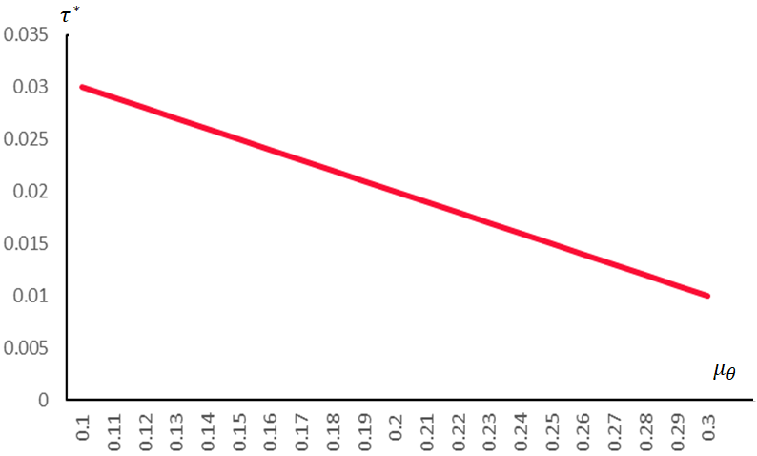

Similarly, solving Eq.s (6.3), (8) and (10) together, then by substituting from Eq. (17) and using the parameter values mentioned above, we obtain the upward sloping relationship between the socially optimal rate of tax and $σ_{θ}$. However, the rate of increase in $τ^{*}$, as $σ_{θ}$ increases, is not constant. This is because as the market risk of product A increases, difference in the response of the relative risk-taking (i.e., in $S_{v}$) and in the response of the efficiency frontier of socially optimal tax (as defined in (8.1)) can be higher or lower. In other words, while the increase in $σ_{θ}$ disincentivises potential suppliers from sustainable practices, this also prevents the supplier from grabbing any potential future gain from sustainable practices. Hence, the social planner needs to increase the optimal tax at variable rates commensurate with the increase in $σ_{θ}$ to reduce the opportunity cost of doing sustainable practices. This is evident in Fig. 2, which confirms our second proposition (Proposition 2).
Fig. 2: Relationship between $τ^{*}$ and $σ_{θ}$
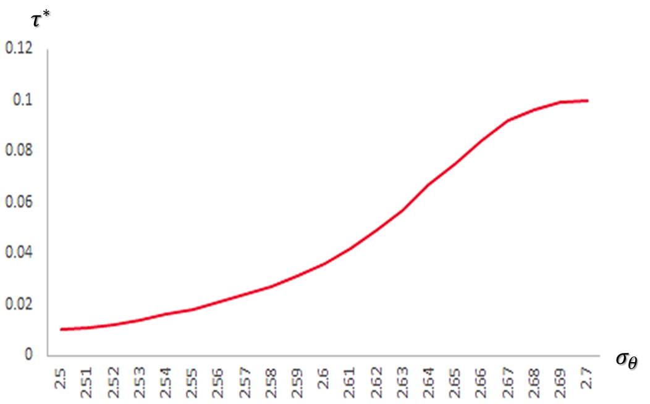

Next, we turn to calibrate the relationship between the socially optimal rate of rebate ($ρ^{*}$) and the average market uncertainty for product A ($μ_{θ}$). As we can see from Fig. 3, higher $μ_{θ}$ induces to increase the socially optimal rate of rebate on the final net earnings for A, in order to incentivize the suppliers towards sustainable practices to maximise expected relative net gain from sustainable practices. This substantiates our claim in Proposition 3(i).

Fig. 3: Relationship between $ρ^{*}$ and $μ_{θ}$
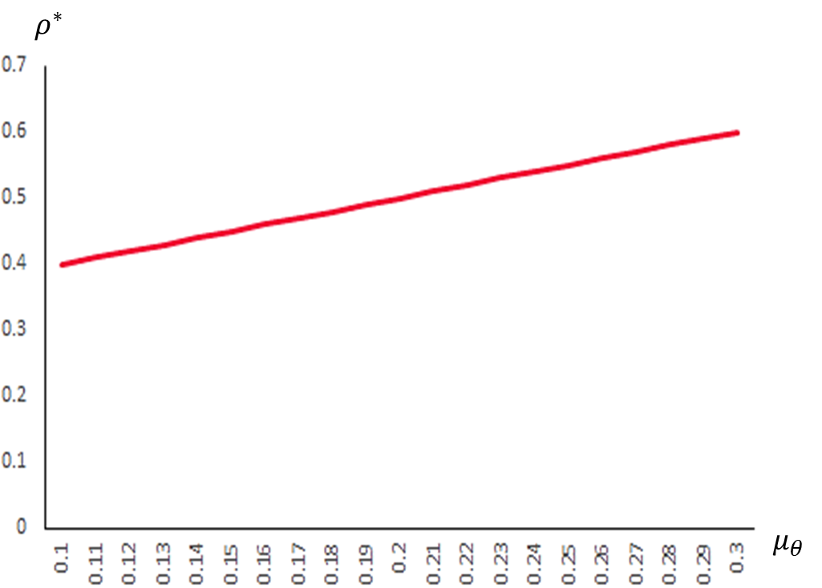

Now we turn to investigating part (ii) of Proposition 3. As $σ_{θ}$ increases, socially optimal rate of rebate ($ρ^{*}$) decreases, but at an increasing rate with higher market risk for product A. This reflects the variance vulnerability of the social planner, which prompts her to reduce the rebate in the event of high market uncertainty for product A. Thus Fig. 4 substantiates our claim in part (ii) of Proposition 3.
Fig. 4: Relationship between $ρ^{*}$ and $σ_{θ}$
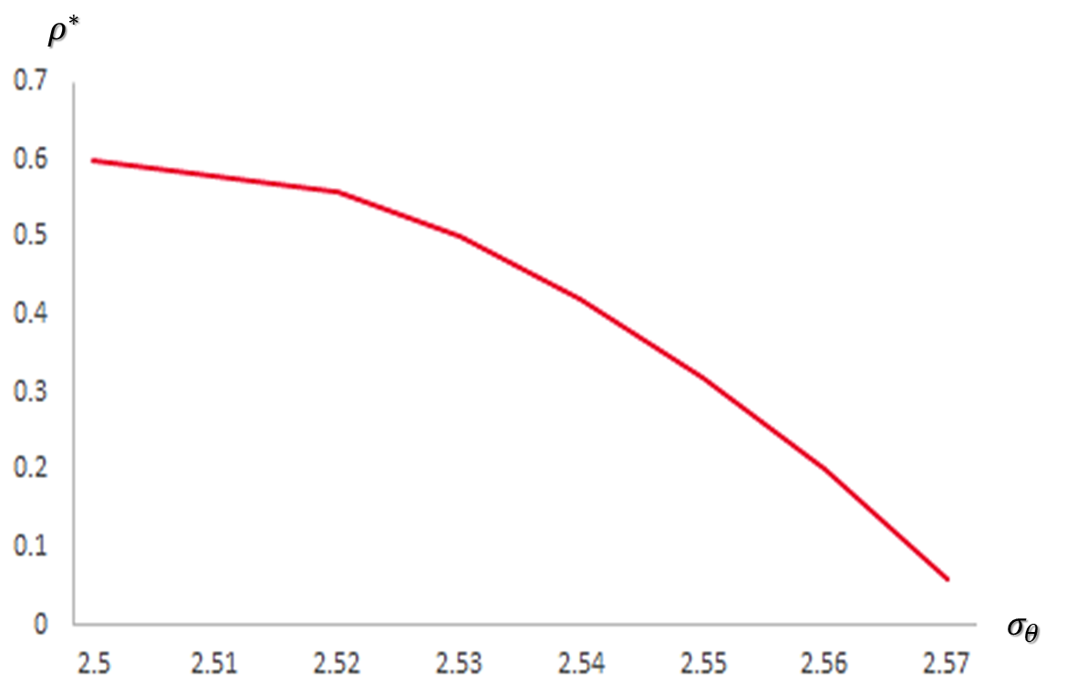

Now we are simulating the relationship between $ρ^{*}$ and the rate of tax ($τ$) obtained by solving simultaneously Eq.s (6.3), (11) and (15), substituting the MRS from Eq. (17) and using the specified parameter values. Then plotting the simulated relationship between $ρ^{*}$ and $τ$, we obtain an upward sloping and convex relationship in Fig. 5(i). This indicates that as the rate of tax increases, $ρ^{*}$ increases at an increasing rate. While a higher pre-tax optimal subsidy rate (before the tax rate increase) increases the post-tax-increase optimal subsidy rate, the increase in tax rate induces two effects on $ρ^{*}$. The first effect is “income effect”, to illustrate which we conduct a thought experiment in Fig. 5(ii). As $τ$ increases, given the relatively higher burden of tax faced by the supplier B, sustainable practices by producing and selling A increases and subsequently, the expected gain from supplying A increases. Hence, the socially optimum rate of rebate () goes up for each given level of tax, reflected by movement from point A to point B. The DARA preference can be substantiated by the decline in slope of the tangent at point B from point A in Fig. 5(ii).
However, from point B to point C, as tax rate increases, the slope of the tangent at point C is also increases, signifying variance vulnerability of preferences. Therefore, more suppliers are induced to supply A optimally and consequently, demands higher optimal rebate.
Fig. 5(i): Relationship between $ρ^{*}$ and $τ$
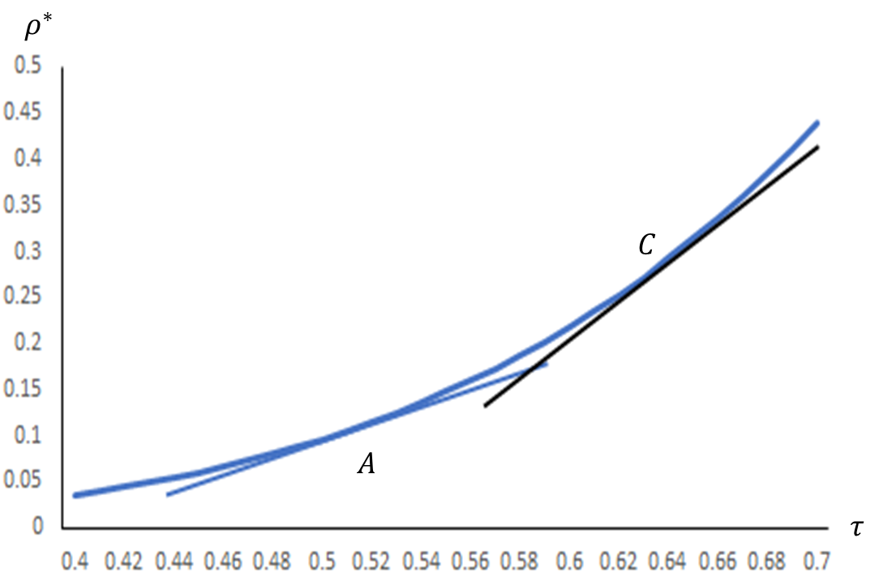

Fig. 5(ii): Thought experiment – Isolating the substitution and income effect of higher tax on $ρ^{*}$
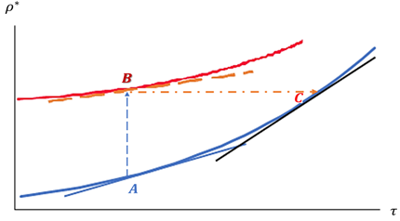

6. Discussion
Advances in behavioural operations have been applied in several contexts of decision making. However, its application in the context of sustainable sourcing has not yet been explored. Although traditionally buyers support sustainable suppliers with a flat monetary incentive structure (KPMG, 2017), our findings suggest that it can lead to unintended attrition of small and medium suppliers from engaging in supplying sustainable textile products and hence supplier incentive schemes should be structured differently so that the targeted performance levels are obtained. Our results provide important contributions to theory and have significant implications for practitioners. We discuss the major findings of our study and its theoretical and practical implications in the following sections.
6.1 Contributions to academic literature
In the extant literature on sustainable sourcing most prior literature have looked at communication mechanisms, standard setting, certifications and incentives (and penalties) between the focal (buyer) firm and suppliers. Similarly, the setting for such inquiries encompassed quality, lean and relatively recently sustainability programs. While such global inquiries have been useful in the extant literature, more nuanced inquiries have emerged recently. For instance, under what circumstances do sustainable suppliers migrate to conventional practises (Shalique et al., 2021; Wiengarten et al., 2019). How do measures like monetary incentives, subsidies, rebates, discount in sourcing inputs, training, and continuous monitoring help reduce suppliers migrating away from sustainability (Rui and Lai, 2015; Villena, 2019). What is the impact of monitoring mechanisms such as supplier audits, tax policy, or penalties on unsustainability practices by suppliers? (Rui and Lai, 2015; Ye et al., 2021; Lin et al., 2022). How can government (or buyers) employ various incentivisation scheme through rebates and subsidies that favour sustainability practices (Ye et al., 2021). Most prior studies have employed case studies and surveys-based analyses to see the impact of taxes and rebates in understanding the behaviour of sustainable suppliers (Gimenez and Tachizawa, 2012; Giunipero et al., 2019). Also, a detailed explanation behind possible migration of risk-averse sustainable suppliers towards supplying sustainable products has not been tackled.
Our contributions to academic literature are in three major areas. First, we contributed to the sparse use of analytical models and thinking which discovered interesting insights that could not be captured through survey research or case studies alone. For example, issues such as considering the appropriate socially optimal tax and rebate structures to encourage sustainable practices under market uncertainty was rendered possible because of our reliance on analytical models. Second, the implementation of sustainability has been plagued due to lack of resources. Especially, financially constraint small and medium scale suppliers have not been adequately studied. In this industry, the players tend to be more sensitive to tax rate increases as they benefit more from rebates compared to large scale suppliers. Our study revealed that a long-term sustainability orientation via tax and rebate- rate setting could influence small and medium scale suppliers to adopt sustainable practices. Thirdly, to the best of our knowledge, no prior study looked at the influence of policy maker (government) influence on the suppliers decision to continue (or abandon from) sustainability programs. Our study captures nuanced details as to how government incentives need to be provided to reduce migration of risk averse sustainable suppliers. Specifically, by balancing the effects of an increase in uniform rate of tax and the socially optimal rate of rebate on sustainable products an acceptable equilibrium can be arrived.
6.2 Contributions to managers and policy makers
To the managers and policy makers, our study points to many contributions. Managers should understand the behavioral characteristics that govern decision making by suppliers towards sustainability. They should have an overall awareness of how suppliers are influenced by regulatory policies that favour sustainability. In particular, they should be sensitive to the small-scale suppliers. In this paper, we isolated the role of benevolent fiscal policies in promoting migration of the risk-averse suppliers to sustainable textile products under uncertain market condition, from the unsustainable textile products. We modeled the decision of a risk-averse benevolent social planner, aiming to maximise the post-tax net gain from switching to the sustainable textile products, under uncertain market condition for the sustainable product A, minimising the risk associated with market share for A.
Deploying the MVU model we first derived the socially optimal rate of tax, corresponding to the socially optimal sales that maximises the expected gain from migrating to sustainable practices and minimises the risk associated with uncertain market for A. Then our comparative static results demonstrated that the socially optimal rate of tax declines as the possibility of loss in the market for A gets magnified, provided that the willingness-to-pay for refusing to sustainable practices decreases as the expected prospective gain from switching towards A becomes higher (viz., the “decreasing absolute risk aversion” preference structure). After that we further proved that as the variability of the market risk increases the socially optimal rate of tax must be reduced, if and only if the increase in market risk for A disincentivises risk-averse potential supplier from involving in supplying A (viz., the sufficiency condition that the elasticity of risk aversion with respect to the change in market risk for A must be greater than (-1) for the “variance vulnerable” decision-maker). These results provide useful insights for policymakers in terms of designing the optimal tax in such a manner that the sustainable practices will not be hurt; rather prospective suppliers would be encouraged to migrate towards sustainable practices.
Second, we derived the socially optimal rate of rebate, corresponding to the socially optimal sales maximising expected gain from switching towards sustainable practices and minimising the risk of sustainable practices. Consequently, we proved that the expected market loss for A induces to reduce the socially optimal rate of rebate on the final net earnings for A, while the socially optimal rate of rebate decreases for “variance vulnerable” supplier progressively at higher rates with increase in market risk for product A. Next, we establish that with the rate of tax increases, the socially optimal rate of rebate on product A must increase at an increasing rate, in order to induce the potential suppliers migrating towards sustainable practices. Hence, the managers and policymakers must work hand-in-hand in order to make sure that the optimal rebate is designed in such sustainable manner promoting the switch from unsustainable practices.
7. Conclusions
In this paper, we addressed the basic research problem of understanding why suppliers continue or exit from sustainability programs. We used an analytical model in which we retained the incentive-penalty framework as has been hinted in prior research but introduced the intervention of a policy maker, i.e., the government who extends incentives via rebates to sustainability related investments and levies a tax rate that is associated with conventional (departure away from sustainability) practices. This constitutes the most novel part of this paper and has hitherto not been studied in the prior literature.
This paper is not without limitations. We examine the stylized context of a textile supply chain although the parameters that were used in our numerical example came from real life data. It is possible that the findings from this paper cannot be generalized beyond the textile industry. Taking a conservative stance, it may also not be extrapolated beyond the first-tier suppliers in this industry. It is likely that in lower tiers of the supply chain, suppliers are more reluctant to adopt sustainability programs. A large volume of past literature has examined the role of buyers in inducing suppliers towards sustainability. In such contexts, contract issues and pricing are relevant. We have not specifically addressed this issue but indirectly tackled it via estimating the effect on the profit function. (see Tang et al., 2016). Also, increasingly the investments in sustainability are shared across many firms, universities and government agencies. For example, sustainability related innovation in the organic cotton industry has been spread across multiple players within the textile industry. This can mitigate large investments by single suppliers especially small and medium scale suppliers. With respect to our analytical model, recent research (Johnstone and Lindley, 2013). has examined the Borch paradox phenomena within MVU models. This paradox questions a fundamental assumption in MVU models that indifference curves capture the preferences of a rational investor when they do not. We leave these promising issues for future research.

Data Availability Statement: The data and materials that support the results or analyses presented in our paper will be made freely available upon request.
REFERENCES
Agrawal, V., & Lee, D. (2019). The effect of sourcing policies on suppliers’ sustainable practices. Production and Operations Management, 28(4), 767-787.
Aouadi, A., & Marsat, S. (2018). Do ESG Controversies Matter for Firm Value? Evidence from International Data. Journal of Business Ethics, 151(4), 1027-1047.
Arrow, K. J. (1965) Aspects of the theory of risk bearing. In: The Theory of Risk Aversion. Helsinki: Yrjo Jahnssonin Saatio. Reprinted in: Essays in the Theory of Risk Bearing, Markham Publ. Co., Chicago, 1971, 90-109.
Babich, V., & Tang, C. S. (2012). Managing opportunistic supplier product adulteration: Deferred payments, inspection, and combined mechanisms. Manufacturing & Service Operations Management, 14(2), 301-314.
Bontems, P., & Nauges, C. (2019). Production choices with water markets and risk aversion: the role of initial allocations and forward trading. European Review of Agricultural Economics, 46(4), 579-608.
Broll, U., Guo, X., Welzel, P., & Wong, W.-K. (2015). The banking firm and risk taking in a two-moment decision model. Economic Modelling, 50, 275-280.
Chen, Y. J., & Deng, M. (2013). Supplier certification and quality investment in supply chains. Naval Research Logistics (NRL), 60(3), 175-189.
Chen, J., Qi, A., & Dawande, M. (2019). Supplier centrality and auditing priority in socially-responsible supply chains. Manufacturing & Service Operations Management, 22(6), 1107-1286.
Chen, L., Yao, S., & Zhu, K. (2020). Responsible sourcing under supplier-auditor collusion. Manufacturing & Service Operations Management, forthcoming, https://doi.org/10.1287/msom.2019.0861.
Chen, S., Zhang, Q., & Zhou, Y. P. (2019). Impact of supply chain transparency on sustainability under NGO scrutiny. Production and Operations Management, 28(12), 3002-3022.
Chen, X., Benjaafar, S., Elomri, A. (2019) On the effectiveness of emission penalties in decentralized supply chains, European Journal of Operational Research, 274(3), 1155-1167
Eder-Hansen, J., Kryger, J., Morris, J., Sisco, C. and Larsen, K.B. (2012), “The nice consumer: towards a framework for sustainable fashion consumption in the EU”, Danish Fashion Institute, Nordic Fashion Association, Copenhagen.
Eichner, T., (2008). Mean variance vulnerability. Management Science, 54, 586–593.
Eichner, T., & Wagener, A. (2009). Multiple Risks and Mean-Variance Preferences. Operations Research, 57, 1142–1154.
Eichner, T., & Wagener, A. (2011). Portfolio allocation and asset demand with mean–variance preferences. Theory and Decision, 70, 179–193.
Eichner, T. & Wagener, A. (2012). Tempering effects of (dependent) background risks: A mean-variance analysis of portfolio selection. Journal of Mathematical Economics, 48, 422-430.
Fahimnia, B., Pournader, M., Siemsen, E., Bendoly, E., & Wang, C. (2019). Behavioral operations and supply chain management–a review and literature mapping. Decision Sciences, 50(6), 1127-1183.
Gimenez, C., & Tachizawa, E. (2012). Extending sustainability to suppliers: a systematic literature review, Supply Chain Management, 17(5), 531-543.
Giunipero, L. C., Bittner, S., Shanks, I., & Cho, M. H. (2019). Analyzing the sourcing literature: Over two decades of research. Journal of Purchasing and Supply Management, 25(5), 100521.
Guo, X., Wagener, A., Wong, W-K., & Zhu, L. (2018). The two-moment decision model with additive risks, Risk Management, 20(1), 77–94
Hitchcock, T. (2012), “Low carbon and green supply chains: the legal drivers and commercial pressures”, Supply Chain Management, 17(1), 98-101. https://doi.org/10.1108/13598541211212249.
Huang, X., & Jiang, G. (2021). Portfolio management with background risk under uncertain mean-variance utility. Fuzzy Optimization and Decision Making, 20(3), 315-330.
Jiang, M., Chen, D., Yu, H., (2021) Research on Reward and Punishment Contract Model and Coordination of Green Supply Chain Based on Fairness Preference, Sustainability, 13, 8749. https://doi.org/10.3390/su13168749.
Johnstone, D., Lindley, D., (2013)., Mean–Variance and Expected Utility: The Borch Paradox, Statistical Science, 28(2), 223-237.
KPMG (2017). The KPMG Green Tax Index, accessed 10 March 2019, available at https://home.kpmg/content/dam/kpmg/tw/pdf/2017/09/655445_NSS_2017Green_TaxIndex_v18web.pdf
Lin, Z. (2020), Manufacturer rebate in green supply chain with information asymmetry, INFOR: Information Systems and Operational Research, 58(4), 723-737.
Mukherjee, S., & Padhi, S. S. (2022). Sourcing decision under interconnected risks: an application of mean–variance preferences approach. Annals of Operations Research, 313(2), 1243-1268.
Nidhi, M.B., Madhusudanan Pillai, V. (2019) Product disposal penalty: Analysing carbon sensitive sustainable supply chains, Computers and Industrial Engineering, 128, 8-23.
Padhi, S. S., & Mukherjee, S. (2021). Optimal portfolio choices to split orders during supply disruption risks: An Application of sport's principle for Routine Sourcing. Decision Sciences (in press); 1– 20. https://doi.org/10.1111/deci.12511.
Porteous, A. H., Rammohan, S. V., & Lee, H. L. (2015). Carrots or sticks? Improving social and environmental compliance at suppliers through incentives and penalties. Production and Operations Management, 24(9), 1402-1413.
Pratt, J. W. (1964) Risk aversion in the small and in the large. Econometrica, 32, 122-136.
Rui, H., & Lai, G. (2015). Sourcing with deferred payment and inspection under supplier product adulteration risk. Production and Operations Management, 24(6), 934-946.
Serra, T., Zilberman, D., Goodwin, B. K., & Featherstone, A. (2006). Effects of decoupling on the mean and variability of output. European Review of Agricultural Economics, 33(3), 269-288.
Shao, L., Yang, J., & Zhang, M. (2017). Subsidy scheme or price discount scheme? Mass adoption of electric vehicles under different market structures. European Journal of Operational Research, 262(3), 1181-1195.
Shalique, S., Padhi, S. S, Jayaram, J., and Pati, R. K, (2021) Adoption of symbolic versus substantive sustainability practices by lower-tier suppliers: A behavioral view, International Journal of Production Research, 1-28, https://doi.org/10.1080/00207543.2021.1939454
Tamayo-Torres, I., Gutierrez-Gutierrez, L., & Ruiz-Moreno, A. (2019). Boosting sustainability and financial performance: the role of supply chain controversies. International Journal of Production Research, 57(11), 3719-3734. doi:10.1080/00207543.2018.1562248.
Tang, C. S., Sodhi, M. S., & Formentini, M. (2016). An analysis of partially-guaranteed-price contracts between farmers and agri-food companies. European Journal of Operational Research, 254(3), 1063-1073.
Touboulic, A., & Walker, H. (2015). Love me, love me not: A nuanced view on collaboration in sustainable supply chains. Journal of Purchasing and Supply Management, 21(3), 178-191.
Villena, V. H. (2019). The Missing Link? The Strategic Role of Procurement in Building Sustainable Supply Networks. Production and Operations Management, 28(5), 1149-1172.
Ye, F., Cai, Z., Chen,Y-J., Li,Y., Hou, G. (2021). Subsidize farmers or bioenergy producer? The design of a government subsidy program for a bioenergy supply chain, Naval Research Logistics, 68, 1082–1097.
Wang, W., Zhang, Y., Zhang, W., Gao, G., Zhang, H. (2021). Incentive mechanisms in a green supply chain under demand uncertainty, Journal of Cleaner Production, 279, 123636, https://doi.org/10.1016/j.jclepro.2020.123636
Wiengarten, F., Fan, D., Pagell, M., & Lo, C. K. (2019). Deviations from aspirational target levels and environmental and safety performance: Implications for operations managers acting irresponsibly. Journal of Operations Management, 65(6), 490-516.

https://inkstickmedia.com/the-fashion-industrys-slow-transition-to-sustainability/
https://www.financialexpress.com/industry/apparel-parks-in-india-a-look-at-their-current-state/2257298/
https://www.just-style.com/news/clean-clothes-campaign-calls-brands-out-for-freeriding-on-others-health-safety-efforts/
https://www.ecotextile.com/2022032129104/materials-production-news/new-deal-to-promote-cambodian-garment-sector.html
https://www.theregreview.org/2022/02/28/gamble-fashion-sustainability-new-york-fashion-act/
See, for example, Eichner and Wagener (2009; 2011); Padhi and Mukherjee (2021); Mukherjee and Padhi (2022).
See Eichner (2008).
$U_{μ}=\frac{∂U}{∂μ}$.
$S_{μ}=\frac{∂S(.)}{∂μ}$.
See, for example, Eichner (2008); Eichner & Wagener (2009; 2011); Padhi & Mukherjee (2021); Mukherjee & Padhi (2022).
$S_{v}=\frac{∂S(.)}{∂v}$.

