Title

Hybrid simulation modelling for dementia care services planning

Authors
D.C. Evenden^{a,b}, S.C. Brailsfordª, C.M. Kipps^{c}, P.J. Roderick^{d}, B. Walsh^{b}, and for the Alzheimer’s Disease Neuroimaging Initiative*
ª Southampton Business School, University of Southampton, Southampton, UK;
^{b} Health Sciences, University of Southampton, Southampton, UK;
^{c} University Hospital Southampton, Southampton, UK
^{d} School of Medicine, University of Southampton, Southampton, UK;
*Data used in preparation of this article were obtained from the Alzheimer’s Disease Neuroimaging Initiative (ADNI) database (adni.loni.usc.edu). As such, the investigators within the ADNI contributed to the design and implementation of ADNI and/or provided data but did not participate in analysis or writing of this report. A complete listing of ADNI investigators can be found at:
http://adni.loni.usc.edu/wp-content/uploads/how_to_apply/ADNI_Acknowledgement_List.pdf

Corresponding author:
Dr Dave Evenden
Southampton Business School
University of Southampton
University Road
Southampton
SO17 1BJ

dave.evenden@soton.ac.uk
word count: 4155 excluding Acknowledgements, References, and Appendix.

Title

Hybrid simulation modelling for dementia care services planning

Abstract
Dementia is an increasing problem in today’s ageing society, and meeting future demand for care is a major concern for policy-makers and planners. This paper presents a novel hybrid simulation model that simultaneously takes population-level and patient-level perspectives to calculate the numbers of patients at different stages of disease severity over time, and their associated care costs. System Dynamics is used at population level to capture ageing, dementia onset, and all-cause mortality, whereas disease progression is modelled at individual patient level using Agent-Based methods. This enables the model to account for variability between patients in the rate of cognitive decline, dementia-related mortality and response to treatment interventions. Using epidemiological data from the medical literature, disease progression is modelled via a longitudinal clustering method to identify progression type, followed by mixed-effects regression to reflect each individual’s rate of cognitive decline. Results are presented for population data from the south of England, and show that the currently available interventions have only modest effects at population level.
Keywords: hybrid simulation, dementia, disease progression, healthcare

1 Background
Dementia is a long-term neurodegenerative condition associated with progressive cognitive and functional decline, often requiring ongoing and eventually high levels of care. It is mainly, but not exclusively, associated with old age, and while medication can temporarily delay symptom progression in some patients, there is currently no cure. The onset is insidious, occurring many decades before clinical symptoms appear, making protective medical interventions difficult to target. Provision of care services is therefore critically important, particularly as 36.5% of the estimated 850,000 people with dementia in the UK are reported to be living in care homes (Alzheimer’s Society, 2014).
This modelling study was undertaken in collaboration with the Wessex Academic Health Science Network (wessexahsn.org.uk). Data availability was an important factor in the model design process; the model uses published data from clinical studies as well as local population data. The model estimates the number of people over 65 with dementia over time (broken down by disease severity stage) and the associated quality-adjusted life-years (QALYs), the costs of care, and the number of deaths. The model can also be used to explore the effects of any potential treatments or interventions. Section 9 of this paper presents comparative results for two currently available interventions, medical treatment and a healthy lifestyle intervention.

2 Previous modelling work in dementia
As part of the Assessment of Health Economics in Alzheimer’s Disease (AHEAD) project, Guo et al., (2014) developed a discrete-event simulation model of the treatment and control arms, representing a drugs ‘trial’ to determine intervention benefits. The dementia cohort was modelled using a fixed and random effects regression model (Getsios et al., 2010). The model depicted incremental cognitive decline, using one single set of coefficients to represent the entire dementia cohort.
System Dynamics was applied to family size trends and family living arrangements in Singapore (Ansah et al., 2013; Thompson et al., 2014; Thompson et al., 2012). These studies considered projections for the potential demand for long-term care, and the impact on acute care services if the provision of long-term care is inadequate. Given the cultural differences in family life and the important role of foreign domestic workers in Singapore, this work is difficult to generalise to the UK. Moreover, model parameters were based on limited, historical data (Reisberg et al., 1996).
A more recent study, IMPACT-BAM (Ahmadi-Abhari et al., 2017; Guzman-Castillo et al., 2017) uses Markov states to model ageing and progression of healthy 35 year olds to age 100 into several impaired health states and death. The model focusses on cardiovascular disease and cognitive impairment as drivers of life expectancy and disability. The results on dementia support other studies (Wu et al., 2017; Matthews et al., 2013) that show that the dominant factor driving the overall number of prevalent cases in future will be the ageing population.
The PACSim model (Kingston, Robinson, et al., 2018; Kingston, Comas-Herrera, et al., 2018) uses microsimulation to predict a decrease in care need for those aged 65-74 and an increase in the number of people with high care dependencies in the over 85s. The authors found that the prevalence of those with four or more multiple morbidities is projected to increase, with most of the anticipated life expectancy gains accompanied by disease. Their model was parameterised from three different population surveys, but dementia was not modelled explicitly and was determined as a post-simulation analysis of related factors.
Other than these studies, to date OR techniques have not been widely applied to care service planning for people with dementia. This is particularly the case with hybrid approaches. The model presented here adds to this previous work by classifying dementia severity by progression type and by using multiple outcome measures to compare scenarios. Most importantly, the use of hybrid simulation allows two entirely different but closely interconnected processes, population dynamics and individual disease progression dynamics, to be modelled using methods appropriate to their specific characteristics, making it possible to explore the interactions between population-level effects and individual-level effects.

3 Computer simulation modelling approach
The model was developed in the software AnyLogic (XJ Technologies, 2015). At the population level, ageing, dementia onset, and mortality are modelled using System Dynamics (SD). At the individual patient level, disease severity progression and the effects of any interventions are modelled using Agent-Based Modelling (ABM) to capture variability between individuals (Macal and North, 2010). Figure 1 shows the conceptual model design, combining SD stocks and flows (upper part) and agent-based severity progression and death (lower part). The interactions between the SD and AB parts, i.e. dementia onset (creating agents) and death (removing agents), are indicated in the side panels. Interfacing continuous SD and discrete ABM or DES modelling methods is a recognised challenge in hybrid simulation (Brailsford et al., 2019). In this model, agents are created and removed by monitoring and discretising the onset and mortality flows for each age group on a weekly basis, as described in section 6.
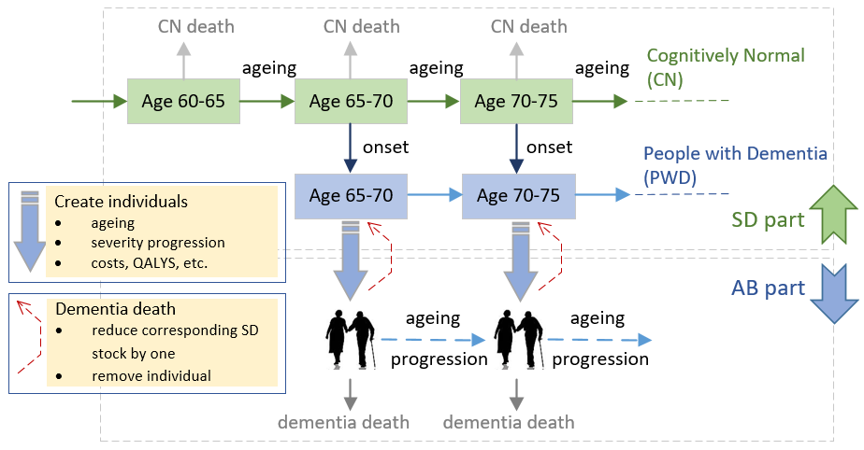
Figure 1 Conceptualisation of ageing, dementia onset, and severity progression

The term “dementia death” in Figure 1 is shorthand for “death of a person with dementia”, since dementia increases the risk of dying from other conditions. Severity progression is classified as slow, intermediate, or fast (Doody et al., 2010), represented by three different mixed effects regression models, as described in section 5. When an agent is created, the progression type and the corresponding regression parameters are randomly sampled. The use of agents to capture heterogeneity in progression and the complexities of response to interventions overcomes the assumption of homogeneity within each stock, as in standard SD modelling (Sterman, 2000; Forrester, 1994). Care costs, quality of life, and years with dementia are calculated for each individual agent and then aggregated at the population level and by progression type.

4 System Dynamics model architecture
The population is broken down into 5-year age groups from 65 to 105. The model excludes early-onset dementia, so people in the “entry” stock [60 to 65] are assumed to be cognitively normal (CN). As shown in Figure 1, each CN stock has two, age-related, outflows: CN deaths and incident (new) cases of dementia. Age-related mortality is also applied to each stock of people with dementia (PWD). The PWD cases and PWD deaths stock levels are monitored at weekly intervals to control agent creation and removal in the ABM component. Age-related mortality and incidence rates were estimated from published data (see Appendix A1).
Conventional SD ageing chains contain flows between adjacent age-group stocks, as indicated in Figure 1; at each time step $dt$, material drains from one stock and flows into the next. The model presented here uses a new approach, and instantaneously transfers the entire remaining contents of each stock (i.e. survivors) at 5-year intervals. This is depicted in Figure 2; note the absence of horizontal flows between stocks. Ageing for both CN and PWD sub-populations is controlled by purpose-written code executed at 5-year intervals. First, the remaining contents of the penultimate stock [95 to 100] are moved to stock [100 to 105]. Next, the contents of stock [90 to 95] are moved to stock [95 to 100], and so on down the age groups until each stock has been aged and the population is subject to new mortality and incidence rates for the next five years of modelled time.
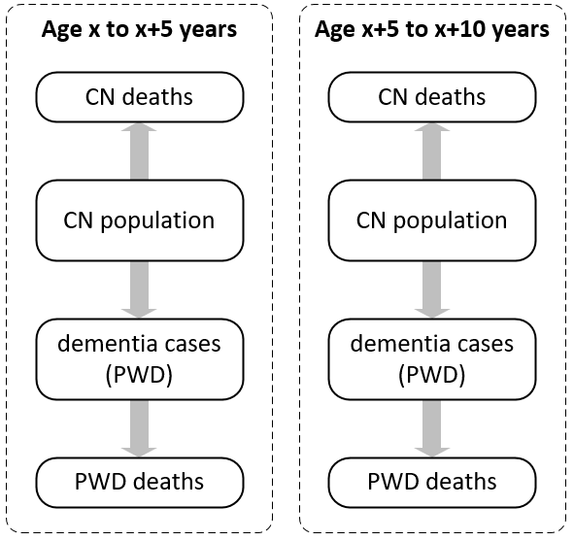
Figure 2 Adjacent age groups [x,x+5] and [x+5,x+10] with no flows between age bands

This approach assumes that the average age in each age group stock remains unchanged over the 5-year period, and hence the age-related mortality and incidence rates also remain unchanged. This relatively minor assumption significantly simplifies the standard approaches in the literature (Sterman, 2000; Eberlein and Thompson, 2012; Eberlein and Thompson, 2013) and avoids the considerable complications of stock mixing that would otherwise arise due to differences between inflows and outflows. This was fairly straightforward to implement in the simulation model, but the corresponding analytical formulation would be very difficult to solve: see Appendices A3 and A4.

5 Agent-based model architecture
Each agent has its own instantiation of a generic statechart that describes all the possible states it can be in and the transitions between them. Agents flow through the statechart under the control of transition routings and conditional logic, depicted conceptually in Figure 3.
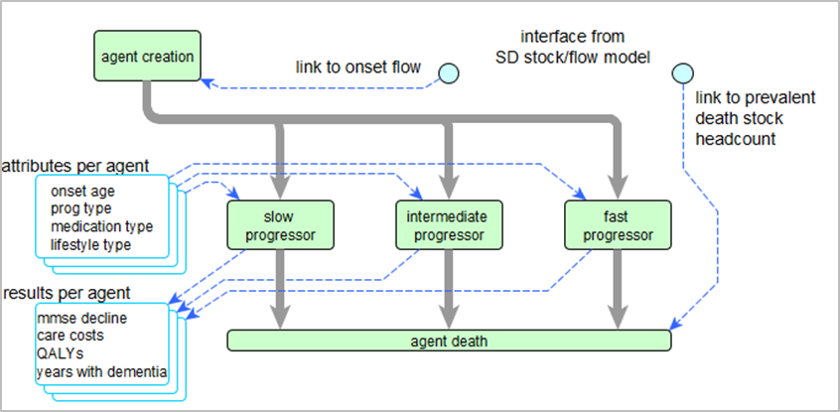
Figure 3 Agent-based severity progression concept

5.1 Agent creation and attribute allocation
When an agent is created, it is allocated several attributes which determine its behaviour. Each agent is allocated a unique ID number, progression type (slow, intermediate, and fast), individual progression rate parameters, potential response to medication (positive or not), and a lifestyle response (more healthy or not). The values of these attributes are sampled from the probability distributions described in Appendix A6. Dementia severity is represented by the score in the mini mental state exam (MMSE), a commonly used clinical instrument to assess a person’s cognitive state (Sheehan, 2012; Folstein et al., 1975). MMSE test scores are ubiquitous in the dementia literature, and enable dementia severity to be associated with QALYs and care costs. Cognitive decline is calculated at monthly intervals, using a mixed effects regression equation to calculate an updated value of the MMSE. The underlying fixed effect parameters are the same for all agents of that progression type, but the random effects adjustments of intercept and slope are sampled for each individual agent. Other attributes are used to track and record simulation outputs, such as age of onset and accumulated care costs. Based on the agent’s monthly MMSE value, additional functions are called to calculate care costs based on published sources (Alzheimer’s Society, 2014) and QALYs, based on summing health utility scores. The equations relating cognitive decline to QALYs and costs are given in Appendix 7.

5.2 Modelling interventions and benefits
The two interventions compared in this paper are medication and a healthy lifestyle, both of which are only effective for some patients. Medication can temporarily slow down disease progression, and a healthy lifestyle can delay the onset of dementia (and also death). These effects and the proportions of patients that benefit are shown in Table 1. The source references are given in Appendix A1.
Table 1 Intervention parameter values
Intervention | Parameter | Value
medication | start time | Onset + 12 months
 | progression delay | 12 months
 | % benefitting | 30%
lifestyle | onset delay | 24 months
 | mortality delay | 12 months
 | % benefitting | 30%

The effect of medication is modelled using conditional triggers that transition the agent to states where progression is temporarily decoupled from the simulation timer. After 12 months, the agent moves out of this state and their severity progression is re-synchronised with simulation time. Other time-dependent calculations (age, elapsed time with dementia, etc.) are not affected. To model the benefits of a healthier lifestyle, agents move to a delayed onset state, remain there for 24 months, and subsequently move into the severity progression states. These agents then later move to a delayed mortality state in which their “scheduled” death is delayed by 12 months. These actions occur only if the patient has a positive response attribute to that intervention.

6 Interaction between SD and ABM
This interaction occurs twice, at dementia onset and at death, and is one of the most innovative features of the model. Both processes originate in the SD part but require changes to be made in the AB part. In each age band, dementia onset is represented by the flow from CN to PWD, but the PWD stocks alone cannot be used to count new cases as they have outflows to PWD deaths. Therefore, in order to determine when a new agent should be created, each age group $[x,x+5]$ has an artificial “onset stock” with (continuous-valued) stock level $N^{x,x+5}$ and integer-valued tracking threshold $P^{x,x+5}$. The inflow to each onset stock duplicates the flow from CN to PWD for that age group using shadow flows. The values of $N^{x,x+5}$ are monitored at one week intervals in the SD part, and if ${N^{x,x+5}>P}^{x,x+5}$, then $\left\lfloor N^{x,x+5}-P^{x,x+5}\right\rfloor$ new agents in that age band are created and $P^{x,x+5}$ incremented to the next integer greater than $N^{x,x+5}$. These onset stocks are simply a modelling device to count the number of new cases; they have no outflows, and hence are not shown in Figures 1 and 2.
For agent removal, i.e. death, the process is slightly simpler as the PWD death stocks have no outflows and hence there is no need for a logical equivalent of the onset stocks. The PWD death stock levels are monitored at one week intervals, and each time the (rounded down) stock level increases, the corresponding integer number of agents whose ages fall within that age band are removed. Since increased dementia severity is associated with increased risk of mortality (Su et al., 2014; Larson et al., 2004; St. John et al., 2002), agent removal is biased preferentially to the more severe cases. This is implemented in the model by sampling an MMSE value from a uniform distribution, and selecting (at random) an agent whose MMSE value exceeds this sampled value. If the chosen agent is in the delayed mortality state, another agent is selected.

7 Model outputs
The main model outputs are the numbers of patients at different stages of disease severity over time, and the numbers of cognitively normal and dementia deaths by age group, also broken down by severity level. These numbers can be used to inform care service planning as well as the design of end-of-life services (Georghiou et al., 2012).
Table 2 Summary outcome measures
Outcome | Comments
Years with dementia (YWD) | Calculated for all patients and also broken down by progression type
Quality adjusted life years (QALYs)
Care costs | Calculated for each patient; costs per annum were estimated by dividing this by YWD
Number of PWD, by age group and severity | Case load indicator for care service planners
Number of deaths of PWD by age group | Case load indicator for end of life care

User-selectable options allow all-female or all-male populations to be simulated, as sex-specific incidence and mortality rates give different distributions of dementia onset age and longevity. The results presented in this paper are for a mixed population (see Appendix A1).

8 Model validation
The simulation was validated by comparing the model results with independent sources where available. For example, Figure 4 compares mortality in a cohort of 5,000 persons starting at age 60, obtained by aggregating CN (green) and PWD (blue) deaths in the model (solid orange) and using reference data from the UK Office of National Statistics (dotted orange).
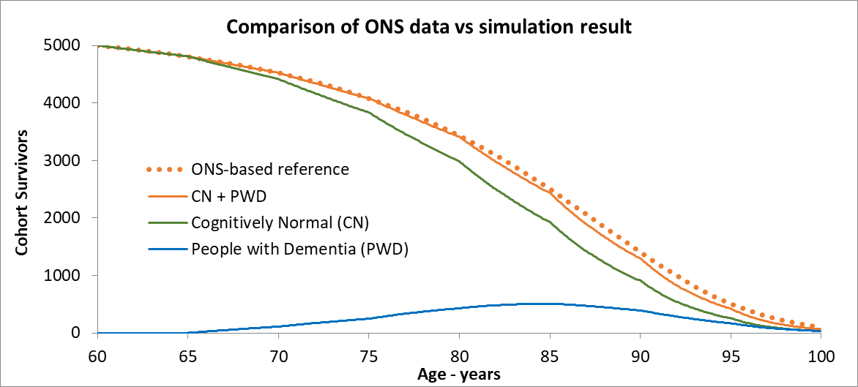
Figure 4 Validation of modelled overall mortality

On average, modelled patients survived 7.761 years with dementia (see Table 5). This value is consistent with published studies, although these studies are relatively old and the ranges are very wide, for example 3.8 to 10.7 years (Xie et al., 2008) and 5.9 to 12.2 years (Waring et al., 2005). The model results for age-related prevalence were compared with published estimates (Alzheimer’s Society, 2014), and the overall number of cases compared with the published lifetime risk of dementia (Fishman, 2017; Brookmeyer and Abdalla, 2018), as shown in Table 3. Given the uncertainty in the published estimates, the simulation results are reasonably consistent.
Table 3 Dementia prevalence and lifetime risk (LTR) of dementia
Age | 65 | 70 | 75 | 80 | 85 | 90 | 95 | LTR
Reference | 1.7% | 3.0% | 6.0% | 11.2% | 18.3% | 29.9% | 41.1% | 31.0%
Simulation | 0.5% | 3.2% | 7.4% | 14.4% | 22.9% | 32.3% | 42.3% | 26.9%

Simulated care cost outcomes were compared with other published care cost data for England (Wübker et al., 2015), not used in the model, which reported that the average annual cost per person was £27,000, rising to £44,600 per annum for people in nursing homes. The model gives an average annual cost of £28,800 per person. Costs are not broken down by progression type in the literature so further comparison is not possible, but assuming that fast progressors are more likely to require nursing home care, these costs also compare well: the simulation gave £45,100 per person per year.

9 Experimentation and results
Table 4 presents the results for a no-intervention scenario, using the mortality rate and incidence parameters given in Table A3 in the Appendix, for a cohort of 10,000 persons entering the model in 2015 at age 60. To account for uncertainty, three parameters (two mortality; one incidence) were varied over a ±20% range, with 10 intervals (so 11 measurement points), giving 11³ = 1331 iterations and an overall total of 2,791,382 agents. This experiment took about 40 minutes on an i5-6600 CPU running at 3.3GHz with 8GB RAM under Windows 10.
Table 4 shows that unsurprisingly, in the younger age groups there are more new cases than deaths from dementia, whereas the reverse is true in the older age groups. This is indicated by the inequality symbols and the grey shading.
Table 4 Numbers of new cases and PWD deaths for a single age cohort
Age group | CN deaths | 95% CI | New cases | 95% CI |  | PWD deaths | 95% CI
60-65 | 380.5 | ± 2.0 | - | - | - | - | -
65-70 | 557.7 | ± 2.7 | 230.4 | ± 2.2 | > | 13.6 | ± 0.1
70-75 | 836.7 | ± 3.9 | 328.8 | ± 3.0 | > | 71.9 | ± 0.7
75-80 | 1159.9 | ± 4.9 | 540.4 | ± 4.7 | > | 223.6 | ± 2.0
80-85 | 1496.8 | ± 5.9 | 601.2 | ± 4.8 | > | 529.6 | ± 4.6
85-90 | 1510.0 | ± 6.3 | 525.6 | ± 4.0 | < | 810.4 | ± 6.5
90-95 | 986.0 | ± 6.7 | 322.7 | ± 2.8 | < | 696.8 | ± 5.3
95-100 | 337.7 | ± 4.3 | 120.6 | ± 1.5 | < | 292.0 | ± 2.2
100-105 | 39.1 | ± 0.5 | 19.0 | ± 0.2 | < | 46.1 | ± 0.5
Total | 7304.4 | ± 19.8 | 2688.7 | ± 19.8 |  | 2684.0 | ± 19.8
Notes: 95% CI values are calculated in AnyLogic as half-width values about the mean.
Stock level rounding errors are <0.5%

Table 5 summarises the baseline results, showing distinct differences by progression type in YWD and care costs.
Table 5 Summary baseline outcomes, aggregated and by progression type
Outcome measure | Mean values and 95% CI
 | Slow | Intermediate | Fast | Total
Years with dementia (YWD)  95% confidence interval | 9.181  ± 0.03 | 6.049  ± 0.026 | 3.439  ± 0.023 | 7.671  ± 0.027
Quality adjusted life years (QALYs)  95% confidence interval | 5.661  ± 0.018 | 3.527  ± 0.014 | 1.802  ± 0.011 | 4.637  ± 0.016
Total care costs  95% confidence interval | £233.1k  ± £994 | £217.9k  ± £1145 | £155.2k  ± £1196 | £220.8k  ± £1011
Annual care costs | £25.4k | £36.0k | £45.1k | £28.8k
Notes: 95% CI values are calculated in AnyLogic as half-width values about the mean
Annual costs are calculated from the stated point estimates

Table 6 presents the results from two further experiments for the same cohort and the two interventions described in section 5.2.
Table 6 Intervention effects, calculated for individual PWD, and averaged over all progression types
Outcome measure | Baseline | Medication | Lifestyle
Years with dementia (YWD)  95% confidence interval | 7.671  ± 0.027 | 7.753  ± 0.027 | 7.376  ± 0.027
Quality adjusted life years (QALYs)  95% confidence interval | 4.637  ± 0.016 | 4.707  ± 0.016 | 4.914  ± 0.015
Total care costs  95% confidence interval | £220.8k  ± £1012 | £217.7k  ± £986 | £205.6k  ± £976
Annual care costs | £28.8k | £28.1k | £27.9k
Summary of benefits
YWD reduction (increase) over baseline |  | (1 month) | 3.5 months
QALY improvement over baseline |  | 0.070 QALY | 0.277 QALY
Overall care costs |  | Saving £3.1k | Saving £15.2k

10 Discussion

10.1 Simulation results
It can be seen from Table 6 that both interventions show a benefit in terms of increased QALYs and reduced costs. However, medication increases YWD by reducing progression rates and mortality, whereas lifestyle interventions reduce YWD and thus result in greater cost savings as well as a greater QALY gain compared with medication. Although medical interventions can be worthwhile at an individual level, only a minority of patients benefit and the average cost saving per patient (£3.1k) is small. On the other hand, the lifestyle intervention results in an average cost saving per patient of £15.2k, and is likely to benefit the CN population as well.
Table 6 shows that slow progressors survive about 9 years, whereas fast progressors only survive 3.4 years on average. This more rapid decline is associated with reduced quality of life and higher mortality. The annual care costs for fast progressors are higher, but they are incurred over a shorter period, resulting in lower average total care costs (£155k). Slow progressors incur higher average total costs (£233k), but over a longer period.

10.2 Clinical and policy implications
Prompt assessment for fast progressors is clearly important, as there is less time to get individual care plans in place and to identify the budgetary means. For a typically-sized care service planning area, with 10,000 persons aged 60-65, there will be several hundred new dementia cases within that cohort over each 5-year interval. The number of new cases within that age cohort peaks at age 80 to 85, after which the number of people dying with dementia exceeds the number of new cases. At this point, the emphasis for care services shifts from managing new cases to providing end of life care.
The scenarios in section 9 were chosen to illustrate the simplest way that the model can be used, i.e. for one single age cohort starting at age 60, and are thus closer to the world of clinical trials than the world of care service planning. However, the model can also handle more realistic population-based scenarios, described in Appendix A.2. These include multiple age cohorts, i.e. new arrivals aged 60-65 every five years; a ‘cross-sectional’ initial population in each age group at time zero; and, most realistic of all, a combination of both these.
Until more effective treatments become available, medication alone is unlikely to make significant reductions in population-level demand for dementia care services. Lifestyle interventions have greater potential, and may also lead to other health benefits in addition to dementia, but require considerable planning and long-term commitment from all stakeholders to ensure that these benefits are realised. An appropriate precautionary approach would be to prepare for increased demand based on the key driver of older population growth, supporting previous recommendations (Prince, 2016). In addition, a deeper appreciation of differing progression rates, and their effect on service need affords better capability in matching service provision with local demand and future service growth.

10.3 Modelling and simulation reflections
The scientifically novel aspects of this model are the ageing mechanism in the SD submodel, the interfaces between SD and AB (i.e. the agent creation and removal processes), and the disease progression analysis in the AB submodel. The hybrid approach exploits the complementary strengths of SD and ABM. In a healthcare context, many problems can benefit from combining a deterministic, population-level system-wide view with a detailed, stochastic, patient-level perspective (Brailsford et al., 2019). Public health campaigns in particular are typically “targeted” at very large populations, more efficiently modelled using SD, but their impact is felt by individual patients, with variable effect. The healthy lifestyle intervention in this paper exemplifies this. Any such intervention would have to be aimed at (say) all people over 50, the majority of whom will never develop dementia (although they might still benefit from taking more exercise and a more healthy diet). For those individuals who do develop dementia, the health benefits are variable. Service planners and decision-makers need to take all these aspects into account.
ABM is still relatively underused in practice (Brailsford et al., 2019), but is a very powerful approach for modelling human systems. It would enable this model to be extended to include complications and comorbidities associated with dementia (Bunn et al., 2014; Poblador-Plou et al., 2014; Kurrle et al., 2012), and also handle more complex network-based interactions, such as social engagement (Badham et al., 2018) and health service provider interactions and behaviours (Mills, 2013), assuming sufficient data were available to parameterize such a model. This model demonstrates the potential of currently underutilised OR techniques (Penn et al., 2015; Monks, 2016) to better understand the interactions between population and patient-level effects of public health interventions. The general principle of modelling macro-micro interactions extends far beyond healthcare into many other application areas.

Acknowledgements
Data collection and sharing for this project was funded by the Alzheimer's Disease Neuroimaging Initiative (ADNI) (National Institutes of Health Grant U01 AG024904) and DOD ADNI (Department of Defense award number W81XWH-12-2-0012). ADNI is funded by the National Institute on Aging, the National Institute of Biomedical Imaging and Bioengineering, and through generous contributions from the following: AbbVie, Alzheimer’s Association; Alzheimer’s Drug Discovery Foundation; Araclon Biotech; BioClinica, Inc.; Biogen; Bristol-Myers Squibb Company; CereSpir, Inc.; Cogstate; Eisai Inc.; Elan Pharmaceuticals, Inc.; Eli Lilly and Company; EuroImmun; F. Hoffmann-La Roche Ltd and its affiliated company Genentech, Inc.; Fujirebio; GE Healthcare; IXICO Ltd.; Janssen Alzheimer Immunotherapy Research & Development, LLC.; Johnson & Johnson Pharmaceutical Research & Development LLC.; Lumosity; Lundbeck; Merck & Co., Inc.; Meso Scale Diagnostics, LLC.; NeuroRx Research; Neurotrack Technologies; Novartis Pharmaceuticals Corporation; Pfizer Inc.; Piramal Imaging; Servier; Takeda Pharmaceutical Company; and Transition Therapeutics. The Canadian Institutes of Health Research is providing funds to support ADNI clinical sites in Canada. Private sector contributions are facilitated by the Foundation for the National Institutes of Health (www.fnih.org). The grantee organization is the Northern California Institute for Research and Education, and the study is coordinated by the Alzheimer’s Therapeutic Research Institute at the University of Southern California. ADNI data are disseminated by the Laboratory for Neuro Imaging at the University of Southern California.

11 References
ADNI, 2016. Alzheimer’s Disease Neuroimaging Initiative. Available at: http://adni.loni.usc.edu/ [Accessed February 1, 2017].
Agüero-Torres, H. et al., 1999. Mortality from dementia in advanced age: A 5-year follow-up study of incident dementia cases. Journal of Clinical Epidemiology, 52(8), pp.737–743.
Ahmadi-Abhari, S. et al., 2017. Temporal trend in dementia incidence since 2002 and projections for prevalence in England and Wales to 2040: modelling study. BMJ, 2856, pp.1–15.
Alzheimer’s Society, 2014. Dementia UK: Update, London.
Ansah, J.P. et al., 2013. Simulating the Impact of Long-Term Care Policy on Family Eldercare Hours. Health Services Research, 48(2pt2), pp.773–791.
van Baal, P.H.M., Hoogendoorn, M. and Fischer, A., 2016. Preventing dementia by promoting physical activity and the long-term impact on health and social care expenditures. Preventive Medicine, 85, pp.78–83.
Badham, J. et al., 2018. Developing agent-based models of complex health behaviour. Health and Place, 54(May), pp.170–177.
Barnett, J.H. et al., 2014. Early intervention in Alzheimer’s disease: a health economic study of the effects of diagnostic timing. BMC neurology, 14(1), pp.1–9.
Barocco, F. et al., 2017. The Progression of Alzheimer’s Disease: Are Fast Decliners Really Fast? A Four-Year Follow-Up. Journal of Alzheimer’s Disease, 57(3), pp.775–786.
Bates, D. et al., 2015. Fitting linear mixed-effects models using lme4. Journal of Statistical Software, 67(1), pp.1–48.
Birks, J., McGuinness, B. and Craig, D., 2013. Rivastigmine for vascular cognitive impairment., Chichester, UK.
Birks, J.S., 2006. Cholinesterase inhibitors for Alzheimer’s disease Cochrane Dementia and Cognitive Improvement Group, ed., Chichester, UK.
Birks, J.S., Chong, L.Y. and Grimley Evans, J., 2015. Rivastigmine for Alzheimer’s disease, Chichester, UK: John Wiley & Sons, Ltd.
Brailsford, S.C. et al., 2019. Hybrid simulation modelling in operational research: A state-of-the-art review. European Journal of Operational Research, 278(3), pp.721–737.
Brookmeyer, R. and Abdalla, N., 2018. Estimation of lifetime risks of Alzheimer’s disease dementia using biomarkers for preclinical disease. Alzheimer’s and Dementia, 14(8), pp.981–988.
Bunn, F. et al., 2014. Comorbidity and dementia: a scoping review of the literature. BMC medicine, 12(1), p.192.
Corrada, M.M. et al., 2010. Dementia incidence continues to increase with age in the oldest old the 90+ study. Annals of Neurology, 67(1), pp.114–121.
CSHA Working Group, 2000. The incidence of dementia in Canada. Neurology, 55(1), pp.66–73.
Doody, R.S. et al., 2010. Predicting progression of Alzheimer’s disease. Alzheimer’s Research & Therapy, 2(4), p.14.
Eberlein, R. and Thompson, J., 2012. Chronological Aging in Continuous Time. In Proceedings of the 30th International Conference of the System Dynamics Society. pp. 1–22.
Eberlein, R.L. and Thompson, J.P., 2013. Precise modeling of aging populations. System Dynamics Review, 29(2), pp.87–101.
Edland, S.D. et al., 2002. Dementia and Alzheimer Disease Incidence Rates Do Not Vary by Sex in Rochester,Minn. Arch Neurol, 59(10), pp.1589–1593.
Elwood, P. et al., 2013. Healthy Lifestyles Reduce the Incidence of Chronic Diseases and Dementia: Evidence from the Caerphilly Cohort Study K. Sathian, ed. PLoS ONE, 8(12), pp.1–7.
Fichter, M.M., Schröppel, H. and Meller, I., 1996. Incidence of dementia in a Munich community sample of the oldest old. European archives of psychiatry and clinical neuroscience, 246(6), pp.320–8.
Fishman, E., 2017. Risk of Developing Dementia at Older Ages in the United States. Demography, 54(5), pp.1897–1919.
Folstein, M.F., Folstein, S.E. and McHugh, P.R., 1975. “Mini-mental state.” Journal of Psychiatric Research, 12(3), pp.189–198.
Forrester, J.W., 1994. System Dynamics, Systems Thinking, and Soft OR. System Dynamics Review, 10(2), pp.1–14.
Ganguli, M. et al., 2005. Alzheimer Disease and Mortality. Archives of Neurology, 62(May 2005), pp.779–784.
Genolini, C. et al., 2015. kml and kml3d: R Packages to Cluster Longitudinal Data. Journal of Statistical Software, 65(4), pp.1–34.
Genolini, C. et al., 2013. KmL3D: A non-parametric algorithm for clustering joint trajectories. Computer Methods and Programs in Biomedicine, 109(1), pp.104–111.
Georghiou, T. et al., 2012. Understanding patterns of health and social care at the end of life, London.
Getsios, D. et al., 2010. Cost Effectiveness of Donepezil in the Treatment of Mild to Moderate Alzheimerʼs Disease. PharmacoEconomics, 28(5), pp.411–427.
Grasset, L. et al., 2016. Trends in dementia incidence: Evolution over a 10-year period in France. Alzheimer’s & Dementia, 12(3), pp.272–280.
Grootoonk, S. et al., 2016. Understanding the Costs of Dementia Diagnosis and Care and the Financial Benefits Arising From Identifying Rapid Progressors. In AAIC 2016. Elsevier.
Guo, S. et al., 2014. Evaluating disease-modifying agents: a simulation framework for Alzheimer’s disease. PharmacoEconomics, 32(11), pp.1129–39.
Guzman-Castillo, M. et al., 2017. Forecasted trends in disability and life expectancy in England and Wales up to 2025: a modelling study. The Lancet Public Health, 2667(17), pp.1–7.
St. John, P.D. et al., 2002. Cognitive scores, even within the normal range, predict death and institutionalization. Age and Ageing, 31(5), pp.373–378.
Jones, R.W. et al., 2017. Disease Progression in Mild Dementia due to Alzheimer Disease in an 18-Month Observational Study (GERAS): The Impact on Costs and Caregiver Outcomes. Dementia and geriatric cognitive disorders extra, 7(1), pp.87–100.
Kahle-Wrobleski, K. et al., 2015. Clinical and Economic Characteristics of Milestones along the Continuum of Alzheimer’s Disease: Transforming Functional Scores into Levels of Dependence. J Prev Alzh Disease, 2(2), pp.2–7.
Kingston, A., Robinson, L., et al., 2018. Projections of multi-morbidity in the older population in England to 2035: Estimates from the Population Ageing and Care Simulation (PACSim) model. Age and Ageing, 47(3), pp.374–380.
Kingston, A., Comas-Herrera, A. and Jagger, C., 2018. Forecasting the care needs of the older population in England over the next 20 years: estimates from the Population Ageing and Care Simulation (PACSim) modelling study. The Lancet Public Health, 3(9), pp.e447–e455.
Kurrle, S., Brodaty, H. and Hogarth, R., 2012. Physical comorbidities of dementia,
Larson, E.B. et al., 2006. Exercise Is Associated with Reduced Risk for Incident Dementia among Persons 65 Years of Age and Older. Annals of Internal Medicine, pp.73–82.
Larson, E.B. et al., 2004. Survival after initial diagnosis of Alzheimer disease. Ann Intern Med, 140(7), pp.501–509.
Macal, C.M. and North, M.J., 2010. Tutorial on agent-based modelling and simulation. Journal of Simulation.
Matthews, F.E. et al., 2013. A two-decade comparison of prevalence of dementia in individuals aged 65 years and older from three geographical areas of England: Results of the cognitive function and ageing study i and II. The Lancet, 382(9902), pp.1405–1412.
Matthews, F.E. et al., 2016. A two decade dementia incidence comparison from the Cognitive Function and Ageing Studies I and II. Nature Communications, 7, p.8.
Miech, R.A. et al., 2002. Incidence of AD may decline in the early 90s for men, later for women: The Cache County study. Neurology, 58(2), pp.209–218.
Mills, A., 2013. Simulating health behavior,
Monks, T., 2016. Operational research as implementation science: definitions, challenges and research priorities. Implementation science : IS, 11(1), p.81.
ONS, 2019. Mortality statistics - underlying cause, sex and age. nomis. Available at: https://forum.alzheimers.org.uk/attachments/nomis-leading-cause-of-death-pdf.57354/ [Accessed February 4, 2019].
ONS, 2014a. nltuk1315reg.xls. National life tables: United Kingdom. Available at: https://www.ons.gov.uk/file?uri=/peoplepopulationandcommunity/birthsdeathsandmarriages/lifeexpectancies/datasets/nationallifetablesunitedkingdomreferencetables/current/nltuk1315reg.xls [Accessed May 4, 2018].
ONS, 2014b. Population Estimates Analysis Tool. Mid-2013 Population Estimates: Pivot table Analysis Tool for the United Kingdom. Available at: https://www.ons.gov.uk/peoplepopulationandcommunity/populationandmigration/populationestimates/datasets/populationestimatesanalysistool [Accessed May 8, 2018].
ONS, 2014c. Table 2, tcm77364153.xls. Subnational population projections for England: 2012-based. Available at: https://www.ons.gov.uk/peoplepopulationandcommunity/populationandmigration/populationprojections/datasets/localauthoritiesinenglandtable2 [Accessed April 20, 2018].
Ott, A. et al., 1998. Incidence and risk of dementia. The Rotterdam Study. American journal of epidemiology, 147(6), pp.574–80.
Penn, M.L. et al., 2015. Modelling self-management pathways for people with diabetes in primary care. BMC family practice, 16, p.112.
Perera, G. et al., 2014. Factors Associated with Response to Acetylcholinesterase Inhibition in Dementia: A Cohort Study from a Secondary Mental Health Care Case Register in London E. M. C. Skoulakis, ed. PLoS ONE, 9(11), p.e109484.
Poblador-Plou, B. et al., 2014. Comorbidity of dementia: a cross-sectional study of primary care older patients. BMC psychiatry, 14(1), p.84.
Prince, M., 2016. Recent global trends in the prevalence and incidence of dementia, and survival with dementia. Alzheimer’s Research & Therapy, 8(1), p.23.
Rait, G. et al., 2010. Survival of People with Clinical Diagnosis of Dementia in Primary Care: Cohort Study. BMJ, 341(7768), p.337.
Ravi, S., 2011. Dementia mortality: Estimates of survival after the onset of dementia range from 4 to 12 years. Indian Journal of Psychiatry, 53(2), p.178.
Ray, S. and Davidson, S., 2014. Dementia and cognitive decline: a review of the evidence, London.
Reisberg, B. et al., 1996. Mortality and temporal course of probable Alzheimer’s disease: a 5-year prospective study. International psychogeriatrics, 8(2), pp.291–311.
Seshadri, S. et al., 1997. Lifetime risk of dementia and Alzheimer’s disease: The impact of mortality on risk estimates in the Framingham Study. Neurology, 49(6), pp.1498–1504.
Sheehan, B., 2012. Assessment scales in dementia. Therapeutic Advances in Neurological Disorders, 5(6), pp.349–358.
Sterman, J.D., 2000. Systems Thinking and Modeling for a Complex World, USA: McGraw-Hill.
Su, Y.-P. et al., 2014. Mini-mental state examination as a predictor of mortality among older people referred to secondary mental healthcare. PloS one, 9(9), pp.1–7.
Thompson, J.P. et al., 2012. Future living arrangements of Singaporeans with age-related dementia. International Psychogeriatrics, 24(10), pp.1592–1599.
Thompson, J.P., Riley, C.M. and Eberlein, R.L., 2014. Modelling for Insight: The Case of Dementia in Singapore. Systems Research and Behavioral Science, 31(2), pp.227–235.
Waring, S.C. et al., 2005. Survival among Patients With Dementia from a Large Multi-Ethnic Population. Alzheimer Disease & Associated Disorders, 19(4), pp.178–183.
Wu, Y.T. et al., 2017. The changing prevalence and incidence of dementia over time - current evidence. Nature Reviews Neurology, 13(6), pp.327–339.
Wübker, A. et al., 2015. Costs of care for people with dementia just before and after nursing home placement: primary data from eight European countries. The European Journal of Health Economics, 16(7), pp.689–707.
Xie, J. et al., 2008. Survival times in people with dementia: analysis from population based cohort study with 14 year follow-up. BMJ, 336(7638), pp.258–62.
XJ Technologies, 2015. The AnyLogic Company. Available at: www.anylogic.com.

This appendix provides a more detailed description of the model, consisting of the following parts:
- Parameter data sources and references
- The population definition
- The SD model as a system of differential equations (DEs)
- The solution to the DEs
- The derivation of dementia incidence and mortality rate
- The dementia severity progression model
- Care cost and QALY equations
  - Data sources
Table A1 Input parameter data sources
parameter | source details
Population mortality | National Life Tables (ONS, 2014a)
Population distribution | Estimates for mid-2016 (ONS, 2014b)
Population projections | 25 year forecast by Local Authority (ONS, 2014c)
Incidence rates | (Brookmeyer and Abdalla, 2018; Fishman, 2017; Grasset et al., 2016; Matthews et al., 2016; Corrada et al., 2010; Rait et al., 2010; Edland et al., 2002; Miech et al., 2002; CSHA Working Group, 2000; Ott et al., 1998; Seshadri et al., 1997; Fichter et al., 1996)
Dementia mortality | (Ganguli et al., 2005; Agüero-Torres et al., 1999; ONS, 2019)  Values interpolated to 5-year age groups
Dementia prevalence | Dementia UK: Update (Alzheimer’s Society, 2014)
Severity Progression | Alzheimer’s Disease Neuroimaging Initiative (ADNI, 2016)
 | Longitudinal clustering method (Genolini et al., 2015)
 | Mixed effects regression (Bates et al., 2015)
Medication benefit | (Birks, 2006; Perera et al., 2014; Birks et al., 2013; Birks et al., 2015) plus expert judgement for the proportion benefitting.
Lifestyle benefit | (van Baal et al., 2016; Larson et al., 2006; Ray and Davidson, 2014; Elwood et al., 2013)
Care costs | (Alzheimer’s Society, 2014; Kahle-Wrobleski et al., 2015; Jones et al., 2017)

  - Population definition
The model allows various population starting scenarios, from single and multiple successive age/birth cohorts, to a cross-sectional age distribution with starting-value stock levels in all age groups for both CN and PWD stocks.
This paper focusses on the results for a single cohort approach, as this provided the most easily interpretable results. Ageing, onset, and death could be directly observed without more complicated interaction effects. Observing a single age cohort also provided clearer insights into the underlying epidemiology, and the intervention benefits for a specific age group.
For multiple age cohorts, the effect of population growth can be explored by making subsequent 60-65 age groups entering the model progressively larger. The model does not attempt to reflect short-term fluctuations in real-world population growth and longevity, but simply depicts general trends. Younger cohorts entering the model are increased by a cohort inflation parameter to reflect projected population increases. Younger cohorts also live longer, and this is controlled by a mortality rate reduction parameter. The ONS-based (ONS, 2014c) reference values in Table A2 show the projected relative growth in each age band over the next 20 years: for example, in 2034 there will be 1.99 times as many 85-year-olds as there were in 2014. Simulation case 1 shows the results for annual increases of 2.2% in population growth at age 60 and a 1.2% reduction in mortality rate. Case 2 shows the results for 2.2% and 3.0% respectively.
Table A2 Population growth and longevity comparison
Age | 65 | 70 | 75 | 80 | 85 | 90 | over 65s | parameters
Reference | 1.22 | 1.55 | 1.64 | 1.81 | 1.99 | 2.81 | 1.55 | (ONS, 2014c)
Case 1 | 1.54 | 1.59 | 1.61 | 1.64 | 1.72 | 1.99 | 1.71 | 2.2% and 1.2%
Case 2 | 1.60 | 1.66 | 1.71 | 1.79 | 1.98 | 2.78 | 1.99 | 2.2% and 3.0%

For the cross-sectional age distribution, the cognitively normal stocks were initialised with headcounts based on published values (ONS, 2014b) of the number of people in each 5-year age group. While this approach is more realistic, older people spend a shorter time in the model and the results are a composite of onset and mortality effects across these different age groups. While the results obtained were more comprehensive, detailed interpretation is thus more difficult, and are not reported here.

  - Analytical formulation
In this section we present a continuous, analytical, formulation of the ageing process in the SD model as a set of ordinary differential equations (ODEs). The broad horizontal arrows in Figure A1 represent how stock levels are transferred at 5-year intervals between age groups. The vertical arrows show the incidence and mortality flows between stocks within an age group. For simplicity this formulation omits the age band index, but (unlike many studies in the literature) the model uses age-related incidence and mortality rates.
The stock of people with dementia $P\left(t\right)$ has initial value $P\left(0\right),$ an inflow of new cases with incidence rate $rI$, and an outflow to the stock $M\left(t\right)$ (dementia deaths) with dementia mortality rate $rM$. $P(0)$ are the survivors with dementia transferred in from the previous age group. Similarly, the stock $CN\left(t\right)$ of cognitively normal (CN) people, has initial value $CN\left(0\right)$ and an outflow to the stock $D\left(t\right)$ of CN deaths with CN mortality rate $rD$.
At the end of each 5-year interval, the surviving $CN(5)$ and $P(5)$ stocks are transferred to the next oldest age group, where they become $CN(0)$ and $P(0)$ for that age group. These transferred stocks therefore represent the initial conditions for the differential equations describing that process.
from previous age group |  | current age group | to next age group
 | 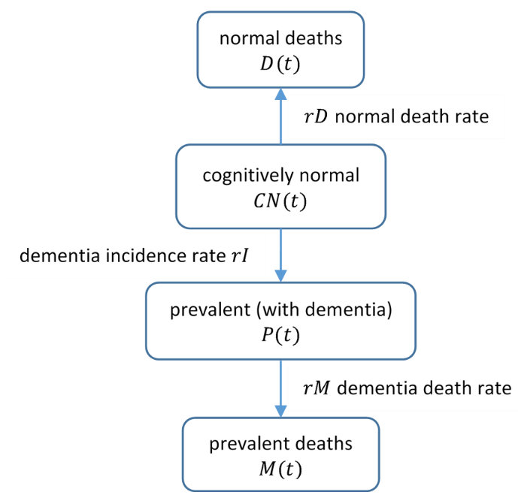
$$CN\left(0\right)$$ |  |  |  | $$CN(5)$$
$$P(0)$$ |  |  |  | $$P(5)$$
Figure A1 Age group stock-flow structure

The rate of change of $CN(t)$ over time $t$ is determined by the incidence rate $rI$ and the CN mortality rate $rD$:
$$dCN(t)/dt= -(rI+rD).CN\left(t\right)$$
The rate of change of $D\left(t\right)$ is determined by $CN\left(t\right)$ and the CN mortality rate $rD$:
$$dD(t)/dt=rD.CN\left(t\right)$$
The rate of change of $P(t)$ is determined by the incidence rate $rI$ from $CN(t)$ and the dementia mortality rate $rM$:
$$dP(t)/dt= rI.CN(t)-rM.P(t)$$
Finally, the rate of change in $M(t)$ is determined by $P(t)$ and the dementia mortality rate $rM$:
$$dM(t)/dt= rM.P\left(t\right)$$

  - Solutions of the differential equations
We present solutions for these ODEs in the case where there are no survivors from the previous age group, i.e. $P(0)=0$.
Number of CN people: $CN\left(t\right)=CN\left(0\right).\exp\left[-t.\left(rI+rD\right)\right]$ (1)
CN deaths: $D\left(t\right)=\frac{CN\left(0\right).rD}{rD+rI}\left(1-\exp\left[-t.\left(rI+rD\right)\right]\right)$ (2)
Number of PWD: $P\left(t\right)=\frac{CN\left(0\right).rI}{rD+rI-rM}\left(\exp\left[-t.rM\right]-\exp\left[-t.\left(rI+rD\right)\right]\right)$ (3)
Dementia deaths:$M\left(t\right)=\frac{CN(0).rI}{rD+rI}.\left(1+\frac{rM}{rD+rI-rM}.\exp\left[-t.\left(rI+rD\right)\right]-\frac{rD+rI}{rD+rI-rM}\exp\left[-t.rM\right]\right)$ (4)
In general, survivors with dementia from the previous age group would be included as an initial condition. In this case, equation (3) becomes:
$$P\left(t\right)=\frac{CN\left(0\right).rI}{rD+rI-rM}.\left(\exp\left[-t.rM\right]-\exp\left[-t.\left(rI+rD\right)\right]\right)+P(0).\exp\left[-t.rM\right]$$
These ODEs are not easy to solve analytically, but are relatively straightforward to implement and solve by simulation.
  - Incidence and mortality parameter derivation
To parameterise the model, published studies were reviewed to obtain the most relevant evidence. Incidence rates – which define onset of dementia in a population were based on a review of several studies (Table A1). The availability of published data in most sources by 5-year age group informed the model’s age group architecture.
Similarly, dementia mortality rates were based on a review of sources (Ganguli et al., 2005; Agüero-Torres et al., 1999; ONS, 2019). Estimated dementia mortality rates were between one-and-a-half times and twice the rates for the cognitively normal population, consistent with previous studies (e.g. Ravi, 2011). Cognitively normal age-related death rates in the model ($rD$) were derived from overall population mortality rate (ONS, 2014a), corrected to account for estimated prevalence (Alzheimer’s Society, 2014), where $rO$ is the overall population mortality rate and $prev$ is the prevalence.
$rD =\frac{rO}{1-prev}– rM.\left(\frac{prev}{1-prev}\right)$
Table A3 presents the population parameters used for a mixed population. The model may also be run with values specific to female and male populations.
Table A3 SD flow parameter values
Age group | CN mortality rate | Incidence rate | PWD mortality rate
 | cases per 1000 person-years
60-65 | 8 | - | -
65-70 | 12 | 5 | 18
70-75 | 20 | 8 | 30
75-80 | 34 | 16 | 51
80-85 | 62 | 25 | 93
85-90 | 112 | 39 | 168
90-95 | 191 | 63 | 287
95-100 | 308 | 110 | 462
100-105 | 308 | 150 | 462

  - Agent based model – dementia progression parameter values
A key set of parameters were the severity progression rates for the three progression types. Cognitive and functional assessments results for 1736 patients (ADNI, 2016), obtained from the Alzheimer’s Disease Neuroimaging Initiative (ADNI) database.
were partitioned using a longitudinal clustering method to identify progression type membership (Genolini et al., 2015; Genolini et al., 2013), and then mixed-effects regression was used to estimate fixed and random effects progression coefficients. These were used to parameterise individual agent-based cognitive decline.
The mathematical formulation of the mixed-effects regression model is:-
$MMSE_{ij}(month)=\left[μ_{0,i}+ N\left(0,σ_{0,i,j}^{2}\right)\right] +[μ_{1,i}+N\left(0,σ_{1,i,j}^{2}\right)].month+μ_{2,i}.month^{2}$
Where $N\left(0,σ_{0,i,j}^{2}\right)$ and $N\left(0,σ_{1,i,j}^{2}\right)]$ are normally distributed adjustments to take account of individual variability for the $j^{th}$agent in the $i^{th}$ progression-type group, to the fixed effect intercept and slope terms $μ_{0i}$ and $μ_{1i}$, and $j∈\{slow,intermediate,fast\}$. A random effects term was also explored for the quadratic term, but as model fit was not significantly improved this was not included. These values are summarised in the following table.
These values are given in Table A4 showing cognitive decline as MMSE points per month, implemented with normally distributed random effects shown as $N(μ_{1},σ^{2}).$ Non-linear slope coefficient values are mean changes per month squared. For example, an agent simulating intermediate progression of dementia symptoms would start with a mean MMSE score of 25.2, declining on average by 10.1 MMSE points after 5 years, but with random effects of $σ_{0}=1.57$ and $σ_{1}=0.074$ to that agent’s intercept and linear slope.
Table A4 Severity progression type parameter values
Type | Baseline | Intercept | Linear slope | Quadratic slope
Slow | 60% | $$N(26.9, {1.39}^{2})$$ | $$N(0.03, {0.044}^{2})$$ | $$μ_{2}=0.00052$$
Intermediate | 30% | $$N(25.2, {1.57}^{2})$$ | $$N(0.14, {0.074}^{2})$$ | $$μ_{2}=0.00047$$
Fast | 10% | $$N(22.5, {1.50}^{2})$$ | $$N(0.38, {0.201}^{2})$$ | $$μ_{2}=0.00165$$

Published studies (Table A5), which report fixed effect linear slope values, show reasonable agreement with our results. For example, 0.38 MMSE points per month (for fast progression types in Table A4) is 4.56 MMSE points per year, comparable with the fast column in Table A5.
Table A5 Summary of published progression rates
Source | Slow | Intermediate | Fast
Soto 2005*  Soto 2008* |  |  | ≥4 pts at ½ year  ≥5 pts at 1 year
Carcaillon 2007* |  |  | ≥3 pts / year
(Doody et al., 2010) | <2 pts / year | 2-5 pts / year | ≥5 pts / year
Musicco* |  |  | 5 pts at 2 years
(Barocco et al., 2017) |  | ≥5 pts at 1.5 years | ≥5 pts at 1 year
(Grootoonk et al., 2016) | ≤3 pts at 2 years | 3-6 pts at 2 years | ≥6 pts at 2 years
Table summarises points on the MMSE scale
* indicates a secondary reference cited in Sona et al. (2013).
Data collection and sharing for this project was funded by the Alzheimer's Disease Neuroimaging Initiative (ADNI) (National Institutes of Health Grant U01 AG024904) and DOD ADNI (Department of Defense award number W81XWH-12-2-0012). ADNI is funded by the National Institute on Aging, the National Institute of Biomedical Imaging and Bioengineering, and through generous contributions from several agencies. ADNI data are disseminated by the Laboratory for Neuro Imaging at the University of Southern California.
  - Agent based model – care costs and QALYs
Monthly costs were calculated using the following equation based on a fit to the care cost references stated in Table A1. For example, a moderate severity MMSE level = 17 equates to a £3,389 monthly care cost or £40,668 per year. This compares with £2,983 per month (Wübker et al., 2015) and £39,294 per year for moderate dementia (Alzheimer’s Society, 2014).
$Costs \left(£\right)= 6568.4-187.85MMSE$
To calculate QALYs, firstly health utility scores were calculated using the following equation based on the AHEAD modelling equations (Getsios, et al., 2010, Equation 6) with the same simplification used by Barnett et al., (2014, page 3), so that:
$Utility = 0.408+0.01MMSE$
Health utility was calculated monthly, so that the QALY result is the summation of health utility values over the years with dementia (YWD):
$QALY = \sum_{YWD}{Utility/12}$

