Interview with professor Bart Baesens about his latest book: Principles of Database Management: The Practical Guide to Storing, Managing and Analyzing Big and Small Data.
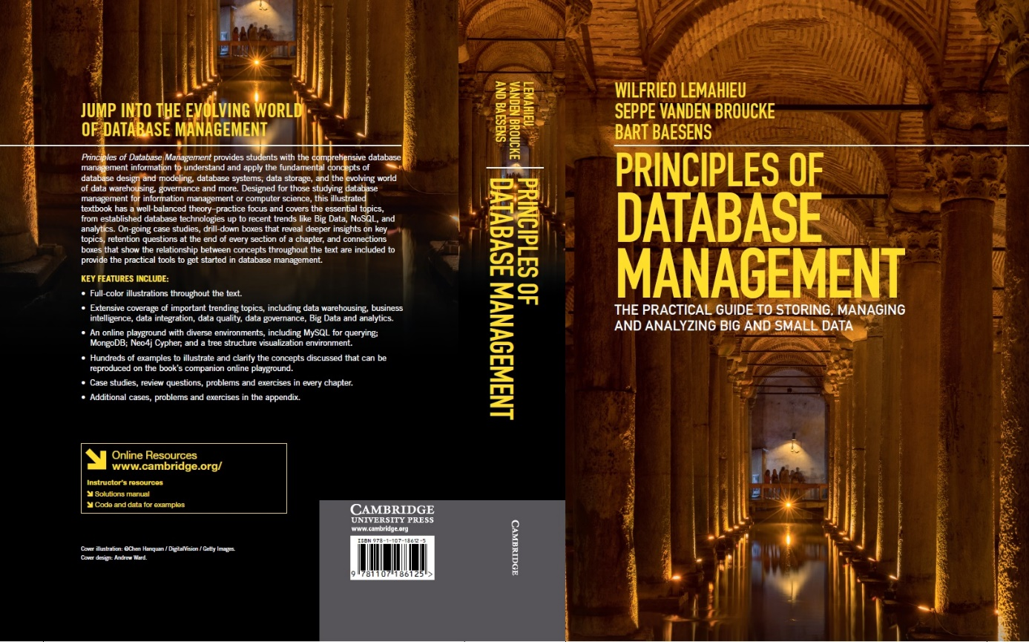
Why did you decide to write your book Principles of Database Management?
This book is the result of having taught an undergraduate database management class and a postgraduate advanced database management class for more than ten years at KU Leuven (Belgium). Throughout these years, we have found no good textbook which covers the material in a comprehensive way without getting flooded by theoretical detail and losing focus. Hence, after having teamed up together, we decided to start writing a book ourselves. This work aims to offer a complete and practical guide covering all the governing principles of database management, including:
- End-to-end coverage starting with legacy technologies to emerging trends such as Big Data, NoSQL databases, Analytics, data governance, etc.
- A unique perspective on how lessons learnt from past data management could be relevant in today’s technology setting (e.g., navigational access and its perils in Codasyl and XML/OO databases)
- A critical reflection and accompanying risk management considerations when implementing the technologies considered, based on our own experiences from participating in data and analytics related projects with industry partners in a variety of sectors, from banking to retail and from government to the cultural sector
- Offering a solid balance between theory and practice, including various exercises, industry examples and case studies originating from a diversified and complimentary business practice, scientific research and academic teaching experience
What is your target audience?
We have tried to make this book complete and useful for both novice and advanced database practitioners and students alike. No matter whether you’re a novice just beginning to work with database management systems, a versed SQL user aiming to brush up your knowledge of underlying concepts or theory, or someone looking to get an update on newer, more modern database approaches, this book aims to familiarize you with all the necessary concepts. Hence, this book is well suited for:
- Under- or postgraduate students taking courses on database management in BSc and MSc programmes in Information Management and/or Computer Science;
- Business professionals who would like to refresh or update their knowledge on database management;
- Information architects, database designers, data owners, data stewards, database administrators or data scientists interested in new developments in the area
Thanks to the exercises and industry examples throughout the chapters, the book can also be used by tutors in courses such as: Principles of Database Management, Database Modelling, Database Design, Database Systems, Data Management, Data Modelling and Data Science. It can also be useful to universities working out degrees in e.g. Big Data and Analytics.
What topics are covered in the book and how is it organized?
The book is organized in four main parts. Chapters 1 through 4 address preliminary and introductory topics regarding databases and database design, starting with an introduction of elementary concepts in chapter 1, followed with a description of common database management system types and their architecture in chapter 2. Chapter 3 discusses conceptual data modeling, with chapter 4 providing a management overview on the different roles involved in data management and their responsibilities.
Part 2 (chapters 5 to 11) then takes a deep dive into the various types of databases, from legacy pre-relational and relational database management systems into more recent approaches such as object-oriented, object-relational and XML-based databases in chapters 8, 9 and 10, ending with a solid and up-to-date overview of NoSQL technologies in chapter 11. This part also includes a comprehensive overview of the Structured Query Language (SQL) in chapter 7.
In part 3, physical data storage, transaction management and database access are discussed in depth. Chapter 12 discusses physical file organization and indexing whereas Chapter 13 elaborates on physical database organization and business continuity. This is followed by an overview on the basics of transaction management in Chapter 14. Chapter 15 introduces database access mechanisms and various database Application Programming Interfaces. Chapter 16 concludes this part by zooming in on data distribution and distributed transaction management.
Chapters 17 to 20 form the last part of this book, where we zoom out and elaborate on data warehousing and emerging interest areas such as data governance, big data and analytics. Chapter 17 discusses data warehouses and business intelligence in depth, with Chapter 18 discussing managerial concepts such as data integration, data quality, and data governance. Chapter 19 provides an in-depth overview of big data and shows how a solid database set-up can make up the cornerstone of a modern analytical environment. Chapter 20 concludes this part and the book by zooming into different types of analytics.
Two appendices are included: one containing an exam bank of questions and another one outlining the on-line playground environment.
Is there any additional material provided (e.g., for instructors or students)?
Yes, the book comes with the following additional material:
- A website with additional information: www.pdbmbook.com
- Free YouTube lectures for each of the 20 chapters, see https://www.youtube.com/watch?v=o36Z_OqC2ac&list=PLdQddgMBv5zHcEN9RrhADq3CBColhY2hl
- PowerPoint slides for each of the 20 chapters, see http://www.pdbmbook.com/lecturers
- A solutions manual with the solutions to all multiple choice and open questions.
- An online playground with diverse environments, including MySQL for querying; MongoDB; Neo4j Cypher; and a tree structure visualization environment
- Full-color illustrations throughout the text
- Extensive coverage of important trending topics, including data warehousing, business intelligence, data integration, data quality, data governance, Big Data, and analytics
- Hundreds of examples to illustrate and clarify the concepts discussed that can be reproduced on the book’s companion online playground
- Case studies, review questions, problems, and exercises in every chapter

When will it be available and can it already be ordered?
Yes, it can already be pre-ordered on Amazon. The book will be available in June in Europe and the UK and in August in the US. We are looking forward to hearing your feedback!

