A novel dual modality sensor with sensitivities to permittivity and conductivity

Jorge R. Salas Avila, Kin Yau How and Wuliang Yin, Senior Member, IEEE
School of Electrical and Electronic Engineering
The University of Manchester, Manchester M13 9PL, UK
jorge.salasavila@postgrad.manchester.ac.uk
kin.how@student.manchester.ac.uk
wuliang.yin@manchester.ac.uk

Abstract - In this paper, an electromagnetic (EM) sensor which can operate simultaneously in capacitive and inductive modalities is developed, and a novel measurement strategy is proposed accordingly. The sensor is composed of two planar spiral coils with large track width, which promotes its capacitive mode. The capacitive coupling is measured in common mode while the inductive coupling is measured in differential mode. In capacitive mode, the sensor is sensitive to the dielectric material distribution, i.e. changes in permittivity; while in inductive mode, it is sensitive to magnetically permeable material and electrically conductive material. Furthermore, it is demonstrated that the sensor can simultaneously measure dielectric and conductive materials. This novel sensor has been designed and implemented. Experimental results verified its effectiveness in dual modality measurement.
Keywords - planar sensors; EM sensor; dual modality; eddy-current testing; combined sensing.

Introduction
Evaluation of materials by using electric and magnetic fields has been extensively performed for various inspection purposes, such as failure detection, quality assurance and material composition inspection [1-2]. The selection of the measurement method is determined by the fundamental electrical and magnetic properties of the material of interest i.e. permittivity, conductivity and permeability [3]. Capacitance measurements are appropriate for evaluating dielectric materials; for example, planar capacitance sensors have been used to inspect variations in dielectric properties of materials [4], [5]. Magnetic induction / eddy-current testing is suitable for evaluating and inspecting conductive materials with many different coil configurations having been investigated, including planar spiral coils [6].
Measuring the change in both capacitance and mutual inductance with a suitable sensor gives the possibility of inspecting the fundamental electrical and magnetic properties with a single sensor. Therefore, insulators, conductors and composite materials can be inspected with one sensor.
Jorge R. Salas Avila would like to thank the National Council of Science and Technology (CONACYT) of Mexico for sponsoring his PhD studies.
Attempts of combining capacitive and inductive measurements have been reported previously. In [7] and [8], by switching between modes of operation or multiplexing, the presence of conductive and dielectric materials is detected with a dual mode sensor, but the sensor is still a physical combination of two sensors (capacitive and inductive). A printed sensor was reported in [9]; by identifying the predominant sensor response above and below the resonant frequency, it was possible to detect and distinguish between conductive and dielectric materials. In [10], meander and mesh planar sensors were employed for inspection of conductive and dielectric materials; the effects of some dielectric samples on the transfer impedance using frequencies up to hundreds of megahertz were reported. This sensor is sensitive to both conductive and dielectric materials, but was not capable of determining both properties simultaneously.
In this paper, we present a novel sensor which inherently is a dual inductive/capacitive sensing element and thus is sensitive to changes in both conductivity and permittivity, and importantly each effect can be separated by using different modes of measurement. As demonstrated, in differential mode, the change in mutual inductance is measured; and in common mode, the change in capacitive coupling is measured. Measurements can be taken in differential and common modes simultaneously with an impedance analyser with suitable configuration, therefore, the sensor can simultaneously measure dielectric and conductive materials and there is no need for switching between different sensing elements. Moreover, the designed planar sensor has some advantages including, easy manufacturing, good repeatability, low cost as in [11], and can be built of flexible materials for inspection of irregular surfaces as in [6].
The sensor was designed and built, and experimental results for measuring conductive and dielectric materials are presented.

Sensor design
The sensor is composed of two planar spiral coils made of copper foil. Fig. 1 depicts the layout of the sensor. The trace width is 4 mm, and the gap between the traces is 1 mm; the separation between the nearest traces of the coil pair is 5 mm, and the distance between the centres of the coil pair is 41 mm. A thin insulator layer made of acrylic plate of 1 mm thickness was placed over the sensor to avoid direct electrical contact between the conductive traces and the sample.
The self-inductance of each coil is ~320 nH, mutual inductance 20 nH and direct coupling capacitance 1.8 pF at 100 kHz measured with an impedance analyser (Sl 1260). The same instrument was used in the following experiments; connections between the sensor and the impedance analyser are shown in Fig. 2. The instrument has two measurement channels which can be independently configured as differential and common modes; thus, differential and common mode measurements can be taken simultaneously with this configuration.

Sensing modes and measurements modes
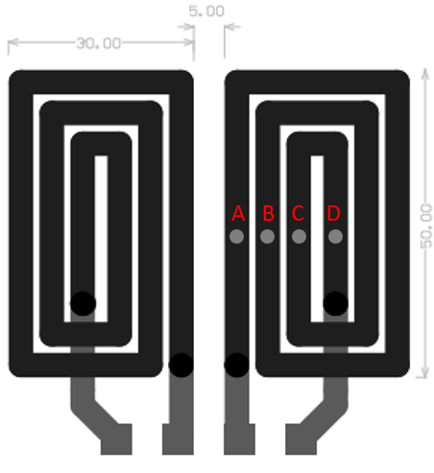
Fig. 1. Sensor layout. Units are in millimetres.

Capacitive sensing mode
With large surface track width, each of the planar coils acts as a capacitive plate, where one is the transmitter and other the receiver. Therefore the capacitive sensing mechanism is similar to that of a two coplanar plate configuration [12]. When a sinusoidal voltage is applied to the transmitter, a potential difference is established and thus a capacitive coupling developed. Introducing permittivity change in the sensing area will perturb the established potential distribution and hence the capacitive coupling, the change of which can then be measured.
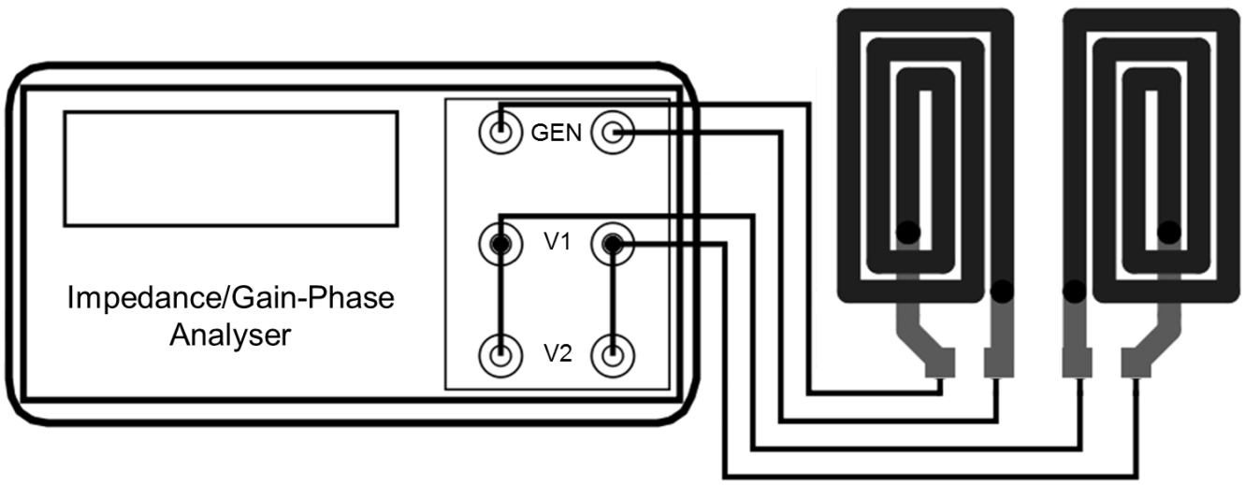
Fig. 2. Connections between the sensor and the impedance analyser.
Depending on the nature of the sample, different effects are expected as discussed in [13]. A grounded object will reduce the electric flux reaching the receiver due to a leakage through the newly formed ground path and therefore reduce the capacitive coupling; a floating sample with a higher permittivity generally increases the capacitive coupling. These effects are referred as shunt mode and transmission mode respectively [12]. Both effects were observed in our sensor, but the interest of this work is for the latter case where the sample is electrically floating.
Goss et al. [14] presented an equivalent circuit for an excitation/detection coil pair with a sample in-between and identified six coupling mechanisms. It was stated that the potential difference between the coils, the surface area of the target, and the direct capacitive coupling between the coils strongly influence the capacitive excitation - capacitive detection mode. While in magnetic inductive measurements, the capacitive coupling effect needs to be minimised, the sensor developed here intentionally exploits this effect. By using a large track width, a significant capacitance coupling between the tracks develops, the strongest being the coupling between the nearest tracks of the excitation and detection pair. Overall, the average coupling effect from all the tracks is measured.
A 2-D finite-element simulation was carried out to explore the sensitivity distribution of the sensor. The excitation coil was segmented as traces with different potentials due to the fact that it is the only load for the signal generator and the voltage drop must occur along the track. For the detection coil, all the track of the was left at the same potential since it is made of a highly conductive material, i.e. copper. The electric potential distribution is shown in Fig. 3.
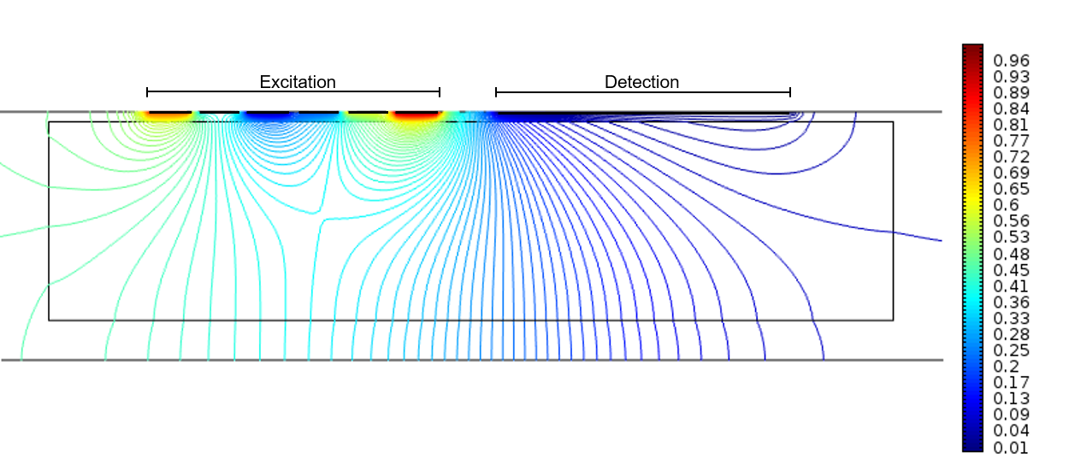
Fig. 3. Electric field distribution over different segments of one planar sensor. Units are in volts.
For the case when a potential difference exists over the detection coil due to inductive coupling, a 2-D finite-element simulation was carried out. Similarly, as in Fig. 3, the excitation coil is segmented as traces with different potentials, but the detection coil is also segmented as traces with different potentials. The developed capacitance between the nearest track of the excitation coil and the points A, B, C and D of the detection coil are shown in Table I. As expected, the strongest capacitive coupling is between the adjacent tracks of the excitation and detection coils i.e. between the excitation coil and the point A of the receiver.

Inductive sensing mode
TABLE I
Capacitance simulation at points A, B, C and D
Track | Relative permittivity
 | 1 | 3 | 80
A | 84.37 pF | 139.46 pF | 271.26 pF
B | 42.18 pF | 69.73 pF | 135.63 pF
C | 28.12 pF | 46.48 pF | 90.42 pF
D | 21.09 pF | 34.86 pF | 67.81 pF
Currents flowing in the tracks on the excitation side produce magnetic field, which induces voltage in the receiving side due to magnetic induction. So, the same planar structure that was used for the capacitive measurement can also be treated as coils for magnetic induction measurement.
The conductivity and magnetic permeability of the sample affect the magnetic induction due to eddy currents and magnetic polarisation, and the effects can be measured through the induced voltage across the receiver coil [15]. As the magnetic field depends on the coil geometry, the sensitivity of the sensor is intrinsically related to its geometry. The analytical solution for the change in impedance of a planar circular spiral coil can be derived from Dodd and Deeds theory as presented by Ditchburn [6]. Circular and rectangular geometries for planar coils have been compared due to its similar behaviour [16].
The simulation of (1) [6] (for a circular planar coil) and measurements of the impedance change of a rectangular planar coil with large width/gap (4 mm/1 mm) over a conductive plate are shown in Fig. 4. The sensor response was measured with an impedance analyser Sl 1260 working in frequency swept mode. Neither simulation parameters nor experimental data were refined to best fit as discussed in [6]. Coil inductance L₀ was found to be 169 nH by simulation.
$$∆Z=\frac{jωμ_{0}πN^{2}}{{\left(a_{2}-a_{1}\right)}^{2}}\int_{0}^{∞}{\frac{e^{-2αh_{1}}}{α^{4}}I^{2}\left(αa_{1},αa_{2}\right)\frac{u_{r}α-α_{1}}{μ_{r}α+α_{1}}dα}$$ | (1)

where

 | $$α_{1}=\sqrt{α^{2}+2j/δ^{2}}$$ | (2)

 | $$δ=\sqrt{2ρ/(ωμ_{0}μ_{r})}$$ | (3)

 | $$I\left(x_{1},x_{2}\right)=\int_{x_{1}}^{x_{2}}{xJ_{1}(x)dx}$$ | (4)

where j is the imaginary unit, ω the angular frequency, μ₀ the free-space permeability, μ_{r} the relative permeability set to 1, N the number of turns set to 3, a₁ the inner radius set to 1 mm, a₂ the outer radius set to 25 mm, h₁ the lift-off set to 1 mm, δ the skin depth, ρ the resistivity set to 78 μΩ, and J₁ is a Bessel function of the first kind. The values for the simulation were taken from the coil used for this test.
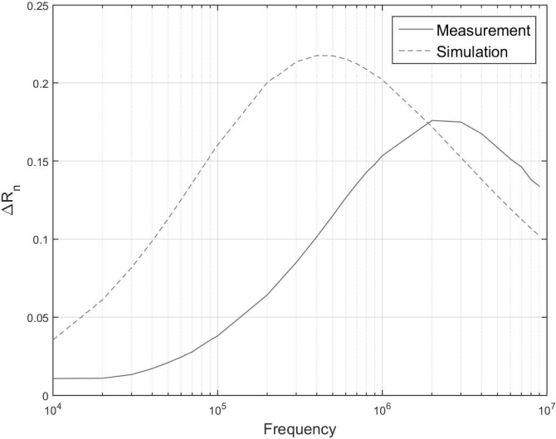
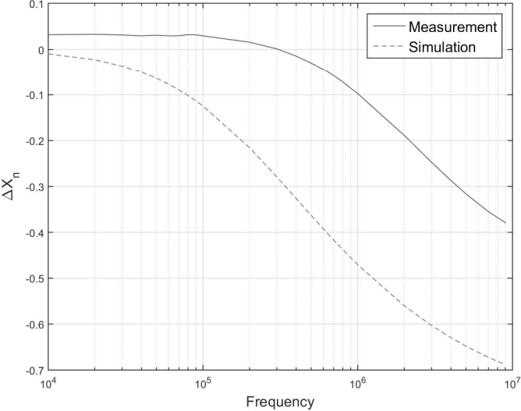
Fig. 4. Comparison between a simulation of the analytical solution for a planar circular spiral coil and measurements of a conductive plate using a planar rectangular coil with large width/gap. Data normalised as $∆R_{n}=∆R/X_{0}$ and $∆X_{n}=∆X/X_{0}$ where $X_{0}=ωL_{0}$.
From Fig. 4, the general trend between a circular planar coil and a rectangular planar coil is similar. The difference can be explained by: 1. the shape difference circular/rectangular; 2. the larger track width. The theoretical solution assumes a filamentary coil while the actual coil trace has a large width.

Measurements modes – common mode and differential mode
Fig. 5 shows an equivalent circuit ignoring the track resistance. Each of the planar coils is treated as an equivalent LC parallel circuit, represented by C1 and L1 for the transmitter, and C2 and L2 for the receiver. The target is modelled as an equivalent RLC parallel circuit, where R3 represents the losses due to eddy currents for a conductive sample; L3 is the inductive element related to the eddy currents; and C3 is the capacitive coupling element related to the displacement currents. Coupling is both capacitive and inductive between the coils (direct coupling: Cd and Md) and through the sample (indirect coupling: Cs1, Ms1, Cs2 and Ms2).
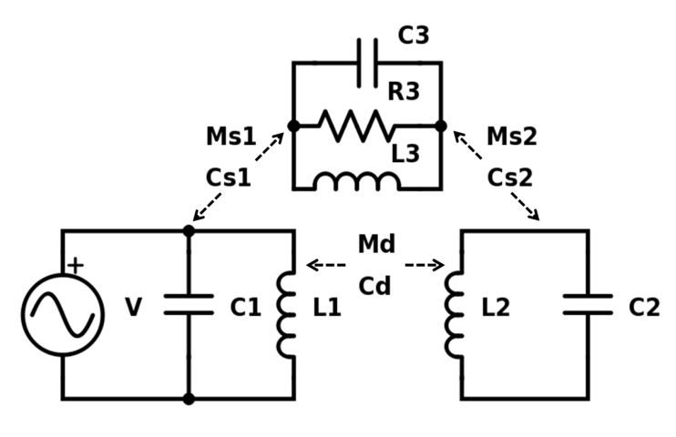
Fig. 5. Equivalent circuit of the sensor and a sample.
The measured capacitance C in (5), considering the equivalent circuit in Fig. 5, is the parallel equivalent of Cd and the series equivalent Cs1, C3 and Cs2; where I is the current that appears at the terminals and depends directly on the frequency f and the voltage difference ΔV [17].

 | $$I=f∆VC$$ | (5)

The change in mutual inductance between the transmitter and the receiver can be detected by measuring the differential voltage change in the receiver coil [15]. As stated by (6) a measurable voltage will appear at the inductively coupled coil by magnetic induction, where ΔV is the change in voltage due to a change in mutual inductance ΔM, j is the imaginary unit and ω the angular frequency.

 | $$∆V=jω∆MI$$ | (6)

In order to separate the inductive and capacitive coupling effects, different measurement modes were used, i.e. common mode and differential mode. With common mode, the measurement is sensitive to the potential difference between the transmitter and receiver and therefore it is related to capacitive coupling. The strongest capacitive coupling effect occurs between the nearest tracks of the transmitter and the receiver. Therefore, when taking common mode measurement, the voltage is measured at the point A of Fig. 1.
For the proposed sensor, simultaneous capacitive/inductive coupling measurement can be carried out. Common mode voltage sees the receiver coil as one conductive surface against a reference potential level. Therefore, a path for the movement of charge due to capacitive coupling is created. Common mode measurements do not force a uniform potential level for the receiver conductive surface; hence a differential voltage by inductive coupling can be induced which is ΔV in (6).
An equivalent circuit for simultaneous mode is shown in Fig. 6. The potential difference between points A and D at the receiver due to inductive coupling is represented with resistors R2 to R4. Capacitances CA to CD represent the capacitive coupling at different points of the receiver track. C1-L1 and C2-L2 represent the excitation and receiver respectively. R1 is a high value resistor to represent a floating condition. Common mode voltage is the measured at point A and differential mode voltage is the voltage difference between the points A and D.
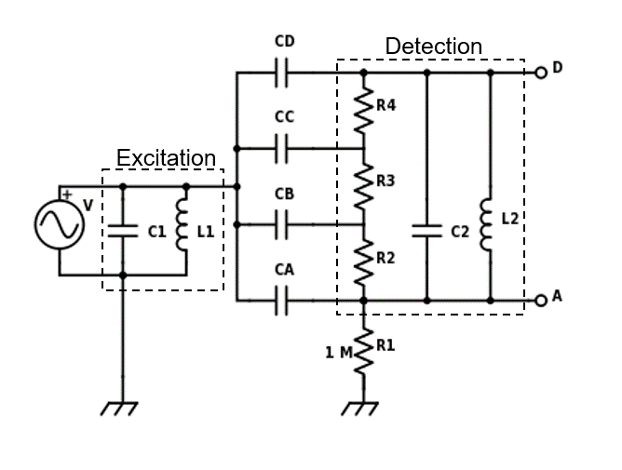
Fig. 6. Equivalent circuit of the sensor in simultaneous mode.

Experimental setup and samples
An impedance/gain-phase analyser Sl 1260 was used to carry out the measurements. The instrument has a signal generator output, and two input voltage channels that can be configured as either common mode or differential mode. As shown in Fig. 2, the excitation coil was connected to the signal generator and the receiver coil terminals were connected to both voltage channels; channel one was configured as differential mode and channel two as common mode.
Fig. 7 shows the schematic connections between the equivalent circuit and the instrument for each channel separately. Fig. 7(a) represents common mode and Fig. 7(b) differential mode. R1 and R2 in both figures represent loading elements; the values were taken from the instrument manual.
As can be seen from Fig. 7(a), when common mode is selected, only one of the terminals is internally connected for measuring purposes. Thus, the receiver coil is represented as only one plate. CX represents the coupling capacitance between the sensor pair. From Fig. 7(b) it can be seen that the measured voltage in differential mode corresponds to the differential voltage between the two terminals of the receiver coil.
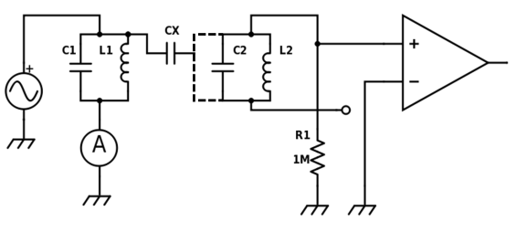
(a) Common mode
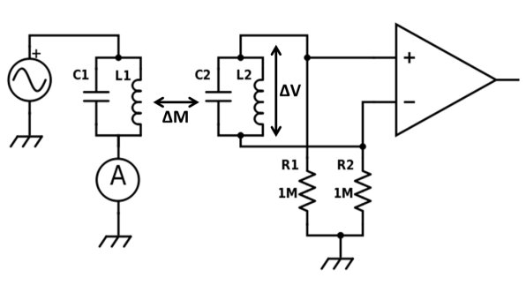
(b) Differential mode
Fig. 7. Instrument connections for each mode separately.
Once all connections are made, simultaneous data of both channels (one in differential mode and the other in common mode) can be obtained with the instrument.
Samples with different properties were prepared to test the behaviour of the sensor. In order to test the inductive coupling, a set of conductive samples with different thickness was created by stacking 1-5 copper foil layers. Each layer has a thickness of 60 μm.
For testing the capacitive effect, plastic sheets of different thickness were used. Different volumes of tap water were also measured. The surface area of the water volume was constant, and the height is linearly related to the volume. For the following discussion, relative permittivity values of 1 for air, 3 for plastic samples and 80 for water samples are assumed; which are typical values for these materials.

Results
Results were obtained first for capacitive sensing/common mode measurement, then for inductive sensing/differential mode, and lastly for the combined mode.
A plot for capacitive sensing/common mode measurement is shown in Fig. 8 for two different frequencies of operation; at both frequencies, as the thickness of the plastic plate increases, the measured voltage increase. The first datum, labelled Air, corresponds to the standing capacitance value of the sensor; in this case, the capacitive coupling is through the fixed insulator attached to the sensor and air. It can be seen that the sensor has a similar response on both frequencies (100 kHz and 1 MHz). As expected from (5), the measured value increases with an increase in the frequency of operation.
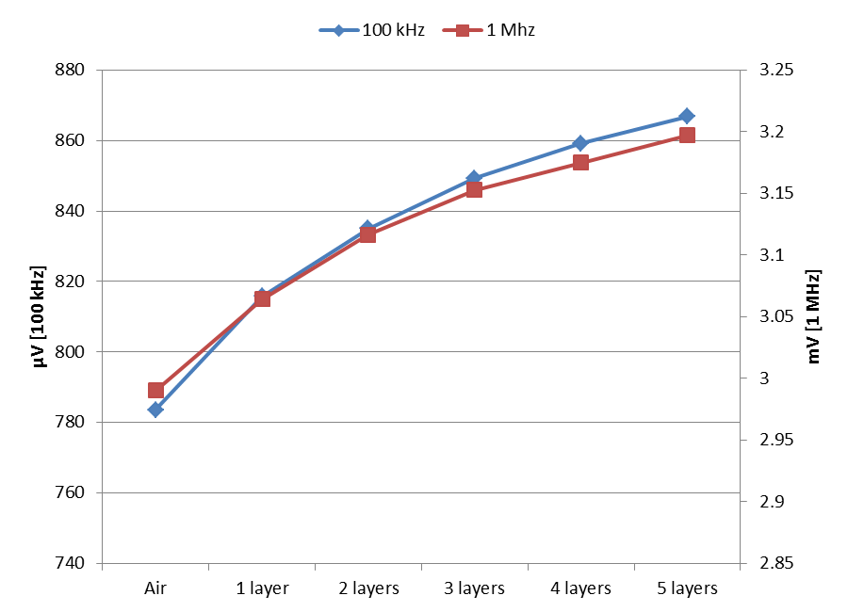
Fig. 8. Voltage change in common mode: plastic samples.
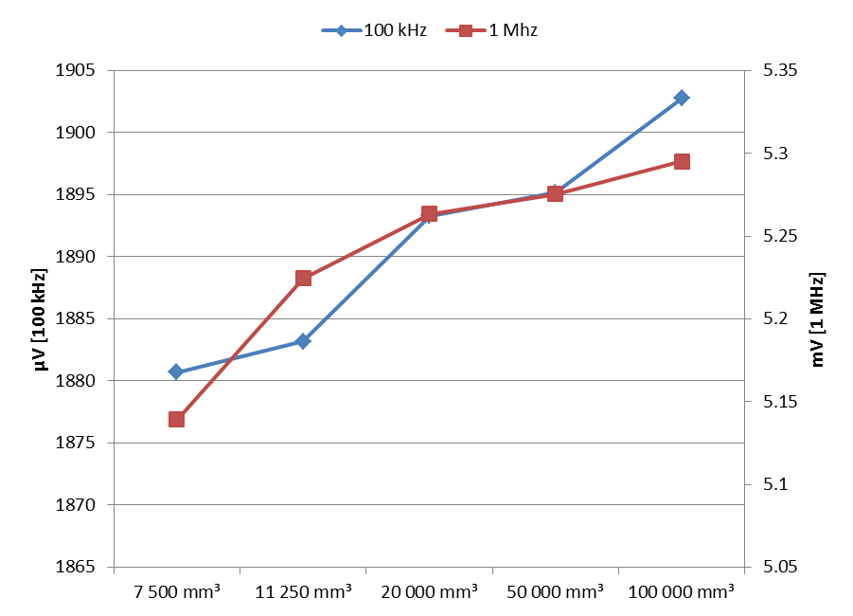
Fig. 9. Voltage change in common mode: water samples.
A similar effect can be seen in Fig. 9, where measurements for different volumes of water are shown, i.e., by increasing the volume of water, the capacitive coupling increases as expected. A larger change in the measured voltage due to the presence of water than plastic plate can be seen, which is attributed to a much higher permittivity of water than that of the plastic sample. Table II compares the voltage change between the air measurement and the first sample presented in the experiments shown in Figures 8 and 9.
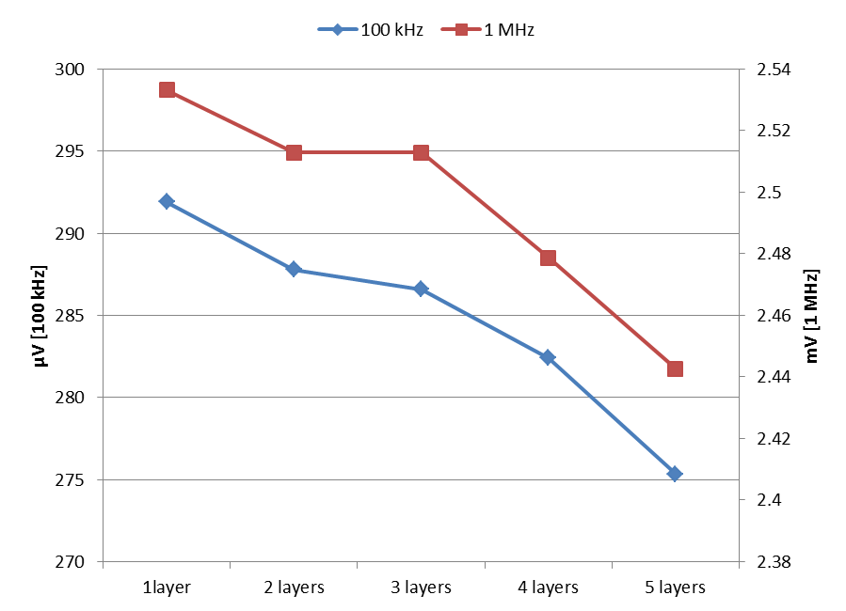
Fig. 10. Voltage change in differential mode: copper samples 5 mm away.
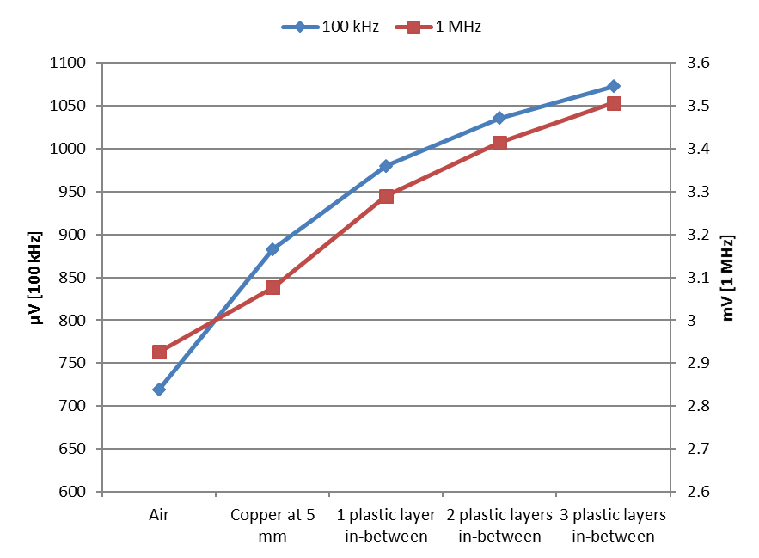
Fig. 11. Voltage change in common mode: plastic samples in-between a five layers copper sample positioned 5 mm away.
For the measurement configured as differential mode, a change in the measured voltage is linked to a change in the conductivity profile of the sample. Fig. 10 shows the change in voltage due to the presence of copper samples with different thickness positioned at 5 mm away. A reduction in the measured voltage is observed when the thickness of the sample increases. This reduction is in accordance with the magnetic induction effect for highly conductive, nonmagnetic samples [15].
TABLE II
Voltage change between air and plastic, and air and water
 | At 100 kHz | At 1 MHz
One-layer plastic sample | 32 μV | 74 μV
7 500 mm³ of water | 1067 μV | 2.17 mV

The third experiment is reported in Fig. 11. A copper sample composed of five foil layers was positioned 5 mm away from the sensor, and then, plastic samples of different thicknesses were placed in-between. Measurements in common mode and differential mode were made simultaneously. As expected, the differential measurement remained the same but the common mode measurements increase with the thickness of the plastic plates. Therefore, it was verified that the sensor can simultaneously operate in both modes.
For differential mode, it was observed that if the frequency of operation is over 5 MHz, the measurements are sensitive to both dielectric and conductive materials. This was attributed to the resonance of the individual coil (receiver/transmitter) due to increased capacitive coupling within the individual coil. This condition is not explored here owing to the effect is combined independently of the measurement method. Additionally, the touch effect described in [14], i.e. by touching the sample (or introducing a permittivity change) a change in the detected signal is observed, is imperceptible for the reported frequencies in differential mode; but it was observed for common mode.

Conclusions and future work
In this work, a novel dual modality sensor and measuring strategy is presented. The sensor acts similarly as a spiral coil pair, and as a two plate planar capacitive sensor depending on the measurement mode. An idealised equivalent circuit of the sensor was utilised to develop the measurement strategy and analyse the sensor for each mode. Results from experimental measurements indicate that measuring in differential mode, the change in mutual inductance is measured; measuring in common mode, the change in capacitance coupling is measured; and that simultaneous measurements for inductive and capacitive coupling can be performed. Therefore, this sensor and the measurement strategy can be employed to inspect insulators, conductors and composite materials. Future research includes testing and quantifying new geometries, inspection of composed materials for non-destructive evaluation, and to build a custom instrument to increase the flexibility of simultaneous common/differential measurements.

References
- U. Kaatze, “Measuring the dielectric properties of materials. Ninety-year development from low-frequency techniques to broadband spectroscopy and high-frequency imaging,” Meas. Sci. Technol., vol. 24, no. 1, p. 12005, 2013.
- J. García-Martín, J. Gómez-Gil, and E. Vázquez-Sánchez, “Non-destructive techniques based on eddy current testing,” Sensors, vol. 11, no. 3, pp. 2525–2565, 2011.
- J. Blitz, Electrical and magnetic methods of non-destructive Testing, 2nd ed. Springer, 1997.
- A. a Nassr, W. H. Ahmed, and W. W. El-Dakhakhni, “Coplanar capacitance sensors for detecting water intrusion in composite structures,” Meas. Sci. Technol., vol. 19, no. 7, p. 75702, 2008.
- X. Yin and D. A. Hutchins, “Non-destructive evaluation of composite materials using a capacitive imaging technique,” Compos. Part B Eng., vol. 43, no. 3, pp. 1282–1292, 2012.
- R. J. Ditchburn, S. K. Burke, and M. Posada, “Eddy-current nondestructive inspection with thin spiral coils: Long cracks in steel,” J. Nondestruct. Eval., vol. 22, no. 2, pp. 63–77, 2003.
- B. George, H. Zangl, T. Bretterklieber, and G. Brasseur, “A combined inductive-capacitive proximity sensor for seat occupancy detection,” IEEE Trans. Instrum. Meas., vol. 59, no. 5, pp. 1463–1470, 2010.
- X. Hu, “Imaging of hidden objects by planar capacitive and magnetic sensor arrays for security applications,” University of Manchester, 2009.
- J. Long and B. Wang, “A metamaterial-inspired combined inductive-capacitive sensor,” SPIE Multisensor, Multisource Inf. Fusion Archit. Algorithms, Appl., 2014.
- S. C. Mukhopadhyay, “Novel planar electromagnetic sensors: modeling and performance evaluation,” Sensors, vol. 5, no. 12, pp. 546–579, 2005.
- L. Abdilla, L. Mangion, and C. Sammut, “Eddy current sensing using planar coils,” IEEE Instrum. Meas. Mag., vol. 15, no. 6, pp. 14–18, 2012.
- X. Hu and W. Yang, “Planar capacitive sensors – designs and applications,” Sens. Rev., vol. 30, no. 1, pp. 24–39, 2010.
- J. R. Smith, “Electric Field Imaging,” Massachusetts Institute of Technology, 1999.
- D. Goss, R. O. Mackin, E. Crescenco, H. S. Tapp, and A. J. Peyton, “Understanding the coupling mechanisms in high frequency EMT,” 3rd World Congr. Ind. Process Tomogr., pp. 364–369, 2003.
- A. J. Peyton, “Electromagnetic induction tomography,” in Industrial Tomography: Systems and Applications, Woodhead Publishing, 2015, pp. 61–107.
- R. J. Ditchburn and S. K. Burke, “Planar rectangular spiral coils in eddy-current non-destructive inspection,” NDT E Int., vol. 38, no. 8, pp. 690–700, 2005.
- W. Q. Yang, “Hardware design of electrical capacitance tomography Systems,” Meas. Sci. Technol., vol. 7, no. 3, pp. 225–232, 1996.

