A 100Gb/s PAM4 Optical Transmitter in A 3D-Integrated SiPh-CMOS Platform Using Segmented MOSCAP Modulators

Arian Hashemi Talkhooncheh, Student Member, IEEE, Weiwei Zhang, Minwo Wang,
David J. Thomson, Martin Ebert, Li Ke, Graham T. Reed, Azita Emami, Senior Member, IEEE
Abstract— This paper presents a 100Gb/s PAM4 optical transmitter system implemented in a 3D-integrated SiPh-CMOS platform. The photonics chip includes a push-pull segmented MZM structure using highly capacitive (500fF to 1pF), yet optically efficient (VπL= 8V.mm) MOSCAP phase modulators. Two pairs of U-shaped modulators with effective lengths of 170µm and 450µm are driven at 50 Gbaud by a dual-channel 28nm CMOS driver, which is flip-chip bonded to the photonics chip. The driver cores utilize digitally controllable pre-distortion and inductive peaking to achieve sufficient electro-optical bandwidth. The drivers deliver 1.2V_{ppd} swing to modulators using a 0.9V supply. An on-chip serializer with differential peaking stages is designed to generate and buffer two independent sets of 50Gb/s data streams to be delivered to the driver cores. The optical input power to the PIC is +10dBm and the EIC consumes 240mW achieving 2.4pJ/bit energy efficiency. The overall EOBW is increased by approximately 52% and 131% for the LSB and the MSB segments, respectively, when compared to their EOBW measured by 65GHz 50-Ohm terminated probes. The 50Gb/s NRZ optical raw eye diagram exhibits 4.3dB ER and 1.2dBm OMA with 0.76dB of TDEC after a 5-tap FFE filter. The 100Gb/s PAM4 optical raw eye diagram shows 4.3dB ER and 1.4dBm OMA with a TDECQ of 1.53dB after 5-tap FFE filter. The PAM4 TDECQ changes by 53% when temperature is increased from 30ºC to 90 ºC at the optimum forward bias voltage of 1V.

Index Terms— Optical interconnects, Silicon photonics, Electrooptic modulators, Bandwidth extension, Pre-distortion, MOSCAP Modulator, SISCAP, Optical transmitters, CMOS driver, PAM4 modulation

INTRODUCTION
H
ighly integrated Silicon Photonics (SiPh)-based solutions are growing as preeminent platforms for implementing low-cost and power-efficient 100+Gb/s/λ optical transceivers. Datacenters continue to require interconnects with more stringent bandwidth densities and energy efficiencies for inter- and intra-datacenter applications. Moreover, applications such as chip-to-chip interconnects in datacenter switches, high-performance FPGAs and GPUs require small form-factors and substantial high volumes. SiPh transceivers co-packaged with CMOS electronics have the potential to meet these requirements. They can also support multi-level Pulse Amplitude Modulation (PAM-N) schemes with improved bandwidth densities. However, the inherent optical power penalty of PAM-N signaling imposes demanding linearity requirements on critical link components, which can lead to power hungry electronics. The modulator type should be carefully chosen and be co-optimized with the electrical driver to satisfy optical transmitter specifications such as optical modulation amplitude (OMA), extinction ratio (ER), signal-to-noise ratio (SNR) and electro-optical power penalties. Micro-ring modulators (MRMs) have small footprints and high electro-optical bandwidth (EOBW). However, they require relatively large voltage swings (usually > 1V) [1-8]. They also suffer from an inherent tradeoff between bandwidth and optical phase efficiency, high sensitivity to process and temperature variations, and non-linear electro-optic characteristics [9-11]. Depletion-based p-n junction phase modulators exhibit high intrinsic BWs. However, due to limited optical modulation efficiency (V_{π}L), they are used in Travelling-Wave Mach-Zehnder Modulators (TW-MZMs) topology, which require terminations and power-hungry drivers to compensate for microwave losses while occupying large areas on chip [12-21]. Electro-absorption modulators (EAMs) provide a balance between their intrinsic BW and optical efficiency (absorption coefficient). They, however, suffer from higher insertion losses, chirp, and limited maximum input power because of saturation, which should be addressed when used for higher-order modulation schemes [22-32]. Metal-oxide-silicon-capacitor (MOSCAP)-based (or the semiconductor-insulator-semiconductor capacitor (SISCAP), as reported in [33-36]) phase modulators operate based on carrier accumulation. These modulators can significantly scale the area and power of optical transmitter (OTX) due to their superior optical modulation efficiency (V_{π}L < 1 V.cm) and compact footprint (< 1mm) [37-41]. MOSCAP modulators, however, could potentially suffer from excessive insertion losses due to high absorption, scattering from surface, sidewall roughness, and crystalline grains of commonly used polysilicon [42]. Moreover, these modulators impose large capacitive parasitics (~3 fF/µm), which could limit the EOBW significantly. Existing wireline drivers cannot meet the requirements of the MOSCAP modulators due to their limited output voltage swings, and their 50Ω termination design [43]. As it will be explained in Section II, a 50Ω terminated design would significantly limit the driver’s BW when driving highly-capacitive MOSCAP modulators. Therefore, it is crucial to take a co-design approach and to compensate for the BW limitations imposed by these large capacitors.
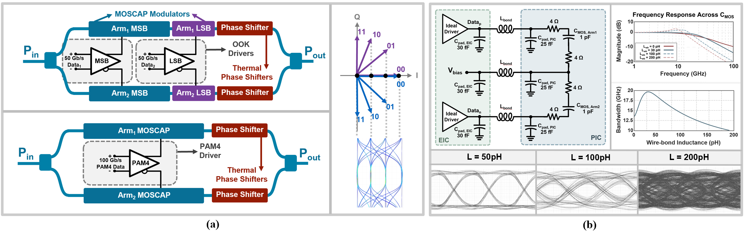
Fig. 1. (a) Variations of an optical PAM4 transmitter, and (b, c) Inductive parasitic effects of wire-bonds on the NRZ eye diagrams.

In this paper, a 3D-integrated 100Gb/s PAM-4 OTX with electronic pre-distortion (PD) and BW extension techniques for driving highly-capacitive MOSCAP modulators is presented. In particular, trade-offs between MOSCAP modulator parameters are carefully studied and used for the co-design of electronics and photonics for optimal EOBW, power consumption and optical efficiency.
This paper is organized as follows: In section II the proposed system-level architecture and its advantages are presented. Section III discusses the silicon-photonics IC (PIC) design, choice of the segmented MZM and its layout, as well as the MOSCAP modulator parasitics and BW analyses. The CMOS TX architecture with all its major building blocks and their interconnections are provided in detail in section IV. The experimental results of the dual-channel CMOS driver and its integration with the PIC are included in section V. Finally, section VI summarizes this paper with performance comparisons and conclusions.

System-Level Analysis

OTX EOBW and Power Optimization Overview:
The proposed optical transmitter system is aimed to operate at the highest possible baud rates using the standard 28nm CMOS process, while the overall power consumption is minimized. A careful electro-optical co-optimization study should be conducted to optimize modulator lengths, hence, the overall EOBW and the electro-optical power consumption. The optimal EOBW is achieved when modulator parasitics are accurately modeled and the driver is designed with proper load matching. This optimization process and driver design also depends on the modulation scheme, hence, the number of modulators.
The OTX is intended to be scalable, to provide a compatible solution for higher-order modulation schemes. In this work, we focus on 4-level pulse-amplitude modulation (PAM4) scheme to demonstrate the performance and the potentials of our approach. The choice of keeping the modulation complexity in the electrical domain [44, 45] or transferring it to the optical domain [46-48], is highly dependent on the type of modulators and the electronics power budget (Fig. 1(a)). Design trade-offs of the proposed U-shaped MOSCAP modulators, and the segmented push-pull MZM will be discussed in detail in section III.
The two OOK drivers shown in Fig. 2(a) need to drive 4 highly capacitive MOSCAP modulators (pairs of 500fF and 1pF capacitors). To achieve an EOBW of 35GHz, required for an error-free 50Gbaud transmission [49], the output impedances of the drivers need to be less than 5Ω and 10Ω, for the most-significant-bit (MSB) and the least-significant-bit (LSB) segments, respectively. However, even the ohmic resistance of the contacts from the PIC pads to MOSCAP junctions could be greater than these values (contact resistances are controlled by dopant densities optimized for modulators’ optical efficiencies). To tackle this challenge, a combination of pre-distortion and inductive peaking are used for the core drivers to extend the EOBW of all segments to 35GHz, when flip-chip bonded to the PIC.
Fig. 1(b) shows time-domain and frequency-domain simulations for a simplified network of the interface between MOSCAPs and the EIC through wire-bonding. The equivalent inductance of shortest wire-bonds from EIC to PIC are approximated to be 300pH to 400pH for wire-bond lengths of 300µm to 400µm. The closed eye diagram in Fig. 1(b), for a wire-bond length of 200µm, shows why the inductance of the wire-bonds exceed the optimal value (L_{bond} ≈ 30pH) for MOSCAP modulators. These inductors perform series peaking for the driver, which could extend the BW by a factor of 1.41, only when the load capacitance (MOSCAP modulator) is more than 10 times the output capacitance of the driver (which is dominated by EIC output pad and driver output capacitances), and the inductor is approximately 10 times smaller than wire-bonding inductance values [50]. To solve this challenge, integration through flip-chip bonding was chosen to reduce L_{bond} to 50pH.

Transmitter System Architecture:
A system-level block diagram of the OTX is shown in Fig. 2(a). It consists of PIC and a CMOS electronic IC (EIC) flip-chip-bonded together using gold micro-pillars. The PIC consists of a segmented push-pull MZM with U-shaped MOSCAP phase modulators. Two thermal phase shifters are placed on each arm for relative optical phase adjustment to bias the MZM. Two grating couplers are used for optical I/O. The EIC includes two channels of 50Gb/s NRZ drivers with differential outputs, each receiving 2 sets of differential 25Gb/s independent data streams from an external arbitrary waveform-generator (AWG). A clock buffer path amplifies the external 25GHz clock signal to drive on-chip 2:1 serializers in each data path. A look-up-table (LUT)-based control unit receives digital signals from an external FPGA to configure drivers peaking strength, pre-distortion settings and the timing between the two drivers’ data paths. As shown in Fig. 2(b), all electrical signals, including high-speed data and clocks, digital control signals, supplies and current references are fed to the PCB, wire-bonded to the PIC, and routed to photonics components or the EIC pads. Analyses of these electrical paths at high-speed are provided in section IV. A Peltier heater is placed underneath the PCB that controls the temperature of the system and is controlled via and external supply.
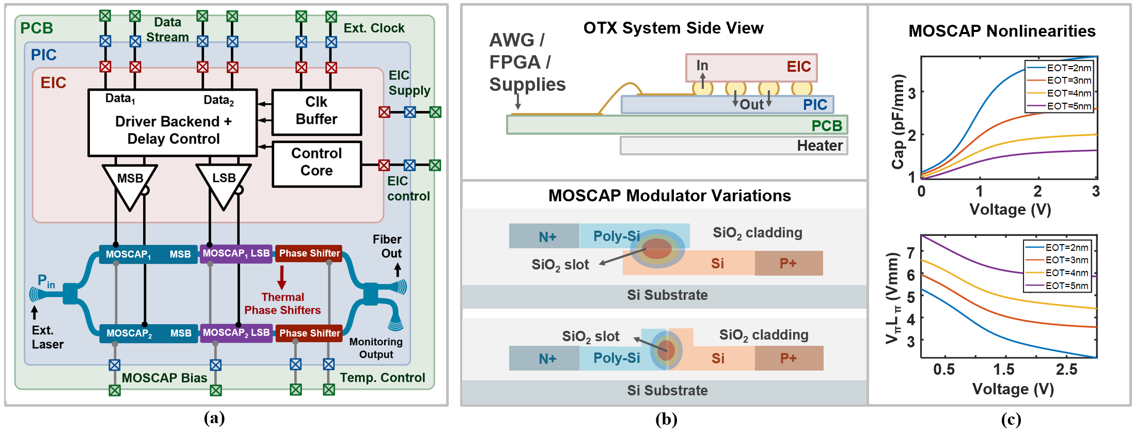
Fig. 2. (a) Top-level OTX block diagram, (b) Cross-section of the OTX system, and MOSCAP Modulator cross-sections, operating based on carrier accumulation, and (c) Capacitance and V_{π}L_{π} nonlinearities for MOSCAPs versus bias voltage.

PIC Design
In this section we first study the structure of MOSCAP modulators and the trade-offs between all design parameters that impact the overall performance of the transmitter. The benefits of the segmented MZM over other architectures, as well as photonics layout considerations are reviewed next. A complete electrical parasitics network of the MOSCAP modulator is also provided, which was used as the actual load model to design the CMOS drivers.

MOSCAP Modulator Structure:
The MOSCAP phase modulators consist of an n-doped polysilicon, a thin layer of oxide (SiO₂ slot/gap), and a p-doped silicon region to form the metal-oxide-semiconductor junction. This structure could be fabricated vertically (V-SISCAP) [33-37] or laterally (H-SISCAP) [38-41] to confine the light, as shown in Fig. 2(b). With proper doping of the poly-crystalline Silicon, this electrically active device can accumulate electrons and holes across the junction, when an electric field is present. The effective refractive index of the waveguide is therefore changed due to charge accumulation when the junction has proper overlap with the optical mode. This effect, known as the Plasma Dispersion, is mathematically described by the Drude-Lorentz model [51, 52] as:
$$\text{∆}\text{n }\text{=}-\frac{e^{2}λ^{2}}{8π^{2}c^{2}ϵ_{0}n}\left( \frac{\text{∆}N_{e}}{m_{e}}+\frac{\text{∆}N_{h}}{m_{h}}\right) \text{(1)}$$
where e is the charge of the electron, c is the speed of light, λ is the operating wavelength, n is the unperturbed refractive index, ε₀ is the vacuum permittivity, ΔN_{e} and ΔN_{h} are the free carrier concentrations of the electrons and holes, m_{e} and m_{h} are the electron and hole respective masses. MOSCAP modulators are compared with their 2 other phase modulator counterparts, which also benefit from the Plasma Dispersion effect. The carrier-injection-type modulators are commonly based on p-i-n junctions. These modulators suffer from limited bandwidth due to the slow diffusion of free electron in the doped region, despite having excellent modulation efficiency. In [53], a 50Gb/s p-i-n modulator using pre-emphasis signaling is reported. RC equalization techniques can increase p-i-n modulator BW while reducing optical modulation efficiency [54-56]. Carrier depletion-based modulators are formed from reversed-bias p-n junctions and are commonly adopted in silicon photonics platforms due to their higher bandwidths. However, since the refractive index is changed due to the width of the depleted region, the V_{π}L of such modulators are limited and longer segments are required (more than 1mm) to achieve reasonable ER [57]. Longer modulator segments need drivers with power-hungry terminations.

Modulator Design Parameters and Trade-offs:
MOSCAP modulators can be designed with excellent modulation efficiencies (V_{π}L as low as 0.9 V.mm [37]). There is, however, an oxide slot thickness (t_{ox})-related trade-off between modulation efficiency V_{π}L, and the junction capacitance, which translates to the EOBW [38-41]. As t_{ox} is increased, the EOBW also increases, however, V_{π}L degrades. Degradation of V_{π}L can, however, be compensated by increasing the length or the modulation voltage levels. An increase in the modulator length, or the voltage amplitude would directly affect the overall power consumption for a targeted optical transmitting signal (OMA and ER). Moreover, the doping of the contacts would reduce the access resistance to the junction, while degrading the optical insertion loss (IL), due to the presence of excessive free carrier charges overlapping the waveguide mode.
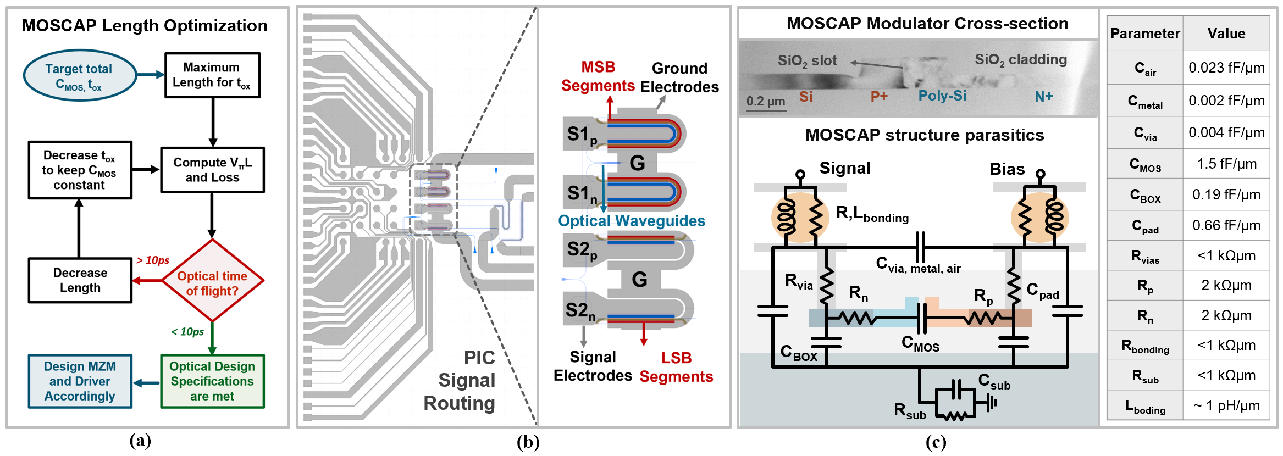
Fig. 3. (a) Proposed MOSCAP modulator length optimization flow, (b) PIC signal routing layout, (c) MOSCAP modulator cross-section and electrical parasitics.

In addition to the above trade-offs, nonlinear effects of MOSCAP modulators under different bias voltages should be considered for optimization. The main nonlinear parameters are defined below [39, 58]:
$$L_{π}\text{(}V_{b}\text{) }\text{=} \frac{λ}{2\left[n_{eff}\left(V_{b}+\frac{V_{s}}{2}\right)-n_{eff}\left(V_{b}-\frac{V_{s}}{2}\right)\right]} \text{(}\text{2-a}\text{)}$$
$$Q_{π}\text{(}V_{b}\text{) }\text{=} L_{π}\text{(}V_{b}\text{)}\int_{V_{b}-\frac{V_{s}}{2}}^{V_{b}+\frac{V_{s}}{2}}{C\left(V\right)dV} \text{(}\text{2-b}\text{)}$$
$$C_{π}\text{=}{Q_{π}}/{V_{s}} \text{(}\text{2-c}\text{)}$$
where L_{π}(V_{b}) is the phase shifter’s length for obtaining a π-shift at a given bias voltage V_{b} and voltage swing of V_{s}. Δn_{eff} is the effective refraction index change of phase shifter’s optical mode. C(V) with units of (fF/μm) characterizes the capacitance of the phase shifter per unit length. Q_{π}(V_{b}) evaluates the required charge variations in the MOS phase shifter structures at a length of L_{π}(V_{b}) for a π phase change under a bias voltage V_{b} and voltage swing V_{s}. Fig. 2(c) shows simulation results for C(V) and V_{π}L_{π}(V) of the modulators with different oxide thicknesses. Increasing the forward-bias voltage of MOSCAPs decreases their V_{π}L, hence, improving the optical efficiency. However, this increase in the bias also increases the effective junction capacitance, C_{MOS}, hence, reducing the EOBW. This trade-off shows that an optimal bias point should be found, in which a proper EOBW and optical efficiency would result in the best optical eye quality, when driven by the CMOS drivers. A high-speed measurement analysis is provided in section V to address this trade-off.
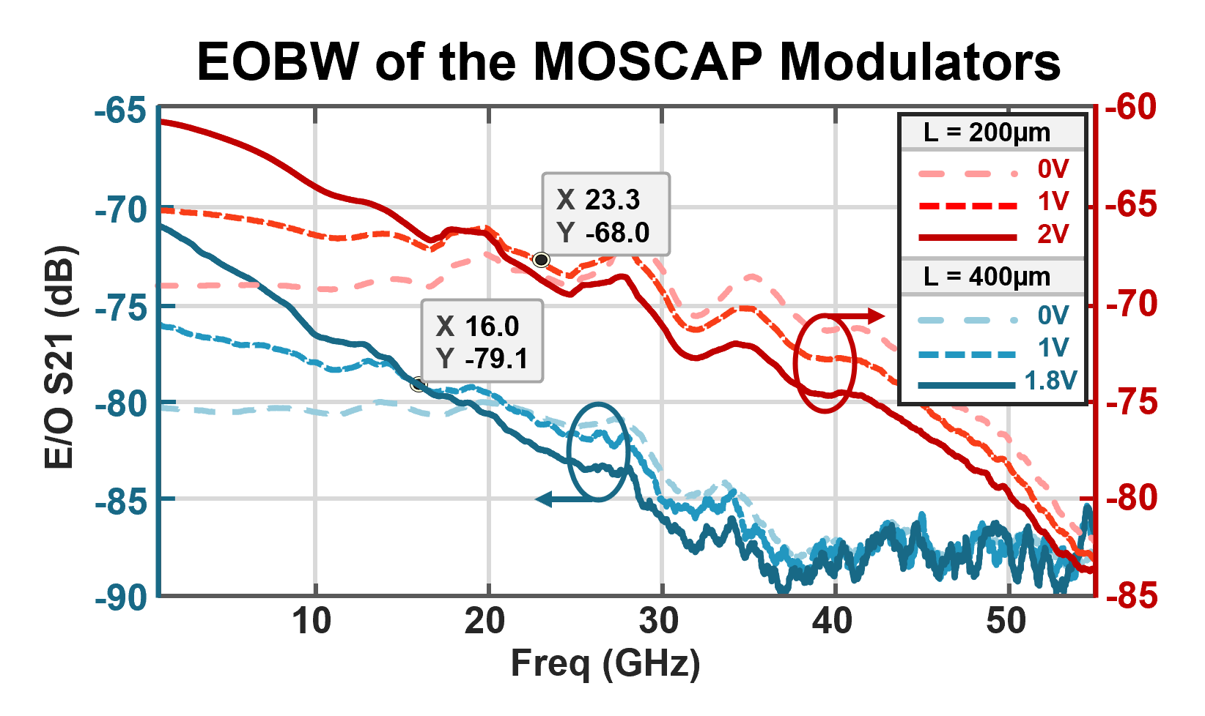
Fig. 4. Measured EOBW of 200m and 400m MOSCAP segments with 65GHz 50Ω-terminated probes.

Considering all these design trade-offs and targeted OTX specifications, a systematic approach was developed to optimize the modulator lengths, as shown in Fig. 3(a). In this design flow, a fixed total capacitance for the modulator and an initial t_{ox} is targeted. When the optimal total length of the modulators is derived, then the MZM architecture and the electronics driver could be designed accordingly.

Modulator Length Optimization and MZM Design:
For the length optimization process of the fabricated MOSCAP modulator, nominal supply voltages of the 28nm CMOS process (0.9V) were used as the maximum allowable driving voltage to minimize the EIC power consumption. The optimization flow resulted in a total MOSCAP length of 620µm with total capacitance of 1.5pF, a t_{ox} of 4nm, and a V_{π}L of 0.5V.cm. This length, however, requires a TW electrode, since the maximum lumped electrode length could be estimated by 1/10th of the wavelength corresponding to a microwave index of 2.1 for a 50GHz signal frequency, to approximately 300µm [14]. Moreover, to achieve an optical PAM4 signal, either an electrical PAM4 driver should be designed to drive this load, or the MZM can be segmented and be driven by OOK drivers (Fig. 1(a)). The drawback of the former choice is that the electronics power consumption could potentially be increased, since a PAM4 driver with larger voltage swings should be designed to drive this huge capacitor. Moreover, the electrode lengths of a single segment would be approximately equal to, if not more than, 300µm, even after folding the modulator segment. Therefore, breaking the modulator into two binary-weighted segments provides a viable solution in this case. Considering the nonlinear MZM curve, the segments lengths were calculated to be 179µm and 450µm with estimated parasitic capacitances of 500fF (LSB) and 1pF (MSB) to generate equally spaced optical PAM4 levels. The layout of the modulators and signal routings on the PIC is shown in Fig. 3(b). MSB modulator segments are folded to form a U-shaped layout to effectively double the modulation efficiency with a fixed electrode length of 150µm and to avoid travelling-wave reflection effects.
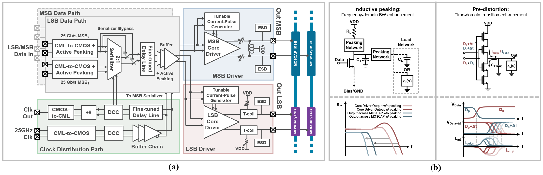
Fig. 5. (a) Top-level block diagram of the 2-channel CMOS driver, and (c) Frequency-domain and time-domain enhancement technics used for core drivers.

MOSCAP Parasitics and nonlinearities:
The details of the parasitic structure of MOSCAP modulators are depicted in Fig. 3(c). These parasitics, in addition to the main junction capacitance C_{MOS}, heavily affect the overall EOBW. As can be seen in Fig. 4, an EOBW measurement for 200µm and 400µm MOSCAP modulators, using a 65GHz 50-Ω terminated probe, shows 16GHz and 23GHz BW at 1V forward bias. These measured BWs are significantly below the required BW for 50Gbaud modulation, which further highlights the necessity of a custom-designed CMOS driver to extend the EOBW to approximately 35GHz.

EIC Design
In this section, the top-level architecture of the dual-channel CMOS driver, followed by the details, analyses and simulation results of each block is presented.

EIC System Architecture:
The top-level block diagram of the EIC is provided in Fig. 5(a). Each driver channel receives two pairs of independent 25Gb/s differential data inputs, which are amplified and buffered through CML-to-CMOS stages. In the clock distribution path, a 25GHz differential input clock signal travelling from the AWG to the chip is buffered and adjusted for its duty cycle internally, before driving two 2:1 serializers. These serializers are used for each driver channel to combine the 25Gb/s data streams using the buffered 25GHz clock signal. An LUT-based delay control unit fine-tunes the relative clock delays between the serializers. Another delay adjustment unit is placed after the serializers to calibrate the 50Gb/s data delay between the driver slices. Differential active peaking is used along the data path buffers both at the back-end and the 50Gb/s buffering stage. The two 50Gb/s data streams are delivered to the last stage (core drivers). Each current-mode differential driver is BW-optimized for the corresponding MOSCAP segments with similar lengths on each MZM arm. A reconfigurable pre-distortion block generates current pulses with tunable widths at each data transition to further improve the drivers’ effective BW. Details of the BW extension techniques and the driver core design are discussed next.

BW Extension Technics and Core Driver Design
Several circuit methods, using active/passive components have proven to effectively extend the BW of amplifiers [59-62]. The goal of BW extension in wireline applications, however, is to minimize the inter-symbol interference (ISI), hence, the data-dependent jitter (DDJ). Our approach to design the core amplifiers with sufficient BW, when connected to MOSCAP modulators, is to deploy both time and frequency domain approaches that reduce the DDJ and to combine these methods to minimize the overall power consumption.
Considering DDJ enhancement in the frequency domain, inductive peaking is an excellent method to extend the BW of wideband amplifiers, with minimal power penalty, when driving purely capacitive loads. However, the achieved BW extension ratios (BWERs) depend heavily on the ratio of the capacitance seen at the drain of the amplifying transistor, to the total capacitance that is to be driven (namely k_{c} = C₁/(C₁+C_{L}) in Fig. 5(b)) [50]. Series, shunt, shunt-series, and bridged-shunt-series peaking technics can achieve BWERs in the range of 2.5 to 4, but only when k_{c} > 0.3. With asymmetric T-coil peaking, however, BWERs more than 4 is achievable for k_{c} < 0.3. It should be noted that the BWER is calculated assuming the circuit is operating in its linear region. However, this assumption does not hold true when amplifiers are driven with limiting input voltages. Therefore, the effective BWER will be smaller and might not be enough to achieve the targeted BW. Moreover, in the case of driving MOSCAPs using flip-chip bonding, the load is not purely capacitive as was shown in Fig. 3(c) (although, C_{MOS} is the dominant loading component). Additionally, the inductive peaking technics affect the group delay, which could hurt the DDJ, even when the BW is extended [50].
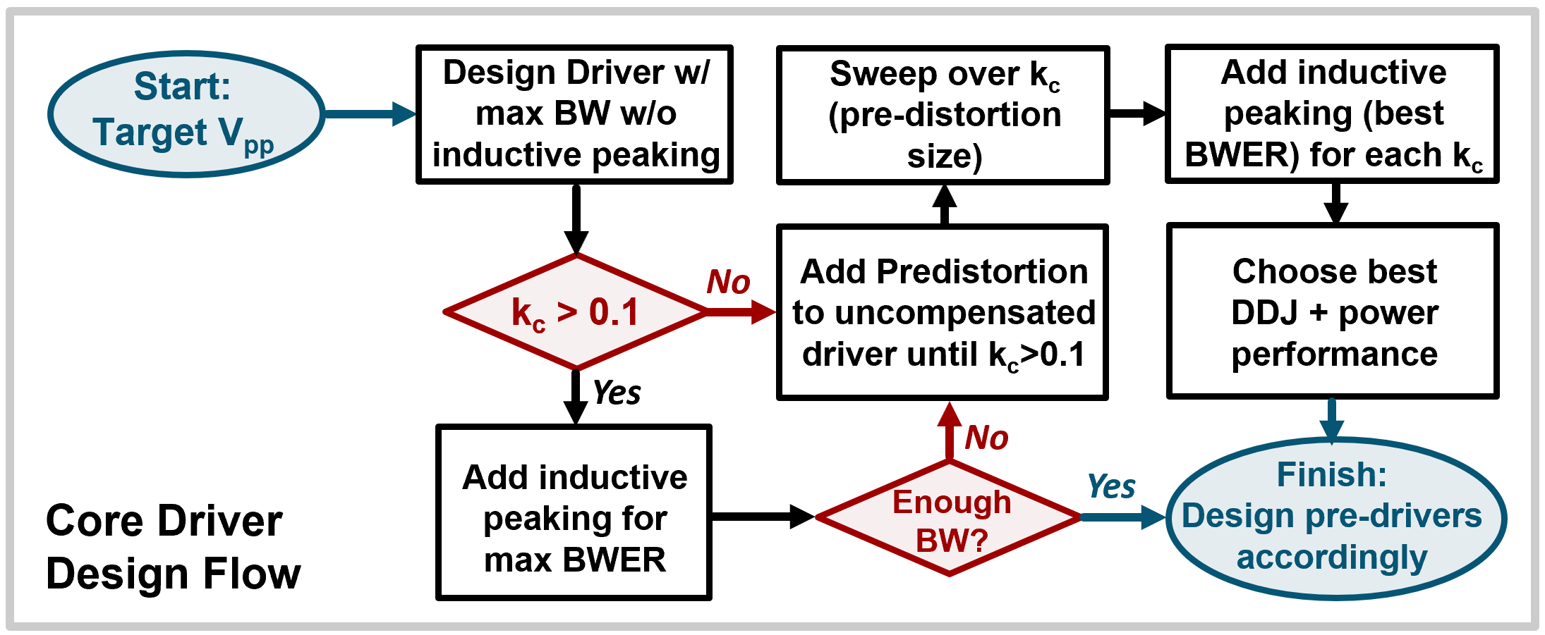
Fig. 6. Proposed core driver design flow for optimal BWER and minimized DDJ and power performance.

DDJ can also be treated in the time domain by improving the step response of the driver [63]. DDJ occurs when the tails of prior bits perturb the data transition time, when it crosses the threshold level. If the data transition time of signal s(t) with data period of T_{b} occurs at t₀ with the absence of prior bits, the total peak-to-peak DDJ can be estimated from the slope of s(t) at t₀ as [63]:
$${\text{∆t}}_{\text{total }}\text{≅} \frac{\text{-1}}{{\left.\frac{\text{ds}\left(\text{t}\right)}{\text{dt}}\right|}_{\text{t=}{\text{t}}_{\text{0}}}}\text{.}\sum_{\text{k=-}\text{∞}}^{\text{-2}}{{\text{a}}_{\text{k}}{\text{p}}_{\text{o}}\left({\text{t}}_{\text{0}}\text{-k}{\text{T}}_{\text{b}}\right)} \text{(4)}$$
Where p_{o}(t) is the pulse response of the driver and a_{k} is either 1 or 0 depending on the k^{th} previous bit value. It could be observed from equation (4) that one way of reducing the total DDJ is decreasing the contributions of prior bits perturbations (decreasing p_{o}(t₀-kT_{b})). Improving the transition times by injecting a current pulse into the load, whenever a data transition occurs (when a_{k} changes from k to k+1) is one way to decrease the perturbations. This current pulse injection would shape the incoming pulse, hence, called pre-distortion. A controlled voltage-mode driver, shown in Fig. 5(b) can be used for this purpose. By applying the main data stream to the gates of the middle transistors and a delayed and inverted version of the same stream to the outer transistors, this branch can inject a current pulse into the output node. The amplitude of the current pulse can be tuned by sizing the transistors, while the width of the pulse can be tuned by the data delay. Although this method could effectively improve the overall DDJ, it comes with certain disadvantages. Using this circuit requires 2 extra buffering paths (4 in total for each driver slice) to deliver the 50Gb/s streams into the gates of the 4 transistors, and to generate an adjustable delay between the 2 paths. Having these extra buffers would burn more power. Additionally, when current pulses are injected to/drawn from the output, extra power from VDD is drawn. Moreover, since the output of this circuit is connected to the output of the main driver, the total capacitance seen at this node is increased, which should be considered for inductive peaking.
Considering the above trade-offs, we propose the following steps (also shown in the flowchart in Fig. 6) to determine the optimal BWER and overall minimized DDJ, while minimizing the power consumption:
      - Design a core driver with no peaking, but maximum BW for a targeted output voltage swing.
      - Determine C₁ and k_{c}: If k_{c} > 0.1, then add inductive peaking with maximum possible BWER and determine if the new BW satisfies the performance.
      - If maximum available BWER was not enough, or if k_{c} < 0.1, then we start over with adding the pre-distortion block to the uncompensated driver (no peaking). The current pulse width should be kept approximately below half of the UI, to avoid ISI due to pre-distortion.
      - Increase the size of the pre-distortion blocks to improve the DDJ, until k_{c} becomes large enough, such that adding a proper inductive peaking would extend the BW to the target value. Here, depending on the achievable k_{c}’s, a combination of a stronger pre-distortion with a weaker peaking, or a weaker pre-distortion and a stronger peaking could result in similar overall BWs. However, there will be a compromise between power consumption and overall DJJ, since stronger peaking might perturb the group delay and could be not as helpful as a stronger pre-distortion.
Using the above approach, the LSB driver core was designed using a CML differential pair with differential T-coil peaking with digitally-reconfigurable load resistors, as shown in Fig. 7(a). A pre-distortion block also helps with the overall DJJ improvement. The k_{c} for this block, when driving two 170µm MOSCAPs was estimated at 0.14. This amplifier drives each MOSCAP segment with a 0.6V_{pp} single-ended swing and consumes 55mW at 50Gbps, with the pre-distortion block contributing to 23% of the overall power consumption. The strong differential T-coils used here, delay the current flowing through the load resistor, and initially charge the drain capacitances and the output load, hence improving the BW. As a result of this current delay, the drain voltages of the amplifier experience large jumps during each transition. Two 100fF cross-coupled capacitors are placed at the input of the driver to further increase the input BW of the stage, by re-directing approximately 10% of the drain currents from the opposite outputs. The T-coil inductors were implemented using available designs in standard libraries with tunable parameters. To reduce the area consumption, a coupled differential T-coil could be custom-designed, similar to [64].
Following the proposed approach resulted in the design of the MSB driver, with more than 2 times larger pre-distortion and differential bridged-shunt peaking, also shown in Fig. 7(a). k_{c} of this stage is estimated at 0.38. The overall DDJ using a weaker pre-distortion and a stronger T-coil peaking would result in a worse DDJ due to distorted group delay, with 0.05 < k_{c} < 0.3, although with a lower power consumption. Each output drives a 400µm MOSCAP segment with 0.6V_{pp} single-ended swing and consumes 98mWat 50Gb/s. The pre-distortion accounts for 38% of the total power for this stage.
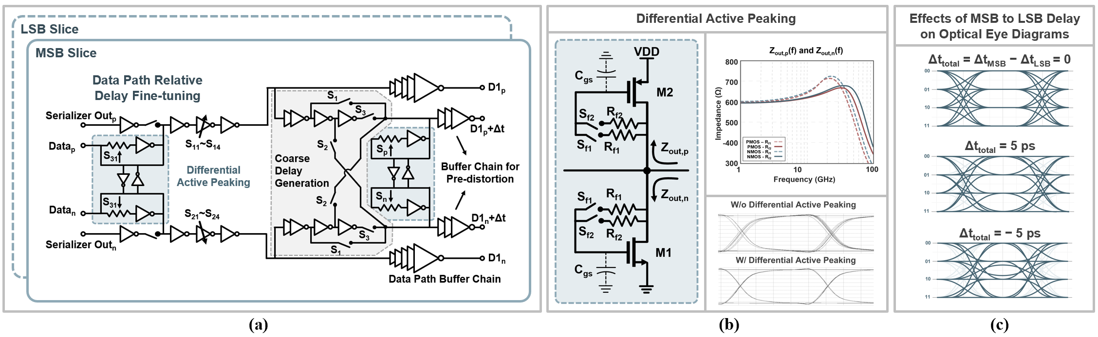
Fig. 8. (a) Data-path buffers, tunable data delay generator, and current pulse width control, (b) differential active peaking output impedance.

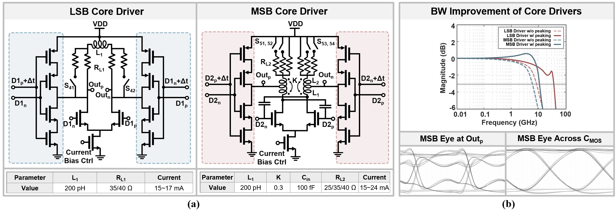
Fig. 7. (a) Schematic of the MSB and LSB core drivers, (b) Frequency response of the core drivers with and without inductive peaking.

The simulated normalized frequency responses of both core drivers with and without peaking are depicted in Fig. 7(b). These simulations include the parasitic capacitances of drivers’ corresponding pre-distortion clocks. As evident from Fig. 7(b), the BWER of the MSB and LSB drivers are 1.8 and 4.5, respectively. The lower BWER of the MSB driver corresponds to the stronger pre-distortion, which results in an overall better DDJ performance. As seen in Fig. 7(b), the post-layout-simulated eye diagrams at the output of the driver stages are pre-distorted, while clean eye diagrams are applied across MOSCAP junctions (C_{MOS}).

Buffers and Current Pulse Generators (for Pre-distortion)
The schematics of the data stream buffers, the delay generators and the pre-distortion pulse width control are shown in Fig. 8(a). The multiplexed 50Gb/s differential data streams (serializer outputs) are first passed through buffers and current-starved inverter stages. Digitally controllable current-starved stages are used to fine-tune the relative delay between the differential data paths in each slice, as well as the phase difference between the two slices. At such high data rates, static inverter stages cannot guarantee complete settling within one UI even with low fanouts, hence, ISI and DDJ in increased. To address this challenge, differential active peaking circuits, which are highlighted in blue in Fig. 8(a) are implemented [65, 66]. The half-circuit of this active peaking block is shown in Fig. 8(b). Transistors M1 and M2, with their biasing feedback resistors, provide an output impedance with a peak at higher frequencies. When attached to the buffer outputs, the inverters provide smaller gain with a higher BW, which effectively removes the ISI substantially, as depicted in Fig. 8(b). The feedback resistors are digitally tunable and can be switched off depending on performance requirements.
As shown in Fig. 8(a), the buffered and delay-tuned 50Gb/s data streams are passed through 4 separate buffering paths. The 2 main paths consist of fixed-sized buffers that deliver the data to both the driver core and the pre-distortion block (labeled as D1_{p} and D1_{n} in Fig. 8(a)). The other 2 paths include a digitally controllable delay generator in addition to buffers, using bypassing inverter stages. As shown in Fig. 8(a), switches S₁ through S₃ control the number of inverters that data streams should pass through. The outputs of these paths (labeled as D1_{p}+Δt and D1_{n}+Δt) are also sent to the pre-distortion block. The pre-distortion blocks generate current pulses with adjustable widths of 2ps, 4ps, or 6ps based on the chosen delay.
A non-zero delay between the data paths of the MSB and LSB slices will result in optical PAM4 eye closure, as shown in Fig. 8(c). Simulations for a relative delay of 5ps or -5ps between the MSB and LSB data paths, show ~20% and ~40% horizontal eye closure, respectively. In case of -5ps relative delay (when LSB leads MSB), the middle eye also experiences ~50% vertical closure, due to 01-to-10 transitions (or vice versa). These transitions experience momentary glitches to 00 and 11, respectively, which increases the settling time, hence increasing ISI for the middle eye.

EIC Backend
All 25Gb/s data streams and the 25GHz clock signal are generated by an AWG and fed to the EIC through high-speed PCB traces and signal routings on the PIC. Fig. 9(a) shows the signal path simulation results including all parasitics from AWG to the first amplifier stage inside the EIC. At the driver back-end, a CML-to-CMOS stage with differential active peaking, shown in Fig. 9(b), is used to amplify the incoming data streams at each data input. The external 25GHz clock is amplified by a CML-to-CMOS stage and then passed through AC-coupled inverter-based TIA stages and buffers, also shown in Fig. 9(b). The clock duty cycle is adjusted by a duty-cycle-correction (DCC) block, which uses controlled DC current injection to adjust the transition times. The two 25Gb/s data streams and the 25GHz clock are then delivered to the 2:1 serializer. The serializer is a differential mixer followed by a CML-to-CMOS stage to generate rail-to-rail 50Gb/s streams.
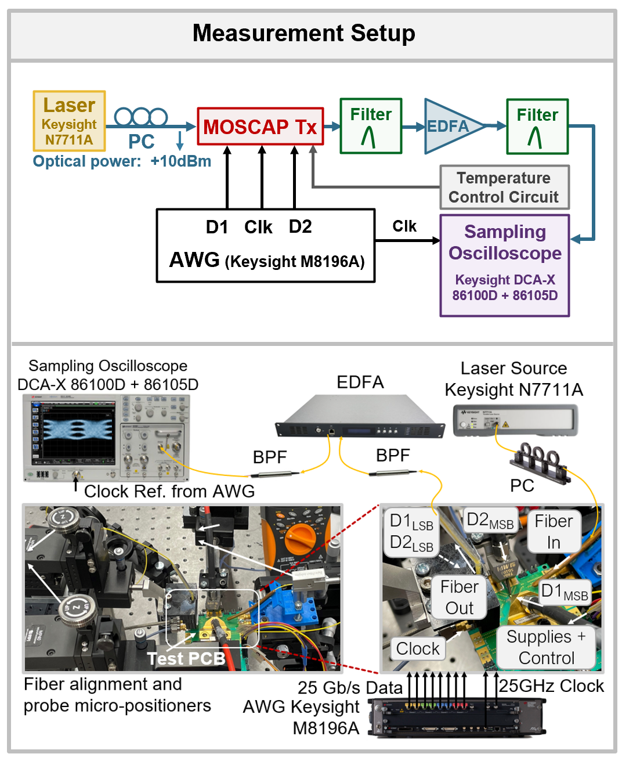
Fig. 10. OTX measurement setup.

Measurement Results
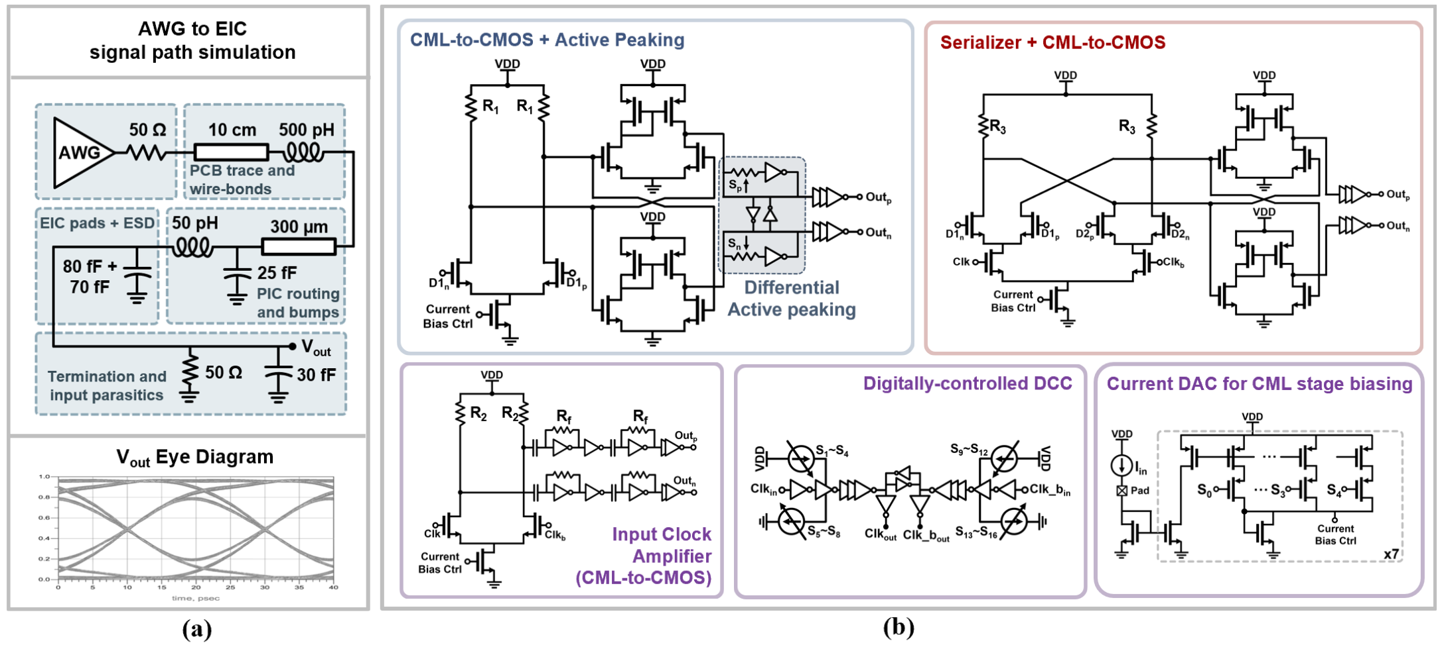
Fig. 9. (a) AWG to EIC signal path simulation for data and clock signals, and (b) EIC back-end, 2:1 serializer, clock buffer, DCC and bias control circuitry.

The TX EIC was fabricated in 28nm CMOS process with an active area of ~0.2mm², which measures 830µm by 750µm. The segmented push-pull MZM is implemented on the PIC with an overall footprint of ~1mm². The measurement setup is shown in Fig. 10. All control signals, voltage supplies (0.9V) and the current reference were delivered to a test PCB, on which the 3D integrated OTX was mounted. An external arbitrary waveform generator (AWG) provides 25Gb/s PRBS-31 data streams and a 25GHz clock signal to the EIC and a trigger signal for an optical sampling scope (OSS). The modulated optical output is fiber coupled to the OSS receiver for eye diagram recording and TX dispersion eye closure (TDEC and TDECQ) measurements. An external laser source inputs 10dBm optical power at 1550nm to the PIC via a grating coupler. An erbium-doped fiber amplifier (EDFA) is placed after OTX to amplify the optical signals by 11dB before passing them to the OSS. Considering a trade-off between the optical efficiency and the EOBW of the MOSCAP modulators when their bias voltage is increased, all segments were forward biased at 1V for optimal performance. The PIC exhibits an overall 6.2dB of optical insertion loss, including the 3dB quadrature point loss. The t_{ox} of MOSCAP modulators in the fabricated PIC under test were measured at 5.5nm, which showed an increase of 1.5nm from the design, due to process non-uniformity (2nm < t_{ox} < 6nm across wafer). This change in t_{ox} also resulted in an increase in the measured V_{π}L to 0.8 V.cm.
The measured 50Gb/s NRZ and 100Gb/s PAM-4 optical eye diagrams are shown in Fig. 11. Fig. 11(a, d) show the eye diagrams when minimum peaking and minimum pre-distortion settings are applied. Fig. 11(b, e) show the measured raw eye diagrams using the optimal BW extension settings for the drivers. The measured OMA (including coupling and on-chip insertion losses as well as the EDFA gain) was 1.4dBm. Both eye diagrams were filtered by IEEE 802.3bs compliant 5-tap equalizers, shown Fig. 11(c, f), exhibiting a TDEC of 0.76dB and TDECQ of 1.53dB.
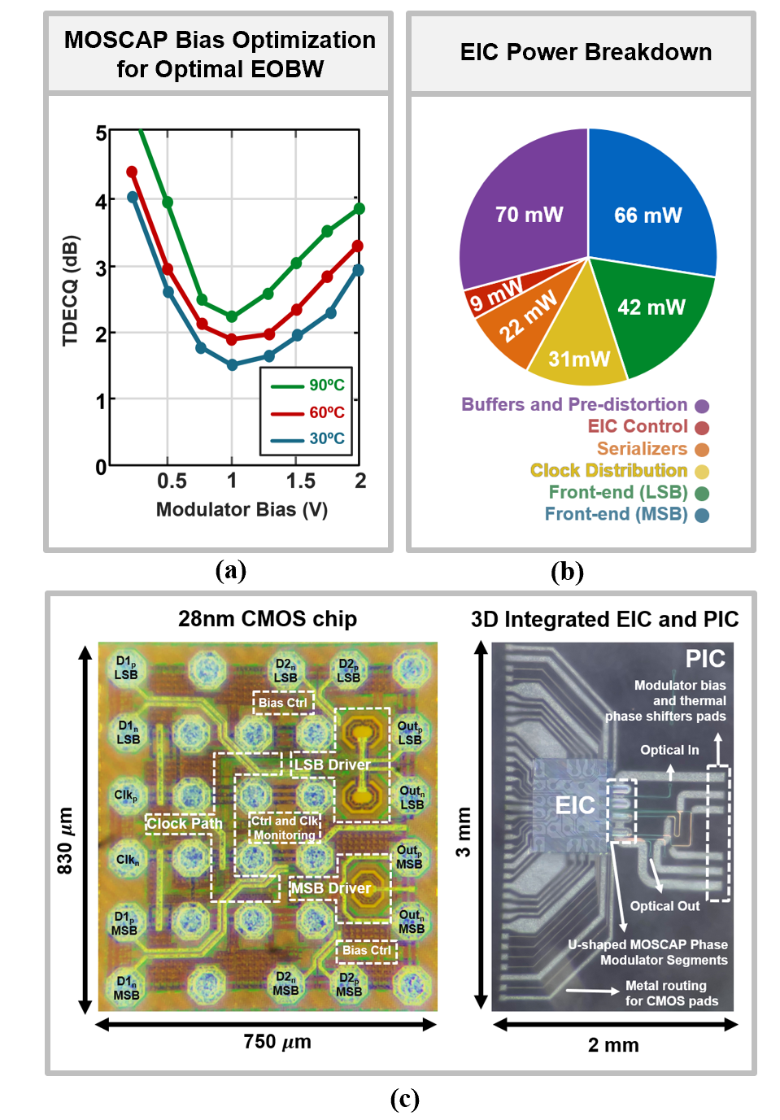
Fig. 12. (a) TDECQ values for 100Gbps PAM4 eye diagrams for different MOSCAP bias voltages and temperatures, (b) EIC power breakdown, and (c) die photos of the 28nm CMOS chip and 3D integration with PIC
Further eye measurements for extreme temperatures and MOSCAP bias voltages are shown in Fig. 11(g-i). At 90ºC, TDECQ is degraded to 2.31dB. Increasing the bias from the optimal value of 1V to 2V has resulted in more optical efficiency, but lower EOBW. As a result, the OMA has remained unchanged, while TDECQ is degraded to 2.97dB. Also, when the bias is decreased to 0.25, eyes are widened thanks to higher EOBW, while vertical closure has resulted in a degraded TDECQ of 4dB.
The last column of Fig. 11 shows eye measurements when there is a relative delay between MSB and LSB data paths. Fig. 11(j) shows outer eyes horizontal closure due to a 4ps delay, which has affected the TDECQ negatively. Generating -4ps of delay degrades the TDECQ even more, since being dominated by the middle eye horizontal and vertical closure, as shown in Fig. 11(k). Finally, Fig. 11(l) shows the measured eye when all extremes occur at the same time, operating at 90ºC, -4ps of relative delay, and 0.25V of bias.
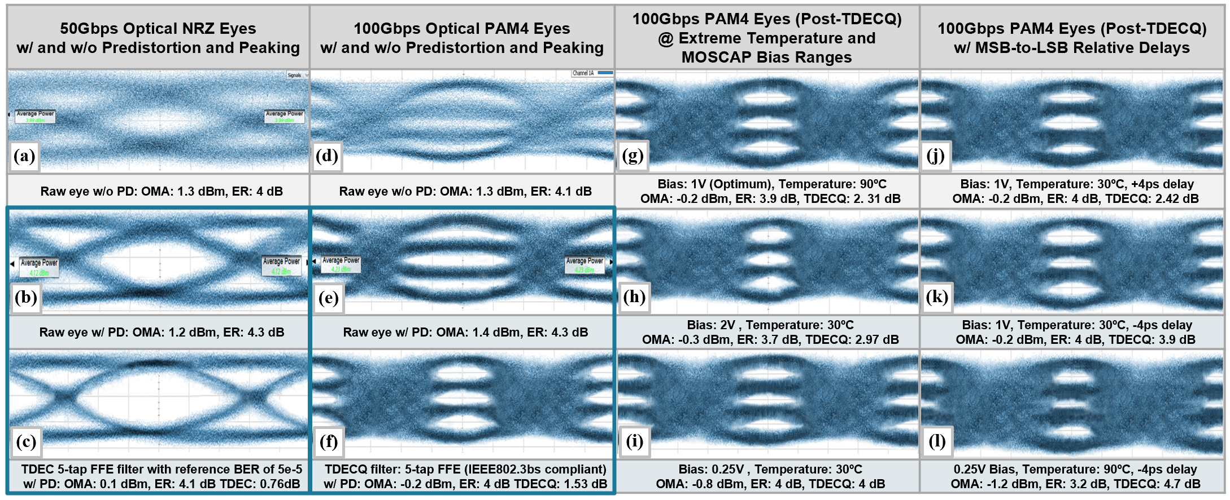
Fig. 11: Measured 50Gb/s NRZ and 100 Gb/s PAM4 eye diagrams before and after on-chip BW extension.
The plot in Fig. 12(a) shows TDECQ values versus MOSCAP forward bias voltage for different temperatures. As described in section III-b, increasing the bias improves the optical efficiency while degrading the inherent BW of the MOSCAP due to the enlarged C_{MOS}. Therefore, an optimal bias point is found at 1V that minimizes the TDECQ. The OTX exhibits 53% degradation in TDECQ performance when biased at 1V for temperature ranges from 30 ºC to 90 ºC.
The power breakdown of the EIC is provided in Fig. 12(b). The CMOS chip dissipates 240mW at 100Gb/s PAM4 (including the clock distribution, serializers and core drivers) to deliver 4dB total ER at 1.53dB TDECQ. Die images of the EIC and its 3D integration with PIC, are shown in Fig. 12 (c).

Conclusion
In this paper, a 3D-integrated 100Gb/s PAM-4 OTX was presented. Electronic pre-distortion and BW extension techniques were implemented to compensate for MOSCAP modulator BW limitations. Trade-offs of MOSCAP modulator parameters were studied and used for co-designing the electro-optical interface for optimal EOBW, power consumption and optical efficiency. Table I in shows the overall performance of the OTX in comparison with the prior art. The proposed TX achieves 2.5× better EIC energy efficiency at 100Gb/s, compared to the state-of-the-art co-integrated optical PAM4 transmitters.
The proposed tightly-integrated SiPh-CMOS OTX demonstrates the potential of compact MOSCAP modulators co-optimized with CMOS drivers, to provide a path for the future 100+Gb/s/λ SiPh transmitters. While this work was focused on optical PAM4 transmission, the system could be scaled up for higher-order coherent modulation schemes, such as quadrature phase shift keying (QPSK) and N-level quadrature amplitude modulation (QAM-N).

Acknowledgment
TABLE I – Performance Summary and Comparison
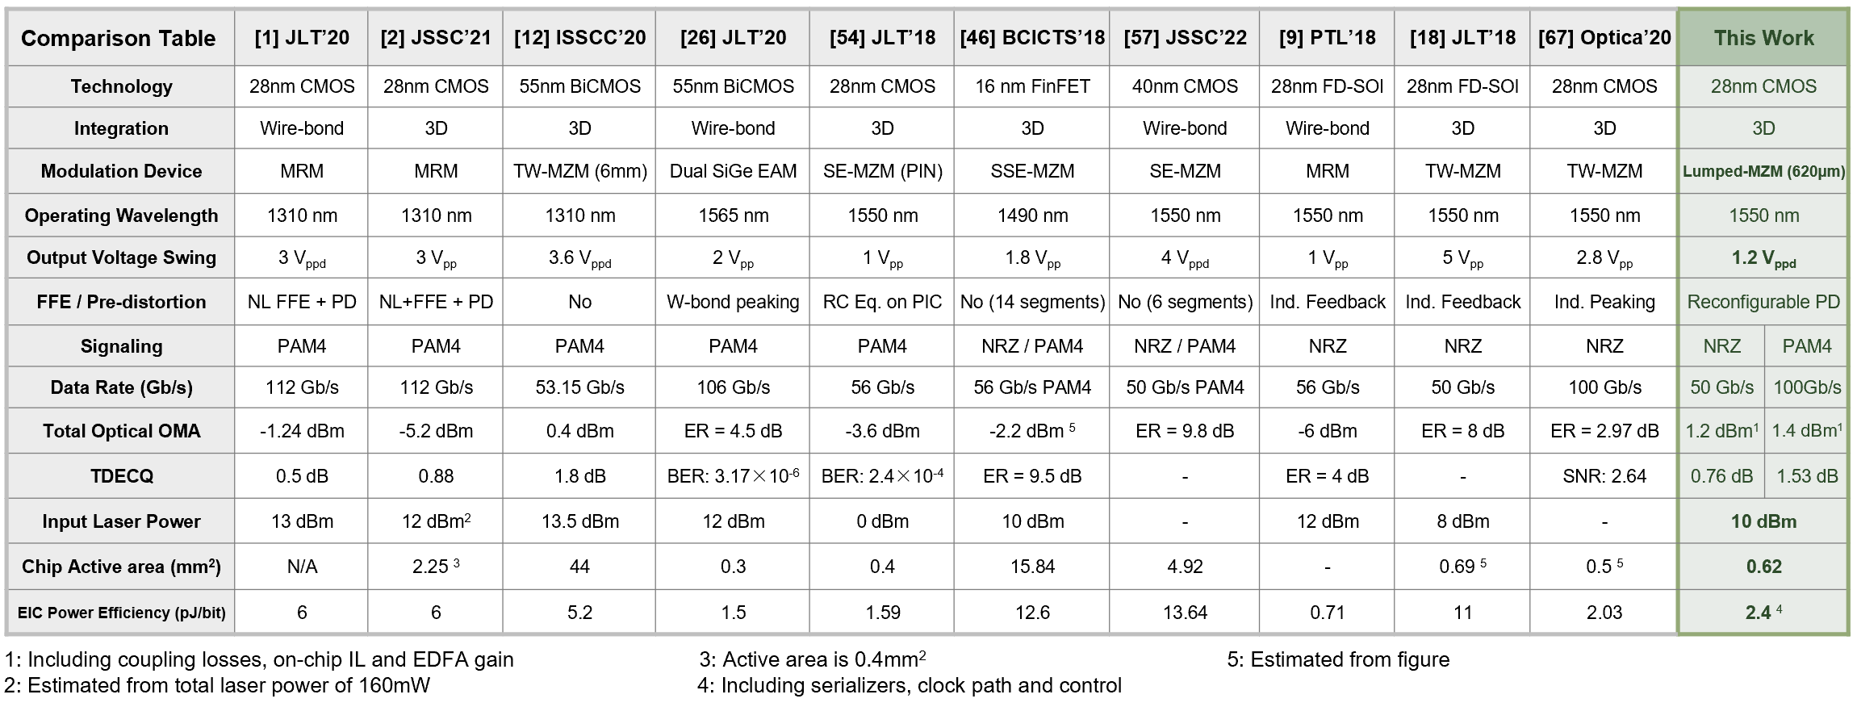

The authors would like to thank Aaron Zilkie, Roshanak Shafiiha, David Nelson and other team members at Rockley Photonics for their continuous technical support and funding. This work was supported by funding from Rockley Photonics and the EPSRC through the prosperity partnership (EP/R003076/1), EPSRC Platform Grant (EP/N013247/1); EPSRC Strategic Equipment Grant (EP/T019697/1) and European Commission H2020 PICTURE Project (780930). D. J. Thomson acknowledges funding from the Royal Society for his University Research Fellowship (UF150325).
References
- H. Li et al., "A 112 Gb/s PAM4 Silicon Photonics Transmitter with Microring Modulator and CMOS Driver," in Journal of Lightwave Technology, vol. 38, no. 1, pp. 131-138, 1 Jan.1, 2020.
- H. Li et al., "A 3-D-Integrated Silicon Photonic Microring-Based 112-Gb/s PAM-4 Transmitter with Nonlinear Equalization and Thermal Control," in IEEE Journal of Solid-State Circuits, vol. 56, no. 1, pp. 19-29, Jan. 2021
- H. Li et al., "A 112 Gb/s PAM4 CMOS Optical Receiver with Sub-pJ/bit Energy Efficiency," 2019 IEEE Optical Interconnects Conference (OI), 2019, pp. 1-2, doi: 10.1109/OIC.2019.8714565.
- H. Li et al., "A 3D-Integrated Microring-Based 112Gb/s PAM-4 Silicon-Photonic Transmitter with Integrated Nonlinear Equalization and Thermal Control," 2020 IEEE International Solid- State Circuits Conference - (ISSCC), 2020, pp. 208-210, doi: 10.1109/ISSCC19947.2020.9063122.
- J. Sharma et al., "Silicon Photonic Microring-Based 4 × 112 Gb/s WDM Transmitter With Photocurrent-Based Thermal Control in 28-nm CMOS," in IEEE Journal of Solid-State Circuits, vol. 57, no. 4, pp. 1187-1198, April 2022, doi: 10.1109/JSSC.2021.3134221.
- M. Rakowski et al., "A 50Gb/s, 610fJ/bit hybrid CMOS-Si photonics ring-based NRZ-OOK transmitter," 2016 Optical Fiber Communications Conference and Exhibition (OFC), 2016, pp. 1-3.
- A. Roshan-Zamir et al., "A two-segment optical DAC 40 Gb/s PAM4 silicon microring resonator modulator transmitter in 65nm CMOS," 2017 IEEE Optical Interconnects Conference (OI), 2017, pp. 5-6, doi: 10.1109/OIC.2017.7965503.
- S. Moazeni et al., "A 40-Gb/s PAM-4 Transmitter Based on a Ring-Resonator Optical DAC in 45-nm SOI CMOS," in IEEE Journal of Solid-State Circuits, vol. 52, no. 12, pp. 3503-3516, Dec. 2017, doi: 10.1109/JSSC.2017.2748620.
- H. Ramon et al., "Low-Power 56Gb/s NRZ Microring Modulator Driver in 28nm FDSOI CMOS," in IEEE Photonics Technology Letters, vol. 30, no. 5, pp. 467-470, 1 March1, 2018, doi: 10.1109/LPT.2018.2799004.
- S. Saeedi and A. Emami, "A 10Gb/s, 342fJ/bit micro-ring modulator transmitter with switched-capacitor pre-emphasis and monolithic temperature sensor in 65nm CMOS," 2016 IEEE Symposium on VLSI Circuits (VLSI-Circuits), 2016, pp. 1-2, doi: 10.1109/VLSIC.2016.7573541.
- S. Saeedi, B. Abiri, A. Hajimiri and A. Emami, "Differential optical ring modulator: Breaking the bandwidth/quality-factor trade-off," 2015 European Conference on Optical Communication (ECOC), 2015, pp. 1-3, doi: 10.1109/ECOC.2015.7341731.
- E. Sentieri et al., "A 4-Channel 200Gb/s PAM-4 BiCMOS Transceiver with Silicon Photonics Front-Ends for Gigabit Ethernet Applications," 2020 IEEE International Solid- State Circuits Conference - (ISSCC), 2020, pp. 210-212.
- G. -W. Lu, H. -B. Zhang, S. Shinada, J. Hong, Y. Cheng and S. Yokoyama, "Power-Efficient O-Band 40 Gbit/s PAM4 Transmitter Based on Dual-Drive Cascaded Carrier-Depletion and Carrier-Injection Silicon Mach-Zehnder Modulator With Binary Driving Electronics at CMOS Voltages," in IEEE Journal of Selected Topics in Quantum Electronics, vol. 27, no. 3, pp. 1-8, May-June 2021, Art no. 3500308, doi: 10.1109/JSTQE.2021.3056721.
- D. Petousi et al., "Monolithically Integrated High-Extinction-Ratio MZM With a Segmented Driver in Photonic BiCMOS," in IEEE Photonics Technology Letters, vol. 28, no. 24, pp. 2866-2869, 15 Dec.15, 2016, doi: 10.1109/LPT.2016.2624700.
- J. Zhou, J. Wang, L. Zhu and Q. Zhang, "High Baud Rate All-Silicon Photonics Carrier Depletion Modulators," in Journal of Lightwave Technology, vol. 38, no. 2, pp. 272-281, 15 Jan.15, 2020, doi: 10.1109/JLT.2019.2933384.
- Z. Yong et al., "A 44Gbps high extinction ratio silicon Mach-Zehnder modulator with a 3D-integrated 28nm FD-SOI CMOS driver," 2017 Optical Fiber Communications Conference and Exhibition (OFC), 2017, pp. 1-3.
- L. Szilagyi, R. Henker, D. Harame and F. Ellinger, "2.2-pJ/bit 30-Gbit/s Mach-Zehnder Modulator Driver in 22-nm-FDSOI," 2018 IEEE/MTT-S International Microwave Symposium - IMS, 2018, pp. 1530-1533, doi: 10.1109/MWSYM.2018.8439675.
- Z. Yong et al., "RF and Thermal Considerations of a Flip-Chip Integrated 40+ Gb/s Silicon Photonic Electro-Optic Transmitter," in Journal of Lightwave Technology, vol. 36, no. 2, pp. 245-251, 15 Jan.15, 2018, doi: 10.1109/JLT.2017.2779757.
- E. Temporiti, G. Minoia, M. Repossi, D. Baldi, A. Ghilioni and F. Svelto, "A 56Gb/s 300mW silicon-photonics transmitter in 3D-integrated PIC25G and 55nm BiCMOS technologies," 2016 IEEE International Solid-State Circuits Conference (ISSCC), 2016, pp. 404-405, doi: 10.1109/ISSCC.2016.7418078.
- N. Hosseinzadeh, K. Fang, L. Valenzuela, C. Schow and J. F. Buckwalter, "A 50-Gb/s Optical Transmitter Based on Co-design of a 45-nm CMOS SOI Distributed Driver and 90-nm Silicon Photonic Mach-Zehnder Modulator," 2020 IEEE/MTT-S International Microwave Symposium (IMS), 2020, pp. 205-208, doi: 10.1109/IMS30576.2020.9223845.
- M. Cignoli et al., "A 1310nm 3D-integrated silicon photonics Mach-Zehnder-based transmitter with 275mW multistage CMOS driver achieving 6dB extinction ratio at 25Gb/s," 2015 IEEE International Solid-State Circuits Conference - (ISSCC) Digest of Technical Papers, 2015, pp. 1-3, doi: 10.1109/ISSCC.2015.7063103.
- A. H. Talkhooncheh, A. Zilkie, G. Yu, R. Shafiiha and A. Emami, "A 100 Gb/s PAM-4 Silicon Photonic Transmitter with Two Binary-Driven EAMs in MZI Structure," 2021 IEEE Photonics Conference (IPC), 2021, pp. 1-2, doi: 10.1109/IPC48725.2021.9593028.
- C. Minkenberg et al., "Reimagining datacenter topologies with integrated silicon photonics," in Journal of Optical Communications and Networking, vol. 10, no. 7, pp. 126-139, July 2018, doi: 10.1364/JOCN.10.00B126.
- P. Srinivasan et al., "Hybrid O-band electro-absorption modulators on multi-micron waveguide silicon photonics platform for optical engine applications," 45th European Conference on Optical Communication (ECOC 2019), 2019, pp. 1-3, doi: 10.1049/cp.2019.0853.
- D. W. U. Chan, Y. Tong, G. -h. Chen, C. -W. Chow and H. K. Tsang, "280 Gb/s Dual-Polarization Transmitter using Ge-on-Si EAMs for Short-Reach Interconnects," 2020 IEEE Photonics Conference (IPC), 2020, pp. 1-2, doi: 10.1109/IPC47351.2020.9252460.
- J. Lambrecht et al., "Low-Power (1.5 pJ/b) Silicon Integrated 106 Gb/s PAM-4 Optical Transmitter," in Journal of Lightwave Technology, vol. 38, no. 2, pp. 432-438, 15 Jan.15, 2020, doi: 10.1109/JLT.2019.2933286.
- J. Verbist et al., "Real-Time and DSP-Free 128 Gb/s PAM-4 Link Using a Binary Driven Silicon Photonic Transmitter," in Journal of Lightwave Technology, vol. 37, no. 2, pp. 274-280, 15 Jan.15, 2019, doi: 10.1109/JLT.2018.2877461.
- A. J. Zilkie et al., "Multi-Micron Silicon Photonics Platform for Highly Manufacturable and Versatile Photonic Integrated Circuits," in IEEE Journal of Selected Topics in Quantum Electronics, vol. 25, no. 5, pp. 1-13, Sept.-Oct. 2019, Art no. 8200713, doi: 10.1109/JSTQE.2019.2911432.
- J. Verbist et al., "DAC-Less and DSP-Free 112 Gb/s PAM-4 Transmitter Using Two Parallel Electroabsorption Modulators," in Journal of Lightwave Technology, vol. 36, no. 5, pp. 1281-1286, 1 March1, 2018, doi: 10.1109/JLT.2017.2789164.
- J. Verbist et al., "Real-Time 100 Gb/s NRZ and EDB Transmission With a GeSi Electroabsorption Modulator for Short-Reach Optical Interconnects," in Journal of Lightwave Technology, vol. 36, no. 1, pp. 90-96, 1 Jan.1, 2018, doi: 10.1109/JLT.2017.2775630.
- G. -W. Lu, J. Hong, H. Zhang, F. Qiu and S. Yokoyama, "DAC-less PAM4 Transmitter Using Electro-Optic Polymer Dual-Drive Mach-Zehnder Modulator with Imbalanced Binary Driving Electronics," 2019 Conference on Lasers and Electro-Optics (CLEO), 2019, pp. 1-2, doi: 10.1364/CLEO_SI.2019.STh1N.7.
- H. Ramon et al., "70 Gb/s 0.87 pJ/bit GeSi EAM Driver in 55 nm SiGe BiCMOS," 2018 European Conference on Optical Communication (ECOC), 2018, pp. 1-3, doi: 10.1109/ECOC.2018.8535467.
- S. Srinivasan, D. Liang and R. G. Beausoleil, "Heterogeneous SISCAP Microring Modulator for High-Speed Optical Communication," 2020 European Conference on Optical Communications (ECOC), 2020, pp. 1-3, doi: 10.1109/ECOC48923.2020.9333221.
- M. Webster, K. Lakshmikumar, C. Appel, C. Muzio, B. Dama and K. Shastri, "Low-power MOS-capacitor based silicon photonic modulators and CMOS drivers," 2015 Optical Fiber Communications Conference and Exhibition (OFC), 2015, pp. 1-3, doi: 10.1364/OFC.2015.W4H.3.
- A. Shastri et al., "Ultra-Low-Power Single-Polarization QAM-16 Generation Without DAC Using a CMOS Photonics Based Segmented Modulator," in Journal of Lightwave Technology, vol. 33, no. 6, pp. 1255-1260, 15 March15, 2015, doi: 10.1109/JLT.2015.2394749.
- I. Charlet, Y. Désières, D. Marris-Morini and F. Boeuf, "Capacitive Modulator Design Optimization Using Si and Strained-SiGe for Datacom Applications," in IEEE Journal of Selected Topics in Quantum Electronics, vol. 27, no. 3, pp. 1-8, May-June 2021, Art no. 3400508, doi: 10.1109/JSTQE.2020.3028447.
- T. Hiraki, et al. “Heterogeneously integrated III–V/Si MOS capacitor Mach–Zehnder modulator,” Nature Photon 11, 482–485 (2017).
- K. Debnath et al., "20Gbps silicon lateral MOS-Capacitor electro-optic modulator," 2018 Conference on Lasers and Electro-Optics (CLEO), 2018, pp. 1-2.
- W. Zhang et al., "High Bandwidth Capacitance Efficient Silicon MOS Modulator," in Journal of Lightwave Technology, vol. 39, no. 1, pp. 201-207, 1 Jan.1, 2021, doi: 10.1109/JLT.2020.3026945.
- W. Zhang et al., "Integration of low loss vertical slot waveguides on SOI photonic platforms for high efficiency carrier accumulation modulators," Opt. Express 28, 23143-23153 (2020)
- K. Debnath et al., "All-silicon carrier accumulation modulator based on a lateral metal-oxide-semiconductor capacitor," Photon. Res. 6, 373-379 (2018)
- W. -C. Hsu, B. Zhou and A. X. Wang, "MOS Capacitor-Driven Silicon Modulators: A Mini Review and Comparative Analysis of Modulation Efficiency and Optical Loss," in IEEE Journal of Selected Topics in Quantum Electronics, vol. 28, no. 3, pp. 1-11, May-June 2022, Art no. 3400211, doi: 10.1109/JSTQE.2021.3127200.
- M. Choi et al., "8 An Output-Bandwidth-Optimized 200Gb/s PAM-4 100Gb/s NRZ Transmitter with 5-Tap FFE in 28nm CMOS," 2021 IEEE International Solid- State Circuits Conference (ISSCC), 2021, pp. 128-130.
- A. Zandieh, P. Schvan and S. P. Voinigescu, "57.5GHz bandwidth 4.8Vpp swing linear modulator driver for 64GBaud m-PAM systems," 2017 IEEE MTT-S International Microwave Symposium (IMS), 2017, pp. 130-133, doi: 10.1109/MWSYM.2017.8058847.
- A. Zandieh, P. Schvan and S. P. Voinigescu, "Linear Large-Swing Push–Pull SiGe BiCMOS Drivers for Silicon Photonics Modulators," in IEEE Transactions on Microwave Theory and Techniques, vol. 65, no. 12, pp. 5355-5366, Dec. 2017, doi: 10.1109/TMTT.2017.2768028.
- C. Li et al., "A 3D-Integrated 56 Gb/s NRZ/PAM4 Reconfigurable Segmented Mach-Zehnder Modulator-Based Si-Photonics Transmitter," 2018 IEEE BiCMOS and Compound Semiconductor Integrated Circuits and Technology Symposium (BCICTS), 2018, pp. 32-35, doi: 10.1109/BCICTS.2018.8551089.
- A. Samani et al., "Silicon Photonic Mach–Zehnder Modulator Architectures for on Chip PAM-4 Signal Generation," in Journal of Lightwave Technology, vol. 37, no. 13, pp. 2989-2999, 1 July1, 2019.
- S. Lin, S. Moazeni, K. T. Settaluri and V. Stojanović, "Electronic–Photonic Co-Optimization of High-Speed Silicon Photonic Transmitters," in Journal of Lightwave Technology, vol. 35, no. 21, pp. 4766-4780, 1 Nov.1, 2017, doi: 10.1109/JLT.2017.2757945.
- S. Liu, P. -C. Peng, L. Huang, C. -W. Hsu, H. Tian and G. -K. Chang, "Bandwidth-Enhanced PAM-4 Transmissions Using Polarization Modulation and Direct Detection With a Tunable Frequency Range," in Journal of Lightwave Technology, vol. 37, no. 3, pp. 1014-1022, 1 Feb.1, 2019, doi: 10.1109/JLT.2018.2885128.
- S. Shekhar, J. S. Walling, and D. J. Allstot, "Bandwidth Extension Techniques for CMOS Amplifiers," in IEEE Journal of Solid-State Circuits, vol. 41, no. 11, pp. 2424-2439, Nov. 2006, doi: 10.1109/JSSC.2006.883336.
- Kim, Y., Takenaka, M., Osada, T. et al. Strain-induced enhancement of plasma dispersion effect and free-carrier absorption in SiGe optical modulators. Sci Rep 4, 4683 (2014). https://doi.org/10.1038/srep04683
- G. T. Reed, C.E. Jason Png, “Silicon optical modulators,” Materials Today, Volume 8, Issue 1, 2005, Pages 40-50, ISSN 1369-7021.
- S. Akiyama et al., "Compact PIN-Diode-Based Silicon Modulator Using Side-Wall-Grating Waveguide," in IEEE Journal of Selected Topics in Quantum Electronics, vol. 19, no. 6, pp. 74-84, Nov.-Dec. 2013, Art no. 3401611, doi: 10.1109/JSTQE.2013.2278438.
- S. Tanaka et al., "Ultralow-Power (1.59 mW/Gbps), 56-Gbps PAM4 Operation of Si Photonic Transmitter Integrating Segmented PIN Mach–Zehnder Modulator and 28-nm CMOS Driver," in Journal of Lightwave Technology, vol. 36, no. 5, pp. 1275-1280, 1 March1, 2018, doi: 10.1109/JLT.2018.2799965.
- Y. Sobu, G. Huang, S. Tanaka, Y. Tanaka, Y. Akiyama and T. Hoshida, "High-Speed Optical Digital-to-Analog Converter Operation of Compact Two-Segment All-Silicon Mach–Zehnder Modulator," in Journal of Lightwave Technology, vol. 39, no. 4, pp. 1148-1154, 15 Feb.15, 2021, doi: 10.1109/JLT.2020.3035684.
- Y. Sobu et al., "Highly power-efficient (2 pJ/bit), 128Gbps 16QAM signal generation of coherent optical DAC transmitter using 28-nm CMOS driver and all-silicon segmented modulator," 2022 Optical Fiber Communications Conference and Exhibition (OFC), 2022, pp. 1-3.
- Q. Liao et al., "A 50-Gb/s PAM-4 Silicon-Photonic Transmitter Incorporating Lumped-Segment MZM, Distributed CMOS Driver, and Integrated CDR," in IEEE Journal of Solid-State Circuits, vol. 57, no. 3, pp. 767-780, March 2022, doi: 10.1109/JSSC.2021.3134874.
- D. Petousi et al., “Performance limits of depletion-type silicon Mach–Zehnder modulators for telecom applications,” J. Lightw. Technol., vol. 31, no. 22, pp. 3556–3562, Nov. 2013.
- T. Lee, Planar Microwave Engineering. Cambridge, U.K.: Cambridge Univ. Press, 2004.
- S. Shopov and S. P. Voinigescu, "A 3×60 Gb/s Transmitter/Repeater Front-End With 4.3 V_{PP} Single-Ended Output Swing in a 28nm UTBB FD-SOI Technology," in IEEE Journal of Solid-State Circuits, vol. 51, no. 7, pp. 1651-1662, July 2016, doi: 10.1109/JSSC.2016.2545703.
- K. Li, D. J. Thomson, S. Liu, P. Wilson and G. T. Reed, "A 30 Gb/s CMOS driver integrated with silicon photonics MZM," 2015 IEEE Radio Frequency Integrated Circuits Symposium (RFIC), 2015, pp. 311-314, doi: 10.1109/RFIC.2015.7337767.
- B. Murray, C. Antony, G. Talli and P. D. Townsend, "Predistortion for High-Speed Lumped Silicon Photonic Mach-Zehnder Modulators," in IEEE Photonics Journal, vol. 14, no. 2, pp. 1-11, April 2022, Art no. 7220611, doi: 10.1109/JPHOT.2022.3158255.
- B. Analui, J. F. Buckwalter and A. Hajimiri, "Data-dependent jitter in serial communications," in IEEE Transactions on Microwave Theory and Techniques, vol. 53, no. 11, pp. 3388-3397, Nov. 2005, doi: 10.1109/TMTT.2005.857118.
- M. H. Nazari and A. Emami-Neyestanak, "A low-power 20Gb/s transmitter in 65nm CMOS technology," 2012 IEEE Radio Frequency Integrated Circuits Symposium, 2012, pp. 149-152, doi: 10.1109/RFIC.2012.6242252.
- H. Lu, C. Su and C. Liu, "A Scalable Digitalized Buffer for Gigabit I/O," in IEEE Transactions on Circuits and Systems II: Express Briefs, vol. 55, no. 10, pp. 1026-1030, Oct. 2008, doi: 10.1109/TCSII.2008.925661.
- C. Menolfi et al., "A 112Gb/S 2.6pJ/b 8-Tap FFE PAM-4 SST TX in 14nm CMOS," 2018 IEEE International Solid - State Circuits Conference - (ISSCC), 2018, pp. 104-106, doi: 10.1109/ISSCC.2018.8310205.
- K. Li et al., "Electronic–photonic convergence for silicon photonics transmitters beyond 100 Gbps on–off keying," Optica 7, 1514-1516 (2020).
Arian Hashemi Talkhooncheh (S’15) received the B.Sc. degree in Electrical Engineering from Sharif University of Technology in Tehran, Iran in 2015. He received the M.Sc. degree in 2016 and is pursuing his PhD degree in Electrical Engineering at the California Institute of Technology (Caltech) with special interests in analog/mixed-signal IC design for high-speed optical interconnects and biomedical applications. He was a recipient of the IEEE Custom Integrated Circuits Conference (CICC 2020) Best Student Paper Award. He holds a national gold medal and an international silver medal of the Olympiad on Astronomy and Astrophysics, 2011.

Weiwei Zhang received his B.S. from East China Normal University (Shanghai, 2012) and master’s degree in nanoscience from École Normale Supérieure de Cachan (Paris, 2013) and PhD degree from University Paris Sud in 2017. Weiwei joined the Optoelectronics Research Centre of the University of Southampton in 2017 and now is a senior research fellow of the silicon photonics group. His research fields include silicon photonic device design, fabrication, and characterization through integration with silicon-based, III-V, CNTs, Erbium doped, etc., materials for electro-optical modulation, light detection, emitting and sensing.

Minwo Wang received the B.S. degree in Electrical Engineering from the University of Massachusetts Amherst (UMass) in 2017, and the M.Sc. degree in Electrical Engineering from the California Institute of Technology (Caltech) in 2018. From 2016 to 2017, he did research in the UMass Radio Frequency Nanoelectronics Group to develop calibration procedures for cryogenic noise measurements. He is a recipient of IEEE Microwave Theory and Techniques Society Undergraduate Scholarship for Spring of 2017. He is continuing his PhD degree in Electrical Engineering at Caltech.

David J. Thomson received his B.Eng. and PhD degrees from the University of Surrey, UK in 2004 and 2010, respectively. He is currently a professorial fellow in the Optoelectronics Research Centre (ORC) at the University of Southampton. David holds a Royal Society University Research Fellowship and is pioneering research in the area of photonics for computing applications and LIDAR. He holds several research projects and leads a team working on the design, fabrication and characterization of novel photonics devices and circuits as well as their integration with electronic functionality.
Martin Ebert received his diploma in nanotechnology from the university of Magdeburg, Germany in 2011. From 2012 to 2015 he was with the Fraunhofer institute for mechanics of materials, Halle, Germany before joining the Electronics and Computer Science group at the University Southampton, UK where he received his Ph.D. in Electronics and Electrical Engineering in 2018. He has over 10 years’ experience in nanotechnology device fabrication and materials characterization.
Li Ke (M’10) (Senior research fellow in the Silicon Photonics Group, Optoelectronics Research Centre (ORC), University of Southampton) received his MSc. degree in Radio Frequency Communications Engineering and Ph.D. degree in Electronic Engineering from the University of Southampton U.K, in 2005 and 2010, respectively. He has twelve years of silicon-proven experience in fully customized analogue and microwave signals (>100GBaud/s) CMOS IC design down to 28nm by using various industry-standard processes. At the moment, he is the lead inventor of two U.K. patents and the researcher co-investigator of EPSRC granted fund “Towards a revolution in optical communications” (£1.3M). In the meantime, he is the Co-investigator of the cooperative project between Optoelectronics Research Centre (ORC), University of Southampton and the Huawei Technologies Co., Ltd for silicon photonics-based CWDM 400G transceiver.

Graham T. Reed FREng, BSc, PhD, FIET, CEng, is Professor of Silicon Photonics at the University of Southampton, UK. In April 2012, he joined Southampton from the University of Surrey, where he was Professor of Optoelectronics, and was Head of Electronic Engineering from 2006 to 2012. Reed is a regular invited and contributing author to the major Silicon Photonics conferences around the world. He has served on numerous international conference committees and has also chaired many others. To name but two, he has been co-chair, of the Silicon Photonics symposium at SPIE Photonics West conference in San Francisco since it was first established in 2006, and in 2011 he was co-chair IEEE Group IV Photonics, held at the Royal Society in London, the latter being the most well supported conference in the history of the event. He is currently a member of 6 international conference committees and has published over 600 journal and papers in the field of Silicon Photonics, including more than 175 invited talks. In 2013 he was the recipient of the IET Crompton Medal for Achievement in Energy, for his work on Silicon Photonics, and in 2014 he was awarded a Royal Society Wolfson Merit Award. He is a Fellow of the Royal Academy of Engineering, Optica, SPIE, IET, and the European Optical Society.

Azita Emami (M’05–SM’17) received the B.S. degree from the Sharif University of Technology in 1996 and the M.S. and Ph.D. degrees in electrical engineering from Stanford University in 1999 and 2004, respectively. From 2004 to 2006, she was with the IBM T. J. Watson Research Center before joining Caltech in 2007. She is currently the Andrew and Peggy Cherng Professor of Electrical Engineering and Medical Engineering with the California Institute of Technology (Caltech), and a Heritage Medical Research Institute Investigator. She also serves as the Executive Officer (Department Head) for Electrical Engineering. Her current research interests include integrated circuits and systems, integrated photonics, wearable and implantable devices for neural recording, neural stimulation, sensing, and drug delivery. She was an IEEE SSCS Distinguished Lecturer in 2017-2018. She is currently an Associate Editor of the IEEE JOURNAL OF SOLID-STATE CIRCUITS (JSSC).

A. Hashemi Talkhooncheh, M. Wang and A. Emami are with the California Institute of Technology (Caltech), Pasadena, CA 91125 USA (e-mail: ahashemi@caltech.edu). W. Zhang, D. J. Thomson, M. Ebert, L. Ke and G. T. Reed are with the University of Southampton, Southampton, UK (e-mail: weiwei.zhang@soton.ac.uk). Color versions of one or more of the figures in this article are available online at http://ieeexplore.ieee.org

