Non-Invasive Assessment of Neuromuscular Disorders by 7 Tesla Magnetic Resonance Imaging and Spectroscopy:
Dedicated Radio-Frequency Coil Development

Alessandra Retico
Istituto Nazionale di Fisica Nucleare (INFN, Sez. Pisa) Pisa, Italy

Riccardo Stara, Maria Evelina Fantacci e Alessandra Toncelli
Dip. di Fisica, Università di Pisa e INFN (Sez. Pisa) Pisa, Italy

Angelo Galante, Tiziana M. Florio e Marcello Alecci
Dipartimento MESVA
Università degli Studi dell'Aquila e INFN (LNGS) L'Aquila, Italy

Mirco Cosottini
Dip. di Ricerca Traslazionale e delle Nuove Tecnologie in Medicina e Chirurgia, Univ. di Pisa e Fondazione IMAGO7 Pisa, Italy

Guja Astrea e Roberta Battini
IRCCS Stella Maris Pisa, Italy

Gianluigi Tiberi, Mauro Costagli e Michela Tosetti
IRCCS Stella Maris e Fondazione IMAGO7 Pisa, Italy

Abstract—Magnetic Resonance (MR) Imaging and Spectroscopy of the muscle is a valuable tool in the diagnosis and monitoring of Neuromuscular Disorders (NMD). New Ultra-High Field (UHF) 7 T MRI systems, with their enhanced Signal-to-Noise Ratio, may offer increased image quality in terms of spatial resolution and/or shorter scanning time compared to lower field systems. In the study of NMD the new features provided by UHF MR may allow the use of functional techniques to improve biochemical and physiological information of skeletal muscle correlated to the pathogenesis and progression of the muscle involvement. This study reports the recent achievements in muscle imaging and spectroscopy obtained at the first Italian 7 T MR scanner available at the IMAGO7 Foundation (Pisa, Italy). Dedicated radio-frequency coils for proton imaging and phosphorous spectroscopy have been designed, developed and validated in vivo, and are now ready for clinical research studies.

Keywords—Neuromuscular disorders; Magnetic Resonance Imaging (MRI); Magnetic Resonance Spectroscopy (MRS); ultra- high field MRI; radio-frequency coils.

I. INTRODUCTION
The current research in the field of Magnetic Resonance (MR) biomedical imaging (MRI) and spectroscopy (MRS) is moving towards increasingly higher static magnetic field strengths.

Whereas 3 Tesla scanners are becoming widespread in clinical applications, scanners working at higher static magnetic fields are still available only to a limited number of laboratories in the World, and only for research purposes. There are about 40 MR systems operating at 7 Tesla or above worldwide, and they have already demonstrated the great capability and potential of the Ultra-High Field (UHF) MR, and highlighted several still-open challenges [1,2]. The IMAGO7 Foundation in Pisa (Italy) detains and manages the first and only 7 Tesla whole-body MR scanner (950-MR scanner, GE Medical Systems, Milwaukee, WI) in Italy.
Among the clinical applications that will benefit from the improved resolution and signal-to-noise ratio (SNR) obtainable at high magnetic field, one can mention MRI and MRS techniques implemented for the studies of inherited Neuromuscular Disorders (NMD). Muscle imaging plays in fact a key role in identifying genetically different pathological muscle conditions [3]. Thanks to the use of MRI, physicians are now able to identify many specific patterns of muscle involvement, with a great shortening of the diagnostic algorithm and an important cost reduction for the health system. However, the identification of specific imaging patterns of genetic NMD is still in progress and represents a challenging research field. Moreover in the era of new genomic medicine, research efforts have identified over 100 genetically distinct rare forms of myopathies, neuropathies, and mitochondrial disorders, and the combination of gene panel and MR muscle imaging information might circumvent the difficulties of multiple variants of unknown significance

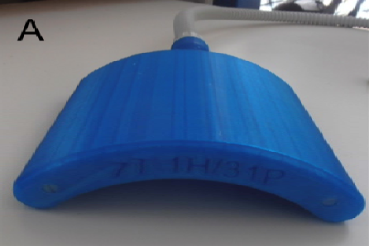
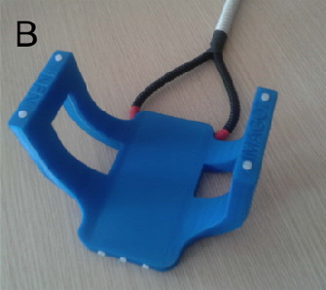
and facilitate reaching the molecular etiology in sporadic and familial NMD.
As MRI is recognized as a fundamental technique for studying muscle structure, also MRS allows for the investigation of muscle metabolism in vivo [4]. Magnetic Resonance spectra
could provide clinicians with important physiological and
metabolic information, which can potentially be very useful to understand the mechanisms of in situ muscle damage. In particular, MRI and MRS with nuclei different from ¹H, for

which the available signal is limited, benefit from the improved SNR obtainable with ultra-high magnetic fields.
A number of in-vivo studies of the musculoskeletal (MSK) system at high field strengths have already been carried out [5- 10]. For example, 7 T MRI combined with multi-nuclear MRS
Fig. 1. A) The multinuclear Transmit/Receive (Tx/Rx) linearly-polarized surface RF coil, suitable for the detection of proton (¹H) and phosphorus (³¹P) signals. B) The quadrature Tx/Rx surface RF coil suitable for the detection of proton signal.

This paper is organized as follows: first, the choice of the coil

provides a powerful tool for rapid high-resolution morphologic and functional muscle imaging. Moreover, they may supply additional information. At UHF, fat suppression should be used to reduce the figchemical shift artifacts between fat and water frequencies. This technique permits the identification of edema and/or inflammation that represent the early signs of damage before the muscle is replaced by fat or fibrotic tissue [4]. Another possible application of 7 T MRI/MRS would be to perform sequential studies during the clinical and instrumental follow up of neuromuscular
design is motivated according to the available MR system and the anatomical region under investigation; then, the choice of the hardware components and the coil construction details are provided; finally, the first in vivo images and spectra on the human calf are presented.

- MATERIALS AND METHODS
- The choice of the coil designs and materials

disorders. This can be useful for a variety of applications: a)
The availability of RF coils
of UHF MR systems is still

allow an earlier diagnosis also in asymptomatic patients, b) improve the monitoring of the progression of muscle
limited. Therefore, UHF research sites often set up RF laboratories to develop suitable coils for specific applications.

involvement; and c) provide valuable information on the
The choice of the RF coil
design depends on the target

efficacy of ongoing therapeutic studies (drugs, gene or stem cell therapy), representing a possible alternative to serial muscle biopsies.
anatomy, on the desired MR acquisition modality (e.g. MRI, multinuclear MRS, perfusion MRI, diffusion MRI, angiography) and it is constrained by the available MR system

UHF MR imaging of the MSK system
offers important
equipment. This study focuses on the adult human calf. A

potential advantages over lower field systems in increased sensitivity and enhanced contrast. However, these benefits can be difficult to realize because of increased radio-frequency
suitable coil design to this purpose has to accommodate an adult human calf. Such design will be suitable also for scanning the thigh of NMD patients.

(RF) inhomogeneity, increased Specific
Absorption Rate
The MR system available at the IMAGO7 Foundation is a 7 T

(SAR) and the relative lack of specialized and commercially available RF coils compared to lower field systems.
In this framework, a research collaboration between the IMAGO7 Foundation and the Italian National Institute for Nuclear Physics (INFN) aims to the development of important
scanner currently equipped with two channels, which can be either both for proton (i.e. ¹H, I and Q channels) or one for proton and the other for Multi-Nuclear Spectroscopy (i.e. ¹H and MNS channel).
Concerning the multinuclear coil, we adopted a solution which

hardware components, such as RF coils for specific MR applications, to exploit the UHF potential in several research areas, including MSK imaging and spectroscopy.
In particular, two different RF coil prototypes (see Fig. 1) suitable for 7T MSK applications are presented in this paper:
resorts to a coil comprising one Tx/Rx channel for ¹H and one Tx/Rx channel for ³¹P.
As the linearly polarized surface coil for proton MRI is expected to suffer the typical transmit field inhomogeneity, in the attempt to obtain a more informative structural image of

- a multinuclear Transmit/Receive (Tx/Rx) linearly- polarized surface RF coil, suitable for the detection of proton (¹H) and phosphorus (³¹P) signals;
- a quadrature Tx/Rx surface RF coil suitable for the detection of the proton signal.
These two RF coil configurations are justified by the need of improved SNR in proton and phosphorus MSK imaging and spectroscopy detected from the same anatomical volume-of- interest (VOI).
the calf muscle a specific coil design has been realized too. It consists of a quadrature surface coil, where the two channels available are both used for proton.
For both these solutions the support holding the coil can be designed using any CAD package, for example AutoCAD; the support has to be designed according to the anatomical district, and has to be comfortable, easy-to-use and safe. To this purpose we left 3 mm between the inner surface (where the coil circuits will lay) and the outer layer (where the calf will be positioned).

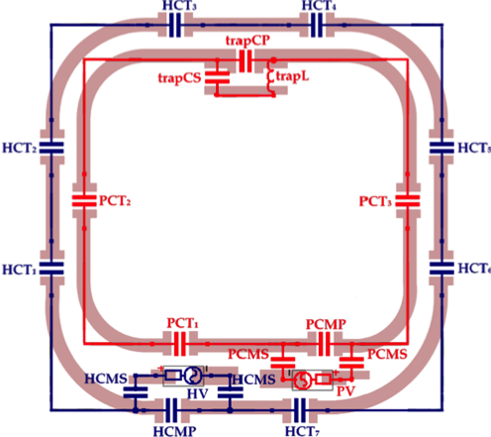
Table 1. Materials used in coil construction.
Item | Model (Manufacturer)
Non-magnetic chip capacitors | 100B, 800B, 800A (ATC)
Non-magnetic inductor | 1812SMS-22NGL (Coilcraft)
Cables | RG-402, RG-58 (Micro-coax, Belden)
PCB board | FR4

Concerning the choice of the materials, we used for the
mechanical support a polycarbonate structure obtained by 3D printing. The coil circuits consist of a printed circuit board (PCB) in FR4, board thickness 200 micron, copper thickness 35 micron. The circuits are covered by a protecting paint for avoiding oxidation. The other materials used in the design are listed in Table 1.

- The dual-tuned (¹H and ³¹P) Tx/Rx surface RF coil for 7 T MRI and MRS
The construction of the dual-tuned Tx/Rx surface RF coil for MRI and MRS at 7 T starts with the realization of the ¹H Tx/Rx channel by etching an external square loop having side length of 110 mm (see Fig. 2). The tuning procedure of the ¹H loop is performed after measuring the inductance, which implies the following operation: 1) a known capacitor has been added to the loop; 2) the correspondent resonance

Fig. 2. Circuit of the dual-tuned ¹H and ³¹P RF coil: the outer loop (110 mm × 110 mm) is tuned at the ¹H resonance frequency; the inner loop (95 mm × 85 mm) at the ³¹P resonance frequency. The trap circuit and the matching circuits are also visible.

The advantage of a second-order trap with respect to a first- order trap is that it is possible to choose the desired impedance at both frequencies. In both cases, the inductor value has to be

frequency has been measured through a Vector Network Analyzer (VNA, E5071C, Agilent Technologies); the inductance is determined by analytical calculation. Next, the loop has been tuned to 298.03 MHz, i.e. the Larmor frequency of the ¹H at 7 T. Next, the coil has to be matched: matching
chosen to optimize the sensitivity at one of the two
frequencies. Once the value of inductor has been chosen, the values of the capacitors for the trap are easily obtained by solving the appropriate equations. The impedance of the trap can be measured using a calibrated fork probe. Fine-tuning

can be achieved either with or without a load, i.e. in the unloaded/loaded condition. A capacitive matching with load is performed; the Q factor is calculated through appropriate VNA measurements, and the corresponding resistance is derived [12]. The matching capacitor was determined by using a Smith Chart procedure [13].
The ³¹P loop is realized by etching a rectangular loop of 95 mm × 85 mm (see Fig. 2). The ³¹P channel is decoupled from the ¹H channel by the insertion in the ³¹P loop of a series
can be achieved slightly bending the wires of the inductor.
Referring to Fig. 2, the list of components used for assembling the coil is given in Table 2.

Table 2. RF components of the dual-tuned coil.

second-order trap circuit [14]. The tuning (at 120.6 MHz,
HCT  1,3,4,5,7 | 6.8 pF
HCT  2,6 | 10 pF
PCT  1,2 | 38.1 pF
PCT  3 | 39.8 pF
HCMP | 1.0 pF
HCMS | 33 pF
PCMP, PCMS | 21.8 pF
trapCP | 5.1 pF
trapCS | 13.6 pF
trapL | 65 nH

which is the ³¹P resonance frequency at 7 T) and the matching procedures are performed following the same steps described for ¹H loop.
Once both loops were separately tuned and matched, decoupling was performed using the trap circuit method [14]. This consists in adding an additional resonant circuit in series with one of the loops at the frequency of the other one. For example, if a resonant circuit tuned to 298 MHz is added in

Coil feeding is performed using a solid coaxial cable. All the corners of the coils are rounded: the curvature radius is 30 mm for the main loops and 2 mm for the end point of the strip. The

series to the ³¹P loop it will behave as a high-impedance
element in series to the ¹H loop, preventing the current flowing. If needed, another trap circuit, tuned to 120.6 MHz, could also be added to the ¹H loop.
The trap circuit can be constituted by an inductor in parallel to
workbench measurements for the ¹H and the ³¹P loops provided the following values reported in Table 3.

Table 3. Workbench measurements for the dual-tuned coil.

a capacitor (“first order”, as in [14]) or by a capacitor in
 | ¹H loop | ³¹P loop
Q unloaded | 105 | 363
Q loaded (human calf) | 14 | 46
Matching (S11, S22) | -19 dB | -30 dB
Coupling (S12, S21) | -23 dB | -12 dB

parallel with a series LC circuit (“second order”, as in [15]).

The scattering parameters S of the circuit were verified also through simulations. Simulations can be performed through full-wave electromagnetic codes (e.g. FEKO¹, which employs frequency-domain Maxwell equation solver or CST², which employs both frequency-domain and time-domain Maxwell equation solver). Simulations can be also used for evaluating B₁⁺ maps (and, thus, homogeneity and coil efficiency) and the SAR [16].
The simulations have been carried out in this case using FEKO. The load is a cylinder equivalent to the human calf

Fig. 4. Direct comparison between the measured and simulated B ⁺ field map.

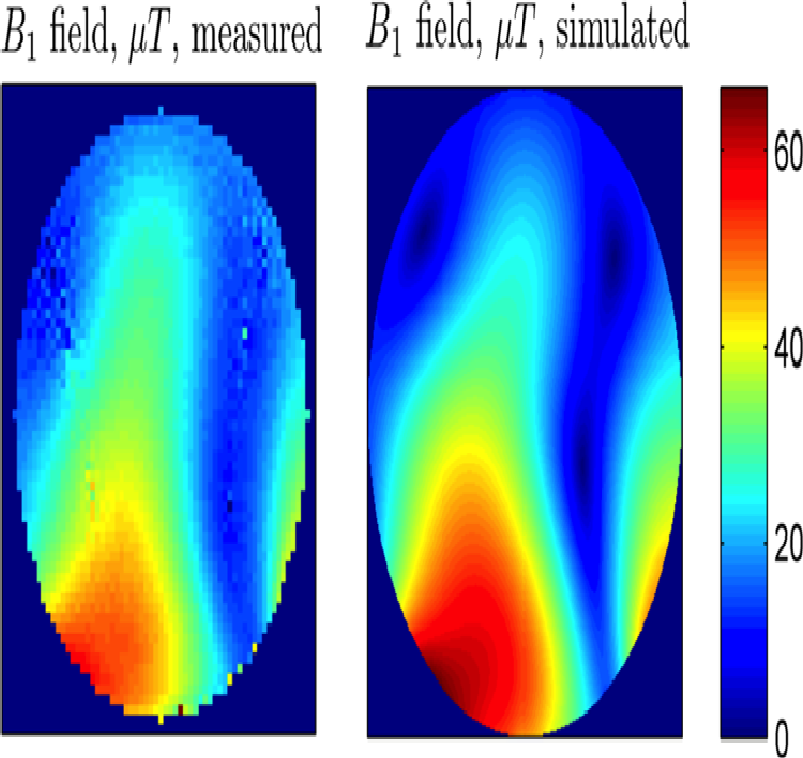
- The quadrature Tx/Rx surface RF coil for 7 T MRI
1

muscle (radius 60 mm, height 200 mm, ε_{r} = 80 and σ = 0.60 S/m), placed 15 mm away from the coil circuit.
Simulated results for the S parameters showed an excellent agreement with the workbench measurements (S₁₁= -18 dB, S₂₂= -20 dB, coupling < -14 dB). The simulated B₁⁺ and E maps obtained for unitary input power of 1 kW for both the ¹H and the ³¹P channels are shown in Fig. 3. It is evident that the ¹H B₁⁺ field map is affected by the known high-field standing- wave phenomena [17], whereas the lower frequency ³¹P field map is as homogeneous as expected for a surface coil.
The dual-tuned surface coil has been integrated into the 7 T MR scanner available at the IMAGO7 Foundation. The B₁⁺ field map has been measured using the Bloch-Siegert Shift
The ¹H coil presented here is constituted of two partially overlapped loops driven in quadrature. The shape of the mechanical frame of the RF coil is a semi-cylindrical saddle of inner radius 70 mm and outer radius 85 mm (see Fig. 1 B). The accessible volume is therefore a cylindrical sample of about 65 cm in diameter. The RF circuit consists of two loops with dimensions 170 mm along the horizontal axis, 60 mm and 130 mm along the vertical axial for the central and peripheral part, respectively. The two loops are geometrically decoupled by a partial overlap of 18 mm (adjustable). Tuning and matching of the loops is performed as shown in the previous sub-section. Referring to Fig. 5, the list of components

method [18], using a load made of a cylindrical bottle
containing water and 0.05M NaCl. The normalization to 1 kW
used for assembling the coil is given in Table 4.
The workbench measurements provided the following values:

has been performed to allow comparison with simulations, which is directly shown in Fig. 4. An excellent agreement between theory and experiment is observed, showing the capability of achieving the desired RF field pattern and flip angle at 7 T.
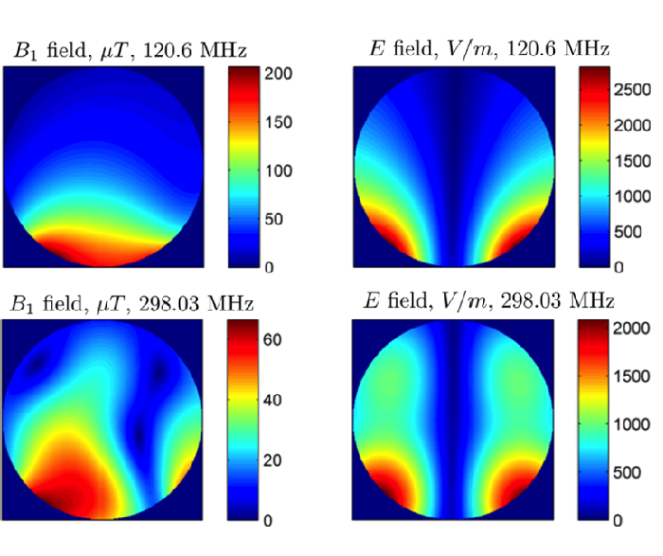
Fig. 3. Simulated B1+ and E field maps for unitary input power of 1kW for both the ¹H and the ³¹P channels of the dual-tuned surface RF coil.

1 http://www.feko.info/
² https://www.cst.com/
matching < -17 dB on both channels, coupling < -15 dB. The Q factors are 120 and 20 for both channels, in loaded and unloaded conditions, respectively.

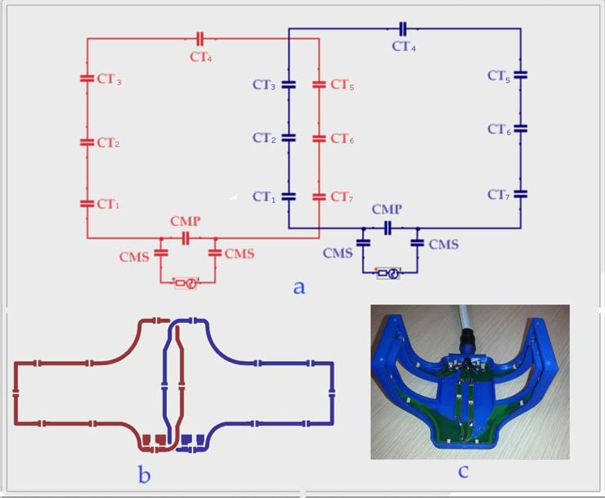
Fig. 5. Circuit of the quadrature ¹H RF surface coil made by two square loops with partial overlapping.

Table 4. RF components of the single-tuned quadrature ¹H RF coil.

CT1 | 6.8 pF
CT2,5 | 5.1 pF
CT3,4,6,7 | 4.2 pF
CMS | 22 pF
CMP | 1.0 pF

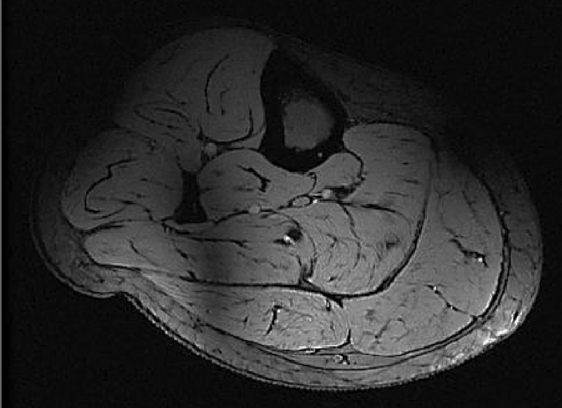

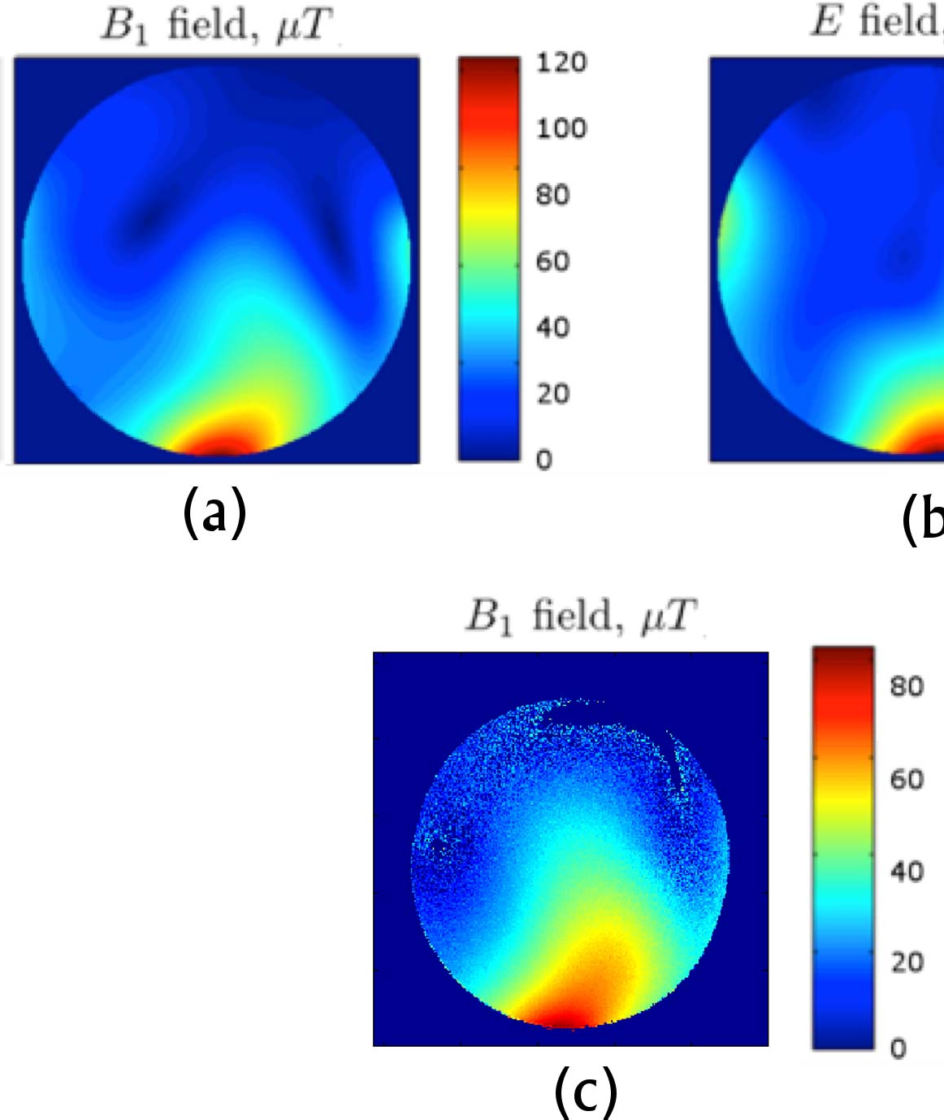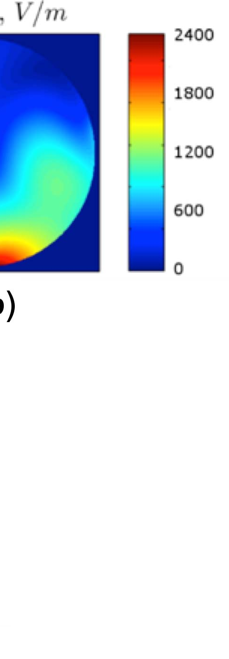Fig. 6. Simulated B ⁺ (a) and E (b) field maps of the quadrature ¹H RF surface
Fig. 7. Calf of a healthy volunteer acquired at 7 T with the dual-tuned surface RF coil and a 3D MERGE sequence (FA = 15°, TR = 55.6 ms, TE = 11.8 ms, BW = 83.3 kHz, FOV = 17 cm x 17 cm, thickness 3 mm, matrix 512 x 512).

1
coil for unitary input power of 1kW. Measured B1+ power.
- for the same input
The dark shadow on the bottom left is due to the B ⁺ field inhomogeneity.

Pi
1

The simulated B₁⁺ and E maps obtained for unitary input power of 1 kW are shown in Fig. 6, which demonstrates that quadrature operation of the 7 T surface coil improves B₁⁺ field homogeneity with respect to a linearly polarized surface coil.
PDE
PCr
PME
γ-ATP
α-ATP
β-ATP
NADH

- IN-VIVO IMAGES AND SPECTRA
The first images and spectra obtained are shown below. The calf of a healthy volunteer acquired with the dual-tuned surface RF coil and a 3D MERGE sequence (FA = 15°, TR = 55.6 ms, TE = 11.8 ms, BW = 83.3 kHz, FOV = 17 x 17 cm²,
thickness 3 mm, matrix 512 x 512) is shown in Fig. 7. The dark

10 5 0 -5 -10 -15 -20
Frequency (ppm)

shadow on the bottom left is due to the typical B₁⁺ field inhomogeneity [19]. It is possible to notice the accurate representation of the different muscle bundles, which is particularly important in NMD imaging.
The dual-tuned coil was used to acquire a ³¹P spectrum of the calf of a healthy human volunteer. A simple pulse-acquire experiment without volume selection was performed with the following parameters: TR = 3 s, number of scans = 48, spectral width = 15151 Hz. Data analysis was performed with a homemade routine in Matlab (MathWorks, Natick, USA)
Fig. 8. ³¹P spectrum of the calf of a healthy human volunteer acquired with a pulse-acquire experiment (48 averages, hard pulse, apod=25Hz)..

The quadrature ¹H surface RF coil allowed the acquisition of muscle images of a NMD patient. The images of the right thigh of a 21 year-old NMD patient with distal weakness have been acquired both at the 1.5 T clinical MR scanner available at the IRCCS Stella Maris Institute (Pisa), and at the 7 T MR scanner of the IMAGO7 Foundation (Pisa). A direct visual comparison between a particular of a 1.5 T axial T1-weighted

and consisted in zero-filling, Gaussian apodization (25 Hz),
FID average, Fast Fourier Transform, zero and first order phase correction and baseline correction.
The result is shown in Fig. 8 with the assignment of the main peaks. Lines from the following metabolites are clearly visible and could unambiguously be assigned: phosphocreatine (PCr),
image acquired accordin to the Mercuri protocol [3] (SE sequence with 1.56 mm in-plane resolution, TR = 540 ms, TE
= 14 ms, thickness = 5 mm) and the corresponding axial image acquired at 7 T (3D MERGE sequence with 0.29 mm in-plane resolution, TR = 69.8 ms, TE = 19.6 ms, thickness 3mm) is shown in Fig. 9. The following structures are clearly visible in

adenosine triphosphate (ATP), inorganic phosphate (Pi),
phosphomonoesters (PME), phosphodiesters (PDE), and nicotinamide adenine dinucleotide (NADH).
the figure: preserved muscle (a); muscle replaced by fat (b); deteriorating muscle showing the peculiar previously only hypothesized cauliflower structure, originally shown in this image (c); and subcutaneous fat (d).

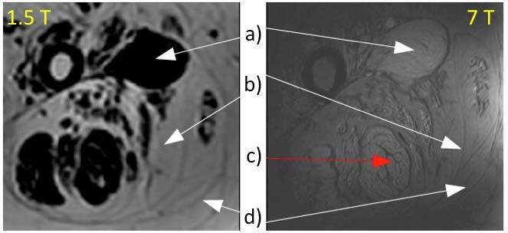
Fig. 9. A particular of a right thigh of a NMD patient acquired with the clinical 1.5 T settings (Mercuri protocol [3]) and at 7 T with the quadrature ¹H surface RF coil. The following structures are visible: preserved muscle (a); muscle replaced by fat (b); deteriorating muscle showing the peculiar previously only hypothesized cauliflower structure, originally shown in this image (c); and subcutaneous fat (d).
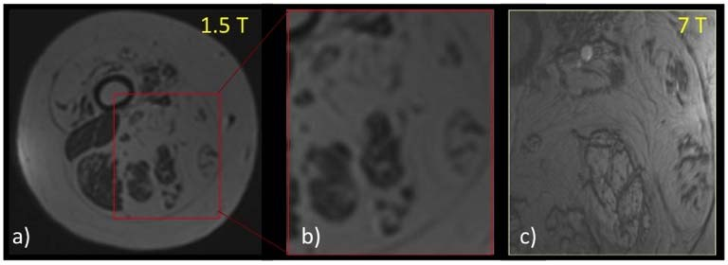
Fig. 10. Right thigh MR images of a 21 years old NMD patient with distal weakness acquired at 1.5 T and at 7 T (lower section with respect to Fig. 9: a) SE at 1.5T; b) a particular of image (a) where the fat infiltration inside the muscles is visible; c) 3D MERGE at 7 T of the same anatomy shown in (b), where the higher definition of the pattern of fat infiltration in the muscles can be noticed, with the possibility to distinguish the architecture of muscle fibers.

The images of a lower section of the tight of the same NMD patient is reported in Fig. 10, where a particular (b) of the image acquired at 1.5 T (a) shows that despite the fat infiltration inside the muscles is visible, it is not possible to distinguish the intracellular from the extracellular fat. By contrast, the image acquired at 7 T (c) shows the pattern of fat infiltration in the muscles with higher definition. Moreover, it is possible to distinguish the architecture of muscle fibers and to speculate about the mechanism at the basis of the muscle deterioration.

- CONLUSIONS
We presented the recent achievements in MRI and MRS of the human muscle obtained at the first Italian 7 T MR scanner available at the IMAGO7 Foundation in Pisa (IT). We designed and developed dedicated RF surface coils for ¹H imaging and ³¹P spectroscopy. Moreover, these RF coil prototypes have been validated in vivo on healthy volunteers and on a NMD patient. The images we showed demonstrate that the research on NMD can take great advantage from the UHF MR potential. Once dedicated RF volume coils allowing for a full coverage of the human lower limbs are available for clinical research studies, UHF MR will hopefully represent a unique research tool for allowing an earlier and more efficient
analysis of the disorder in the search of possible biomarkers of different NMD diseases.

REFERENCES
  - K. Ugurbil, G. Adriany, P. Andersen, et al., “Ultrahigh field magnetic resonance imaging and spectroscopy,” Magn. Reson. Imaging, vol. 21, pp. 1263-1281, 2003.
  - O. Kraff, A. Fischer, A.M. Nagel, C. Mönninghoff, and M.E. Ladd, “MRI at 7 Tesla and Above: Demonstrated and Potential Capabilities,” Journal of Magnetic Resonance Imaging, vol. 41, pp. 13–33, 2015.
  - E. Mercuri, A. Pichiecchio, J. Allsop, S. Messina, M. Pane, F. Muntoni, “Muscle MRI in inherited neuromuscular disorders: past, present, and future,” Journal of Magnetic Resonance Imaging, vol. 25(2), pp. 433- 440, 2007.
  - C. Boesch, “Muscoloskeletal spectroscopy,” Journal of Magnetic Resonance Imaging, vol. 25(2), pp. 321-338, 2007.
  - S. Majumdar, “Ultra-High Field-7 Tesla Imaging of the Musculoskeletal System,” ISMRM High Field Workshop, Rome, Oct 2008.
  - S. Farooki, C.J. Ashman, J.S. Yu, A. Abduljalil, D. Chakeres, “In vivo high-resolution MR imaging of the carpal tunnel at 8.0 Tesla,” Skeletal Radiology, vol. 31(8), pp. 445-450, 2002.
  - G. Gambarota, A. Veltien, D. Klomp, N. van Alfen, R.V. Mulkern, A. Heerschap, “Magnetic resonance imaging and T2 relaxometry of human median nerve at 7 Tesla,” Muscle Nerve, vol. 36(3), pp. 368-373, 2007.
  - R.R. Regatte and M.E. Schweitzer, “Ultra-high field MRI of the muscoloskeletal system at 7.0 T,” Journal of Magnetic Resonance Imaging, vol. 25(2), pp. 262-269, 2007.
  - J.W. van Oorschot, J.P. Schmitz, A. Webb, K. Nicolay, J.A. Jeneson,
H.E. Kan, “31P MR Spectroscopy and Computational Modeling Identify a Direct Relation between Pi Content of an Alkaline Compartment in Resting Muscle and Phosphocreatine Resynthesis Kinetics in Active Muscle in Humans,” PLoS One, vol. 8(9), pp. e76628, 2013.
  - H.E. Kan, D.W. Klomp, C.S. Wong, et al., “In vivo 31P MRS detection of an alkaline inorganic phosphate pool with short T1 in human resting skeletal muscle,” NMR Biomed, vol. 23(8), pp. 995-1000, 2010.
  - G.J. Kemp and G.K Radda, “Quantitative interpretation of bioenergetic data from 31P and 1H magnetic resonance spectroscopic studies of skeletal muscle: an analytical review,” Magn Reson Q, vol. 10, pp. 43- 63, 1994.
  - J. Mispelter, M. Lupu and A. Briguet, “NMR Probeheads for Biophysical and Biomedical Experiments: Theorical Principles Pratical Guidilines,” Imperial College Press, 2006.
  - P. Smith, Electronic Applications of the Smith Chart, 2nd edition, 1995, SciTech/Noble Publishing, Raleigh, North Carolina.
  - M. Alecci, S. Romanzetti, J. Kaffanke, A. Celik, H.P. Wegener, N.J. Shah, “Practical design of a 4 Tesla double-tuned RF surface coil for interleaved 1H and 23Na MRI of rat brain,” J. Magn. Reson., vol 181(2), pp. 203-211, Aug 2006.
  - D.W. Klomp, B.L. van de Bank, A. Raaijmakers, et al., “(31) P MRSI and (1) H MRS at 7T: initial results in human breast cancer,” NMR Biomed, vol. 24(10), pp. 1337-1342, Dec 2011.
  - R. Stara, N. Fontana, G. Tiberi, et al, “Validation of numerical approaches for electromagnetic characterization of magnetic resonance radiofrequency coils,” PIER M, vol. 29, pp. 121-136, 2013.
  - M. Alecci, C.M. Collins, M.B. Smith, and P. Jezzard, "Radio frequency magnetic field mapping of a 3 Tesla birdcage coil: experimental and theoretical dependence on sample properties", Magn. Reson. Med., vol. 46, pp. 379-385, 2001.
  - L.I. Sacolick, F. Wiesinger, I. Hancu, M.W. Vogel, “B1 mapping by Bloch-Siegert shift," Magnetic Resonance in Medicine, vol. 63(5), pp. 1315-1322, 2010.
  - J. Tropp, “Image brightening in samples of high dielectric constant,” J. Magn. Reson., vol. 167(1), pp. 12-24, Mar 2004.

