Low-Complexity Non-Intrusive Load Monitoring Using Unsupervised Learning and Generalized Appliance Models
Qi Liu, Senior Member, IEEE, Kondwani Michael Kamoto, Xiaodong Liu, Senior Member, IEEE, Mingxu Sun, and Nigel Linge
Abstract— Awareness of electric energy usage has both societal and economic benefits, which include reduced energy bills and stress on non-renewable energy sources. In recent years, there has been a surge in interest in the field of load monitoring, also referred to as energy disaggregation, which involves methods and techniques for monitoring electric energy usage and providing appropriate feedback on usage patterns to homeowners. The use of unsupervised learning in Non-Intrusive Load Monitoring (NILM) is a key area of study, with practical solutions having wide implications for energy monitoring. In this paper, a low-complexity unsupervised NILM algorithm is presented, which is designed toward practical implementation. The algorithm is inspired by a fuzzy clustering algorithm called Entropy Index Constraints Competitive Agglomeration (EICCA), but facilitated and improved in a practical load monitoring environment to produce a set of generalized appliance models for the detection of appliance usage within a household. Experimental evaluation conducted using energy data from the Reference Energy Data Disaggregation Dataset (REDD) indicates that the algorithm has out-performance for event detection compared with recent state of the art work for unsupervised NILM when considering common NILM metrics such as Accuracy, Precision, Recall, F-measure, and Total Energy Correctly Assigned (TECA).

Index Terms—Home Energy Management, Non-Intrusive Load Monitoring, Unsupervised Learning, Appliance Modeling

Introduction
U
NDERSTANDING the way people consume electric energy has a number of widespread benefits. From the viewpoint of consumers, they can tell exactly how their daily activities are contributing to their energy bill, and what they can do to improve their energy usage. On the side of the energy suppliers, the provision of such electric energy consumption information can enable them to better align their electric energy generation and transmission with the requirements of consumers. Given the increasing need for electric energy with the continued growth of IoT technologies and the growing inclusion of individuals who previously had no access to electricity to the national electricity grid, it is important to ensure the optimal usage of this resource. While a number of nations, mainly developed nations, have begun to widely adopt renewable sources of energy, quite a number still rely on coal-powered electricity generation which has a significant effect on the environment, both on local and global scales. In summary, understanding how people utilize electric energy can be beneficial to both financial standing and also well-being.
Modern approaches to energy management utilize smart home technologies to enable energy efficiency and conservation [1]-[3]. While these approaches are extremely beneficial, the required infrastructure presents a barrier for adoption. The work presented in this paper takes into consideration home environments that are resource constrained but require a means to monitoring energy usage nonetheless.
Achieving the goals of energy efficiency and energy conservation first requires the ability to monitor electric energy usage. This is done via smart meter technology which has seen a surge in deployments in recent years. Smart meters are able to capture the electric energy signal and transmit it to networked devices in order to offer further analysis and data mining. Such a process is referred to as load monitoring or alternatively energy disaggregation. Load monitoring is categorized as either intrusive, semi-intrusive, or non-intrusive. Intrusive Load Monitoring (ILM) monitors energy usage via smart meters that are attached to each appliance or device that needs monitoring. Semi-Intrusive Load Monitoring (SILM) utilizes a subset of smart meters to capture a subset of the electric energy usage and infers the rest. Lastly, Non-Intrusive Load Monitoring (NILM) makes use of a single smart meter which captures the aggregated electric energy signal. The goal is then to discover the appliances that are contributing to the aggregated signal. NILM is the preferred approach for real-world solutions due to the fact that it has a reduced financial cost and lessens the burden of involvement for the energy monitoring process on the user or homeowner. Equation (1) presents a summary of the NILM problem.
$P\left(t\right)=\sum_{i=1}^{n}{P_{i}}+e\left(t\right)$ (1)
where $P\left(t\right)$ is the total power load as seen at time $t$, $P_{i}$ is the individual power contribution of appliance$i$, and $e\left(t\right)$ is a small noise or error term.
Unsupervised learning has recently gained popularity in NILM work. The main benefit of unsupervised learning is the removal of the dependence on a set of training data. This results in solutions that can be deployed and learn according to the environment where they operate, and therefore greatly simplifies the entire process. One of the major challenges with the application of unsupervised learning in NILM is minimizing the computational complexity as solutions will be deployed in resource constrained environments such as homes. In this work, a fuzzy clustering algorithm is proposed for NILM to address this challenge. An unsupervised approach is therefore presented to provide a low-complexity NILM solution, and a practical approach to offering informative feedback to homeowners.
The rest of the paper is structured as follows: Section II provides a review of recent research work on NILM. Section III introduces the proposed algorithm and provides a walkthrough of its sub-components. The evaluation of the algorithm is presented in Section IV with additional discussion on the outcomes of experimental evaluation processes. Lastly, Section V presents a summary of the research work and a discussion on possible future extensions.

Related Work
NILM was first proposed by Hart in the 1990s [4]. Since then numerous research work has been published with improvements to the initial design and different approaches all with the goal of achieving the same objectives. The typical NILM workflow consists of the following steps: 1) Power Signal Acquisition, 2) Event Detection, 3) Feature Extraction, and 4) Learning & Inference. The first step involves acquiring aggregated energy measurement at an adequate rate so that distinctive load patterns can be identified. Low sampling rates of 1Hz are typically used for NILM as they can be captured by smart meters without modification. High-frequency sampling rates require sophisticated hardware which can introduce additional costs to the energy monitoring process. With the aggregated energy having been acquired, the next step is then to detect the operating states of appliances. The current NILM approaches can be classified as event-based or state-based, depending on the event detection strategies that are utilized. Event-based approaches focus on state transition edges generated by appliances and use change detection algorithm to identify the start and end of an event [5]-[6]. All appliance types have a unique energy consumption pattern often termed as appliance signatures. This unique energy consumption pattern has been used to uniquely identify and recognize appliance operations from the aggregated load measurements [7]. There are two main classes of appliance signatures used by NILM researchers for appliance identification, namely, transient features and steady-state features. Transient features are short-term fluctuations in power or current before settling into a steady-state value. These features have uniquely defined appliance state transitions by extracting features such as shape, size, duration, and harmonics of the transient [7]. Steady-state features are related to more sustained changes in power characteristics when an appliance changes its running state. An example of such changes can be seen in Fig. 1, with the edges possibly indicating the result of an appliance switching from one operation state to another. Steady-state features include commonly cited active power, reactive power, current, and current and voltage waveforms. The final step of the NILM process is then to analyze the extracted appliance signatures and learn a set of appliances models that can be used to infer the electric energy consumption.
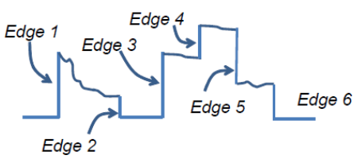
Fig. 1. Rising and falling edges possibly indicating changes in state of appliances and therefore significant events of energy usage.

Several state of the art unsupervised NILM algorithms have been proposed using different approaches including variants of Hidden Markov Models (HMMs), and most recently Graph Signal Processing (GSP), and deep learning.
Several HMM-based NILM algorithms for energy disaggregation at low sampling rate have been proposed in the literature. Kim et al. [8] proposed an unsupervised technique for energy disaggregation using a combination of four FHMM variants. The authors used low-frequency real power feature and assumed a binary state of appliances (ON and OFF state only). The approach used the Expectation Maximization (EM) algorithm to learn model parameters, and employed the Maximum Likelihood Estimation (MLE) algorithm to infer load states. The performance of the technique was limited to a few number of appliances, required appliances to be manually labelled after disaggregation, and suffered from high computational complexity, making it unsuitable for real-time applications [9].
Kolter and Jaakkola [10] introduced a new inference algorithm for unsupervised energy disaggregation called Additive Factorial Approximate MAP (AFMAP) that was computationally efficient and did not suffer from local optima. The AFMAP algorithm was used to perform approximate inference over the additive FHMM. However, the model required appliances to be manually labelled after off-line disaggregation and had a low performance for electronics and kitchen appliances.
Parson et al. [11], researched an approach that used a different HMM from the work done by Kolter and Jaakkola [10] as a Bayesian network for disaggregation of active power with 60s sampling rate. To perform inference, the authors used an extension of the Viterbi algorithm and proposed an EM training process to build a generic appliance model for learning the model parameters. This generic model was then tuned to specific appliance instances using only aggregate data from a house in which NILM was being applied.
Jia et al. [12] presented a fully unsupervised NILM framework based on non-parametric FHMM using low-frequency real power feature. They used the combination of slice sampling and Gibbs sampling to perform inference that simultaneously detected the number of appliances and disaggregated the power signal from the composite signal. However, the inference algorithm became a limitation for larger disaggregation problems as it had the possibility of getting stuck in local optima [13].
Makonin et al. [14] proposed an NILM algorithm for low-frequency sampling rate that used a super-state HMM in which a combination of modeled appliances states was represented as one super state. The authors developed a new variant of Viterbi algorithm called sparse Viterbi algorithm which performed computationally efficient exact inference instead of relying on approximate inference method like in the FHMM based approach.
Despite the fact that HMM-based NILM approaches have been widely used in energy disaggregation they require expert knowledge to set a-priori values for each appliance state. Their performance is therefore limited by how well the generated models approximate true appliance usage [15].
Graph Signal Processing (GSP) or signal processing on graph is an emerging field that extends classical signal processing theory to data indexed by general graphs [16]. GSP represents a dataset using a graph signal defined by a set of nodes and a weighted adjacency matrix [17].
The first GSP-NILM approach that was neither state-based nor event-based was presented by Stankovic et al. [18]. The authors, leveraged the work done by Sandryhaila et al. [19] in order to perform low-complexity multi-class classification of the acquired active power readings without the need for event detection to detect appliance changing states. However, this approach was supervised and employed GSP only for data classification [17].
Zhao et al. [15]-[17] proposed a blind, low-rate and steady state event-based GSP approach that did not require any training. The proposed GSP-NILM disaggregated any aggregate active power dataset without any prior knowledge and relied upon the GSP to perform adaptive threshold, signal clustering and pattern matching.
Different deep learning architectures such as Recurrent Neural Network (RNN) [20], Convolutional Neural Network (CNN) [20]-[22], Auto Encoder [20] and a combination of deep learning and HMM [22]-[24] have been employed to the energy disaggregation problem. While deep learning approaches have achieved success in NILM with regards to accuracy, the dependence on large amounts of data in order to be well generalized is a hindrance for real-world applications.
Alternative techniques have also been widely researched for NILM. These approaches have included the use of fuzzy sets [25]-[26], decision trees [27]-[28], support vector machines [29]-[30], sparse coding [31]-[32], and metaheuristics [33]. While these approaches have had wide ranging success for experimental evaluation, their practical use is limited as they are typically supervised in nature. However, literature indicates that the utilization of fuzzy logic has great value due to the multi-class nature of the NILM problem.
Another subset of the research work has focused on considering the fact that multiple appliances can switch states when a change in power occurs. Amongst the most recent research, two of the promising techniques are based on integer programming (IP) [34]-[35], and cepstrum-smoothing [36]. Further review of approaches in the NILM are presented in [37]-[39].
In summary, the research work conducted in NILM has attained varying levels of success with regards to the NILM metrics, nonetheless a majority of them are limited in use due to the lack of consideration on their practicality for in-home usage. Therefore, the aim of this work is to help fill this gap in the NILM research by presenting a possible solution to the NILM problem with practical implications.
The work presented here is an extension of our previous work [40]-[41] which introduced an unsupervised NILM algorithm based on Competitive Agglomeration (CA) [42] and subsequently Entropy Index Constraints Competitive Agglomeration (EICCA) [43]. In this paper we present our modified unsupervised NILM algorithm which provides an approach to learning appliance models without any reliance on prior information or data, with the goal of providing informative feedback to homeowners. The ability to learn the appliance composition of a house’s aggregated energy without prior knowledge while using a low-complexity technique makes the proposed algorithm a suitable solution for in-home monitoring of energy usage.

Proposed Work
The proposed algorithm is subdivided into a set of modules, each focusing on a single aspect of the NILM process. Due to the ease of installation and minimal cost we only consider the use of a single smart meter which captures the data at a low-sampling rate of 1Hz. We further consider the use of the active power (P) appliance signature due to the fact that it can be extracted from the energy signal using a simple process.

Architecture
The proposed algorithm is envisioned to function as part of a wider framework encompassing the NILM process in a household. This framework requires a minimal architecture which includes a smart meter and a low-power energy device for processing the data and disseminating information to homeowners. This architecture can be seen in Fig. 2.
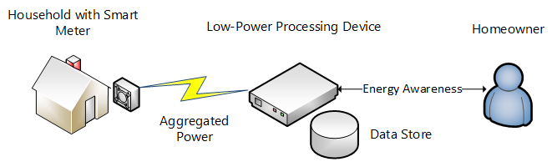
Fig. 2. Overview of energy disaggregation framework. Energy data is acquired at rate of 1Hz using a smart meter, and then sent to a low-power device for further processing. The low-power device processes the data and provides feedback to the homeowner enabling them to be better informed about their electric energy usage.

Algorithm Overview

Data Acquisition
The initial step is to get the necessary data required by the algorithm. This process begins by acquiring the aggregated energy data via a smart meter attached to the mains of the household. This data is then transmitted to a low-power energy device that handles the processing of the data and further communication to the homeowner.

Event Detection and Feature Extraction
The initial step in the processing pipeline is detecting the usage of appliances given the aggregated energy data and extracting features that can be used to model appliances. This is done by recognizing events which denote significant changes in power which could be attributed to an appliance changing from one state to another. The assumption made in this step is that only a single appliance will change its state during the time interval. To extract the features we first need to establish a significance threshold which will be used to filter out those events that do not provide useful information. In this work we utilize a significance threshold of 5W. The choice of this value enables the algorithm to additionally model and detect the usage of low-power devices such as phone chargers, which are commonly used within homes and therefore contribute to the aggregated load. The feature extraction process is summarized in (2).
${∆P}_{t_{i}}= P_{t_{i+1}}- P_{t_{i}}$ (2)
where ${∆P}_{t_{i}}$ is the difference in active power between two 1 second intervals $P_{t_{i+1}}$ and $P_{t_{i}}$. If ${∆P}_{t_{i}} ≥5W$then the event is denoted as being significant and the difference is stored as a feature for further use.
The extracted features consist of both negative and positive transitions. Given that a negative transition will likely have a corresponding positive transition of similar magnitude and vice-versa we simplify the features by transforming them into an invariant form which is done by converting them to their absolute form. This similarity between positive and negative transitions can be seen in Fig. 3 which displays the distribution of a set of features extracted from single day energy usage in a household.
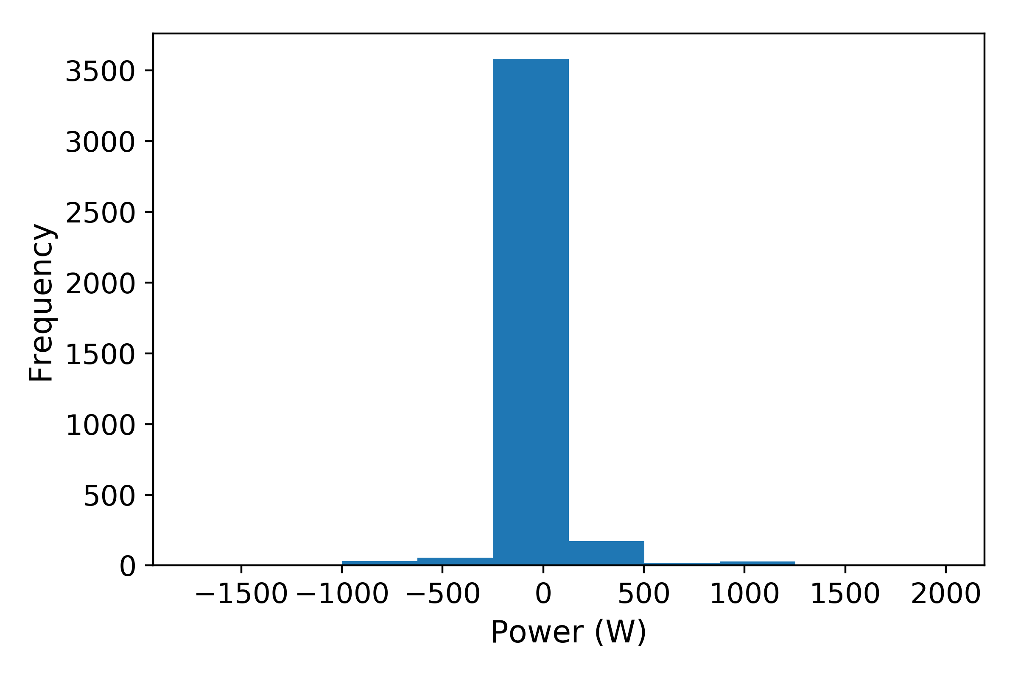
Fig. 3. Feature distribution from a single day of energy usage.
Once the features have been extracted they are then reduced to a generalized form via clustering. In order for this process to be unsupervised the number of feature clusters need not be fixed. We therefore make use of an adaptation of the EICCA which is a clustering technique that begins with an over-specified number of clusters, and gradually reduces this number by making cluster members compete for membership among the clusters. Clusters with low cardinality are eliminated upon every iteration until the clusters stabilize. This trait makes an adapted EICCA suitable to discover potential appliance types in the aggregated energy data. Such an approach also avoids additional steps required to specify the number of appliance types upfront.

Model Learning and Inference
The output of the Event Detection and Feature Detection step is a set of generalized features. These features can be used to attribute the energy usage to a group of commonly recognized power states. In order to better inform homeowners of their energy usage, these features need to be transformed into appliance models which are a composite of features. The appliance models can then better describe the energy usage to the homeowner.
Appliance models can be broadly categorized as those with two states (ON/OFF), and those with multiple states. Appliances with ON/OFF states are referred to as Type I in NILM. Multiple state appliances covers finite states, constantly ON, and continuously variable states, which are referred to as Type II, Type III, and Type IV respectively. To define the appliance models we consider two scenarios:

Two State Appliance Models
Given that the features represent both positive and negative transitions with the same magnitude, they are each expanded into two-state appliance models, with the positive transition representing the ON state and the negative transition representing the OFF state.

Multi-State Appliances Models
To define multi-state appliance models we further examine the aggregated energy signal and try to match a pattern of usage where two significant events occur subsequently. This is done in two phases where we consider significant events that occur immediately after one another, and those that are separated by a single time window of steady-state. The defined appliance models are then stored for further use in inferring their usage.
The final step is to recognize the usage of appliance models in the aggregated energy signal. As the features are generalized, exact matches to significant events are not possible, we therefore considered a significant event as being recognized if the feature matched it within a 5% error margin and within 5W of the magnitude of the significant event. The latter condition is introduced to cater for small variations that exceed the 5% error margin but are actually within 5W of the actual event. These conditions are imposed in order to increase the accuracy of the event matches. Furthermore, given that the algorithm needs to also be able to track the usage of low-power devices, large differences in the magnitude of these variations can have adverse effects on the feedback provided to homeowners. The process for the model inference is two-fold, and is as follows:

Evaluation of Feature and Appliance Model
The first task is to evaluate the features and appliance models to verify whether they are suitable for further use in appliance usage recognition. This considers common NILM metrics such as Accuracy, Precision, Recall, F-measure, and Total Energy Correctly Assigned (TECA), which will be further discussed in Section IV-A.

Recognition of Appliance Model Usage
The second task is to detect significant events and attribute the energy consumption to the defined appliance models. This is done by monitoring the aggregated energy signal and comparing each significant event to the existing appliance models. Each matched significant event is tied to the operation of an appliance model, which can be used to denote patterns of energy usage in a household, and to identify periods of high energy consumption during the day.

Experimental Evaluation
To validate and evaluate the proposed work, a set of experiments have been conducted making use of energy data provided by the six houses in the Reference Energy Data Disaggregation Dataset (REDD) [44]. The REDD consists of power consumption data from real homes, inclusive of energy readings at whole house level as well as for each individual circuit in the house. Each house consists of a mixture of appliances in use including lighting, dishwasher, stove, refrigerator, smoke alarm, and air conditioning, etc. This variety of appliance usage makes the REDD suitable for testing our proposed algorithm.
The experiments were setup to validate the performance of the algorithm in accordance to commonly cited NILM metrics, and most importantly the feasibility of the algorithm for practical implementation. In Context 1 we considered the disaggregation of energy data from the six REDD houses for both a single day period and over a three day period. In Context 2 we focused on the feasibility of the algorithm using single day energy data from REDD House 2. We further evaluated our approach to model learning and inference in this context. Context 3 verifies the performance of the algorithm when run on a low-power energy device. The main focus of the experimentation was data from House 2 of the REDD due to its common use for additional experimental evaluation outside of the NILM performance metrics in literature, and sufficient level of appliance complexity for evaluating energy disaggregation.
The parameters of the adapted EICCA were set as follows: the initial number of clusters Cmax was set to 100, the initial value of η was set to 5, the time constant τ was set to 10, the iterative threshold ε was set to 10⁻³, and the competition threshold ε₁ was set to 0.05.
The algorithm and experiments were implemented using Python 3.6 and made use of the NumPy and Pandas libraries. The experiments were conducted on a 64-bit computer running a dual core 2.50GHz processor with 8GB RAM, and 1TB storage. Context 3 was performed on a 64-bit single-board computer running a quad core 1.2GHz processor with 1GB RAM, and 2GB storage.

NILM Metrics
NILM has a number of metrics that are used to evaluate different approaches used by researchers. For our experiments we considered a subset of the commonly cited metrics namely, Precision (3), Recall (4), F-measure (5), Total Energy Correctly Assigned (TECA) (6), and Accuracy (7), in order to evaluate the performance of the algorithm.
$\text{Precision (}\text{P}\text{) = }\frac{TP}{TP+FP}$ (3)
$\text{Recall (}\text{R}\text{) =} \frac{TP}{TP+FN}$ (4)
$F-measure {(f}_{1}\text{) = }\frac{2· P·R}{P+R}$ (5)
$TECA=1- \frac{\sum_{t=1}^{T}{\sum_{i=1}^{K}{\left|{\hat{y}}_{t}^{(i)}-y_{t}^{i}\right|}}}{2\sum_{y=1}^{T}{{\overline{y}}_{t}}}$ (6)
$Accuracy (Acc.)= \frac{TP+FN}{TP+FP+TN+FN}$ (7)
where Precision is the positive predictive values, Recall is the true positive rate or sensitivity, TP is true-positives (correctly predicted that the appliance was ON), FP is false-positives (predicted appliance was ON but was OFF), and FN is false-negatives (appliance was ON but was predicted OFF). F-measure is the harmonic mean of Precision and Recall, and TECA measures the amount of energy that was correctly classified. In (6), $T$ is the time sequence, $K$ is the number of appliances, ${\hat{y}}_{t}^{(i)}$ is the estimated state of appliance $i$ at time $t$, and $y_{t}^{i}$ is the ground truth state.

Experiments

Context 1: Algorithm Performance
The evaluation process of the algorithm considered single day and three energy data gathered from REDD houses 1 to 6. The first step was to validate the chosen method for event detection and feature extraction. Fig. 4 presents the distribution of the features given their original form and after transformation by the feature extraction process from both single day and three day energy usage. The transformed features can be seen to retain their magnitude while taking on a positive only form. This indicates that our chosen approach is valid and ensures that the feature space is reduced which further simplifies future processing given a resource constrained environment.
TABLE II
NILM Metrics for Three Day Energy Usage
REDD House | Acc. (%) | P (%) | R (%) | $f_{1}$ (%) | TECA (%)
1 | 95.96 | 95.67 | 96.17 | 95.92 | 63.61
2 | 98.90 | 98.97 | 98.60 | 98.79 | 93.89
3 | 88.99 | 85.39 | 90.44 | 87.84 | 77.16
4 | 97.80 | 97.32 | 98.22 | 97.77 | 90.82
5 | 95.04 | 94.46 | 94.59 | 94.52 | 75.13
6 | 97.37 | 97.01 | 97.61 | 97.31 | 83.10

TABLE I
NILM Metrics for Single Day Energy Usage
REDD House | Acc. (%) | P (%) |  | R (%) | $f_{1}$ (%) | TECA (%)
1 | 94.71 | 93.71 |  | 95.58 | 94.63 | 81.40
2 | 98.36 | 98.58 |  | 97.80 | 98.18 | 91.73
3 | 97.90 | 97.74 |  | 97.92 | 97.83 | 91.95
4 | 98.98 | 99.02 |  | 98.86 | 98.94 | 93.65
5 | 99.20 | 99.36 |  | 98.73 | 99.04 | 98.84
6 | 97.93 | 97.69 |  | 98.14 | 97.91 | 83.25

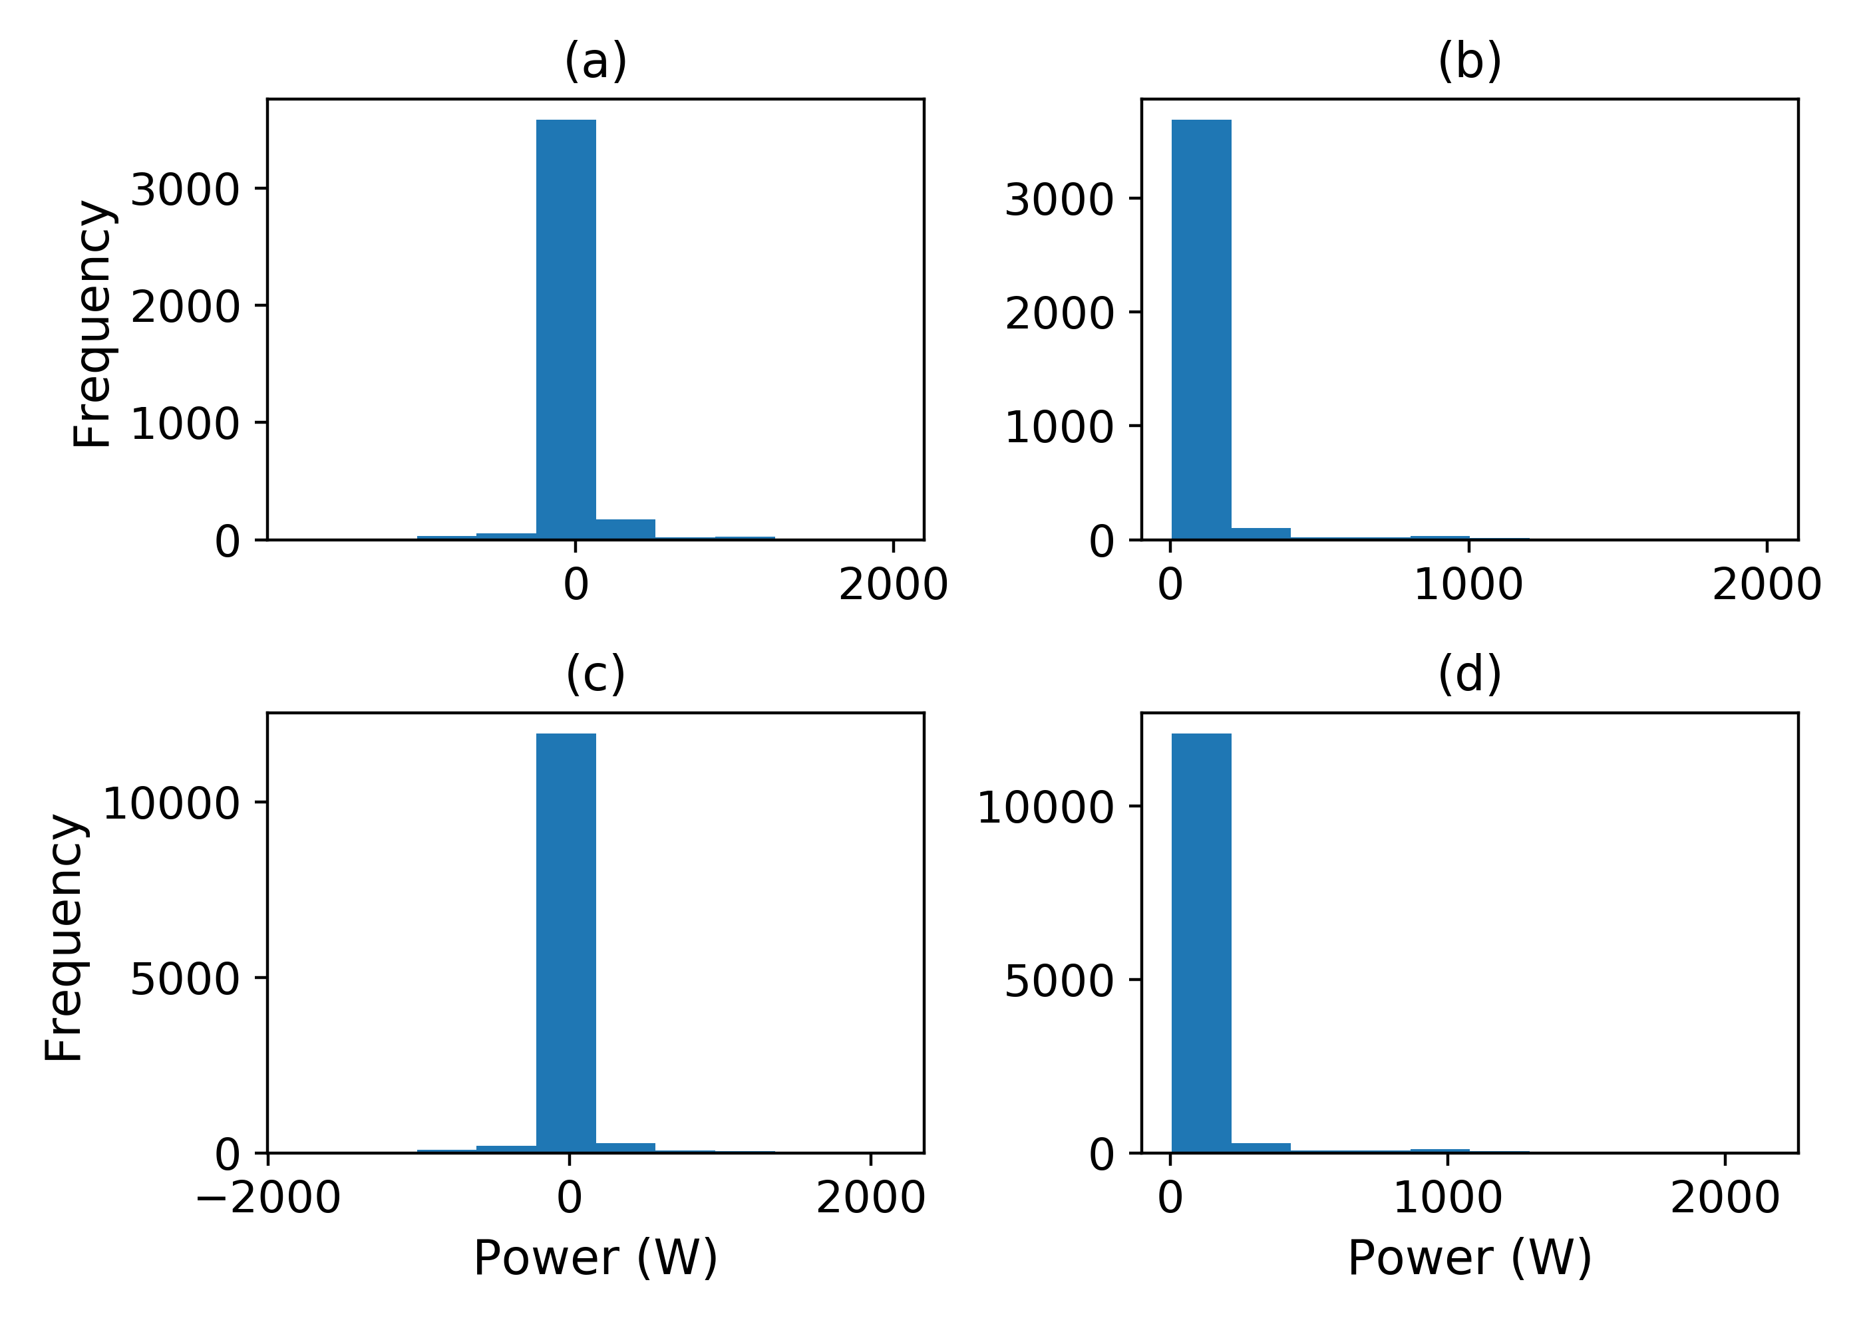
Fig.4. (a) Single day actual feature distribution (b) Single day transformed feature distribution (c) Three day actual feature distribution (d) Three day transformed feature distribution, from REDD House 2.
With the features having been extracted and transformed, the next step was to generalize them using the clustering algorithm. The results of this process for features from REDD House 2 can be seen in Fig. 5.
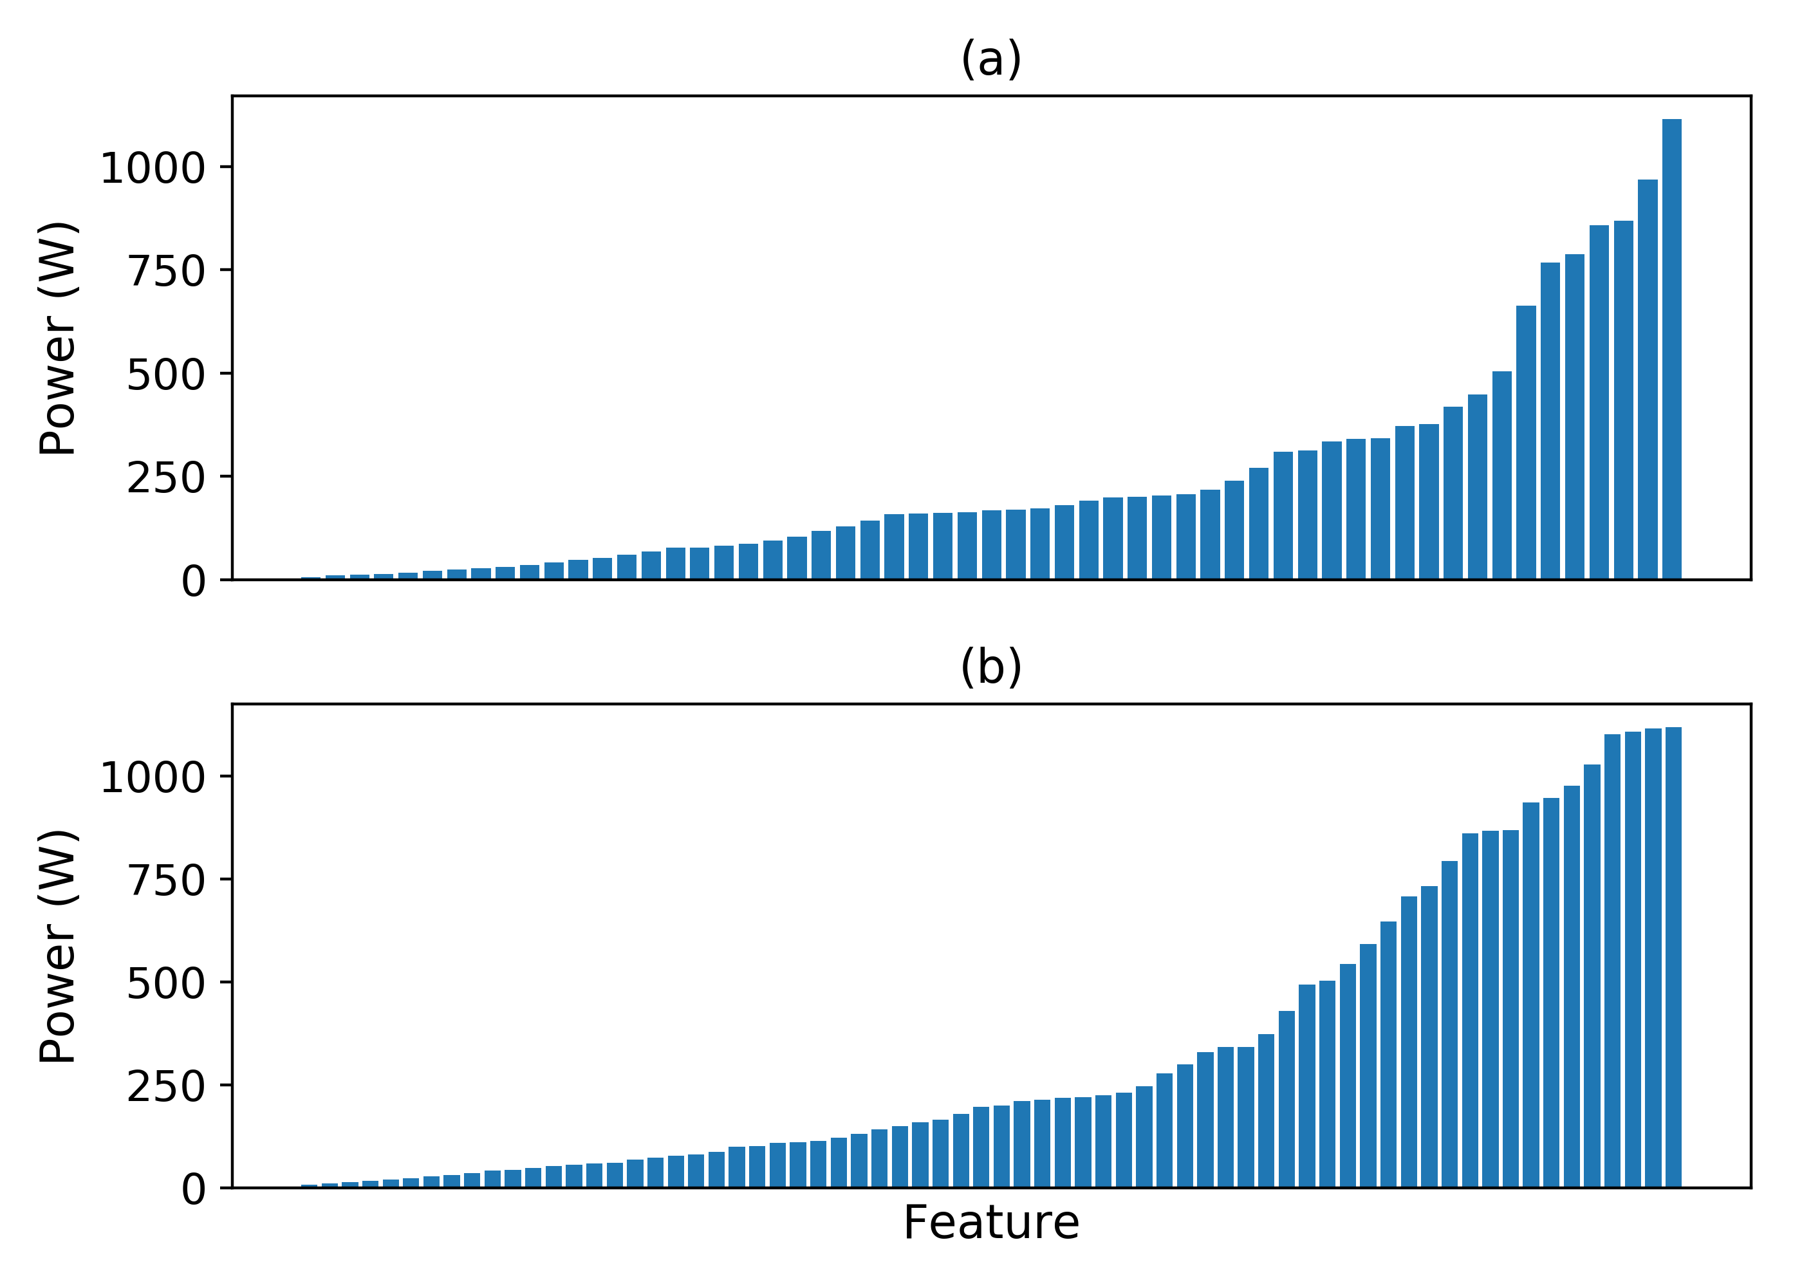
Fig.5. Generalized features from (a) single day energy usage (b) three day energy usage, from REDD House 2.
The results indicate that the proposed algorithm enables us to generalize the features and produce a set that can be considered for model learning. Given that this process has discovered the “optimal” set of features from the initial set, it can then be justified that the work presented utilizes an unsupervised learning approach to energy disaggregation.
The final step of this section is to evaluate the performance of the algorithm using the generalized features and the subset of NILM metrics mentioned in Section IV-A. The results of the evaluation process for single day and three day energy usage can be seen in Table I and Table II respectively.
The evaluation metrics provide an indication that the algorithm has good performance in terms of recognizing events that occurred in aggregated energy for each of the six REDD houses. The results for Accuracy, Precision, Recall, and F-measure were generally good for both single day and three day energy usage. However, a dip in performance can be seen in these metrics for House 3 for three day energy usage, which could possibly indicate a period of increased complexity in terms of appliance composition. The TECA metrics varied across houses with lowest performance in houses 1, 3, and 6. These houses are known to have a larger number of appliances in use which could be a contributing factor to these results. However the performance for this metric is also generally good across houses and periods of energy usage.
In summary, the algorithm performed generally well given energy with varying complexity. It can also be seen that the generalized features are able to detect quite a high number of the energy usage events occurring in the energy usage for the six REDD houses. This is further indicated in Fig. 6 which provides a comparison between the actual significant events (Fig. 6a and Fig. 6b) and the detected significant events (Fig. 6c and Fig. 6d).
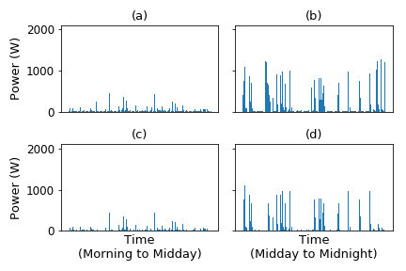
Fig.6. Comparison between Actual significant events shown in (a) and (b) and Detected significant events shown in (c) and (d), from single day energy usage in REDD House 2.
A comparison was made between this work and recent state of the art approaches which utilize similar metrics and energy data for evaluation. Given the wide variety of techniques used in NILM research work, direct comparisons between experimental results are not possible, as taken into consideration for this evaluation. The comparison between single day energy disaggregation and the state of the art work is presented in Table III. The comparison indicates that the proposed approach generally has better performance across metrics when compared to some of the similar recent state of the art NILM algorithms.
TABLE III
Comparison With State Of The Art
Approach | Acc. (%) | P (%) | R (%) | $f_{1}$ (%) | TECA (%)
FHMM [10] | - | 82.70 | 60.30 | 71.29 | -
HDP-HSMM [45] | - | - | - | - | 81.50
DTW [46] | - | 91.24 | 81.77 | 86.16 | -
House 1 | 94.71 | 93.71 | 95.58 | 94.63 | 81.40
House 2 | 98.36 | 98.58 | 97.80 | 98.18 | 91.73
House 3 | 97.90 | 97.74 | 97.92 | 97.83 | 91.95
House 4 | 98.98 | 99.02 | 98.86 | 98.94 | 93.65
House 5 | 99.20 | 99.36 | 98.73 | 99.04 | 98.84
House 6 | 97.93 | 97.69 | 98.14 | 97.91 | 83.25

Context 2: Modeling Learning and Inference
Single day energy data from REDD House 2 was used in order to evaluate the chosen approach to model learning and inference. The energy usage for the single day can be seen in Fig. 7.
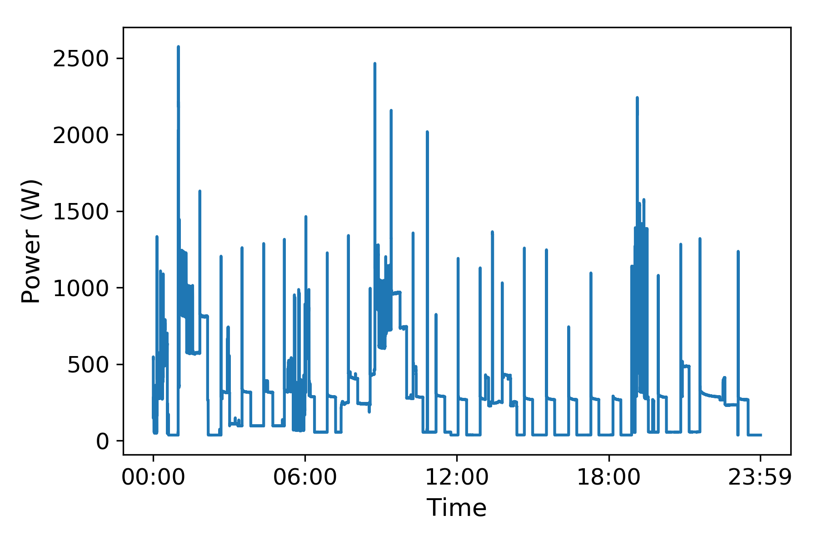
Fig.7. Single day energy usage from REDD House 2.
The first step was to verify the multi-state appliance modeling process. As mentioned in Section III-A, the algorithm aims to define multi-state appliance models. The detected events were examined by the algorithm, and subsequently detected events were combined into multi-state models. A further step was taken to merge models based on commonalities in feature usage. Fig. 8 displays all the discovered appliance models and the interactions of their internal states for the given period of energy usage, and a subset of these appliance models is provided in Fig. 9. Fig. 8 and Fig. 9 indicate that there are some common patterns in the energy usage based on the internal state interactions of the appliance models. The patterns are more pronounced in Fig. 9 which shows that these interactions could possibly represent the usage of certain types of appliances. Given the large number of generated appliance models as seen in Fig. 8, the goal for future work will be to reduce them to a manageable set that represents operations that are similar to real-world devices.
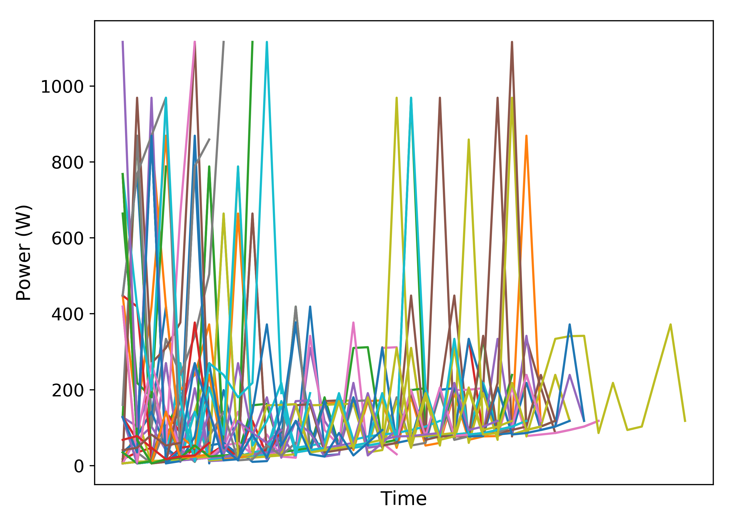
Fig.8. Internal state interactivity for all discovered appliance models during single day energy usage from REDD House 2.
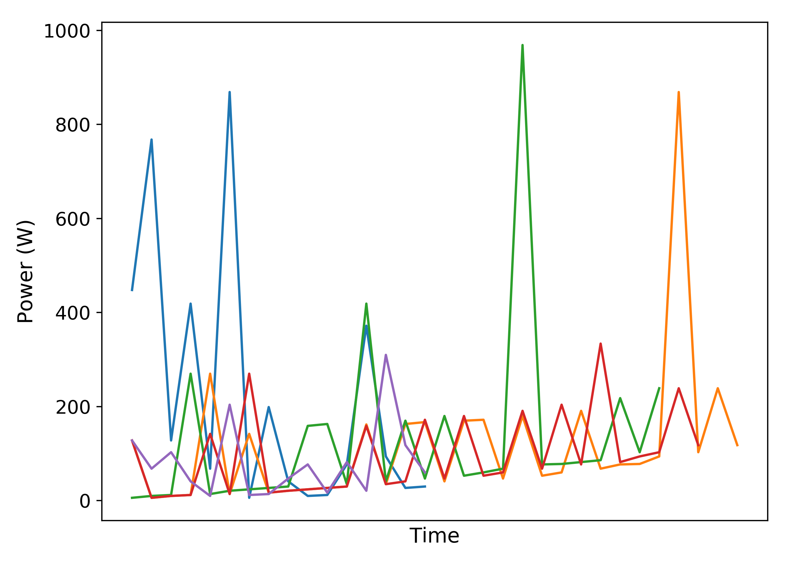
Fig.9. Internal state interactivity for subset of discovered appliance models during single day energy usage from REDD House 2.
The final step was to use the discovered appliance models to provide insights on future energy usage. To achieve this the appliance models learnt from a single day of usage were used to track energy usage in the following day (Fig. 10).
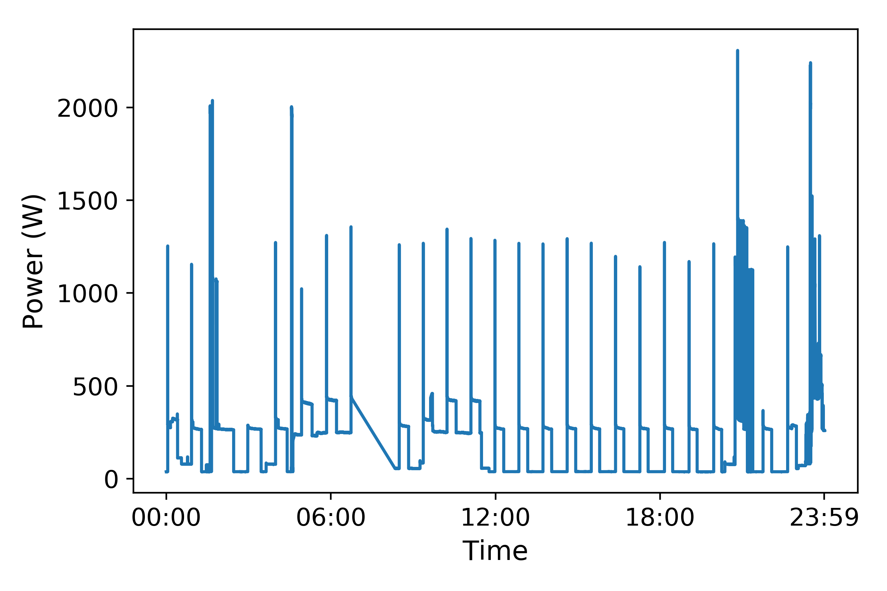
Fig.10. Energy usage in subsequent day of REDD House 2.
To limit complexity, the experiment was conducted using the two-state appliance models. To provide valuable feedback to the homeowner, the outcome of this step was to highlight events of high energy usage during the day. High energy usage was defined as any power usage over 350W, and the results are displayed in Fig. 11, which shows that sporadic occurrences of high energy usage throughout the day with a majority of the occurrences happening late in the night.
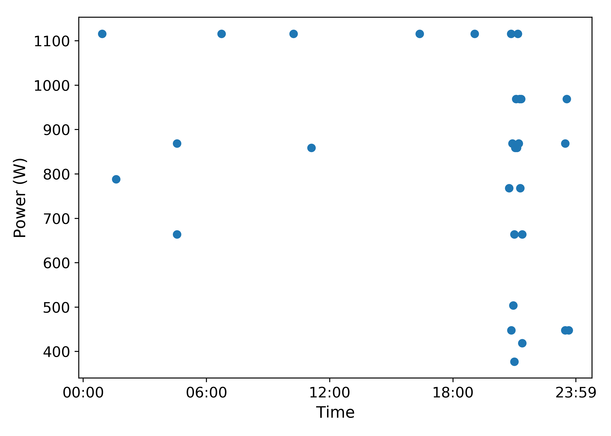
Fig.11. Events of high energy usage detected in subsequent day of REDD House 2.
Additionally NILM metrics were used to evaluate the energy disaggregation for the new period, and these are shown in Table IV. The metrics indicate that the appliance models discovered in the previous day can be applied to subsequent periods of energy usage. Nonetheless, the results of the energy disaggregation, in particular the TECA metric indicates that new features need to be incorporated to ensure that previously unseen patterns of energy usage can be better detected.
TABLE IV
NILM Metrics for Subsequent Day Energy Usage
REDD House | Acc. (%) | P (%) | R (%) | $f_{1}$ (%) | TECA (%)
2 | 96.20 | 96.79 | 94.71 | 95.74 | 87.95

Context 3: Energy Disaggregation on Low-Power Energy Devices
The final experiment was to verify the performance of the algorithm when run on a low-power energy device. We made use of the same energy data from REDD House 2 as in Section IV-B2. The algorithm performed the disaggregation within 416s and produced the metrics shown in Table V.
TABLE V
NILM Metrics for Single Day Energy Usage Disaggregation on Low-Power Energy Devices
REDD House | Acc. (%) | P (%) | R (%) | $f_{1}$ (%) | TECA (%)
2 | 99.70 | 99. 80 | 99.60 | 99.70 | 97.92

Discussion
The results of the experimental evaluation indicate that the algorithm performs well given both single day and three day energy usage. This along with the ability to learn useful appliance models in unseen energy data indicates that it is feasible for the unsupervised NILM problem. It has been noted that further work is required in order to produce a set of well-defined appliance models that can mimic real appliance usage, and this will form part of the future work.
The results of further experimentation indicate that the algorithm can perform well when implemented on a low-power energy device thus showing that it can be implemented for actual use.

Conclusion
This paper presents a new approach to the unsupervised NILM problem with practical implications. Experimental evaluation using energy data from six houses of the Reference Energy Disaggregation Dataset (REDD) demonstrates that the proposed algorithm performs well with regards to energy disaggregation. Further experimentation also indicates that the algorithm can learn useful appliance models that can be used to provide insights on energy usage to homeowners. It has been noted that the chosen approach to appliance modeling requires some additional steps to provide a set of well-defined appliance models, and this will form part of the future research work.

References
- J. Han, C. Choi, W. Park, I. Lee, and S. Kim, “Smart home energy management system including renewable energy based on ZigBee and PLC,” IEEE Trans. Consum. Electron., vol. 60, no. 2, pp. 198–202, Jul. 2013, DOI: 10.1109/TCE.2014.6851994
- Q. Liu, G. Cooper, N. Linge, H. Takruri, and R. Sowden. “DEHEMS: creating a digital environment for large-scale energy management at homes,” IEEE Trans. Consum. Electron., vol. 59, no. 1, pp. 62-69, Apr. 2013, DOI: 10.1109/TCE.2013.6490242
- A. R. Al-Ali, I. A. Zualkernan, M. Rashid, R. Gupta, and M. Alikarar, “A smart home energy management system using IoT and big data analytics approach,” IEEE Trans. Consum. Electron., vol. 63, no. 4, pp. 426–434, Nov. 2017, DOI: 10.1109/TCE.2017.015014
- G. W. Hart, “Nonintrusive appliance load monitoring,” in Proc. of the IEEE, vol. 80, no. 12, pp. 1870-1891, Dec. 1992, DOI: 10.1109/5.192069
- K. S. Barsim, R. Streubel, and B. Yang, “An approach for unsupervised non-intrusive load monitoring of residential appliances,” in Proc. of the 2nd Int.l Workshop on Non-Intrusive Load Monitoring, Austin, TX, USA, 2014.
- Y. F. Wong, Y. A. Şekercioğlu, T. Drummond, and V. S. Wong, “Recent approaches to non-intrusive load monitoring techniques in residential settings,” in Proc. of IEEE Symp. on Computational Intell. Appl. in Smart Grid (CIASG), Singapore, 2013, pp. 73-79. DOI: 10.1109/CIASG.2013.6611501
- A. Zoha, A. Gluhak, M. AlicImran, and S. Rajasegarar, “Non-intrusive load monitoring approaches for disaggregated energy sensing: a survey,” Sensors, vol. 12, no. 12, pp. 16838-16866, Dec. 2012, DOI: https://doi.org/10.3390/s121216838
- H. Kim, M. Marwah, M. F. Arlitt, G. Lyon, and J. Han. “Unsupervised disaggregation of low frequency power measurements,” in Proc. of the 11th SIAM Int. Conf. on Data Mining, Mesa, AZ, USA, 2011, pp. 747-758.
- O. Parson, “Unsupervised training methods for non-intrusive appliance load monitoring from smart meter data,” Ph.D. dissertation, Dept. of Physical Sci. and Eng., Univ. of Southampton, Southampton, UK 2014.
- J. Z. Kolter, and T. Jaakkola, “Approximate inference in additive factorial hmms with application to energy disaggregation,” in Proc. of the Int. Conf. on Artificial Intell. and Statist., vol. 22, La Palma, Canary Islands, 2012, pp. 1472-1482.
- O. Parson, S. Ghosh, M Weal, and A Rogers, “Non-intrusive load monitoring using prior models of general appliance types,” in Proc. of the twenty-Sixth AAAI Conf. on Artificial Intell. (AAAI-12), Toronto, Ontario, Canada, 2012.
- R. Jia, Y. Gao, and C. J. Spanos, “A fully unsupervised nonintrusive load monitoring framework,” in Proc. of the IEEE Int. Conf. on Smart Grid Comm. (SmartGridComm), Miami, FL, USA, 2015, pp. 872-878.
- J, V. Gael, and Z. Ghahramani, “Bayesian nonparametric hidden markov models,” Ph.D. dissertation, Univ. of Cambridge, Cambridge, UK, 2011.
- S. Makonin, F. Popowich, I. V. Bajic, B. Gill, and L. Bartram, “Exploiting hmm sparsity to perform online real-time nonintrusive load monitoring,” IEEE Trans. Smart Grid, vol. 7, no. 6, pp. 2575-2585, Nov. 2016, DOI: 10.1109/TSG.2015.2494592
- B. Zhao, L. Stankovic, and V. Stankovic, “On a training-less solution for non-intrusive appliance load monitoring using graph signal processing,” IEEE Access, vol. 4, pp. 1784-1799, Apr. 2016, DOI: 10.1109/ACCESS.2016.2557460
- A. Sandryhaila and J. M. F. Moura, “Big data analysis with signal processing on graphs: representation and processing of massive data sets with irregular structure,” IEEE Signal Process. Mag., vol. 31, no. 5, pp. 80-90, Sept. 2014, DOI: 10.1109/MSP.2014.2329213
- B. Zhao, L. Stankovic and V. Stankovic, “Blind non-intrusive appliance load monitoring using graph-based signal processing,” in Proc. of IEEE Global Conf. on Signal and Inform. Process. (GlobalSIP), Orlando, FL, USA, 2015, pp. 68-72
- V. Stankovic, J. Liao, and L. Stankovic, “A graph-based signal processing approach for low-rate energy disaggregation,” IEEE Symp. on Computational Intell. for Eng. Solutions (CIES), Orlando, FL, USA, 2014, pp. 81-87, DOI: 10.1109/CIES.2014.7011835
- A. Sandryhaila, and J. M. F. Moura, “Classification via regularization on graphs,” in Proc. of IEEE Global Conf. on Signal and Inform. Process., Austin, TX, USA, 2013, pp. 495-498, DOI: 10.1109/GlobalSIP.2013.6736923
- J. Kelly, and W. Knottenbelt, “Neural nilm: deep neural networks applied to energy disaggregation,” in Proc. of the 2nd ACM Int.l Conf. on Embedded Syst. for Energy-Efficient Built Environments – BuildSys '15, Seoul, Republic of Korea, 2015, pp. 55-64.
- P. Paulo, “Applications of deep learning techniques on nilm,” Ph.D. dissertation, Dept. Elect. Eng., Universidade Federal do Rio de Janeiro, Rio de Janeiro, Brazil, 2016.
- C. Zhang, M. Zhong, Z. Wang, N. Goddard, and C. Sutton, “Sequence-to-point learning with neural networks for nonintrusive load monitoring,” in Proc. of the Thirty-Second AAAI Conf. on Artificial Intell. (AAAI-18), New Orleans, LA, USA, 2018. https://arxiv.org/pdf/1612.09106.pdf
- L. Mauch, and B. Yang, “A novel dnn-hmm-based approach for extracting single loads from aggregate power signals,” in Proc. pf IEEE Int. Conf. on Acoust., Speech and Signal Process. (ICASSP), Shanghai, China, 2016, pp. 2384-2388, DOI: 10.1109/ICASSP.2016.7472104
- A. Huss, “Hybrid model approach to appliance load disaggregation,” Ph.D. dissertation, Dept. Comp. Sci. and Comm., KTH Royal Institute of Technology, Stockholm, Sweden, 2015.
- Y Y. Lin, M. Tsai and C. Chen, “Applications of fuzzy classification with fuzzy c-means clustering and optimization strategies for load identification in NILM systems,” in Proc. of IEEE Int. Conf. on Fuzzy Systems (FUZZ-IEEE 2011), Taipei, Taiwan, 2011, pp. 859-866, DOI: 10.1109/FUZZY.2011.6007393
- Ducange, F. Marcelloni, and M. Antonelli, “A Novel Approach Based on Finite-State Machines with Fuzzy Transitions for Nonintrusive Home Appliance Monitoring,” IEEE Trans. Ind. Informat., vol. 10, no. 2, pp. 1185-1197, May 2014, DOI: 10.1109/TII.2014.2304781
- M. Nguyen, S. Alshareef, A. Gilani, and W. G. Morsi, “A novel feature extraction and classification algorithm based on power components using single-point monitoring for NILM,” in Proc. of IEEE 28th Canadian Conf. on Elect. and Comp. Eng. (CCECE), Halifax, NS, Canada, 2015, pp. 37-40, DOI: 10.1109/CCECE.2015.7129156
- J. Gillis, and W. G. Morsi, “Non-intrusive load monitoring using orthogonal wavelet analysis,” in Proc. of IEEE Canadian Conf. on Elect. and Comp. Eng. (CCECE), Vancouver, BC, Canada, 2016, pp. 1-5, DOI: 10.1109/CCECE.2016.7726786
- C. Duarte, P. Delmar, K. W. Goossen, K. Barner, and E. Gomez-Luna, “Non-intrusive load monitoring based on switching voltage transients and wavelet transforms,” in Proc. of 2012 Future of Instrumentation Int. Workshop (FIIW), Gatlinburg, TN, USA, 2012, pp. 1-4, DOI: 10.1109/FIIW.2012.6378333
- Zoha, A. Gluhak, M. Nati, M. A. Imran, and S. Rajasegarar, “Acoustic and device feature fusion for load recognition,” in Proc. of 2012 6th IEEE Int. Conf. Intelligent Syst., Sofia, Bulgaria, 2012, pp. 386-392, DOI: 10.1109/IS.2012.6335166
- J. Z. Kolter, S. Batra, and A. Y. Ng, “Energy disaggregation via discriminative sparse coding,” in Proc. of 23rd Conf. on Neural Inform. Process. Syst., Vancouver, BC, Canada, 2010, pp. 1153-1161.
- A. Rahimpour, H. Qi, D. Fugate, and T. Kuruganti, “Non-intrusive energy disaggregation using non-negative matrix factorization with sum-to-k constraint,” IEEE Trans. Power Syst., vol. 32, no. 6, pp. 4430-4441, Nov. 2017, DOI: 10.1109/TPWRS.2017.2660246
- D. Egarter, W. Elmenreich, “Load disaggregation with metaheuristic optimization,” in Proc. of 4th D-A-CH Energieinformatik Conf., Karlsruhe, Germany, 2015, pp. 1-12.
- M. Z. A. Bhotto, S. Makonin, and I. V. Bajić, “Load disaggregation based on aided linear integer programming,” IEEE Trans. Circuits Syst. II, Express Briefs, vol. 64, no. 7, pp. 792-796, July 2017, DOI: 10.1109/TCSII.2016.2603479
- F. M. Wittmann, J. C. López, and M. J. Rider, “Nonintrusive load monitoring algorithm using mixed-integer linear programming,” IEEE Trans. Consum. Electron., vol. 64, no. 2, pp. 180-187, May 2018, DOI: 10.1109/TCE.2018.2843292
- S. Kong, Y. Kim, R. Ko, and S. Joo, “Home appliance load disaggregation using cepstrum-smoothing-based method,” IEEE Trans. Consum. Electron., vol. 61, no. 1, pp. 24-30, February 2015, DOI: 10.1109/TCE.2015.7064107
- M. Zeifman and K. Roth, “Nonintrusive appliance load monitoring: review and outlook,” IEEE Trans. Consum. Electron., vol. 57, no. 1, pp. 76-84, February 2011, DOI: 10.1109/TCE.2011.5735484
- I. Abubakar, S. N. Khalid, M. W. Mustafa, H. Shareef and M. Mustapha, “An overview of non-intrusive load monitoring methodologies,” in Proc. of 2015 IEEE Conf. on Energy Conversion (CENCON), Johor Bahru, Malaysia, 2015, pp. 54-59, DOI: 10.1109/CENCON.2015.7409513
- J. R. Herrero et al., “Non-intrusive load monitoring (NILM): A state of the art,” in Proc. of 15th Int. Conf. on Practical Appl. of Agents and Multi-Agent Syst., Porto, Portugal, 2017, pp. 125-138, DOI: 10.1007/978-3-319-61578-3_12
- K. M. Kamoto, Q. Liu, and X. Liu, “Unsupervised energy disaggregation of home appliances,” in Proc. of 3rd Int. Con. on Cloud Computing and Security, Nanjing, Jiangsu, China, 2017, pp. 398-409. DOI: 10.1007/978-3-319-68505-2_34
- K. M. Kamoto, and Q. Liu, “Monitoring home energy usage using an unsupervised nilm algorithm based on entropy index constraints competitive agglomeration (EICCA),” in Proc. of 4th Int. Conf. on Cloud Computing and Security, Haikou, Hainan, China, 2018, pp. 478-490. DOI: 10.1007/978-3-030-00018-9_42
- H. Frigui, and R. Krishnapuram, “Clustering by competitive agglomeration,” Pattern Recognition, vol. 30, no. 7, pp. 1109-1119, 1997, DOI: 10.1016/S0031-3203(96)00140-9
- C. Huang, F. Chung, and S. Wang, “Generalized competitive agglomeration clustering algorithm,” in Proc. of Int. J. of Mach. Learning and Cybern., vol. 8, no. 6, pp. 1945–1969, 2017, DOI: 10.1007/s13042-016-0572-5
- J. Z. Kolter, and M. J. Johnson, “REDD: a public data set for energy disaggregation research,” in Proc. of Workshop on Data Mining Applications in Sustainability (SIGKDD), San Diego, CA, USA, 2011
- M. J. Johnson, and A. S. Willsky, “Bayesian Nonparametric Hidden Semi-Markov Models,” J. of Mach. Learning Res., vol. 14, no. 1, pp. 673–701, Feb. 2013.
- L. Jing, G. Elafoudi, L. Stankovic, and V. Stankovic, “Power disaggregation for low-sampling rate data,” in Proc. of the 2nd Int. Workshop on Non-Intrusive Load Monitoring, Austin, TX, USA, 2014

Qi Liu (M’11, SM’18) received the B.S. degree in Computer Science and Technology from Zhuzhou Institute of Technology, China in 2003, and M.S. and Ph.D. in Data Telecommunications and Networks from the University of Salford, UK in 2006 and 2010. His research interests include context awareness, data communication in MANET and WSN, and smart grid. His recent research work focuses on intelligent agriculture and meteorological observation systems based on WSN.

Kondwani Michael Kamoto received the B.S. in Information Technology (Software Development) from Nelson Mandela Metropolitan University, Port Elizabeth, South Africa in 2011, and M.S. degree in Computer Science and Technology from Nanjing University of Information Science & Technology, Nanjing, China, in 2017. His research interests include home energy management, IoT in electric power and power systems, smart meter data analytics, and context-awareness.

Xiaodong Liu (M’00, SM’17) received his PhD in Computer Science from De Montfort University and joined Napier in 1999. He is a Reader and is currently leading the Software Systems research group in the IIDI, Edinburgh Napier University. He was the director of Centre for Information & Software Systems. He is an active researcher in software engineering with internationally excellent reputation and leading expertise in contex-aware adaptive services, service evolution, mobile clouds, pervasive computing, software reuse, and green software engineering.

Mingxu Sun was born in Jinan, China in 1984. He received the B.S. degree in control engineering from the University of Jinan, in 2007 and the M.S. degree in manufacturing engineering and the PhD degree in medical engineering from the University of Salford, Manchester, UK, in 2014. Since 2014, he has been a Research Assistant with the Rehabilitation Technologies & Biomedical Engineering Group at University of Salford, UK. His research interests includes: 1) development of functional electrical stimulation systems for use in stroke rehabilitation, together with novel approaches of using inertial sensors for their control; 2) use of inertial sensors to understand the real world use of walking aids.

Nigel Linge received his BSc degree in Electronics from the University of Salford, UK in 1983, and his PhD in Computer Networks from the University of Salford, UK, in 1987. He was promoted to Professor of Telecommunications at the University of Salford, UK in 1997. His research interests include location based and context aware information systems, protocols, mobile systems and applications of networking technology in areas such as energy and building monitoring.

This work has received funding from the European Union Horizon 2020 research and innovation programme under the Marie Sklodowska-Curie grant agreement no.701697, Major Program of the National Social Science Fund of China (Grant No.17ZDA092), Basic Research Programs (Natural Science Foundation) of Jiangsu Province (BK20180794), 333 High-Level Talent Cultivation Project of Jiangsu Province (BRA2018332) and the PAPD fund. Q. Liu is with the Jiangsu Collaborative Innovation Center of Atmospheric Environment and Equipment Technology (CICAEET), Nanjing University of Information Science & Technology, No. 219, Ningliu Road, Nanjing, 210044, China and the School of Computing, Edinburgh Napier University, 10 Colinton Road, Edinburgh, EH10 5DT, UK (e-mail: qi.liu@nuist.edu.cn). K. M. Kamoto is with the School of Computer and Software, Nanjing University of Information Science & Technology, No. 219, Ningliu Road, Nanjing, 210044, China (e-mail: k_kamoto@yahoo.co.uk). X. Liu is with the School of Computing, Edinburgh Napier University, 10 Colinton Road, Edinburgh, EH10 5DT, UK (e-mail: x.liu@napier.ac.uk). M. Sun is with the School of Electrical Engineering, University of Jinan, China and the Centre for Health Sciences Research, University of Salford, The Crescent, Salford, M5 4WT, UK (e-mail: cse_sunmx@ujn.edu.cn). N. Linge is with the School of Computing Sciences and Engineering, University of Salford, The Crescent, Salford, M5 4WT, UK (e-mail: n.linge@salford.ac.uk).

