Online assessment of learning and engagement in university laboratory practicals

David E. Whitworth and Kate Wright

Dr Dave Whitworth has been teaching laboratory-based classes for more than 10 years, and has a particular interest in students’ development of generic and subject-specific research and laboratory skills. He holds a BA from the University of Oxford, a PhD from the University of Warwick, and is a Fellow of the Higher Education Academy. Kate Wright has been working in the field of e-learning since 2003 and in that time has been involved in developing the use of a number of e-learning tools and systems, including Blackboard, Qwizdom and online assessment. She has an interest in e-assessment and led the rollout of Questionmark Perception at Aberystwyth. Address for correspondance: Dr David Whitworth, Institute of Environmental and Rural Sciences, Cledwyn Building, Penglais Campus, Aberystwyth University, SY23 3DD, UK. Email: dew@aber.ac.uk

Abstract.
In science education, laboratory practicals are frequently assessed through submission of a report. A large increase in student numbers necessitated us adapting a traditional practical report into an online test with automated marking. The assessment was designed to retain positive features of the traditional laboratory report, but with added pedagogic and administrative benefits made possible through the online medium.
After performing their experiments students were given idealised data, enabling immediate comparison with their own results, and asked to perform a series of calculations based on that ideal data. The two-part test asked questions about the students’ calculations. Part one was formative, ensuring that the students had mastered basic concepts, before advanced concepts were tested in part two. The test rewarded correct methodology and understanding as well as the right answers, and gave absolute consistency to the marking scheme. Students could submit at their convenience and received instant feedback. The assessment was met with emphatically positive feedback from students.
In addition, it was possible to track submissions by students, providing insights into their behaviour. Students appeared to group into three submission styles – early submitters, considered submitters and last minute submitters – information which can be useful to guide pedagogic practice. In the latest iteration, analysis of submission behaviour gave us confidence to reduce the time before the submission deadline, which resulted in a substantial increase in student attainment.

Practitioner notes:
What is already known about this topic
- Laboratory practicals are traditionally assessed through a written report.
- Large class sizes create administrative burdens due to the time required for feedback provision and marking.
- Online submission provides a mechanism to automate marking and feedback provision.
- Online assessments must be carefully designed to test higher-level learning outcomes.
What this paper adds
- A strategy is presented to turn a traditional laboratory report into an online test.
- Adaptive release ensures basic competence before the bulk of the assessment can be attempted.
- It is possible to build online tests to give a reasonable and honest assessment.
- Online submission allows data capture regarding student submission behaviour.
Implications for practice and/or policy
- Online assessments are an opportunity for more efficient teaching.
- They can be easily engineered to replace traditional assessments, with additional pedagogic benefits.
- E-assessment enables hybrid assessments, melding formative and summative elements.
- Online submission data can be used to inform pedagogy regarding student engagement with coursework.

Introduction.

Assessment is a key part of life in universities for both staff and students. A variety of forms of assessment are regularly used by staff to ensure that students have met the learning outcomes of their courses, as well as to provide the students with information about their progress in the subject studied. The role and nature of assessment is a highly debated area within the sector, with much emphasis being placed on the importance of assessment for learning as opposed to the more traditional assessment of learning (Knight, 1995). One key element of this is feedback – what do students learn from their work, beyond the knowledge of whether it met a certain standard? The importance of feedback is not generally disputed, but much has been written on the nature, timing, delivery and use of feedback (Butler and Roediger, 2008, Boud and Falchikov, 2006, Gikandi et al., 2011).
The traditional classification of assessment tends to divide students’ work into two categories – formative and summative. In this classification, formative assessment tends to ‘count for less’ and would result in a larger amount of feedback. Summative assessment would be considered as the ‘final exam’ where students receive little in the way of feedback beyond a mark. However, in a landscape where all “assessment is ‘an engine for learning’” (Knight, 1995), this distinction becomes blurred. If all assessment is intended to help students progress in their knowledge of a field of study then even the final (‘summative’) assessment must therefore provide avenues for developing further. Given the nature of modular degrees and the timing of summative assessment, how can assessment for learning be integrated into summative assessment? What role should feedback play in high-stakes assessment? Hernández discusses the ‘conflict’ between the aims of these differing classes of assessment, with reference to Carless’ work on learning-orientated assessment (LOA) (Hernández 2012; Carless, 2007). The concept of learning-orientated assessment is a useful one with regard to the assessment discussed below, as it has some similarities in both aim and approach, even though LOAs are designed in collaboration with learners, which this assessment wasn’t.
Another area for consideration in the development of assessment is the nature of the task itself. Whilst developments in pedagogic practice have broadened the range of activities taking place in classrooms and lecture halls, closed-book, timed, essay-based assessment methods remain prevalent in the sector. If educators are to take a “holistic view of assessment” as proposed by Boud (1995), then understanding the way in which assessments work in the broader context of both the curriculum and the students’ development of understanding is vital. The fundamental place of assessment in the curriculum means that the design of an assessment needs to consider diverse aspects of pedagogy, from theory to practice (Downing and Haladyna, 2006). The potential complexities of assessments have led to the emergence of assessment design frameworks, such as evidence-centred design (Mislevy, Almond and Lukas 2003), which explicitly defines a multi-layered conceptual assessment framework. This allows the precise alignment of assessment elements with desired learning outcomes, and provides an ontology for comparing and improving assessments.
With the introduction of online assessment, and computer-aided assessment (CAA) more generally, it has been argued that this mode of assessment has the potential to address many of the issues discussed above. The opportunities for automated marking and instant feedback are key factors in its increasing use, and the wide range of media which can be used online allows for more authentic and holistic assessment. Online assessment in UK higher education is not new (Llamas-Nistal et al., 2013). Given the increasing number of students enrolled on degree courses in the UK and the administrative benefits of automated marking and feedback, it is being employed in a wide range of subjects and formats. However, a common criticism of online assessment is the use of what Gipps terms “ ‘simple’ CAA” (Gipps, 2005; Conole and Warburton, 2005). In this type of assessment there is typically a heavy use of multiple choice questions which test basic facts rather than higher order thinking, pushing staff and students towards a ‘pop quiz’ mentality which rewards surface learning (Bull and Danson, 2004, Voelkel, 2013).
Assessments based on laboratory practicals in the sciences typically require students to perform and report post-class analysis of data generated during the practical. There then follows the time-consuming task of marking the students’ output, which in turn delays the receipt of marks and feedback by students. We developed and implemented an online test as an improved version of a traditional practical report. This precluded the use of an assessment design framework, so we instead adopted an ‘experience-based development’ approach. For a small investment in time to set up the assessment, there were distinct advantages for staff and students. Students were able to submit the assessment at their convenience from anywhere with an internet connection, and received their mark and tailored feedback immediately upon submission. Electronic assessment required no staff time, was absolutely objective, and provided data on the behaviour of students as they engaged with the assessment, which could then be used to guide pedagogic practice.

Background: the traditional practical assessment.
The practical described here investigates an enzyme-catalysed reaction and how it reaches equilibrium, by measuring the concentration of a reactant with time using a colorimetric assay. The students’ data takes the form of numerical values (absorbance measurements). After the practical, students perform a series of calculations to transform their raw data into meaningful quantities. Absorbance values are used to calculate reactant concentrations, which allows inference of the concentration at equilibrium, the equilibrium constant, and thereafter the Gibbs free energy change of the reaction.
Prior to the practical students are provided with relevant theory in a series of lectures, with one lecture devoted to the up-coming practical and subsequent data-analysis (Figure 1). During the practical students are given a booklet which contains instructions on how to perform the experiment, blank tables for data collection, and a guide to performing the necessary calculations (Figure 2). Students work through a series of calculations and then submit the completed protocol booklet. Marking rewarded correct working rather than the quality of the students’ raw data and usually took 10-15 minutes including annotation of the booklet with individualised feedback.

[Figure 1]
[Figure 2]

The BlackboardTM virtual learning environment (VLE) was used as a repository for materials associated with this practical (lecture slides, protocol booklet, and example data for students who were unable to attend the session or who failed to obtain suitable experimental data).
Due to a restructuring of teaching and increased recruitment, the numbers registered for this first year BSc metabolism practical jumped from around 30 students, to over 300. Faced with marking >300 scripts (representing two whole weeks), we devised an alternative online version of the assessment as a BlackboardTM test. We wished to retain the original nature of the practical and assessment as much as possible, while enabling online submission and automated marking, and taking as much pedagogic advantage of the change of milieu as possible.

Methods

The online assessment.
In setting up the test there were several major issues to be addressed during the initial development (Figure 3). Firstly, students’ experimental data tend to be of variable quality, and the ability to obtain good quality data is not one of the learning outcomes. Secondly, calculations represent a pipeline, where an incorrect answer earlier in an assessment can preclude correct answers later in the assessment. Thirdly, for maximum benefit, feedback needs to be provided immediately, alongside the mark, but without compromising the security of the assessment – for instance stopping groups of students from using trial and error over a series of submissions to co-operatively deduce the correct answers. In order to address these and other pedagogic concerns, the test was implemented as follows.
The practical required manipulation of several liquids and pieces of equipment, so for safety reasons we chose to continue to provide students with a hardcopy protocol booklet in case of spillages. Students thus entered their data into the booklet manually rather than using a web-form or interactive data table. In the protocol booklet, in addition to the blank table for entry of the students’ own experimental data, was an identical table already containing ‘ideal’ data. Students were instructed to perform calculations on the ideal data rather than their own, reducing variability in the expected answers. They were directed to perform the same calculations as previously, however the protocol booklet finished by directing them to the Blackboard test. A screenshot of two questions in the test is shown in Figure 4. The questions asked for the input of specific values from within the series of calculations, but also asked some interpretative questions, usually as multiple choices. For instance, after the students had calculated a value for ΔG^{o’}, they were then asked whether this meant that the reaction was favourable or not, and how favourable/unfavourable – testing one of the main learning outcomes from the practical, ie the ability to relate thermodynamic parameters (ΔG^{o’}) to favourability of biochemical reactions. An additional benefit of this approach was that the students were able to immediately compare their own data with the ideal data and gain an instant appreciation of how good their own data were. Completion of the protocol booklet was not assessed per se, except indirectly through the Blackboard test.

[Figure 3]
[Figure 4]

Despite using ideal data some variability in student answers was expected to remain. However, it was assumed to be relatively minor (due to students choosing to round answers to different numbers of significant figures), so we specified within the test that the correct answer ± 5 % was sufficient for full marks. Care had to be taken however that such residual variability didn’t have cumulative effects, for instance multiplying two answers each with 4 % deviation from their correct values has the potential to increase the residual deviation to 8 %.
The test had to reward correct method and understanding and avoid penalising students repeatedly for making a mistake early in the series of calculations. Therefore, common errors were factored into the assessment, so for instance, if the students were asked to calculate A/B, they got half a mark for instead calculating B/A. But arguably the most important aspect of the test was an ‘adaptive release’ feature. The test was sub-divided into two parts (Figure 5). The first part of the test (2 marks) concerned turning absorbance values into concentrations, while the second part (8 marks) required students to use the calculated concentration values to determine other quantities, for instance equilibrium constants. If a student couldn’t get full marks for Part I, they would be unable to access most of the marks for Part II. Therefore Part II only became available to attempt if they had got both marks for Part I. Students were allowed to re-attempt Part I as many times as they liked until they answered both questions correctly, however only one attempt was allowed for Part II. In addition, to encourage thorough preparation of answers for Part II, completion of Part I was given a deadline two days before that for Part II (Figure 5).
Feedback was provided to the student after every attempt of Parts I and II, however care was taken to guide students toward the correct answer, but without actually providing the answer. So for instance, in Part I a common mistake was to provide answers in molar (M) rather than in millimolar (mM) units as requested by the question. Therefore one line of the feedback for a failed question in Part I was ‘Remember to give your answer in millimolar not molar units’. The feedback provided was based on several years’ experience of running the previous paper-based assessment, and the mistakes commonly made therein.
One consequence of this approach was that 20 % of the test (Part I) essentially became a formative assessment, and a great deal of consideration was given to whether this was appropriate. Many arguments could have been for or against this approach, however as those two marks were worth just 0.3 % of the overall year mark, and as commonly used 5-answer multiple choice questions give 20 % of the marks if answered randomly, we decided to make the formative element of the test mark-bearing.

[Figure 5]

Results.

Implementation and outcomes.
The test has now been used for three teaching cycles and has thus saved six weeks of marking, despite taking less than one day to set up. While several emails were received seeking guidance on performing the calculations, very few regarded the nature of the test. The only significant issue, which became apparent during the first year (easily countered during subsequent years), was that non-UK students often entered numbers using commas rather than stops to represent a decimal point, and the test took, for example, 4,2 to be 42, rather than the 4.2 intended.
Feedback from students was very positive. In the end-of-module feedback, 90 % of students agreed that ‘using online submission is a good idea’ and that they ‘found the online submission process easy to use’. Many offered positive comments, including ‘The online assessment was a very good idea. Online submission was easy and should be used more often’, and ‘The online submission was fantastic. The quick results given were also great: If you could get other modules to adopt this practice that would be great.’
The original paper-based assessment gave annual average marks of 70.5 % ± 4.1% (mean ± standard deviation, n=3 years, for a total of 146 students), while the e-assessment has given annual average marks of 69.8 % ± 0.1 % (n=2, for 581 students) in its first two years (2012 and 2013). Thus the e-assessment is very reliable - arguably more reliable than the traditional version of the assessment, albeit with very similar mean results across years.

Student submission behaviour.
In addition to the pedagogic advantages and increased efficiency, it was possible to extract information regarding the working habits of students using the test. While the test was available (28 days including the day of the practical session), information was collected regularly about which students had submitted attempts (for both Part I and Part II), and what marks they achieved. Figure 6 shows the relationship between submission and time, for both parts of the test.

[Figure 6]

Despite having four weeks to complete the assignment, only a fifth of students attempted the test in the first three weeks, with around 1/3 of students taking Part I of the test in the 24 hours immediately preceding the deadline. Only four students took the opportunity to complete the assessment within the first two days, and they were asked why they had submitted so quickly. Two apparently wanted to submit the work while it was fresh in their heads, the others wanted to submit early because they didn’t like having coursework outstanding. All were positive about electronic submission (see quotations in Box 1).

“... on-line assessments such as this are much preferable to more formal assessments such as essays, it's much more manageable and stress-free to complete.”
“I prefer the layout ... because of the 2 parts. I like the fact this means you need to understand what your doing so your less likely to fail it really badly!”
“In terms of electronic submission in general, I prefer this method because it doesn't involve lots of printing and organizing”
“I think online assesment is a good idea, and the feedback for each answer is particualy useful; as is only allowing passage to the second part of the test by 100% passing of part 1”
“If I don't do things immediately they fall into the “I'll do it tomorrow” pile and it stresses me out.
So I just do everything immediately, except my revision, I'll do that tomorrow.”
Box 1: Comments from students who submitted their assessment early.

The average mark with time was also captured (Figure 7). No overall trend in marks was noticed, suggesting that students hadn’t collaborated to ‘beat the system’.

The data collected from this exercise accords with other research into student submission patterns, both on paper and using computer-based systems, which shows that students have a tendency to postpone handing in their work until immediately before a deadline (Howell et al., 2006; Gregory and Morón-García, 2009). This pattern can be seen in this assessment, with a large proportion of the students leaving the test until one day before the deadline, despite having 28 days to complete. The majority of students taking this course therefore demonstrate the ‘normal’ procrastination behaviour discussed by Howell et al. (p.1526), with no relationship between procrastination and marks achieved, as noted by Gregory and Morón-García (2009).

Email traffic was also logged over the same period (Figure 8), and this demonstrated three regimes – a low-traffic regime during the first 2½ weeks, a one week period of higher traffic, and then no emails for the final three days. Strangely, the period of high email-traffic coincided with a steady decrease in the average mark, suggesting either that advice given by email impeded student attainment, or that it was the weaker students who requested help (our preferred interpretation).

[Figure 7]
[Figure 8]

We therefore suggest a three-phase model of student submission. In the ‘early submitter’ phase (days -28 to -10 in this case), submission is by a small proportion of students who don’t like having assessments outstanding. In the ‘considered submitter’ phase (days -10 to -3 here), submission rates increase coincidently with increased requests for help, and a small drop in marks. Presumably submissions during this phase are from weaker students, but those who leave themselves time to attempt the assessment and assimilate guidance from staff. The ‘last minute submitter’ phase sees a dramatic increase in the number of submissions, with a slight increase in marks obtained. This category includes students of all abilities, who leave assessments to the ‘last minute’, and don’t seek guidance from staff. Again this matches the research on procrastination which demonstrates that procrastination behaviour patterns don’t correlate with performance on the task (Howell et al., 2006).

Intervention.
Using the insights gathered above, in the third implementation of this assessment (2014), we intervened in a manner which we expected would positively affect submission behaviour. During the lecture preceding the laboratory session, student submission and emailing behaviours were discussed with the students, and two principles highlighted; that early submission did not correlate with lower marks, and that large numbers of students left submission to the final day which reduced the support that they could access. In addition, the time allowed for submission of Part II was reduced from four weeks (28 days) to two weeks (12 days).
Submission behaviour was not radically affected by the intervention, except that the tail of early-submissions contracted (Figure 6). In the days immediately preceding the deadline, a greater proportion of the class tended to have submitted compared to the previous year. For instance, far fewer students left it to the last day to submit Part II of the assessment (7.2 % rather than 19.5 % of the cohort). The time-dependence of email queries and marks attained were also not noticeably affected, giving similar results to those shown in Figures 7 and 8, with most email queries arriving 7-10 days before the deadline, coincident with a very slight drop in average module mark. However, the largest observed effect of the intervention was on student attainment, with the average module mark increasing from 70 % to 79 %.
Although student submission behaviour was not apparently affected by the intervention, with the same 3 phases of submission behaviour observed, the reduced time before the deadline meant that those who would normally procrastinate and submit immediately before the deadline, were being forced to do so much sooner after the initial laboratory practical. We propose that the increase in average mark was due to his effect, with the practical session being fresher in students’ minds at the time they undertook the assessment. The more ‘imminent’ deadline also seemed to encourage students to engage with demonstrators, who reported that unusually large numbers of students requested their assistance in tackling the assessed problems during the practical session.

Discussion.

The assessment discussed in this paper was designed to meet a number of requirements, both learning and teaching related as well as administrative. In addition to testing key skills in laboratory practice and data manipulation it enabled both staff and students to benefit from the efficiencies afforded by online testing platforms. The design stage of making the assessment electronic entailed careful consideration of the learning outcomes to be assessed, likely mistakes in the assessment, and the role of feedback in the learning process. Design choices were informed by experience and feedback from previous years when paper-based versions of the assessment were employed - for instance, the appreciation that providing B/A was a common mistake when learners should have been calculating A/B. In addition, problems appearing as a consequence of the assessment becoming electronic were solved in later iterations of the assessment. For example, feedback from students identified the tendency of students from parts of Europe to use a comma instead of a decimal place, which was easily countered by adding bespoke feedback in Part I of the test.
It can be argued that this assessment meets Struyven, Dochy and Janssens’ (2005) definition of a ‘fair’ assessment method. The task presented to the students is authentic, as it is something that they could be required to do in a professional context, as well as potentially using it in later years for dissertation work. Its reasonableness is evident in the provision of model data. Although the students were required to undertake the experiment and collect the values, the learning objective tested by the assessment was the ability to calculate parameters such as equilibrium constants. Therefore, this assessment split the ability to observe and record data (as measured in the laboratory practical) from the ability to perform the required calculations. The combination of the practice in the laboratory and the provision of model data produced additional learning benefits for the students; they gained authentic experience of laboratory procedures and were able to compare their own results with correct results, providing immediate formative feedback on their ability to carry out experiments.
We would also propose that the assessment described in this article demonstrates a number of characteristics inherent in a more holistic approach to assessment. Some of the elements of the assessment undertaken are shared by Carless’s LOA approach, particularly with regard to a task that mirror’s ‘real-world applications of the subject-matter’ (Carless, 2007). Our assessment is not a full-fledged LOA as it wasn’t designed in collaboration with students. Nevertheless, the provision of model data goes some way towards the second principle of LOA - whilst the students weren’t involved in the development of criteria, they were given the chance to engage with ‘quality exemplars’. Although the assessment wasn’t designed as an LOA its design engages with many of the elements of the approach, which may be due in part to the fact that it was required to fulfil a variety of functions or ‘multiple demands’.
Understanding these demands was a major part of the planning process. The assessment aimed to assess the learning which had taken place as well as help students to expand their competencies. The assessment was designed to help students show what they knew, rather than penalising them for what they didn’t know. Part I of the assessment, with its emphasis on mastering threshold concepts vital to the more advanced calculations required for Part II, allowed students to be confident in their values before progressing to later stages of the test.
The assessment described here has provided a number of valuable insights relevant to staff wishing to explore online assessment. For instance, it goes beyond assessing “low level recall” (Bull and Danson, 2004) - students were required to manipulate data and perform calculations based on laboratory work, while the inclusion of sample data provided an authentic context for their calculations.
The test was implemented using a VLE familiar to both staff and students. Students were discouraged from bypassing the practical and going straight to the online test, by imposing a capped mark of 40 % for uncondoned absence from the practical session and by making the test only available after the practical. Evaluation of the test demonstrated that for a small investment of time, marking time was significantly reduced and student satisfaction with the method of testing was overwhelmingly positive. An additional outcome of the intervention was a greater understanding of the working habits of students and the development of a model for understanding student submission patterns, which could be useful in guiding pedagogic practice (for instance by scheduling problem-solving classes to coincide with the submission window of ‘considered submitters’, or ‘tuning’ the length of time available until the deadline).

Further developments.
This particular assessment will continue to be developed in response to student feedback and reflective pedagogic evaluation. Our next intention is to embed another principle of LOA, by making the test and its feedback available for students to access and test themselves through the remainder of their studies. As the students perform many calculations, only some of which are currently tested, we also intend to create a bank of questions, from which sets of questions can be drawn at random to give each student a different test from their peers. We also intend to investigate reducing the time allowed for submitting the test to one week, potentially further increasing student attainment. It is also our intention to deploy this mode of assessment in other modules. To establish its general applicability, we will next tackle a third year undergraduate module focussed on problem-solving in biophysical chemistry.

Conclusions.

We transformed a traditional laboratory practical assessment into an online test with only trivial modifications, facilely gaining important advantages such as instant feedback provision, objective marking, and significant savings of staff time. Although this assessment was linked to a life science practical, we believe the test format could be easily adopted as a development for many traditional types of assessment, across a range of disciplines. Tracking submissions also enabled us to explore undergraduate submission behaviours, which seemed to fall into three main categories; early submitters, considered submitters and last minute submitters. As part of a data-led intervention, we reduced the time available for students to attempt the assessment, which had an unforeseen consequence of driving up the average assessment mark.

References.

Boud, D. (1995) Assessment and learning: Contradictory or Complimentary? In: Knight, P. (1995) Assessment for Learning in Higher Education. London: Kogan Page.
Boud, D., & Falchikov, N. (2006). Aligning assessment with long-term learning. Assessment & Evaluation in Higher Education, 31: 399-413.
Bull, J. & Danson, M. (2004) Computer-assisted assessment (CAA). York: LTSN Generic Centre Assessment Series 14.
Butler, A. & Roediger, H. (2008) Feedback enhances the positive effects and reduces the negative effects of multiple-choice testing. Memory & Cognition. 36: 604-616
Carless, D. (2007) Learning-orientated assessment: conceptual bases and practical implications. Innovations in Education and Teaching International. 44: 57-66.
Conole, G. & Warbuton, B. (2005) A review of computer-assisted assessment. Research in Learning Technology. 13: 17-31.
Downing, S.M. & Haladyna, T.M. (2006) Handbook of test development. Mahwah, NJ: Lawrence Erlbaum Associates, Inc.
Gikandi, J. W., Morrow, D., & Davis, N. E. (2011). Online formative assessment in higher education: A review of the literature. Computers & Education, 57: 2333-2351.
Gipps, C.V. (2005) What is the role for ICT‐based assessment in universities? Studies in Higher Education. 30: 171-180.
Howell, A., Watson, D., Powell, R. & Buro, K. (2006) Academic procrastination: The pattern and correlates of behavioural postponement. Personality and Individual Differences. 40: 1519-1530.
Hernández, R. (2012) Does continuous assessment in higher education support student learning? Higher Education. 64: 489-502.
Knight, P. (1995) Assessment for Learning in Higher Education. London: Kogan Page.
Mislevy, R.J., Almond, R.G. & Lukas, J.F. (2003) A brief introduction to evidence-centered design. Princeton, NJ: Education Testing Service.
Gregory, K. & Morón-García, S. (2009) Assignment submission, student behaviour and experience. Engineering Education 4: 16-28.
Llamas-Nistal, M., Fernández-Iglesias, M., González-Tato, J. & Mikic-Fonte, M. (2013), Blended e-assessment: Migrating classical exams to the digital world. Computers & Education 62: 72-87.
Struyven, K., Dochy, F. & Janssens, S. (2005) Students’ perceptions about evaluation and assessment in higher education: a review. Assessment & Evaluation in Higher Education 30: 331–347.
Voelkel, S. (2013) Combining the formative with the summative: the development of a two-stage online test to encourage engagement and provide personal feedback in large classes. Research in Learning Technology 21: 79-96.

Figure Captions.

Figure 1. Screenshots of the pre-practical lectures slides. The presentation included; (A), an overview of the theory behind the practical; (B), explanation of the experimental procedures; (C), illustrative data; and (D), guidance on how to analyse the data.
Figure 2. Screenshots of the protocol booklet. The booklet included; (A), an overview of the theory behind the practical; (B), step-by-step instructions; (C), a blank table for data entry; and (D), step-by-step instructions regarding the calculations required.
Figure 3: Initial design brief. Some of the initial requirements for the tests which were discussed when we started redesigning the assessment. The examples show how design choices were made by mapping desired student tasks, marking criteria and their interdependence onto test options within the Blackboard environment.
Figure 4. Screenshot of two questions from the test.
Figure 5: Outline of test design. A flow diagram of the test structure, including student engagement, automated marking and feedback provision.
Figure 6. The relationship between submission and proximity to deadline. Each datapoint represents the number of students (cohort size was 307 in 2013 and 321 in 2014) having submitted an attempt at Part I (circles) or Part II (squares) on a particular day in 2013 (closed symbols) or 2014 (open symbols). Day 0 was the deadline for Part II, and day -2 the deadline for Part I. In 2013 the assessment opened on day -28, while it started on day -12 in 2014.
Figure 7. Marks achieved with time. Each datapoint represents the average mark for Part I and Part II together (out of 10) received by the cohort on different days (leading up to the day of the deadline, day = 0). The numbers by each datapoint represent the numbers of students having submitted by that day in 2013.
Figure 8. Email traffic as a function of time. Each datapoint represents the cumulative % of emails received by that day (leading up to the day of the deadline, day = 0) in 2013.
Figure 1

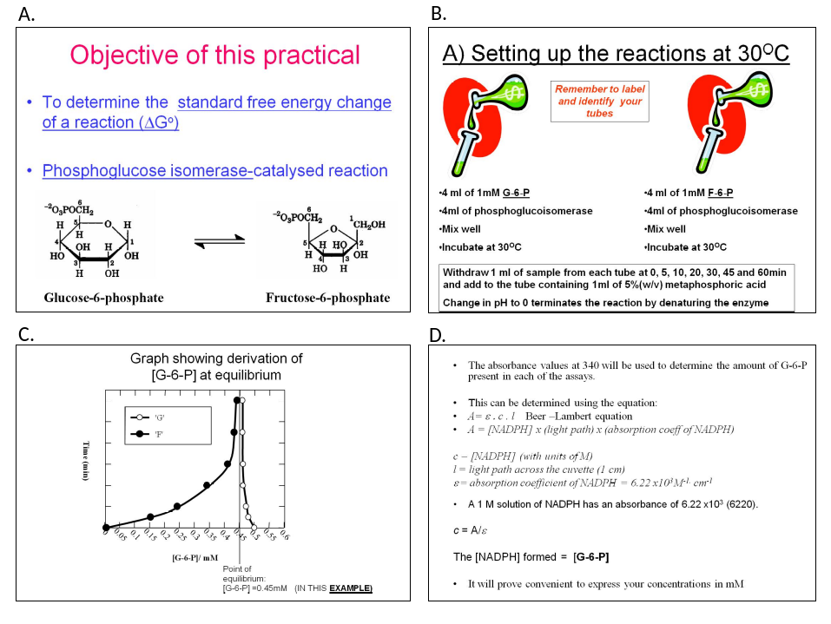

Figure 2

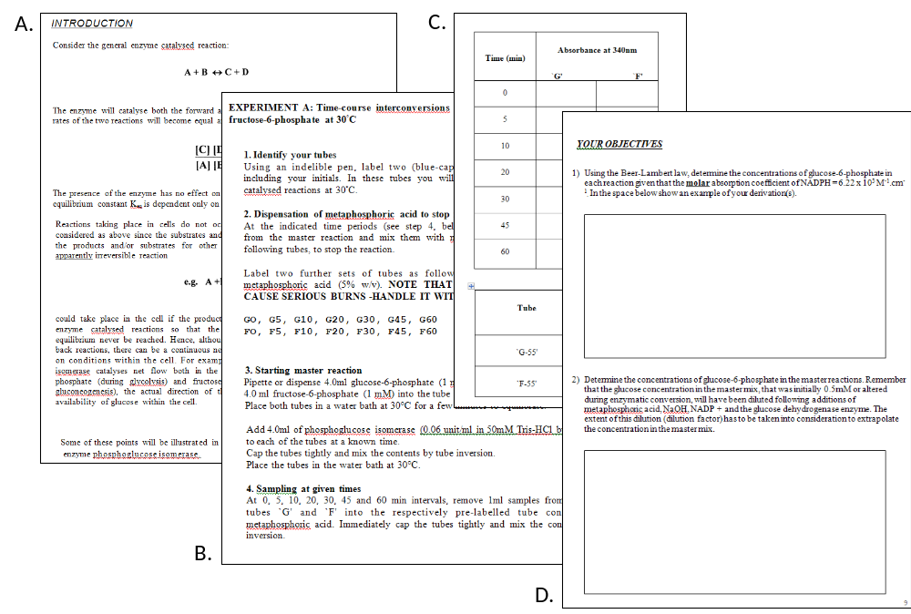

Figure 3

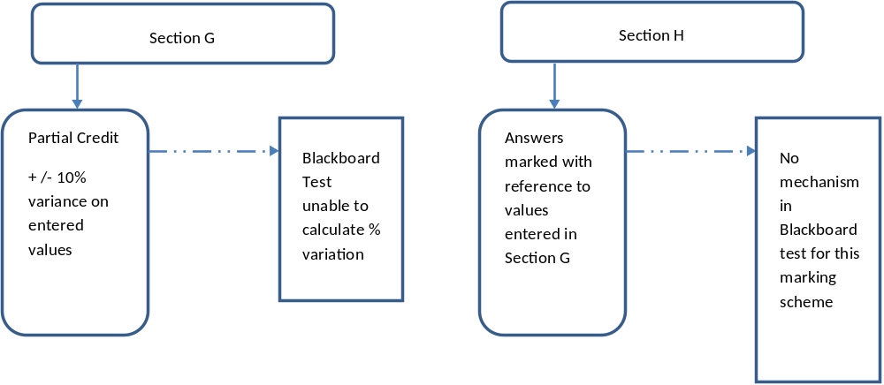

Figure 4

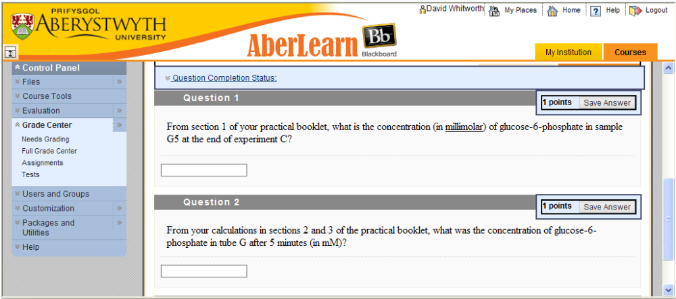

Figure 5

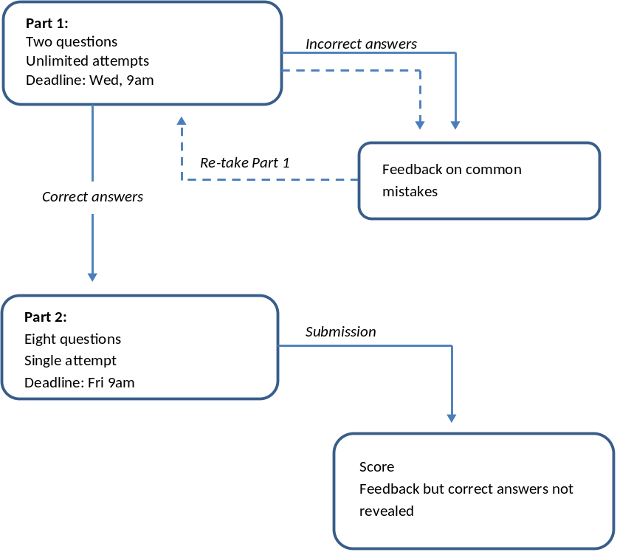

Figure 6

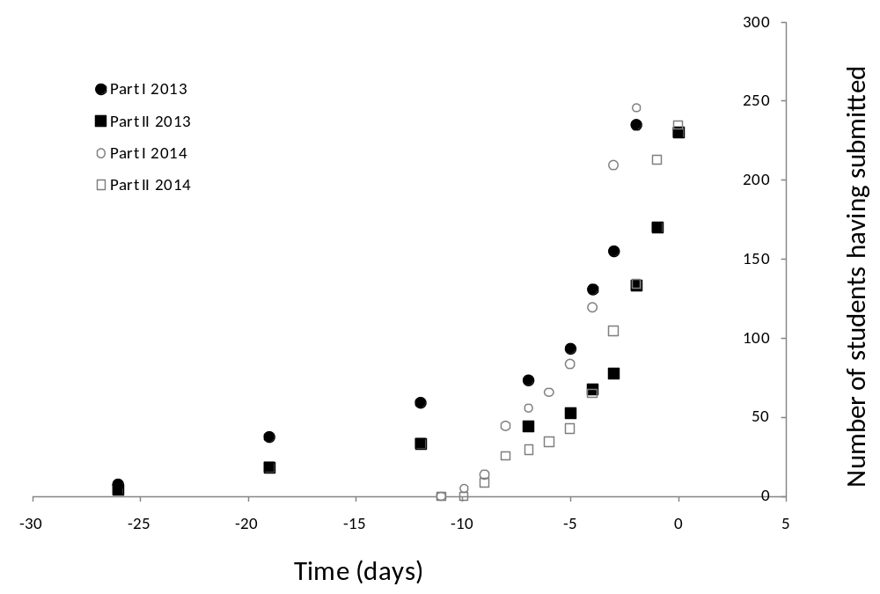

Figure 7

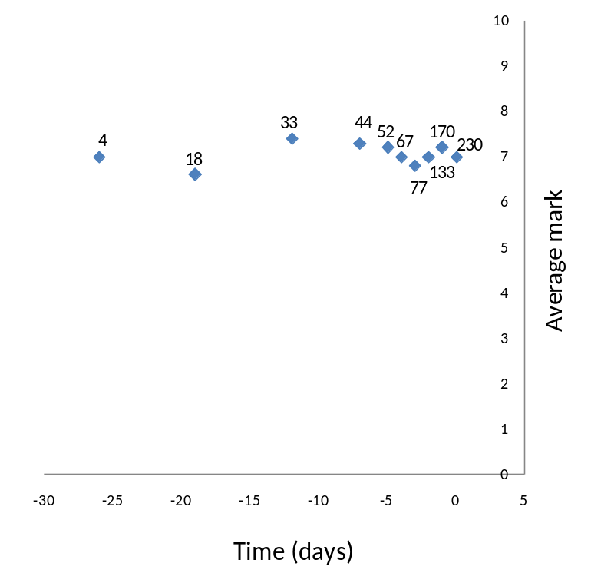

Figure 8



