A multi-agent architecture for lamb supply chain

Nishikant Mishra, Wyn Morris, Akshit Singh and Steve McGuire

School of Management & Business, Aberystwyth University, United Kingdom

ABSTRACT
Small and medium size farming firms are unaware of the modern production system adjustments available to improve efficiency in lamb production and the lamb supply chain. These factors have collectively led to many serious issues confronting the sheep industry such as the Bullwhip effect, quality of carcass not meeting the specifications of abattoirs, retailers etc. This paper is postulating a multi agent scheme for the lamb supply chain, which addresses above-mentioned issues facilitating a feedback system. This scheme involves various autonomous agents having their unique roles and responsibilities at different stages in the lamb supply chain to make it more efficient and customer focused. This scheme will lead to profit maximisation for the farmer, abattoir, and customers enabling maximum utilisation of resources all along the lamb supply chain.
Keywords: supply chain, multi agent model, and lamb supply chain.
1. INTRODUCTION
The UK has a complex lamb production system with different breeds of sheep grazing, hill, upland and lowland grassland, which are interlinked by a stratified system. The stratification of the UK sheep industry involves particular breeds occupying specific environments to which they are adapted for example the hill breeds. Lambs and older animals are moved from higher to lower ground, thus connecting the various production systems. In the uplands, hill breeds are crossed with longwool breeds to produce a recognized cross, for example the mule. The females (mule) are then used in lowland flocks as breeding stock and crossed with a terminal sire to produce a finished lamb for market whilst the ewe retains the good maternal characteristics of the hill breed. The hill and upland areas are mostly concerned with an extensive grass based systems with a stocking rate of 1-2 ewes/ha (Hybu Cig Cymru, 2011). The lowland farms are more intensive and although they make use of available grass, they also have a tendency to make use of concentrate feed and alternative forages.
The UK system relies heavily on this crossbred system with the use of terminal sires for finished lamb production. This crossbred system increases the complexity of the lamb supply chain. There are around 70 pure-breds and 12 recognised crosses existing in the UK, enabling sheep farming under various climates and topography across the country (Hybu Cig Cymru, 2011). Seasonality, competition and price fluctuations are factors influencing the lamb supply chain.
At present, UK agriculture is heavily subsidised under the Common Agricultural Policy’s Single Farm Payment Scheme (The Treaty of Rome & foundations of CAP, 2008). These subsidies have led to a production system that has taken its eye off the market. Farmers have a tendency to produce lambs and then look for a market rather than provide what the customer requires. As a result, we often see less productive animals on productive land due to the ease of the system for the farm manager.
Environmental subsidies are also seen as a conflict to a productive and efficient lamb production system. Finally, the payment system for finished lambs is heavily skewed towards payment on carcass weight with minimal penalties for poor carcass conformation or fat content.
The result of the foresaid problems is an inefficient lamb supply chain. There is an expected reduction in farm subsidies in the near future and abattoirs are looking to modify their payment systems. These factors will dramatically change the UK lamb industry. Therefore, farmers have to be far more market or consumer focussed, they will be required to make informed decisions on what to produce, how to produce it and when.
Autonomous agents can be defined as software entities that are programmed to perform certain complex tasks like data collection from various sources, processing of tasks and information (as per industry), coordinating with other agents to perform complex operations etc. They are designed to require minimum human intervention for their operation. They can keep the record of both their and their user’s activities and can even provide feedback to the users from their past experiences. Multi agent scheme employs various such autonomous agents and perform certain complicated tasks with more accuracy, less time and human intervention (Luo Y et al., 2002).
Due to the complexity and constraints within the lamb supply chain, this paper aims to produce a multi-agent lamb supply chain scheme with the intention to assist farmers in making informed decisions on their production systems. This will allow specially small and medium farmers to make production efficiencies and adapt to a changing market by providing them with a feedback system. This phenomenon will lead to maximisation of profit for the farmer and better utilisation of resources.
The organisation of the paper is as follows. Section 2 consists of literature review focussed on decision-making system in fresh meat industry especially at farm end. It is followed by an overview of Lamb supply chain in section 3. Then, the multi agent model is explained in the context of lamb supply chain in section 4. The communication channel employed for communication among agents is described in section 5. Thereafter, a case study on lamb enterprise using this multi agent scheme is discussed in section 6. It is followed by managerial implications and contributions in section 7. Finally, the article is concluded in section 8.
2. LITERATURE REVIEW
This section highlights the research work done in the domain of utilisation of decision support system in the farms of red meat species. The availability of managerial time and its allocation largely affects production decisions e.g. technology adoption, economic performance and the household’s economic wellbeing (Fernandez-Cornejo et al., 2007). Agricultural production systems defined by Le Gal et al. (2010) are “the combination of productive activities at farm level, utilising farm and environmental resources”. The management of these production systems involve wide ranging decisions regarding the selection of crops; livestock and operations that will structure farm activities. Farm decisions are taken on interconnected time scales: strategic (several years), tactical (seasonal), and operational (daily/weekly) in order to fulfil production objectives (Le Gal et al., 2010). Manos et al. (2010) finds that decision making in agriculture is a process not based on stable, simple and well-defined rules, but on knowledge, information, experience and skills of the producers/decision makers.
Farm systems are highly complex with a numerous interactions between farm system components; this makes it difficult for farmers to value the benefit of new information therefore leaving a wealth of technology unused (Webby, 2002). McCown (2002a) states that “agricultural modelling and its applications have inherited much from the field of operations research; the present problem of non-adoption by farmers also has an historical precedence in Operations research.” Decision support systems (DSS) and information systems (IS) have been designed to serve functions deemed by ‘management scientists’ to be potentially useful to managers. Unfortunately, the use of agricultural DSSs by farm managers has been low (McCown, 2002b).
Girard and Hubert (1999) believe that “in order to develop decision support tools that will assist farmers in managing their farms effectively, farm advisors need to gain a clear understanding of the way these farms function.” This includes knowledge of farm objectives, rules and problems as well as an understanding of the farmers’ decision-making process. Manos et al. (2010) also recognises that the decision making process requires from the producers/decision makers a qualitative evaluation and understanding of the problem they are facing. An effective decision support system therefore requires developing a commonality of knowledge between the farm decision maker and adviser (Girard and Hubert, 1999).
The implementation of DSS on family farms are problematic, therefore it is of importance to have a close relationship between the DSS developer and the potential user (McCown, 2002b). The low priority of DSS on farms must not be a deterrent and it is important to discover the actual potential of such tools in farm decision-making (McCown, 2002b). Reasons why farmers do not adopt some innovations is either that they are not faced with the problem for which these innovations were designed (Fujisaka S, 1994) or that the innovations have no relevance in their actual situation (Frank B, 1995).
Research suggests that farmers will potentially be more accepting of the DSS if involved in the processes and reasoning that underpinned it. Active engagement with farmers is recommended to provide a source of practical know-how that can help inform the DSS and lead to a better product (Oliver et al. 2011).
If tools are to be used directly by the farming community or in cooperation with the regulatory community then there is an imperative for clear communication between science providers and science users. It will maximise the utility of products for both parties. Active engagement in early stages is important to bridge rather than reinforce the science-stakeholder divide and accommodate knowledge or understand the concerns of those who need to use emerging tools (Quinn et al. 2010); (Barreteau et al. 2010). Embracing farmers as experts and utilising their detailed local knowledge into DSS can result in a product that is more reflective of the farm system and perhaps more accessible or appealing to the farming community. Entering into a dialogue with end-users at early stages of DSS development and then throughout the design process has considerable benefits and also facilitates social learning (Van Delden et al. 2011). The formation of trusting relationships with the farming community and dialogue should take place organically (Oliver et al. 2011).
The development of DSS for farmers still seems appealing: information technology making agricultural systems science more accessible and useful for guiding management of production systems. It is realistic to think that scientifically sound DSS should be useful to a farmer, and as both models and computer software have improved immensely in their capabilities and ease of use this should make DSS far more appealing (McCown, 2002b). It must however be noted that farmers cease to care about tools when they can’t see sufficient practical value for action resulting from the output, taking into consideration the costs, including managerial time and attention (McCown, 2002b).
McCown (2002b) assumes that decision-makers with bounded rationality are unable to consistently choose optimal actions; therefore the provision of formal analysis that identifies such an action would make a genuine contribution to better management. An accompanying assumption has been that rational managers would embrace this ‘support’.
It is now clear that farmers often cease to need computerised decision aids once a decision becomes routine. External guidance of farmer actions using information systems has increased to include not only intervention to aid better choice of actions but also intervention to facilitate learning and modification of decision process (McCown, 2002b).
For many agricultural professionals with experience in building and implementing DSS, the activity has been peripheral to the main enterprise of modelling. Researchers have good intentions to provide tools that would benefit farm management however, when the expectations of farmer adoption have not been realised, researchers have tended to turn to other activities rather than try to learn from the disappointment, and make appropriate adjustments (McCown, 2002b).
If farmers are to make full use of Decision Support Software and adopt their full potential, it is imperative that they undergo an iterative learning process. Researchers or DSS developers must assist with this learning process whilst also improving their knowledge. By understanding what farmers are learning, researchers will then understand the essence of action research and be better prepared with future work and activity (McCown, 2002b).
McCown (2002b) states that “We appear to be in transition from an era of, generally, uncritical exploitation of the DSS idea to one in which a combination of reflection and insight may enable delivery of more useful and more used computer-mediated scientific support for farm management.” There is a requirement to provide farmers with the opportunity to evaluate how innovations may impact on their production systems. Sterk et al. (2009) comments that this is true “whether the innovations are proposed by outside agents or designed by the farmers themselves.”
In livestock production, the technical sub-system includes the coordinated set of operations related to reproduction, feeding, and health maintenance of the herd (Le Gal et al., 2010). Matrix models take the herd as a combination of same age animal’s cohorts (Lesnoff, 1999). In all of these models, technical acts are considered as control variables but the technical subsystem is not explicitly represented. Modelling the decision sub-system consists mainly of designing software that mimics farmer decision-making processes (Le Gal et al., 2010).
Different modelling work has been undertaken to represent these relationships and to evaluate ex-ante the impact of a livestock strategy on the technical, economic, or ecological performance of a farm (Le Gal et al., 2010).
Seeking to subtly represent actual technical and biophysical processes can become a handicap if the objective is to provide farmers with a support tool for the design of production systems. Similarly, the use of rule-based models to represent farmers’ decisions is complicated to formalize and program (Le Gal et al., 2010).
Manos et al. (2010) through the work of (Sprague and Carlson, 1982) outlined that a typical DSS comprises of the following 3 components:
1. The Data Base and the Data Base Management System
2. The Model Base and the Model Base Management System
The User Support Base and User Base Support Base Management System
Future prospects for model-based intervention in farming practice: There is every reason to expect that farmers’ dependency on computers will continue to grow, in keeping with trends in the wider society (McCown, 2002b).
Acquiring farmer knowledge is vital as we seek expert data. It is recommended that this is available throughout the development of DSS by developing a working relationship between researchers and the farming community. Expert data can then be gathered formally and informally throughout the process (Oliver et al., 2011). The increased use of farmers as experts to inform and validate the model signifies a shift towards an integrated and collaborative approach resulting in greater acceptance (Oliver et al., 2011).

3. LAMB SUPPLY CHAIN
This section describes the product flow in lamb supply chain from farm to customers. The complete lamb supply chain is depicted in Figure 1. Sheep farmers decide the breed of sheep which are ideal for their farm. Then, these lambs are fattened on the farms till they are ready for their chosen market or finished. Finished lambs are transported to abbatoirs where they are killed, cut into primals and deboned. These primal cuts are transferred to the processor. The processor develops these primal cuts into popular products like joints, steaks, burger, meatball, mince etc. These products are packed, labelled and sold to wholesalers and retailers. Now, wholesalers sell their beef to both retailers and food service industry. Food service industry cooks the raw lamb and serves their customers. The retailers on the other hand sell lamb to the customer through their convenience store and supermarket.

Sheep Farms
Slaughterhouse
Processor
Wholesale
Customer
Retailer
Food service
Figure 1 showing complete lamb supply chain (Mena et al., 2011).

The next section explains the multi agent scheme consisting of various autonomous agents to optimise the lamb supply chain.

4. MULTI AGENT SCHEME
The multi agent scheme consists of ten autonomous agents, which will be employed to optimise the lamb supply chain. The schematic diagram of the proposed multi agent scheme is shown in figure 2. These agents will communicate among themselves to perform various

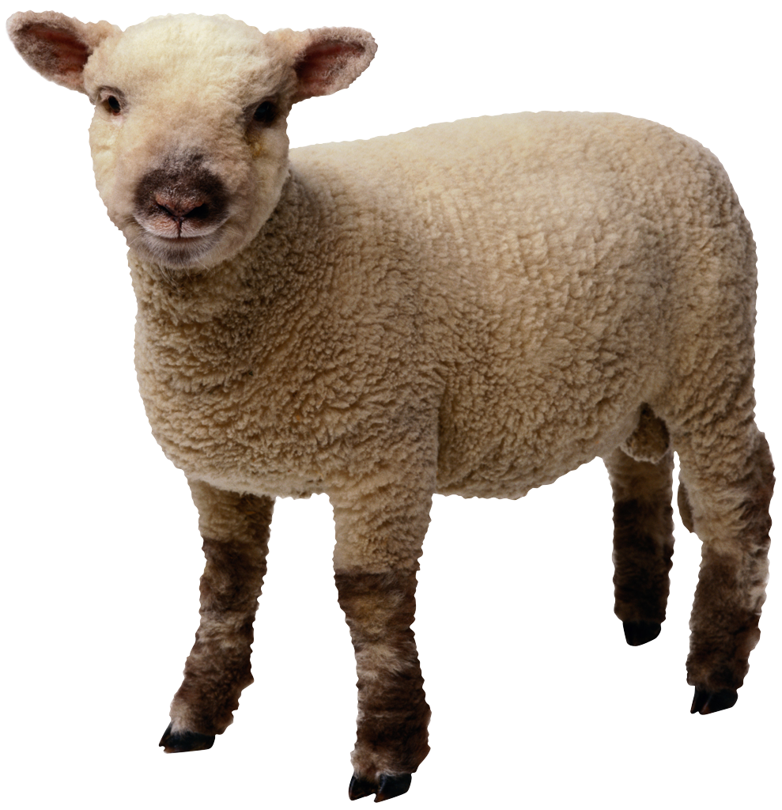
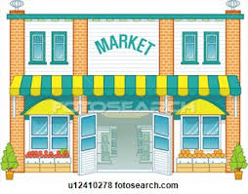
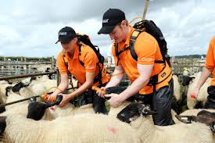
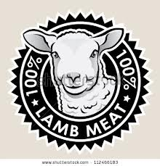
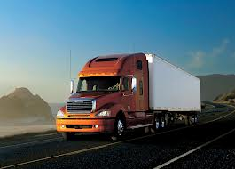
Knowledge Base Agent
Farm Management Agent
Lamb Selection Agent
Lamb selected or retained by farmer
Marketing Agent
Market
Sheep Husbandry Agent
Welfare of lambs
Production system Agent
Online decision support system
Stocking rate
Farm type Agent
Decide breed of sheep
Abattoir Agent
High quality meat
Abattoir Agent
Feedback in Lamb supply chain
Logistics
Figure 2. Schematic diagram of multi agent lamb supply chain

functions like deciding type of farm, breed of sheep, stocking rate etc., which is most suitable for a particular farm. Moreover, they will facilitate a feedback from abattoir to farmers regarding the quality and conformation of the carcass, which assists farmers to take necessary actions to improve the output of the lamb production system. The functioning of these agents along with their protocols is described below.

4.1 Farm Type Agent
The main task of this agent is to identify the farm type. This is achieved by assessing farm location, climate especially rainfall, topography, soil type and depth. The results of this analysis will determine which breed or breeds of sheep are best suited to the farm type. The suitability of the breed of sheep to the farm type is critical to the success of the overall system.
Farm type agent protocol: Farm type _ agent ( ) assesses all the inputs like farm location, rainfall, topography, soil type etc. and then predicts the breed of the sheep best suited for this particular farm. It then saves a copy using save_ copy ( ) function and passes this information to Knowledge base _ agent ( ) using Pass _ copy ( ) function.
Farm type _ agent ( )
{
Farm _ agent (Calculate the best suited breed of sheep as per Farm type);
Save _ copy ( );
Pass _ copy ( )
{
Farm _ agent ( ) -> Knowledge base _ agent ( );
//Pass this operational information to Knowledge Base Agent
}
}

4.2 Farm Management Agent
This agent will analyse many inputs and assess which production system is best suited given all the managerial considerations. These include managerial time spent on the sheep enterprise, farming expectations and desires. The education and experience of the farm manager and any workers needs to be considered. The conflict between other farm enterprises and income sources such as off-farm work and subsidies needs to be measured. Farm capital resources need to be considered, for example if the farmer has sheep housing then he can lamb earlier in the year. This agent will further narrow down the options of which breed is suitable for the farm and farm manager and consider breed characteristics such as lambing ease, prolificacy and maternal ability.
Farm Management Agent protocol – This agent receives all the inputs like Farm capital resources, previous experience of farm managers etc. using Register _input ( ) function. Then, Farm _ management ( ) function, predicts best suited production system and breed of lamb. This information is then passed to Knowledge base _ agent ( ) using Pass _ copy ( ) function.

Farm management _agent ( )
{
Register _ inputs (managerial time, previous experience, farm capital resources);
// Collect all the input data necessary for analysis.
{
Farm _ management (Predicts best suited production system, sheep breed);
}
Pass _ copy ( )
{
Farm _ management ( ) -> Knowledge base _ agent ( );
//Pass information and results to Knowledge Base Agent
}
}

4.3 Production System Agent
The farmer has made a decision on breed of sheep best suited for his farm by utilising above-mentioned agents. Now, he must decide on their stocking rate. This agent will then assess the impact of stocking rate and make use of the Lamb feed management calculator in order to determine lambing time, and feeding strategy. This agent will collect data from the knowledge base agent on feed, fertiliser, straw costs and deal with warehousing requirements.
Production system agent protocol – Initially, information is being transferred using Pass _ copy ( ) function from Knowledge base _ agent ( ) to Farm _ management ( ). Then, Farm _ management ( ) agent calculates stocking rate and its impact , lambing time and warehousing requirements. Then, this information is passed to Knowledge base _ agent ( ) using Pass_copy ( ) function.

Production system _agent ( )
{
Pass _ copy ( )
{
Knowledge base _ agent ( ) -> Farm _ management ( );
// Pass information on feed, fertilizer and straw costs to Farm _management ( )
}
Production _system (calculate stocking rate & its impact, determine lambing time & warehousing requirements);
{
Pass _ copy ( )
{
Production _ system ( ) -> Knowledge base _ agent ( );
//Pass information and results to Knowledge Base Agent
}
}
}

4.4 Sheep Husbandry Agent
This agent is concerned with the day-to-day wellbeing of the sheep flock. This agent must monitor farm hygiene, disease prevention, traceability issues and farm assurance. The agent will use the knowledge base agent and collect market based information for the purchase of veterinary products and electronic identification tagging. This agent will also be linked to the farm management agent with regards to managerial time and desires.
Sheep husbandry agent protocol- Sheep_ husbandry receives information from Knowledge base _ agent ( ) and Farm_ management ( ) using Pass_ copy ( ) function. Then, it does it functions like monitoring farm hygiene, disease prevention etc. and report all its actions to Knowledge base _ agent ( ) using Pass_ copy ( ) function.

Sheep husbandry _ agent ( )
{
Pass _ copy ( )
{
Knowledge base _ agent ( ) -> Sheep _husbandry ( );
// Pass information on Veterinary products and electronic tagging to Sheep _husbandry ( )
}

Pass _ copy ( )
{
Farm_ management ( ) -> Sheep _husbandry ( );
// Pass information on managerial time & farm expectations to Sheep _husbandry ( )
}

{
Sheep _husbandry (monitor farm hygiene, disease prevention, traceability issue, farm assurance);
}
{
Pass _ copy ( )
{
Sheep _ husbandry ( ) -> Knowledge base _ agent ( );
//Pass information and results to Knowledge Base Agent
}
}

4.5 Lamb Selection Agent
This agent must use the Knowledge base agent to determine the best marketing options for the lambs. An economic decision must be made with regards to selling them as store lambs, finished lambs or lambs for breeding. This selection process will also determine any lambs being retained by the farmer for his own flock replacements. Selection at this point is very subjective and the farmer will assess breed characteristics for any lambs being retained or sold for breeding purposes. The remainder of the lambs being sold as stores or finished lambs will be determined by lamb weight, fat content and market prices. It must be noted that this is the area that requires investment, as the farmer measures the fat content in lambs manually only. There is scope for development of more accurate techniques to ensure lambs are meeting the correct grades. This agent will be linked to the managerial agent in terms of strategy and objectives.
Lamb selection agent protocol – Lamb selection _ agent ( ) receives information from Knowledge base _ agent ( ) and Farm_ management ( ) using Pass_ copy ( ) function. Then, Lamb _selection ( ) determines best marketing option for lamb and does economic decision making on selling or retaining a particular lamb. It passes this information to Knowledge base _ agent ( ) using Pass_ copy ( ) function.
Lamb selection _ agent ( )
{
Pass _ copy ( )
{
Knowledge base _ agent ( ) -> Sheep _selection ( );
// Pass information on market price of lamb, stores and breeding lambs to Lamb _selection ( )
}

Pass _ copy ( )
{
Farm _ management ( ) -> Sheep _selection ( );
// Pass information on Farm strategy and objectives to Lamb _selection ( )
}
{
Lamb _selection (Determine best marketing option for lamb, make economic decision on retaining or selling a particular lamb);
//Select best combination of stores, finished lambs and breeding lambs
}
{
Pass _ copy ( )
{
Lamb _ selection ( ) -> Knowledge base _ agent ( );
//Pass information and results to Knowledge Base Agent
}
}

4.6 Marketing Agent
This agent will be linked to the lamb selection agent. It will analyse the lambs selected and their intended markets. This can be a livestock market, to another farmer, through a procurement group, or via a buyer straight to the abattoir. This agent will then use the Knowledge base agent to determine where the best market for the selected lambs will be. This can be a combination of markets based on lamb breed characteristics, lamb weight, lamb fat content and location to markets. Farmers have a tendency to look at the overall lamb price or the price they receive per kg of lambs when making marketing decisions. This agent will need to utilise the Knowledge base agent to identify the costs associated with the different sales options, as these are often not transparent. The marketing agent will also be linked to the Farm management agent, to include the farm manager’s expectations and risk aversion in its decision-making.
Marketing agent protocol – Marketing _agent ( ) will collect information form Lamb selection _agent ( ) , Knowledge base _agent ( ) and Farm management_ agent ( ) using Pass _ copy ( ) function. Then, it calculates the best market or combination of markets for selected lambs and sends this information to knowledge base agent ( ) using Pass _ copy ( ) function.

Marketing _agent ( )
{
Pass _ copy ( )
{
Lamb selection _ agent ( ) -> Marketing _agent ( );
// Pass information of selected Lambs to Marketing _agent ( )
}

Pass _ copy ( )
{
Knowledge base _ agent ( ) -> Marketing _agent ( );
// Pass information regarding all markets for selected Lambs to Marketing _agent ( )
}
Pass _ copy ( )
{
Farm management _ agent ( ) -> Marketing _agent ( );
// Pass information of Farm manager’s expectations and risk aversion to Marketing _agent ( )
}
{
Marketing _agent (Calculates the best market or combination of markets for the selected lambs)
}
Pass _ copy ( )
{
Marketing _ agent ( ) -> Knowledge base _ agent ( );
//Pass information and results to Knowledge Base Agent
}
}

4.7 Abattoir Agent
The abattoir agent will be concerned with handling and welfare of lambs to limit the stress to the animal and provide the supermarkets with the highest amount of saleable meat. Currently, in the UK, lamb quality is classified using three variants, which are lamb weight, conformation class based on the EUROP classification and fat class. The combination of these three will determine the pay grade of the animal. The fat class and conformation are again decided on human observations at present and are very subjective and open to discrepancies. The Knowledge base agent must gather this final data and present it back into the multi-agent system. This phenomenon will help in making necessary amendments so that more lambs reach the best combination of weight, conformation and fat class specification and therefore achieve a higher carcass price for the animal.
Abattoir agent protocol – Abattoir _agent ( ) receives information form Knowledge base _ agent ( ). Then, Abattoir _agent ( ) facilitates stress free handling of lambs and make necessary amendments in farming practice to improve the quality of lamb in terms of fat content and conformation.

Abattoir _agent ( )
{
Pass _ copy ( )
{
Knowledge base _ agent ( ) -> Abattoir _selection ( );
// Pass information on fat class and conformation to Lamb _selection ( )
}
{
Abattoir _agent (facilitates stress free handling of lambs, make amendments to improve lambs fat content and conformation);
}
Pass _ copy ( )
{
Abattoir _ agent ( ) -> Knowledge base _ agent ( );
//Pass information and results to Knowledge Base Agent
}
}

4.8 Technology Agent
There is considerable room for human error within the current lamb selection and grading systems. It is therefore desirable that further research and investment is undertaken in developing more precise carcass grading technologies that are affordable to implement. If computerised grading is adopted within UK abattoirs, this will further add data to the Knowledge base agent. Therefore, the whole multi-agent system will have greater understanding of the various production systems outputs.
The current system is not effective, as carcass conformation has no relation to carcass yield. The technology agent needs to be updated and developed by accessing information on video analysis of meat yields and carcass dissection data. Having accurate and consistent Knowledge based feedback within the lamb supply chain, will reduce wastage, improve marketing opportunities and allow for a more consistent product. As a result, farmers can expect increased financial returns through production efficiencies and an improved saleable product.
For production system changes to occur and such models to be adopted, the industry should increase the price penalty on lambs of poor conformation and unacceptable fat content. There is a requirement to develop a payment system based on carcass meat yield and eating quality. Farmers need to make informed decisions with regards to their production systems.
Technology agent protocol – Technology _agent ( ) keeps accessing video analysis of meat yields and carcass dissection data. Furthermore, it facilitates the feedback on carcass quality within the Lamb supply chain. It passes this information in turn to Knowledge base _ agent ( ) using Pass _ copy ( ) function.

Technology _agent ( )
{
Technology _agent (access video analysis of meat yields and carcass dissection data, facilitate feedback within lamb supply chain);
Pass _ copy ( )
{
Farm _ agent ( ) -> Knowledge base _ agent ( );
//Pass this operational information to Knowledge Base Agent
}

}

4.9 Logistics agent
This agent comes into action the moment it receives a signal from Marketing agent regarding the selected market for selling lambs. The Logistics agent decides the type of transport to be adopted for transporting the selected lambs to market. It makes a decision as to whether the farmers own transport will be used or it will be outsourced to an industrial partner. It takes into consideration the number of lambs to be transported, the distance between the farm and selected market, appropriate means of transport (by road and sea) and the best logistics company as per situation. It also decides which route the transport should select, considering all the aspects like scheduled time of delivery, any traffic diversion because of maintenance works, bad weather etc. It makes an optimized trade off between the cheapest and quickest mode of transport of lambs to market. It also keeps the record of logistics used in the past and is capable of giving feedback of that particular logistic firm in future. Once the logistics agent has made its decision about transport, it informs the Knowledge base agent by sending a signal.
Logistics agent protocol – Logistics _agent ( ) will collect information from Marketing _agent ( ) about the destination market. Then, it will consider all the impacting factors with its algorithm and predicts the best-suited mode of transport (Logistics). Then, it will check the feedback of that chosen logistic option from its database. Finally, it will decide the best suited logistic option and inform knowledge base agent ( ) about its decision using Pass _ copy ( ) function.

Logistics _agent ( )
{
Pass _ copy ( )
{
Marketing _ agent ( ) -> Logistics _agent ( );
// Pass information of selected Lambs to Logistics _agent ( )
}

{
Logistics _agent (Calculates the best Mode of transport for sending lambs to markets and check it feedback from its database)
}
Pass _ copy ( )
{
Logistics _ agent ( ) -> Knowledge base _ agent ( );
//Pass information and results to Knowledge Base Agent
}
}

4.10 Knowledge Base Agent
This agent collects the information and data from other agents and keeps a track of their activities. It can update itself both online and offline. This agent has the information about the status of a particular operation in this multi agent lamb supply chain and the processing time of that operation. This agent has the record of all successful and unsuccessful decisions made in the past by other agents. It uses this information to guide them so that they do not repeat the same mistakes. The next section explains the communication channel deployed by the agents to communicate amongst them in this multi agent scheme.

5. COMMUNICATION CHANNEL
The potency of a multi agent scheme relies heavily on the quick and precise communication between the agents. The agents send signals to communicate among themselves. The receiving agent calculates the course of action and any sudden change by interpreting these signals. Developers have developed many languages for effective communication between agents like Knowledge Query Manipulation Language (KQML), Agent Communication Language etc. One of the most advanced and widely used languages is MALLET (Multi- Agent Logic Language for Encoding Teamwork). The main aim to develop this language was to boost team oriented programming. MALLET helps in smooth information flow in the system and accurate encoding of information, which could be procedural or declarative. MALLET (by using sequential and iterative processes) will be used in this multi agent lamb supply chain to facilitate communication among the agents. CAST (Collaborative Agents for Simulating Teamwork) is an interpreter of MALLET. The schematic diagram of CAST is depicted in Figure 3.
MALLET Parser
Teamwork knowledge in MALLET
Domain knowledge
Cast Reasoning Engine
Individual Mental model
Proactive behaviours
Goal Management
Share team Knowledge
Process Tracking
Figure 3. CAST architecture (Fan et al., 2006)

Characteristics of communication channel are briefly described as following: -
- Interpretability – The communication language used should be easy to interpret or decoded by the agents.
- Accurate- The communication language used should be clear, precise and expressive.
- Multiple Usage- The communication language used should have the quality of multiple usage in order that stored information can be retrieved any number of times, saving money and effort.
Agents define their tasks, capabilities and plans before starting communication. They, then integrate their tasks with agents as per their condition. The agent in turn transfers its own pre- requirements like required knowledge and information to the following agent. This communication can be iterative (WHILE, FOR), Parallel (PAR), Sequential (SEQ), Choice specific (CHOICE) or conditional (IF). The agent completes its operation only when its pre requirements are fulfilled. If by chance, an agent fails to fulfil these requirements, it receives assistance from other agents and they cooperate with each other. The next section consists of a case study of a sheep enterprise, which employed the multi agent scheme for their firm to improve their efficiency and profit.
6. CASE STDUY
This case study involves a medium size sheep farm enterprise. This enterprise will utilize an automated system of multi agent lamb supply chain throughout the process from deciding breed of sheep to selling lambs. Initially, it will use the farm type agent to identify, which breed of sheep is best suited for the farm. It will be achieved by assessing farm location, topography, rainfall, soil type, altitude and feedback from. Then, it will inform Knowledge base agent about its decision. Now, farm management agent will analyse managerial time spent on farms, farming expectations, desires and predict which production system is best suited to the farm. Moreover, it will take into account farm capital resources like sheep housing and other income sources such as off farm work and subsidies. This agent also seeks feedback from knowledge base agent and therefore helps to further narrow down which breed is ideal for farm and its characteristics like lambing ease, prolificacy and maternal ability. Now, the production system agent will come into action. Firstly, it will determine the stocking rate for the farm. Then, it will utilize the online decision support system for sheep farms to determine lambing date and feeding strategy (grass, creep or a combination) for maximum profit to the farmer. The user interface of an online decision support system is shown in Figure 3.

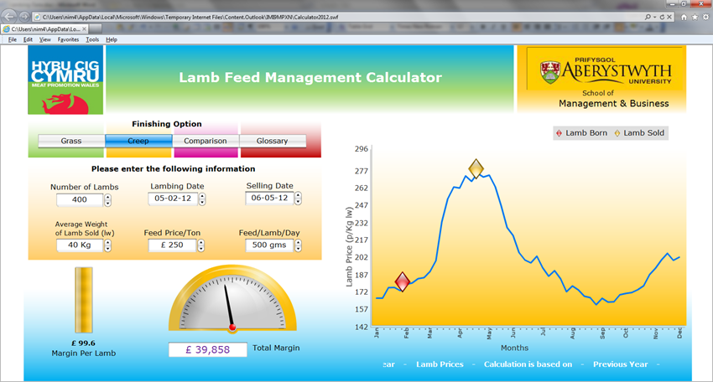 Production system agent will calculate the number of lambs from the stocking rate determined and size of farm. Now, it will use the calculated number of lambs and try different combinations of lambing date with grass and creep as shown in the screenshot to determine the most profitable combination for the farmer. This agent also deals with warehousing requirements by collecting data on feed, fertilizer, straw costs from knowledge base agent. It will inform knowledge bas agent about its decision. Sheep husbandry agent will continuously monitor the wellbeing of sheep for example hygiene, disease prevention, traceability issues and farm assurance. This agent is also responsible for purchase of veterinary products and electronic identification tagging of lambs (like RFID or barcode). It will continuously seek feedback from knowledge bas agent. Production system agent receives input from the Farm management agent in terms of managerial time and desires. Lamb selection agent decides if a particular lamb is to be sold or retained by the farmer. Selected lambs could be sold as store lamb, finished lamb or lambs for breeding or a suitable combination. Extracting market data from Knowledge base agent makes this decision. Now, Marketing agent will take charge from lamb selection agent and decide the best possible market for selected combination of lambs. It could be livestock market, another farmer, a procurement group or straight to abattoir via a buyer. It is executed by taking information about various markets from the knowledge base agent. It also takes into account farm manager’s expectations and risk aversion by taking data from the farm management agent. Marketing agent will pass this information of selected market to the Logistics agent, who will assess all the factors for example number of lambs to be transported, the distance between the farm and selected market etc. and chooses logistic firm. Logistic agent informs Knowledge base agent about its decision. Abattoir agent is concerned with stress free handling of lambs so that highest quality meat is delivered to supermarket. A specific fat class, conformation and weight of the lamb carcass decide the overall quality and price. Abattoir agent takes data from Knowledge base agent regarding these specifications and make necessary amendments in farm practices so that these specifications are met at the time of selling lambs. In the end, technology agent with the help of knowledge base agent facilitates a feedback system within the lamb supply chain from abattoir to farmer regarding the quality of lambs supplied. This will reduce product waste, improve marketing opportunities and enables a more consistent product. Therefore, the sheep farm enterprise will receive a significantly higher financial return and enable maximum utilisation of resources. The next section includes managerial implications and contributions of this research.
Figure 3. Screen shot of online decision support system
7. MANAGERIAL IMPLICATIONS AND CONTRIBUTIONS
This article suggests a multi agent scheme for efficient product flow in the lamb supply chain. It explains the working principle of all autonomous agents involved in the multi agent scheme to accomplish various tasks involved in supply chain for example deciding type of farm, breed of lambs, appropriate market for selling lambs etc. This multi agent scheme can facilitate various tasks such as material flow, keeping records, developing a feedback system etc. along the lamb supply chain with minimal human intervention. The operations of the autonomous agents become more precise and efficient as they can access the past experiences stored in Knowledge base agent thereby reducing the probability of mistakes committed in the past. This phenomenon can remarkably influence the methods and approaches of traditional decision making in the lamb supply chain. Hence, this multi agent system can play a crucial role in assisting lamb supply chain managers in the decision making process at various stages. This multi agent system has application in sheep farms, abattoirs, logistics and consequently creates a more quality and consistent product for customers at a reasonable price. There is flexibility of expanding this multi agent scheme by involving more function specific agents and by modifying the system as per the specifications of a lamb enterprise. Therefore, this work adds to the domain of decision support system in the red meat supply chain where the application of a multi agent system has been recommended for decision making in the lamb supply chain.
8. CONCLUSION
The proposed multi agent system of the lamb supply chain is capable of addressing various issues in the lamb supply chain, thereby making it more efficient and quality oriented. In this multi agent system, ten autonomous agents were proposed which are Farm type agent, Farm management agent, Production system agent, Sheep husbandry agent, Lamb selection agent, Marketing agent, Abattoir agent, Technology agent, Logistics agent and Knowledge base agent. These agents were operating in different segments of the lamb supply chain; some were operating at farm end, some at abattoir, some were keeping records of market, logistics etc. These agents facilitate appropriate decision making in various stages all along the lamb supply chain. There was a proper communication channel established between these agents for effective communication. Furthermore, they enabled a feedback system in the lamb supply chain so that more lambs are produced as per market’s requirement. All factors mentioned above will collectively lead to maximum profit of the farmer, abattoir, customers and optimum utilisation of resources. This phenomenon has been explained in the case study with a simulated example showing the execution of the multi agent scheme for lamb supply chain. Moreover, the agents employed in this scheme can be altered as per the expectations and constraints of a particular lamb production enterprise. This scheme is flexible enough so that further agents can be adjoined to tackle with other sophisticated issues of the lamb industry. These agents could be enhanced by framing them in web based domains so as to further improve their communication amongst themselves and also keeping up to date records of the external aspects such as market fluctuations, logistics firms etc. This paper has the further scope of pilot study of a multi agent lamb supply chain with real time data to check its efficiency and integrity.

RFERENCES
Barreteau O, Bots P & Daniell K, 2010. A Framework for Clarifying Participation in Participatory Research to Prevent its Rejection for the Wrong Reasons. Ecology and Society, 15.
Chan F T S and Chan H K, 2004. A new model for manufacturing supply chain networks: a multi agent approach. Proceedings of the Institution of Mechanical Engineers, Part B: Journal of Engineering Manufacture,218(4), 443-454,
Fan X. et al., 2006. MALLET – a multi agent logic language for encoding teamwork. IEEE Transactions on Knowledge and Data Engineering,18(1), 123-138.
Fernandez-Cornejo J., Nehting R., Hendricks C., Southern M & Gregory A, 2007. Off-farm income, technology adoption, and farm economic performance.
Frank B, 1995. Constraints limiting innovation adoption in the north Queensland beef industry. I: A socio-economic means of maintaining a balanced lifestyle. Agricultural Systems,47, 291-321.
Fujisaka S, 1994. Learning from six reasons why farmers do not adopt innovations intended to improve sustainability of upland agriculture. Agricultural Systems, 46, 409-425.
Girard N. and Hubert B, 1999. Modelling expert knowledge with knowledge-based systems to design decision aids: the example of a knowledge-based model on grazing management. Agricultural Systems, 59, 123-144.
Grabara J and Starostka M, 2009. The Bullwhip effect in supply chain. Advanced Logistics systems, issue 1, 127-133.
Hybu Cig Cymru (HCC), 2011. Welsh Lamb Industry Information.
Le Gal P Y, Merot A, Moulin C H, Navarrete M & Wery J , 2010. A modelling framework to support farmers in designing agricultural production systems. Environmental Modelling & Software, 25, 258-268.
Lee J H and Kim C O, 2008. Multi-agent systems applications in manufacturing systems and supply chain management: a review paper. International Journal of Production Research, 46(1), 233 – 265.
Leitão P, 2009. Agent-based distributed manufacturing control: A state-of-the-art survey. Engineering Applications of Artificial Intelligence, 22(7), 979-991.
Lesnoff M, 1999. Dynamics of a sheep population in a Sahelian area (Ndiagne district in Senegal): a periodic matrix model. Agricultural Systems, 61(3), 207-221.
Luo Y, Davis, D N, & Liu K, (2002). A multi-agent system framework for decision support in Stock Trading. IEEE Network Magazine Special Issue on Enterprise Networking and Services.
Manos B D, Ciani A, Bournaris T, Vassiliadou I & Papathanasiou J, 2010. A taxonomy survey of decision support systems in agriculture. Agricultural Economics Review, 5.
Maturana F P and Norrie D H, 1996. Multi-agent Mediator architecture for distributed manufacturing. Journal of Intelligent Manufacturing, 7(4), 257-270.
McCown R., 2002a. Locating agricultural decision support systems in the troubled past and socio-technical complexity of ‘models for management’. Agricultural Systems, 74, 11- 25.
McCown R, 2002b. Changing systems for supporting farmers' decisions:problems, paradigms, and prospects. Agricultural Systems, 74, 179-220.
Mena C, Adenso-Diaz B, Yurt O, 2011. The causes of food waste in the supplier- retailer interface: Evidences from UK and Spain. Resources, Conservation and Recycling, 55 (6), 648-658.
Oliveira E, Pereira G, and Gomes C, 2002. Reliable framework architecture for multi-agent systems interaction. The 7th International Conference on Computer Supported Cooperative Work in Design, 276 – 281.
Oliver D M, Fish R D, Winter M, Hodgson C J, Heathwaite A L & Chadwick D R, 2011. Valuing local knowledge as a source of expert data: Farmer engagement and the design of decision support systems. Environmental Modelling & Software.
Quinn P, Hewett C, Muste M & Popescu I, 2010. Towards new types of water-centric collaboration. Water management, 163, 39-51.
Sprague R H Jr. and Carlson E D, 1992. Building Effective Decision Support Systems. Englewood Cliffs, N.J.: Prentice-Hall, Inc.
Sterk B, Leeuwis C & Vanittersum M, 2009. Land use models in complex societal problem solving: Plug and play or networking? Environmental Modelling & Software, 24, 165-172. The Treaty of Rome and Foundations of the CAP. Circa.europa.eu.irc/opoce/fact_sheets/info/data/policies/article_7208. Europa, 2008.
Van Delden H., Seppelt R, White R & Jakeman A, 2011. A methodology for the design and development of integrated models for policy support. Environmental Modelling & Software, 26, 266-279.
Webby R, 2002. The value of decision support models for farmer learning. Proceedings of the conference – New Zealand grassland, 45-48.

